EMPLOYEE MANAGEMENT SYSTEM
Project Report
A Desktop Application built with C# (Windows Forms) and Microsoft SQL Server
Actors: Admin • Manager • Employee
Prepared using Visual Studio 2026
August 2026

Table of Contents
# | Chapter | Page
1. | Introduction | 3
2. | Key Features | 3
3. | Actors & User Stories | 4
4. | System Architecture | 5
5. | Entity Relationship (ER) Diagram | 6
6. | Use Case Diagram | 7
7. | Database Design (Tables) | 8
8. | SQL Script | 9
9. | Application Modules / Screens | 11
10. | How to Run the Project | 12
11. | Conclusion | 13

1. Introduction
The Employee Management System is a C# and SQL Server based desktop application designed to help an organization manage its employees, their salary records, and role-based access from a single, easy-to-use Windows Forms interface. The system is modelled after a typical three-tier college/university OOP project: a login screen, a role-aware main menu, and dedicated modules for Employee, Salary, and View (reports).
The application supports three types of users (actors): Admin, Manager, and Employee. Admin and Manager have full control over employee and salary data, while a logged-in Employee can only view information relevant to them — they cannot add, edit, or delete any record. This mirrors real-world HR software where regular staff should never be able to alter company records.

2. Key Features
- Secure login system with three roles: Admin, Manager, and Employee.
- Role-based access control — only Admin/Manager can Add, Edit or Delete records.
- Employee module: maintain full employee profiles (name, designation, department, contact, joining date).
- Salary module: monthly salary records with Basic, Bonus, Deduction, and auto-calculated Net Salary.
- View module: company-wide summary for Admin/Manager, and personal profile & salary history for Employee.
- Each employee automatically gets a linked login account when they are added to the system.
- All data is stored in a relational SQL Server database (EmployeeDB) with proper foreign keys.
- Clean, form-based Windows Forms UI, easy to extend with more modules later.

3. Actors & User Stories

As an Admin
- I want to log in securely, so that I can access the management dashboard.
- I want to add, edit, or delete employees, so that employee records stay accurate and up to date.
- I want to manage salary records for any employee, so that payroll data is always correct.
- I want to view a company-wide overview (total employees, departments, salary paid), so I can monitor the organization at a glance.

As a Manager
- I want to log in with my own account, so that I can manage my department's data.
- I want to add, edit, or delete employees and salary records, so that I can keep my team's information current.
- I want to view overall reports, so that I can track department performance and payroll costs.

As an Employee
- I want to log in with my own account, so that I can check my own information.
- I want to view the employee list, so that I know my colleagues and their designations.
- I want to view my own salary history, so that I can track my payments — without being able to edit anything.
- I want to view my profile summary, so that I can confirm my personal and job details are correct.

4. System Architecture
The application follows a simple layered structure typical of a college WinForms project:
- Presentation Layer — Windows Forms (Login, Dashboard, Employee, Salary, View screens).
- Business / Session Layer — Session.cs stores the logged-in user and enforces role permissions (CanEdit).
- Data Access Layer — DbAccess.cs wraps ADO.NET (SqlConnection, SqlCommand, SqlDataAdapter) for all database calls.
- Database Layer — Microsoft SQL Server database 'EmployeeDB' with three tables: Employee, UserTable, Salary.

Login & Navigation Flow
LoginForm --(valid credentials)--> DashboardForm
DashboardForm --[Employee]--> EmployeeListForm --[Add/Edit]--> AddEditEmployeeForm
DashboardForm --[Salary]--> SalaryForm --[Add/Edit]--> AddEditSalaryForm
DashboardForm --[View]--> ViewForm (read-only report for every role)
DashboardForm --[Logout]--> back to LoginForm

5. Entity Relationship (ER) Diagram
The database has three related tables. Employee holds core profile data. UserTable stores login credentials and the Role for every user, and links to Employee when the account belongs to an Employee. Salary stores one row per employee per month, and NetSalary is derived from Basic + Bonus − Deduction.
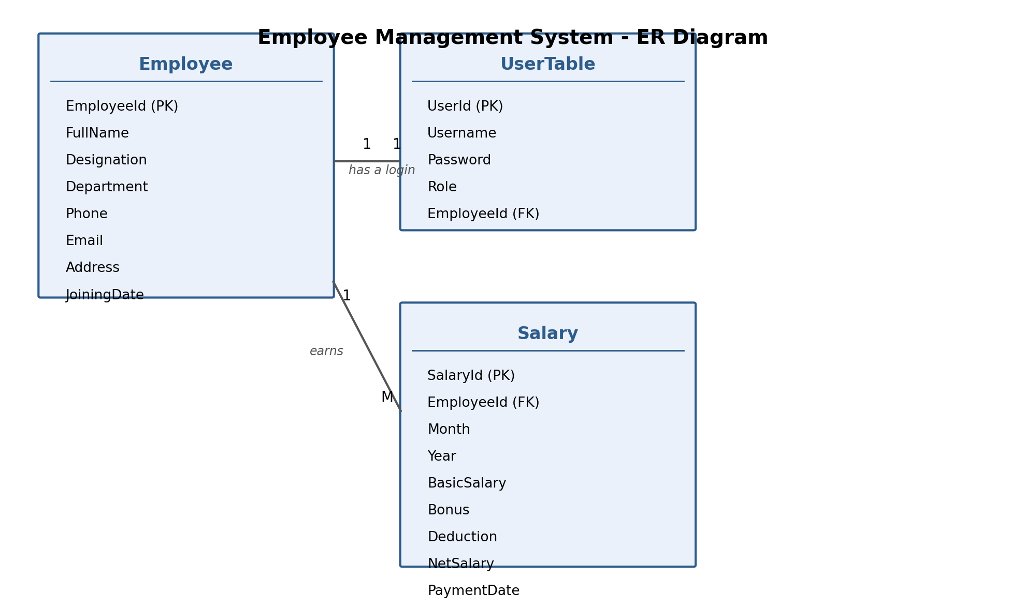
Figure 1: ER Diagram of the Employee Management System

6. Use Case Diagram
The diagram below shows how the three actors interact with the main system functions. Admin and Manager share the same editing capabilities; Employee is restricted to the 'view' use cases only.
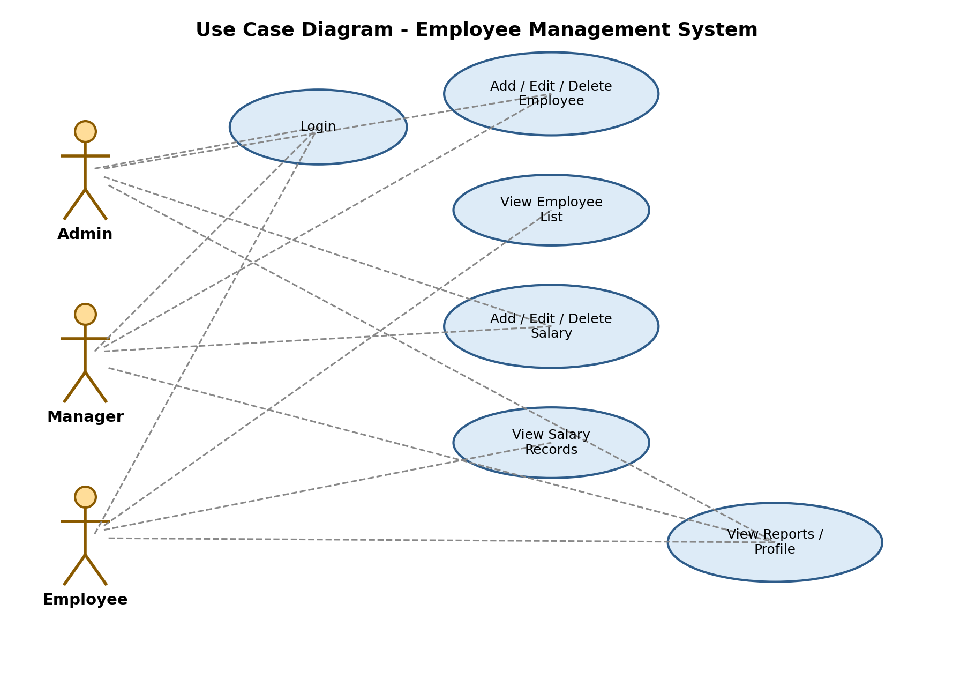
Figure 2: Use Case Diagram of the Employee Management System

7. Database Design (Tables)

7.1 Employee
Column | Type | Notes
EmployeeId | INT (PK, Identity) | Auto-generated primary key
FullName | VARCHAR(100) | Employee's full name
Designation | VARCHAR(50) | Job title, e.g. Software Engineer
Department | VARCHAR(50) | e.g. IT, HR, Finance, Sales
Phone | VARCHAR(20) | Contact number
Email | VARCHAR(100) | Contact email
Address | VARCHAR(150) | Home address
JoiningDate | DATE | Date the employee joined

7.2 UserTable
Column | Type | Notes
UserId | INT (PK, Identity) | Auto-generated primary key
Username | VARCHAR(50), Unique | Login username
Password | VARCHAR(50) | Login password
Role | VARCHAR(20) | 'Admin', 'Manager', or 'Employee'
EmployeeId | INT (FK), Nullable | Links to Employee; NULL for Admin/Manager

7.3 Salary
Column | Type | Notes
SalaryId | INT (PK, Identity) | Auto-generated primary key
EmployeeId | INT (FK) | References Employee.EmployeeId
Month | VARCHAR(15) | e.g. 'July'
Year | INT | e.g. 2026
BasicSalary | DECIMAL(10,2) | Base pay for the month
Bonus | DECIMAL(10,2) | Extra payment, default 0
Deduction | DECIMAL(10,2) | Any deduction, default 0
NetSalary | DECIMAL(10,2) | Basic + Bonus − Deduction
PaymentDate | DATE | Date the salary was paid

8. SQL Script
Run the following script once in SQL Server Management Studio (SSMS) before running the application. The full script is also included as EmployeeDB_Script.sql in the project folder.

8.1 Create Database & Tables
CREATE DATABASE EmployeeDB;
GO
USE EmployeeDB;
GO
CREATE TABLE Employee (
EmployeeId INT IDENTITY(1,1) PRIMARY KEY,
FullName VARCHAR(100) NOT NULL,
Designation VARCHAR(50) NOT NULL,
Department VARCHAR(50) NOT NULL,
Phone VARCHAR(20),
Email VARCHAR(100),
Address VARCHAR(150),
JoiningDate DATE NOT NULL
);
GO
CREATE TABLE UserTable (
UserId INT IDENTITY(1,1) PRIMARY KEY,
Username VARCHAR(50) UNIQUE NOT NULL,
Password VARCHAR(50) NOT NULL,
Role VARCHAR(20) NOT NULL CHECK (Role IN ('Admin','Manager','Employee')),
EmployeeId INT NULL,
FOREIGN KEY (EmployeeId) REFERENCES Employee(EmployeeId)
);
GO
CREATE TABLE Salary (
SalaryId INT IDENTITY(1,1) PRIMARY KEY,
EmployeeId INT NOT NULL,
Month VARCHAR(15) NOT NULL,
Year INT NOT NULL,
BasicSalary DECIMAL(10,2) NOT NULL,
Bonus DECIMAL(10,2) DEFAULT 0,
Deduction DECIMAL(10,2) DEFAULT 0,
NetSalary DECIMAL(10,2) NOT NULL,
PaymentDate DATE NOT NULL,
FOREIGN KEY (EmployeeId) REFERENCES Employee(EmployeeId)
);
GO

8.2 Sample Data
INSERT INTO Employee (FullName, Designation, Department, Phone, Email, Address, JoiningDate)
VALUES
('Rafiul Islam', 'Manager', 'Sales', '01711111111', 'rafiul@company.com', 'Dhaka', '2022-01-10'),
('Nusrat Jahan', 'Software Eng.', 'IT', '01722222222', 'nusrat@company.com', 'Dhaka', '2023-03-15');
INSERT INTO UserTable (Username, Password, Role, EmployeeId)
VALUES
('admin', 'admin123', 'Admin', NULL),
('manager1', 'manager123', 'Manager', 1),
('emp1', 'emp123', 'Employee', 2);
INSERT INTO Salary (EmployeeId, Month, Year, BasicSalary, Bonus, Deduction, NetSalary, PaymentDate)
VALUES
(1, 'July', 2026, 60000, 5000, 0, 65000, '2026-07-30');

8.3 Useful Queries
-- All employees
SELECT * FROM Employee;
-- Salary history of one employee
SELECT * FROM Salary WHERE EmployeeId = 2;
-- Employee count per department
SELECT Department, COUNT(*) AS TotalEmployees FROM Employee GROUP BY Department;
-- Total salary paid in a given year
SELECT SUM(NetSalary) AS TotalPaid FROM Salary WHERE Year = 2026;

9. Application Modules / Screens

9.1 Login Screen
The entry point of the application. The user enters a Username and Password, which are checked against UserTable. On success, the Role determines what the Dashboard allows.

9.2 Dashboard (Main Menu)
Shown right after login, with three big buttons as requested: Employee, Salary, and View. A Logout button returns to the Login screen.

9.3 Employee Module
Lists every employee in a grid. Admin and Manager see Add / Edit / Delete buttons; an Employee sees a read-only list only (no edit buttons are shown at all for that role).

9.4 Salary Module
Lists salary records. Admin/Manager can see and manage records for every employee. An Employee only ever sees rows that belong to their own EmployeeId, and cannot add/edit/delete.

9.5 View Module
For Admin/Manager, this shows a company overview: total employees, total departments, and total salary paid in the current year, plus a breakdown by department. For an Employee, it shows their own profile and salary history instead.

10. How to Run the Project
- Install SQL Server (Express is enough) and SQL Server Management Studio (SSMS).
- Open SSMS, connect to your server, open EmployeeDB_Script.sql, and click Execute to create the database, tables and sample data.
- Open Visual Studio 2026, then open EmployeeManagementSystemSln.sln.
- In DbAccess.cs, confirm the Data Source in the connection string matches your SQL Server instance name.
- Press F5 (Start) to build and run the application.
- Log in with one of the sample accounts, e.g. admin / admin123, manager1 / manager123, or emp1 / emp123.

11. Conclusion
The Employee Management System demonstrates core object-oriented and database concepts: multi-actor authentication, role-based authorization, layered ADO.NET data access, and a clean Windows Forms UI. It can be extended further with features such as attendance tracking, leave management, or exporting salary slips to PDF.

