
Project REPORT
Course: CSE215L(Programming Language-II )
Section: 11
Faculty: Dr. Shamim Al Mamum Sir
Professor
Department of Electrical and Computer Engineering

PROJECT NAME: SUBSCRIPTION MANAGER

Submitted by:
- Name: Raiyan Choudhury
ID: 2531141042

- Name: Tafsir Hasan
ID: 2523828642

- Name: Hassan Shayer Palok
ID: 2524003042

Scan For Project

Project link : https://github.com/Raiyanc01/SubscriptionManager

Submission Date: 16 August, 2026

Table of Contents
Table of Contents 2
1. Introduction 4
1.1 Purpose / Objective 4
1.2 Problem Statement 4
1.3 Scope of the Project 4
2. Project Overview / Description 4
2.1 Key Features 4
2.2 Scope Boundaries 5
3. System Requirements 5
3.1 Hardware Requirements 5
3.2 Software Requirements 6
4. Design / Methodology 6
4.1 Startup Path 6
4.2 Persistence-to-Object Path 6
4.3 Object-Oriented Design 7
4.4 UML Class Diagram…………………………………………………………….8
4.5 Flowchart………………………………………………………………………...9
5. Implementation 9
5.1 Authentication Workflow 9
5.2 Adding a Subscription 9
5.3 Details and Cancellation 9
5.4 Swing Interface and Interaction Model 9
5.5 Event-Driven Behavior 10
5.6 Persistence and Data Management 10
5.7 Credential Flow 10
5.8 Subscription Flow 10
5.9 Important Observations 10
5.10 Authentication and Data Protection 11
5.11 Budgeting and Real-Time Calculations 11
5.12 Renewal and Budget Progress 11
6. Output / Testing 12
6.1 Validation and Exception Handling 12
6.2 Testing Evidence 12
6.3 Final Assessment 12
7. Challenges Faced & Solutions 13
7.1 Strengths 13
7.2 Observed Limitations and Improvement Directions 13
8. Conclusion 14
9. References 14
10. Appendix 14
10.1 Team Contributions 14
10.2 Source Files Analyzed 15

1. Introduction

1.1 Purpose / Objective
Subscription Manager is a local Java desktop application built to record recurring subscriptions, monitor renewal progress, track monthly and annual spending, and control access to subscription information. It combines a Java Swing graphical interface with an object-oriented subscription model and local text-file persistence.
The program starts through the Main class, initializes the required files, loads existing subscription data, and opens the login window. After successful authentication, the current user is stored, the corresponding subscription file is loaded, and the dashboard is displayed.

1.2 Problem Statement
Individuals who subscribe to multiple recurring services (streaming platforms, software tools, memberships, etc.) often lack a simple, centralized way to track renewal dates, monitor spending against a budget, and manage account access securely. This project addresses that gap with a self-contained desktop tool that requires no external database or internet connection.

1.3 Scope of the Project
- Represent monthly and annual subscriptions using reusable object-oriented classes.
- Provide active, expired, searchable and detailed subscription views.
- Calculate spending and compare it with editable monthly and annual budgets.
- Persist user credentials and subscription records between runs.
- Provide registration, password recovery, attempt limits and subscription-level verification.
- Provide an administrator view for user and subscription management, including the ability to delete any user's subscription.

2. Project Overview / Description
The table below summarizes the project at a glance.
Attribute | Detail
Project type | Java desktop application
Technology | Java + Java Swing
Persistence | Local text files (.txt)
Core areas | OOP, GUI, authentication, budgeting, file handling
Source basis | 10 supplied Java source files

2.1 Key Features
Area | Implemented Capability | Main Components
Authentication | Username/password/safe-pass login with three-attempt lockout. | LoginManager, EncryptionUtils
Registration | Creates local accounts after input validation. | LoginManager, FileManager
Recovery | Username + phone verification followed by password reset. | LoginManager, FileManager, EncryptionUtils
Subscriptions | Monthly/annual records, categories, auto-renewal, details and cancellation workflow. | Subscription classes, SubscriptionManager
Search | Live search by subscription name. | SubscriptionManager
Budget | Monthly/annual expense totals and progress bars. | SubscriptionWindow, MonthlySubscription, AnnualSubscription
Admin | User table, selected-user subscriptions and account deletion. | SubscriptionManager, FileManager
Persistence | Credentials and per-user subscription files. | FileManager

2.2 Scope Boundaries
- No database or cloud backend appears in the supplied implementation.
- No formal automated test suite is included in the supplied source set.
- Budget values are editable in memory but are not persisted.
- Security claims are limited to what the code actually implements.

3. System Requirements

3.1 Hardware Requirements
- Any standard desktop or laptop computer capable of running the Java Virtual Machine (JVM).
- Minimum 4 GB RAM recommended for smooth Swing GUI performance.

3.2 Software Requirements
- Java Development Kit (JDK) — required to compile and run the application.
- Java Swing (included in the standard JDK) — used for the entire graphical interface.
- A Java-capable IDE (e.g., Eclipse or IntelliJ IDEA) or command-line javac/java tools.
- No external database or internet connection is required; persistence uses local .txt files.

4. Design / Methodology
The project is not split into formal modules, but its responsibilities form a practical presentation, control, domain, persistence and protection structure.
Area | Responsibility | Examples
Presentation | Windows, dialogs, panels, tables, buttons and progress indicators. | LoginManager, SubscriptionManager, SubscriptionWindow
Application control | Startup, current-user state and dashboard operations. | Main, SubscriptionManager
Domain model | Subscription state and plan-specific behavior. | Subscription, MonthlySubscription, AnnualSubscription, Cancelable
Persistence | Reading, writing and reconstructing records. | FileManager
Protection | Credential transformation and reversal. | EncryptionUtils

4.1 Startup Path
Main.main() → ensureFilesExist() → loadSubscriptions() → showLoginWindow() → loadUserSubscriptions() → showDashboard()

4.2 Persistence-to-Object Path
User text file → readFile(user) → parseSubscriptionLine() → Concrete subscription object → Main.subscriptions
FileManager selects MonthlySubscription or AnnualSubscription based on the stored plan value. This is a direct bridge between persistence and the polymorphic object model.

4.3 Object-Oriented Design
The central OOP design is an abstract Subscription class with concrete monthly and annual implementations. These concepts participate in real calculations and GUI workflows.
Concept | Evidence | Application Use
Abstraction | Subscription is abstract and requires getMonthlyCost(). | Budget calculations use Subscription references.
Inheritance | MonthlySubscription and AnnualSubscription extend Subscription. | Shared fields and behavior are reused.
Polymorphism | Different concrete objects are handled through Subscription references. | getMonthlyCost() produces plan-specific results.
Interface | Cancelable declares cancelSubscription(). | Both concrete subscription classes implement the capability.
Encapsulation | Subscription fields are private with accessors/mutators. | State is controlled through methods such as getCost(), isActive() and setAutoRenew().
Overloading | Constructor variants exist with/without sellerWebsite. | Different initialization forms are supported.
Overriding | Concrete classes override getMonthlyCost() and cancelSubscription(). | Same method name has plan-specific behavior.

The Subscription class also owns domain logic for masking card values and calculating renewal progress, keeping those behaviors close to the data they operate on.

4.4 Flowchart
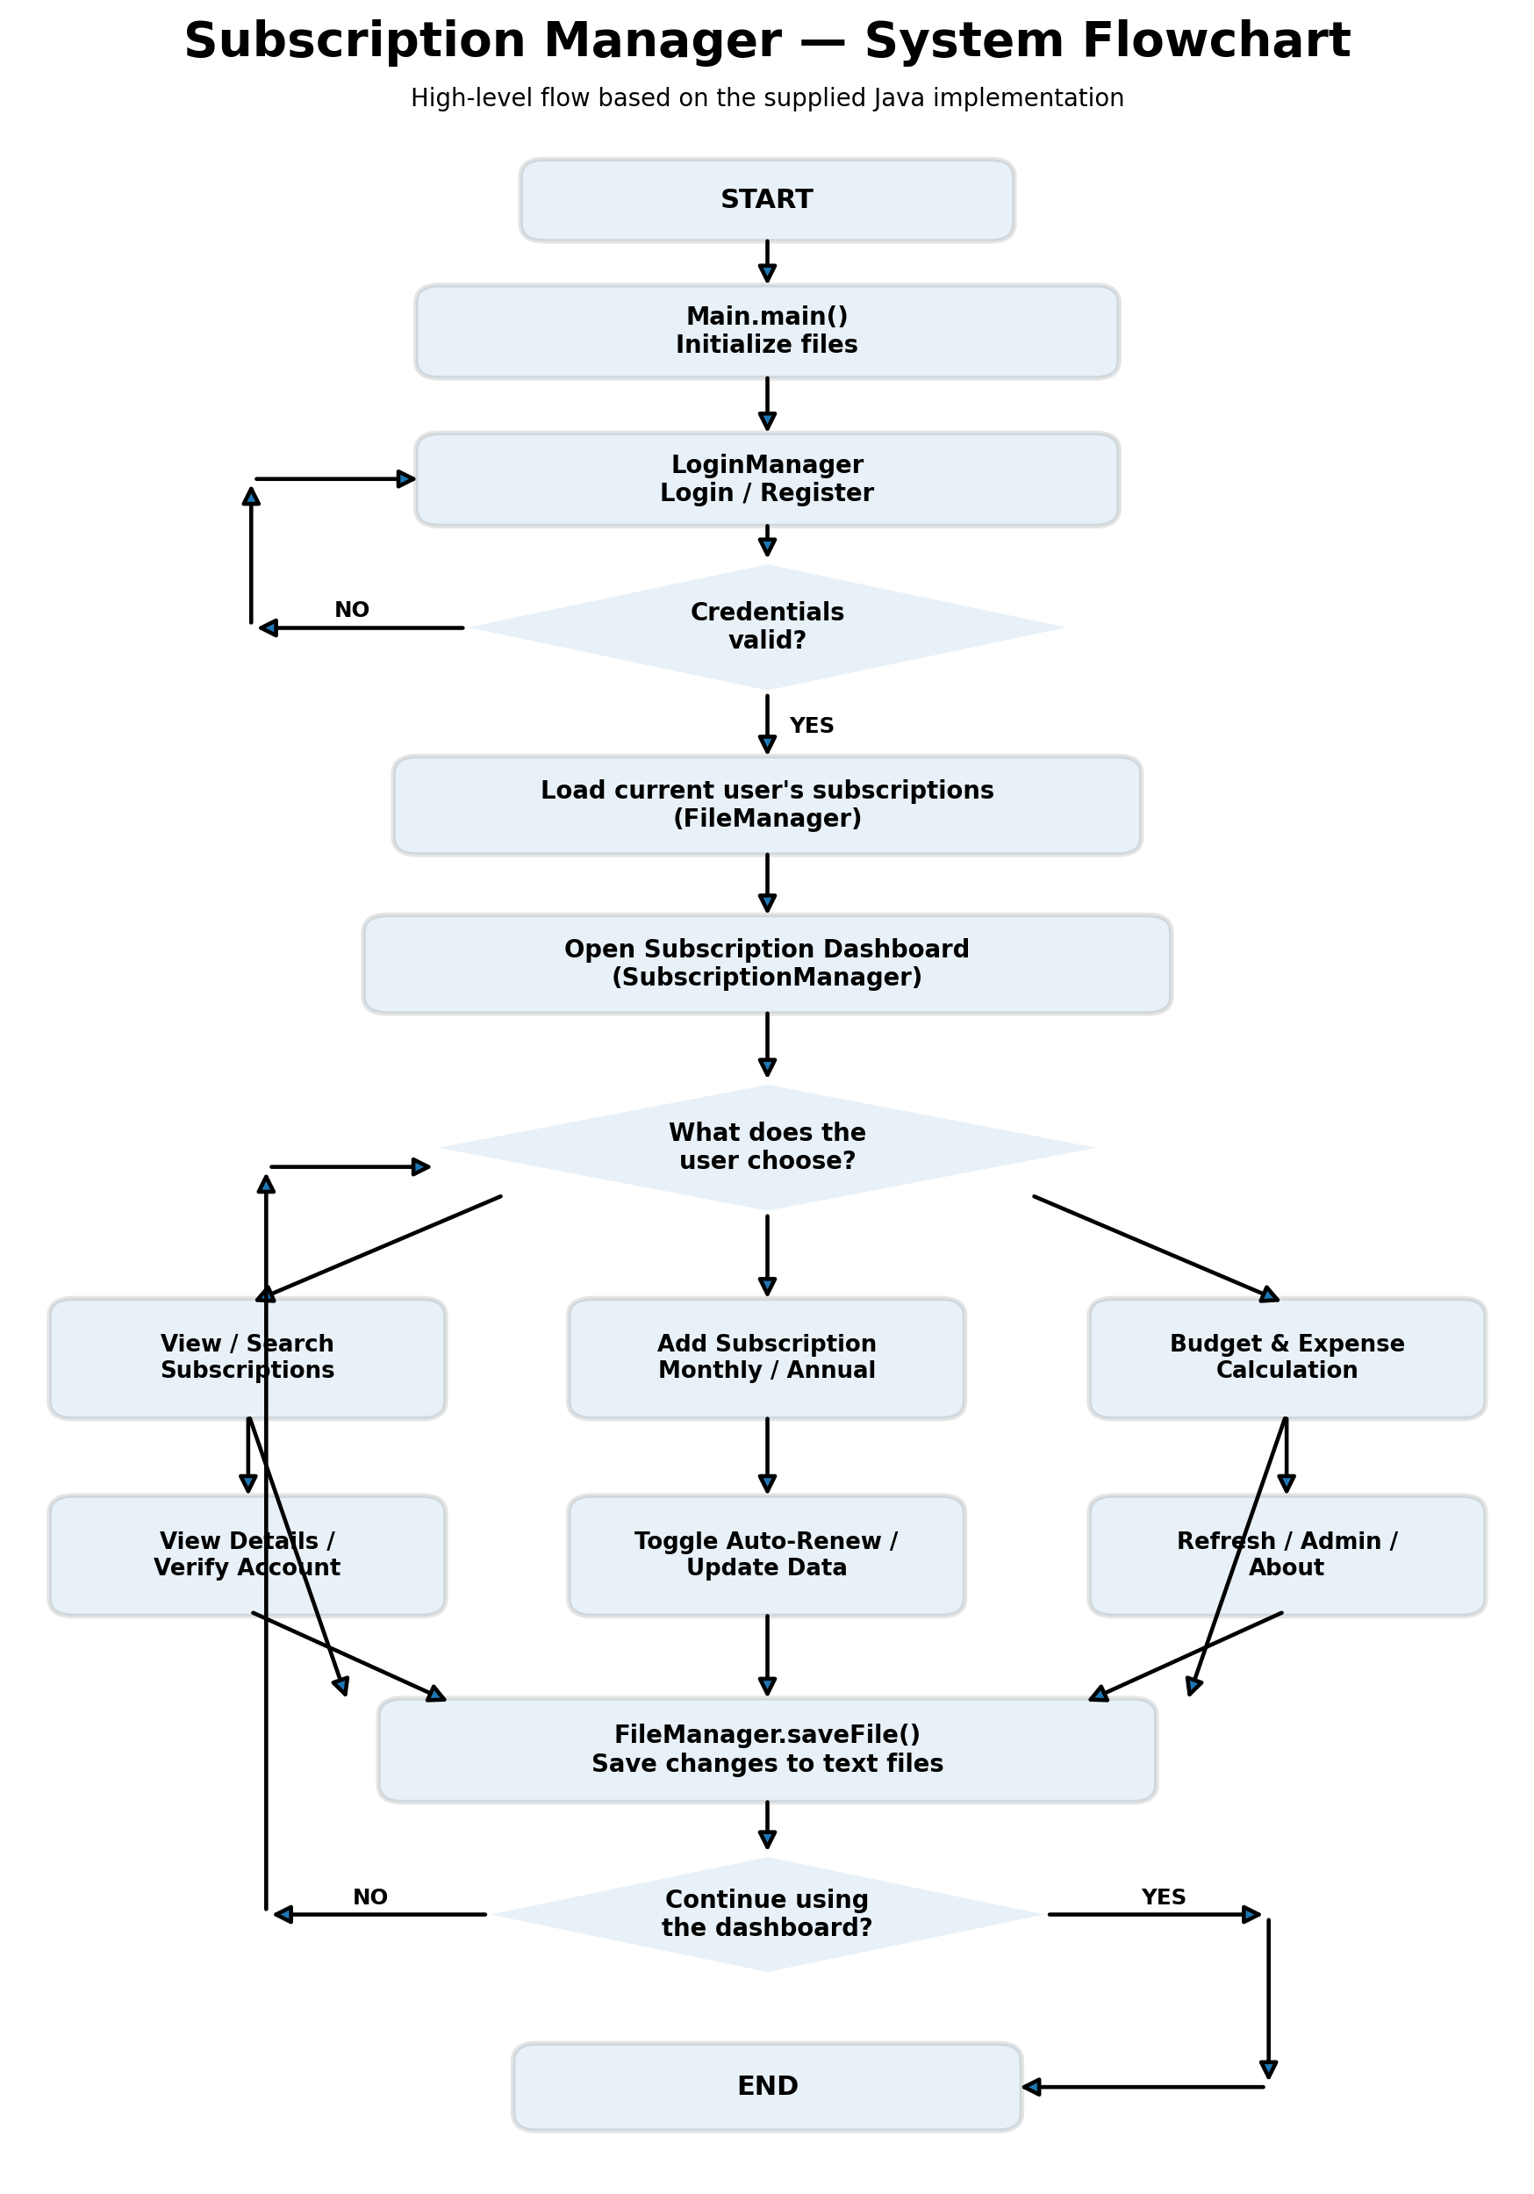
4.5 UML Diagram
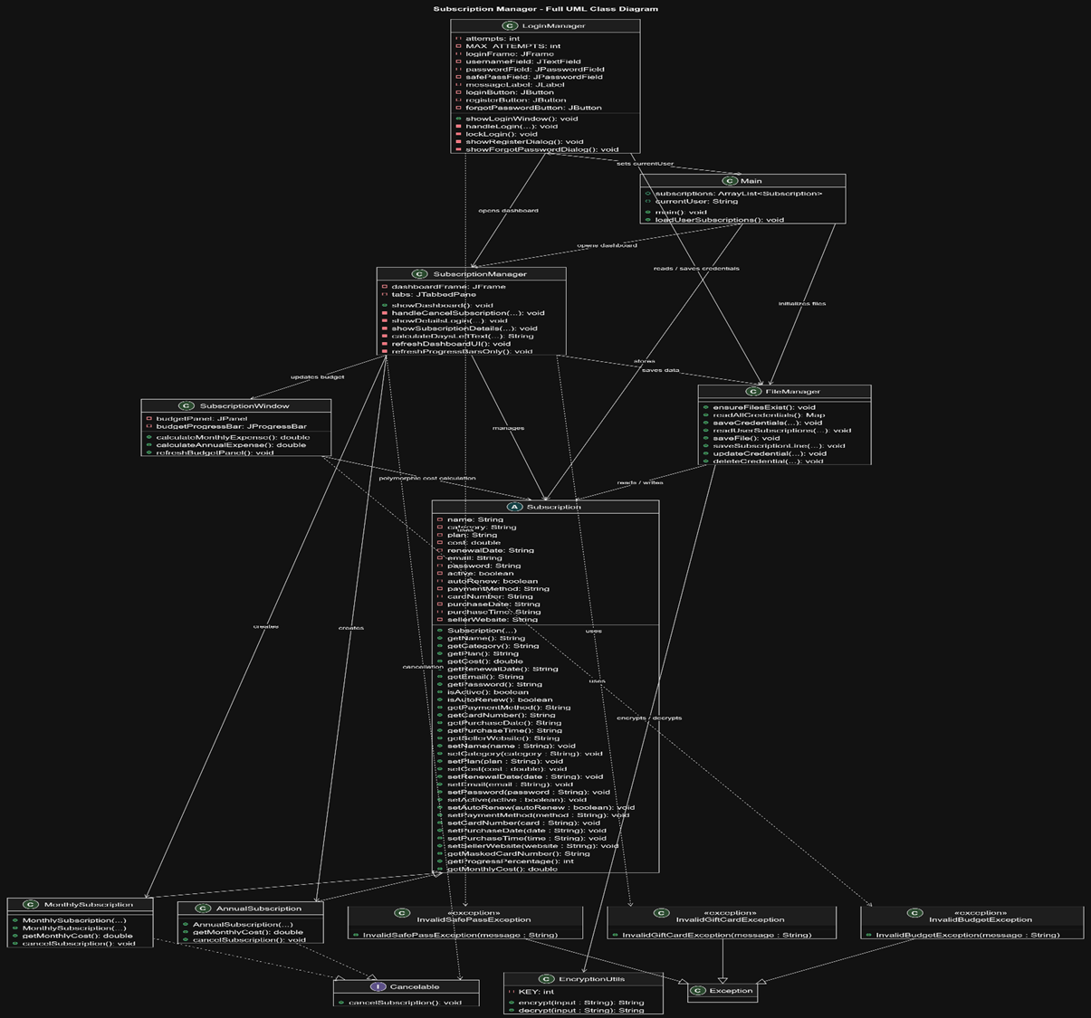

5. Implementation

5.1 Authentication Workflow
Input → Safe-pass validation → Read credentials → Decrypt + compare → Load user file → Dashboard
- The safe pass must contain exactly six alphanumeric characters.
- Three failed login attempts disable the login controls.
- Successful authentication sets Main.currentUser and loads that user's subscription file.

5.2 Adding a Subscription
Form input → Validate → Calculate renewal → Create subclass → Save object → Refresh dashboard
- Monthly plans may request a number of months; annual plans use one year.
- Gift card input is validated with a custom InvalidGiftCardException.
- The selected plan determines whether MonthlySubscription or AnnualSubscription is constructed.
- The object is added to Main.subscriptions and persisted through FileManager.saveFile().

5.3 Details and Cancellation
Select record → Verify email/password → Details or cancel → Persist
- The details dialog verifies the subscription credentials before revealing information.
- Auto-renewal can be toggled and saved.
- Cancellation checks the Cancelable interface before invoking cancelSubscription().

5.4 Swing Interface and Interaction Model
The user interface is implemented entirely with Java Swing. SubscriptionManager is the largest presentation/controller class and constructs the dashboard, navigation tabs, search view, add form, admin panel and subscription detail dialogs.
Component | Role
JFrame | Login and dashboard windows
JDialog | Registration, reset, verification and details
JTabbedPane | Budget, subscribed, expired, search, add, admin and About Us navigation
JTable | Admin user and subscription tables
JProgressBar | Renewal and budget visualization
JOptionPane | Confirmation, error and status messages

5.5 Event-Driven Behavior
- Buttons use ActionListener callbacks and lambda expressions.
- The search field updates results through a KeyAdapter.
- A Swing Timer refreshes renewal progress every second.
- A WindowAdapter stops the timer when the window closes.
- MouseAdapter opens GitHub links in the About Us section.
After a successful subscription save, the dashboard is rebuilt so the new record becomes visible without requiring a manual refresh.

5.6 Persistence and Data Management
FileManager provides local persistence using Scanner and FileWriter. One credential file is used for accounts, while subscriptions are stored in files named for the current user.

5.7 Credential Flow
credentials.txt → readAllCredentials() → Map → LoginManager

5.8 Subscription Flow
subscriptions_<user>.txt → Scanner → parseSubscriptionLine() → Subscription objects
When reading, the parser splits the record, decrypts the password and constructs the appropriate concrete subscription class. When writing, FileManager serializes fields through getters and transforms the password before writing it.

5.9 Important Observations
- Per-user subscription files isolate the current user's working data from other users.
- Admin inspection can read another user's subscription file without replacing the current user's Main.subscriptions list.
- Deleting a user removes the credential entry and attempts to delete the corresponding subscription file.
- The simple comma-separated format has no formal CSV escaping.
- Payment card/account values are persisted as raw values even though the interface masks them.

5.10 Authentication and Data Protection
Control | Implementation | Assessment
Safe pass | Exactly six alphanumeric characters | Input validation
Attempt limit | Three failed attempts lock the form | Basic brute-force friction
Credential transformation | Fixed XOR key + Base64 | Obfuscation, not modern password hashing
Recovery | Username + phone verification | Local recovery path
Detail verification | Subscription email/password | Additional access check
Payment masking | Only last four digits shown for card-style values | UI protection only
Admin gate | Admin tab shown only for username 'admin' | Simple role check

5.11 Budgeting and Real-Time Calculations
Budget calculations are isolated in SubscriptionWindow. Monthly expense is the sum of getMonthlyCost() for active subscriptions; annual expense is the monthly result multiplied by twelve.
Active subscriptions → getMonthlyCost() → Monthly expense → × 12 → Annual expense
Budget | Default | Constraint
Monthly | $200 | Cannot exceed annual budget
Annual | $2,400 | Cannot be below monthly budget

5.12 Renewal and Budget Progress
Subscription.getProgressPercentage() parses purchase and renewal dates, calculates elapsed versus total minutes, and clamps the result between 0 and 100. SubscriptionManager presents the result through a progress bar and marks expired records accordingly.
- Below 60%: green.
- 60–79%: blue.
- 80% or higher: warning-oriented display.
- The dashboard timer also calls refreshBudgetPanel(), keeping the budget display synchronized with the live progress update.

6. Output / Testing

6.1 Validation and Exception Handling
Custom exception classes and standard Java exceptions are used to prevent invalid values from silently becoming application state.
Exception | Location | Purpose
InvalidSafePassException | LoginManager | Reject invalid six-character safe pass
InvalidGiftCardException | SubscriptionManager | Reject short gift-card coupon input
InvalidBudgetException | SubscriptionWindow | Protect monthly/annual budget relationship
IllegalArgumentException | Login/recovery flows | Handle invalid or missing input
NumberFormatException | Cost/budget forms | Handle invalid numeric input
IOException | File operations | Report persistence failures

6.2 Testing Evidence
Reliability features visible in the code include file initialization, input validation, GUI error dialogs, bounded renewal-progress calculations, and recovery from several malformed-input conditions. No formal automated test suite (e.g., JUnit) was supplied with the source set; testing evidence is based on code-level safeguards rather than dedicated test cases.

6.3 Final Assessment
Area | Assessment
OOP | Strong course-level integration of major OOP concepts into real workflows.
GUI | Broad Swing interface with windows, dialogs, tabs, tables and progress indicators.
Persistence | Functional local credential and per-user subscription persistence.
Validation | Multiple custom and standard exception paths are implemented.
Security | Several access controls exist, but credential transformation is weak and sensitive local data remains exposed.
Testing | No formal automated test suite was supplied.

7. Challenges Faced & Solutions

7.1 Strengths
- The OOP hierarchy is used in real budgeting and persistence workflows.
- The GUI covers authentication, dashboard navigation, search, budgeting, details and administration.
- Per-user files provide straightforward local persistence.
- Custom exceptions are integrated into user-facing operations.

7.2 Observed Limitations and Improvement Directions
Observation | Effect | Recommended Improvement
Cancellation only prints a message | The cancellation handler invokes cancelSubscription() but does not set active = false. | Change state, persist, then refresh the dashboard.
Logout does not reopen login | The dashboard closes and a message appears; LoginManager is not called. | Clear session state and reopen login if intended.
Weak credential protection | Fixed XOR/Base64 is reversible. | Use a modern password-hashing scheme with salts.
Raw payment data in files | UI masking does not protect stored values. | Avoid storage or use proper encryption/key management.
Large SubscriptionManager class | Many UI and application responsibilities are concentrated in one class. | Refactor into focused view/controller classes.
Budgets are not persisted | Custom values disappear after restart. | Persist per-user budget settings.
Simple comma parsing | Embedded commas can corrupt records. | Use proper CSV escaping or structured serialization.

8. Conclusion
Subscription Manager is a substantial Java Swing desktop application combining subscription tracking, budgeting, authentication, local persistence and administrative functionality. Its central design is an abstract Subscription model with concrete monthly and annual implementations, and that design is connected to real calculations, file reconstruction and GUI presentation.
The project demonstrates abstraction, inheritance, polymorphism, encapsulation, interface implementation, constructor overloading and method overriding in an integrated application. The event-driven Swing layer provides a practical interface for those domain objects, while FileManager preserves user data across program runs.
The main opportunities for improvement are stronger credential protection, safer payment-data handling, persistent budget settings, a complete cancellation state transition, a complete logout-to-login flow, structured data serialization, and refactoring of the large dashboard class. These improvements would make the system more secure, maintainable and robust without changing its core purpose.

9. References
No external references were cited in the original project documentation. This report was compiled entirely from the supplied Java source code and its inline design decisions.

10. Appendix

10.1 Team Contributions
Member | Source-Marked Contribution
Raiyan Choudhury | EncryptionUtils, SubscriptionManager, Program Designer, Debugging
Tafsir Hasan | MonthlySubscription, AnnualSubscription, Cancelable, FileManager
Hassan Shayer Palok | Subscription, LoginManager, Main, SubscriptionWindow

10.2 Source Files Analyzed
- AnnualSubscription.java
- Cancelable.java
- EncryptionUtils.java
- FileManager.java
- LoginManager.java
- Main.java
- MonthlySubscription.java
- Subscription.java
- SubscriptionManager.java
- SubscriptionWindow.java

References-
*www.3schools.com
*https://share.google/aa3DdPIlbB72SM9tQ
*Thinking in java by Bruce Eckel 4th edition

Project Link:

https://github.com/Raiyanc01/SubscriptionManager


