Software Requirements Document for “Gamification for learning”

Author: Team 26
Akzhol Bakytzhan
Dosymbetov Alimkhan
Ferdaussiuly Aibek
Sauyrkulov Serikadil
Tukpetov Raiymbet

Version | Date | Author | Change
0.1 | 20/02/15 | Group 26 | Initial Document

Table of Contents
1 Introduction 3
1.1 Purpose 3
1.2 Scope 3
1.3 Definitions, acronymns, abbreviations 3
1.4 References 3
1.5 Overview 3
2 Overall Description 4
2.1 Product Perspective 4
2.2 Product functions 5
2.3 User characteristics 5
2.4 Constraints 5
2.5 Assumptions and Dependencies 5
3 Specific Requirements 6
3.1 External Interface Requirements 6
3.2 FEATURES 6
3.3 Performance requirements 6
3.4 Design Constraints 6
3.5 Software System Attributes 6
3.6 Other Requirements 7

Introduction

Purpose
The purpose of this SRS document is to provide a detailed requirements information and description of the functionalities of the Gamification for learning system.

Scope
This document will describe the use cases and featuers of Gamification for learning system.

Definitions, acronymns, abbreviations

Term | Description
Student
Teacher
Administrator

References
https://code.google.com/p/gamification-sdu-en3-04/source/browse/Docs

Overview
[OMIT]

Overall Description

Gamification for learning system is a useful web application for university SDU to teaching students easy and help them tighten knowledge of programming, English, mathematics with gaming system. They are can plays games for learning together, and receive points and give honors. Teachers can creates tournaments and manage their, and can see results of students. And each user will have login and password.

Product Perspective
This application is similar to several existing gaming application such as kahoot, battlecode, blackboard etc. The product is called “Gamification for learning” of Engineer first course students SDU will be developed on the web application on domain kz. This product is based on modern technologies HTML5, CSS3, styles bootstrap. Product can run on a personal computer with minimum system requirements and even on mobile devices. And it will focus on mobile devices. Support for asynchronous transfer to both sides: client-server and server to client.

Concept of Operations
This application will run on the sdu.edu.kz server system.

Major User Interfaces
See Appendix_

Example Screenshot and description
See Appendix_

Hardware Interfaces
This software requires no more than standard personal computer peripherals.

Software Interfaces
// example: CGI-URL or function signatures etc (OMIT for now).

Communication Interfaces
// example: modem etc (OMIT for now)

Memory Constraints
// RAM, and other storage constraints (OMIT for now)

Operations
// special operations (if any) (OMIT for now)

Site Adaptation Requirements
//ex: Japanese language etc (OMIT for now)

Product functions 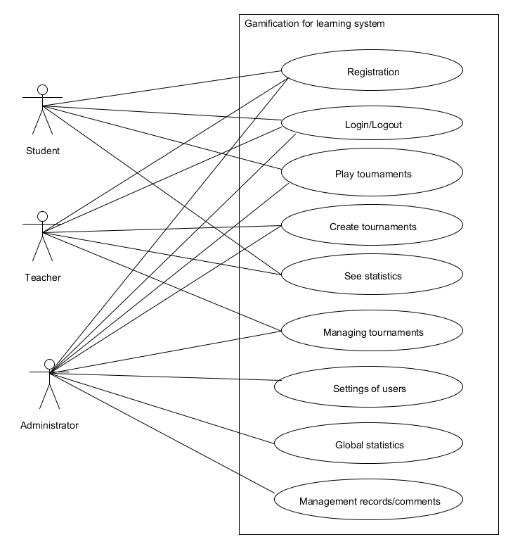

Student – plays tournaments and learn.
Teachers –. create tournaments and shows results of students.
Administrator – control and administrate all contents.

Use cases:
  - Student:
    - Registration
    - Authorization
    - Play tournaments
    - Takes honors and score
  - Teacher
    - Registration
    - Authorization
    - Create tournaments
    - Show statistics
    - Management tournaments
  - Administrator
    - Registration
    - Authorization
    - Play tournaments
    - Create tournaments
    - Show statistics
    - Management tournaments
    - Settings of users
    - Managing comments and records

Example use case
Registration
- Description: To use create a new account
- Actors: student, teacher, admin
- Main flow:
  - User fills in necessary fields(name, surname, e-mail, etc.) and presses SUBMIT button
  - Client sends server a request to register new account with provided information.
  - Server composes and runs SQL request to insert data into `users` table in the
  - database.
  - When insertion is successful, server sends client appropriate message.
  - Client receives server message and opens Main Window.
- Alternate flow:
  - User fills in necessary fields(name, surname, e-mail, etc.) and presses SUBMIT button
  - Client sends server a request to register new account with provided information.
  - Server composes and runs SQL request to insert data into `users` table in the
  - database.
  - When user already exist, server sends client appropriate message.
  - Client receives server message.
- Pre-conditions: User installed application on his/her computer.
- Post-conditions: User will have new account in the system.

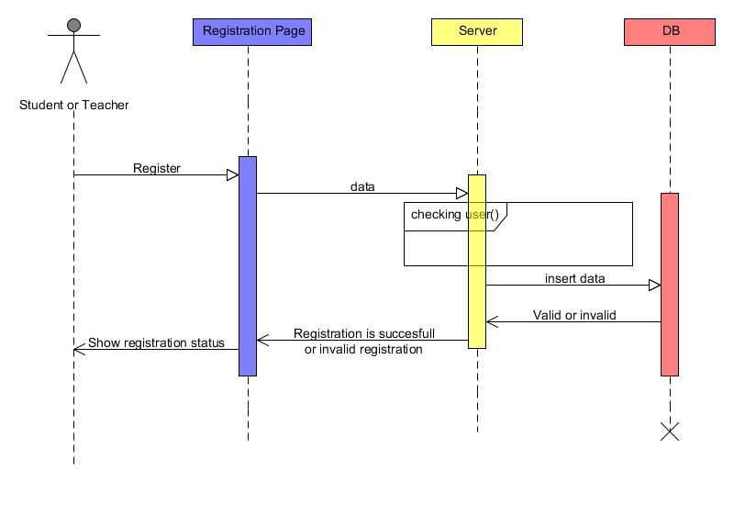

Authorization (Login)
- Description: To use login/logout to account
- Actors: student, teacher, admin
- Main flow:
    - User fills login form and click button login
    - Client sends username and password to server
    - Server select where username and password on database and checking
    - When username and password incorrect, server sends appropriate message to client
    - Client receives message
- Alternate flow:
  - User fills login form and click button login
  - Client sends username and password to server
  - Server select where username and password on database and checking
  - When username and password correct, server sends appropriate message to client
  - Client receives message and open user page
- Pre-conditions: User will be registered on server.
- Post-conditions: User login on yourself account.
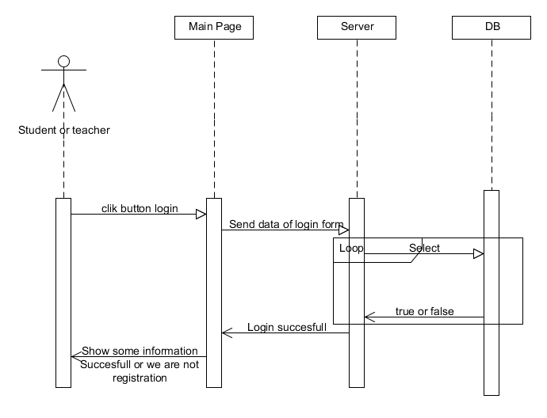

Play tournaments
- Description: To use play tournaments on system and take scores and honors
- Actors: students, admin
- Main flow:
  - User choose tournament and click button play sends id tournament to server
  - Server receive id and select questions and answers on database
  - While all questions answered server sends questions to client and client sends answers to server , so server check answer and send result to client
  - When ends server save data of clients and send appropriate message
  - Client receive message and open user page
- Alternate flow: no
- Pre-conditions: User will be registered student
- Post-conditions: User take score and honors(if merit)
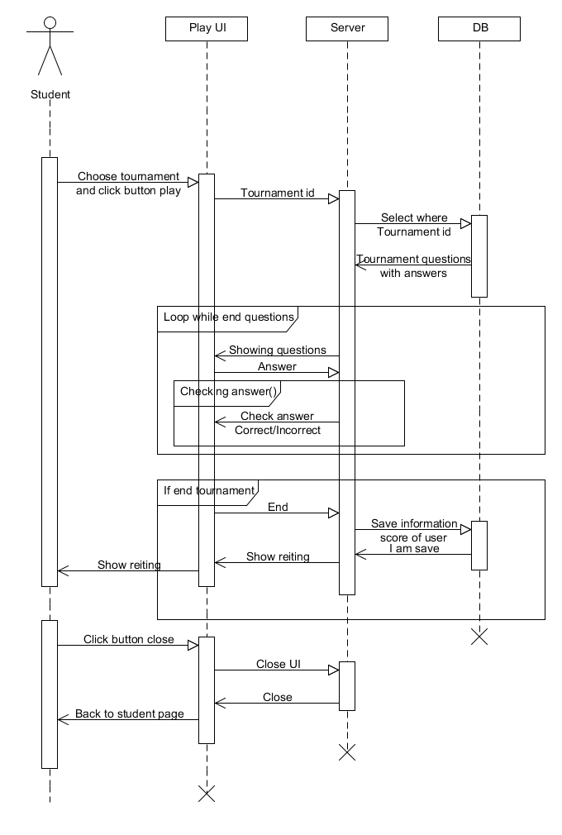
Create tournaments
- Description: To use create a new tournament
- Actors: teacher, admin
- Main flow:
  - User presses button Create tournament and send request to server
  - Server receive and send question page with forms
  - Client fill forms and can add questions to tournament ,so presses button save client send request to server
  - Server save tournament and send appropriate message
  - Client receive message and open user page
- Alternate flow: no
- Pre-conditions: User will be registered teacher
- Post-conditions: User creates new tournament and must be viewed on my tournaments
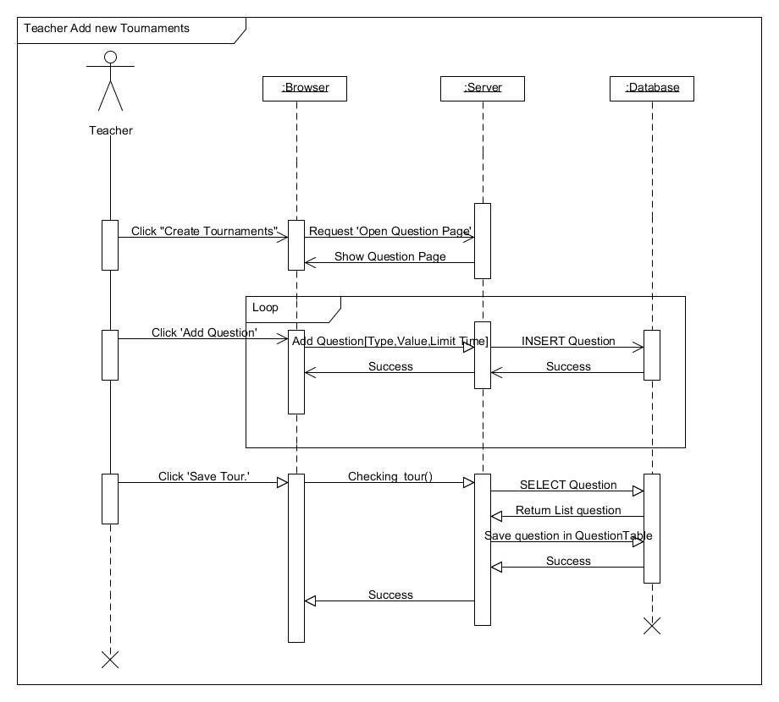

Write comment
- Description: To use write comments to tournaments
- Actors: student, teacher, admin
- Main flow:
  - User write comment and pressed button submit
  - Server receive request and run SQL transaction and send appropriate message to client
  - Client receive message
- Alternate flow: no
- Pre-conditions: Users must be logged.
- Post-conditions: User write their thinks about tournament.

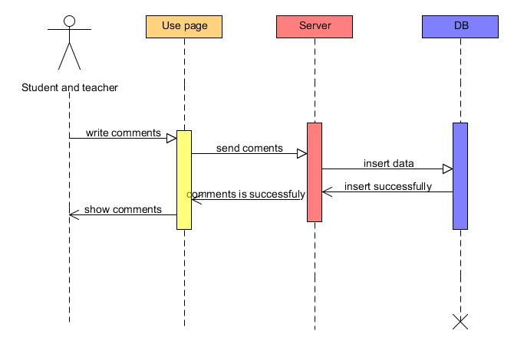

Show statistics
- Description: To use show statistics of the tournament
- Actors: student, teacher, admin
- Main flow:
  - User pressed button show statistics
  - Server receive request and run select statistics and send data to client
  - Client receive information
- Alternate flow:
- Pre-conditions: User must be logged and student must be take part, teacher must be author of tournament
- Post-conditions: User take statistic and show it

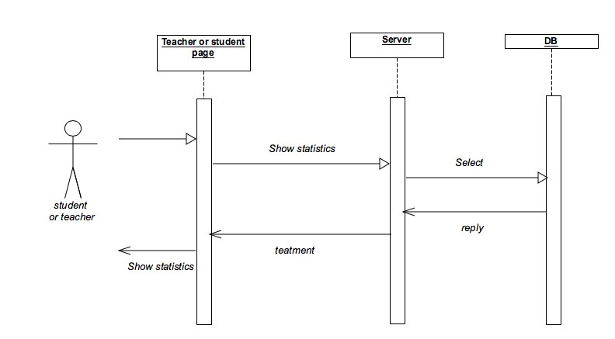

Managing tournaments
- Description: To use managing tournament and does actions such delete, update, change status
- Actors: teacher, admin
- Main flow:
- User pressed button edit tournament
- Server receive request and send tournament form
- User fill form and send data to server
- Server receive data and run update transaction and send appropriate message
- Client receive message

- User pressed delete tournament
- Server receive request and run delete transaction and send appropriate message
- Client receive message
- User pressed change status OPEN or CLOSE tournament
- Server receive request and run change status transaction and send appropriate message
- Client receive message
  - Alternate flow: no
  - Pre-conditions: User must be teacher or admin and choose tournament which want to change
  - Post-conditions: Tournament will be deleted, updated, changed status.

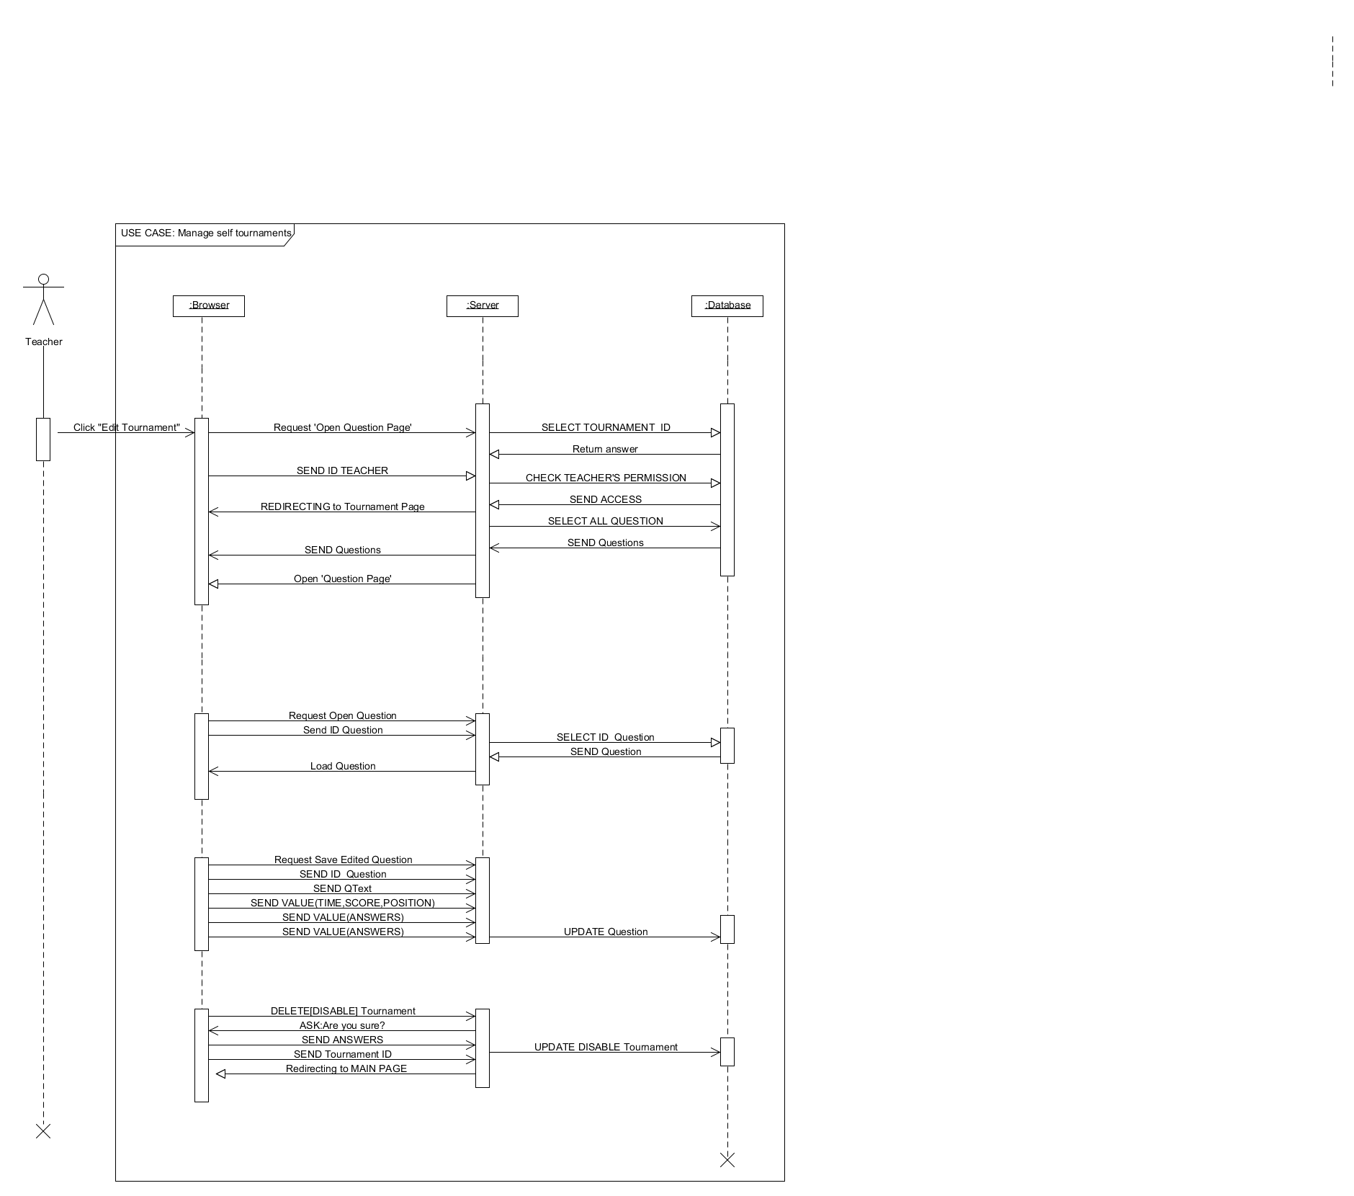
Settings of users
- Description: Use administrator for administrate of users (delete, update, add)
- Actors: admin
- Main flow:
  - When pressed delete user and send request to server
  - Server receive request and run SQL transaction and send appropriate message to client
  - Client receive message

  - When pressed add user and send request to server
  - Server receive request and run SQL transaction and send appropriate message to client
  - Client receive message

  - When pressed update user and send request to server
  - Server receive request and send user form
  - Client fill form and send data to server
  - Server receive data and run SQL transaction and send appropriate message to client
  - Client receive message
- Alternate flow:
- Pre-conditions: User must be admin and logged on yourself admin page
- Post-conditions: Admin does delete, add or update users
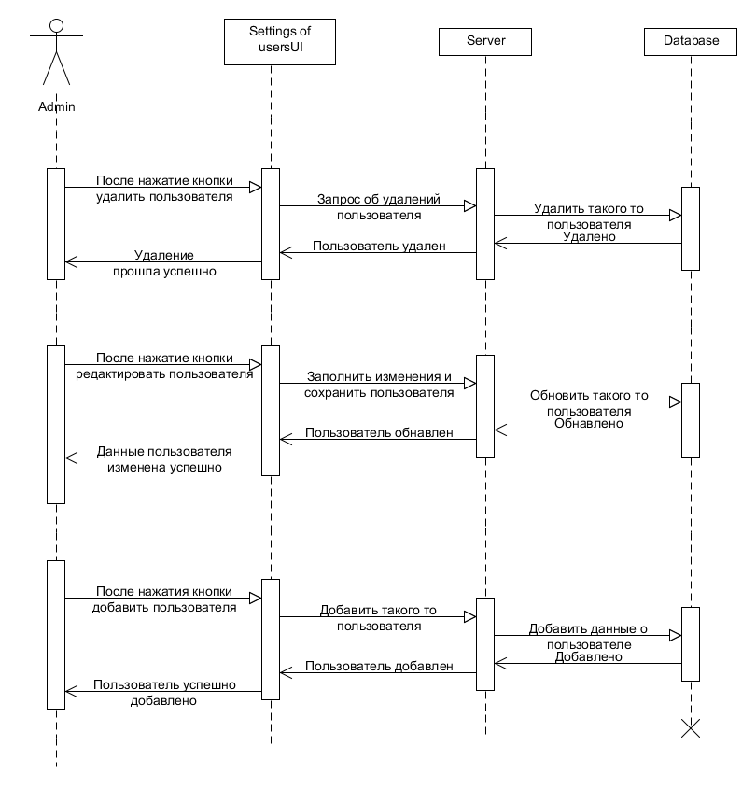

Managing records
- Description: To use administrate records such add new record, update, remove
- Actors: admin
- Main flow:
  - When client pressed button new record and send request to server
  - Server receive request and run record form
  - Client fill record form and press Ok and send data of form to server
  - Server check data and run SQL transaction insert
  - When pressed delete record
  - Server run SQL transaction delete and sent appropriate message
  - Client receive message
  - When pressed update record
  - Server receive request and run record form
  - Client fill record form and press Ok and send data of form to server
  - Server check data and run SQL transaction update
- Alternate flow:
  - If client fills form incorrect and send data to server
  - Server check data and send error message to client
  - Client receive message
- Pre-conditions: User installed application on his/her computer.
- Post-conditions: User will have new account in the system.
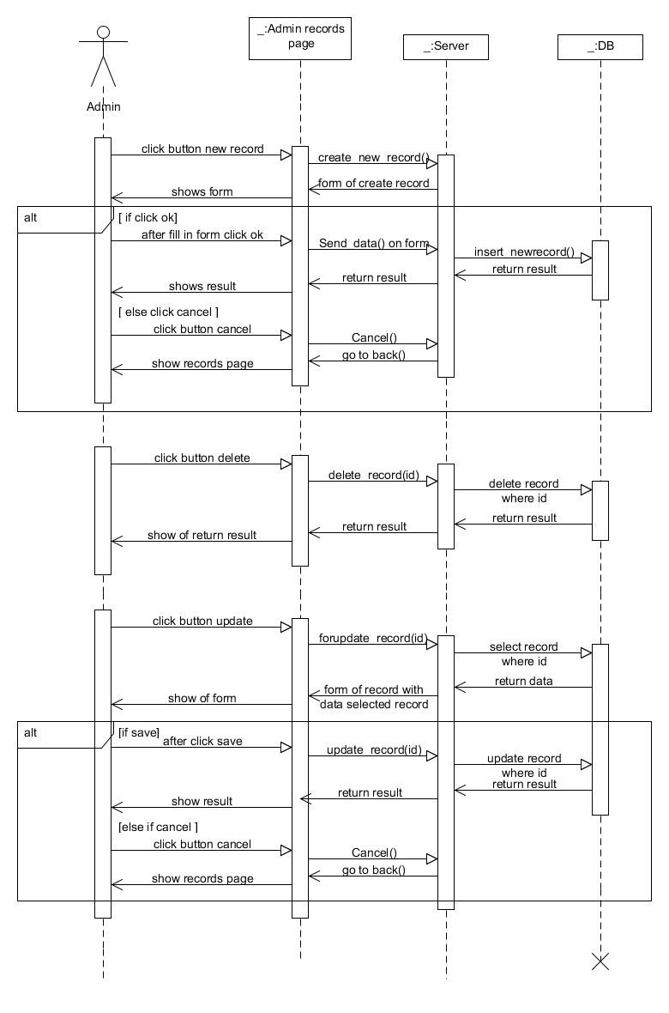
Managing comments
  - Description: To use administrate comments such delete, add to reserve.
  - Actors: admin
  - Main flow:
    - Client press menu comments
    - Server open comments page
    - Client choose comments and press button delete
    - UI send appropriate message to server
    - Server do this request on database
    - Return appropriate message to client
    - Client receive message and open comments page
  - Alternate flow: no
  - Pre-conditions: User must be admin and logged on admin page
  - Post-conditions: Admin does something with comments

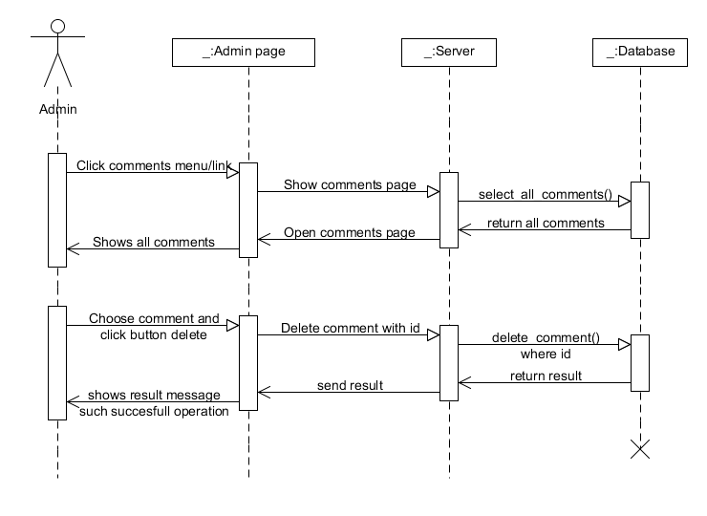

User characteristics
- Students: A men who are studying on first course of engineering faculty in the university of SDU and use the system to learn English, programming, mathematics easy and obvious with support gaming system.
- Teachers: Teachers of SDU which creates yourself tournaments and controlling it(ex. Delete, update, open, close…) and see statistics of students on the tournament.
- Administrator: PhD Meirambek Zhaparov who administrate all the contents, users of the web site and managing all data.

Constraints
This system is used mainly by students of first course engineers and instructors of university SDU.
This is an application for university SDU.
This web application is used only for support to learning students.

Assumptions and Dependencies
Network dependencies
Assumed this product will be used on PC, and mobiles devices(Android, IOS)
Assumed that server will supported around 2000 users

Specific Requirements

// Here you need to put in details (if any). Mark items [None] if you do not have any information.

External Interface Requirements

User Interfaces

Hardware Interfaces

Software Interfaces

Communications Interfaces

FEATURES

FEATURE-1 ….

…

…..

Performance requirements

Design Constraints

Software System Attributes

Reliability

Availability

Security

Maintainability

Portability

Other Requirements

// ADD Appendices (if any)
// Regenerate Table of Contents

