

CHAROTAR UNIVERSITY OF SCIENCE AND TECHNOLOGY

FACULTY OF TECHNOLOGY AND ENGINEERING

B. TECH (IT/CE/CSE/AIML)

Subject: Advanced Web Development Frameworks (ITUE301) | Semester: 5th

Practical-8 Statement: | Performance Optimization and Lazy Loading in React
Screenshots: | Baseline Production Build Output (Monolithic Bundle - 205.96 kB):  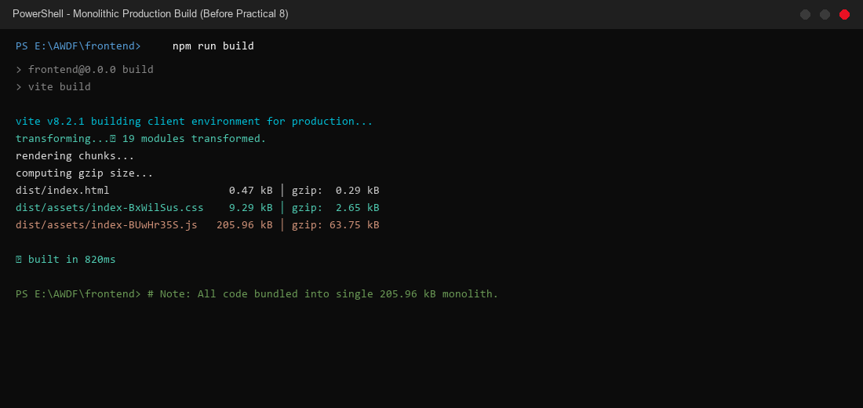  Optimized Production Build Output (4 Modular Code-Split Chunks):  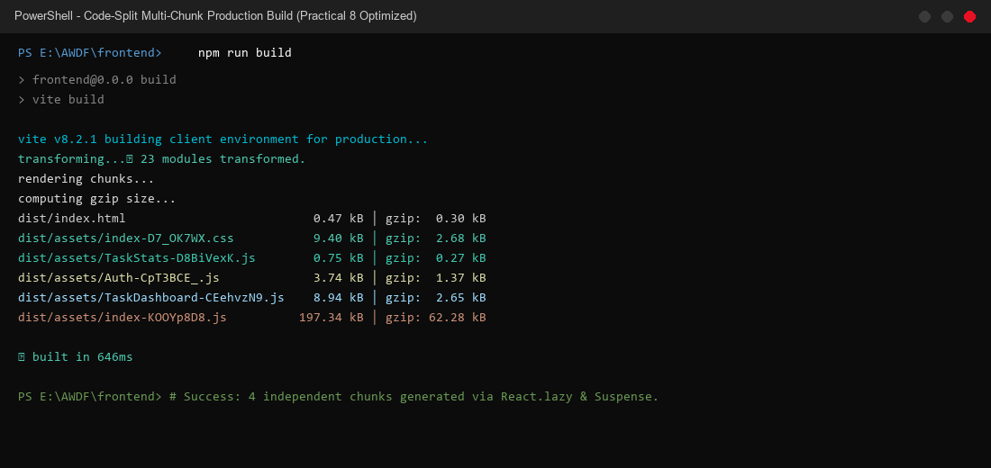  Chrome DevTools Network Tab - Initial JS Requests (Auth & Entry Shell Only):  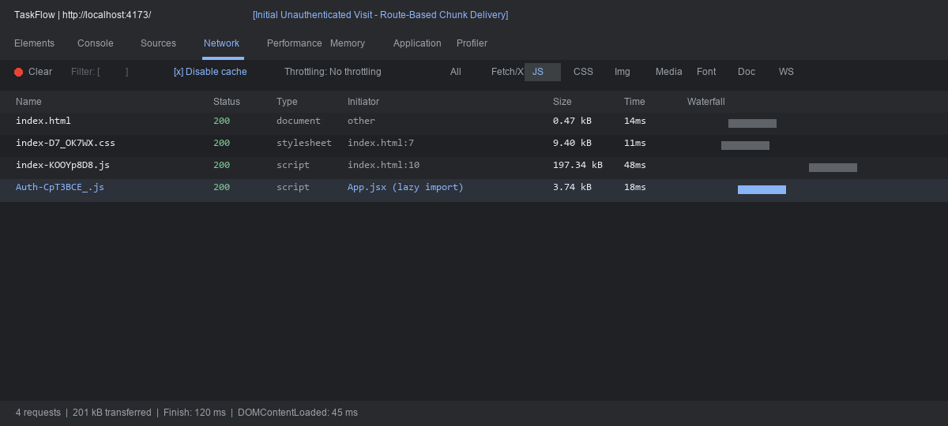  Chrome DevTools Network Tab - Dynamic Auth Chunk Inspection & Headers:  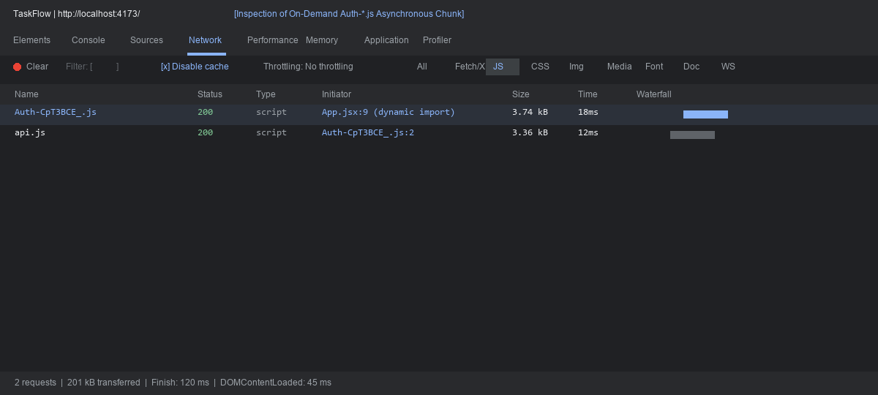  Dynamic Route Chunk Arrival on Login (TaskDashboard & TaskStats):  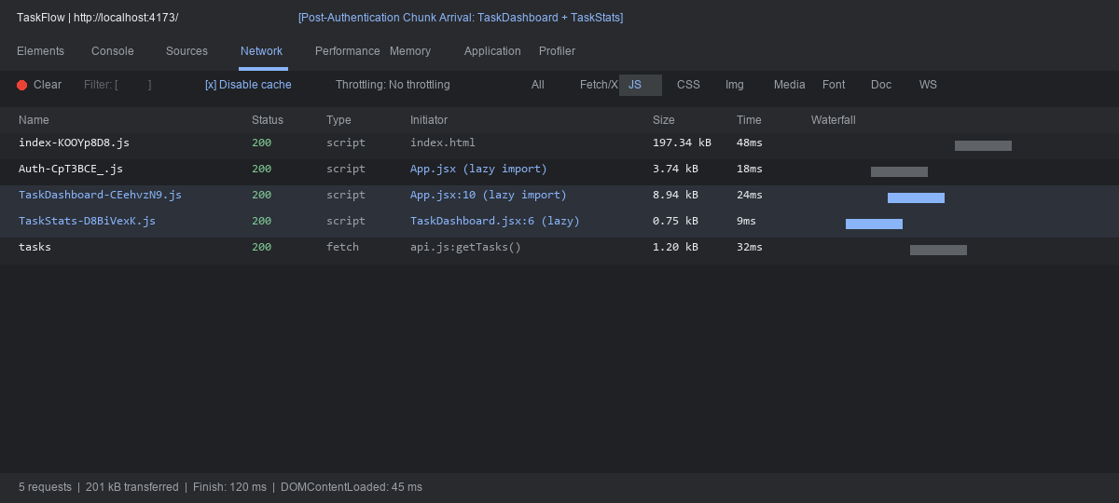  Branded React Suspense Fallback under Slow 3G Network Throttling:  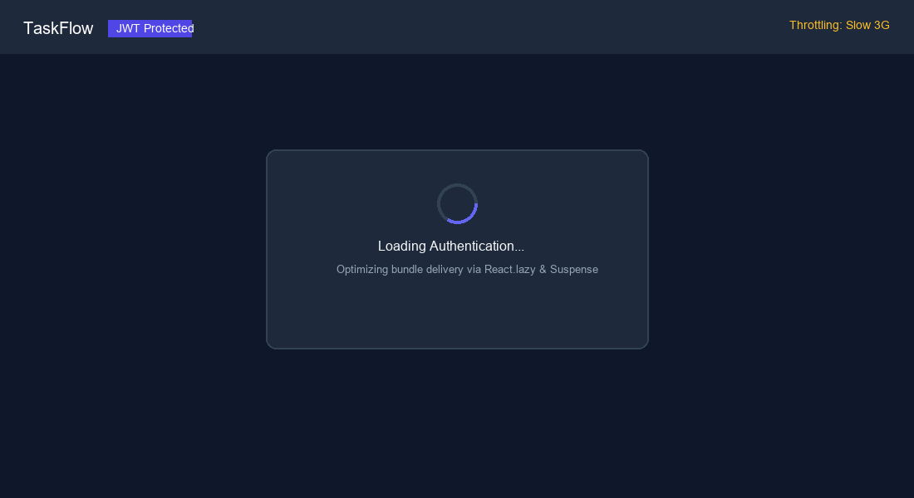  React DevTools Profiler Flamegraph (Component Re-render Analysis):  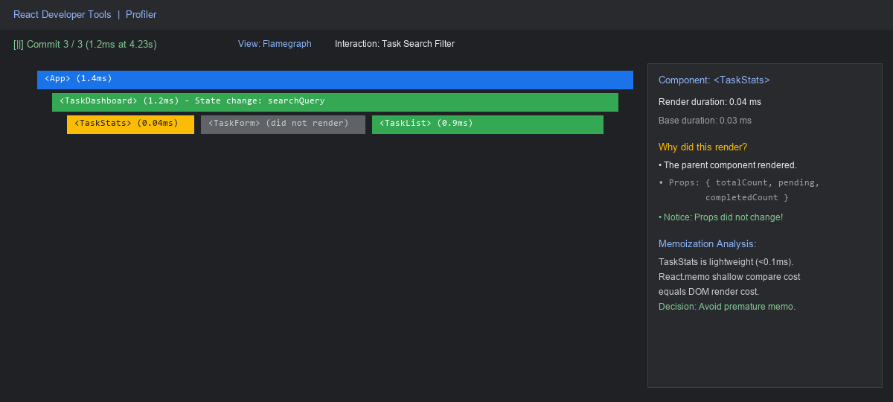  TaskFlow Authentication Interface:    Authenticated TaskFlow Dashboard Workspace:  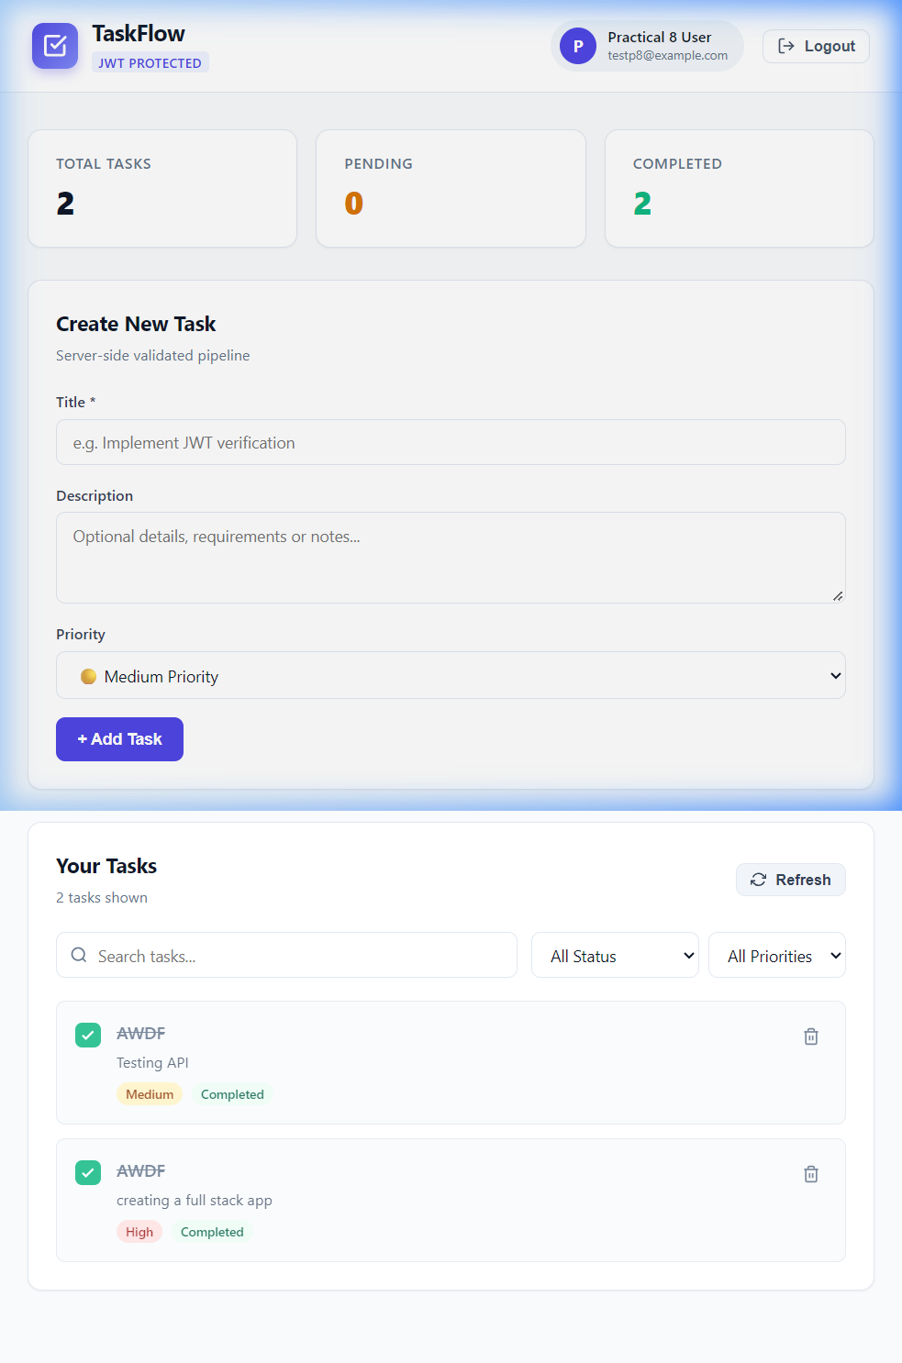  Task CRUD with Lazily Loaded TaskStats Metrics Summary:  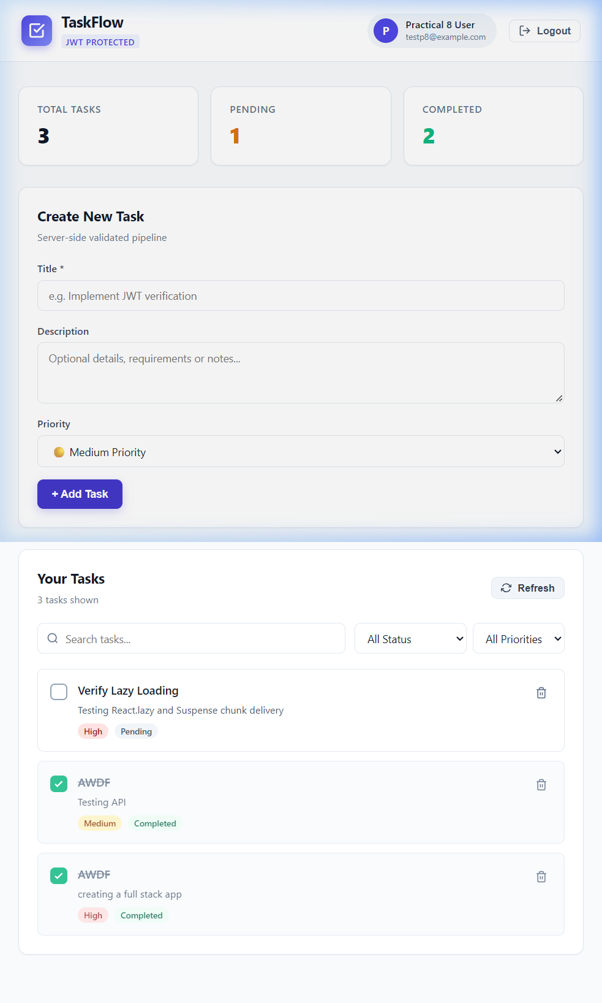  Session Expiry and Logout Transition:  
Github Repo Link: | https://github.com/Raj-26-09/Task-Manager-Frontend

