Assignment – Correlation b/w Attrition & other Parameters

* import pandas as pd
* dataset1 = pd.read_csv("D:/AI_ML_Course/Day 7/general_data.csv")
* import matplotlib.pyplot as mplt

1. Attrition with Age

* from scipy.stats import pearsonr
* stats, page=pearsonr(dataset1.Attrition,dataset1.Age)
* print(stats, page)
* -0.15920500686577965 1.996801615886744e-26
* scatter_plot = page
* mplt.scatter(stats, scatter_plot)

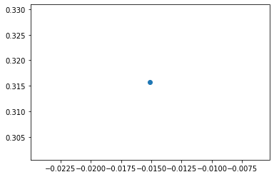

1. Attrition with DistanceFromHome

* stats, pdfh=pearsonr(dataset1.Attrition,dataset1.DistanceFromHome)
* print(stats, pdfh)
* -0.009730141010179674 0.5182860428050771
* scatter_plot = pdfh
* mplt.scatter(stats, scatter_plot)

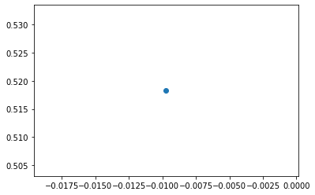

1. Attrition with JobLevel

* stats, pjl=pearsonr(dataset1.Attrition,dataset1.JobLevel)
* print(stats, pjl)
* -0.010289713287495042 0.49451717271828405
* scatter_plot = pjl
* mplt.scatter(stats, scatter_plot)

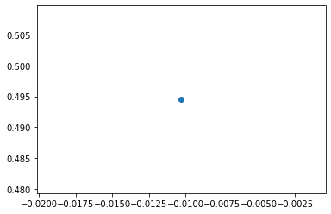

1. Attrition with Monthly Income

* stats, pmi=pearsonr(dataset1.Attrition,dataset1.MonthlyIncome)
* print(stats,pmi)
* -0.031176281698115007 0.03842748490600132
* scatter_plot = pmi
* mplt.scatter(stats, scatter_plot)

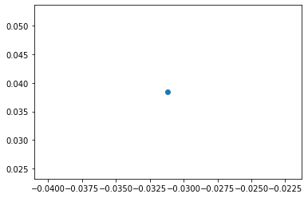

1. Attrition with Percent Salary Hike

* stats, ppsh=pearsonr(dataset1.Attrition,dataset1.PercentSalaryHike)
* print(stats, ppsh)
* 0.03253259489105349 0.030743386433355353
* scatter_plot = ppsh
* mplt.scatter(stats, scatter_plot)

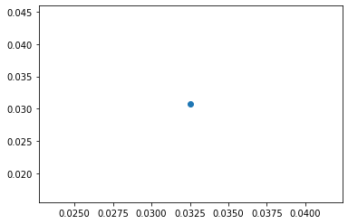

1. Attrition with Years At Company

* stats, pyac=pearsonr(dataset1.Attrition,dataset1.YearsAtCompany)
* print(stats,pyac)
* -0.1343922139899772 3.1638831224877484e-19
* scatter_plot = pyac
* mplt.scatter(stats, scatter_plot)

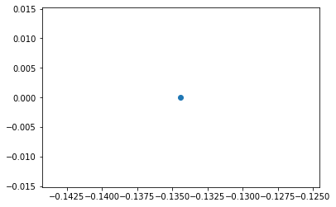

1. Attrition with Years Since Last Promotion

* stats, pyslp=pearsonr(dataset1.Attrition,dataset1.YearsSinceLastPromotion)
* print(stats, pyslp)
* -0.03301877514258434 0.028330336189396753
* scatter_plot = pyslp
* mplt.scatter(stats, scatter_plot)

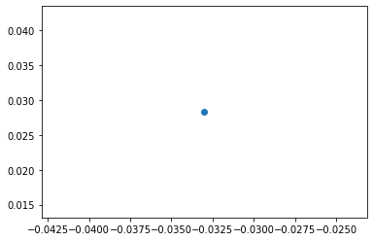

1. Attrition with Years with Current Manager

* stats, pywcm=pearsonr(dataset1.Attrition,dataset1.YearsWithCurrManager)
* print(stats, pywcm)
* -0.15619931590162847 1.7339322652896276e-25
* scatter_plot = pywcm
* mplt.scatter(stats, scatter_plot)

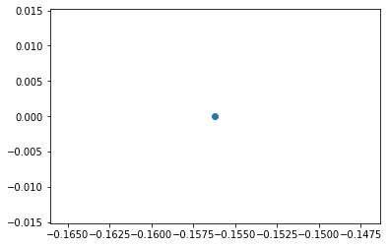

1. Attrition with Education

* stats, pe=pearsonr(dataset1.Attrition,dataset1.Education)
* print(stats, pe)
* -0.015111167710968713 0.3157293177118575
* scatter_plot = pe
* mplt.scatter(stats, scatter_plot)

