**PRACTICAL: 1**

**AIM:** Introduction to Android and Create “Custom Message” application. That will display “Custom Message” in the middle of the screen in the Black color with the Yellow background.

**CODE:**

|  |
| --- |
| **Activity_main.xml**  <?xml version="1.0" encoding="utf-8"?>  <RelativeLayout xmlns:android="http://schemas.android.com/apk/res/android"  xmlns:app="http://schemas.android.com/apk/res-auto"  xmlns:tools="http://schemas.android.com/tools"  android:layout_width="match_parent"  android:layout_height="match_parent"  android:background="#FFEB3B"  tools:context=".MainActivity">  <TextView  android:layout_width="wrap_content"  android:layout_height="wrap_content"  android:layout_centerInParent="true"  android:text="Hello World!"  android:textColor="#E91E63"  android:textColorLink="@android:color/holo_orange_light"  android:textSize="30sp"  android:visibility="visible"  app:fontFamily="sans-serif-condensed-medium"  app:layout_constraintBottom_toBottomOf="parent"  app:layout_constraintLeft_toLeftOf="parent"  app:layout_constraintRight_toRightOf="parent"  app:layout_constraintTop_toTopOf="parent"  app:layout_constraintVertical_bias="0.239"  tools:visibility="visible" />  </RelativeLayout>  **AndroidManifest.xml**  <?xml version="1.0" encoding="utf-8"?>  <manifest xmlns:android="http://schemas.android.com/apk/res/android"  package="com.example.add">  <application  android:allowBackup="true"  android:icon="@mipmap/ic_launcher"  android:label="17IT008"  android:roundIcon="@mipmap/ic_launcher_round"  android:supportsRtl="true"  android:theme="@style/AppTheme">  <activity android:name=".MainActivity">rr  <intent-filter>  <action android:name="android.intent.action.MAIN" />  <category android:name="android.intent.category.LAUNCHER" />  </intent-filter>  </activity>  </application>  </manifest>  **MainActivity.java**  package com.example.add;  import androidx.appcompat.app.AppCompatActivity;  import android.os.Bundle;  public class MainActivity extends AppCompatActivity {  @Override  protected void onCreate(Bundle savedInstanceState) {  super.onCreate(savedInstanceState);  setContentView(R.layout.activity_main);  }  } |

**OUTPUT:**

**Device: Redmi Note 4**

**PotraitView:**

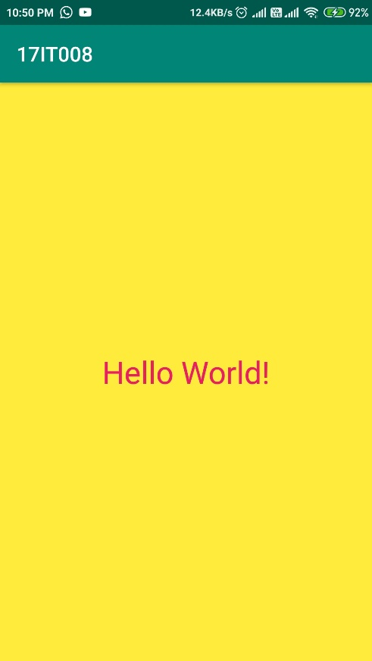

**LandscapeView:**

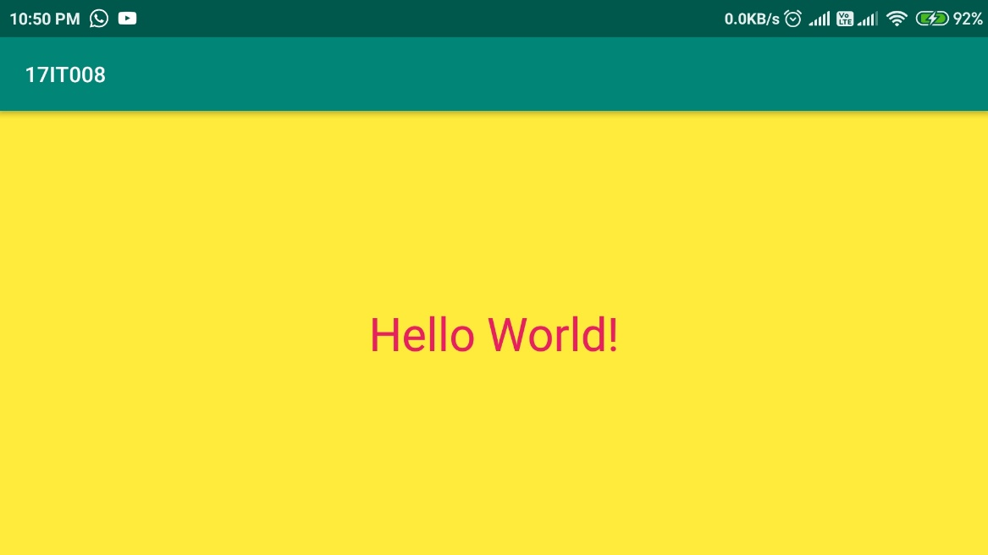

**Description**: Above Screenshots contain the yellow background with custom text in it.

In Portrait View and Landscape View**.**

**LEARNING OUTCOME:** 1. learned How install apps with USB debugging.

2. learned to use Relative layout in Activity_main.xml

3. learned To Run apps in Emulator.

4. learned to do the basic programming in android studio.