**Image Processing**

**(01CE0507)**

**Department of Computer Engineering**

**5th Semester**

**Lab Manual**

**(July-Dec 2022)**

**Index**

|  |  |  |  |
| --- | --- | --- | --- |
| **Lab** | **Programs** | **Date** | **Signature** |
| 1 | Study of matlab image processing toolkit and various commands on matlab. |  |  |
| 2 | Point processing in spatial domain   1. Negation of an image 2. Thresholding of an image 3. Contrast Stretching of an image |  |  |
| 3 | Write a program for histogram equalization. |  |  |
| 4 | Write a program to apply various filtering techniques in matlab.   1. Low pass filtering 2. High pass filtering 3. Median filtering |  |  |
| 5 | Write a program for image segmentation   1. Local thresholding 2. Global thresholding |  |  |
| 6 | Write a program for color image processing   1. Color approximation 2. Quantization |  |  |
| 7 | Write a program, for Image restoration   1. Facial Images 2. Texture Images |  |  |
| 8 | Write a program for edge detection. |  |  |
| 9 | Write a program for smoothening and sharpening for 8-bit color image. |  |  |
| 10 | Write a program to implement morphological operations. |  |  |

**Practical 1**

**Aim:** Study of matlab image processing toolkit and various commands on matlab.

* **Introduction to Various component of MATLAB Tool like editor, command window, workspace.**
* **Basic Syntax, Variables, Commands**
  + **Use of Semicolon (;) in MATLAB**

1. **Without Semicolon**

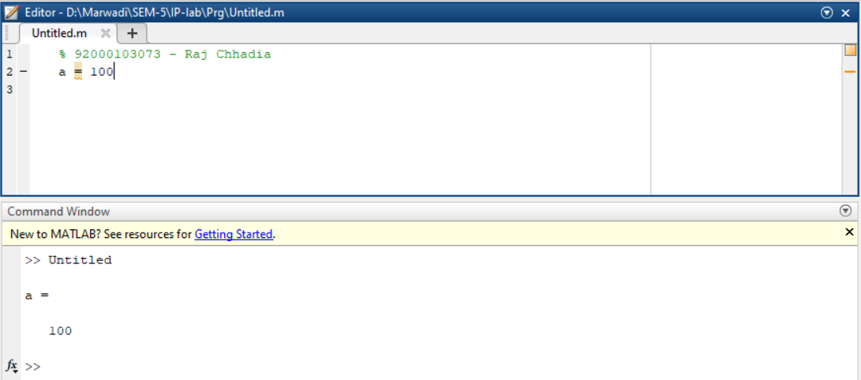

1. **With Semicolon**

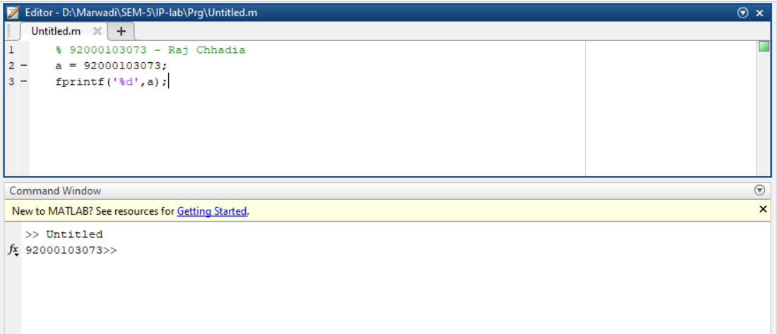

* + **Adding Comments**

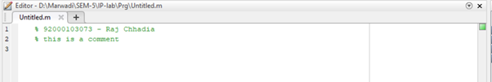

* + **Commonly used Operators and Special Characters**

1. **Arithmatic Operation**

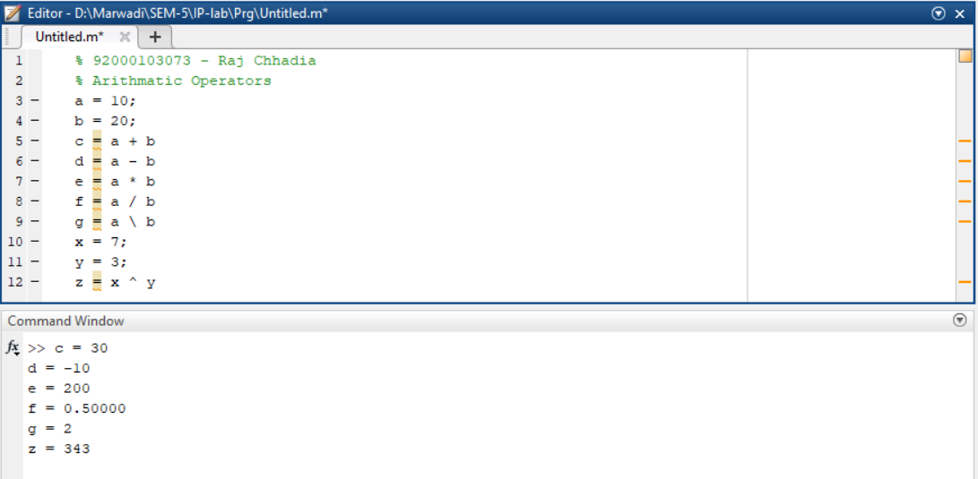

1. **Relation Operation**

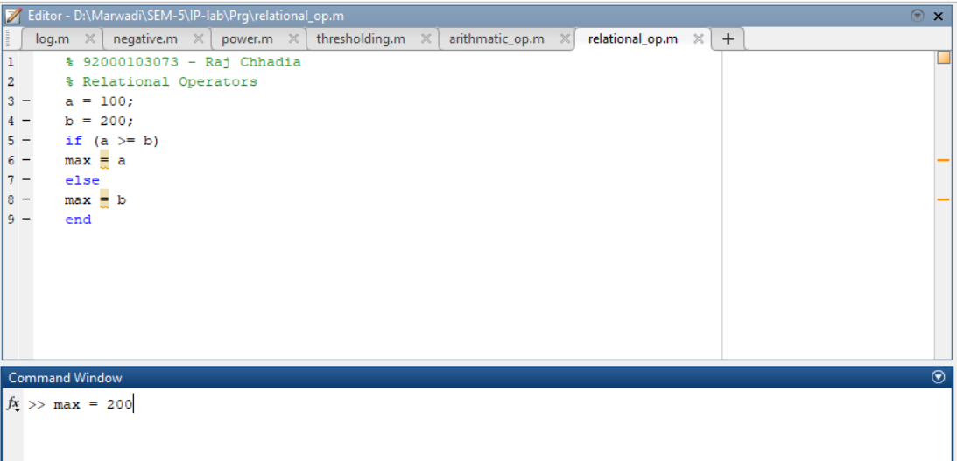

1. **Logical opereation**

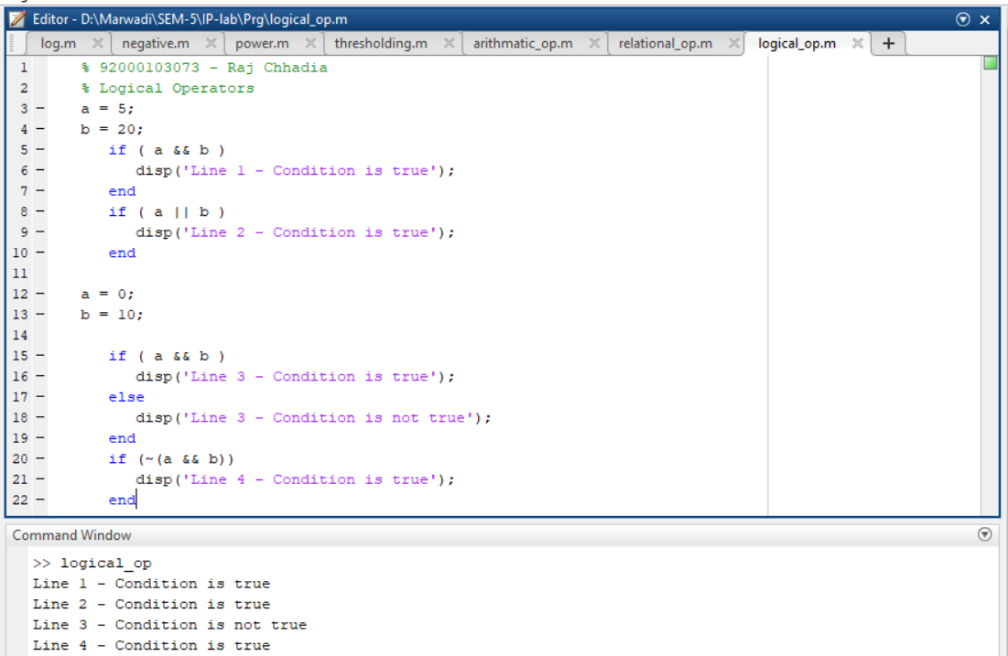

* + **Special Variables and Constants**

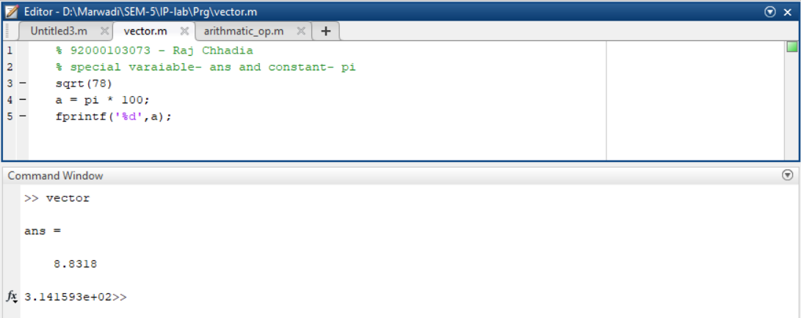

* + **save and load Command**
  + **who and whos command**

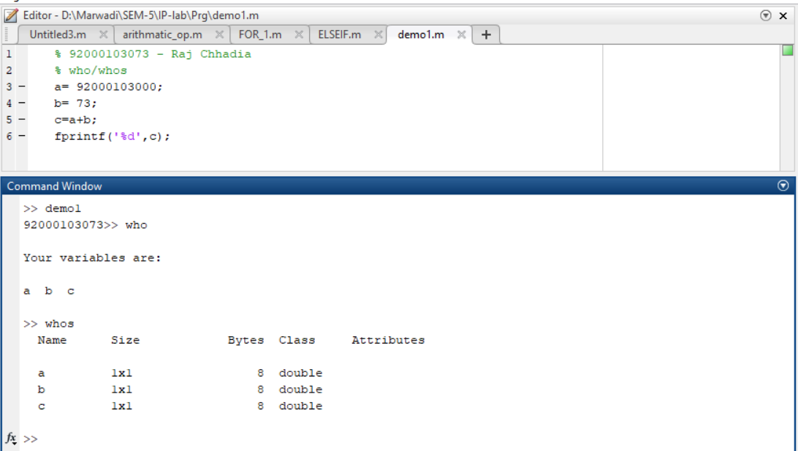

* + **clear and clc Command**

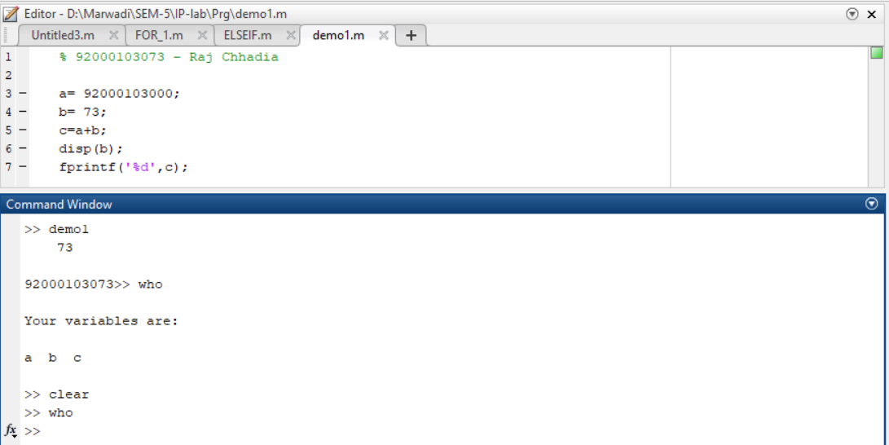

* + **disp and fprintf command**

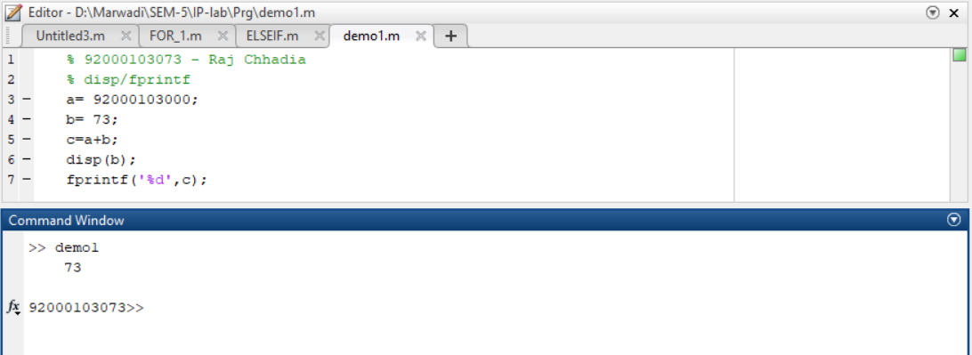

* + **input command**
  + **M-Files**
  + **Plotting Commands**
* **Data Types in MATLAB**
  + **List of Data Types**
  + **Data Type Conversion**
  + **Determination of Data Types**
* **Operators in MATLAB**
  + **Types of Operators**
  + **Arithmetic Operators**
  + **Relational Operators**
  + **Logical Operators**
  + **Bitwise Operations**
* **Decision Making in MATLAB**
  + **if ... end statement**

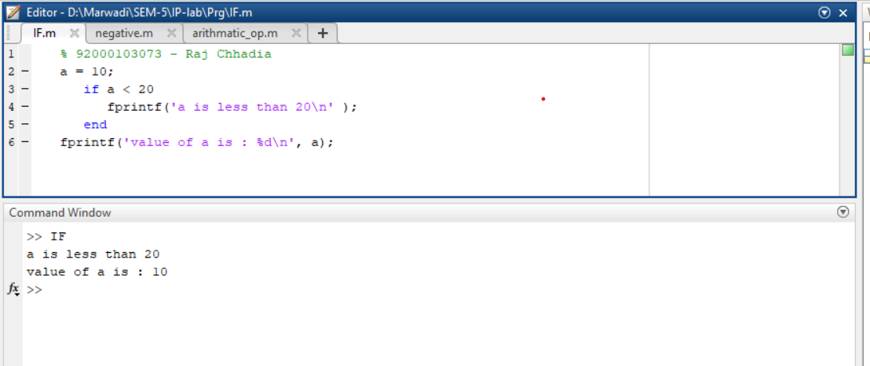

* + **if...else...end statement**

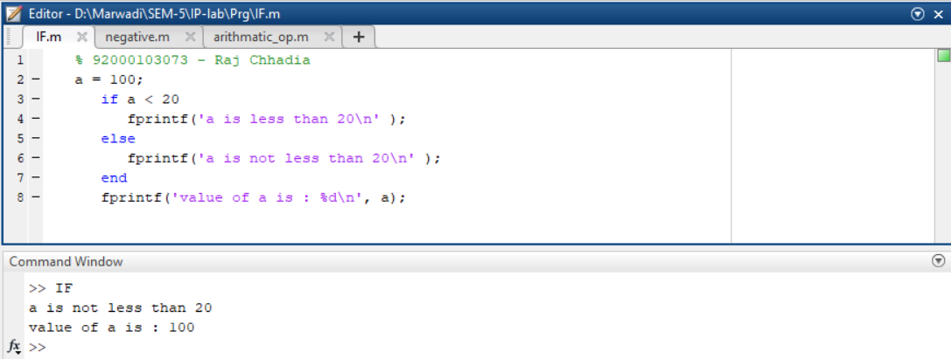

* + **If... elseif...elseif...else...end statements**

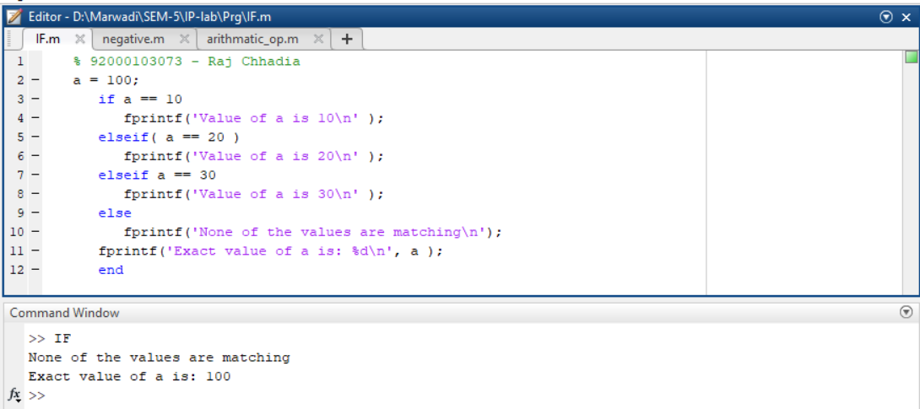

* + **nested if statements**

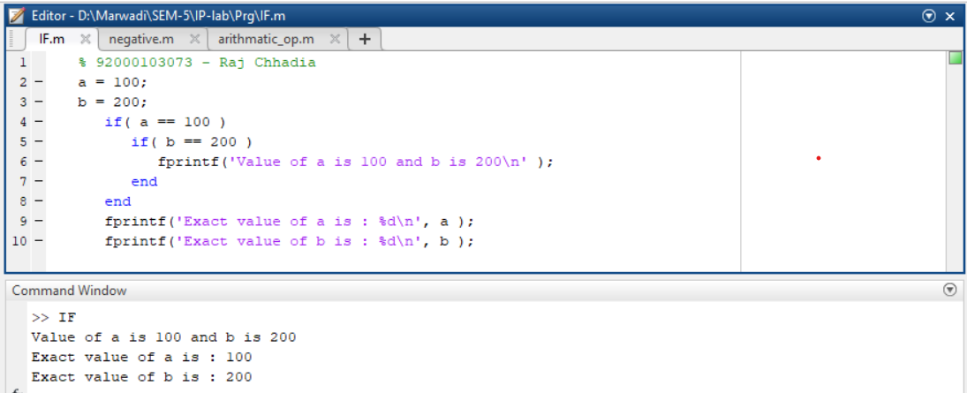

* + **switch statement**

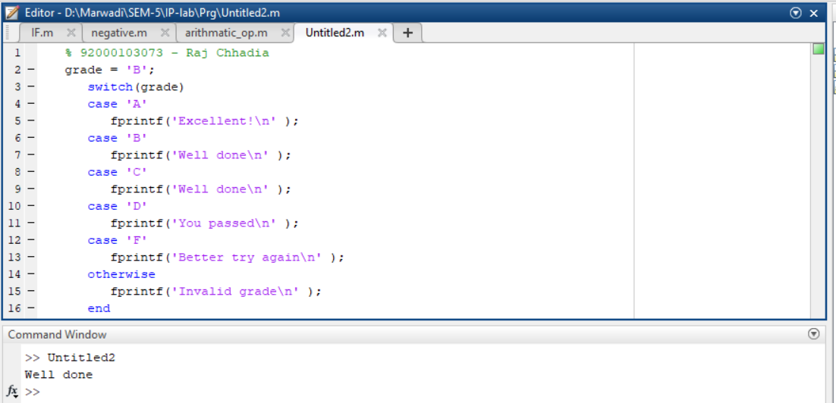

* **Loop Types in MATLAB**
  + **while loop**

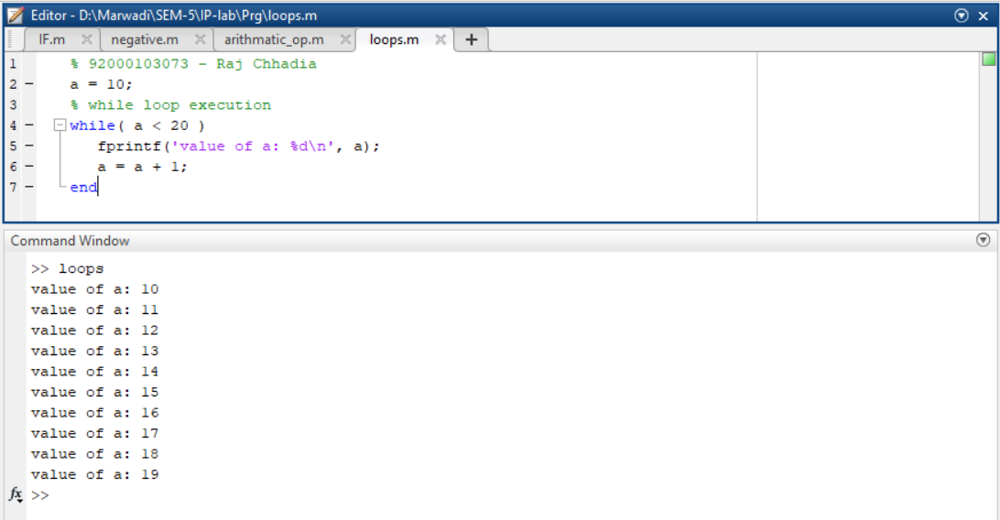

* + **for loop**

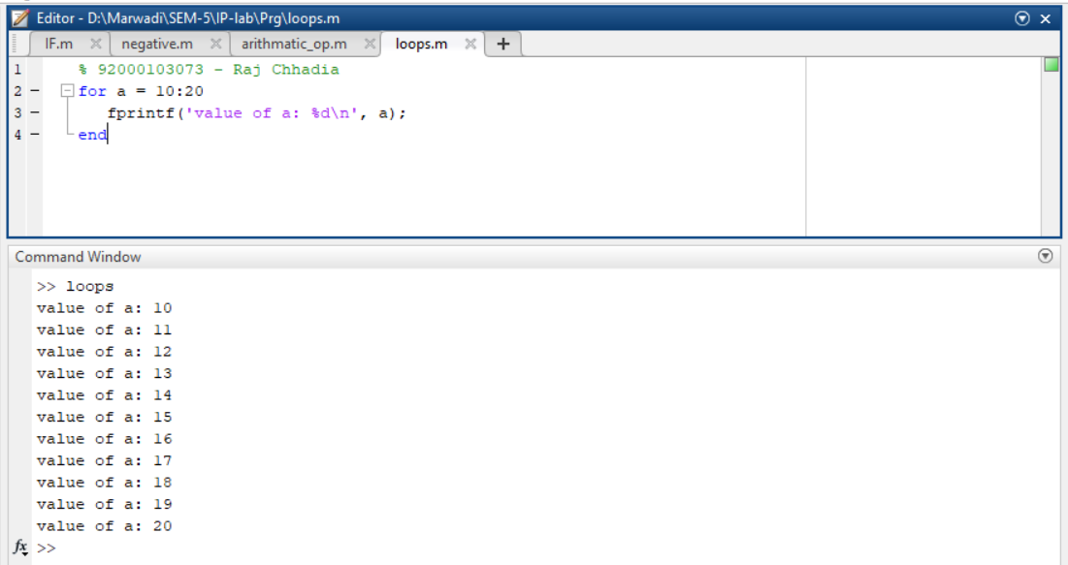

* + **nested loops**

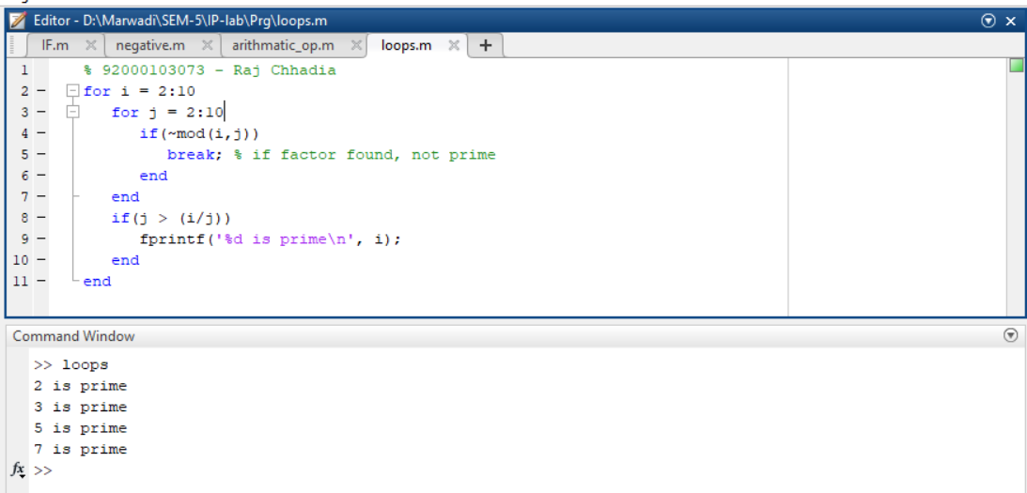

* + **break statement**

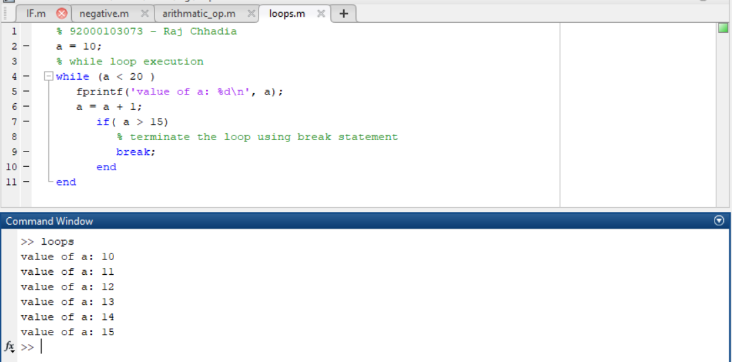

* + **continue statement**

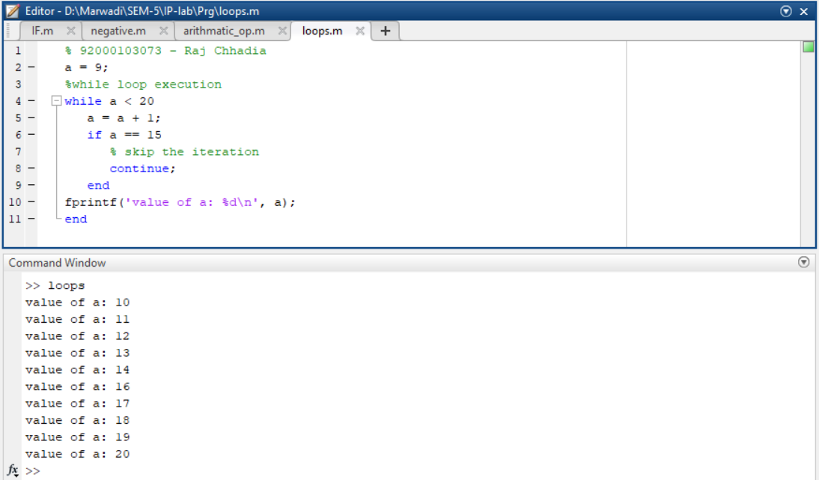

* **Vectors in MATLAB**
  + **Row Vectors**
  + **Column Vectors**
  + **Referencing the Elements of a Vector**
  + **Vector Operations**
    - **Addition and Subtraction of Vectors**
    - **Scalar Multiplication of Vectors**
    - **Transpose of a Vector**
    - **Appending Vectors**
    - **Magnitude of a Vector**
    - **Vector Dot Product**
    - **Vectors with Uniformly Spaced Elements**
* **Matrix in MATLAB**
  + **Referencing the Elements of a Matrix**
  + **Matrix Operations**
    - **Addition and Subtraction of Matrices**
    - **Division of Matrices**
    - **Scalar Operations of Matrices**
    - **Transpose of a Matrix**
    - **Concatenating Matrices**
    - **Matrix Multiplication**
    - **Determinant of a Matrix**
    - **Inverse of a Matrix**
* **Arrays in MATLAB**
  + **Special Arrays in MATLAB**
    - **zeros( ) function**
    - **ones( ) function**
    - **eye( ) function**
    - **rand( ) function**
* **Image Processing Toolkit**
  + **imread( ) and imshow( ) command**
  + **imwrite( ) command**
  + **size( ) command**
  + **imfinfo( ) command**
  + **impixel( ) command**
  + **subplot( ) command**
  + **imagesc( ) command**
  + **imresize( ) command**
  + **imcrop( ) command**
  + **im2bw( ) command**
  + **rgb2gray( ) command**
  + **grayslice( ) command**
  + **imadd( ) command**
  + **imsubtract( ) command**
  + **imdivide( ) command**
  + **immultiply( ) command**
  + **imcomplement( ) command**
  + **uigetfile( ) command**

**Practical 2**

**Aim:** Point processing in spatial domain

1. Negation of an image
2. Thresholding of an image
3. Contrast Stretching of an image
4. **Negation of an image**

**Code:**

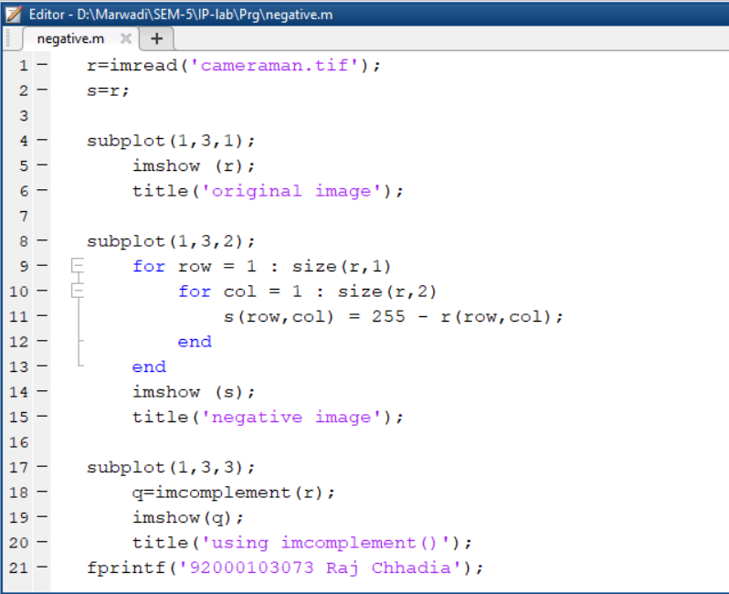

**Output:**

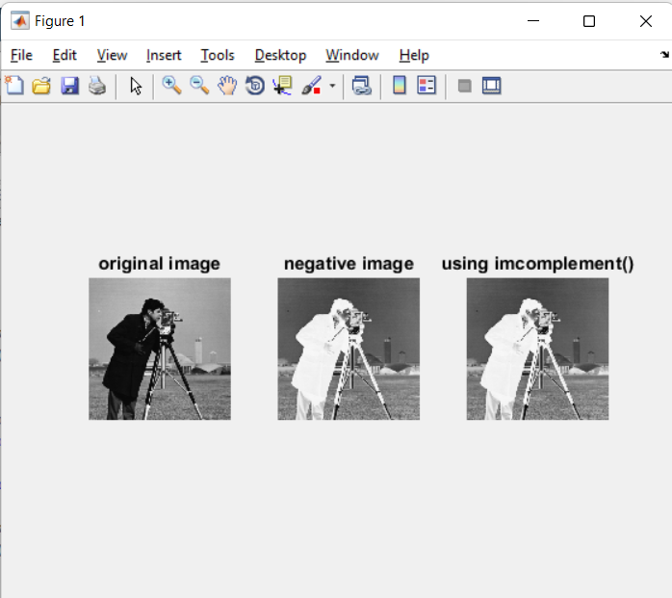

1. **Thresholding of an image**

**Code:**

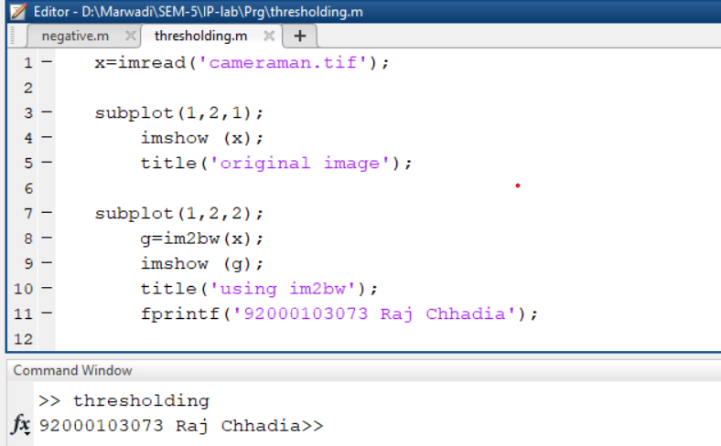

**Output:**

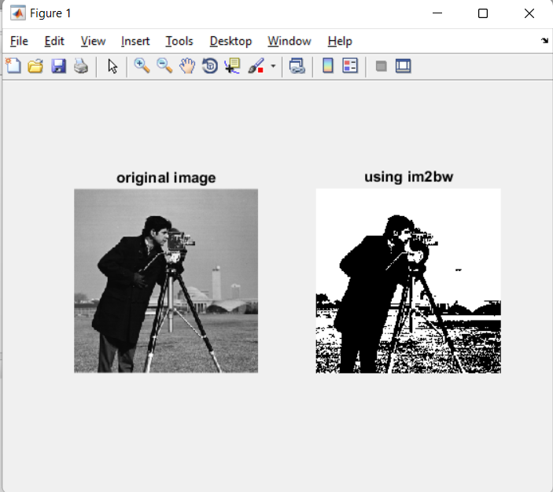

1. **Contrast Stretching of an image**

**Code:**

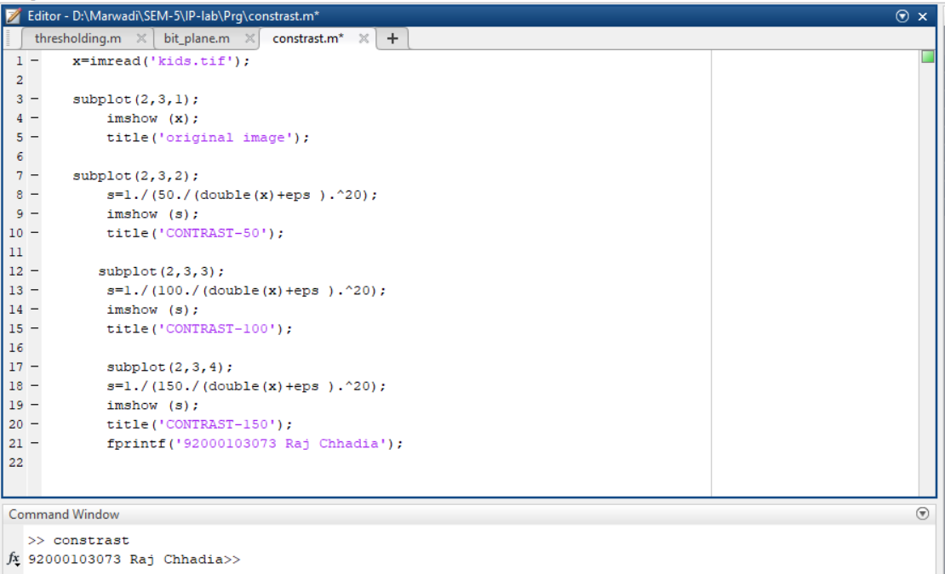

**Output:**

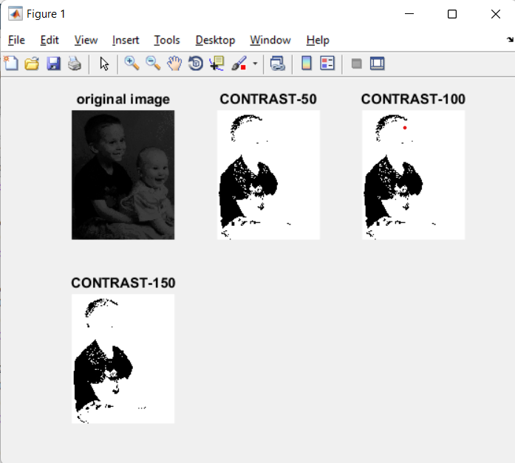

**Extra:**

1. Log Transformation
2. Power-Law Functions
3. Gray-level slicing
4. Bit-plane slicing
5. **Log Transformation**

**Code:**

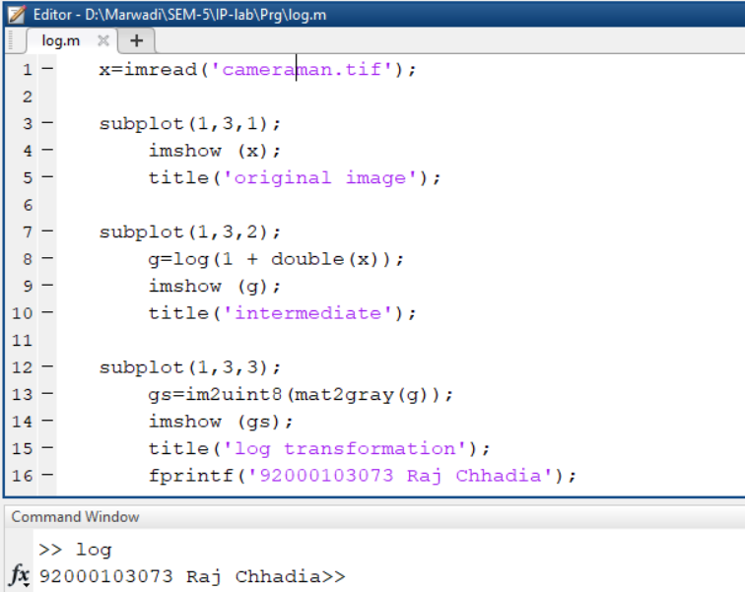

**Output:**

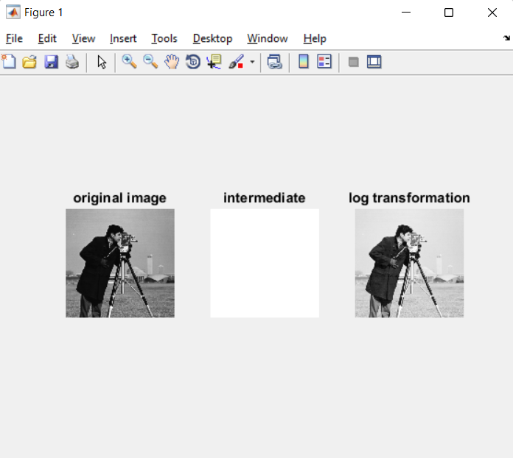

1. **Power-Law Functions**

**Code:**

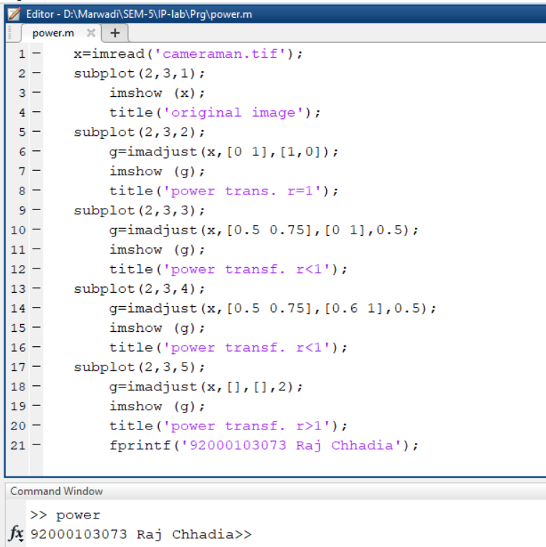

**Output:**

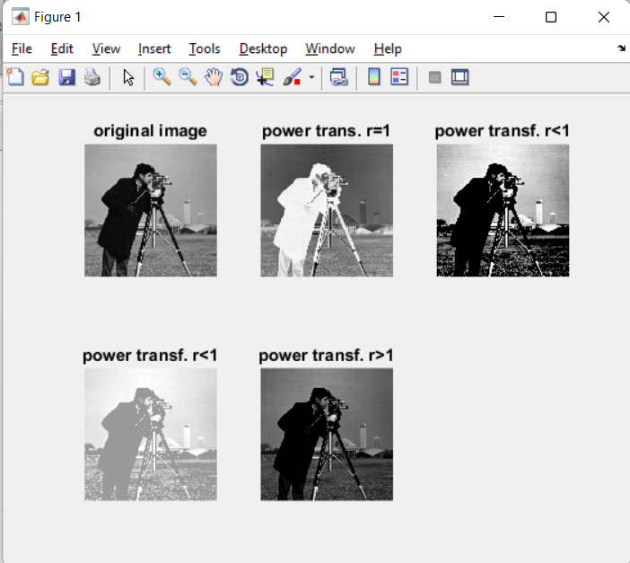

1. **Gray-level slicing**

**Code:**

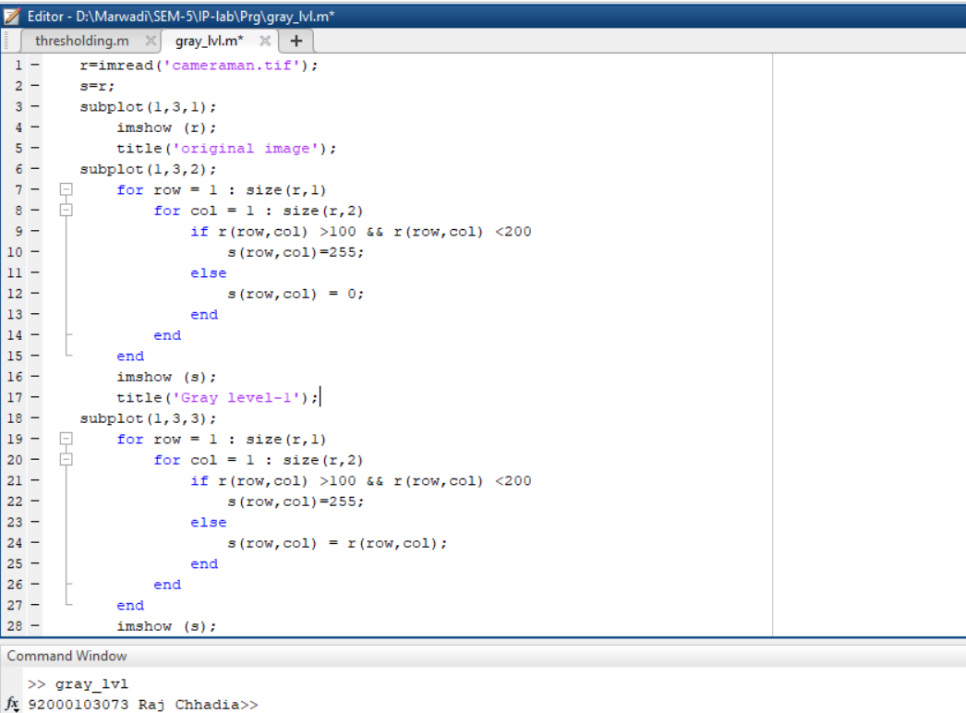

**Output:**

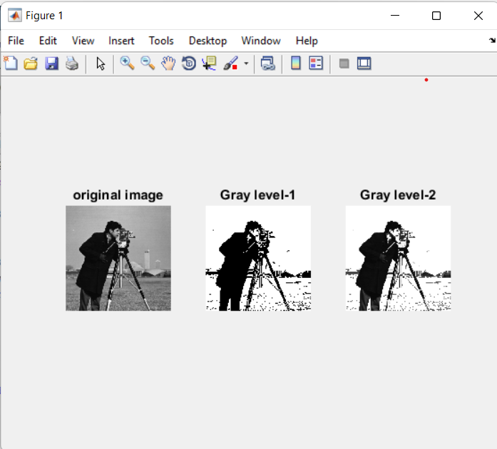

1. **Bit-plane slicing**

**Code:**

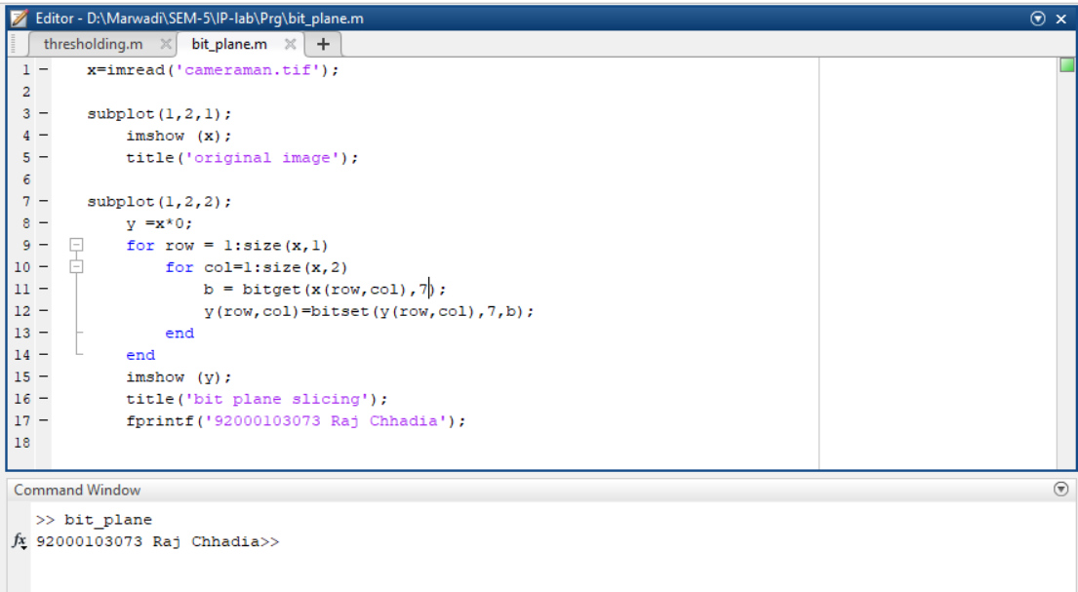

**Output:**

