EXPERIMENT NO. 04 – CLOCK DATA RECOVERY



Group Number:
Name:
Roll Number:

____________________________________________________

Digital Communication Systems
Department of Electronics & Electrical Communication Engineering
Indian Institute of Technology Kharagpur
____________________________________________________

TITLE: Design of Clock Data Recovery (CDR) Circuits
________________________________________________________________________________________
PROBLEM STATEMENT: Using the PN sequence generated in the first experiment as data, design an elementary clock data recovery (CDR) circuit.
_________________________________________________________________________________
KEY COMPONENTS: IC CD4046, IC741(Op-Amp), Resistors, Capacitors, Digital oscilloscope, Function generator, Breadboard, Connecting wires, and Power supply.
<Add more as necessary>
BRIEF THEORY & BACKGROUND:
The experiment aims to design a circuit for the clock data recovery (CDR) at the receiver using the PN sequence generated. The clock generated should correspond to the one used to generate the PN sequence.
In a communication system, clock and data recovery plays a pivotal role, in particular, in the operation of high-speed transceivers. The latter find utility across a spectrum of applications like optical communications, backplane routing, and chip-to-chip interconnections. These systems deal with incoming data streams that are asynchronous and subject to noise, necessitating the extraction of a synchronized clock to enable coherent operations. Moreover, it becomes imperative to "retune" the data, eliminating any accumulated jitter during transmission. Meeting the rigorous requirements set by communication standards places formidable challenges before both system architects and circuit designers.
Essentially, receivers employ a decision device to identify and estimate the (possible) transmitted bit pattern. Toward the same, a basic requirement is to establish the underlying clocking pattern which generates the transmitted pattern synchronously prior to the decision making. The principal aim of the clock data recovery circuit is to generate such a repetitive clock signal with low distortion seen as clock jitter, and if necessary, re-tune (and track) in case there is loss of synchronization. As mentioned in [1], the clock signal must adhere to several key criteria:
- Its frequency should match the data rate; for instance, a data rate of 10 Gb/s (where each bit lasts 100 ps) corresponds to a clock frequency of 10 GHz, featuring a 100 ps period.
- It should maintain a precise phase relationship with the data stream to optimize the sampling of individual bits by the clock. When the rising edges of the clock align with the midpoint of each bit, it ensures that sampling occurs at a point furthest from preceding and subsequent data transitions, allowing for maximum tolerance to jitter and other timing uncertainties.
- The clock signal should exhibit minimal jitter, as it constitutes the primary contributor to the jitter in the retimed data.
<Explain the workings of a basic CDR circuit with a block diagram for necessary theory background. Comment on some possible architectures and pros and cons to the extent possible.>

EXPECTED OUTCOMES:

Design and implement the following circuit to demonstrate clock data recovery. Note that several parts need to be carefully designed.

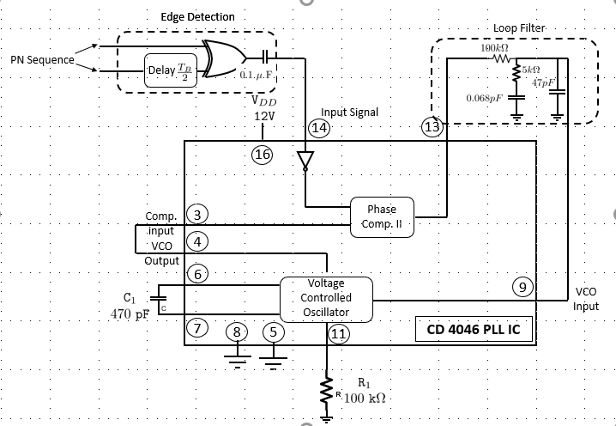

Fig. 1: Clock data recovery circuit
You will use a phase-locked loop (PLL) IC for this experiment. Here is a brief primer on the same.
CD 4046: Phase Locked Loop IC
In the following, we present some basic details of the CD 4046 PLL IC. Refer the IC datasheet [2] for more details.

The figure below shows a block diagram of the 16-pin CD4046B IC, which has been implemented on a single
monolithic integrated circuit. The PLL structure consists of a low-power, linear VCO and two
different phase comparators, having a common signal-input amplifier and a common comparator
input. A 5.2-V Zener diode is provided for supply regulation, if necessary. The VCO can be
connected either directly or through frequency dividers to the comparator input of the phase
comparators. The LPF is implemented through external parts because of the radical
configuration changes from application to application and because some of the components
cannot be integrated.
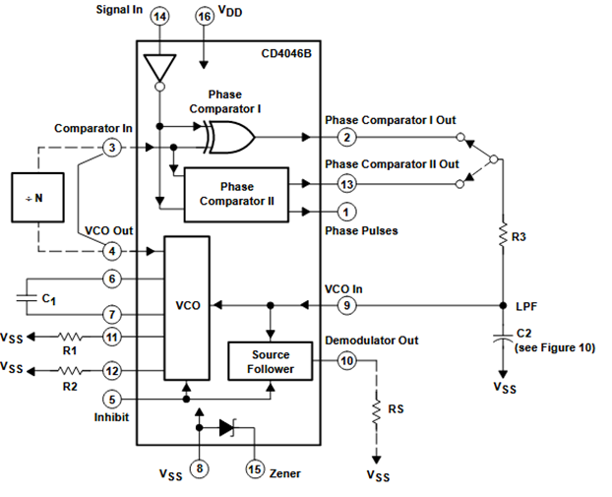
Fig. 2: CD 4046B PLL IC

Coming back to the CDR design problem, there are several design sub-problems that need to be considered for the experiment.
1. Edge detector: From the input PN sequence (or data sequence in general), we first extract the spikes. Keep it in the NRZ format.
AJB: remove(i.e., convert the not-return to zero (NRZ) data to return-to-zero (RZ) data.
You will need to design the delay block in the edge detector with care. What will the output of the edge detector look like?

2. Phase-locked Loop (PLL): A basic PLL is given in the following block diagram:
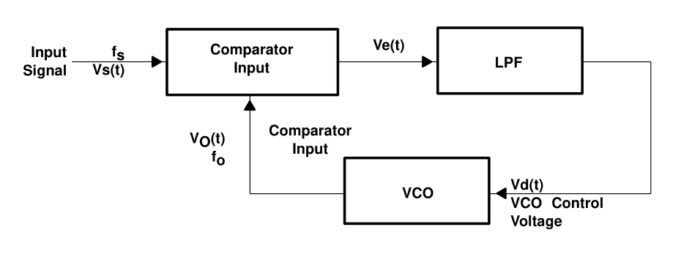
An important consideration for the design of the PLL is the feedback loop gain. Seen from the perspective of a closed-loop feedback control system, stability of the filter is essential and this is crucially characterized through the filter. You will need to design the loop filter carefully to ensure that the control system is stable. Do present a detailed analysis justifying the design of your loop filter. Is this a filter with a single pole or a multi-pole transfer system? If latter, why would we need multi-pole systems? Comment on this.
3. Jitter suppression: This problem couples with the PLL design problem. Jitter can be a serious problem in the recovered clock. Design the loop filter so as to also ensure that clock jitter is reduced (without compromising stability).
Loop filter design considerations:
The loop filter design is crucial to ensure both stability of the feedback control system as well as to compensate for any jitter in the recovered clock.
Problem Setup Assumptions:
Assume the following for the experiment:
Clock frequency for generating the PN sequence: 10kHz.
R_{b}=100kOhms, R_{a}=5kOhms, C_{a}=0.068microF, C_{b}=47microF. These choices ensure that the VCO tracks a range of frequencies from 0Hz to 70kHz. Read the datasheet to understand how this choice was made, and correlate with the problem statement.
Specific choices for the loop filter parameters will be mentioned in the lab session. You will need to design the edge detector appropriately, and then comment on the all the different aspects of the design (loop filter, edge detector, transfer function) accordingly (read the earlier sections for specific questions).

Outcomes:
1. Present the recovered clock signal and comment on the clock jitter present, if any, and comment on the potential weakness in the design for this jitter. How would you compensate for it?
2. Identify the specific assumptions made in the design of the CDR circuit (what is the receiver assumed to know so as to complete the design?) and point out the potential limitations of the circuit discussed.
3. Suggest improvements to the design while getting rid of the assumptions to make the circuit more realistic.
ACKNOWLEDGEMENTS:
Mention (enumerate) all references including private communication, reference papers, public articles, etc. Look up online resources to understand how references are cited.

REFERENCES:
[1] Razavi, Behzad. "Challenges in the design high-speed clock and data recovery circuits." IEEE Communications magazine 40.8 (2002): 94-101.
[2] Morgan, David K. "CD4046B phase-locked loop: A versatile building block for micropower digital and analog applications." Texas Instruments Application Report, SCHA002A (2003).
<Add appropriate references>

