Indian Institute of Technology, Kharagpur

Department of Electronics & Electrical Communication Engineering
Subject: Digital Communication Laboratory (EC 39002), Spring 2026
Course Instructors: Prof. Jithin Ravi, Prof. Ritwik K. Layek, Prof. A. J. Budkuley

Experiment 5: Quadrature Phase Shift Keying
(QPSK) Modulation and Demodulation

Objective:

- To implement QPSK modulation for a random bit sequence(Generate the PN sequence because the clock source information is needed to convert the serial bits into parallel bits).
- For the obtained modulated signal, design and implement a demodulator.

Key Components:
IC 741 op-amp, IC 7474 (D_flip flop), IC 7404 (Inverter), IC M4016 switch, resistors, capacitor, IC 7486 (Quad 2-i/p XOR gate), IC 74164/7495 (Shift register).

Brief Theory:
Phase Shift Keying (PSK)
PSK is the digital modulation technique in which the phase of the carrier signal is changed by choosing either the sine and cosine signals at a particular time. PSK technique is widely used for wireless LANs, bio-metric, contactless operations, along with RFID and Bluetooth communications.
Quadrature Phase Shift Keying (QPSK)
1.The Quadrature Phase Shift Keying (QPSK) is a variation of BPSK, and it is also a Double Side Band Suppressed Carrier (DSBSC) modulation scheme, which sends two bits of digital information at a time, called as bigits.

2.Instead of the conversion of digital bits into a series of digital stream, it converts them into bit pairs. This decreases the data bit rate to half, which allows space for the other users.
QPSK Modulator;
The QPSK Modulator uses a bit-splitter, two multipliers with local oscillator, a 2-bit serial to parallel converter, and a summer circuit.

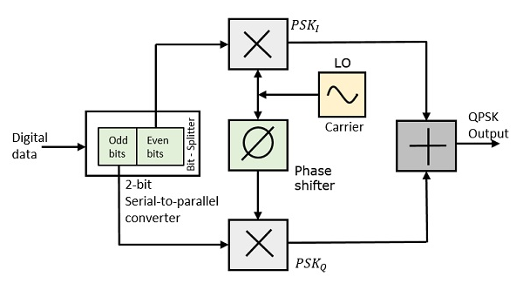

At the modulator’s input, the message signal’s even bits (i.e., 2nd bit, 4th bit, 6th bit, etc.) and odd bits (i.e., 1st bit, 3rd bit, 5th bit, etc.) are separated by the bits splitter and are multiplied with the same carrier to generate odd BPSK (called as PSK_{I}) and even BPSK (called as PSK_{Q}). The PSK_{Q} signal is any how phase shifted by 90° before being modulated.
The QPSK waveform for two-bits input is as follows, which shows the modulated result for different instances of binary inputs.

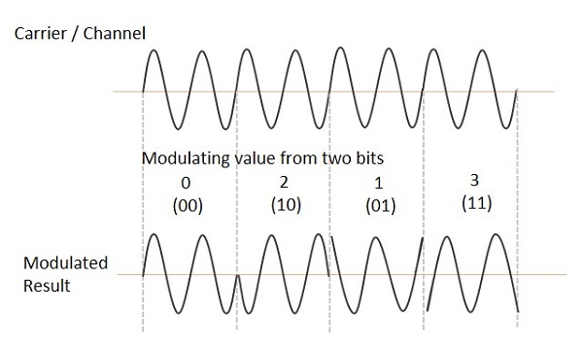

Expected Outcome:

- Using a PN sequence as the input data, design a circuit to generate a QPSK signal and observe in the oscilloscope.
- For the designed demodulator, observe that the input data is recovered.

