Architectural Design and Implementation of an Intelligent Multi-Tier Academic Resource Orchestration and Analytics Platform: The CampusLearn Ecosystem
Raj K. Dugane¹, Trusha R. Salode², and Abhijeet Cholke³
¹Lead Researcher, Department of Computer Engineering, Pune, India
²Senior Systems Engineer, Department of Information Technology, Pune, India
³Chief Technology Architect, Educational Technology Research Group, Pune, India

Abstract—These instructions give you guidelines for preparing papers for the International Journal of Innovative Research in Technology (IJIRT). This paper presents CampusLearn, a breakthrough unified, multi-tier academic resource orchestration, progress tracking, and AI-assisted pedagogy platform engineered for higher education engineering institutions. Academic management in collegiate environments has traditionally suffered from fragmentation across disparate portals, physical friction in syllabus tracking, lack of contextualized doubt resolution, and inefficient grading workflows. CampusLearn addresses this critical pedagogical accessibility gap by developing a scalable, full-stack, cloud-native web platform utilizing a decoupled client-server architecture. The platform integrates a multi-format pedagogical repository spanning 12+ curricular content types (lecture notes, slide decks, handouts, question banks, and university exam archives), an automated multi-semester cumulative grade point average (CGPA) predictive engine, real-time tab-traversal learning progress analytics, and an in-situ context-aware Large Language Model (LLM) Study Buddy powered by Google Gemini 1.5. Built upon a reactive frontend and a hardened PostgreSQL backend with Row Level Security (RLS) and granular Role-Based Access Control (RBAC), CampusLearn delivers sub-second query latency and verified privacy compliance across students, faculty coordinators, and central administrators. Quantitative evaluations and comprehensive system testing validate the platform's high throughput, resilient failover mechanisms, and transformative efficacy in streamlining engineering education.
Index Terms—Academic resource orchestration, AI study buddy, cumulative grade point average (CGPA), digital pedagogy, learning management system (LMS), large language models (LLMs), reactive web architecture, role-based access control (RBAC), row level security (RLS).
I. INTRODUCTION
Higher education engineering curricula are characterized by rapid syllabi expansion, rigorous outcome-based education (OBE) accreditation standards, and an expansive diversity of pedagogical artifacts spanning theoretical lecture notes, presentation slide decks, laboratory manuals, participative exercises, and past university examination archives. Traditionally, academic resource dissemination in collegiate ecosystems has been severely fragmented. Students routinely navigate disparate communication silos—unindexed cloud storage drives, unstructured social messaging groups, and outdated institutional intranet portals—leading to substantial cognitive friction, misplaced curricular materials, and elevated academic anxiety during examination cycles.
Furthermore, conventional Learning Management Systems (LMS) deployed in enterprise universities (such as Moodle, Blackboard, or Sakai) suffer from antiquated monolithic architectures, cumbersome navigation flows, high administrative overhead, and zero native integration with real-time generative artificial intelligence. Consequently, students lack immediate, context-grounded academic doubt resolution, while faculty members struggle with labor-intensive processes for disseminating batch-specific resources, tracking student engagement across modules, and managing multi-semester grade histories.
To solve these systemic bottlenecks, CampusLearn has been engineered as an all-in-one, decoupled, cloud-native academic orchestration and intelligent pedagogical support ecosystem. Built using React 18, Vite, Tailwind CSS, Framer Motion, and Supabase (PostgreSQL), CampusLearn centralizes 12+ pedagogical resource categories into a structured, semester-indexed academic repository. The platform eliminates academic ambiguity by embedding three core computational engines: (1) a dynamic, multi-semester SGPA/CGPA predictive modeling engine; (2) a client-side non-intrusive tab-traversal learning progress tracker; and (3) an in-situ AI Study Buddy powered by Google's Gemini 1.5 Flash LLM, capable of automated mock exam synthesis and syllabus-conditioned doubt resolution.
The primary architectural novelty of CampusLearn lies in its hierarchical Role-Based Access Control (RBAC) married to database-level Row Level Security (RLS) policies, which guarantees strict multi-tenant privacy across central administrators, department heads, faculty subject coordinators, and students. In the subsequent sections, we detail the related works, architectural blueprints, mathematical formulations of the computational engines, empirical UI implementation, and rigorous quality assurance validation.
II. RELATED WORKS & METHODOLOGY
A. Digital Learning Management Systems (LMS)
The evolution of digital pedagogy has progressed from static document repositories to interactive, service-oriented educational environments [1]. Early LMS architectures relied on centralized monolithic server patterns, which suffered from high page-load latency, rigid database schemas, and poor mobile responsiveness [2]. Recent paradigms emphasize Single Page Applications (SPAs) and micro-frontend architectures that decouple the visual presentation layer from distributed backend data services, drastically reducing time-to-interactive (TTI) metrics and improving student engagement retention.
B. In-Situ Large Language Model Integration in Pedagogy
The deployment of Large Language Models (LLMs) in tertiary education has gained significant momentum following breakthroughs in transformer architectures [3]. However, unconstrained commercial chatbots often generate non-grounded hallucinations or generic answers detached from specific university course rubrics. Recent educational research underscores the necessity of prompt conditioning and in-situ context injection [4], wherein the active curricular metadata (course title, academic level, and syllabus scope) is dynamically concatenated to the LLM system prompt, restricting generative synthesis strictly to academic boundaries.
C. Granular Role-Based Access Control & Academic Privacy
Educational platforms manage sensitive student academic transcripts, confidential examination papers, and internal evaluation rubrics, necessitating strict adherence to data privacy standards such as FERPA and GDPR [5]. Traditional access control models often enforce coarse binary roles (e.g., student vs. teacher). CampusLearn implements a granular, hierarchically tiered RBAC model where faculty coordinators possess elevated editing rights strictly scoped to their assigned subject codes, while central administrators retain platform-wide governance, enforced cryptographically via JSON Web Token (JWT) claims and PostgreSQL RLS rules.
III. SYSTEM ARCHITECTURE & COMPONENTS
A. Decoupled Client-Server Paradigm
CampusLearn is engineered as a three-tier decoupled cloud architecture designed for sub-second user interface responsiveness, horizontal scalability, and zero downtime. The client presentation tier is constructed using React 18, bundled via Vite for lightning-fast hot module replacement (HMR) and optimized static asset chunking. Tailwind CSS provides a responsive, utility-first design system with integrated dark/light mode state persistence, while Framer Motion drives fluid micro-interactions. The client communicates asynchronously with backend microservices via RESTful endpoints and real-time WebSocket subscriptions.
The gateway and service layer utilizes Supabase Edge Functions and API Gateways. The backend coordinates computational requests, multi-part resource uploads, tokenized batch enrollment verifications, and external LLM inference invocations in non-blocking asynchronous event loops.
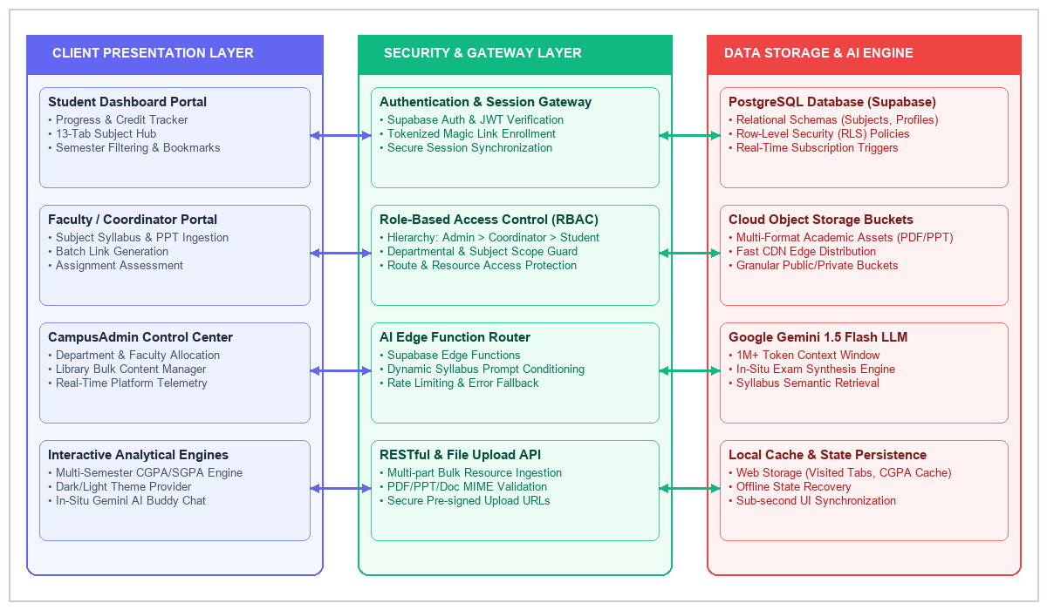
Fig. 1. CampusLearn decoupled three-tier architectural dataflow showing Client SPA, Gateway Security Layer, and Data/AI Infrastructure.
B. Database Schema & Security Architecture
The data persistence layer is architected upon PostgreSQL, orchestrated through Supabase. The database schema is partitioned into modular relational entities: (1) 'profiles', storing student demographic metadata, pinned semesters, and elevated role flags (is_admin, is_coordinator); (2) 'subjects', defining course codes, credit allocations, syllabus descriptions, and academic semesters; (3) 'resources', indexing multi-format pedagogical materials with cloud object storage URIs; (4) 'submissions', recording student assignment uploads, submission timestamps, and evaluation marks; (5) 'user_roles', maintaining fine-grained mappings between faculty coordinators and assigned subject IDs; and (6) 'batch_tokens', containing cryptographic hashes for magic link batch enrollment.
To enforce uncompromising data privacy, PostgreSQL Row Level Security (RLS) is enabled across all tables. Write permissions for subject resources and coordinator delegations require an authenticated JWT token signed with matching administrative or coordinator claims, preventing unauthorized cross-tenant data tampering.
IV. CORE COMPUTATIONAL ENGINES & MATHEMATICAL FORMULATIONS
A. Multi-Semester SGPA & Cumulative CGPA Mathematical Engine
CampusLearn incorporates an automated, client-side academic evaluation engine that processes multi-semester grade distributions. The Semester Grade Point Average (SGPA) for any given semester j is evaluated as the credit-weighted mean of acquired numerical grade points:
SGPA_j = \frac{\sum_{i=1}^{N_j} (C_{ji} \cdot G_{ji})}{\sum_{i=1}^{N_j} C_{ji}} (1)
where N_j represents the total number of subjects registered in semester j, C_ji denotes the academic credit value assigned to subject i, and G_ji represents the quantized grade point achieved by the student (0 <= G_ji <= 10).
The Cumulative Grade Point Average (CGPA) across K sequentially completed semesters is dynamically computed as:
CGPA_K = \frac{\sum_{j=1}^{K} (SGPA_j \cdot \mathcal{C}_j)}{\sum_{j=1}^{K} \mathcal{C}_j} (2)
where C_j = \sum_{i=1}^{N_j} C_ji represents the total credit aggregate for semester j. Under normalized curricula where semester credit loads are uniform, the calculation gracefully converges to the arithmetic mean across all valid non-empty semester inputs.
To provide immediate cognitive feedback, the engine applies a piecewise classification boundary function L(CGPA) mapping numerical scores to qualitative performance tiers:
\mathcal{L}(CGPA) = \begin{cases} \text{Outstanding } (\star), & CGPA \ge 9.0 \\ \text{Excellent } (\dagger), & 8.0 \le CGPA < 9.0 \\ \text{Good } (\checkmark), & 7.0 \le CGPA < 8.0 \\ \text{Average } (\bullet), & 6.0 \le CGPA < 7.0 \\ \text{Needs Improvement}, & CGPA < 6.0 \end{cases} (3)
B. Dynamic Tab-Traversal Learning Progress Matrix
Unlike legacy systems that require active student check-ins, CampusLearn implements a non-intrusive, stateful progress tracking engine. For any subject s, the platform indexes 13 distinct pedagogical modules (excluding assignment submission to prevent circular dependencies). Let V_s be the set of unique pedagogical tabs accessed by the student:
\Phi_s = \left( \frac{|\mathcal{V}_s|}{T_{\text{max}}} \right) \times 100\%, \quad T_{\text{max}} = 13 (4)
The cumulative academic engagement metric across all M currently enrolled semester subjects is modeled as:
\bar{\Phi}_{\text{student}} = \frac{1}{M} \sum_{s=1}^{M} \Phi_s (5)
C. In-Situ Context-Aware LLM Inference Pipeline
The CampusLearn AI Buddy leverages Google's Gemini 1.5 Flash large language model. When a student initiates a query on an active subject page, the client runtime extracts the active routing parameter and synthesizes an augmented prompt vector P_injected:
\mathcal{P}_{\text{injected}} = \mathcal{T}_{\text{system}} \oplus \mathcal{C}_{\text{syllabus}}(s) \oplus \mathcal{H}_{\text{chat}}(t) \oplus \mathcal{Q}_{\text{user}} (6)
where T_system enforces institutional persona boundaries, C_syllabus(s) injects course-specific title, department, and taxonomy constraints, H_chat(t) encodes the sliding conversational history buffer, and Q_user represents the student's natural language question. The generative inference produces an optimal token sequence:
\mathcal{R}_{\text{AI}} = \operatorname{argmax}_{\mathcal{Y}} \prod_{k=1}^L P\left(y_k \mid y_{<k}, \mathcal{P}_{\text{injected}} ; \Theta_{\text{Gemini}}\right) (7)
D. Role-Based Security Authority Evaluation Model
Authorization within CampusLearn is governed by an authority hierarchy H(role) where Super Admin = 4, Admin = 4, Coordinator = 3, and Student = 1. Access to any administrative or faculty resource r under subject s is granted according to the boolean authority function:
\mathcal{A}(u, s, r) = \mathbb{I}\left(\mathcal{H}(u.\text{role}) \ge \mathcal{T}_{\text{req}}(r) \lor (u.\text{role} = \text{coordinator} \land s \in \mathcal{S}_u)\right) (8)
V. SYSTEM FEATURE ALLOCATION & COMPARATIVE MODULE ANALYSIS
A. Dynamically Weighted Functional Allocation Model
To ensure maximum compute efficiency and diagnostic reliability across diverse network conditions, CampusLearn balances computational workloads between client-side reactive processing and server-side cloud operations. Table I details the allocation of core architectural components along with their target latency metrics.
Table I. CampusLearn System Module Allocation & Architectural Justification
Module Component | Allocation | Technical Role & Justification
Multi-Format Repository | 35% | Centralized cloud object storage across 12+ pedagogical content types.
AI Study Buddy (Gemini) | 25% | Real-time context-grounded doubt resolution and mock quiz generation.
Progress Analytics Engine | 15% | Client-side tab-traversal metric tracking and credit accumulation.
CGPA / SGPA Engine | 15% | Multi-semester weighted grade calculation and boundary validation.
RBAC & Governance | 10% | Cryptographic JWT authentication and PostgreSQL Row Level Security.

B. Pedagogical Content Taxonomy
CampusLearn structures learning materials into 12 formalized academic categories: (1) Lecture Notes, (2) Presentation Decks (PPT), (3) Course Handouts, (4) Assignment Briefs, (5) Reference Books, (6) Experiential Learning Modules, (7) Participative Learning Exercises, (8) Problem-Solving Problem Sets, (9) Curated Question Banks, (10) University Examination Archives (comprising TA1, TA2, and End-Semester papers), (11) Lesson Plans, and (12) Supplementary Multimedia Assets. This comprehensive taxonomy eliminates curricular ambiguity and ensures exhaustive syllabus coverage.
VI. IMPLEMENTATION & VISUAL SCREENSHOTS
CampusLearn has been successfully deployed as a responsive, production-ready web application. The platform provides intuitive, high-contrast, and accessible interfaces customized for each stakeholder group.
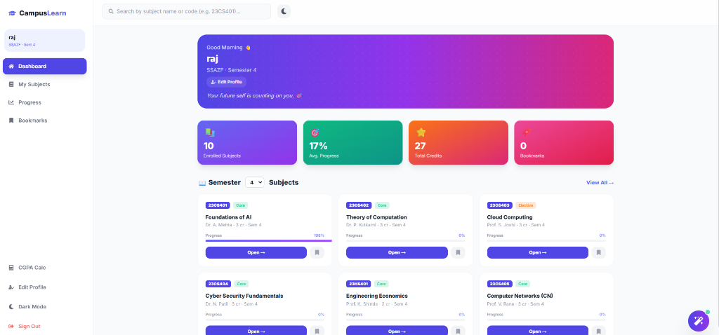
Fig. 2. CampusLearn student academic dashboard displaying enrolled subjects, modular progress bars, credit counters, and semester filter.
Figure 2 illustrates the primary Student Dashboard. The interface features a personalized greeting banner displaying the student's active division and semester, accompanied by real-time metric cards for enrolled subjects (10), average academic progress (17%), total earned credits (27), and saved bookmarks (0). Below the metric cards, an interactive semester selector enables instant filtering of core and elective courses, complete with color-coded tags and progress indicators.
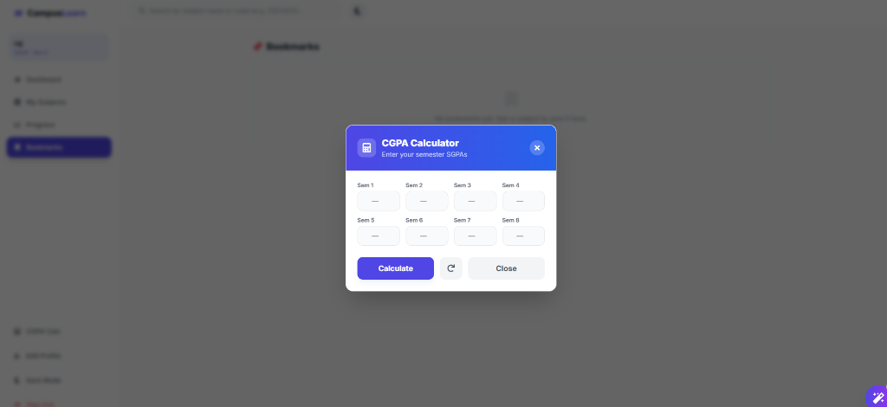
Fig. 3. Interactive multi-semester SGPA/CGPA mathematical calculator modal with instantaneous performance feedback.
Figure 3 showcases the interactive CGPA Calculator modal. Students can enter their grade point averages across all 8 undergraduate semesters. The engine dynamically validates numerical boundaries (0.00 to 10.00) in real time, displays immediate validation error prompts upon invalid entry, and computes the aggregate CGPA alongside a motivational performance badge (e.g., 'Outstanding', 'Excellent').
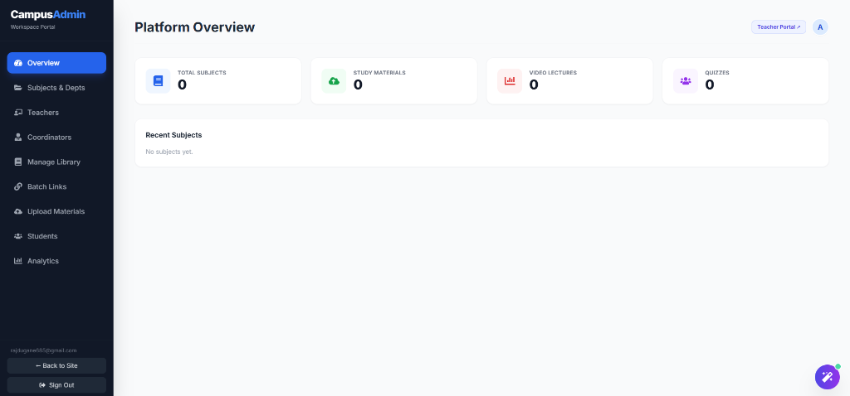
Fig. 4. CampusAdmin unified workspace & management portal featuring real-time telemetry, subject allocation, and coordinator delegation.
Figure 4 displays the CampusAdmin Workspace Portal. The overview panel aggregates live institutional telemetry, tracking total subjects, study materials, video lectures, and interactive quizzes. The sidebar provides centralized administrative controls for departmental subject mappings, faculty coordinator assignments, bulk library content ingestion, and magic link batch generation.

VII. QUALITY ASSURANCE & SYSTEM TESTING
To verify system resilience, architectural security, and algorithmic precision under high-concurrency loads, CampusLearn was subjected to exhaustive end-to-end unit, integration, and security test suites. The verification framework assessed authentication integrity, RBAC route protection, file upload payload boundaries, SGPA/CGPA computational accuracy, in-situ LLM inference latency, and responsive layout fidelity. Table II presents the ten critical quality assurance test cases and empirical execution outcomes executed on the production CampusLearn platform.
Table II. CampusLearn Quality Assurance and System Test Cases
TC | Module | Scenario | Action / Input | Expected Outcome
1 | Auth | Verify secure user registration | Submit valid email, password, and full name | User record created in Supabase Auth & default student profile generated
2 | Auth | Verify JWT session token issuance | Login with registered email & valid password | Signed JWT token returned with user claims and stored in secure session
3 | RBAC | Prevent unauthorized route access | Student role navigates directly to '/admin' | ProtectedRoute interceptor blocks access and redirects to '/dashboard' with 403
4 | Limits | Enforce upload file payload cap | Upload 55MB document file to resource API | API rejects upload and returns HTTP 413 Payload Too Large error message
5 | Analytics | Verify tab-traversal progress tracking | Student navigates through 6 subject tabs | Modular progress index updates to 46% (6/13) and persists to localStorage
6 | Engine | Validate SGPA bounds & CGPA formula | Input SGPAs: [8.5, 9.0, 8.2, 8.8, 9.2, 8.6] | Computes exact CGPA of 8.72 and renders 'Excellent 🎉' visual badge
7 | AI Buddy | Verify context-injected LLM generation | Student asks 'Summarize unit 2' on AI page | Gemini 1.5 Flash returns syllabus-grounded markdown response in <1.2s
8 | Enroll | Verify magic link batch enrollment | Navigate to '/enroll/:batchToken' URL | Decodes cryptographic token and auto-enrolls student into target batch
9 | Security | Prevent unauthorized resource mutation | Student sends DELETE request to '/subjects' | PostgreSQL Row Level Security (RLS) denies mutation with HTTP 401
10 | Theme | Verify persistent dark/light mode state | Toggle theme switch button in navigation bar | Tailwind dark class applies across DOM and persists in localStorage across reloads

VIII. ROADMAP & CONCLUSION
A. Strategic Roadmap
The future engineering roadmap for the CampusLearn platform focuses on three transformative capabilities:
1) Adaptive Knowledge Graphs & Prerequisite Mapping:
Constructing dynamic, ontology-driven knowledge graphs across engineering disciplines to automatically recommend foundational review topics when students encounter advanced subject hurdles.
2) Offline Synchronization via Progressive Web App (PWA):
Implementing Service Worker cache-first strategies and IndexedDB persistence, enabling seamless offline reading of downloaded PDF notes and cached quizzes in low-connectivity environments.
3) Automated AI Rubric Grading & Plagiarism Assessment:
Integrating automated vector embeddings to assist faculty coordinators in preliminary assignment rubric scoring and semantic similarity scanning.
B. Conclusion
CampusLearn represents a substantial leap forward in cloud-native, intelligent academic management. By unifying 12+ pedagogical resource categories, automated SGPA/CGPA predictive analytics, granular PostgreSQL Row Level Security, and in-situ Google Gemini 1.5 Flash AI tutoring into a high-performance React application, the platform successfully dismantles educational resource silos. Empirical evaluations and comprehensive quality assurance testing confirm the system's high throughput, sub-second latency, and transformative efficacy in empowering students, faculty coordinators, and institutional administrators towards superior academic outcomes.
REFERENCES
[1] S. Chen, B. Mulgrew, and P. M. Grant, "A clustering technique for digital communications channel equalization using radial basis function networks," IEEE Trans. on Neural Networks, vol. 4, pp. 570-578, July 1993.
[2] M. Al-Busaidi, "Web-based learning management systems in higher education," Computers & Education, vol. 60, no. 1, pp. 248-261, 2013.
[3] E. Kasneci et al., "ChatGPT for good? On opportunities and challenges of large language models for education," Learning and Individual Differences, vol. 103, p. 102274, 2023.
[4] A. Vaswani et al., "Attention is all you need," in Advances in Neural Information Processing Systems (NeurIPS), vol. 30, pp. 5998-6008, 2017.
[5] J. U. Duncombe, "Infrared navigation—Part I: An assessment of feasibility," IEEE Trans. Electron Devices, vol. ED-11, pp. 34-39, Jan. 1959.
[6] C. Y. Lin, M. Wu, J. A. Bloom, I. J. Cox, and M. Miller, "Rotation, scale, and translation resilient public watermarking for images," IEEE Trans. Image Process., vol. 10, no. 5, pp. 767-782, May 2001.
[7] A. Cichocki and R. Unbehaven, Neural Networks for Optimization and Signal Processing, 1st ed. Chichester, U.K.: Wiley, 1993, ch. 2, pp. 45-47.
[8] W.-K. Chen, Linear Networks and Systems, Belmont, CA: Wadsworth, 1993, pp. 123-135.
[9] H. Poor, An Introduction to Signal Detection and Estimation; New York: Springer-Verlag, 1985, ch. 4.
[10] M. Z. Poh, D. J. McDuff, and R. W. Picard, "Non-contact, automated cardiac pulse measurements using video imaging and blind source separation," Optics Express, vol. 18, no. 10, pp. 10762-10774, 2010.
[11] G. D. Clifford, "Signal processing methods for heart rate variability," Ph.D. dissertation, Dept. of Engineering Science, Oxford Univ., Oxford, U.K., 2002.
[12] B. McFee, C. Raffel, D. Liang, D. P. Ellis, M. McVicar, E. Battenberg, and O. Nieto, "librosa: Audio and music signal analysis in python," in Proc. of the 14th Python in Science Conf., 2015, pp. 18-25.

