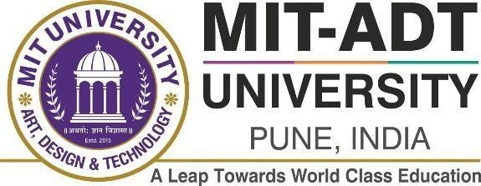

SCHOOL OF COMPUTING
Department of Computer Science and Engineering

Project Synopsis

Group ID:TYAIA313
Project Title: Campus Learn Group Members:

Enrollment Number | Roll No. | Name of student | Email Id | Contact Number
ADT25SOCBD141 | 68 | Raj Dugane | rajdugane00@gmai l.com | 9022003828
ADT25SOCBD077 | 68 | Trusha Salode | trushasalode@gmai l.com | 9421644771

Problem Statement: Students often struggle to access study materials like notes, PPTs, and video lectures as resources are scattered across multiple platforms. This leads to learning delays and dependency on faculty. Hence, a unified and easily accessible academic platform is needed to centralize all study resources.

Abstract: The increasing digitalization of education has highlighted the need for centralized access to academic study materials. In many universities, students struggle to obtain notes, presentations, and lecture videos due to unorganized and scattered resource distribution methods such as messaging groups and offline sharing. To overcome these challenges, this project proposes a web-based University Study Material Management & Access Portal designed to provide quick and structured access to subject-wise learning resources.

The system enables students to select their academic program, department, and semester to view and download relevant materials such as notes, PPTs, and video lectures. It also offers a

secure admin panel for authorized faculty or administrators to upload and manage content efficiently. The platform uses modern web technologies with responsive design to ensure accessibility on both mobile and desktop devices.

This proposed solution not only enhances the learning experience by promoting flexibility and independent learning but also maintains organized resource management throughout the academic cycle. The application aims to become a reliable, scalable, and user-friendly digital resource hub for university students.

Tools and Technique Use:

Sr. No. | Category | Tools / Technologies Used
1 | Frontend | React.js
2 | Backend | Node.js, Express.js
3 | Database | Firebase
4 | Programming Language | JavaScript
5 | Styling | CSS, Bootstrap
6 | Version Control | Git, GitHub

Literature Survey: Detail survey done

The digital transformation in education has drastically changed how students access and share academic resources. Several platforms and learning management systems (LMS) such as Google Classroom, Moodle, and Coursera have contributed to making learning more accessible and interactive. However, most of these platforms are either generic, require institutional subscriptions, or lack department-specific customization for universities.

A study by R. Kumar et al. (2020) highlights that students often depend on informal channels like messaging apps and personal drives to exchange study materials, leading to disorganization and data loss. Similarly, S. Mehta and P. Patel (2021) emphasized the importance of centralized digital platforms to improve academic collaboration and reduce learning barriers caused by unstructured data sharing.

Furthermore, research by D. Sharma (2022) on digital education in India reveals that students prefer web-based, mobile-friendly interfaces where they can access structured content such as

notes, video lectures, and assignments. This aligns with the concept behind Campus Learn, which aims to centralize academic materials specific to courses, departments, and semesters.

Existing systems like Google Drive, Microsoft Teams, and YouTube are commonly used by students but lack integration with course structures and faculty communication. Campus Learn bridges this gap by allowing categorized access to learning resources and facilitating direct communication between students and faculty members. The system enhances resource accessibility, fosters a collaborative learning environment, and reduces dependency on informal communication channels.

Proposed System (Block Diagram):
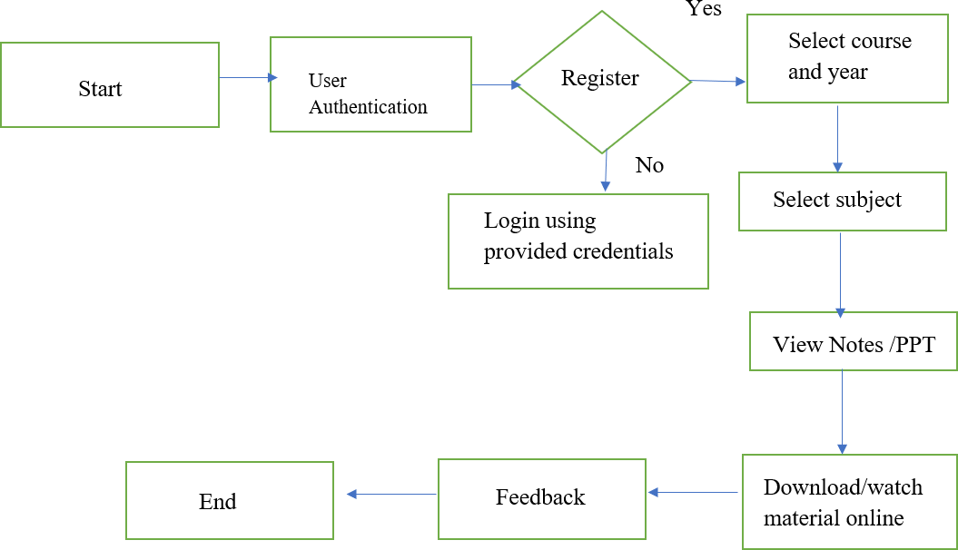

Conclusion: The system successfully provides a centralized digital learning platform where students can easily access all required study materials based on course structure. It promotes e-learning, academic efficiency, and better knowledge sharing, making the learning process more transparent and accessible.

References:

- Agarwal, A., & Kumar, P. (2021). Impact of E-learning Platforms on Higher Education in India. International Journal of Educational Technology, Vol. 18(4), pp. 112–120.
- Sharma, R., & Patel, K. (2020). A Study on Digital Education Platforms and Their Role in Student Learning. International Journal of Computer Applications, Vol. 176(10), pp. 25–30.
- Singh, M., & Gupta, N. (2022). Adoption of MOOCs in Indian Universities: Challenges and Opportunities. Journal of Emerging Technologies in Learning, Vol. 17(2), pp. 45–

53.
- Mishra, A., & Deshmukh, P. (2023). Developing Educational Portals Using MERN Stack: A Case Study. Journal of Advanced Computing and Communication Systems, Vol. 5(3),
pp. 87–92.
- National Education Policy 2020. Ministry of Human Resource Development, Government of India.

