**Karmani Project Setup**

**Steps to clone Karmani API**

**1. Step 1:**

* Go to the following Bitbucket link **–** [**https://bitbucket.org/edcs-karnataka-gov/workspace/repositories**](%20https:/bitbucket.org/edcs-karnataka-gov/workspace/repositories)

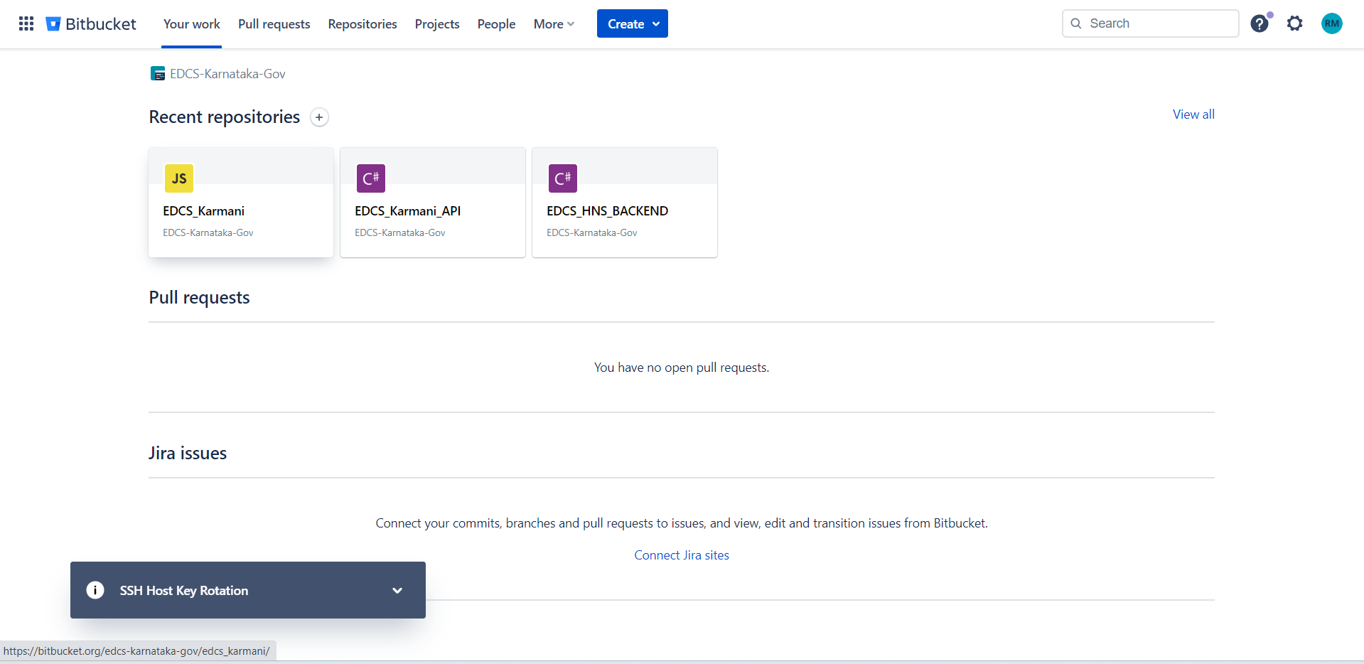

**2. Step 2:**

* Under Repositories section click on Repository named **“EDCS_Karmani_API”.** The following screen appears**.**

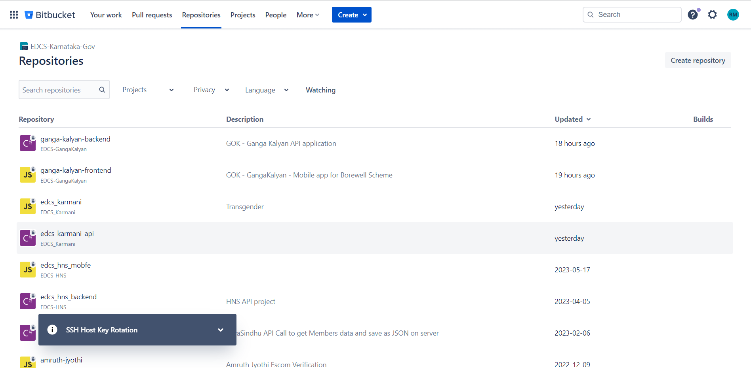

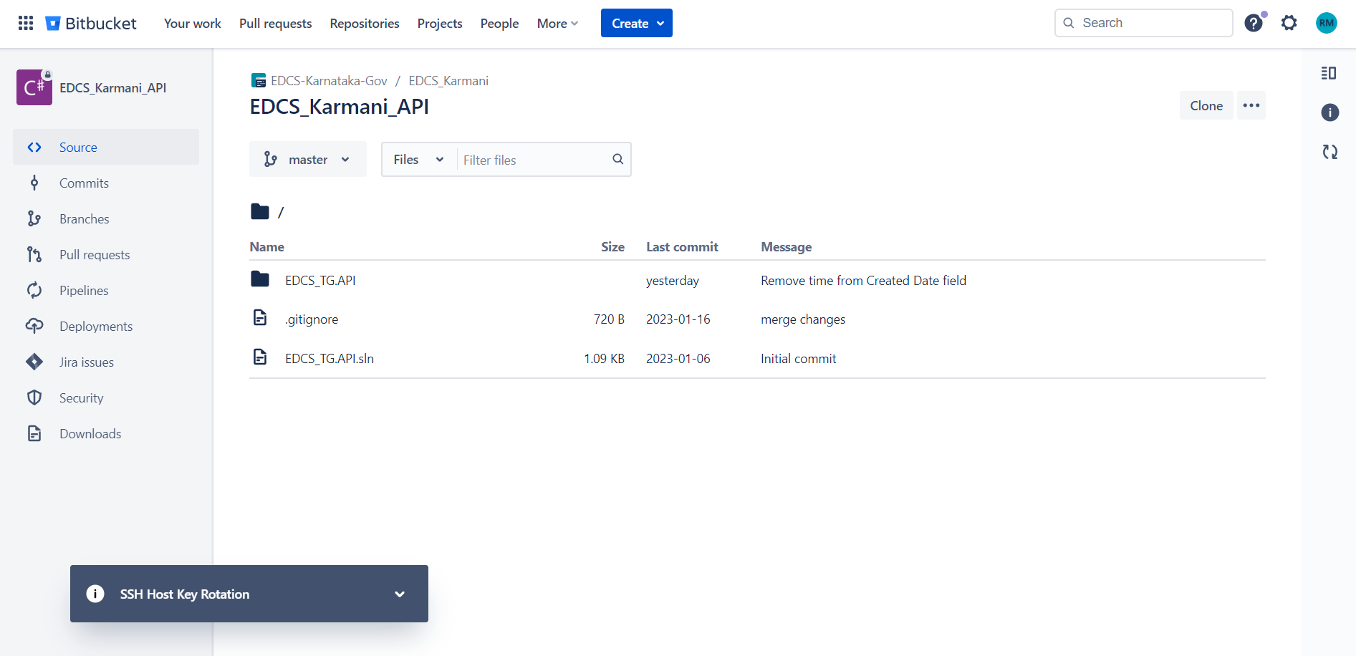

* In the above screen click on clone Button which is on top right corner of the screen**.**

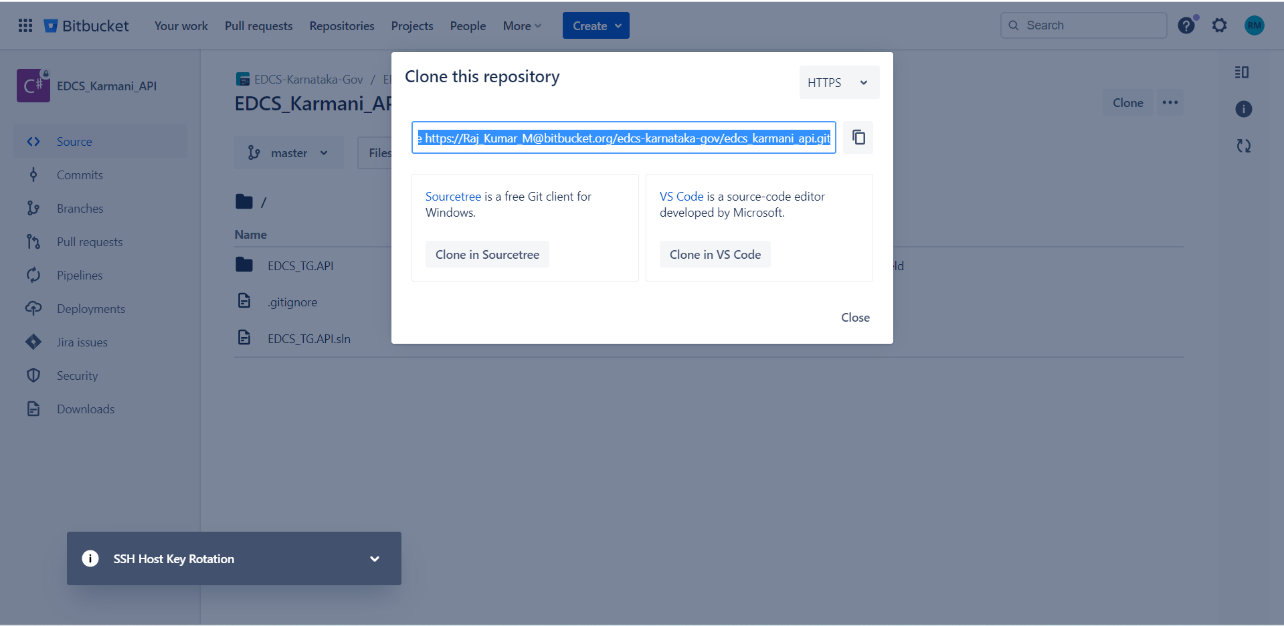

* Change the protocol from **“SSH”** to **“HTTPS”**
* Copy cloning link**.**

**Step 3:**

* Open visual studio and click on **“Clone a repository”**

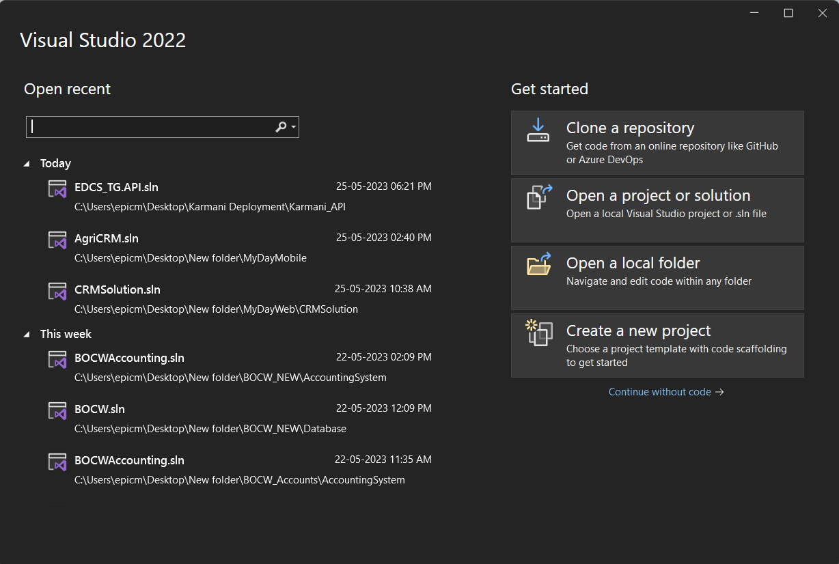

* Paste the link for cloning the project in Repository location field
* Create a folder named **“Karmani”** under **“D”** drive and browse the path to that folder and click on clone

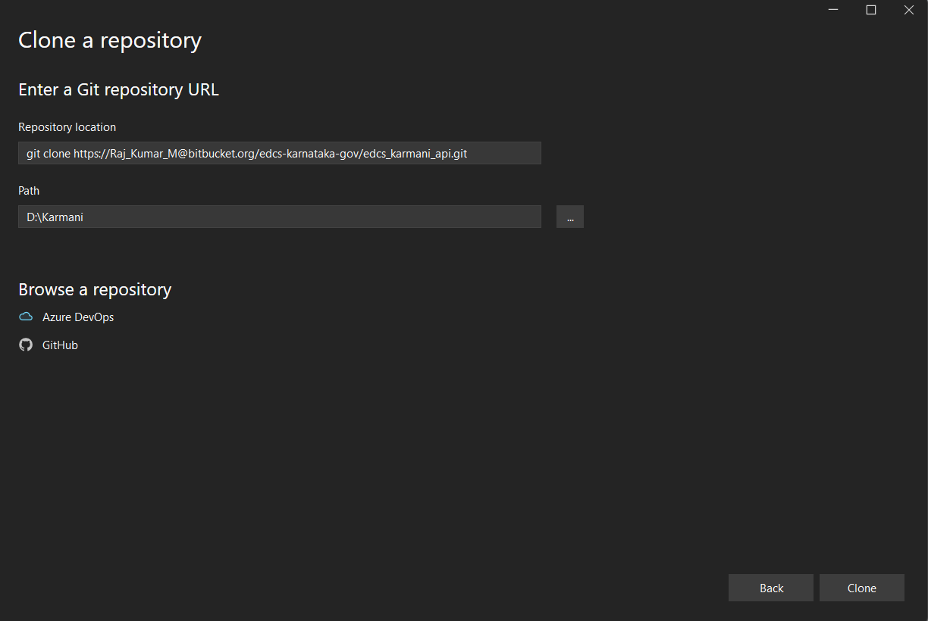

**Steps to run the Project**

**1.Step 1**

* Open **“EDCS_API.sln”** project in visual studio
* Go to build in the menu bar and then select clean project, Once the project is cleaned and then select Build project from same menu.

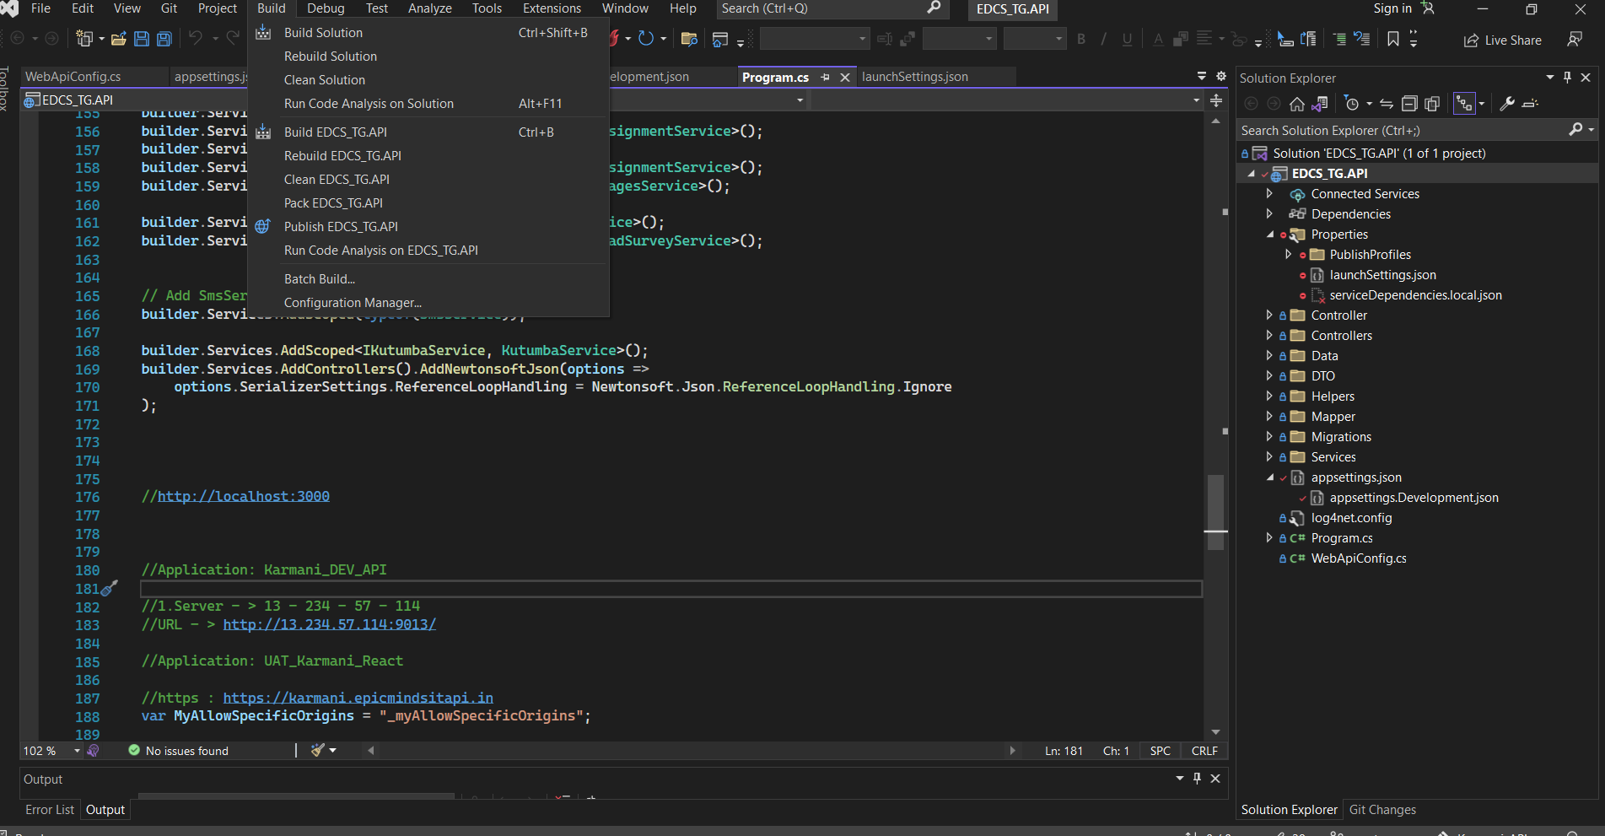

**2. Step 2**

* Once the above steps are completed run **“EDCS_API.sln”** project

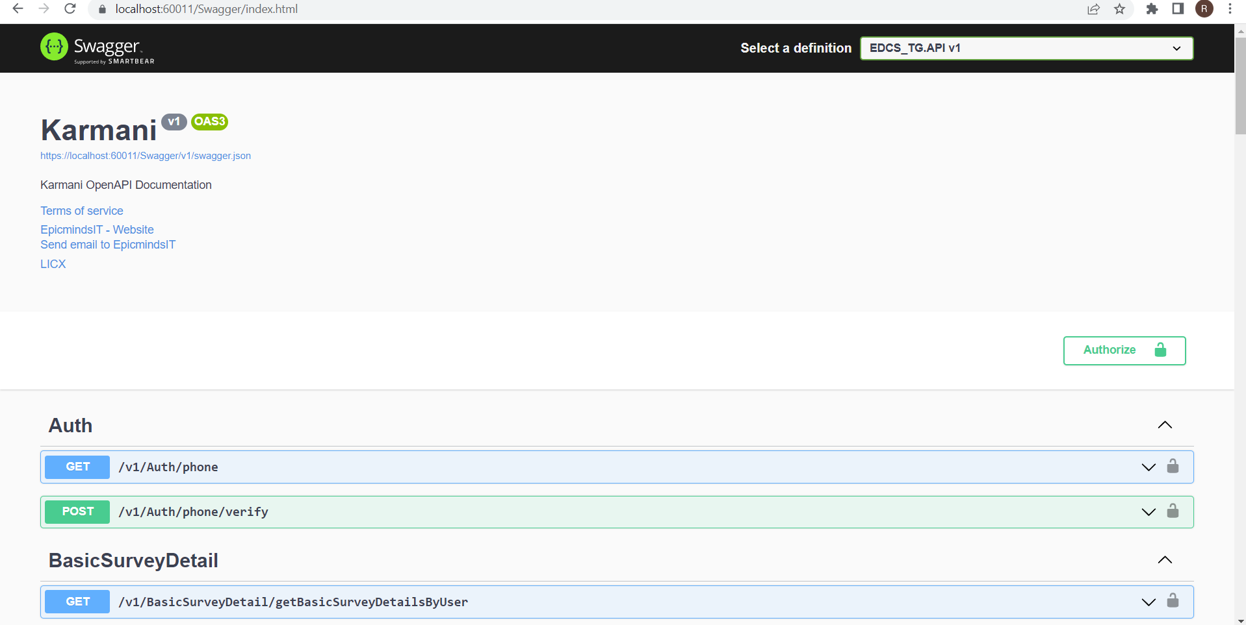

**Steps to clone Karmani UI**

**1. Step 1:**

* Go to the following Bitbucket link **–** [**https://bitbucket.org/edcs-karnataka-gov/workspace/repositories**](%20https:/bitbucket.org/edcs-karnataka-gov/workspace/repositories)



**2. Step 2:**

* Under Repositories section click on Repository named **“EDCS_Karmani”.** The following screen appears**.**

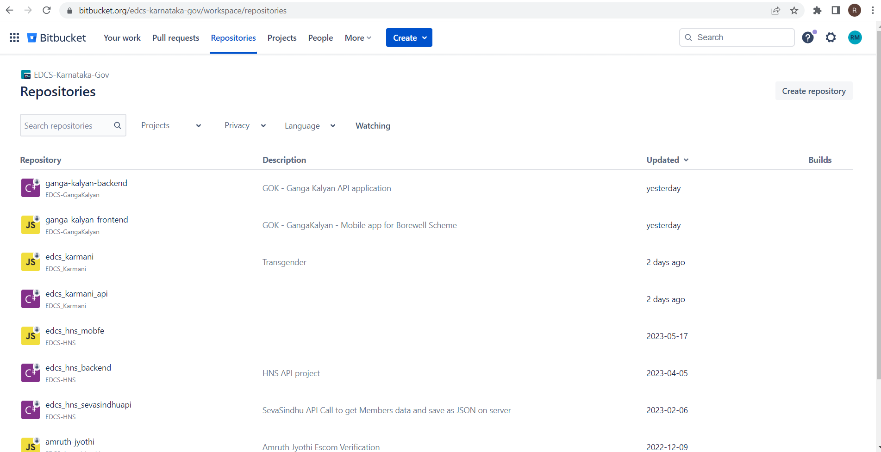

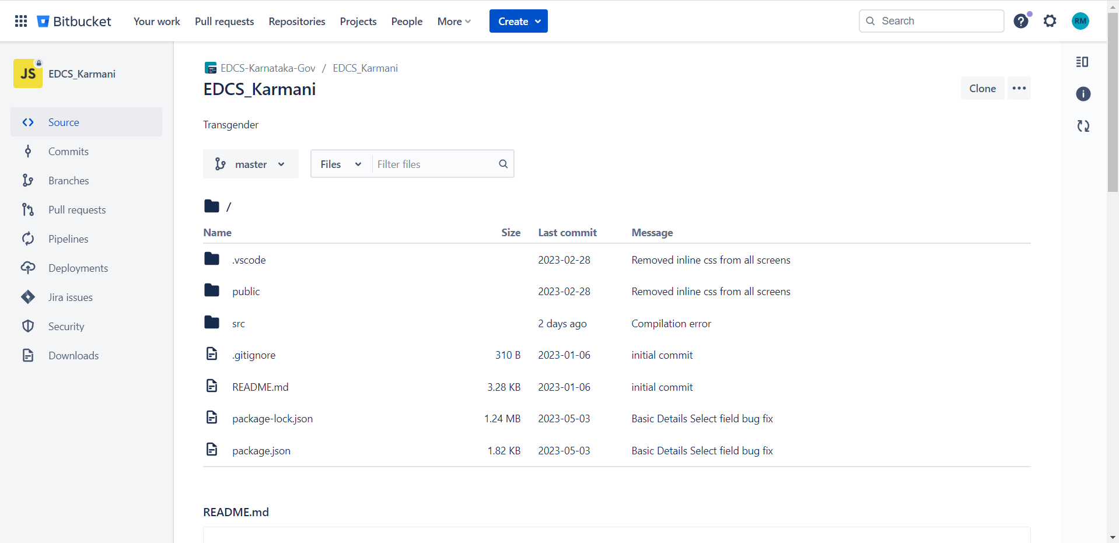

* In the above screen click on clone Button which is on top right corner of the screen**.**

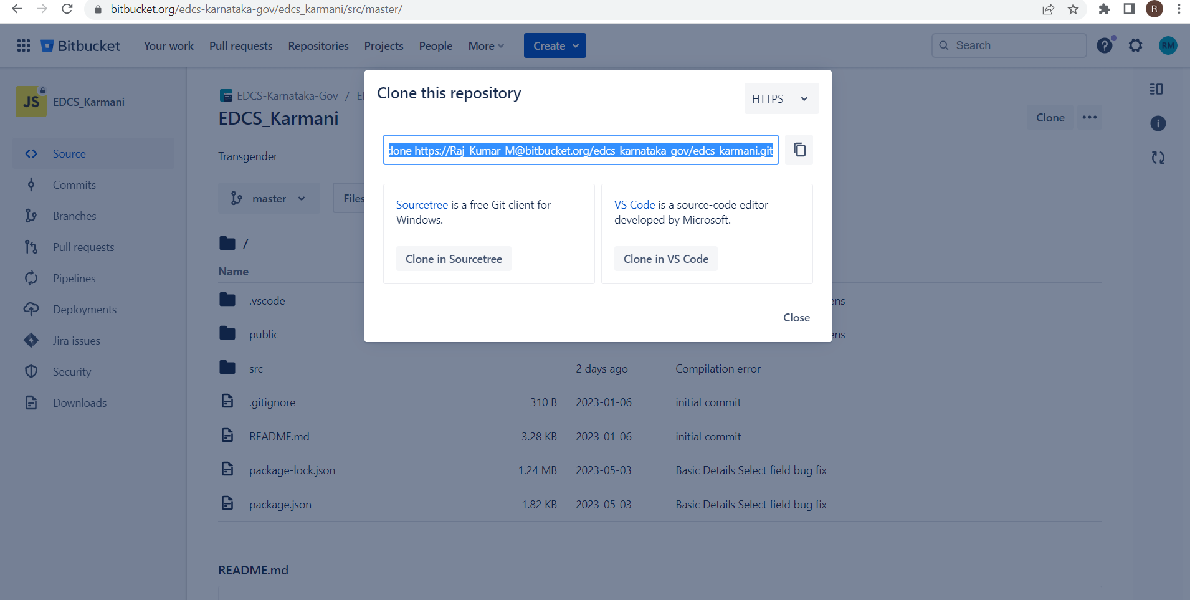

* Change the protocol from **“SSH”** to **“HTTPS”**
* Copy cloning link**.**

**Step 3:**

* Open visual studio and click on **“Clone a repository”**



* Paste the link for cloning the project in Repository location field
* Create a folder named **“Karmani_UI”** under **“D”** drive and browse the path to that folder and click on clone

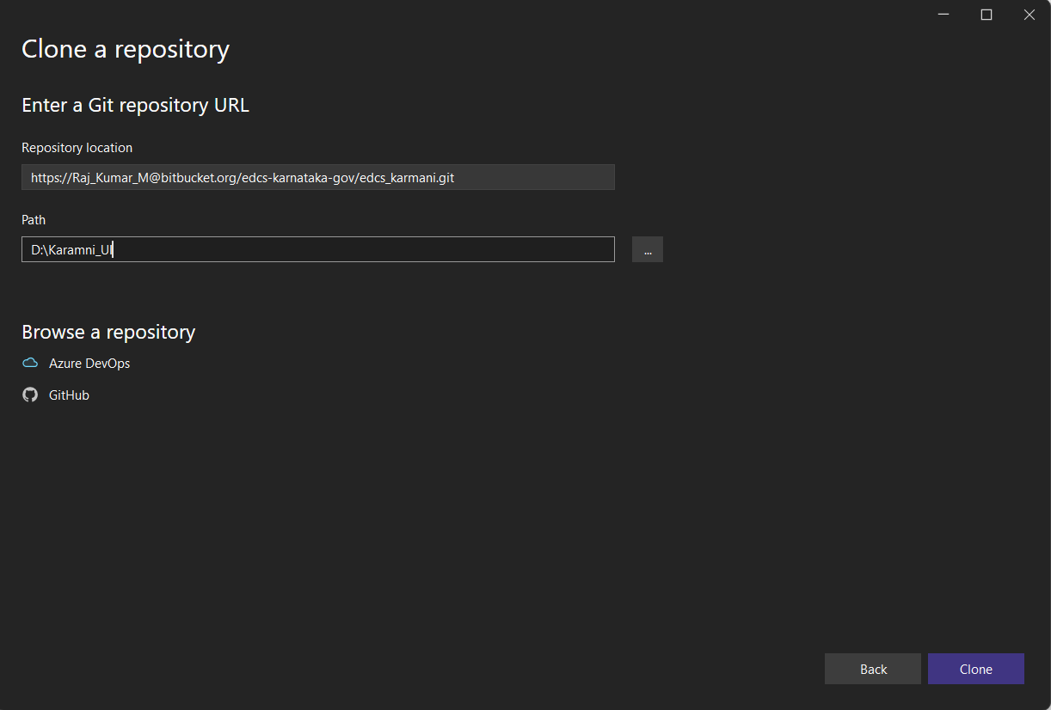

**Steps to run the Project**

**1.**Open the project in visual studio code**.**

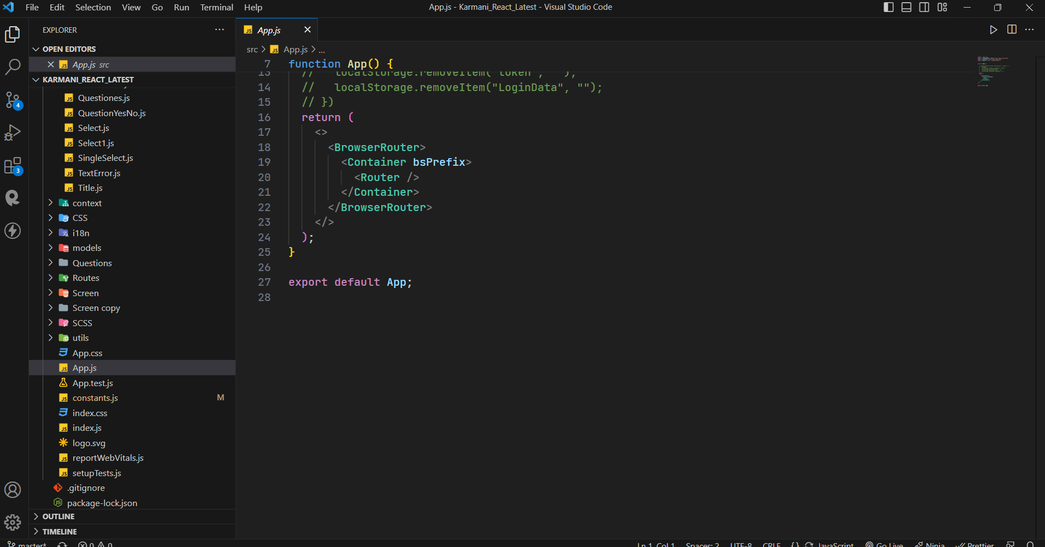

**2.**open **“Constants.js”** file and uncomment the local **“URL”**

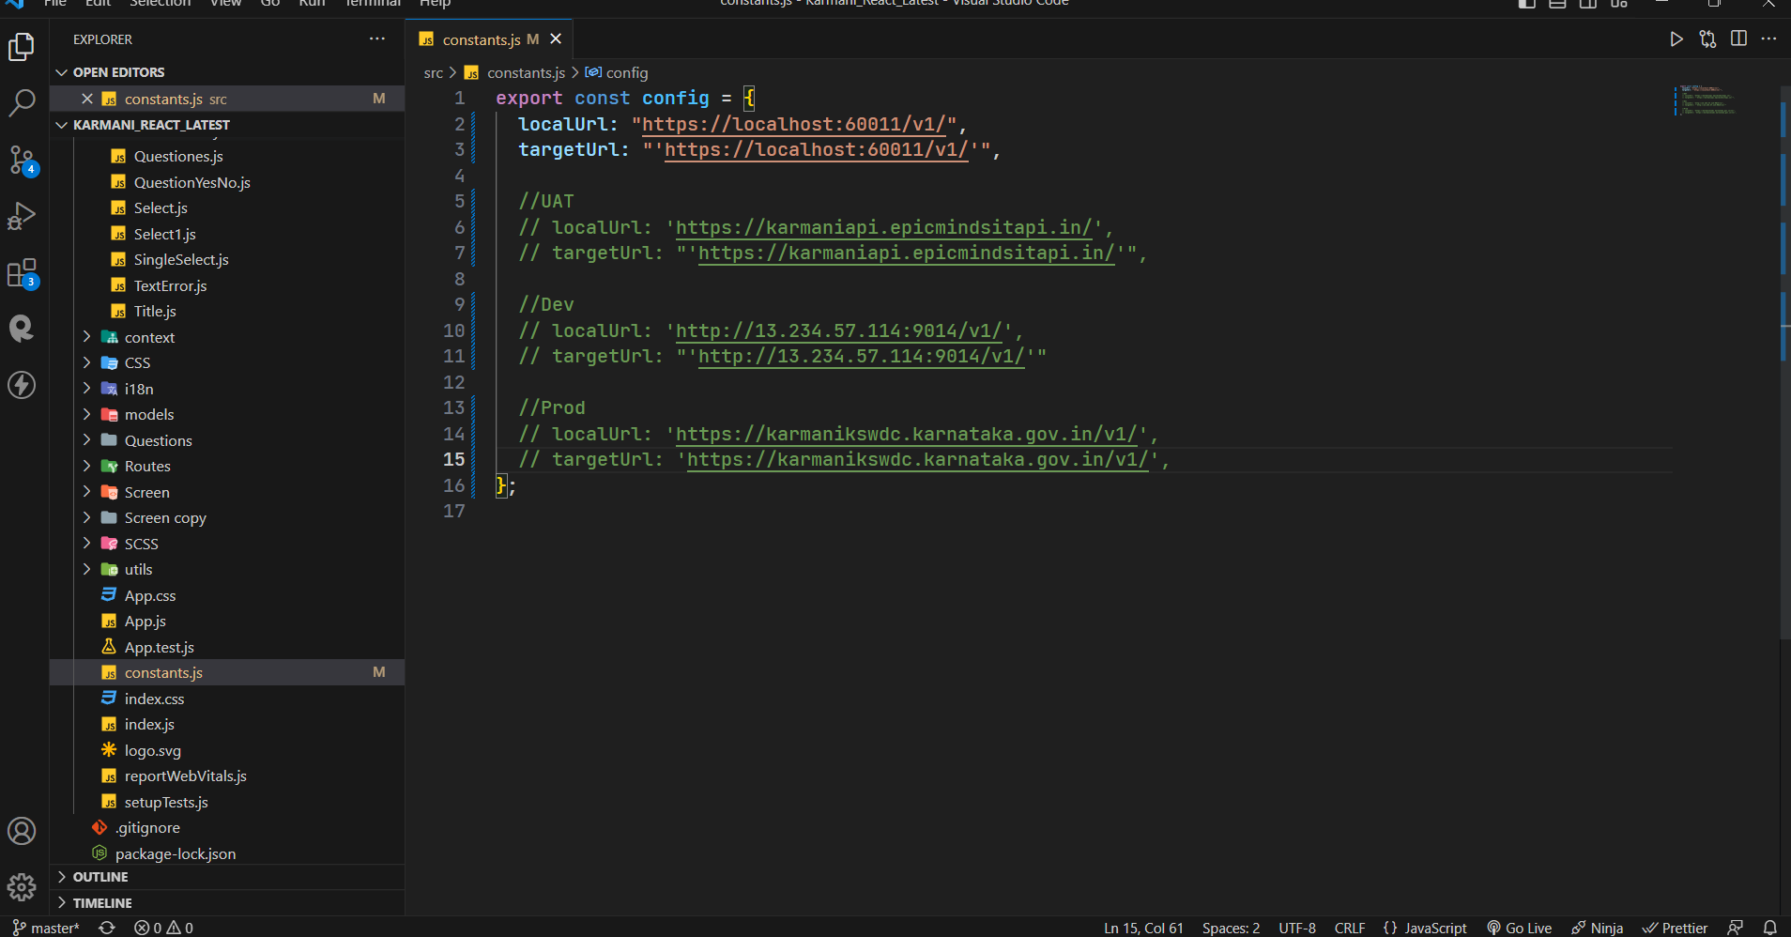

**3.**Open new terminal and run the command **“npm start”**

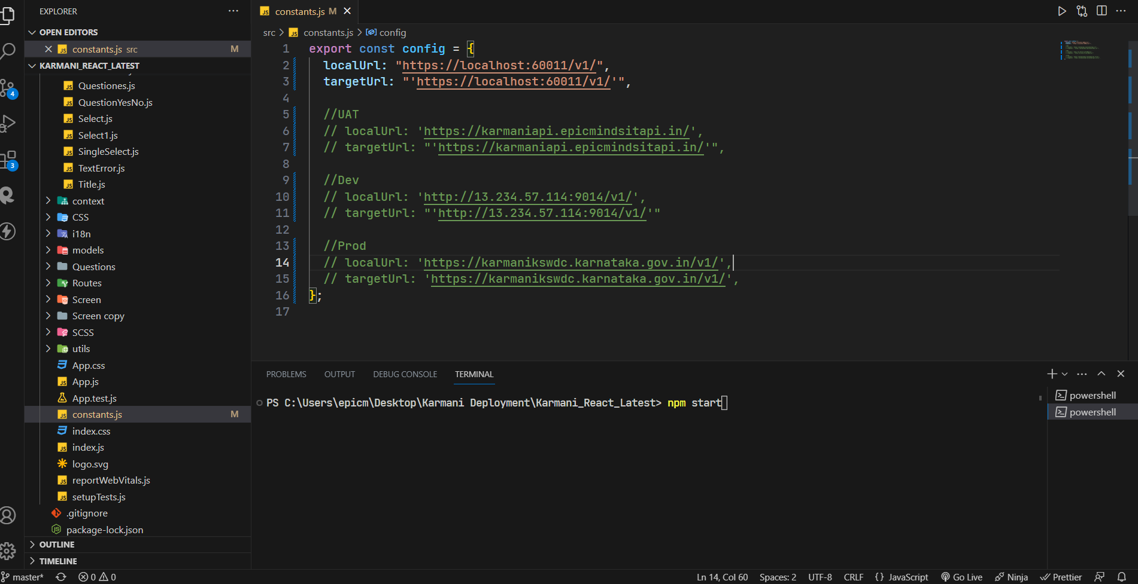

**4.**Once the server is started open browser and go the link[**http://localhost:3000**](http://localhost:3000)

