Design Document

Version: 1.0

My Day – Add Issue/return Changes, Add Contact and Edit Contact (Client - PJMMG)

**Author:** Raj Kumar M

Creation Date: 23/05/2023

Last Updated: 23/05/2023

**Document Control**

|  |  |  |  |
| --- | --- | --- | --- |
| **Change Records** | | | |
| Date | Owner | Version | Change Reference |
| 23-05-2023 | Raj Kumar M | 1.0 | DD on Entity Contact |
| 23-05-2023 | Raj Kumar M | 1.0 | DD on Issue/returns. |
|  |  |  |  |
|  |  |  |  |
|  |  |  |  |
|  |  |  |  |
|  |  |  |  |
|  |  |  |  |
|  |  |  |  |
|  |  |  |  |
|  |  |  |  |
|  |  |  |  |
|  |  |  |  |
|  |  |  |  |
|  |  |  |  |
|  |  |  |  |

|  |
| --- |
| **Reviewers:** |
| **Project Owner:** Anand K  **Manager Technical:**  **Lead Engineer:** Swetha M  **Lead QA:** Suraj  **Business Owner**: Shobith S |

**Table of Contents**

**Business Requirements…………………………………………………………………..**

**US#001: Add new Contact in Dashboard……………………………………………….**

* 1. Design Decision………………………………………………………………
  2. Implementation……………………………………………………………....
     1. Add ‘+’ icon against on click of entity details………………….
     2. On click of ‘+’ icon Add new Contact popup is opened……….
     3. On click of Save data should save with confirm message……..
  3. Validation…………………………………………………………………….

**US#002: Edit Contact in Dashboard……………………………………………………**

* 1. Design Decision………………………………………………………………
  2. Implementation……………………………………………………………....
     1. Add ‘edit’ icon against on click of entity details………………….
     2. On click of ‘edit’ icon Edit Contact popup is opened……….
     3. On click of Save data should save with confirm message……..
  3. Validation…………………………………………………………………….

**US#003: Make Agreement # field in Add Issue/Return UI as Input Field ……………**

* 1. Design Decision………………………………………………………………
  2. Implementation……………………………………………………………....
  3. Validation…………………………………………………………………….

# **Business Requirements**

1. Add new contact in Dashboard
2. Edit Contact in Dashboard
3. Make Agreement field in Add Issue/Return UI as Input Field

**US#001: Add new Contact in Dashboard**

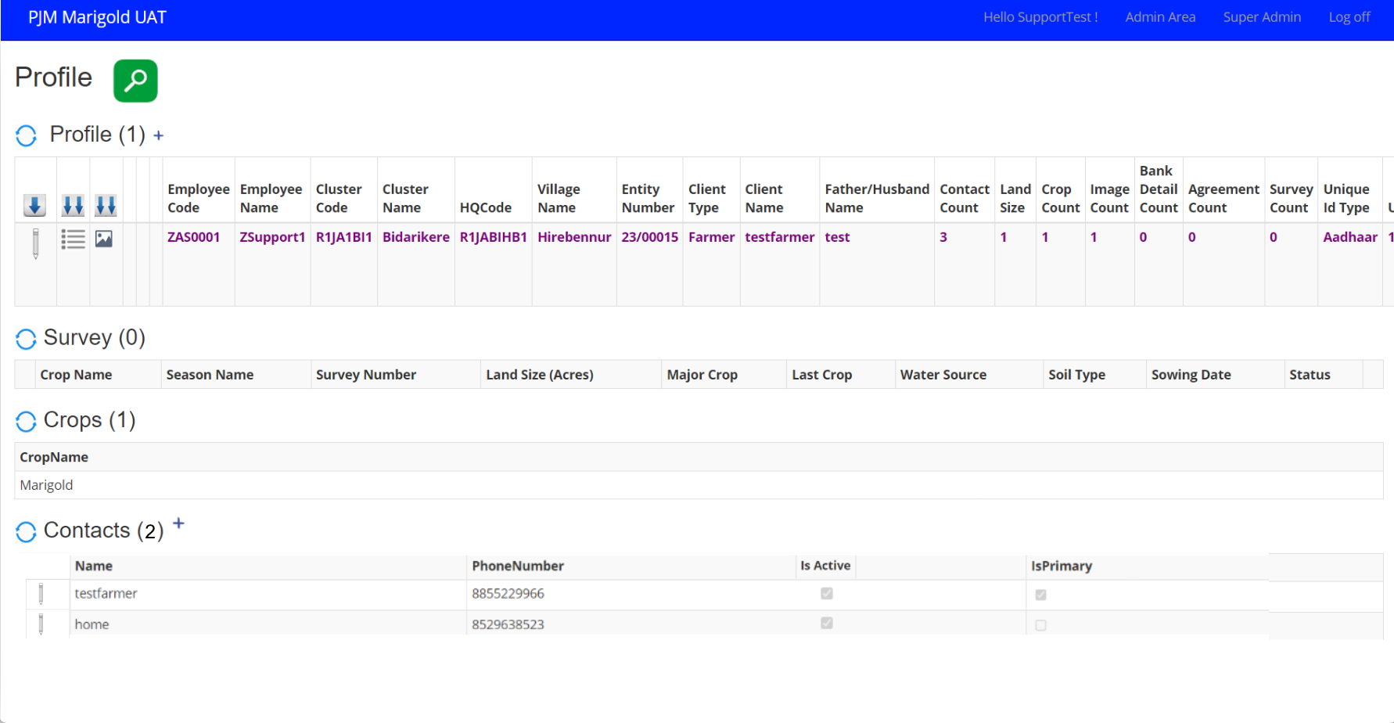

Fig: 1.0 Add new Contact button

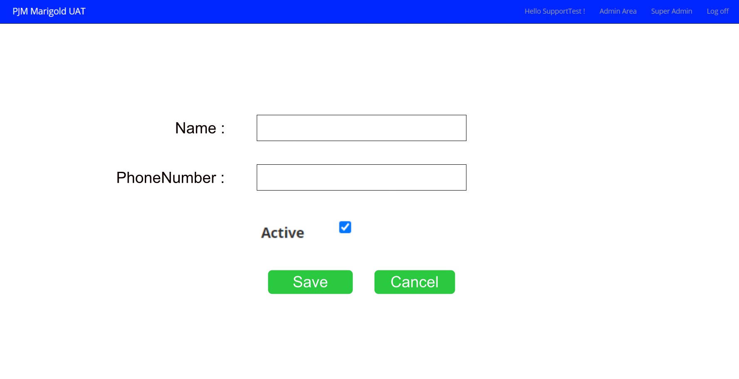 Fig: 1.1 Adding new contact popup

## 1.1 Design Decision

1. Add new contact in Admin Area

* Profile > Select the entity > Click on show details > Click on add new contact

1. New pop up is generated with following fields

* Name – Input Field
* Phone Number – Input Field

1. Both the fields are input and Mandatory

## Implementation

* + 1. Add ‘+’ icon against on click of entity details
    2. On click of ‘+’ icon Add new Contact popup is opened
    3. On click of Save data should save with confirm message
    4. DB-Objects Affected:
* Data will be stored to **<EntityContact>**
* isActive column must be added to **<EntityContact>** table

## Validation

1. Name field should accept only characters
2. Phone Number Field Should accept only numbers and not more than 10 digits
3. Both the fields are Mandatory.

**US#002: Edit Contact in Dashboard**

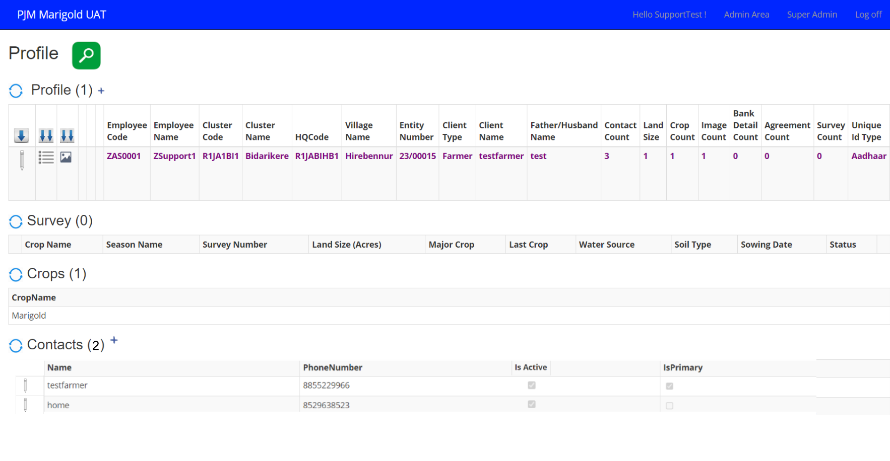

Fig: 1.2 Edit Contact button

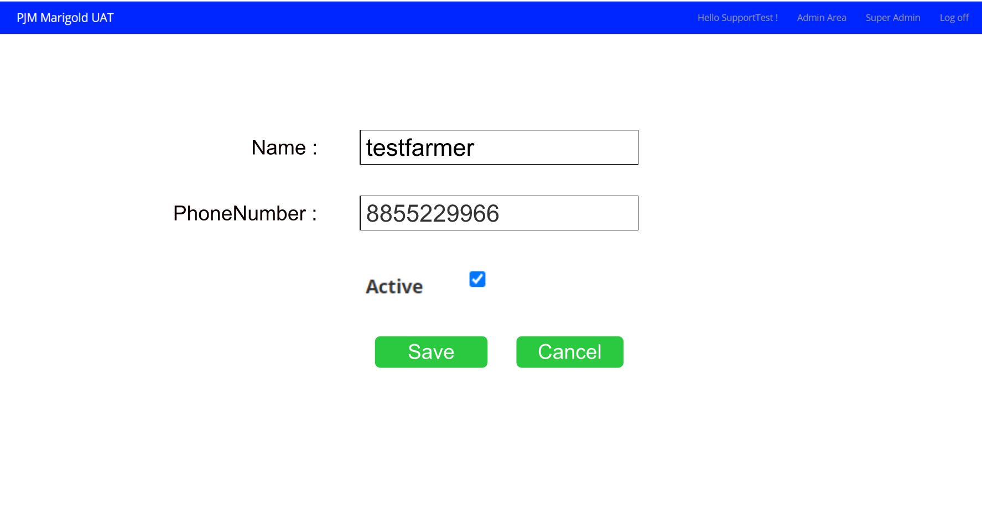

Fig: 1.3 Edit contact popup

## Design Decision

1. Edit contact in Admin Area

* Profile > Select the entity > Click on show details > Click on Edit contact

1. New pop up is generated with following fields

* Name – Input Field
* Phone Number – Input Field

1. Both the fields are input and Mandatory
2. Both the fields are pre-populated with data

## Implementation

* + 1. Add ‘edit’ icon against on click of entity details
    2. On click of ‘edit’ icon Edit Contact popup is opened

2.2.3 On click of Save data should save with confirm message

* + 1. DB-Objects Affected:
* Data will be fetched from **<EntityContact>**
* Data will be stored to **<EntityContact>**
* isActive column must be added to **<EntityContact>** table

## 2.3 Validation

1. Name field should accept only characters
2. Phone Number Field Should accept only numbers and not more than 10 digits
3. Both the fields are Mandatory.

**US#003: Make Agreement # field in Add Issue/Return UI as Input Field**

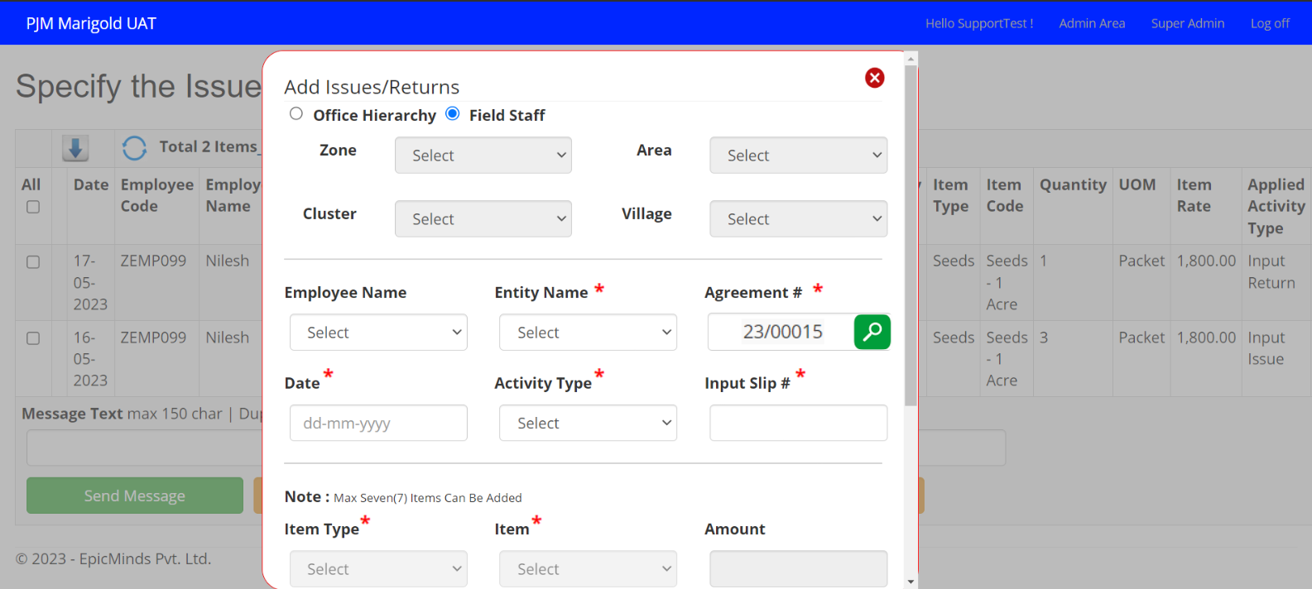

Fig: 1.4 Add Issue/Return Popup

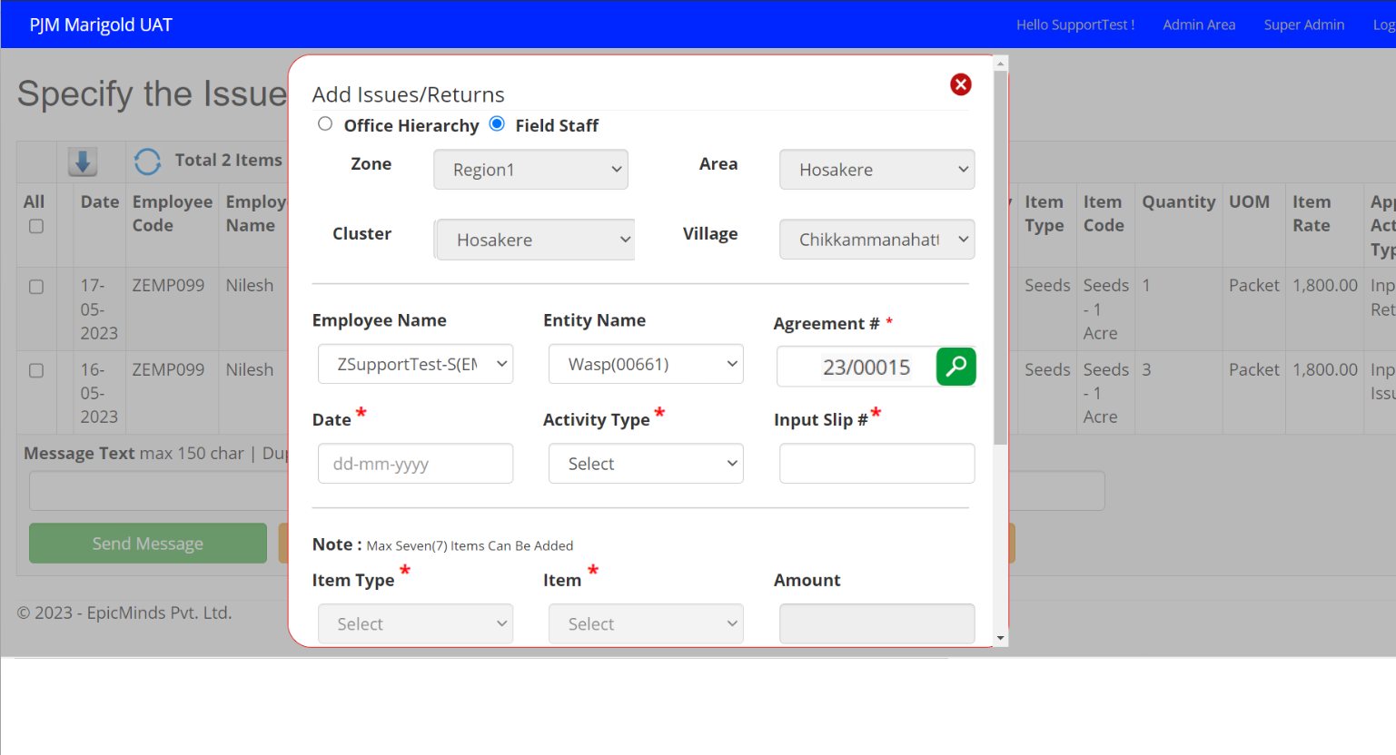

Fig: 1.5 Add Issue/Return Popup after clicked on search

## 3.1 Design Decision

1. Add Issue/Return in Dashboard:

* Dashboard > Issue/Return > Click on Search > Click on Add Issue/Return

2. Add Issue/Return Popup is Opened

* Make Agreement # field as Input field
* After entering Agreement number and clicked on Search icon Office Hierarchy, Employee Name, Entity Name fields are auto populated.

## Implementation

3.2.1 Make Agreement # field as Input Field

3.2.2 After entering Agreement number and clicked on Search icon Office Hierarchy, Employee Name, Entity Name fields are auto populated.

* + 1. Then, the existing flow is continued.

3.2.4 DB-Objects Affected:

* Data will be fetched from existing tables

1. **<Entity>**
2. **<Tenant Employee >**
3. **<Workflow Season>**
4. **<Code table>**
5. **<AgreementNumber>**

* Data will be stored to **<EntityAgreement>**