**PJMargo Expense Report Generation Process**

**Step – 1 :**

* Create Folder named “**Travel Log**”

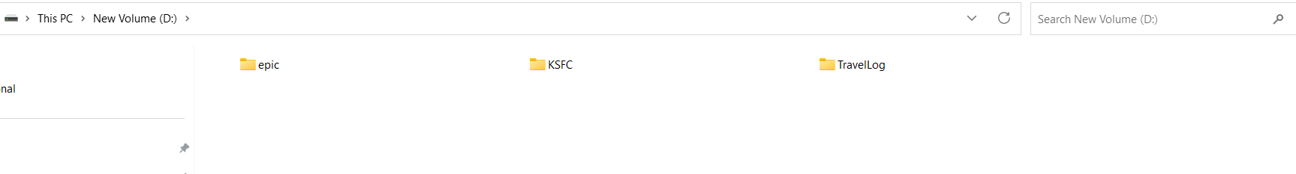

* Create Folder name INPUT and OUTPUT in the same folder

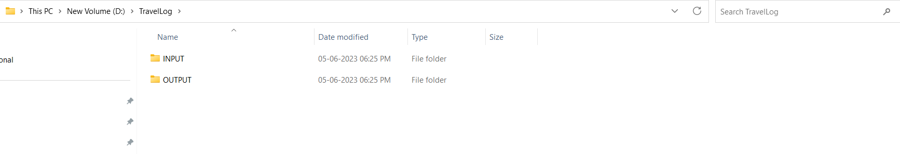

* Input File Folders

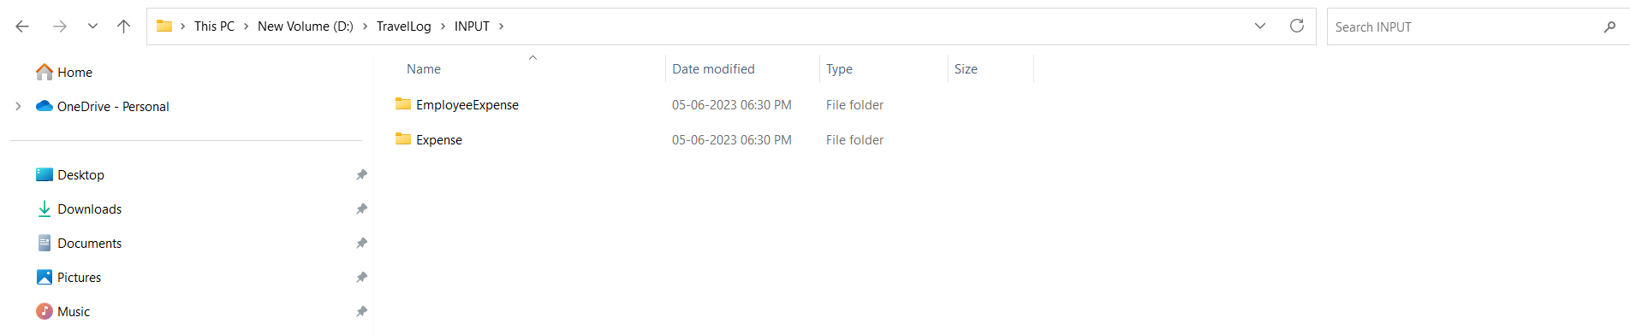

* Output File Folders

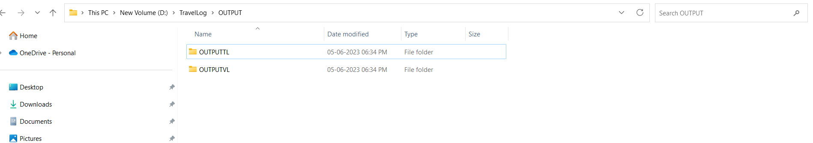

* Download **Expense** and **Employee Expense** Files and save to Designated folders of **Expense** and **Employee Expense**

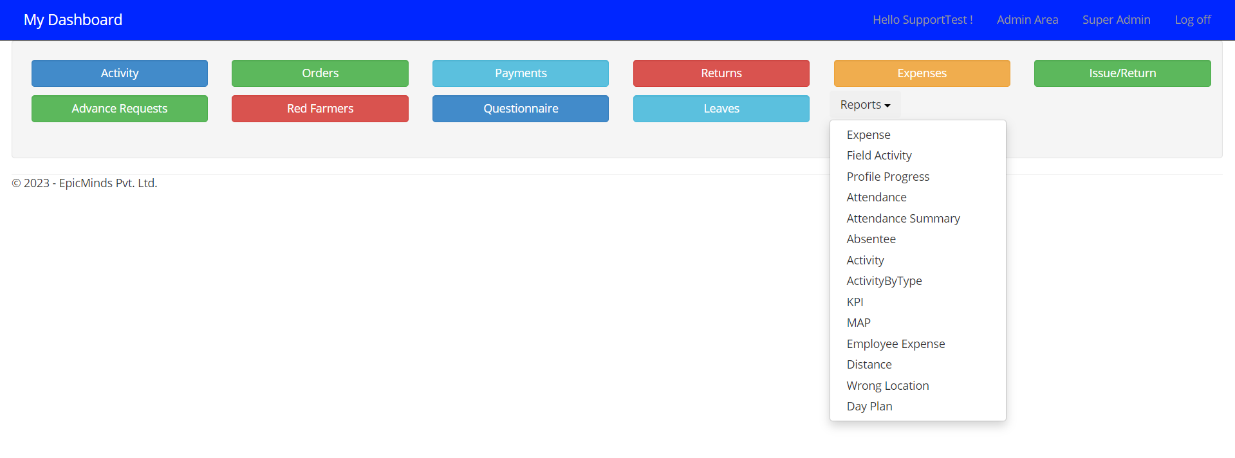

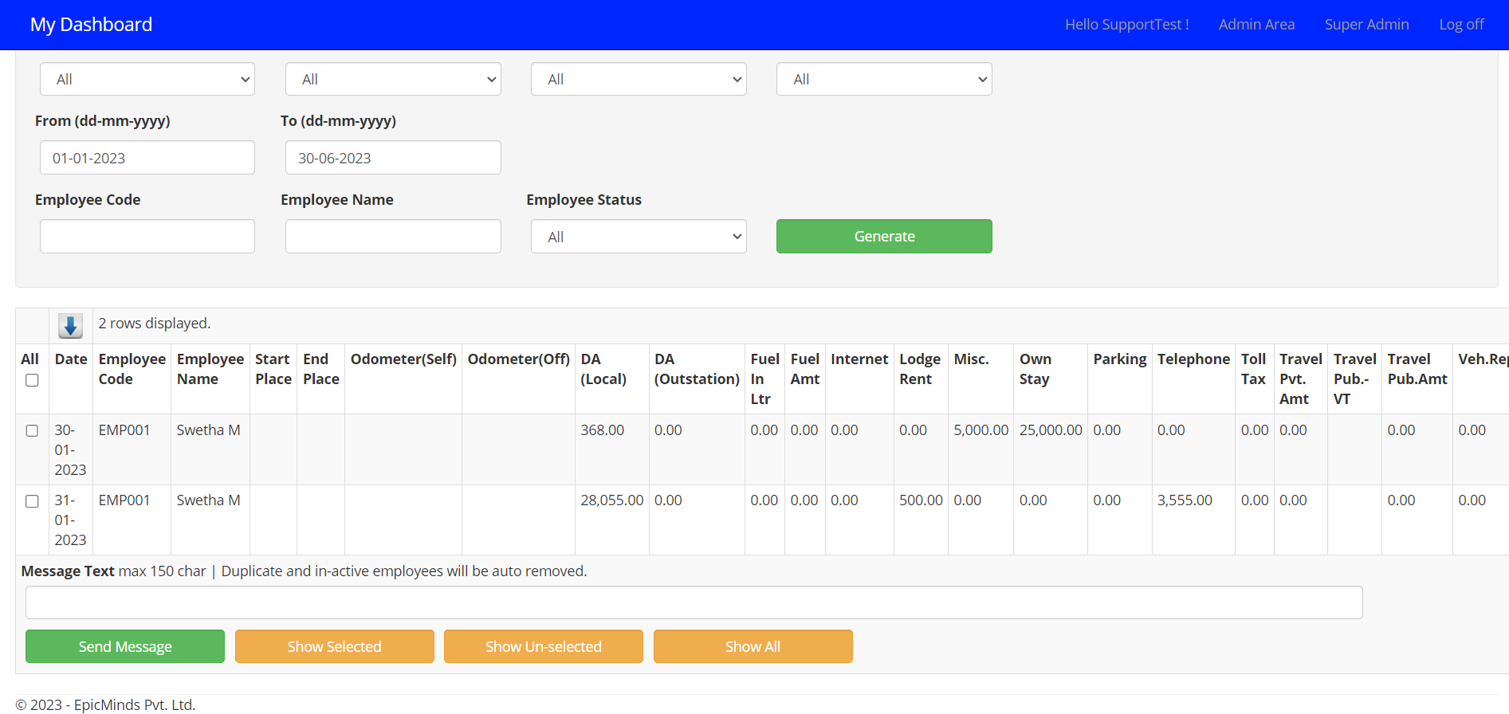

* Copy and paste the files in following folders



**Step – 2 :**

* Open “**Copy of MBC_TRAVEL.XLSB**” File

Click No to Refresh All the Table in Workbook

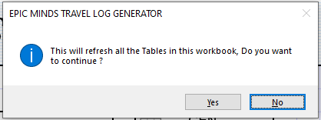

* Click on SetParameters

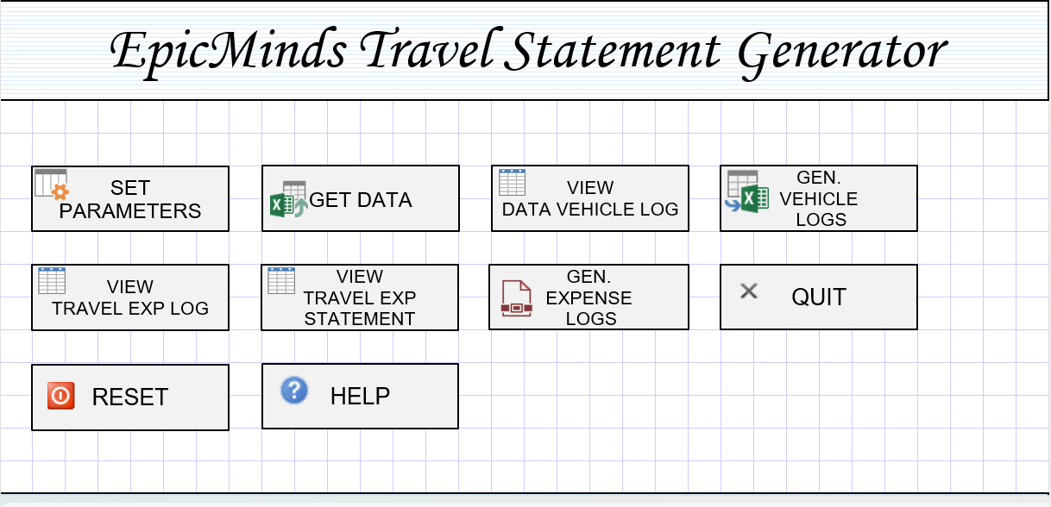

* Set Input, Output Files Parameters Paths and then Click Save

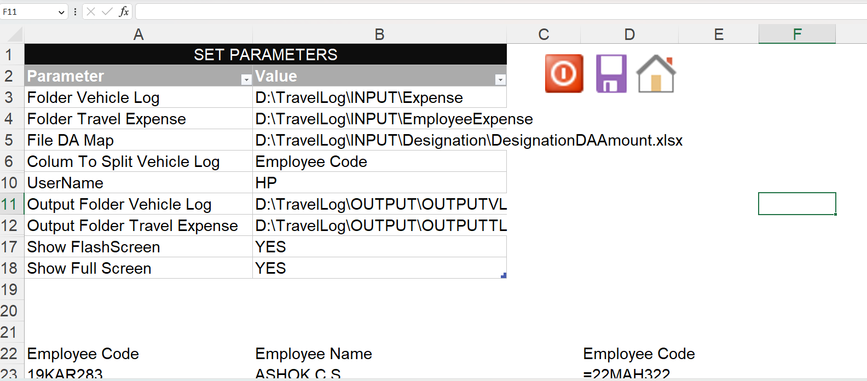

* Click Yes to Refresh all the Tables in the Workbook

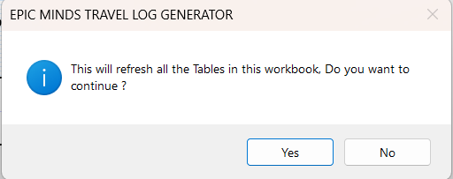

* Check the Imported Data

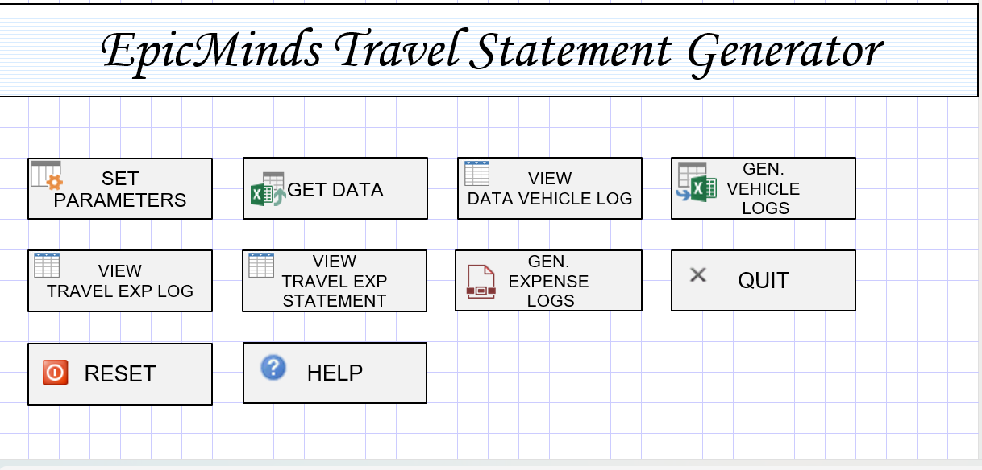

* Click on Gen Vehicle Logs for **OutputVL** Data



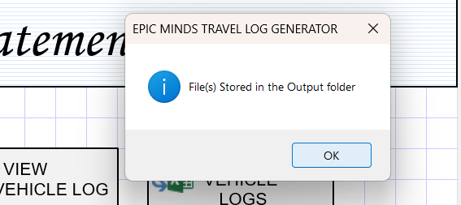

* Generated data Will Stored in OutputVL folder

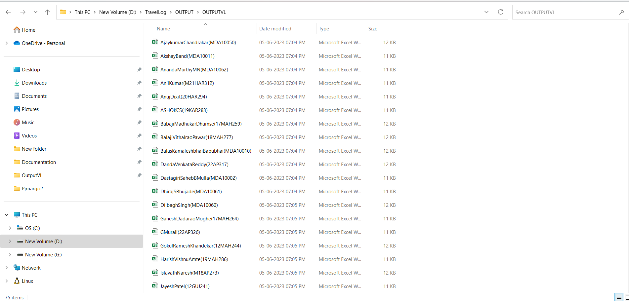

* Click on Gen Expense Logs for **OutputTADA** Data





* Generated Data Will stored in OutputTADA folder

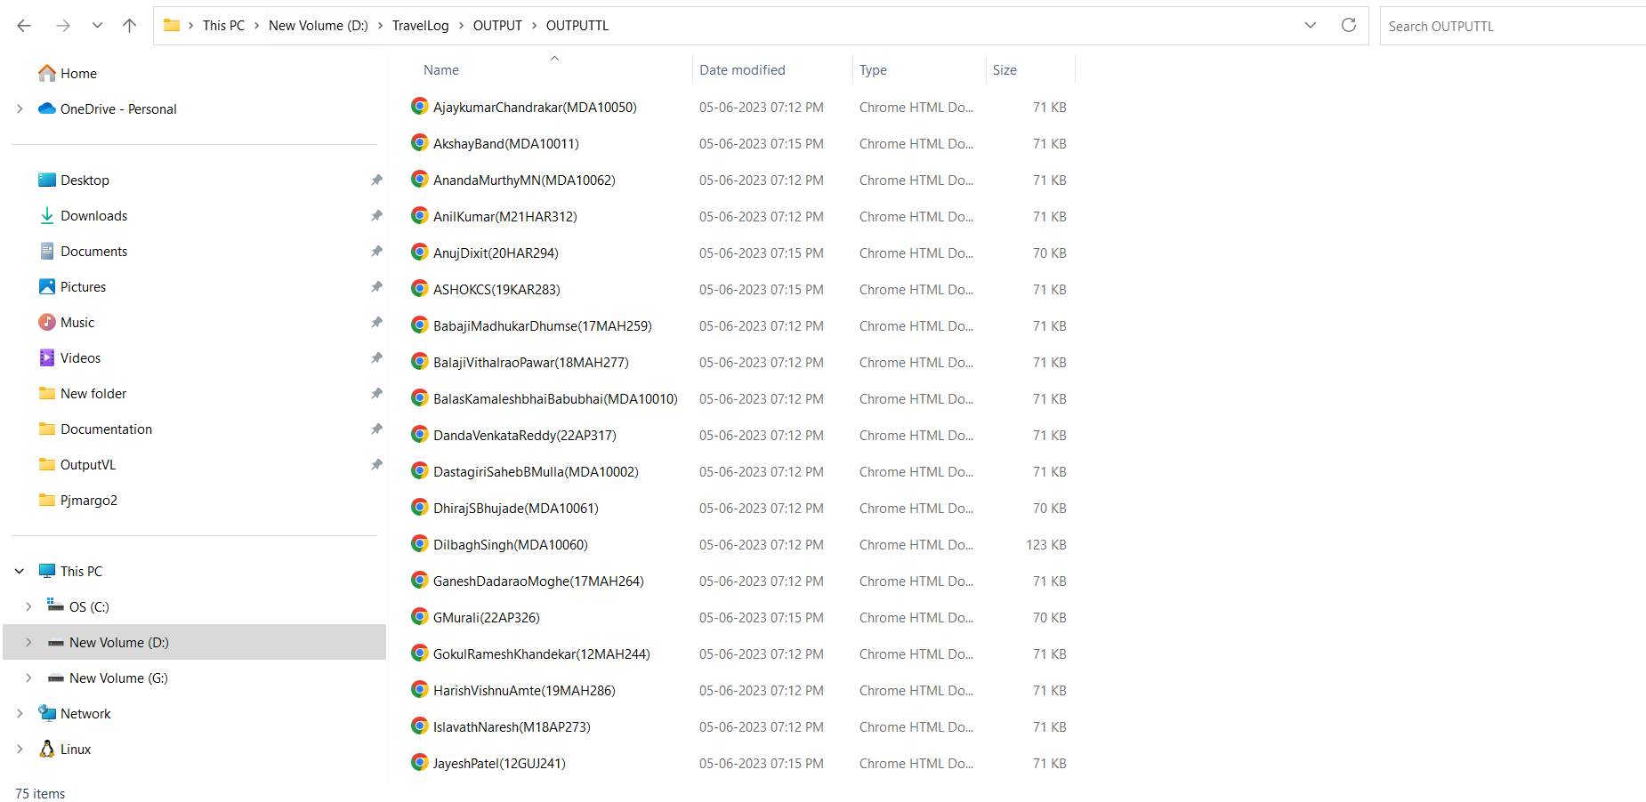

* Click on Quit for Exist from the file

