Design Document

Version: 0.1

KSFC – Primary / Collateral Security

(IDM Module)

**Author: Rajesh V**

Contributor(s): Pankaj Kumar

Creation Date: 28/06/2022

Last Updated: 28/06/2022

**Document Control**

|  |  |  |  |
| --- | --- | --- | --- |
| **Change Records** | | | |
| Date | Owner | Version | Change Reference |
| 28-06-2022 | Rajesh | 0.1 | Document Created |
|  |  |  |  |
|  |  |  |  |
|  |  |  |  |
|  |  |  |  |
|  |  |  |  |
|  |  |  |  |
|  |  |  |  |
|  |  |  |  |
|  |  |  |  |
|  |  |  |  |
|  |  |  |  |
|  |  |  |  |
|  |  |  |  |

|  |
| --- |
| **Reviewers:** |
| **Project Owner:** Anand K  **Manager Technical:** Pankaj K  **Lead Engineer:** Rajesh V  **Lead QA:** Gagana  **Business Owner**: Sudhanshu |

Table of Contents

US#1: Display a list of Account numbers to the user to perform Legal Documentation 3

**1.1** **Account Numbers Table - Screenshot:** 4

**1.2** **Column mapping for Account numbers table:** 4

US#2: Legal Documentation – Primary / Collateral Security Tab 4

**2.1 Legal Documentation – Primary / Collateral Security Tab - Screenshot:** 4

US#3: Add New Security Holder Details in Primary / Collateral Security Tab 5

**3.1 Add New Security Details Pop up Form - Screenshot:** 5

**3.2 Column mapping for Security Details:** 6

US#4: View Security Holder Details in Primary / Collateral Security Tab 6

**4.1 View Security Details Pop up Form - Screenshot:** 6

US#5: Edit Security Holder Details in Primary / Collateral Security Tab 7

**5.1 View Security Details Pop up Form - Screenshot:** 7

US#6: Delete Security Holder Details in Primary / Collateral Security Tab 7

# US#1: Display a list of Account numbers to the user to perform Legal Documentation

* Login to KSFC application with Admin URL
* User must be enabled as **Legal Officer** [Role]
* Click on **IDM legal** link.

## **Account Numbers Table - Screenshot:**

Figure: List of Account Numbers for Legal Documentation

## **Column mapping for Account numbers table:**

|  |  |  |
| --- | --- | --- |
| **Column Binding** | **Table Name** | **Column Name** |
| Loan ID | loan_temp | Column<LoanId> |
| Account Number | loan_temp | Column<LoanAccNo> |
| Sub Loan | loan_temp | Column<SubLoan> |
| Unit Name | loan_temp | Column<UnitName> |
| Action |  |  |

# US#2: Legal Documentation – Primary / Collateral Security Tab

* Click on **View** button against any Account Number displayed in the main table
* The page will be redirected to Legal Documentation – Primary / Collateral Security Tab

## **2.1 Legal Documentation – Primary / Collateral Security Tab - Screenshot:**

Fig: Legal Documentation – Primary / Collateral Security Tab.

# US#3: Add New Security Holder Details in Primary / Collateral Security Tab

* Click on **Add New Security Holder** button inside the List of Primary / Collateral Security Details Accordion
* Pop Up form will be displayed
* Enter all the Details
* Click on **Submit** button to submit the form details
* Store the New Security Holder Details in the session manager

## **3****.1 Add New Security Details Pop up Form - Screenshot:**

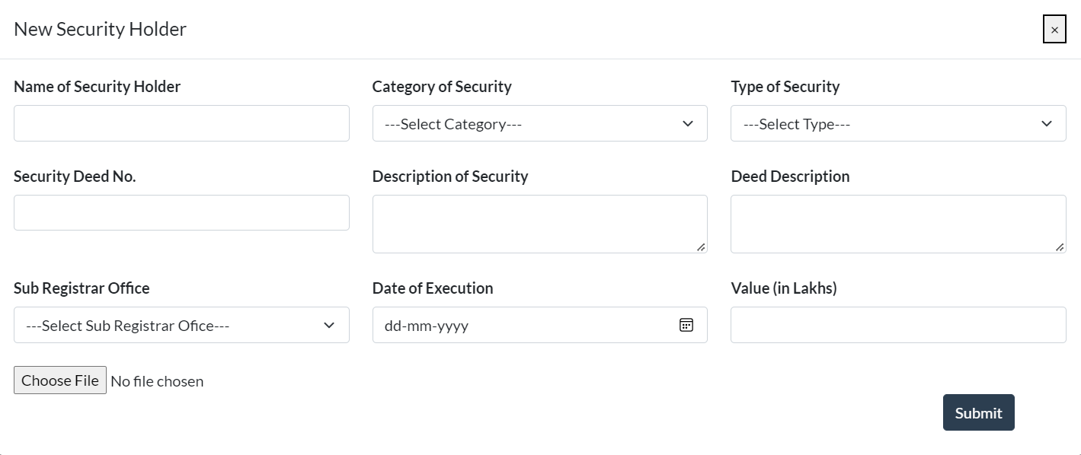

* In the above screen shot the dropdowns are mapped to the following tables in database:
  + Category of Security - <security_category_cdtab>
  + Type of Security - <security_type_cdtab>
  + Sub Registrar Office - <sub_registrar_cdtab>

## **3.2 Column mapping for Security Details:**

|  |  |  |
| --- | --- | --- |
| **Column Binding** | **Table Name** | **Column Name** |
| Name of Security Holder | ld_security_temp | Column<Securityholder> |
| Category of Security | ld_security_temp | Column<SecurityCategory> |
| Type of Security | ld_security_temp | Column<SecurityType> |
| Security Deed No. | ld_security_temp | Column<SecurityDeedNo> |
| Description of Security | ld_security_temp | Column<SecurityDescription> |
| Deed Description | ld_security_temp | Column<DeedDescription> |
| Sub Registrar Office | ld_security_temp | Column<SubRegistrarOffice> |
| Date of Execution | ld_security_temp | Column<DateOfExecution> |
| Value (in lakhs) | ld_security_temp | Column<ValueInLakhs> |

# US#4: View Security Holder Details in Primary / Collateral Security Tab

* Click on **View** button in the table which displays the list of Security holders for a particular account number.
* The view screen pop up is displayed.
* The screen would be read only

## **4.1 View Security Details Pop up Form - Screenshot:**

# US#5: Edit Security Holder Details in Primary / Collateral Security Tab

* Click on **Edit** button in the table which displays the list of Security holders for a particular account number.
* The Edit screen pop up is displayed.
* Click on **Submit** button to submit the form details
* Store the updated values in the session manager

## **5.1 View Security Details Pop up Form - Screenshot:**

# US#6: Delete Security Holder Details in Primary / Collateral Security Tab

* Click on **Delete** button in the table which displays the list of Security holders for a particular account number.
* A confirm dialog will be displayed
* Click Yes to **Delete** the records details from the session manager.

# US#7: Flow Diagram – Add New Security Details [Sample]

HTTP GET REQUEST

View Form in Browser

HTTP POST

HTTP POST