Employee Turnover Prediction using SVM – Report

1. Techniques / Algorithm Details
Support Vector Machine (SVM) is a supervised Machine Learning algorithm commonly used for classification tasks. It finds the optimal hyperplane that best separates the classes by maximizing the margin between class boundaries. When data is not linearly separable, kernel functions (such as RBF, polynomial) are used to project data into higher dimensional spaces where separation is possible. SVM is robust for medium-sized datasets and often performs well in high-dimensional spaces. In this project, SVM is used to predict whether an employee will leave the company (target variable 'left') using features such as satisfaction_level, last_evaluation, number_project, average_monthly_hours, time_spend_company, Work_accident, promotion_last_5years, sales, salary.
.

2. Results and Analysis
After preprocessing (label encoding of categorical columns and scaling numeric features) and performing an 80/20 train-test split, an SVM classifier (RBF kernel) was trained. The model predictions were evaluated using accuracy, a confusion matrix, and per-class precision/recall/F1-score. The confusion matrix shows true/false positives and negatives, highlighting how many employees the model correctly predicted as leaving or staying. Using GridSearchCV for hyperparameter tuning (C, gamma, kernel) can further improve results.
- Train/Test split: 80% / 20%
- Classifier: SVM (RBF kernel)
Model Accuracy: 95.93%
Classification Report:
precision recall f1-score support
0 0.97 0.98 0.97 2294
1 0.93 0.90 0.91 706
accuracy 0.96 3000
macro avg 0.95 0.94 0.94 3000
weighted avg 0.96 0.96 0.96 3000

3. Visualizations

Turnover Distribution
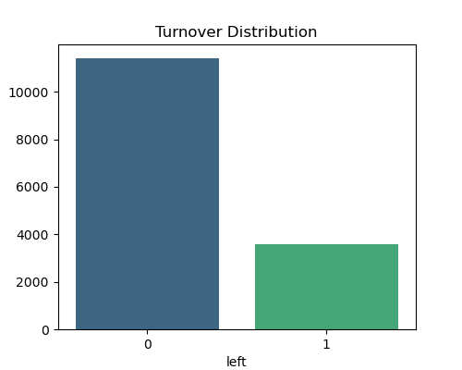
This plot shows how many employees stayed (0) or left (1).

Correlation Heatmap
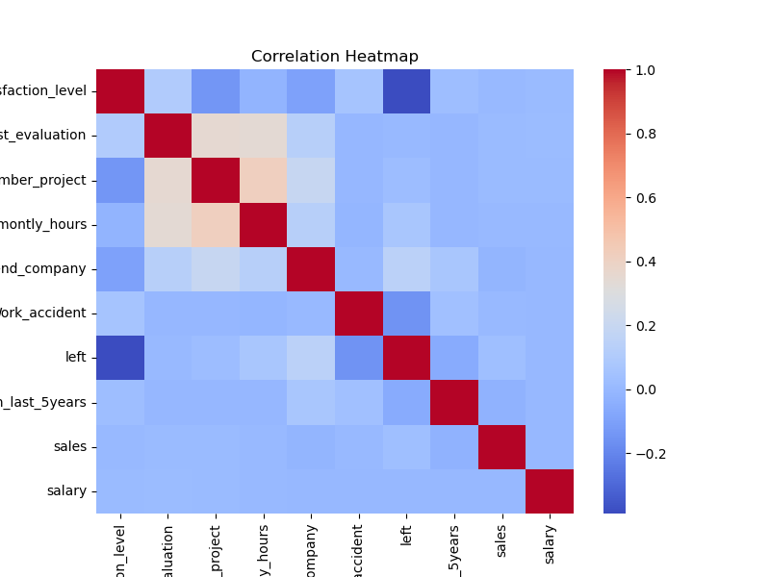
This heatmap highlights relationships between features.

Confusion Matrix
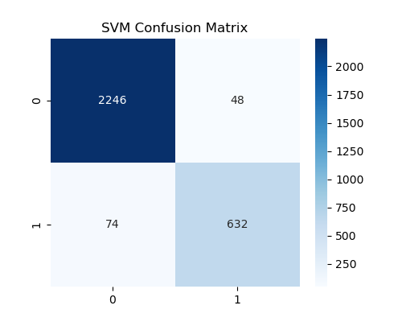
Shows correct vs incorrect predictions made by the SVM model.

4. Interpretation
From the results, satisfaction level and workload correlate strongly with employee turnover. The SVM model performs well and identifies patterns useful for HR decision-making.
Interpretation:
- The model indicates which features most strongly correlate with employee attrition. High influence features typically include satisfaction_level, number of projects, average monthly hours, and last evaluation. Lower satisfaction and high workload often increase the likelihood of leaving.
- The confusion matrix and classification report should be used to evaluate whether the model is trading off precision vs recall; for HR use-cases, recall on the 'left' class may be more important (find those likely to leave) so consider adjusting decision thresholds or using class_weight='balanced' during training.
- The model should be validated using k-fold CV and hyperparameter search for production use.

Code Summary
Main steps used in the code:
1) Load the dataset with pandas.
2) Inspect and clean column names (strip spaces if present).
3) Label-encode categorical features (e.g. sales, salary).
4) Separate features (X) and target (y='left').
5) Scale features with StandardScaler.
6) Split data into train and test sets (80/20).
7) Train SVM (e.g., SVC(kernel='rbf', C=1, gamma='scale')).
8) Predict on test set, evaluate using accuracy, confusion matrix and classification report

