1. Introduction to Computer Architecture
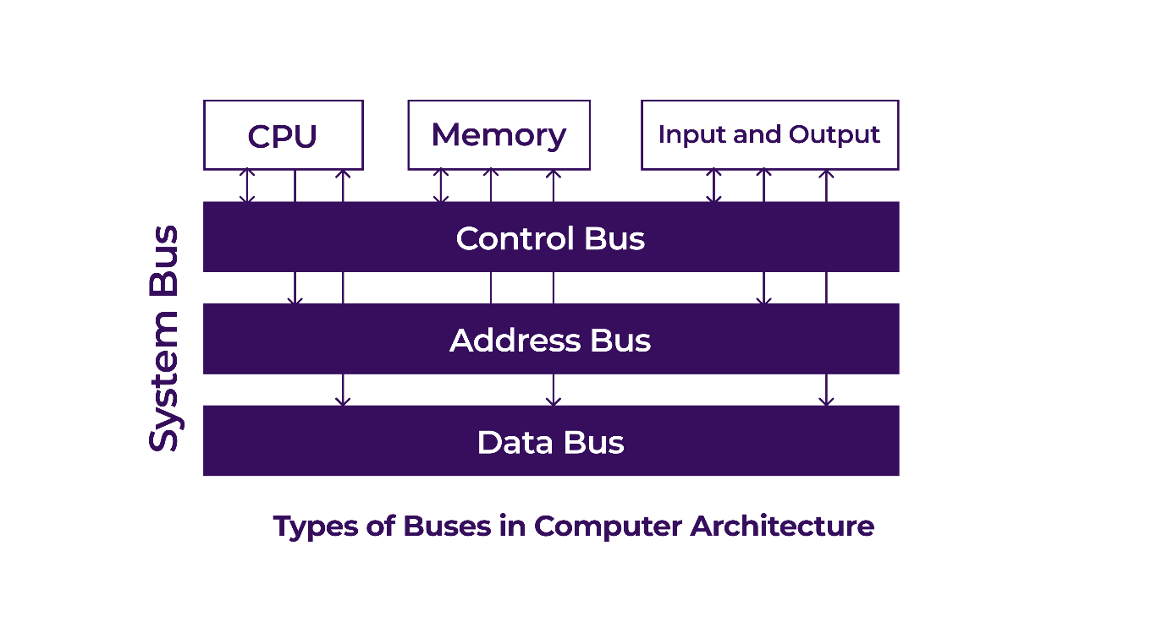
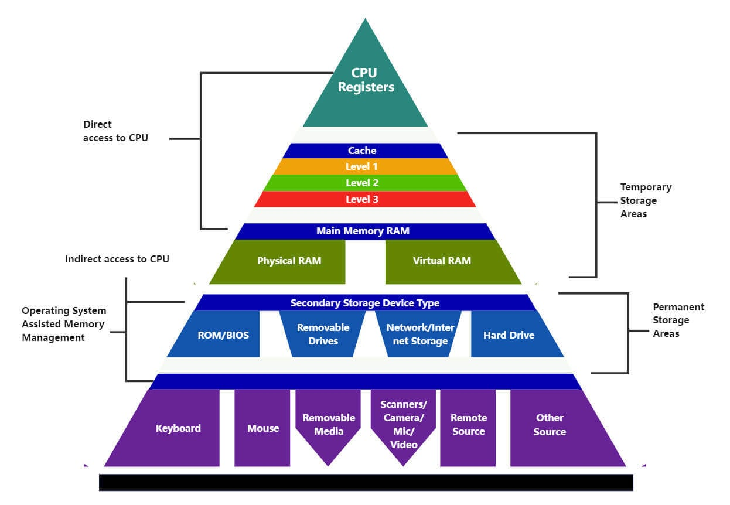
Computer Architecture is the design and organization of computer components and how they interact.
It determines system performance, efficiency, and capability.

Major elements include:
- CPU (Central Processing Unit)
- Cores
- RAM (Main Memory)
- Cache Memory
- Storage (HDD/SSD)
- System Buses
A strong architecture ensures:
- Fast processing
- Efficient memory usage
- Smooth multitasking
- Low latency

2. CPU (Central Processing Unit)
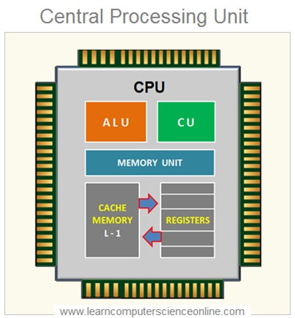
The CPU is the brain of the computer, responsible for executing all instructions.
Main parts:
✔ ALU (Arithmetic Logic Unit)
Performs calculations and logical operations.
✔ CU (Control Unit)
Controls all operations and instruction execution.
✔ Registers
High-speed temporary storage inside CPU.
CPU performance depends on:
- Clock speed (GHz)
- Cache memory
- Number of cores
- Instruction set architecture (ISA)
- Fabrication technology (nanometers)

3. CPU Cores
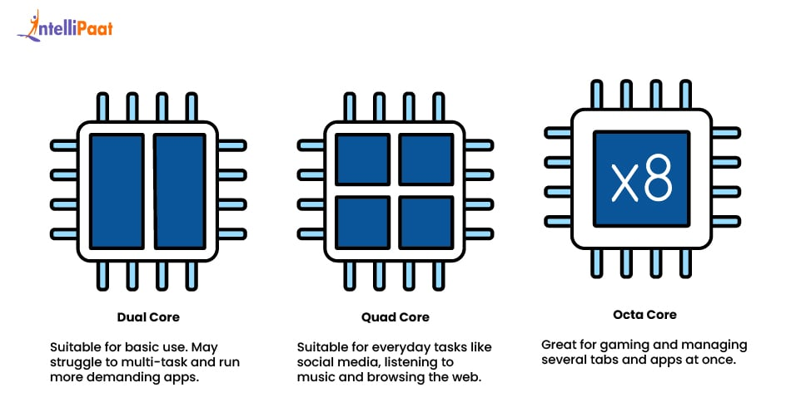
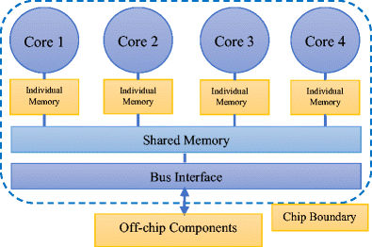
A core is an independent execution unit inside the CPU.
Modern CPUs have:
- Dual-core
- Quad-core
- Hexa-core
- Octa-core
- 16/32/64+ core (server CPUs)

Advantages of multiple cores
- Parallel processing
- Better multitasking
- Smoother performance
- Less CPU bottleneck
- Faster gaming, rendering, coding
Each core can execute its own instructions, making the CPU much faster.

4. RAM (Random Access Memory)
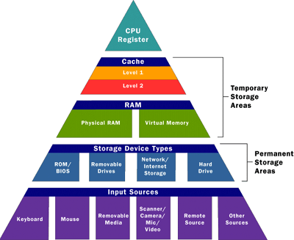
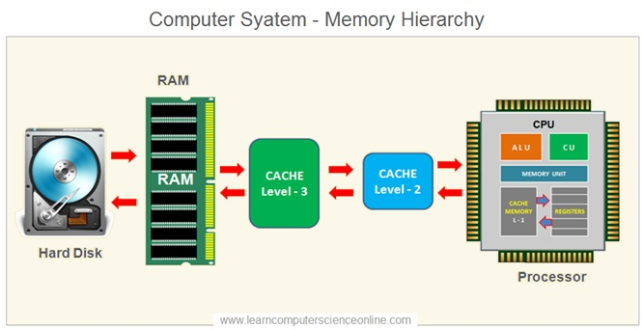
RAM stores data and instructions currently being used by the CPU.
It is volatile, meaning it erases when power is off.
Characteristics:
- Very fast
- Temporary data storage
- Directly accessed by the CPU
- More RAM = better multitasking
Types:
🟦 DRAM (Dynamic RAM)
Used as system RAM (DDR3, DDR4, DDR5)
🟥 SRAM (Static RAM)
Much faster, used in cache memory

5. Cache Memory
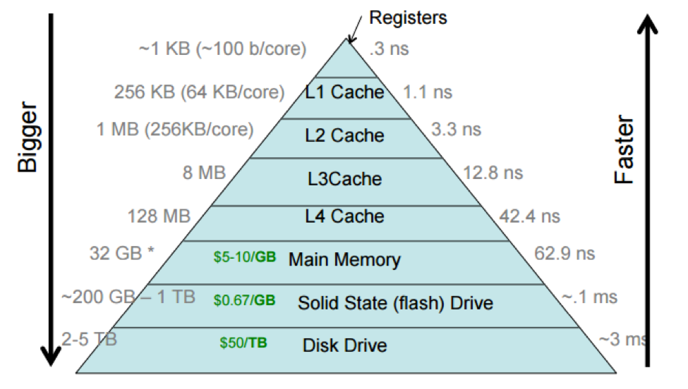

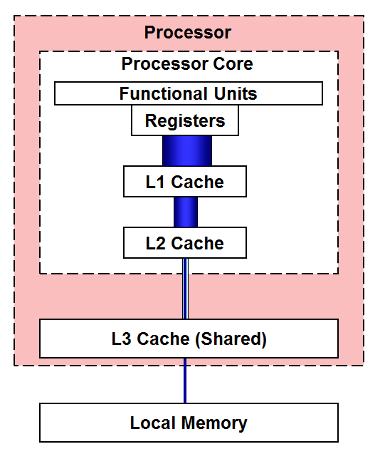
Cache is high-speed memory located very close to the CPU, storing frequently used instructions.
Why cache exists?
Without cache → CPU waits for slow RAM → slowing down performance
With cache → CPU gets data instantly → huge speed improvement
Cache Levels:
- L1 Cache → Fastest, inside each core
- L2 Cache → Larger, slightly slower
- L3 Cache → Shared among all cores

6. Conclusion
Computer Architecture defines how all hardware components function together.
- CPU executes instructions
- Cores allow multiple tasks simultaneously
- RAM stores active data
- Cache speeds up CPU operations
Together, they form the foundation of modern computing.

