Case Study: Smart Traffic Light Control System (STLCS)

Introduction
Urban traffic congestion is one of the biggest challenges faced in developing and developed cities. Increasing population, growing number of vehicles, and limitations of manual traffic control systems result in longer travel times, delays for emergency vehicles, and increased pollution. To overcome these issues, the Smart Traffic Light Control System (STLCS) was conceptualized. This system uses IoT sensors, edge controllers, cloud platforms, and intelligent algorithms to dynamically manage traffic signals based on real-time data. The project followed a complete Software Development Life Cycle (SDLC) to ensure structure, quality, and reliability in its development.

1. Requirement Gathering & Analysis
This phase involved extensive interactions with multiple stakeholders including traffic police, road engineers, municipal officials, emergency response teams, and field operators. Key functional requirements included dynamic signal timing, emergency vehicle prioritization, real-time monitoring, historical data analytics, and fully automated operation. Non-functional requirements such as scalability, low-latency response, reliability, and secure cloud communication were also documented. A feasibility analysis was conducted to understand operational challenges such as weather impact, sensor placement limitations, and power fluctuations.

2. System Design
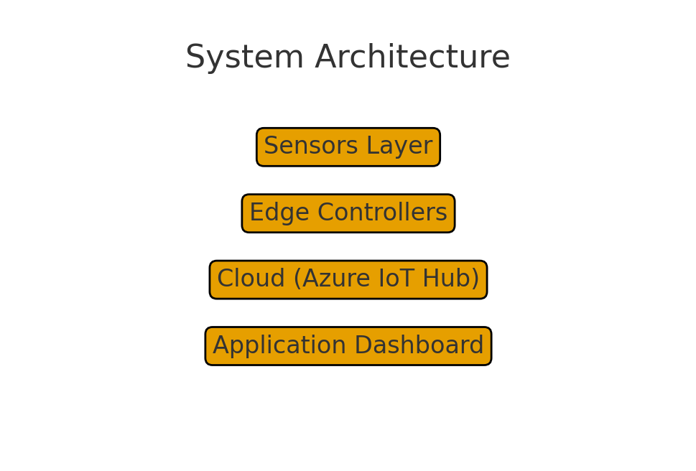
The system architecture was divided into four major layers: Sensors Layer, Edge Controllers, Cloud Services, and Application Layer. Detailed UML diagrams, data flow diagrams, and database schemas were created. The edge controllers (e.g., Raspberry Pi or microcontrollers) were programmed to preprocess traffic data before sending it to Azure IoT Hub. The cloud processed the incoming data, applied decision-making algorithms, and updated the traffic dashboard built using .NET technology.

3. Implementation
The implementation phase included development of IoT firmware for sensors, .NET Core-based APIs for real-time traffic data retrieval, Azure serverless functions for decision-making logic, and a web dashboard for traffic officers. Algorithms such as weighted vehicle density calculation, lane priority switching, and emergency vehicle detection were implemented. The backend was deployed using Azure App Service and connected digitally with the edge controllers.

4. Testing
Multiple testing methods were executed to ensure flawless operation. Device-level testing validated sensor accuracy while integration testing ensured proper communication between IoT devices and cloud services. Performance testing simulated peak-traffic scenarios to check system responsiveness. Security testing ensured encryption of all traffic data. Field testing at selected intersections helped validate the real-world performance of the STLCS.

5. Deployment
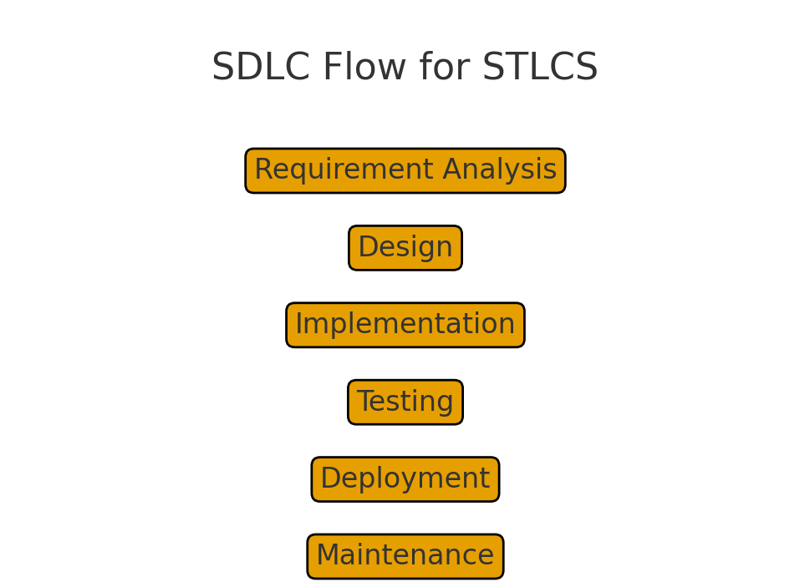
Deployment followed Azure DevOps CI/CD pipelines. A pilot deployment was executed at two intersections before full rollout. Blue-Green deployment was used to avoid downtime during updates. Over-the-air firmware updates allowed continuous sensor improvements without physical intervention. The dashboard was deployed on Azure and connected with live sensor feeds.

6. Maintenance
Post-deployment, the system required continuous monitoring, periodic sensor calibration, security patching, and performance tuning. New features such as night-mode traffic optimization and festival-day patterns were added during maintenance. Azure monitoring tools ensured quick detection of anomalies.

Conclusion
The Smart Traffic Light Control System demonstrates how effective utilization of SDLC improves the quality, reliability, and scalability of complex engineering solutions. The system significantly reduced congestion, improved emergency vehicle response time, and enhanced the overall efficiency of city traffic operations. Following SDLC ensured structured development, risk reduction, and long-term sustainability.

