VIRTUAL RETAIL
DATABASE DESIGN
Data Modeling • ERD • Relational Schema • Architecture Plan

Week 1 Task | SQL Developer Internship
Database platform: PostgreSQL | Design type: OLTP relational system

Prepared by: ______________________________
Submission date: __________________________

Document Control
Item | Details
Document purpose | Define a practical, normalized relational data model for a virtual retail business.
Intended audience | SQL Developer Intern, database reviewers, application developers, retail operations stakeholders.
Scope | Product catalog, customers, addresses, suppliers, warehouses, inventory, orders, payments, shipments, and reporting.
Proposed DBMS | PostgreSQL. SQL examples use PostgreSQL-compatible syntax.
Assumptions | Single retail organization, multiple warehouses, online orders, one currency per order, payment attempts tracked separately.
Status | Design proposal; requires business-owner validation before production implementation.

Contents
- 1. Executive Summary
- 2. Business Requirements and Assumptions
- 3. Architecture Overview
- 4. Entity-Relationship Diagram
- 5. Relational Schema and Data Dictionary
- 6. Normalization and Design Rationale
- 7. Constraints and Data Integrity
- 8. Indexing and Query Performance
- 9. Operational Workflows
- 10. SQL Implementation Examples
- 11. Security, Backup, and Scalability
- 12. Validation and Test Plan
- 13. Risks and Future Enhancements
- 14. Conclusion

1. Executive Summary
This document proposes a relational database for a virtual retail environment that sells products online, manages stock across warehouses, records customer orders, processes payment attempts, and tracks fulfilment. The design uses PostgreSQL and a normalized transactional schema. It separates master data (products, customers, suppliers) from transaction data (orders, order items, payments, shipments) and inventory balances.
The model emphasizes referential integrity, traceable transactions, historical accuracy, and predictable query performance. A product's current catalog price is stored in Products, while the unit price actually charged is copied to Order_Items at checkout. This prevents future price changes from rewriting historical sales. Inventory is keyed by product and warehouse so the same product can be stocked in multiple locations.

Design goals
- Represent retail entities and their relationships without unnecessary duplication.
- Preserve accurate order, payment, and fulfilment history.
- Prevent invalid references and invalid quantity or monetary values.
- Support operational SQL queries and common business reports.
- Allow capacity growth through indexing, connection pooling, partitioning when justified, and read replicas where appropriate.

2. Business Requirements and Assumptions

2.1 Functional requirements
Area | Requirement | Data support
Catalog | Create, update, classify, and deactivate products. | Products, Categories
Supplier management | Record supplier contact details and which suppliers provide each product. | Suppliers, Product_Suppliers
Inventory | Track on-hand stock per product and warehouse; identify low stock. | Warehouses, Inventory
Customer management | Maintain customer identity and multiple addresses. | Customers, Addresses
Sales | Create orders with one or more line items and preserve the sale price. | Orders, Order_Items
Payments | Record payment attempts, amounts, methods, and statuses. | Payments
Fulfilment | Track shipments and carrier/tracking information. | Shipments
Reporting | Report revenue, best-selling products, stock levels, and order status. | Transactional tables and indexed queries

2.2 Non-functional requirements
- Consistency: related updates must be committed or rolled back together where they form one business operation.
- Integrity: primary keys, foreign keys, uniqueness, NOT NULL, and CHECK constraints enforce core rules.
- Security: least-privilege database roles, parameterized SQL, encrypted connections, and no storage of raw payment-card data.
- Availability and recoverability: scheduled backups, tested restoration, monitoring, and documented recovery objectives.
- Performance: index frequent lookup and join columns based on observed query plans, not by indexing every column.

2.3 Assumptions and boundaries
- A customer may place many orders; a guest-checkout model could be added later using nullable customer references and guest contact fields.
- Each order uses one currency. Multi-currency sales would require currency codes and explicit conversion/rate policies.
- Taxes, discounts, returns, refunds, promotions, and loyalty points are not in the core schema but are listed as extensions.
- Payment processing is handled by a compliant payment service provider. The database stores provider references and status, not raw card numbers or CVV.
- Inventory quantity is represented as an integer for countable retail items. Fractional quantities require a numeric quantity type and revised validation.

3. Architecture Overview
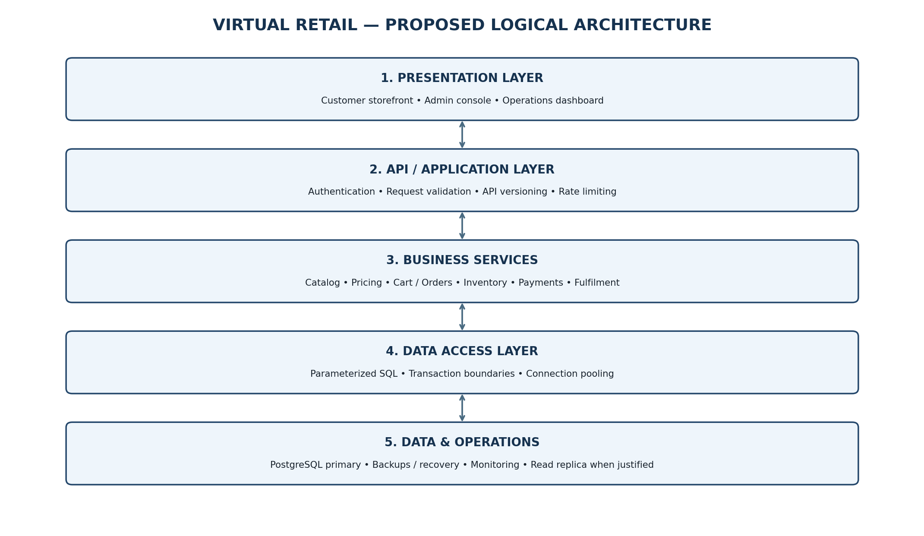
Figure 1. Proposed logical architecture. Arrows represent request/response and data-access flow.

3.1 Layer responsibilities
Layer | Responsibilities | Design notes
Presentation | Storefront, admin console, operations dashboard. | No direct database credentials in browser or client code.
API / application | Authentication, request validation, authorization, rate limiting, API versioning. | Validate inputs before calling business services.
Business services | Catalog, checkout, inventory, payment coordination, fulfilment. | Business rules should be explicit and testable.
Data access | Parameterized SQL, transaction boundaries, connection pooling. | Avoid string-concatenated SQL; keep transactions short.
Database / operations | PostgreSQL storage, constraints, indexes, backups, monitoring. | Start with a primary database; add replicas or partitioning when metrics justify them.

3.2 Typical checkout data flow
- The API authenticates the customer and validates the cart.
- The order service opens a database transaction and checks product status and stock availability.
- Stock is reserved or decremented using a concurrency-safe update; competing checkouts must not oversell stock.
- The order and order-item rows are written with the agreed price, quantity, and totals.
- The payment provider is called through a controlled payment workflow. External network calls should not hold a database transaction open.
- Payment status is recorded from the provider response or verified webhook. Shipment records are created when fulfilment begins.

4. Entity-Relationship Diagram
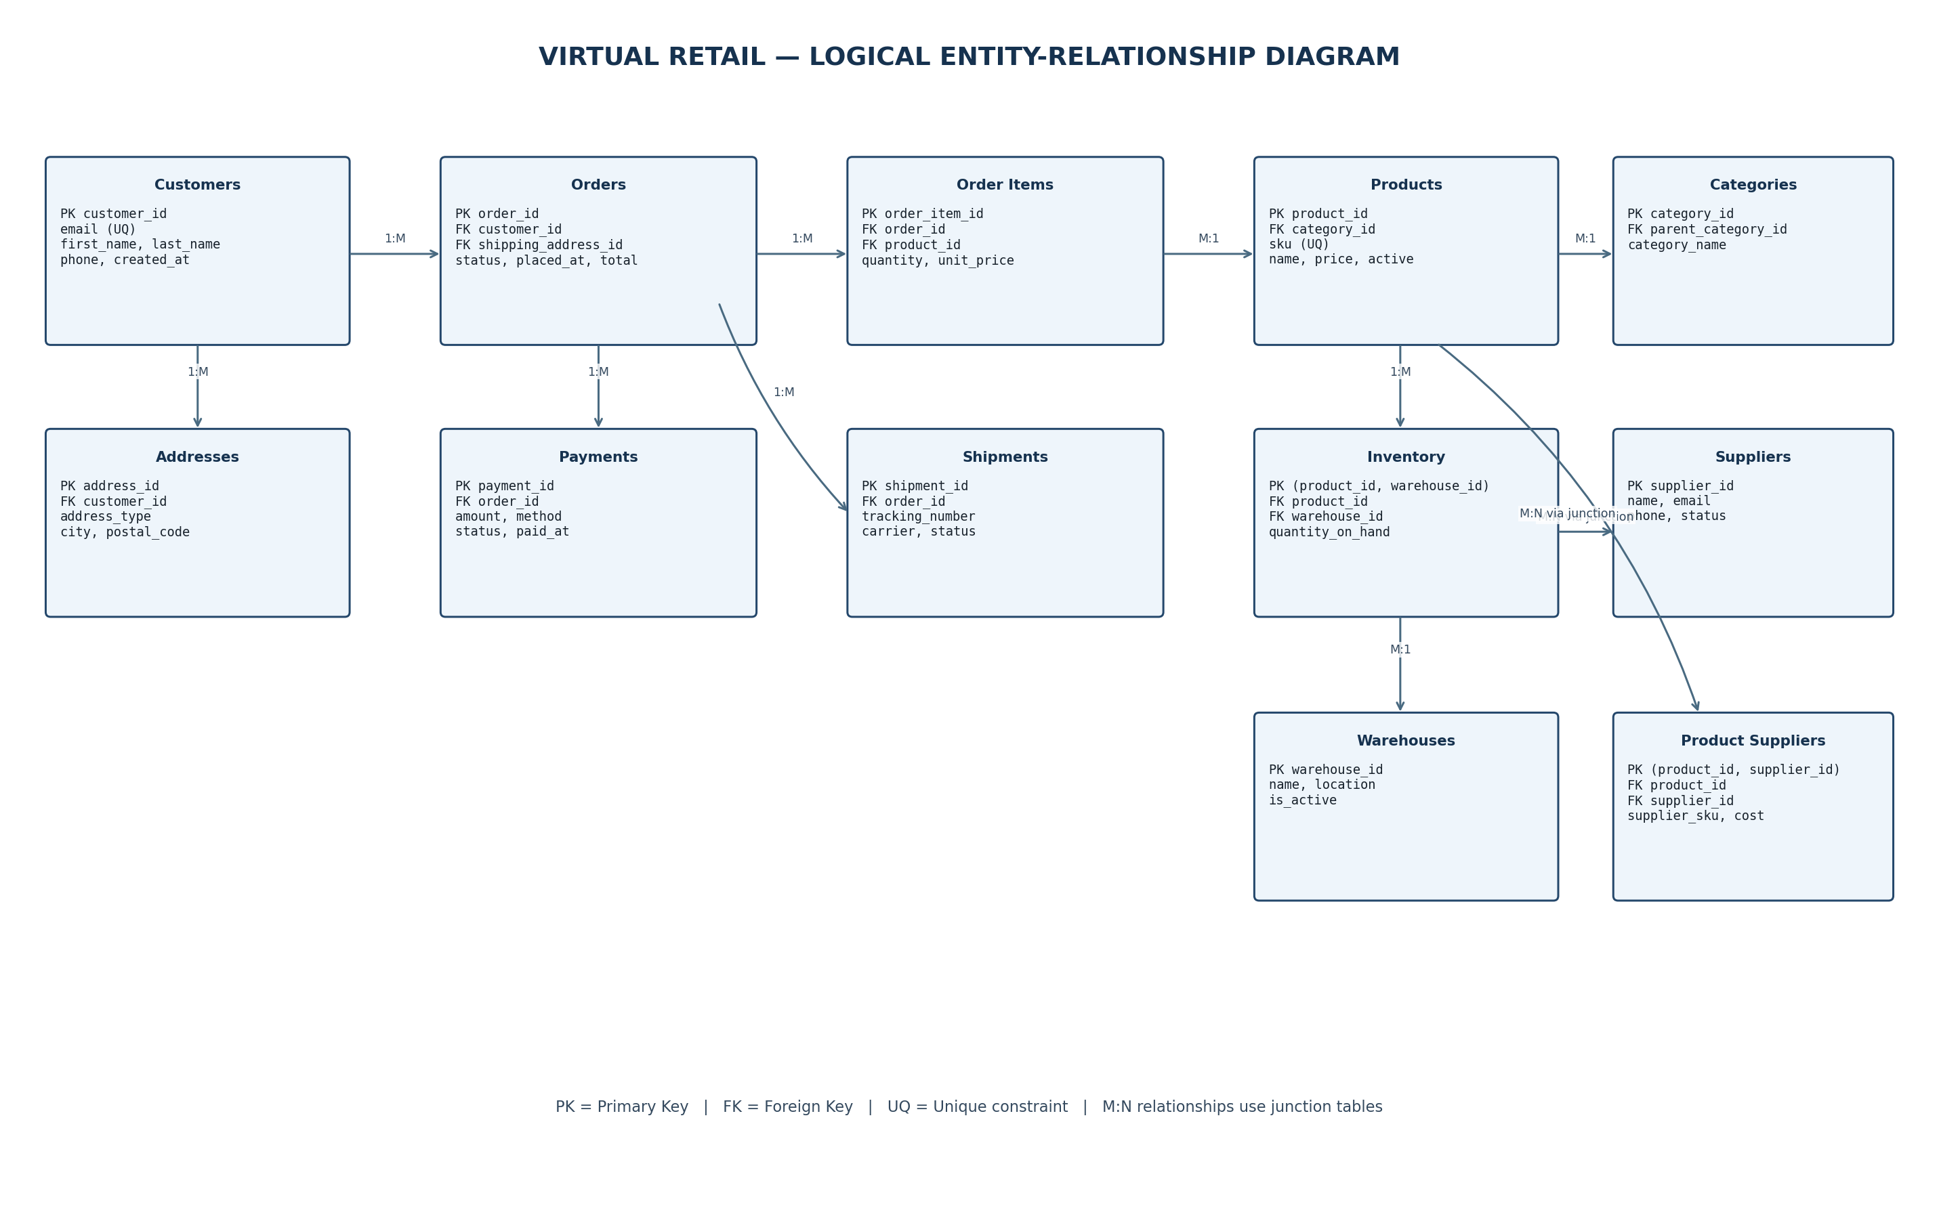
Figure 2. Logical ERD showing the main entities and selected relationships. See the schema and data dictionary for complete keys and constraints.

4.1 Relationship summary
Relationship | Cardinality | Implementation
Customers → Orders | 1 to many | Orders.customer_id references Customers.customer_id.
Customers → Addresses | 1 to many | Addresses.customer_id references Customers.customer_id.
Orders → Order_Items | 1 to many | Order_Items.order_id references Orders.order_id.
Products → Order_Items | 1 to many | Order_Items.product_id references Products.product_id.
Categories → Products | 1 to many | Products.category_id references Categories.category_id.
Products ↔ Suppliers | Many to many | Product_Suppliers junction table.
Products ↔ Warehouses | Many to many | Inventory junction/balance table keyed by product_id and warehouse_id.
Orders → Payments | 1 to many | Supports multiple payment attempts or split payments.
Orders → Shipments | 1 to many | Supports split shipments and partial fulfilment.

4.2 Modeling notes
- Junction tables resolve many-to-many relationships and may store relationship-specific attributes such as supplier cost or stock quantity.
- Orders.shipping_address_id points to the selected address, but production checkout should also snapshot the shipping address on the order or use an immutable order-address table so later customer edits do not alter historical deliveries.
- Order_Items.unit_price is a historical sale-price snapshot. Product.price is the current catalog price and must not be used to recalculate old orders.
- The ERD is logical: the physical implementation may add audit tables, reservation records, or order-address snapshots based on operational needs.

5. Relational Schema and Data Dictionary
Notation: PK = primary key; FK = foreign key; UQ = unique; NN = NOT NULL. Monetary values use NUMERIC rather than floating-point types.
Table | Proposed columns and constraints | Purpose / rationale
Customers | customer_id BIGINT PK; email VARCHAR(255) UQ NN; first_name VARCHAR(100) NN; last_name VARCHAR(100) NN; phone VARCHAR(30); created_at TIMESTAMPTZ NN; status VARCHAR(20) NN | Customer identity. Email uniqueness policy should be case-insensitive if required.
Addresses | address_id BIGINT PK; customer_id BIGINT FK NN; address_type VARCHAR(20) NN; recipient_name VARCHAR(200); line1 VARCHAR(200) NN; line2 VARCHAR(200); city VARCHAR(100) NN; state_region VARCHAR(100); postal_code VARCHAR(20) NN; country_code CHAR(2) NN; created_at TIMESTAMPTZ NN | Stores reusable billing/shipping addresses. Validate ownership when an address is selected for an order.
Categories | category_id BIGINT PK; parent_category_id BIGINT FK nullable; category_name VARCHAR(120) UQ NN; description TEXT | Self-referencing hierarchy supports nested product categories.
Products | product_id BIGINT PK; category_id BIGINT FK NN; sku VARCHAR(64) UQ NN; product_name VARCHAR(200) NN; description TEXT; current_price NUMERIC(12,2) NN CHECK >= 0; is_active BOOLEAN NN; created_at TIMESTAMPTZ NN; updated_at TIMESTAMPTZ NN | Catalog master data. SKU is a stable business identifier.
Suppliers | supplier_id BIGINT PK; supplier_name VARCHAR(200) NN; email VARCHAR(255); phone VARCHAR(30); status VARCHAR(20) NN; created_at TIMESTAMPTZ NN | Supplier master data.
Product_Suppliers | product_id BIGINT FK; supplier_id BIGINT FK; supplier_sku VARCHAR(100); unit_cost NUMERIC(12,2) CHECK >= 0; lead_time_days INTEGER CHECK >= 0; PRIMARY KEY(product_id, supplier_id) | Junction table for products supplied by multiple suppliers.
Warehouses | warehouse_id BIGINT PK; warehouse_name VARCHAR(150) UQ NN; location_description VARCHAR(255); is_active BOOLEAN NN | Physical or virtual stock locations.
Inventory | product_id BIGINT FK; warehouse_id BIGINT FK; quantity_on_hand INTEGER NN CHECK >= 0; reorder_level INTEGER NN CHECK >= 0; updated_at TIMESTAMPTZ NN; PRIMARY KEY(product_id, warehouse_id) | Current stock balance by product and warehouse. A separate movement ledger is recommended for auditability.
Orders | order_id BIGINT PK; order_number VARCHAR(40) UQ NN; customer_id BIGINT FK NN; shipping_address_id BIGINT FK; status VARCHAR(30) NN; currency_code CHAR(3) NN; subtotal NUMERIC(12,2) NN CHECK >= 0; tax_amount NUMERIC(12,2) NN CHECK >= 0; shipping_amount NUMERIC(12,2) NN CHECK >= 0; discount_amount NUMERIC(12,2) NN CHECK >= 0; grand_total NUMERIC(12,2) NN CHECK >= 0; placed_at TIMESTAMPTZ NN; updated_at TIMESTAMPTZ NN | Order header. Store totals for the confirmed transaction and reconcile them against lines and tax/discount rules.
Order_Items | order_item_id BIGINT PK; order_id BIGINT FK NN; product_id BIGINT FK NN; quantity INTEGER NN CHECK > 0; unit_price NUMERIC(12,2) NN CHECK >= 0; line_discount NUMERIC(12,2) NN CHECK >= 0; line_total NUMERIC(12,2) NN CHECK >= 0 | Order lines snapshot sale price. Consider unique(order_id, product_id) only if duplicate product lines are not permitted.
Payments | payment_id BIGINT PK; order_id BIGINT FK NN; provider VARCHAR(60) NN; provider_reference VARCHAR(150); amount NUMERIC(12,2) NN CHECK > 0; currency_code CHAR(3) NN; method VARCHAR(30) NN; status VARCHAR(30) NN; created_at TIMESTAMPTZ NN; paid_at TIMESTAMPTZ | One order may have multiple payment attempts. Enforce provider-reference uniqueness when provided.
Shipments | shipment_id BIGINT PK; order_id BIGINT FK NN; carrier VARCHAR(100); tracking_number VARCHAR(150); status VARCHAR(30) NN; shipped_at TIMESTAMPTZ; delivered_at TIMESTAMPTZ; created_at TIMESTAMPTZ NN | Supports split shipment and delivery lifecycle tracking.

5.1 Primary and foreign key policy
- Use generated surrogate IDs (BIGINT identity columns) for internal joins, while retaining unique business keys such as SKU and order_number.
- Declare foreign keys on all relationships. Choose ON DELETE behavior deliberately; for transactional history, RESTRICT/NO ACTION is generally safer than cascading deletion.
- Use NOT NULL for required attributes and CHECK constraints for simple domain rules such as non-negative price and positive order quantity.
- Use unique constraints for business identifiers and provider references where uniqueness is guaranteed by the provider.
- Use TIMESTAMPTZ for event timestamps and store timestamps consistently in UTC; convert to local time in the application/reporting layer.

6. Normalization and Design Rationale

6.1 First Normal Form (1NF)
Each column stores a single value and each row is uniquely identified. Product lists are not stored as comma-separated text in Orders; each product line is represented by a separate Order_Items row.

6.2 Second Normal Form (2NF)
For tables with composite keys, non-key attributes depend on the entire key. In Inventory, quantity_on_hand depends on the product–warehouse pair. In Product_Suppliers, supplier-specific cost and lead time depend on the product–supplier pair.

6.3 Third Normal Form (3NF)
Non-key attributes depend on the key rather than on other non-key attributes. Category details live in Categories rather than being repeated on every product. Supplier contact details live in Suppliers rather than being copied into each product row.

6.4 Intentional duplication and snapshots
Order line prices and order totals are transaction snapshots, not accidental denormalization. They preserve the values agreed at checkout. The system should calculate them in a trusted service or transaction and validate their consistency. Historical addresses should likewise be snapshotted or made immutable for each order.

6.5 Alternatives considered
Decision | Chosen approach | Reason / trade-off
Product and warehouse stock | Inventory composite key (product_id, warehouse_id). | Simple stock balance lookup; add an inventory movement ledger for audit history.
Order lines | Separate Order_Items table. | Supports variable line count and product-level reporting.
Payments | Separate one-to-many Payments table. | Supports failed attempts, retries, refunds/extensions, and provider reconciliation.
Product suppliers | Junction table. | Models many-to-many relationship and stores supplier-specific attributes.
Current vs historical price | Products.current_price plus Order_Items.unit_price. | Protects historical sales when catalog prices change.
Surrogate keys | BIGINT identity primary keys plus unique business keys. | Stable joins without relying on mutable business identifiers.

7. Constraints and Data Integrity

7.1 Integrity rules
- A product must reference an existing category; a category parent must reference an existing category.
- An order must reference an existing customer and a valid shipping address where shipping is required.
- An order item must reference an existing order and product; quantity must be greater than zero.
- Product prices, line totals, tax, shipping, and discounts cannot be negative.
- Inventory on hand and reorder levels cannot be negative.
- Order status, payment status, shipment status, and address type should be controlled by CHECK constraints or reference tables.
- Use idempotency keys for checkout/payment requests to avoid duplicate orders or charges on retries.
- Do not delete completed order history casually; use lifecycle status, retention policy, and controlled archival.

7.2 Concurrency-safe stock updates
A read-then-write pattern without locking can oversell stock when two customers check out simultaneously. Use an atomic conditional update or row-level locking inside a short transaction.
UPDATE inventory
SET quantity_on_hand = quantity_on_hand - :requested_qty,
updated_at = CURRENT_TIMESTAMP
WHERE product_id = :product_id
AND warehouse_id = :warehouse_id
AND quantity_on_hand >= :requested_qty
RETURNING quantity_on_hand;
If the statement returns no row, stock is insufficient or the inventory key does not exist. The application must treat this as a failed reservation and avoid confirming the order.

8. Indexing and Query Performance
PostgreSQL automatically creates indexes for primary keys and unique constraints. Foreign-key columns are not automatically indexed in every case, so indexes should be added to support joins and frequent filters.
Index / constraint | Purpose | Notes
UNIQUE Products(sku) | Fast SKU lookup and duplicate prevention. | Already created by the unique constraint.
UNIQUE Orders(order_number) | Fast order-number lookup. | Already created by the unique constraint.
INDEX Orders(customer_id, placed_at DESC) | Customer order history. | Supports customer filter and newest-first sorting.
INDEX Orders(status, placed_at) | Operations queue by status and age. | Validate selectivity and query plans.
INDEX Order_Items(order_id) | Retrieve all lines for an order. | Useful for joins and order details.
INDEX Order_Items(product_id) | Product sales and product-related joins. | Can support best-seller aggregation.
INDEX Payments(order_id, created_at DESC) | Payment history for an order. | Avoid indexing every status field without evidence.
INDEX Shipments(order_id) | List shipments for an order. | Add tracking-number index if lookup is frequent.
INDEX Inventory(warehouse_id, product_id) | Warehouse stock queries. | Composite primary key already begins with product_id; this index supports reverse lookup.
PARTIAL INDEX Inventory(product_id, warehouse_id) WHERE quantity_on_hand <= reorder_level | Low-stock queue, if this query is frequent. | A partial index using a row-relative comparison may not be valid as a stable predicate; use a maintained low_stock flag or index the key and filter at query time.

8.1 Indexing principles
- Index columns used frequently in WHERE, JOIN, ORDER BY, and uniqueness checks.
- Prefer composite indexes whose leading columns match common query predicates.
- Avoid redundant indexes: every additional index consumes storage and adds write overhead.
- Use EXPLAIN (ANALYZE, BUFFERS) with representative data to validate plans before and after index changes.
- Keep planner statistics current with routine ANALYZE/autovacuum; monitor slow queries and table/index bloat.

9. Operational Workflows

9.1 Product setup and replenishment
- Create or select a category, then create the product with a unique SKU and current catalog price.
- Link one or more suppliers through Product_Suppliers and record supplier-specific cost and lead time.
- Create inventory rows for the warehouses that stock the product.
- Use stock thresholds to produce replenishment alerts; actual purchase-order management is a future extension.

9.2 Order placement
- Validate customer, address ownership, product active status, price, and quantity.
- Recalculate subtotal, discounts, taxes, shipping, and grand total in trusted server-side logic.
- Within a short transaction, create the order and order items and reserve/decrement stock using concurrency-safe updates.
- Commit the database work, then coordinate payment with the payment provider using idempotency and a retry-safe workflow.
- Update payment/order status only from verified provider responses or authenticated webhooks.

9.3 Fulfilment
- After the business rules allow fulfilment, create a shipment row linked to the order.
- Store carrier, tracking number, and shipment status transitions.
- Support multiple shipments if an order is split across warehouses or delivery batches.
- Keep order status and shipment status definitions documented so reports do not confuse paid, packed, shipped, and delivered states.

9.4 Reporting and decision support
- Sales by date: aggregate confirmed order totals by day or month.
- Best sellers: aggregate Order_Items quantity and revenue by product.
- Low inventory: compare quantity_on_hand with reorder_level.
- Customer repeat purchase: count completed orders by customer.
- Payment reconciliation: compare internal payment records with provider settlement reports.

10. SQL Implementation Examples
The following examples illustrate the proposed PostgreSQL schema. They are representative core DDL, not a complete production migration; create the remaining tables in dependency order and validate all business rules.
CREATE TABLE customers (
customer_id BIGINT GENERATED ALWAYS AS IDENTITY PRIMARY KEY,
email VARCHAR(255) NOT NULL UNIQUE,
first_name VARCHAR(100) NOT NULL,
last_name VARCHAR(100) NOT NULL,
phone VARCHAR(30),
status VARCHAR(20) NOT NULL DEFAULT 'active',
created_at TIMESTAMPTZ NOT NULL DEFAULT CURRENT_TIMESTAMP
);
CREATE TABLE categories (
category_id BIGINT GENERATED ALWAYS AS IDENTITY PRIMARY KEY,
parent_category_id BIGINT REFERENCES categories(category_id),
category_name VARCHAR(120) NOT NULL UNIQUE,
description TEXT
);
CREATE TABLE products (
product_id BIGINT GENERATED ALWAYS AS IDENTITY PRIMARY KEY,
category_id BIGINT NOT NULL REFERENCES categories(category_id),
sku VARCHAR(64) NOT NULL UNIQUE,
product_name VARCHAR(200) NOT NULL,
description TEXT,
current_price NUMERIC(12,2) NOT NULL CHECK (current_price >= 0),
is_active BOOLEAN NOT NULL DEFAULT TRUE,
created_at TIMESTAMPTZ NOT NULL DEFAULT CURRENT_TIMESTAMP,
updated_at TIMESTAMPTZ NOT NULL DEFAULT CURRENT_TIMESTAMP
);
CREATE TABLE warehouses (
warehouse_id BIGINT GENERATED ALWAYS AS IDENTITY PRIMARY KEY,
warehouse_name VARCHAR(150) NOT NULL UNIQUE,
location_description VARCHAR(255),
is_active BOOLEAN NOT NULL DEFAULT TRUE
);
CREATE TABLE inventory (
product_id BIGINT NOT NULL REFERENCES products(product_id),
warehouse_id BIGINT NOT NULL REFERENCES warehouses(warehouse_id),
quantity_on_hand INTEGER NOT NULL DEFAULT 0 CHECK (quantity_on_hand >= 0),
reorder_level INTEGER NOT NULL DEFAULT 0 CHECK (reorder_level >= 0),
updated_at TIMESTAMPTZ NOT NULL DEFAULT CURRENT_TIMESTAMP,
PRIMARY KEY (product_id, warehouse_id)
);
CREATE TABLE orders (
order_id BIGINT GENERATED ALWAYS AS IDENTITY PRIMARY KEY,
order_number VARCHAR(40) NOT NULL UNIQUE,
customer_id BIGINT NOT NULL REFERENCES customers(customer_id),
shipping_address_id BIGINT,
status VARCHAR(30) NOT NULL DEFAULT 'pending',
currency_code CHAR(3) NOT NULL DEFAULT 'INR',
subtotal NUMERIC(12,2) NOT NULL CHECK (subtotal >= 0),
tax_amount NUMERIC(12,2) NOT NULL DEFAULT 0 CHECK (tax_amount >= 0),
shipping_amount NUMERIC(12,2) NOT NULL DEFAULT 0 CHECK (shipping_amount >= 0),
discount_amount NUMERIC(12,2) NOT NULL DEFAULT 0 CHECK (discount_amount >= 0),
grand_total NUMERIC(12,2) NOT NULL CHECK (grand_total >= 0),
placed_at TIMESTAMPTZ NOT NULL DEFAULT CURRENT_TIMESTAMP,
updated_at TIMESTAMPTZ NOT NULL DEFAULT CURRENT_TIMESTAMP
);
CREATE TABLE order_items (
order_item_id BIGINT GENERATED ALWAYS AS IDENTITY PRIMARY KEY,
order_id BIGINT NOT NULL REFERENCES orders(order_id),
product_id BIGINT NOT NULL REFERENCES products(product_id),
quantity INTEGER NOT NULL CHECK (quantity > 0),
unit_price NUMERIC(12,2) NOT NULL CHECK (unit_price >= 0),
line_discount NUMERIC(12,2) NOT NULL DEFAULT 0 CHECK (line_discount >= 0),
line_total NUMERIC(12,2) NOT NULL CHECK (line_total >= 0)
);
CREATE INDEX idx_orders_customer_date
ON orders(customer_id, placed_at DESC);
CREATE INDEX idx_order_items_order ON order_items(order_id);
CREATE INDEX idx_order_items_product ON order_items(product_id);
CREATE INDEX idx_inventory_warehouse_product
ON inventory(warehouse_id, product_id);

10.1 Example business queries
-- 1. Most frequently sold products (example excludes cancelled orders)
SELECT p.product_id, p.product_name,
SUM(oi.quantity) AS units_sold,
SUM(oi.line_total) AS line_revenue
FROM order_items oi
JOIN orders o ON o.order_id = oi.order_id
JOIN products p ON p.product_id = oi.product_id
WHERE o.status NOT IN ('cancelled')
GROUP BY p.product_id, p.product_name
ORDER BY units_sold DESC
LIMIT 10;
-- 2. Current stock below its configured reorder level
SELECT p.sku, p.product_name, w.warehouse_name,
i.quantity_on_hand, i.reorder_level
FROM inventory i
JOIN products p ON p.product_id = i.product_id
JOIN warehouses w ON w.warehouse_id = i.warehouse_id
WHERE i.quantity_on_hand <= i.reorder_level
AND p.is_active = TRUE
ORDER BY w.warehouse_name, p.product_name;
-- 3. Order history for one customer
SELECT order_number, status, currency_code, grand_total, placed_at
FROM orders
WHERE customer_id = :customer_id
ORDER BY placed_at DESC
LIMIT 50;

11. Security, Backup, and Scalability

11.1 Security controls
- Use separate database roles for migrations, application runtime, reporting, and read-only support.
- Grant only required table and operation permissions; do not run the application as a superuser.
- Use parameterized queries and validate all external input to reduce SQL injection risk.
- Encrypt database connections in transit and protect credentials in a secrets manager or secure environment configuration.
- Never store raw card numbers or CVV. Store tokenized provider references and only the minimum payment metadata needed.
- Restrict access to customer personal information, log privileged access, and define retention/deletion procedures.

11.2 Backup and recovery
- Schedule automated backups and retain them according to business and regulatory requirements.
- For tighter recovery objectives, configure point-in-time recovery using base backups and archived WAL.
- Test restoration periodically in an isolated environment; a successful backup job alone does not prove recoverability.
- Define Recovery Point Objective (RPO) and Recovery Time Objective (RTO) with stakeholders.

11.3 Scalability path
Stage | Approach | When to consider
Initial | One PostgreSQL primary, normalized schema, sensible indexes, connection pooling, monitoring. | Suitable baseline for many small and medium workloads.
Growth | Tune slow queries, improve indexes, batch writes carefully, archive old operational data, use caching for safe read-heavy data. | When latency or resource metrics show sustained pressure.
Read scaling | Add a read replica for eligible reports and read-only traffic; account for replication lag. | When reads compete with checkout transactions.
Large history | Partition very large time-oriented tables such as orders or audit events by date, only after measuring benefit. | When table size and maintenance/query patterns justify complexity.
High availability | Managed failover or a tested replication/failover design; monitor replication and recovery. | When downtime tolerance requires it.

Avoid premature sharding. A well-indexed PostgreSQL database with measured query patterns is simpler to operate than a distributed design introduced before it is necessary.

12. Validation and Test Plan
Test case | Action | Expected result
Unique SKU | Insert two products with the same SKU. | Second insert is rejected by unique constraint.
Invalid product reference | Insert an order item for a non-existent product. | Foreign-key violation; no orphan order item.
Invalid quantity | Insert an order item with quantity 0 or -1. | CHECK constraint rejects the row.
Negative price | Set current_price to a negative value. | CHECK constraint rejects the update.
Concurrent checkout | Two transactions attempt to reduce stock below zero. | Only valid quantity reductions succeed; stock never becomes negative.
Order history | Change a product's current price after an order. | Existing order-item unit_price remains unchanged.
Payment retry | Repeat a checkout request with the same idempotency key. | Application returns/reuses the original operation rather than creating a duplicate charge.
Backup restore | Restore a backup to a test environment. | Data is accessible and recovery steps are documented.
Performance | Run EXPLAIN ANALYZE on order history and low-stock queries with representative volume. | Plans and latency meet agreed targets; adjust indexes if needed.

12.1 Acceptance criteria
- All core entities and relationships are documented and keys are defined.
- ERD and data dictionary are consistent with the proposed schema.
- Normalization rationale explains both duplication avoidance and intentional historical snapshots.
- SQL examples demonstrate DDL, joins, aggregation, and inventory checks.
- Security, backup, testing, and scalability decisions are stated with trade-offs.
- The database design is reviewed against the final business rules before deployment.

13. Risks and Future Enhancements
Risk / gap | Impact | Recommended follow-up
No inventory movement ledger in core model | Balance changes may be hard to audit. | Add Inventory_Movements with reason, quantity delta, reference, actor, and timestamp.
Historical address mutability | Customer edits could alter the address referenced by an old order. | Snapshot shipping/billing address fields per order or use immutable order-address rows.
Tax and discount complexity | Totals may be inconsistent if rules are implicit. | Define tax jurisdictions, promotion rules, rounding policy, and calculation ownership.
Returns/refunds not modeled | Post-sale adjustments and restocking cannot be fully tracked. | Add Returns, Return_Items, Refunds, and inventory adjustments.
No purchase orders | Supplier replenishment workflow is not represented. | Add Purchase_Orders and Purchase_Order_Items.
Status free text risk | Typos or inconsistent status values may affect reports. | Use CHECK constraints or normalized status/reference tables and define valid transitions.
Customer email case sensitivity | Case variants could create duplicate accounts. | Use a case-insensitive unique strategy if the business requires case-insensitive email identity.

13.1 Suggested next-phase entities
- Inventory_Movements: auditable ledger for receipts, reservations, sales, returns, and adjustments.
- Order_Address_Snapshots: immutable address used for a particular order.
- Returns and Refunds: manage post-sale service and financial adjustments.
- Purchase_Orders and Purchase_Order_Items: supplier ordering and receiving.
- Promotions and Coupons: controlled discount eligibility and redemption.
- Audit_Events: selected security-sensitive and business-critical changes.

14. Conclusion
The proposed virtual retail database uses a normalized relational model to separate customer, catalog, supplier, stock, sales, payment, and shipment data while preserving the relationships needed for daily operations. Primary keys, foreign keys, unique constraints, and CHECK constraints protect data quality. Historical order-line pricing, transaction boundaries, and concurrency-safe inventory updates support accurate checkout behavior. Indexes are selected around expected access patterns, while replicas, partitioning, and other scaling techniques are introduced only when measured workload justifies them.
Before implementation, the business should confirm its policies for guest checkout, currencies, tax, discounts, returns, stock reservation, payment states, address snapshots, and data retention. With these decisions documented and the validation plan completed, this model provides a sound starting point for a maintainable and scalable retail database.

Appendix A — Submission Checklist
- Replace the prepared-by field and submission date on the cover.
- Review the ERD against the final instructor requirements.
- Run the DDL in a test PostgreSQL database after completing the remaining table definitions.
- Capture query-plan evidence and test results if the internship evaluator requests implementation proof.
- Ensure no real customer data, passwords, payment-card details, or production credentials are included.

