Rajvardhan Zende
202501100016
SE1 S11 ESSENTIALS OF DATA SCIENCE

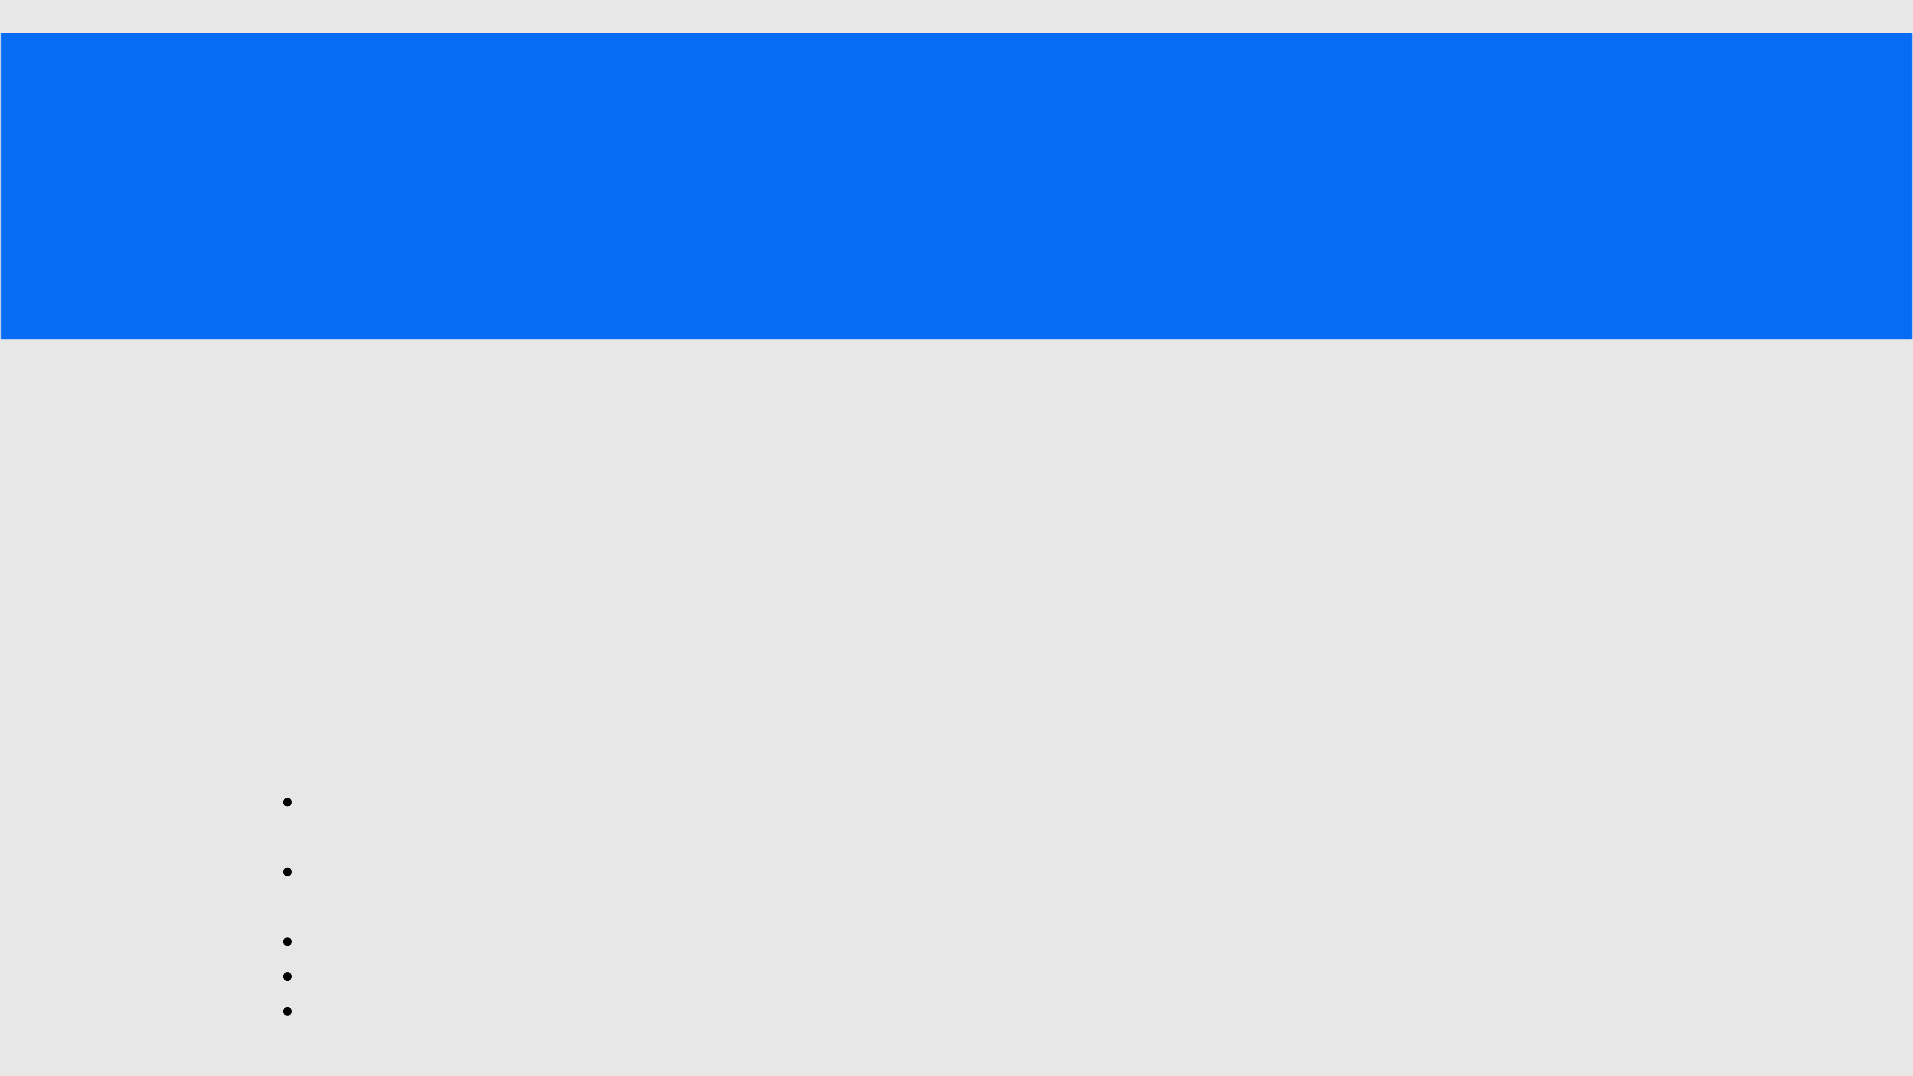
PRACTICE LAB ASSIGNMENT
2.1.1 LIST OPERATIONS WriteaPythonprogramthatimplements a menu-driven interface for managing a list of integers. The program shouldhavethefollowingmenuoptions:
1. Add
2. Remove
3. Display
4. Quit
The program should repeatedly prompt the user to enter a choice from the menu. Depending on the choice selected, the program should perform the following actions:
Add: Prompts the user to enter an integer and add it to the integer list. If the input is not a valid integer, display "Invalid input".
Remove: Prompts the user to enter an integer to remove from the list. If the integer is found in the list, remove it; otherwise, display "Element not found". If the list is empty, display "List is empty".
Display: Displays the current list of integers. If the list is empty, display "List is empty".
Quit: Exits the program.
The program should handle invalid menu choices by displaying "Invalid choice".Ensure that the program continues to prompt the user until they choose to quit (option 4).

INPUT | OUTPUT
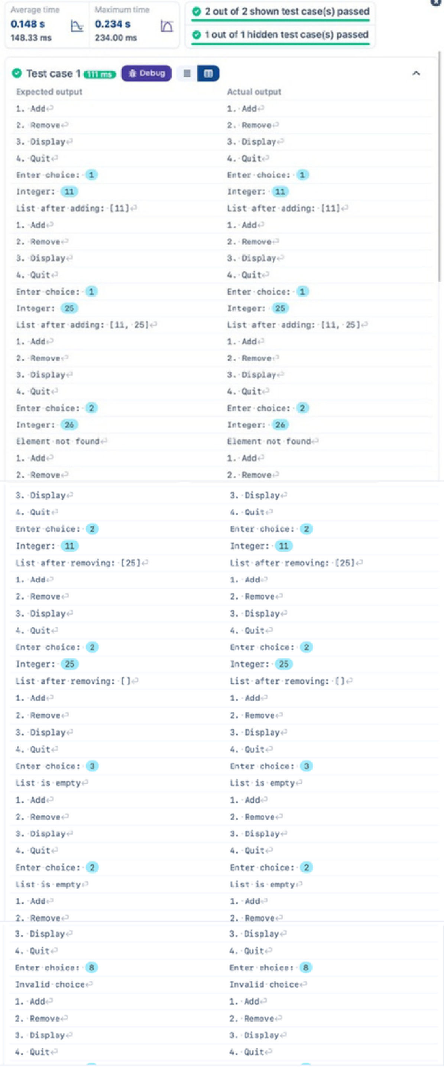
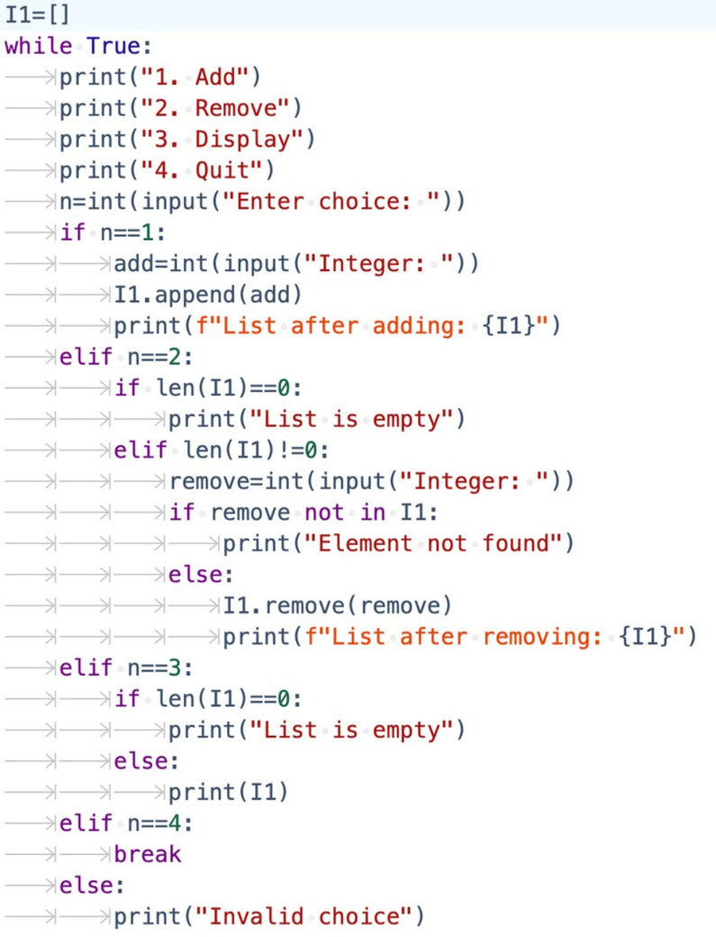


2.1.2 DICTIONARY OPERATIONS
WriteaPython programtoperforminsertion, update,deletion, and traversaloperations on a dictionary. An initial dictionary containing10predefinedrecords isalreadygiven in the program.
Operations to be Performed:
1.Insertion – Insert a new key-value pair into the dictionary using user input. 2.Update – Update the value of an existing key using user input.
3.Deletion – Delete a specified key from the dictionary using user input.
4.Traversal – Traverse the final dictionary and display all key-value pairs.
Input and Output Format:
1.Read an integer representing the key to be inserted and a string representing its value. Insert this new key-value pair into the dictionary and display the dictionary after insertion.
2.Read an integer representing the key to be updated and a string representing the new value. Update the value of the specified key (only if it exists) and display the dictionary after the update.
3.Read an integer representing the key to be deleted. Delete the specified key from the dictionary (only if it exists) and display the dictionary after deletion.
4.Finally, traverse the dictionary and display all key-value pairs.
The program should also display the original dictionary before performing any operations. Each output should be printed with appropriate messages.
Note:
All operations must be performed using dictionary methods.
Perform deletion only if possible; leave the dictionary unchanged.
Refer to the visible test cases for better understanding and strictly match with the input/outputs.

INPUT OUTPUT
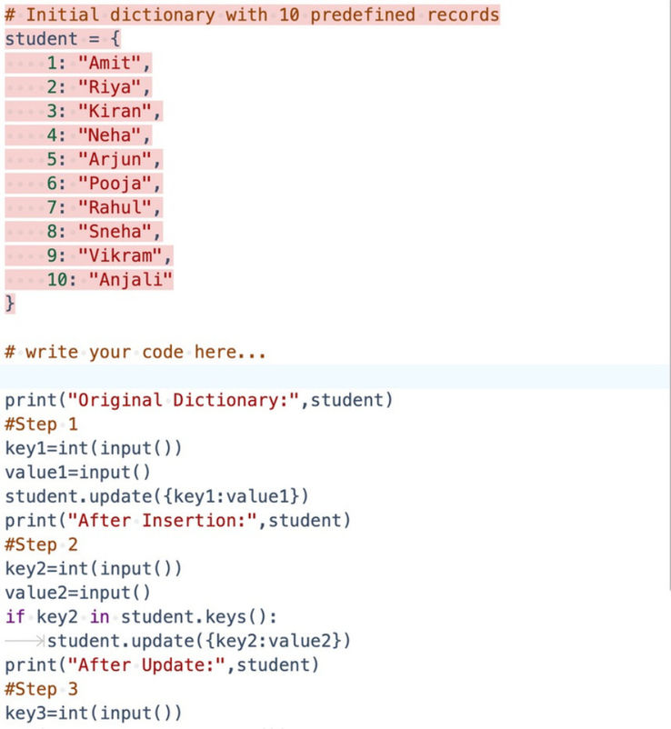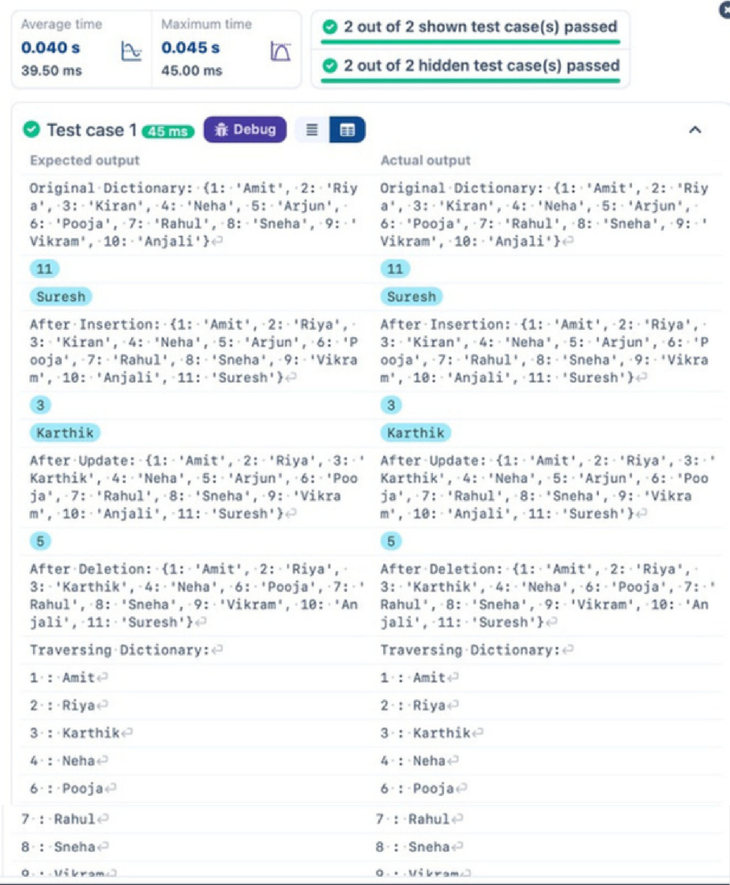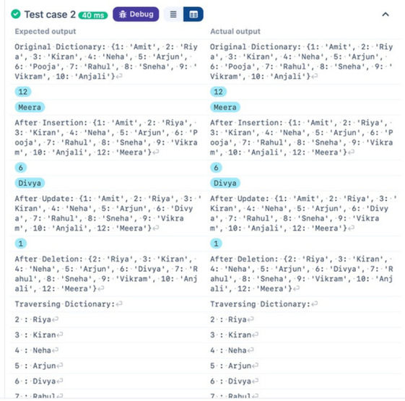
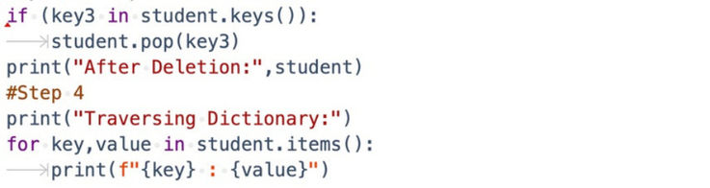

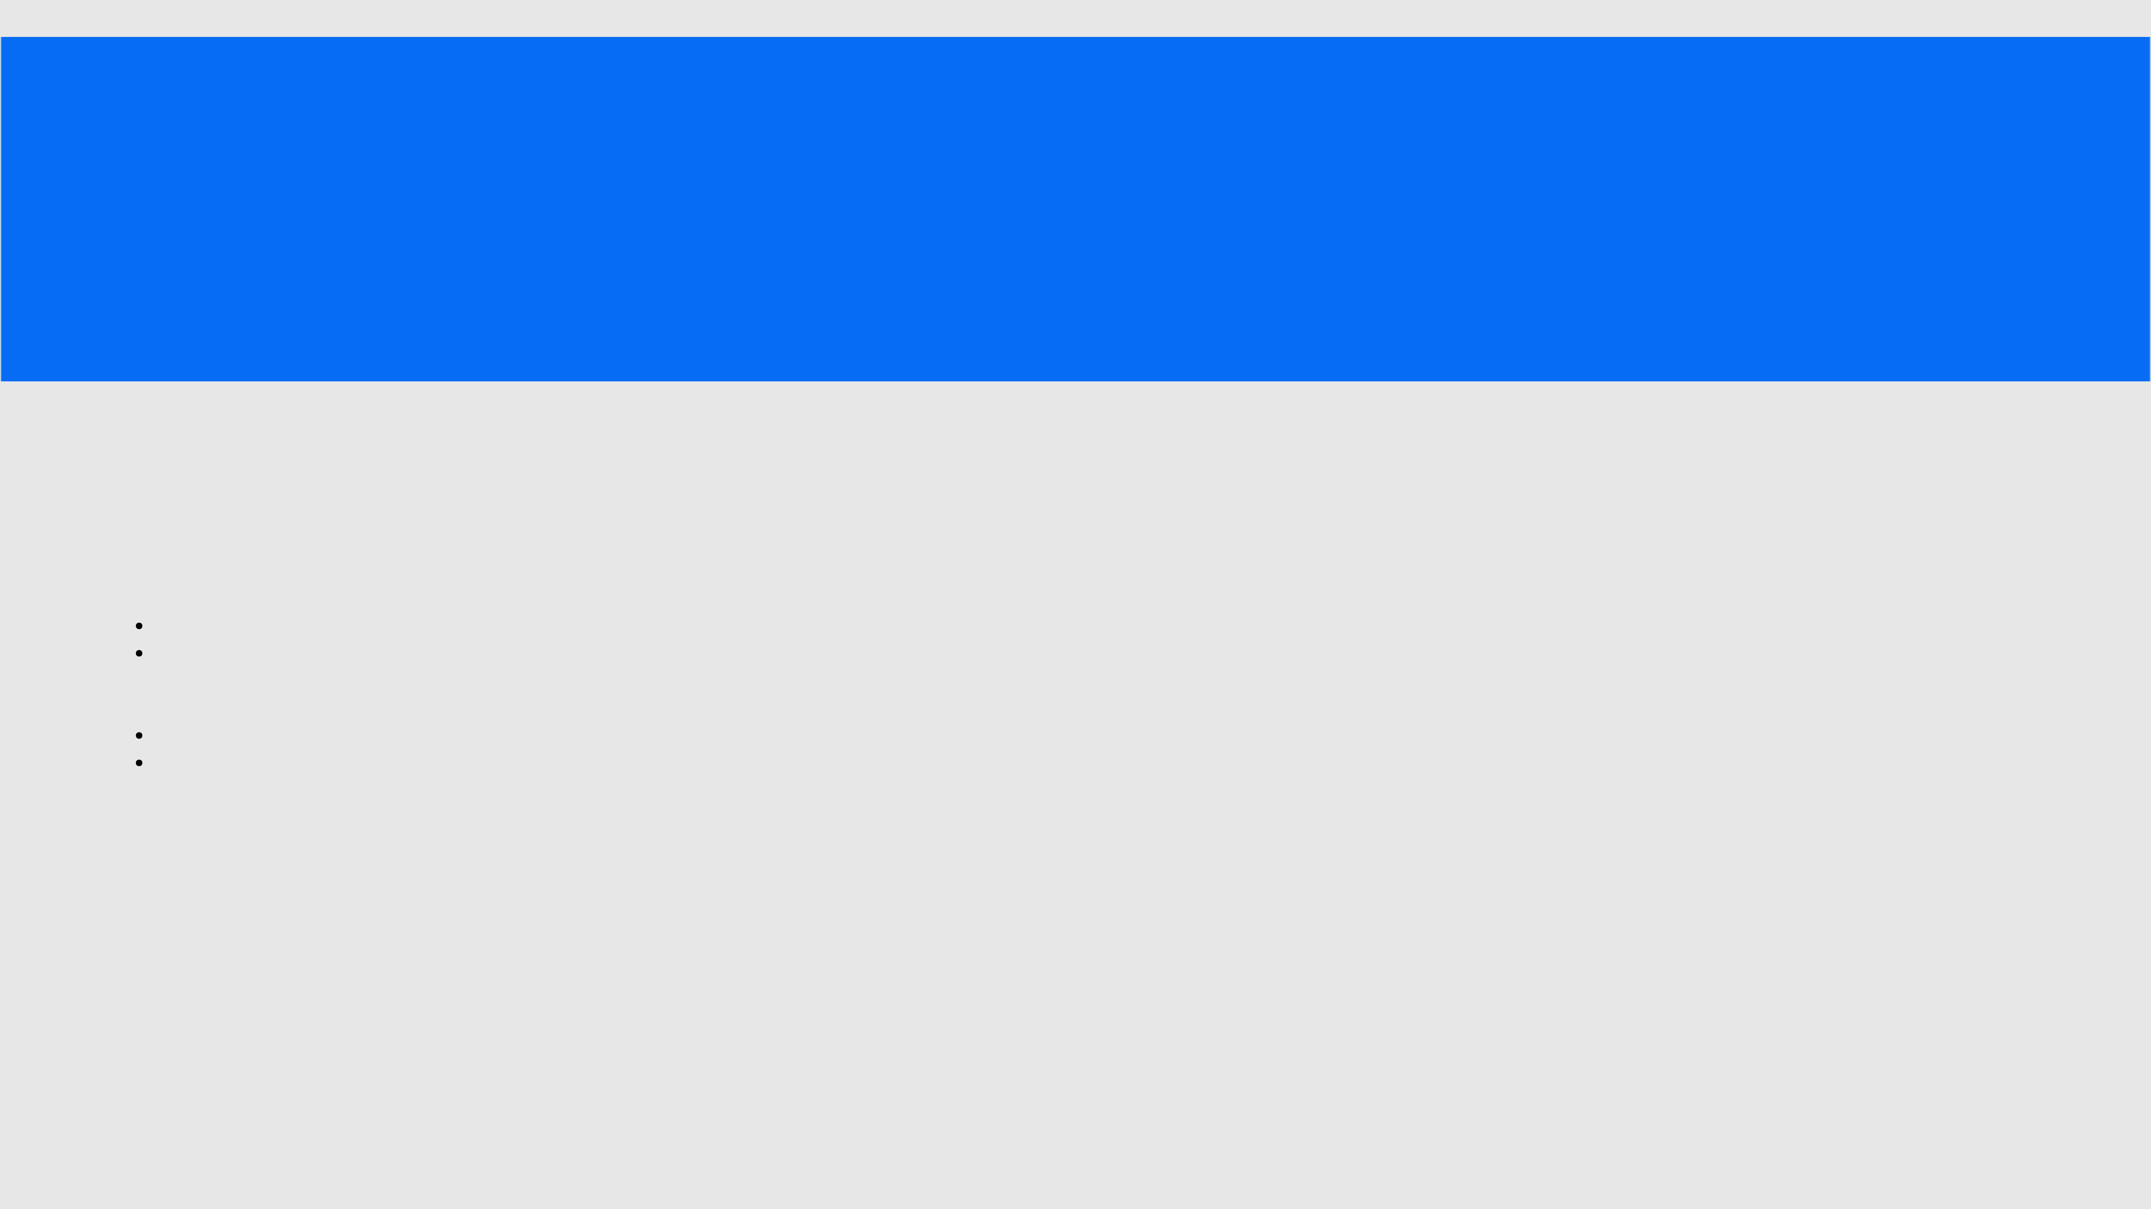
LAB ASSIGNMENT
2.2.1 LINEAR SEARCH TECHNIQUE
Inputformat:
The first line of input contains the arrayofintegers whichareseparatedbyspace
The last line of input contains the key element to be searched
Output format:
If the element is found, print the index. If the element found multiple times, print the starting index If the element is not found, print Not found.
Sample Test Case:
Input:
1 2 3 4 3 5 6
3
Output:
2

INPUT OUTPUT

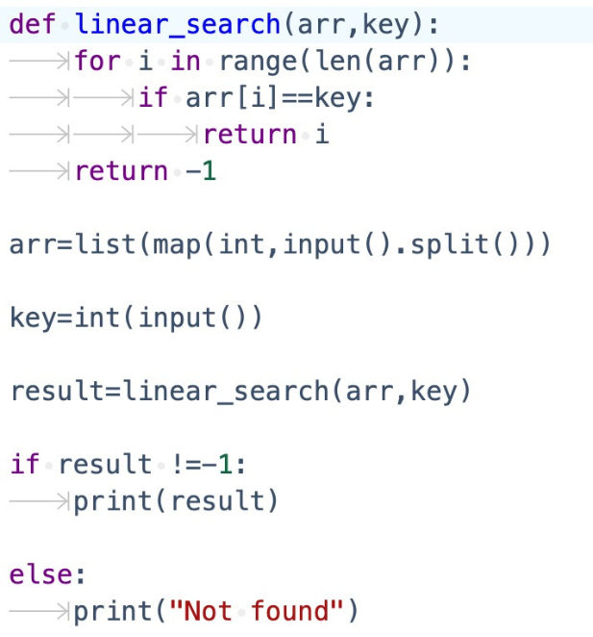

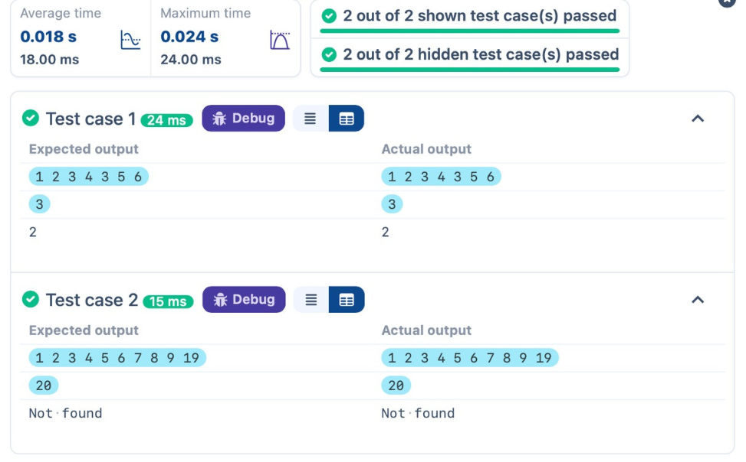

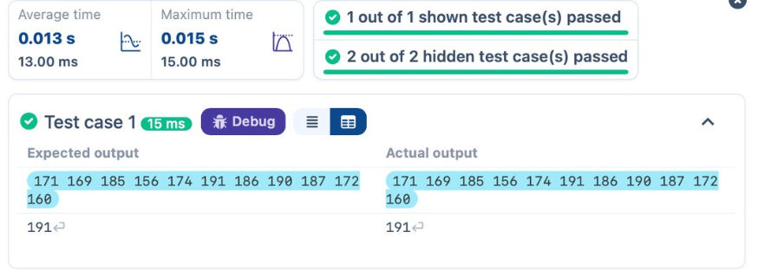
2.1.2 CAPTAIN OF THE TEAM You areprovidedwiththeheightsof11cricketplayers(in centimeters). Your task is to identify the tallest player, who willbeselectedasthecaptainoftheteam.
Input Format:
The first line of input will contain 11 integers, each representing the height of a player (in centimeters), each separated by a space.
Output Format
The output should be the height (in centimeters) of the tallest player.

INPUT
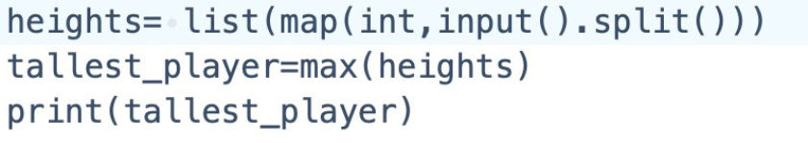

OUTPUT

