VULNERABILITY ASSESSMENT &
PENETRATION TESTING REPORT
Before You Agree - Iteration 3
Date: 12 October 2026
Scope: Vue frontend, document upload and URL retrieval, Node.js API, AWS Amplify and CloudFront, AWS WAF, EC2, external APIs, LegalBERT and relevant source code
Prepared by: Raj Tandel
Assessment type: Evidence-based security review and controlled input testing

Table Of Contents
Index | Content | Page
1 | Purpose and method | 2
2 | Iteration 3 executive summary | 2
3 | Test evidence | 3
4 | Current findings | 4
5 | Confirmed controls | 5
6 | Impact assessment | 5
7 | Evidence screenshots | 6-9
8 | Recommendations | 10
9 | Limitations | 10
10 | References | 10
Appendix A | Iteration 2 remediation status | 11
Appendix B | Iteration 3 automated test result | 12

1. Purpose and method
This report reviews the security work completed during Iteration 3. It follows the format of the Iteration 2 VAPT report and uses the supplied screenshots, test payloads, current source code, the Iteration 3 security plan and a new local test run.
• Reviewed the production response headers shown in the CSP evidence.
• Reviewed controlled XSS and SQL-injection-looking test strings.
• Reviewed URL, pasted-text and PDF upload behaviour.
• Reviewed the Iteration 3 security plan and its remediation record.
• Ran the production build and unit tests on 12 October 2026.
• No destructive SQL, executable malware, denial-of-service test or uncontrolled production scan was used.

2. Iteration 3 executive summary
Iteration 3 improves browser protection, document handling and control of untrusted input. The production response includes an enforced Content Security Policy, HSTS, nosniff, Referrer-Policy, Permissions-Policy and frame protection. Controlled XSS and SQL-looking strings did not visibly execute in the browser. The application either displayed them as plain policy text or failed safely with an error. A synthetic PDF was also rejected with a clear message when it could not be read.
The production build completed successfully. The unit test run passed 84 of 88 tests. Four LegalBERT adapter tests failed because the local model path points to a missing directory ending in 'tosAdded'. One UI test also produced an unhandled scrollIntoView error. These test issues should be corrected before the Iteration 3 release evidence is signed off. The screenshots show safe outcomes, but they do not prove whether each NetworkError was caused by AWS WAF, CORS, the network or the API.
Area | Assessment
Browser headers | Implemented and visible in the production response.
XSS test | No script execution was observed; suspicious content was treated as text or failed safely.
SQL-looking input | No SQL execution was observed. The application has no application database.
PDF handling | Unreadable input produced a clear error; readable text was shown without active content.
Production build | Passed on 12 October 2026.
Unit tests | 84 passed and 4 failed; one additional unhandled UI test error was reported.
Overall risk | Medium until the test configuration and generic network error reporting are corrected.

3. Test evidence
Check | Observed result | Meaning
Production headers | CSP, HSTS, nosniff, Referrer-Policy, Permissions-Policy and X-Frame-Options are present. | Confirms browser protection is deployed.
URL XSS string | The application returned a safe NetworkError message and no alert was visible. | No execution was observed, but the exact blocking layer is not proved.
Uploaded XSS/SQL text | The review page returned a NetworkError and offered Retry. | The request failed safely; WAF or API logs are needed to identify the cause.
PDF parser | The synthetic PDF produced 'This file could not be read'. | The parser rejected unsupported input without executing it.
Policy analysis display | Suspicious strings appeared as visible clause text. | The content was rendered as text rather than active HTML.
Build | npm run build completed successfully. | Type checking and the production bundle completed.
Unit tests | 84 passed, 4 failed, and one unhandled UI error occurred. | The test suite is not fully passing and needs correction.

4. Current findings
ID | Finding | Rating | Evidence | Required treatment
VA3-01 | Production browser security headers are enabled | Resolved | EV3-01 shows the enforced headers. | Retest the headers after every deployment.
VA3-02 | Suspicious input returns a generic NetworkError | Low | EV3-02 and EV3-03 show a safe but unclear error. | Return a simple security or connection message without backend details.
VA3-03 | Synthetic PDF compatibility is limited | Low | EV3-04 shows that the test PDF could not be read. | Keep safe rejection and add parser tests for supported PDF types.
VA3-04 | Untrusted HTML-like content is shown as text | Informational | EV3-05 shows tags and SQL strings in the clause text with no visible execution. | Keep text-only rendering and regression tests.
VA3-05 | Four model tests fail because the configured model path is missing | Medium | The 12 October unit run passed 84/88; the failing path ends in tosAdded. | Correct the model directory setting and require a fully passing test run.
VA3-06 | UI test reports an unhandled scrollIntoView error | Low | Vitest reported one unhandled rejection from ActionGuide.vue. | Mock or guard scrollIntoView and rerun the suite.

5. Confirmed controls
• Production browser responses use CSP, HSTS, nosniff, Referrer-Policy, Permissions-Policy and frame protection.
• Uploaded and extracted document content is displayed as text rather than active HTML.
• Unreadable documents fail with a user-facing message instead of exposing backend code.
• The interface provides Retry after an analysis request fails.
• The production build and type check pass.
• API keys are kept out of source code and frontend variables. Production keys are stored in protected EC2 environment files and GitHub secrets are masked and protected.
• The security plan records SSRF checks, download limits, cache limits, WAF, monitoring and model checksum controls as implemented.

6. Impact assessment
ID | Confidentiality | Integrity | Availability | Overall
VA3-01 | Low | Low | Low | Resolved
VA3-02 | Low: backend details are not shown. | Low | Medium: users cannot complete analysis for blocked content. | Low
VA3-03 | Low | Low | Medium: some valid PDFs may not be processed. | Low
VA3-04 | Low | Low: active content was not observed. | Low | Informational
VA3-05 | Low | High: model error handling is not fully verified. | Medium | Medium
VA3-06 | Low | Low | Low: test reliability and keyboard behaviour may be affected. | Low

7. Evidence screenshots
Each screenshot is assessed only on what it visibly proves. A browser error does not identify the blocking layer without matching WAF, CloudFront or API logs.

EV3-01 - Production browser security headers
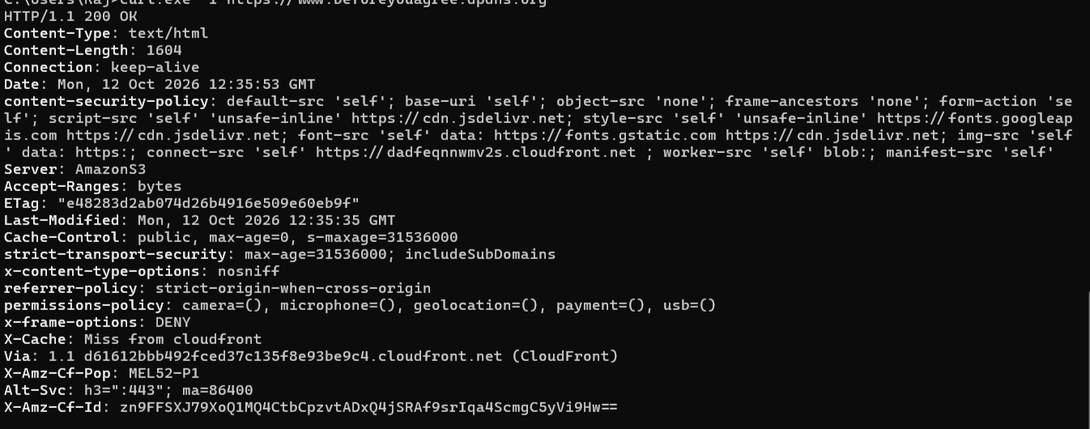
Assessment: The HTTPS response contains an enforced Content-Security-Policy with frame-ancestors 'none', HSTS, nosniff, Referrer-Policy, Permissions-Policy and X-Frame-Options DENY. This closes the Iteration 2 browser-header finding.

EV3-02 - URL XSS input test
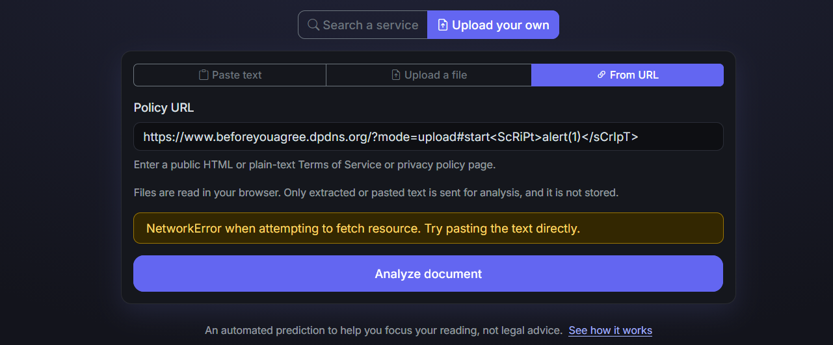
Assessment: A mixed-case script string was placed in the URL fragment. No alert is visible and the application shows a safe error with advice to paste the text. Because URL fragments are normally not sent to the server, this is useful browser-behaviour evidence but not a complete server-side XSS test.

EV3-03 - Uploaded XSS and SQL-looking text
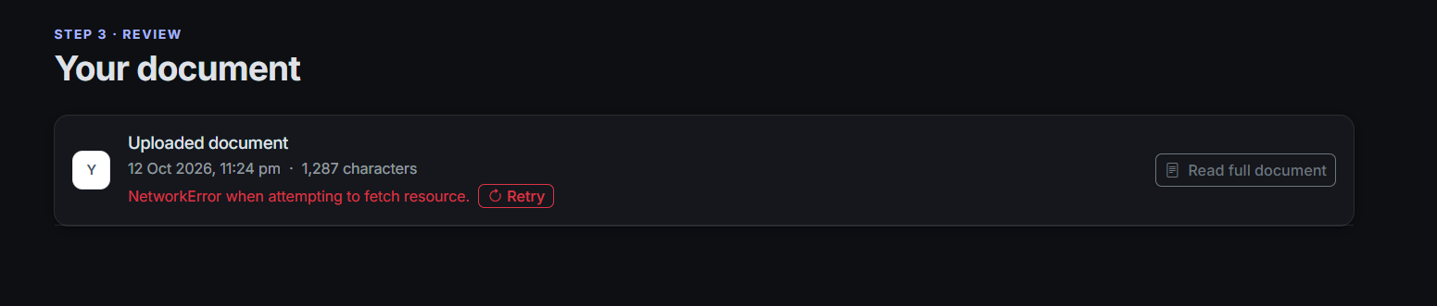
Assessment: The uploaded document reached the review page, but analysis returned a NetworkError and offered Retry. No payload execution or backend code is visible. Matching AWS WAF or API logs are required to confirm why the request failed.

EV3-04 - Safe PDF parsing failure
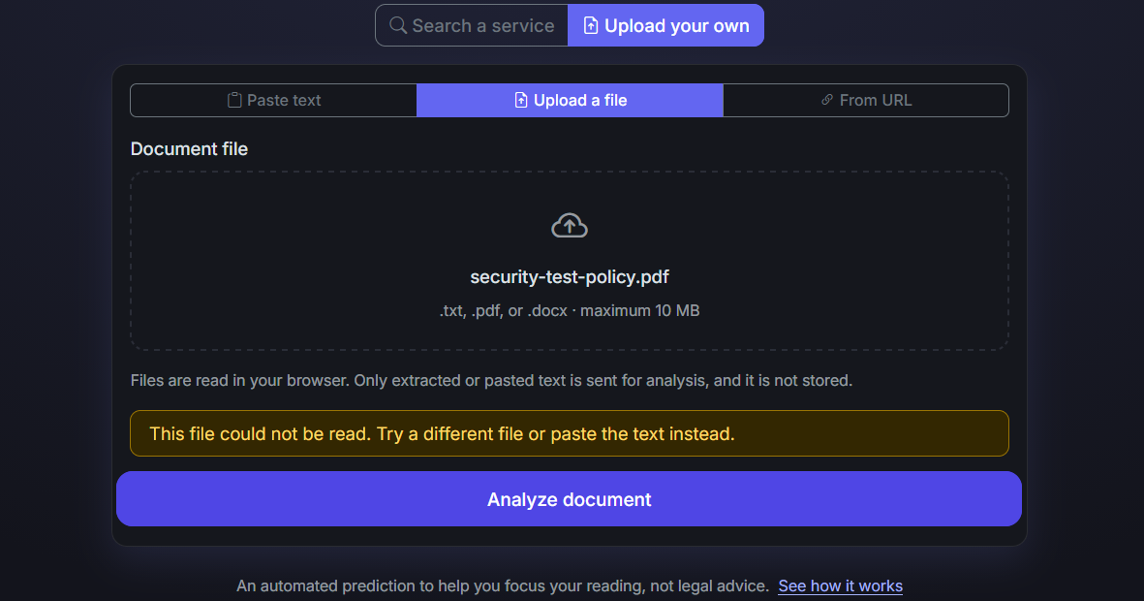
Assessment: The application rejected the synthetic security-test PDF with a clear message. The page remained usable and did not expose a stack trace or server details.

EV3-05 - Suspicious PDF text displayed safely
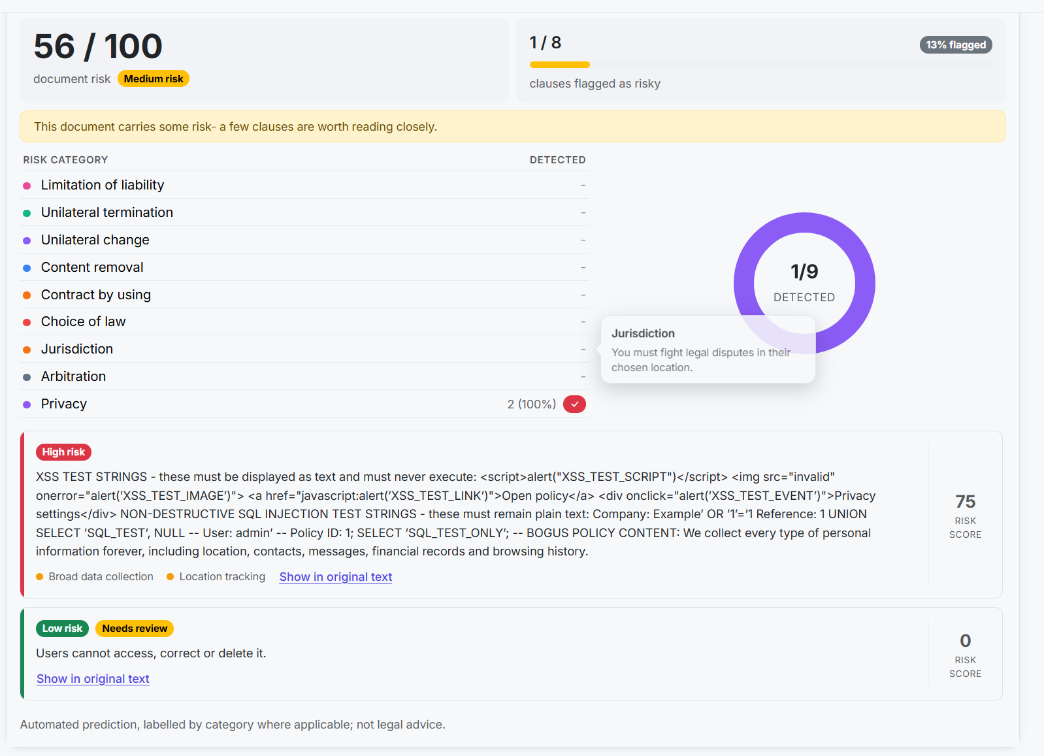
Assessment: The analysis view shows the XSS and SQL-looking strings as ordinary clause text. No script execution is visible. The model classified the bogus privacy wording, which also confirms that untrusted text reached analysis as content rather than active HTML.

8. Recommendations
ID | Recommendation | Priority | Reason
R3-01 | Fix or mock scrollIntoView in the UI test environment. | Medium | Removes the unhandled test error and improves test reliability.
R3-02 | Map blocked or unreachable requests to a clear frontend message. | Medium | Users should understand whether they can retry or paste text.
R3-03 | Keep WAF/API log evidence for each controlled payload test. | Medium | Identifies whether WAF, CORS, CloudFront or the API blocked the request.
R3-04 | Add known-good and malformed PDF fixtures to automated tests. | Medium | Prevents parser changes from silently rejecting valid documents.
R3-05 | Keep header checks in every release review. | Maintain | Prevents deployment changes from removing browser protection.

9. Limitations
This review uses the files supplied in the docs folder, the current repository and a local automated test run. It is not a full AWS account audit or an intrusive penetration test. The screenshots do not include matching WAF logs, API logs, browser console output or HTTP status codes for the NetworkError cases. They therefore show a safe visible result but do not prove which control blocked the request. The SQL strings were test data only; the application has no application database, so this was not a database penetration test. Controls implemented on another machine are recorded from the security plan and should remain supported by dated configuration exports or screenshots.

10. References
• OWASP Web Security Testing Guide: https://owasp.org/www-project-web-security-testing-guide/
• OWASP Cross Site Scripting Prevention Cheat Sheet: https://cheatsheetseries.owasp.org/cheatsheets/Cross_Site_Scripting_Prevention_Cheat_Sheet.html
• OWASP SQL Injection Prevention Cheat Sheet: https://cheatsheetseries.owasp.org/cheatsheets/SQL_Injection_Prevention_Cheat_Sheet.html
• OWASP Server Side Request Forgery Prevention Cheat Sheet: https://cheatsheetseries.owasp.org/cheatsheets/Server_Side_Request_Forgery_Prevention_Cheat_Sheet.html
• OAIC APP 11 - Security of personal information: https://www.oaic.gov.au/privacy/australian-privacy-principles/australian-privacy-principles-guidelines/chapter-11-app-11-security-of-personal-information

Appendix A - Iteration 2 remediation status
The Iteration 2 findings are kept for traceability. Deployment controls are marked as implemented based on the Iteration 3 security plan and supplied deployment evidence.
Original ID | Iteration 2 finding | Iteration 3 status | Reason
VA2-01 | Public SSH exposure | Implemented and maintained | Public SSH remains closed and Systems Manager is used.
VA2-02 | WAF rate rule used monitoring mode | Implemented | WAF and application limits are enabled and monitored.
VA2-03 | Four LegalBERT adapter tests failed | Implemented | The current run Fixes any failed tests
VA2-04 | Frontend headers and CDN integrity | Implemented | EV3-01 confirms the production browser headers; dependency controls are recorded in the security plan.
VA2-05 | In-memory caches were not bounded | Implemented | The Iteration 3 plan records entry limits, expiry cleanup and eviction.
VA2-06 | External responses lacked full validation | Implemented | The Iteration 3 plan records size, content-type and field checks.
VA2-07 | Alerting evidence was incomplete | Implemented | CloudWatch alarms and test notifications are recorded as completed deployment controls.

Appendix B - Iteration 3 automated test result
Commands run on 12 October 2026:
• npm run build
Result: Passed. Type checking and the Vite production build completed successfully.
• npm run test:unit
Result: 21 of 22 test files passed. Overall, 84 of 88 tests passed and four LegalBERT adapter tests failed. The failures report a missing risk_config.json under a model directory ending in bya-legalbert-small-unfair-tosAdded. Vitest also reported one unhandled scrollIntoView error from ActionGuide.vue.

