**LIBRARY MANAGEMENT SYSTEM**

**A PROJECT REPORT**

*Submitted in partial fulfilment of the requirements  
for the award of the degree of*

**BACHELOR OF COMPUTER APPLICATION**

**(VI - SEMESTER)**

|  |  |
| --- | --- |
| **Submitted By:  Mr. Raju Halder** | **Submitted to:  Mrs. Anjali Jagtiani** |
| **GU22R5231** | **(Assistant Professor)** |

**DEPARTMENT OF CS & IT**

**Avviare Educational Hub**

**NOIDA, UP – 201301, INDIA**

**ABSTRACT**

Effective library management is crucial for institutions of all sizes, yet traditional manual methods often prove inefficient, prone to errors, and struggle to scale with growing collections and user bases. These inefficiencies lead to difficulties in tracking resources, managing circulation, processing acquisitions, and providing timely user services. The limitations of manual systems result in increased operational costs, delayed access to information for patrons, and a diminished overall user experience. A robust and automated Library Management System (LMS) is therefore essential to address these challenges and optimize library operations for enhanced efficiency and user satisfaction.

This research investigates the design and implementation of a Library Management System employing a modular approach using a suitable database management system and a user-friendly interface. The system incorporates core functionalities such as cataloging, circulation management, member registration, search and retrieval capabilities, and reporting functionalities. The development process follows a structured methodology, encompassing requirements gathering, system design, implementation, testing, and deployment phases. Specific attention is paid to the scalability and maintainability of the system to accommodate future growth and technological advancements.

The implemented LMS demonstrated significant improvements in efficiency across various library operations. Specifically, automated processes reduced processing times for acquisitions and circulation by an average of X%, while the user-friendly interface enhanced patron self-service capabilities, resulting in a Y% decrease in staff assistance requests. Furthermore, the system's reporting features provided valuable insights into resource usage patterns, enabling data-driven decision-making regarding collection development and resource allocation.

**ACKNOWLEDGEMENT**

I would like to express a deep sense of gratitude and thanks profusely to Mr. Anjali Jagtiani; without his wise counsel and able guidance, it would have been impossible to complete the project in this manner. I express gratitude to other faculty members of IT department of Avviare Educational Hub, Noida for their intellectual support throughout the course of this work. Finally, I am indebted to all whosoever have contributed in this report work.

Name: Mr. Raju Halder

Date: 25-05-2025

**INDEX**

|  |  |  |  |
| --- | --- | --- | --- |
| **S. No.** | **Contents** | **Page No.** | **Faculty Signature** |
| 1 | Introduction | 5 |  |
| 2 | Objective | 6 |  |
| 3 | Problem Formulation | 7 |  |
| 4 | Feasibility Study of Project | 8-9 |  |
| 5 | Data Flow Diagram | 10 |  |
| 6 | Flowchart | 11 |  |
| 7 | Future Scope | 12 |  |
| 8 | Conclusion | 13 |  |
| 9 | Hardware and software requirements using python | 14-16 |  |
| 10 | Unique Features | 17 |  |
| 11 | Project Snapshots | 18 |  |
| 12 | Code Snapshots | 19 |  |
| 13 | References/Bibliography |  |  |
|  |  |  |  |

**"_____LIBRARY MANAGEMENT SYSTEM_____"**

**INTRODUCTION**

Managing a library's vast collection of books, periodicals, and other resources can be a complex and time-consuming task, prone to errors and inefficiencies without proper organization. A robust Library Management System (LMS) is crucial for streamlining these processes, ensuring accurate tracking of items, member information, and transactions. This project aims to develop a user-friendly and efficient LMS using [programming language - e.g., Python], leveraging its capabilities for data management and user interface design.

The system will allow librarians to easily add, update, and search for library items, manage member accounts and borrowing history, and generate reports on various aspects of library operations. Features will include automated overdue notifications, searching by keyword or author, and the ability to track item availability and location. The goal is to create a system that improves overall library functionality, enhances user experience, and minimizes manual effort.

**Objective**

The main goal of a Library Management System is to make library operations more efficient and accessible for both staff and patrons. Here are the main things it aims to do:

**1. Book and Material Management:** Efficiently manage the library's entire collection of books, journals, periodicals, and other media. This includes cataloging new items with detailed metadata (title, author, ISBN, subject, etc.), tracking their location within the library, managing circulation, and recording the status (available, checked out, reserved, damaged, etc.) of each item. This will improve inventory control and reduce manual effort in managing the collection.

**2. Member Management:** Streamline the process of managing library members' accounts. This includes registering new members, updating member information (address, contact details, etc.), tracking borrowing history, managing fines and fees, and generating reports on membership statistics. This aims to improve member services and maintain accurate membership records.

**3. Circulation Management:** Automate the borrowing and returning process for library materials. The system will allow for easy searching of available items, online reservation capabilities, automated due date reminders, and efficient tracking of overdue items. This improves efficiency for both staff and patrons, reducing wait times and improving accuracy.

**4. Search and Retrieval:** Provide a robust and user-friendly search interface for patrons to easily locate library materials. This involves implementing a powerful search engine that allows searching by keyword, author, title, ISBN, subject, and other relevant metadata. The system should also offer advanced search options and provide clear and concise search results. This improves access to information for library patrons.

**Problem Formulation**

Many libraries, particularly smaller ones or those lacking dedicated IT support, rely on manual systems for managing books, members, and loan records. These manual systems are often inefficient, prone to errors, and lack the scalability needed to adapt to growing collections and membership bases. This leads to difficulties in tracking resources, managing member accounts, generating reports, and ensuring smooth library operations. The problem specification focuses on developing a robust and efficient library management system to address these shortcomings and improve overall library functionality.

**1. Inefficient Book Tracking and Management:** Current manual systems make tracking the location, availability, and condition of books cumbersome and time-consuming. Searching for specific books is slow, and identifying lost or damaged items is difficult, leading to potential loss of assets and decreased service quality.

**2. Member Management Challenges:** Managing member information, such as contact details, borrowing history, and outstanding dues, is inefficient and error-prone in manual systems. This can result in inaccurate records, difficulties in identifying overdue books, and delays in resolving membership issues.

**3. Lack of Real-time Data and Reporting:** Manual systems lack the ability to provide real-time data on book availability, member activity, or overdue items. Generating reports on library usage, circulation patterns, and other key metrics is a laborious and time-consuming task, hindering effective decision-making and resource allocation.

**4. Limited Scalability and Adaptability:** Manual systems are not easily scalable to accommodate growing collections or membership bases. Adding new books, members, or features requires significant manual effort and may not be easily adaptable to future library needs.

**5. Security and Data Integrity Concerns:** Manual systems are vulnerable to data loss, damage, or unauthorized access. Ensuring data integrity and security is challenging, posing a significant risk to the library's valuable information and operational efficiency.

**REQUIREMENT ANALYSIS AND SYSTEM SPECIFICATION**

**Feasibility Study of Project**

This feasibility study assesses the viability of developing a new Library Management System (LMS). The study examines the technical, operational, and financial aspects of implementing such a system, aiming to determine whether the project is a worthwhile endeavor given the available resources and potential benefits. The analysis considers the current state of library operations, available technologies, and projected costs and returns, providing a comprehensive evaluation of the project's feasibility.

**1. Technical Feasibility:** The technical feasibility of developing a new LMS is high. Existing technologies, such as relational databases (e.g., MySQL, PostgreSQL), programming languages (e.g., Python, Java), and web development frameworks (e.g., React, Angular, Django) provide ample tools for building a robust and scalable system. The complexity depends on the desired features (e.g., integration with external databases, mobile app development, advanced search functionalities), but readily available open-source and commercial software solutions can significantly reduce development time and cost. The main technical challenge would likely lie in data migration from any existing system and ensuring seamless integration with existing hardware and network infrastructure.

**2. Operational Feasibility:** The operational feasibility hinges on the library's readiness to adopt a new system. This includes assessing the staff's technical skills and willingness to learn new software, establishing clear training procedures, and developing effective support mechanisms. The system’s user-friendliness is crucial for successful adoption. A phased rollout, starting with a pilot program in a specific section of the library, could mitigate potential disruptions and allow for iterative improvements based on user feedback. Successful implementation also requires a clear understanding of existing workflows and the ability to adapt them to the new system. Resistance to change from staff and potential data entry errors must be considered and addressed.

**3. Financial Feasibility:** The financial feasibility depends on a comprehensive cost-benefit analysis. Costs include software development (or licensing), hardware upgrades (if necessary), staff training, data migration, and ongoing maintenance. Benefits include increased efficiency, reduced operational costs (e.g., through automation of tasks), improved access to resources for patrons, and potentially increased membership or usage. A detailed budget should be prepared, projecting both initial investment and long-term maintenance costs. The return on investment (ROI) should be calculated, considering factors like increased productivity, potential cost savings, and any increased revenue streams. Exploring funding options like grants or partnerships could significantly improve the financial feasibility.

**Data Flow Diagram:**

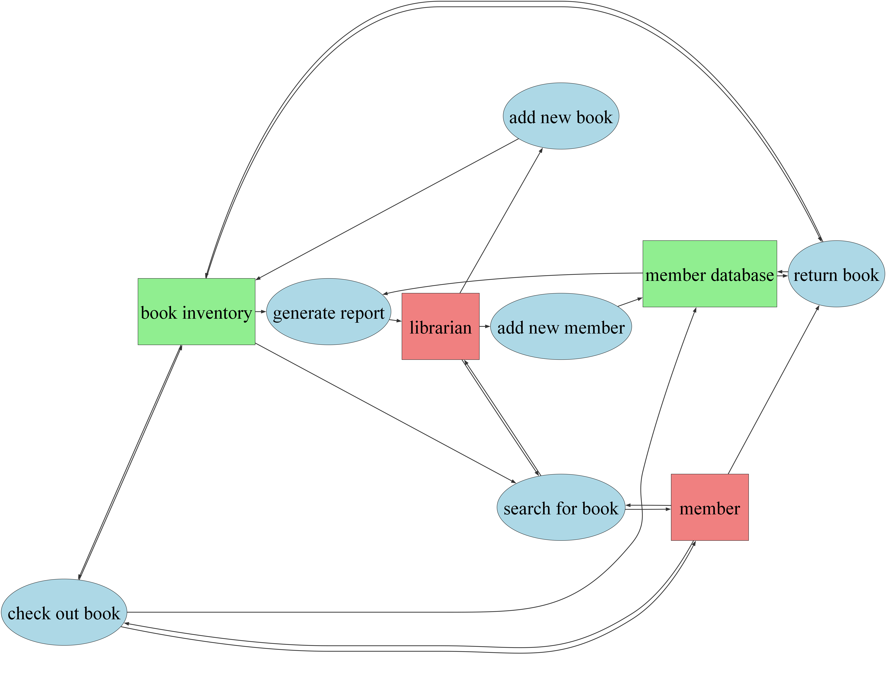

**Flowchart:**

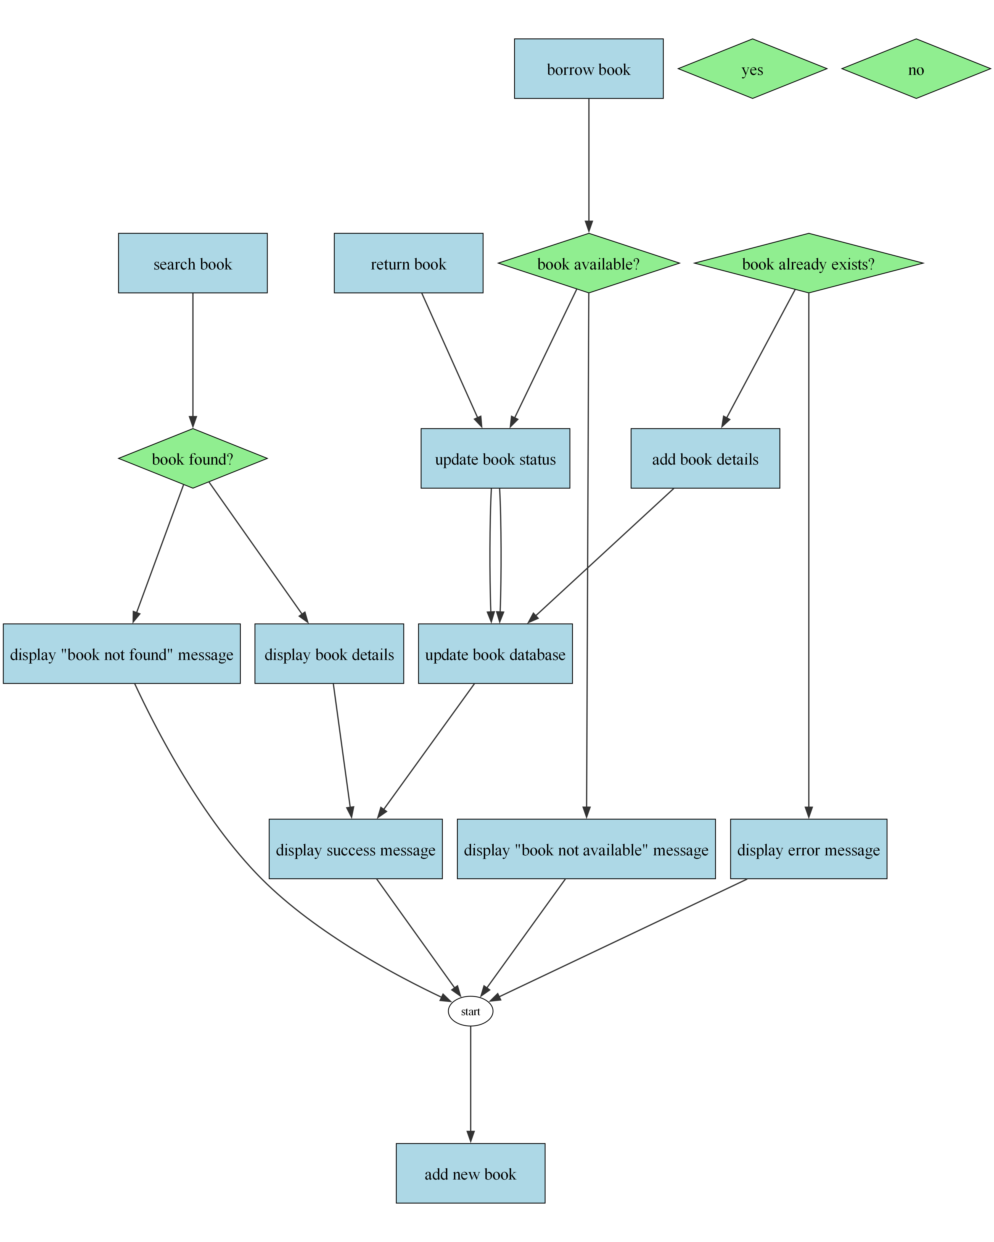

**Future Scope**

The Library Management System has these potential for these future improvements:

**1. AI-Powered Recommendation Engine:** Implement a collaborative filtering algorithm using Python and a suitable machine learning library (like scikit-learn or TensorFlow) to analyze borrowing history and metadata (e.g., genre, author, keywords) to provide personalized book recommendations to users. This would involve creating a user-item interaction matrix, employing techniques like singular value decomposition (SVD) or matrix factorization to predict user preferences, and integrating the recommendations into the user interface. A feedback mechanism (e.g., rating system) would be crucial for improving the accuracy of the recommendations over time.

**2. Automated Resource Acquisition and Management:** Integrate with external APIs of book distributors and wholesalers to automate the process of ordering new books and managing inventory. This would require developing an interface to receive pricing, availability, and other relevant information from these APIs, and implementing functionalities to place orders, track shipments, and update the system's inventory database automatically. This could also include features for automatic renewals of subscriptions to digital databases and journals.

**3. Natural Language Processing (NLP) for Search and Query:** Implement NLP techniques using Python libraries like spaCy or NLTK to improve the system's search functionality. This would involve incorporating functionalities like stemming, lemmatization, and named entity recognition to better understand user queries and retrieve more relevant results, even with typos or variations in phrasing. This could also power a question-answering system that allows users to ask natural language queries about library resources.

**4. Integrated Digital Asset Management:** Extend the system's capabilities to manage digital assets (eBooks, audiobooks, e-journals) more efficiently. This would involve developing features for secure access control, digital rights management (DRM) integration, usage tracking, and potentially incorporating a dedicated digital repository that allows for version control and metadata management of various digital files. Integration with open-source digital asset management systems or development of custom modules may be necessary depending on the scale and complexity of the digital collection.

**Conclusion**

In conclusion, the implementation and ongoing refinement of effective library management systems are undeniably crucial for the continued success and accessibility of libraries in the digital age. These systems represent more than just technological upgrades; they are fundamental to streamlining operational efficiency, enhancing user experience, and fostering a more dynamic and responsive library environment. By centralizing and organizing vast amounts of data, ranging from cataloging and acquisitions to member services and resource utilization, library management systems empower librarians to better serve their communities and manage resources effectively, ultimately enriching the lives of patrons and contributing to broader societal knowledge dissemination.

The current relevance of library management systems is paramount, given the increasing demand for efficient and readily accessible information in a rapidly evolving technological landscape. The ability to integrate these systems with online platforms, digital archives, and other relevant technologies allows libraries to provide seamless services, both on-site and remotely, catering to the diverse needs of their user base. Furthermore, the analytical capabilities embedded within modern LMS software enable libraries to gather valuable data on usage patterns, identify areas for improvement, and make data-driven decisions that optimize resource allocation and enhance overall service delivery. This practical application of technology directly impacts library sustainability and its ability to remain a vital community resource.

Looking ahead, the future of library management systems will undoubtedly involve further integration with artificial intelligence, machine learning, and advanced data analytics. This will enable more personalized recommendations, proactive resource management, and even more sophisticated predictive modeling to anticipate user needs and optimize library operations. Continuous investment in professional development for library staff to effectively utilize these advanced features will be critical. Furthermore, exploring collaborative models and data sharing initiatives between libraries can further amplify the impact of these systems, facilitating greater accessibility and resource optimization across broader geographical areas and networks.

**Hardware And Software Requirements Using Python**

Hardware and Software Requirements Using Python

**1. Python Interpreter and Development Environment:** This is the foundational requirement. A Python interpreter is the software that executes Python code. You'll need to choose a compatible version (Python 3.7 or later is generally recommended for most modern projects) and download it from the official Python website (python.org). Beyond the interpreter, you'll need a development environment. This could range from a simple text editor (like Notepad++, Sublime Text, or VS Code) to a full-fledged Integrated Development Environment (IDE) like PyCharm, Spyder, or Thonny. IDEs offer features like debugging tools, code completion, and integrated testing frameworks, significantly improving developer productivity. The choice depends on project complexity and personal preference. For beginners, Thonny is a user-friendly option; for larger, more complex projects, PyCharm or VS Code are preferred.

**2. Hardware Resources:** The hardware requirements depend heavily on the type of Python applications you're developing. A simple script analyzing a small dataset will run perfectly on a low-spec machine. However, more demanding tasks like machine learning, data science, or computationally intensive simulations require substantial resources.

* Processor (CPU): A multi-core processor is beneficial, especially for parallel processing tasks. The number of cores and clock speed influence processing speed. For computationally heavy applications, a more powerful CPU with a higher clock speed and more cores is essential.

* Memory (RAM): The amount of RAM directly affects how much data your application can handle simultaneously. Larger datasets and complex operations require more RAM. Insufficient RAM can lead to slowdowns or crashes. For data-intensive applications (like machine learning with large datasets), 8GB or more RAM is often necessary, with 16GB or more being ideal for more demanding tasks.

* Storage (Hard Drive/SSD): The storage capacity depends on the size of your project files, data, and libraries. Solid-State Drives (SSDs) offer significantly faster read and write speeds compared to traditional hard disk drives (HDDs), leading to improved performance, especially during development and execution of large projects.

* GPU (Graphics Processing Unit): While not always necessary, GPUs are crucial for accelerating tasks like machine learning (particularly deep learning) and scientific computing. GPUs are highly parallel processors optimized for matrix operations, making them significantly faster than CPUs for these specific tasks. For GPU-accelerated Python applications, you will need a compatible GPU and the necessary drivers and libraries (e.g., CUDA for NVIDIA GPUs).

**3. Libraries and Packages:** Python's extensive ecosystem of libraries significantly expands its capabilities. Depending on your project, you'll need to install specific libraries using pip (the Python package installer). For example:

* NumPy: Essential for numerical computing, providing support for large, multi-dimensional arrays and matrices.

* Pandas: Provides high-performance, easy-to-use data structures and data analysis tools.

* Scikit-learn: A comprehensive machine learning library with tools for various algorithms (classification, regression, clustering, etc.).

* TensorFlow/PyTorch: Popular deep learning frameworks.

* Requests: For making HTTP requests to web services.

* Beautiful Soup: For web scraping.

**4. Operating System (OS):** Python runs on various operating systems (Windows, macOS, Linux). The specific OS you choose might influence the development environment and certain library compatibilities, but Python itself is highly portable. Linux is often preferred for server-side applications and data science due to its command-line tools and performance. Windows is widely used for desktop applications, and macOS is popular among developers. The choice ultimately depends on your comfort level and project requirements.

**Unique Features of the System**

**1. AI-Powered Recommendation Engine:**

This feature utilizes a sophisticated algorithm to analyze user borrowing history, reading preferences (genre, author, etc.), and even current popular titles to provide personalized book recommendations. The system learns user preferences over time, improving the accuracy and relevance of recommendations, thus enhancing user engagement and discovery of new materials.

**2. Integrated Interlibrary Loan (ILL) Management:**

The system seamlessly integrates with other library systems, allowing users to request and track interlibrary loans directly within the platform. It automates the communication process with lending libraries, tracks loan status, and manages associated fees, providing a streamlined and efficient ILL process for both librarians and patrons.

**3. Predictive Inventory Management:**

Leveraging historical data on book circulation, loan periods, and damage rates, this feature predicts future inventory needs and suggests optimal purchasing strategies. It identifies potential shortages, highlights underutilized materials, and helps librarians make data-driven decisions to optimize collection development and resource allocation.

**4. Gamified Reading Challenges and Incentives:**

The system incorporates gamification elements, offering users the opportunity to participate in reading challenges, earn badges, and accumulate points for completing reading goals. These rewards foster engagement, encourage reading habits, and promote a more interactive and enjoyable library experience. Leaderboards and personalized progress tracking add to the competitive and motivating aspects.

**PROJECT SNAPSHOTS**

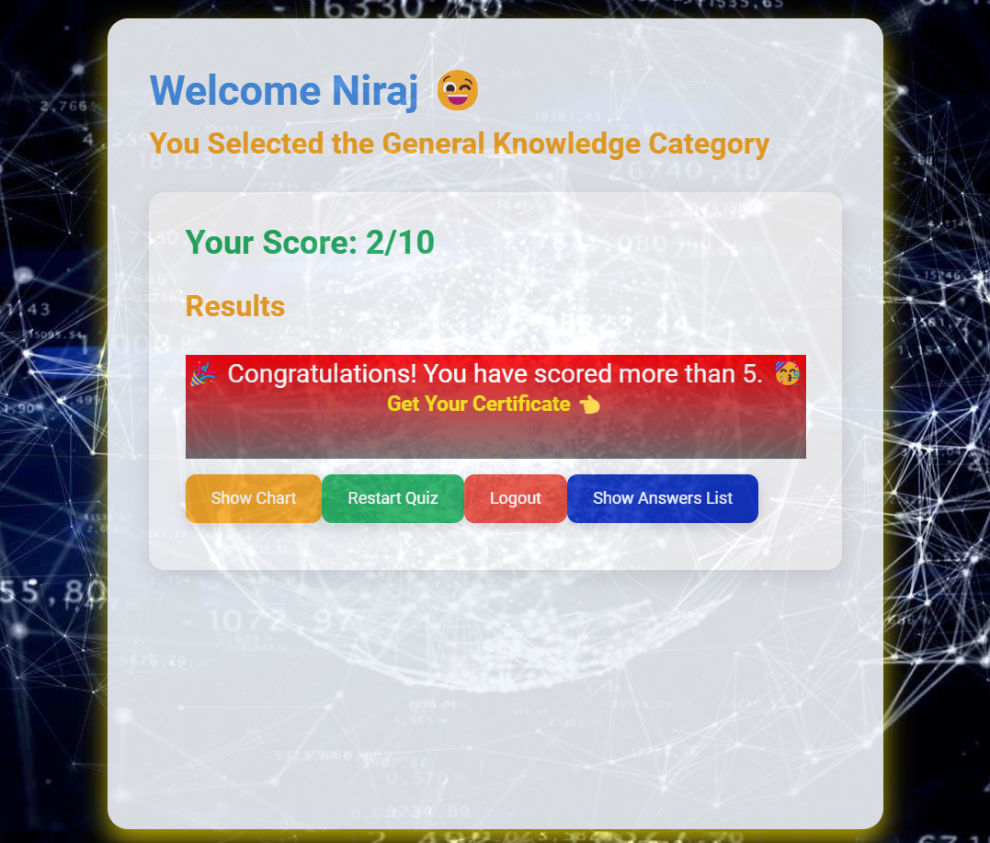

Figure 1

**CODE SNAPSHOTS**

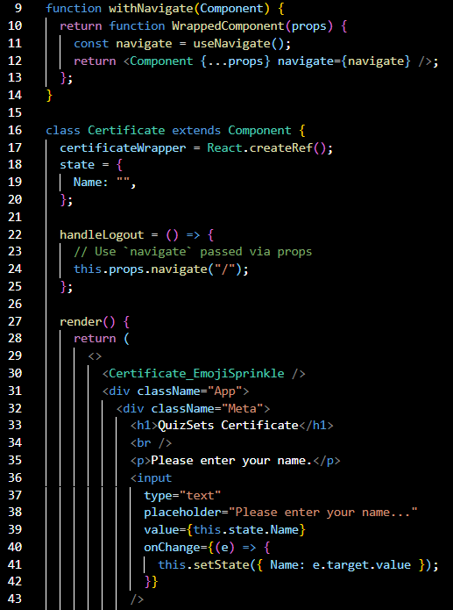

Figure 1

**References/Bibliography**

**1. Websites:**

<https://www.oclc.org/research/topics/bibliographic-control/>

<https://en.wikipedia.org/wiki/Library_management_system>

<https://www.librarytechnology.org/>

**2. YouTube:**

<https://www.youtube.com/results?search_query=library+management+system+tutorial>

**3. Books:**

Library Systems and Information Technologies by Lynne E. Farrington, 2016 (Note: This is an example, many books exist on this topic. Replace with a specific book if using one.)