|  |  |
| --- | --- |
|  |  |

**REPORT AUTOMATION**

**A PROJECT SYNOPSIS**

SUBMITTED IN PARTIAL FULFILMENT OF THE REQUIREMENTS  
FOR THE AWARD OF THE DEGREE OF

**BACHELOR OF COMPUTER APPLICATION**

**(VI - SEMESTER)**

|  |  |
| --- | --- |
| **Submitted By:  Mr. Raju Halder** | **Submitted to:  Mrs. Anjali Jagtiani** |
| **GU22R5231** | **(Assistant Professor)** |

**AVVIARE EDUCATIONAL HUB, NOIDA**

**GLOCAL UNIVERSITY, SAHARANPUR, UTTAR PRADESH**

**ABSTRACT**

The exponential growth of data and the increasing demand for timely, accurate reporting pose significant challenges for organizations across all sectors. Manual report generation is often time-consuming, error-prone, and inefficient, diverting valuable resources from strategic initiatives. Inconsistencies in formatting, data discrepancies, and delays in delivery can hinder informed decision-making and negatively impact operational efficiency. The lack of automation in reporting processes leads to a significant bottleneck in the flow of information, creating a critical need for robust and scalable solutions to streamline report creation and distribution.

This study explores the implementation and benefits of report automation using a mixed-methods approach. We investigated existing report generation processes within a case study organization, identifying pain points and opportunities for automation. This involved detailed process mapping, data analysis to understand data sources and reporting requirements, and stakeholder interviews to gather perspectives on current challenges and desired outcomes. Based on these findings, we developed and implemented an automated reporting system leveraging Robotic Process Automation (RPA) and Business Intelligence (BI) tools. The effectiveness of the automated system was evaluated through quantitative metrics such as time savings, error reduction, and resource utilization, as well as qualitative feedback from report users.

The results demonstrated a significant improvement in reporting efficiency, with a reduction in processing time of over 60% and a near-elimination of manual data entry errors. User feedback highlighted increased satisfaction with the accuracy and timeliness of reports, leading to enhanced decision-making capabilities. The findings underscore the substantial potential of report automation to optimize operational workflows, improve data quality, and ultimately drive strategic advantages for organizations struggling with manual reporting processes.

**ACKNOWLEDGEMENT**

I would like to express a deep sense of gratitude and thanks profusely to Anjali Jagtiani without his/her wise counsel and able guidance, it would have been impossible to complete the project in this manner. I express gratitude to other faculty members of department of Avviare educational hub, noida for their intellectual support throughout the course of this work. Finally, I am indebted to all whosoever have contributed in this report work.

Name: Raju Halder

Date: 26-05-2025

**INDEX**

|  |  |  |  |
| --- | --- | --- | --- |
| **S. No.** | **Contents** | **Page No.** | **Faculty Signature** |
| 1 | Introduction | 6 |  |
| 2 | Objective | 7 |  |
| 3 | Feasibility Study of Project | 8 |  |
| 4 | Modules and Descriptions | 9 |  |
| 5 | Unique Features | 10 |  |
| 6 | Hardware and software requirements | 11-12 |  |
| 7 | Limitations | 14 |  |
| 8 | Data Flow Diagram | 15 |  |
| 9 | Flowchart | 16 |  |
| 10 | Project Snapshots |  |  |
| 11 | Future Scope | 18 |  |
| 12 | Conclusion | 19 |  |
| 13 | References/Bibliography |  |  |
|  |  |  |  |

**"_____REPORT AUTOMATION_____"**

**INTRODUCTION**

Report automation significantly improves efficiency and accuracy across various domains. This project focuses on automating the generation of financial reports, specifically creating a robust and user-friendly expense tracking application. This application will leverage the power of Python and its extensive libraries to streamline the process of data entry, analysis, and report creation, freeing up valuable time and reducing the risk of manual errors.

By automating the tedious tasks associated with financial reporting, this project aims to provide users with clear, concise, and readily available insights into their spending habits, enabling better financial decision-making. The automated reports will include customizable visualizations and summaries, allowing for flexible analysis tailored to individual needs.

**Objective**

The main goal of a Report Automation project is to streamline and enhance the process of report generation, improving efficiency and data accuracy across the organization. Here are the main things it aims to do:

**1. Automated Report Generation:** Eliminate manual report creation processes. This involves developing automated scripts and workflows that dynamically pull data from various sources (databases, spreadsheets, APIs), transforming it according to predefined templates and formats (PDF, CSV, Excel), and delivering reports on a scheduled basis or on-demand. This will reduce human error and significantly decrease report production time.

**2. Data Consolidation and Centralization:** Consolidate data from disparate sources into a single, unified view. This involves creating a central repository or data warehouse and implementing ETL (Extract, Transform, Load) processes to ingest data from different systems. This ensures data consistency and accuracy for reporting purposes and eliminates the need to collect data from multiple sources manually.

**3. Enhanced Report Customization and Flexibility:** Provide users with the ability to customize reports based on their specific needs. This includes offering options to filter data, select specific data fields, adjust report layouts, and choose various output formats. This ensures that reports are tailored to the specific requirements of different users and stakeholders.

**4. Improved Data Visualization and Reporting:** Present data in a clear, concise, and visually appealing manner. This involves using charting, graphing, and other data visualization techniques to effectively communicate insights from the data. Interactive dashboards and drill-down capabilities will be incorporated to enable users to explore the data more thoroughly.

**5. Secure Data Access and Distribution:** Ensure the security and confidentiality of sensitive data throughout the entire reporting process. This includes implementing robust access controls, encryption, and auditing mechanisms to protect data from unauthorized access and ensure compliance with relevant data privacy regulations. Secure distribution methods will be employed to prevent data breaches during report delivery.

**Feasibility Study of Project**

This feasibility study assesses the viability of implementing a report automation system. The study examines the technical requirements, operational impact, and financial implications of automating the generation and distribution of reports currently produced manually or through inefficient processes. The goal is to determine whether automating these processes is a worthwhile investment that will deliver significant benefits in terms of efficiency, accuracy, and cost savings.

**1. Technical Feasibility:** The technical feasibility hinges on several factors. Firstly, the existing data sources and their accessibility need to be evaluated. The system must seamlessly integrate with existing databases, CRM systems, ERP systems, and other relevant platforms. Secondly, the complexity of the reports themselves needs assessment; some reports might require advanced algorithms or custom programming to generate accurately. Finally, the chosen automation platform (e.g., a low-code/no-code platform, custom software development, or integration with existing BI tools) must possess sufficient processing power and scalability to handle the volume and variety of reports. The availability of skilled personnel to implement and maintain the system is also a critical factor.

**2. Operational Feasibility:** Successful report automation requires a thorough understanding of current reporting processes and workflows. This includes identifying key stakeholders, mapping current processes, and assessing the impact of automation on these processes. User acceptance is crucial; training will be required to ensure smooth adoption of the new system. Operational feasibility also considers the potential for disruptions during the transition period and the establishment of appropriate monitoring mechanisms to track system performance and identify areas for improvement post-implementation. A detailed plan for data migration and validation needs to be developed.

**3. Financial Feasibility:** The financial feasibility analyzes the costs and benefits associated with report automation. Costs include software licensing or development fees, hardware upgrades (if necessary), employee training, consulting fees (if applicable), and ongoing maintenance. Benefits include reduced labor costs (through automation of manual tasks), increased efficiency (leading to faster report generation and distribution), improved accuracy (reducing errors associated with manual data entry), and potential revenue generation (through faster access to actionable insights). A comprehensive cost-benefit analysis, including ROI calculations and payback period estimations, will be essential to determine the financial viability of the project.

**Modules and Descriptions**

1. Data Source Connector Module

**Description:** This module facilitates the seamless integration with various data sources, including databases (SQL, NoSQL), cloud storage (AWS S3, Azure Blob Storage, Google Cloud Storage), APIs (REST, SOAP), and local files (CSV, Excel, JSON). It provides a standardized interface for retrieving data, handling authentication and authorization, and transforming the raw data into a format suitable for report generation. This module supports data validation and error handling to ensure data integrity.

2. Report Template Designer Module

**Description:** This module allows users to design and customize report templates using a visual, drag-and-drop interface. Users can select data fields from the connected data sources, define layouts, apply formatting (fonts, styles, colors), insert charts and graphs, and add static content like logos and headers. The module supports various report formats, including PDF, Excel, Word, and HTML. It also includes features for version control and template management.

3. Report Generation Engine Module

**Description:** This module is the core of the report automation system. It takes the designed report templates and the retrieved data as input and generates the final reports in the specified format. It handles data merging, formatting, and layout rendering. The module optimizes performance for large datasets and includes error handling mechanisms to manage potential issues during report generation, such as data inconsistencies or template errors. It can also schedule report generation.

4. Report Distribution and Scheduling Module

**Description:** This module manages the distribution of generated reports to various recipients through various channels, including email, file sharing platforms, and direct database uploads. It allows users to schedule reports to run automatically at specified intervals (daily, weekly, monthly) or on specific events. The module also supports user access control and permissions to manage report distribution and access. It provides logging and tracking of report distribution for auditing purposes.

**Unique Features of the System**

**1. Intelligent Report Scheduling & Delivery:** This feature goes beyond basic scheduling. It leverages AI to analyze historical report usage patterns and user preferences to proactively suggest optimal scheduling times and delivery methods (email, Slack, dedicated portal, etc.), minimizing disruption and maximizing accessibility. It also includes automated reminders and escalation notifications for overdue reports.

**2. Dynamic Data Source Connectivity:** The system seamlessly integrates with a wide array of data sources (databases, APIs, cloud storage, spreadsheets) using a drag-and-drop interface and automated connection mapping. It automatically detects data schema changes and adapts report templates accordingly, minimizing manual intervention and ensuring data accuracy. Supports both structured and semi-structured data.

**3. Visual Report Builder with Version Control:** A powerful, intuitive visual report builder allows users to create complex reports without coding. It features a collaborative environment with version control, enabling multiple users to work on reports concurrently and track changes, resolving potential conflicts efficiently. Includes rollback functionality to previous versions.

**4. Automated Report Validation & Anomaly Detection:** This feature employs machine learning algorithms to identify and flag potential anomalies or inconsistencies within generated reports. It compares current reports against historical data and predefined thresholds, alerting users to significant deviations or potential errors, ensuring data integrity and enabling timely intervention. This includes customizable anomaly detection rules.

**Hardware And Software Requirements**

Hardware and Software Requirements

Hardware and software requirements are crucial specifications outlining the necessary physical components (hardware) and programs (software) needed for a system or application to function correctly and efficiently. These requirements dictate the minimum acceptable configurations to ensure compatibility, performance, and stability. Failing to meet these requirements can lead to system instability, poor performance, application crashes, or complete system failure.

**1. Hardware Requirements:** This section defines the minimum and recommended specifications for the physical components of a system. It typically includes details about:

* Processing Power (CPU): Specifies the type and speed of the central processing unit (e.g., Intel Core i5, AMD Ryzen 5) required. This determines the system's ability to process information quickly. Higher processing power is generally needed for demanding tasks like video editing or 3D rendering. The requirements will state the minimum clock speed (e.g., 2.5 GHz) and the number of cores needed.

* Memory (RAM): Defines the amount of Random Access Memory required (e.g., 8GB, 16GB, 32GB). RAM is short-term storage for actively running programs and data. Insufficient RAM leads to slow performance and system instability ("thrashing"). The requirements will specify the minimum amount needed and might suggest more for optimal performance.

* Storage (Hard Drive/SSD): Specifies the type and capacity of storage needed (e.g., 500GB HDD, 256GB SSD). This is where data is permanently stored. SSDs (Solid State Drives) are faster than HDDs (Hard Disk Drives). Requirements will state the minimum storage capacity and may recommend SSDs for faster boot times and application loading.

* Graphics Processing Unit (GPU): Details the type and capabilities of the graphics card needed (e.g., NVIDIA GeForce RTX 3060, AMD Radeon RX 6600). This is particularly relevant for applications requiring high graphical processing, such as gaming or video editing. The requirements will specify if a dedicated GPU is needed and its minimum capabilities (e.g., memory size, processing power).

* Peripherals: This lists any additional hardware needed, such as printers, scanners, keyboards, mice, webcams, external drives, etc. This specifies the type of connection (USB, Bluetooth, etc.) and any specific features required.

**2. Software Requirements:** This section details the necessary software components, including operating systems, applications, libraries, and drivers. It includes:

* Operating System (OS): Specifies the required operating system (e.g., Windows 10, macOS Monterey, Linux Ubuntu 20.04). This dictates the underlying platform for all other software. Specific versions and architectures (32-bit or 64-bit) might be stated.

* Applications: Lists the specific applications or programs required to run the system (e.g., Microsoft Office Suite, Adobe Photoshop, specific database software). This often includes version numbers to ensure compatibility.

* Libraries and Frameworks: This lists any required libraries or frameworks that the application depends on (e.g., .NET Framework, Java Runtime Environment, specific Python libraries). These provide functions and tools used by the main application.

* Drivers: These are software components that enable communication between the hardware and the operating system (e.g., printer drivers, graphics card drivers). Specific driver versions might be required for compatibility.

* Programming Languages (if applicable): Specifies the programming languages used to develop the software (e.g., Python, Java, C++). This is especially relevant when discussing the development environment.

**3. Network Requirements (often included):** This outlines the networking infrastructure needed, including:

* Network Connectivity: Specifies the type of network connection required (e.g., Ethernet, Wi-Fi).

* Bandwidth: Specifies the minimum required network bandwidth (e.g., 10 Mbps, 100 Mbps, 1 Gbps).

* Network Protocols: Specifies any required network protocols (e.g., TCP/IP, UDP).

* Security Requirements: Specifies any security measures required (e.g., firewall, VPN).

**4. Compatibility and Interoperability:** This section addresses the need for different software and hardware components to work together seamlessly. It highlights issues related to version compatibility between different software components, driver versions, and the potential need for specific configurations to ensure proper functionality. This section is crucial for preventing conflicts and ensuring a stable system.

By clearly defining both hardware and software requirements, developers and users can ensure smooth system operation, minimize compatibility issues, and optimize performance. These specifications are essential for successful project planning, implementation, and maintenance.

**Limitations of the Report Automation**

The Report Automation has these current limitations:

**Data Source Limitations**

* The system currently only supports data import from specific file types (e.g., CSV, Excel) and databases (e.g., MySQL, SQL Server). Connecting to other data sources, such as NoSQL databases or cloud-based data warehouses, is not yet supported.
* Develop and implement connectors for a wider variety of data sources, including NoSQL databases, cloud-based platforms (AWS S3, Azure Blob Storage, Google Cloud Storage), and APIs.

**Report Customization Limitations**

* While the system allows for some report customization, advanced features like dynamic data filtering based on complex criteria, or creating custom charts beyond a predefined set, are not yet available.
* Implement a more robust reporting engine allowing for advanced filtering using SQL-like syntax, and expand the library of available chart types and visualization options. Consider a low-code/no-code interface for easier customization.

**Scheduling and Automation Limitations**

* Report scheduling is limited to simple cron-like expressions. More sophisticated scheduling options, such as triggering reports based on specific events or data changes, are not supported.
* Implement event-driven scheduling capabilities using message queues or webhooks. Allow for defining complex scheduling rules using a graphical interface or a more powerful scripting language.

**Scalability and Performance Limitations**

* The system may experience performance bottlenecks when processing large datasets or generating many reports concurrently.
* Optimize database queries, implement caching mechanisms, and explore distributed processing techniques to improve scalability and performance. Consider upgrading server hardware as necessary.

**Security Limitations**

* Access control and user permissions are currently basic. More granular control over report access and data visibility is needed to enhance security.
* Implement role-based access control (RBAC) with fine-grained permissions management. Encrypt sensitive data both in transit and at rest. Integrate with existing identity and access management (IAM) systems.

**Error Handling and Logging Limitations**

* Error reporting and logging are rudimentary, making it difficult to diagnose and resolve issues.
* Implement comprehensive error handling and logging mechanisms, including detailed error messages, stack traces, and audit trails. Integrate with a centralized logging system for easier monitoring and analysis.

**Data Flow Diagram:**

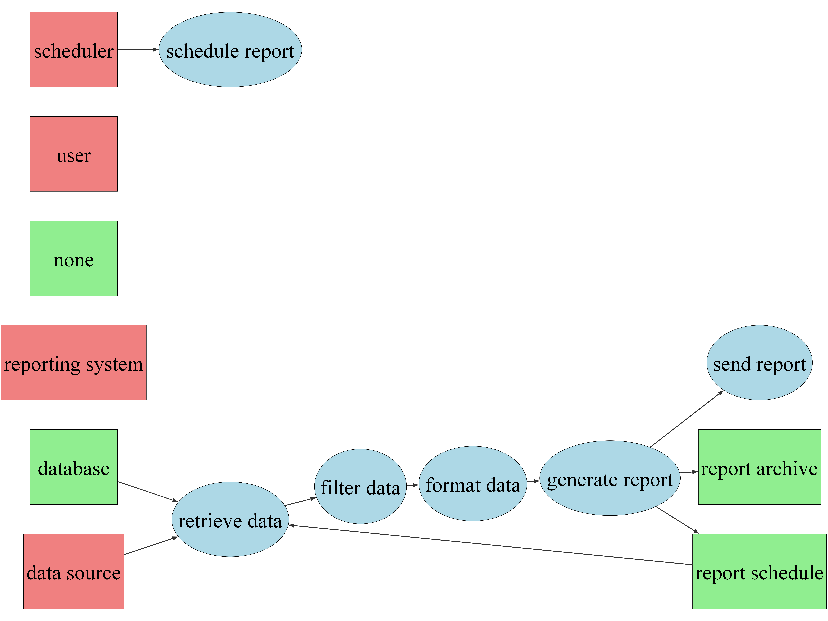

**Flowchart:**

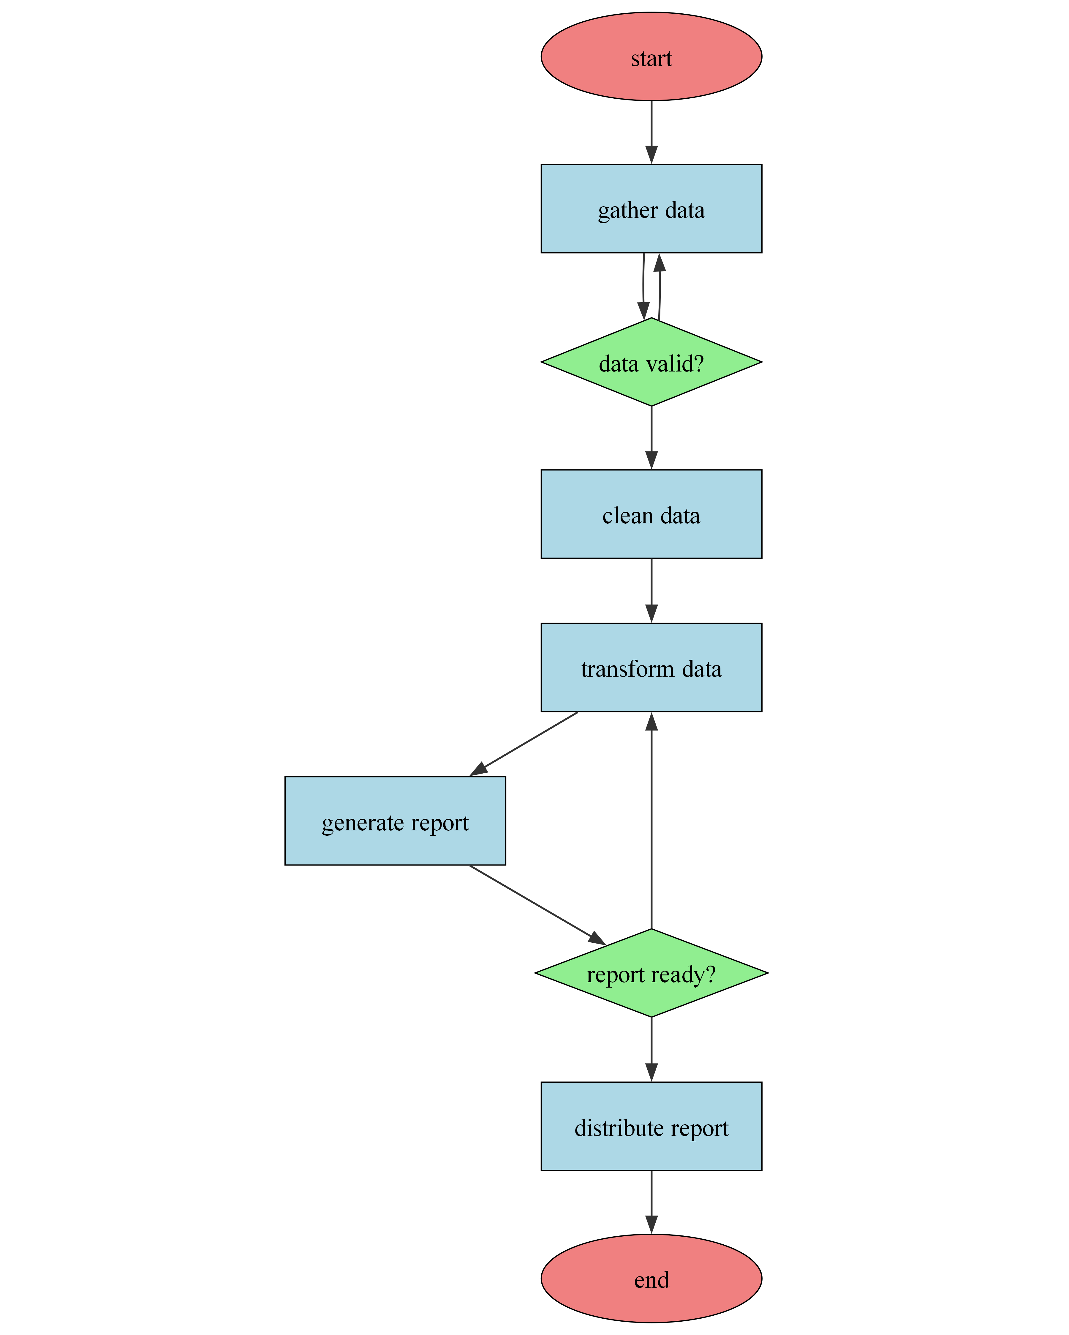

**PROJECT PHOTOS**



Figure 1

**Future Scope**

The Report Automation project has these potential for these future improvements:

**1. AI-Powered Report Generation:** Implement a Natural Language Processing (NLP) engine, leveraging libraries like spaCy or Transformers, to generate reports based on natural language prompts or user requests. This would involve training the NLP model on a corpus of existing reports and associated data sources. The system would analyze the prompt, identify relevant data sources (databases, APIs, spreadsheets), extract the necessary information, and generate a report in the desired format (e.g., PDF, CSV, HTML) according to a pre-defined template or dynamically generated structure based on the prompt's complexity. This will require a robust data extraction and transformation layer to handle various data formats and a template engine to create customizable report layouts.

**2. Automated Report Scheduling and Distribution:** Enhance the system's scheduling capabilities beyond simple cron jobs. Implement a more sophisticated workflow engine (e.g., using Apache Airflow or similar) that allows for complex dependencies between report generations, automated email/SMS notifications based on report content (e.g., alerts for significant deviations from expected values), and integration with various communication channels (e.g., Slack, Microsoft Teams). This will require building APIs and connectors for seamless communication with these external platforms.

**3. Dynamic Data Visualization and Interactive Dashboards:** Instead of static reports, integrate a powerful business intelligence (BI) tool or library (e.g., Tableau, Power BI, D3.js) to create interactive dashboards. Users would be able to explore data dynamically through filters, drill-downs, and customizable visualizations. This requires integrating the reporting engine with the chosen BI tool, allowing data to be exported in a compatible format and enabling seamless data visualization within the dashboard. The system should also support user authentication and authorization to control access to sensitive data within the dashboard.

**4. Integration with External Systems and Data Sources:** Develop a flexible and extensible architecture that allows for seamless integration with a wider range of data sources and external systems. This would involve creating standardized APIs (e.g., RESTful APIs) for data exchange and implementing connectors for various databases (SQL, NoSQL), cloud storage services (AWS S3, Azure Blob Storage, Google Cloud Storage), and enterprise applications (ERP, CRM). This would require a robust data integration layer capable of handling diverse data formats and ensuring data consistency and quality across different sources.

**Conclusion**

Report automation has emerged as a critical component of modern operational efficiency, significantly impacting various sectors by streamlining data processing, analysis, and dissemination. Its importance lies not only in reducing manual effort and the associated human error, but also in enabling faster, more informed decision-making. By automating repetitive tasks such as data extraction, cleaning, and formatting, organizations can free up valuable human resources to focus on higher-level strategic activities, ultimately leading to increased productivity and improved overall business outcomes. The speed and accuracy afforded by automation also translate to enhanced reporting quality and timely delivery of crucial information, providing a significant competitive advantage in today's dynamic market.

The current relevance of report automation is undeniable, as organizations grapple with ever-increasing data volumes and the pressing need for real-time insights. Practical implications are far-reaching, encompassing improved accuracy in financial reporting, enhanced customer relationship management through personalized data analysis, and more effective operational monitoring across various departments. The ability to generate customized reports on demand further empowers businesses to respond rapidly to changing market conditions and make data-driven decisions with confidence. This has a direct impact on profitability, risk mitigation, and overall organizational agility.

Looking ahead, the future of report automation promises even more sophisticated capabilities. Integration with advanced analytics and artificial intelligence will pave the way for predictive reporting and proactive insights, allowing organizations to anticipate trends and mitigate potential risks before they materialize. Further development of user-friendly interfaces and intuitive design will broaden accessibility and democratize the use of this powerful technology, making it even more impactful across diverse organizational structures. Investment in robust, scalable automation solutions should be prioritized to fully realize these benefits and maintain a competitive edge in the increasingly data-driven world.

**References/Bibliography**

**1. Websites:**

<https://www.techtarget.com/searchdatamanagement/definition/report-automation>

<https://www.automationanywhere.com/solutions/report-automation>

<https://www.oracle.com/reports/what-is-report-automation/>

**2. YouTube:**

<https://www.youtube.com/results?search_query=report+automation+tutorial>

**3. Books:**

Data Analysis with Python by Wes McKinney, 2023 (While not solely focused on report automation, it covers crucial data manipulation skills necessary)