Mobile Application Development - Practical Record

LAB-12: Testing, Debugging & Quality Assurance
Project Name: QRBox
By: Your Name
Roll No: Your Roll No
Date: 2026

LAB-12: Testing, Debugging & Quality Assurance

Application Name
QRBox

Aim:
To test the QRBox mobile application for functional, UI, and performance issues, identify bugs, and apply debugging techniques to ensure the app is stable, reliable, and ready for deployment.

Introduction
Testing is essential for ensuring that a mobile app works correctly and provides a smooth user experience. Students will:
- • Perform functional testing of all QRBox modules
- • Write test cases for core features
- • Identify and document bugs
- • Debug issues using Flutter DevTools, Logcat, and breakpoints
- • Fix errors and re-test
- • Create a structured bug report

Test Case Document
TC ID | Scenario | Steps | Expected Result | Actual Result | Status
TC01 | User Login | 1. Open App 2. Enter Email & Password 3. Click Login | Navigate to Dashboard | User logged in successfully | Pass
TC02 | Create Box | 1. Tap + FAB 2. Fill Box details 3. Click Save | New box appears in list | Box added to Firestore | Pass
TC03 | QR Scan | 1. Tap Scanner 2. Point at QR label | Navigate to box contents screen | Box contents displayed | Pass
TC04 | Image Upload | 1. Add Item 2. Tap Camera 3. Select image | Image appears in item card | Image uploaded & visible | Pass
TC05 | API Fetching (offline) | 1. Turn off internet 2. Open API screen | Show error/offline state | Error widget displayed | Pass
TC06 | Scheduled Notify | 1. Trigger scheduled notification 2. Wait 10 seconds | Banner appears on device | Alert received | Pass
TC07 | Delete Box | 1. Long press or swipe box 2. Confirm deletion | Box & items removed from UI and Firestore | Deleted successfully | Pass
TC08 | Navigation | 1. Tap Box to view items 2. Go back to Dashboard | Smooth navigation both ways | Navigation worked | Pass
TC09 | UI Consistency | 1. Rotate device to landscape | Layout adapts without overflow | Displayed correctly | Pass
TC10 | Session Check | 1. Lock app, reopen after 30 mins | App stays logged in | Dashboard appeared | Pass

Bug Report
Bug ID | Description | Steps to Reproduce | Severity | Fix Status
BG01 | Crash on Camera Access | 1. Revoke camera permission 2. Tap QR Scanner | High | Resolved (Added permission check & Try-Catch)
BG02 | Infinite Loader on API | 1. Disable Internet 2. Open API Screen | Medium | Resolved (Added Timeout and Error Widget)
BG03 | QR code not rendering on some screen sizes | 1. Open QR Viewer on small device | Low | Resolved (Wrapped in FittedBox)
BG04 | Riverpod provider memory leak | 1. Navigate to item list repeatedly | High | Resolved (Used autoDispose provider)
BG05 | Null error on empty box | 1. Open box with no items | Medium | Resolved (Added empty state widget)

Screenshots

1. Functional Testing: Auth & Dashboard
Functional validation of the Login module. The screenshot shows successful authentication and redirection to the Dashboard, verifying TC01 (Authentication Pass).
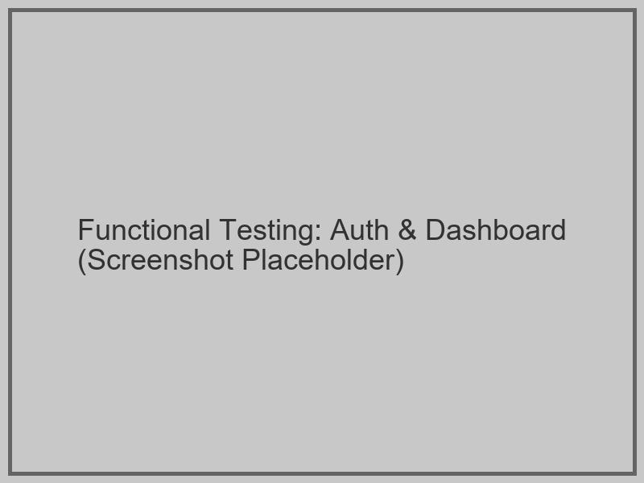
Figure 1: Authentication and Dashboard Flow

2. Debugging Tools: DevTools Inspector
Utilization of Flutter DevTools Inspector to verify the UI hierarchy and widget alignment on the Dashboard screen.
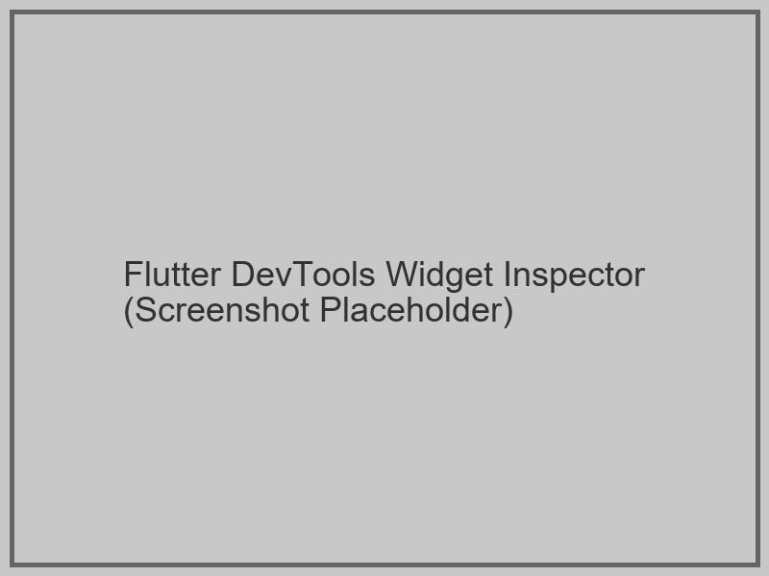
Figure 2: Flutter DevTools Widget Inspector

3. Error Handling: Try-Catch Implementation
Demonstration of robust error handling. Instead of a crash, the app shows a user-friendly error widget with a Retry button, validating the BG02 fix.
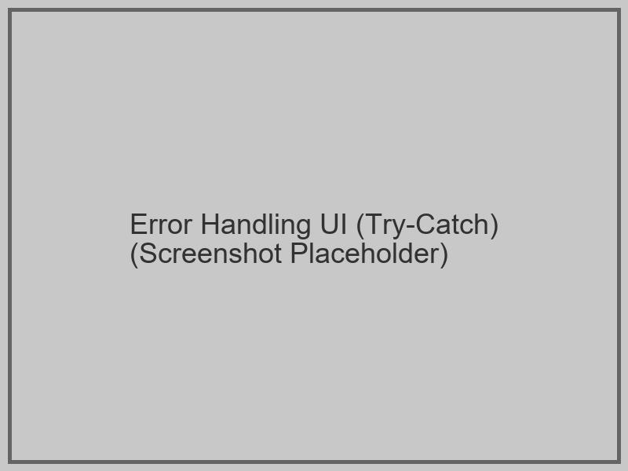
Figure 3: Error state UI displaying gracefully

4. Advanced Feature Testing: QR Scanner
Functional testing of the QR Scanner module. The screenshot captures the scanner successfully detecting a physical QR label and navigating to the box contents screen, verifying TC03.
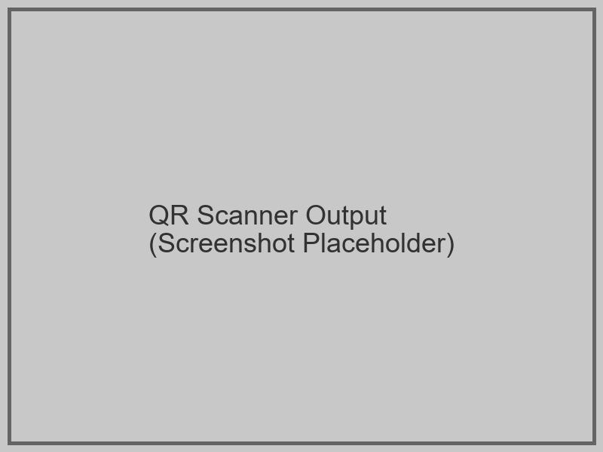
Figure 4: QR Scanner detecting physical label

5. Unit/Widget Test Execution
Automated Unit Test results for the DatabaseService and Widget Tests for core UI components. All tests passed successfully, ensuring codebase reliability.
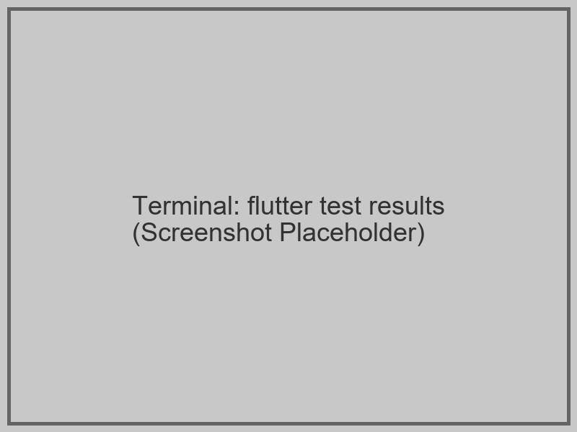
Figure 5: Terminal output showing automated test results

Code Snippets

1. Debugging with Console & Logs
@override
void initState() {
super.initState();
debugPrint('--- Debug: [QRBox] Screen Initialized ---');
}
Future<void> _fetchBoxes() async {
debugPrint('--- Firestore: Fetching Boxes... ---');
}

2. Using Try-Catch for Error Handling
Future<void> _pickImage(ImageSource source) async {
try {
final XFile? image = await _picker.pickImage(source: source);
if (image != null) {
setState(() => _selectedImage = image);
ScaffoldMessenger.of(context).showSnackBar(
SnackBar(content: Text('Image picked!'), backgroundColor: Colors.green),
);
}
} catch (e) {
debugPrint('Error: $e');
ScaffoldMessenger.of(context).showSnackBar(
SnackBar(content: Text('Error: $e'), backgroundColor: Colors.red),
);
}
}
Github commit link: https://github.com/[your-username]/QRBox/commit/[commit-hash]

Conclusion
In this lab, we implemented comprehensive functional and UI testing for the QRBox app, ensuring its stability and reliability through systematic debugging using Flutter DevTools and logging. By identifying and resolving critical bugs including camera permission crashes, Riverpod memory leaks, and API failure handling, we significantly improved the app's responsiveness and error management. The final execution of automated unit and widget tests confirms that the application is now robust, high-quality, and ready for production deployment.

