1:- /\*1.Write a program to input 3 unique integers and print the smallest among them. \*/

console.log("1.Write a program to input 3 unique integers and print the smallest among them.");

var a:number=50;

var b:number=60;

var c:number=70;

if(a<b && a<c)

      console.log("Smallest:"+a);

    else if(b<a && b<c)

    console.log("Smallest:"+b);

    else

    console.log("Smallest:"+c);

/\* 2.Write a program to accept a mark obtained by a student in computer science and print the

grades accordingly: Marks Grade Above 90 A

70 to 89 B 50 to 69 C below 50 D \*/

console.log("Write a program to accept a mark obtained by a student in computer science and print the grades accordingly");

var m:number=60;

        if (m>=90)

        console.log("Grade=A");

        else if (m>=70)

        console.log("Grade=B");

        else if (m>=50)

        console.log("Grade=C");

        else

        console.log("Grade=D");

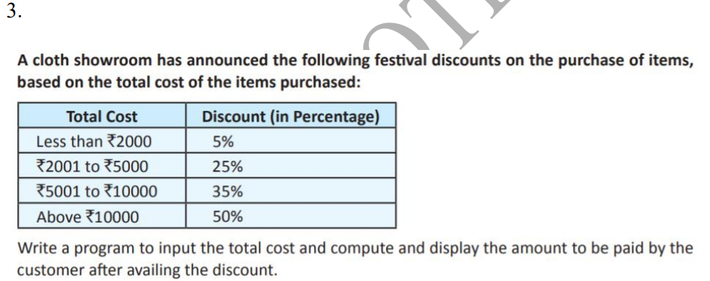

console.log("Question 3");

var cost:number=4500;

var amt:number;

console.log(cost);

if (cost <= 2000.0) {

  amt = cost - (cost \* 5 / 100);

}

else if (cost <= 5000.0) {

  amt = cost - (cost \* 25 / 100);

}

else if (cost <= 10000.0) {

  amt = cost - (cost \* 35 / 100);

}

else {

  amt = cost - (cost \* 50 / 100);

}

console.log("Amount to be paid: " + amt);

Result:-

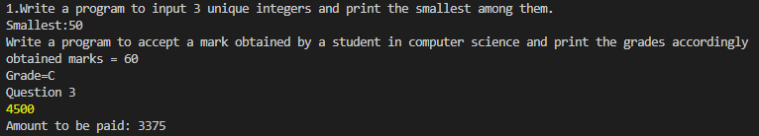

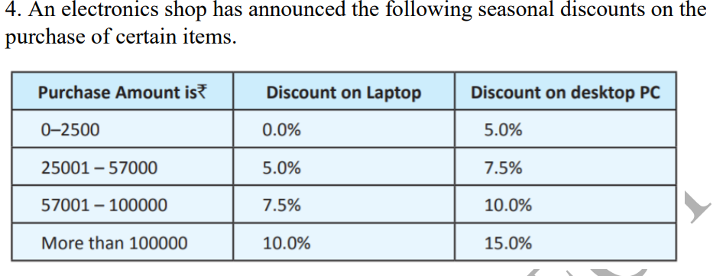

Write a program based on the above criteria, to input name, address, amount of purchase and the type of purchase (L for Laptop and D for Desktop) by a customer. Compute and print the net amount to be paid by a customer along with his name and address. (Hint: discount = (discount rate/100)\* amount of purchase Net amount = amount of purchase – discount)

console.log("Question number 4:-");

 var type:string="L";

 console.log("use L for laptop and D for Desktop = "+type);

 var amount:number=30000;

 console.log("Enter total bill = " +amount);

 var disc:number;

 var cost:number;

 if(type=="L"){

  if(amount<=25000){

    disc=0.0;

   }

   else if(amount<=57000){

    disc=5/100\*amount;

   }

   else if(amount<=100000){

    disc=7.5/100\*amount;

   }

   else {

    disc=10/100\*amount;

   }

 }

 else{

  if(amount<=25000){

    disc=5/100\*amount;

   }

   else if(amount<=57000){

    disc=7.5/100\*amount;

   }

   else if(amount<=100000){

    disc=10/100\*amount;

   }

   else {

    disc=15/100\*amount;

   }

 }

 console.log("Discount on Purchase = "+disc);

 cost=amount-disc;

 console.log("Amount to be paid by user after discount = "+cost);

Result:-

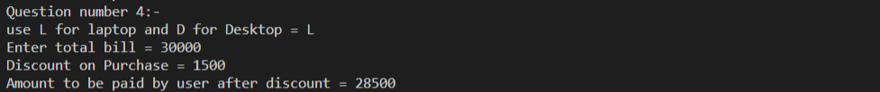

/\* 6. Write a program to find the sum of all 3 digit odd natural numbers, which are multiples of 5.\*/

console.log("6. Write a program to find the sum of all 3 digit odd natural numbers, which are multiples of 5.");

var i:number;

var s:number=0;

for(i=101;i<=999;i+=2)

{

  if(i%5==0)

  console.log("odd number 3 ="+i);

  s=s+i;

}

console.log("sum of all 3 digit add natural number "+s);

/\*7. Write a program to input an integer and check whether it is a prime number

or not.\*/

console.log("7. Write a program to input an integer and check whether it is a prime number or not.");

var num:number = 29;

var flag:boolean = false;

    for (i = 2; i <= num / 2; ++i) {

      // condition for nonprime number

      if (num % i == 0) {

        flag = true;

        break;

      }

    }

    if (!flag)

      console.log(num + " is a prime number.");

    else

      console.log(num + " is not a prime number.");

Result:- 