* 1. Cover Page & Title Page
  2. Bonafide Certificate
  3. Abstract
  4. Table of Contents
  5. List of Tables
  6. List of Figures
  7. List of Symbols, Abbreviations and Nomenclature
  8. Chapters
  9. Appendices

References

***Pre-defined Notification Alert and***

***Shortest Route Prediction based on***

***User’s Location***

*A PROJECT REPORT*

*Submitted by*

M.Ganesh Thangaraj - 12007104019

R.Prem Kumar - 12007104066

P.H.Sharath Narayan -12007104093

*In partial fulfilment for the award of the degree*

*Of*

*Bachelor Of Engineering*

*IN*

*Computer Science and Engineering*

*Velammal engineering College*

*Anna University : Chennai 600 025*

*April 2011*

ANNA UNIVERSITY : CHENNAI – 600 0025

BONAFIDE CERTIFICATE

Certified that this project report ” ***Pre-defined Notification Alert and Shortest Route Prediction based on User’s Location*** *”* is a bonafide work of **“ M.Ganesh Thangaraj , R.Prem Kumar , P.H.Sharath Narayan”** who carried out the project under my supervision.

SIGNATURE SIGNATURE

**Dr.N.Sankar Ram Mr.M.S. Murali Dhar**

**Head of Department SUPERVISOR,** Asst.Professor I

Computer Science and engineering Computer Science and engineering

Velammal Engineering College, Velammal Engineering College,

Velammal Nagar , Velammal Nagar ,

Ambattur Redhills Road, Ambattur Redhills Road,

Chennai – 6000066 Chennai – 6000066

**VELAMMAL ENGINEERING COLLEGE**

Velammal Nagar , Ambattur Redhills Road , Chennai – 600 0066

**VIVA VOICE EXAMINATION**

The Viva Voice examination of this project work ” ***Pre-defined Notification Alert and Shortest Route Prediction based on User’s Location*** *”* is a bonafide record of project done at the Department of Computer science and Engineering , Velammal Engineering College during the academic year 2010- 2011 by

**M.Ganesh Thangaraj 12007104019**

**R.Prem Kumar 12007104066**

**P.H.Sharath Narayan 12007104093**

Of final year Bachelor of engineering in Computer Science and engineering submitted for the university examination on ________

**Internal Examiner External Examiner**

**ACKNOWLEDGEMENTS**

We submit this project with deep sense of gratitude and reverence to our beloved parents for their encouragement and prayers.

It gives us immense pleasure and happiness to express our sincere regards to our honourable **Chairman Thiru M.V.Muthuramalingam** , our respected Academic Advisor Dr.G.Gopalakrishan for the various facilities and guidance provided throughout the course of our study.

We express our deep sense of gratitude to **Dr.N.Sankar Ram** , Head Of the Department of Computer science and engineering for her support during the entire course.

We thank our project supervisor **Mr.M.S. Murali Dhar** , Asst.Professor I , who provided valuable suggestions , improvements and guidance in completing this project . This requires a special mention and our indebtedness to him.

Also , we thank our class mates and friends who have rendered their help continuously. Above all it is the blessings of the Almighty that has carried us through our work.

**ABSTRACT**

In today’s daily world all of us do carry a mobile phone with us . Most of the cell phones can be used to access maps of various locations. Much more value can be added to the cell phone services , so it enables people to be more updated about their daily work. Much reminders is set on cell phones based on time, but using the gps reminders can be set in cell phones based on user’s position. If user gets the reminders , when he is in 200metres from the desired position , an alert is popped out to the user , reminding of his work .User can skip the alert and set a flag, if he comes across that place after sometime again the alert is popped out. If the task is completed by the user , he can reset the flag. Additionally user can chose the shortest path to desired requirement from a particular point ,If user wants to find the nearest medical shop from his location , he find it. The main advantage of this would be in remote areas, maps on those areas won’t be available so for those places the geo tagging concepts can be used and map initialisation can also be done by the user based on certain category .

**TABLE OF CONTENTS**

**CHAPTER NO. TITLE PAGE NO.**

**ABSTRACT**

**LIST OF FIGURES**

**LIST OF SYMBOLS**

1. **INTRODUCTION**
   1. About the project
   2. Literature Survey

1.2.1 Existing system

1.2.2 Proposed system

1. **SYSTEM ANALYSIS**
   1. Requirement Specification

2.1.1. Hardware requirements

2.1.2 Software requirements

2.2 Technologies used

2.2.1 J2ME

2.2.2 Eclipse SDK

2.2.3 Android SDK

1. **SYSTEM DESIGN**
   1. Project Design

3.1.1 Data Flow Diagram

3.1.2 UML Diagrams

3.1.2.1 Use case diagrams

3.1.2.2 State Diagram

3.1.2.3 Activity Diagram

3.1.2.4 Class Diagram

3.1.2.5 Collaboration Diagram

3.1.2.6 Sequence Diagram

3.1.2.7 Component Diagram

1. **CHAPTERS**

4.1 Location Initialization

4.2 Setting Alerts

4.3 Alert Evocation

4.4 Finding Nearest Spot

**LIST OF FIGURES**

3.1.1 Data flow Diagrams

3.1.2.1 Use case diagrams

3.1.2.2 State Diagram

3.1.2.3 Activity Diagram

3.1.2.4 Class Diagram

3.1.2.5 Collaboration Diagram

3.1.2.6 Sequence Diagram

3.1.2.7 Component Diagram

**LIST OF SYMBOLS**

SDK – Software Development Kit

GPS - Global Positioning System

GPRS - General packet radio service

LBS – Location Based Services

LBA – Location Based Advertisements

JDT - Java Development Tools

ADT - Android Development Tools

IDE - Integrated development environment

**1. INTRODUCTION**

**1.1 ABOUT THE PROJECT**

In today’s daily world all of us do carry a mobile phone with us . Most of the cell phones can be used to access maps of various locations. Much more value can be added to the cell phone services , so it enables people to be more updated about their daily work. Much reminders is set on cell phones based on time, but using the gps reminders can be set in cell phones based on user’s position. If user gets the reminders , when he is in 200metres from the desired position , an alert is popped out to the user , reminding of his work .

User can skip the alert and set a flag, if he comes across that place after sometime again the alert is popped out. If the task is completed by the user , he can reset the flag. Additionally user can chose the shortest path to desired requirement from a particular point ,If user wants to find the nearest medical shop from his location , he find it. The main advantage of this would be in remote areas, maps on those areas wont be available so for those places the geo tagging concepts can be used and map initialisation can also be done by the user based on certain category .

The user comes across three options in the main screen. 1. Alerts 2.Shortest path 3. My Locations. Selecting the alerts option, the user can set a new alert based on location , time , date and proximity radius. Proximity alerts are set during this time to make sure when the alert should be evoked based on user’s wish. The user can also specify the note that should be displayed when the alert is evoked, this note might be the work the user needs to do at that specified location.

By selecting the Shortest path option, the user is asked to give information about for what category he needs to find the shortest path. If user selects the particular category, the place that is nearer to his current location is shown. If the user selects the My locations , the user can Geo tag the particular location and he can also edit the information about the particular location he has already set. While tagging the particular location , user is asked to give the name the category of that location.

Concepts like geo tagging , shortest path detection and proximity alerts are used in the project to make it to work in a efficient way.Inorder use this , the user must possess a Mobile phone that runs on Andriod 2.1 and the phone should have GPS and GPRS/Wi-Fi. Inorder to display the map GPRS is used and in order to implement the geo tagging GPS is used.

**1.2 LITERATURE SURVEY**

**BASE PAPER –**

**Title – Location based Mobile Advertising**

**About Paper -**

The scope of this project is to use Location-Based Services and create an advertising platform for mobile phones based on the location of the user.

The system is aimed mainly at location-based marketing but can be used for other purposes such as location-based news, general information, events, weather and much more. Information will be delivered to the subscribers based on what the advertisers have specified. This data will be delivered via SMS.

**Author** – Matthew Sammut , Dep. Artificial Intelligence, University of Malta

**References –**

AG, YellowMap. 2002. Business Models for LBA. Europe : s.n., 2002.

BlackBerry. 2010. Smartphones and Cell Phones at Blackberry.com. Blackberry.com. [Online] Research In Motion (RIM), January 20, 2010. [Cited: May 22, 2010.] http://www.blackberry.com/.

CentOS. 2010. The Community Enterprise Operating System. [Online] [Cited: May 6, 2010.] http://www.centos.org.

**1.2.1 Existing system**

Basic reminder system : Many modern cell phones feature built-in alarms that do not require the phone to be powered on for the alarm to go off. Some of these cell phones feature the ability for the user to set the tone of the alarm, and in some cases music can be downloaded to the phone and then chosen to play for waking.

Geo tagging - Itis the process of adding geographical identification metadata to various media such as photographs, video, websites, SMS messages, or RSS feeds and is a form of geospatial metadata. These data usually consist of latitude and longitude coordinates, though they can also include altitude, bearing, distance, accuracy data, and place names. It is commonly used for photographs, giving geotagged photographs. Geotagging can help users find a wide variety of location-specific information. For instance, one can find images taken near a given location by entering latitude and longitude coordinates into a suitable image search engine. Geotagging-enabled information services can also potentially be used to find location-based news, websites, or other resources.Geotagging can tell users the location of the content of a given picture or other media or the point of view, and conversely on some media platforms show media relevant to a given location.

Proximity alerts : It’s often useful to have your applications react when a user moves toward, or away from, a specific location. Proximity alerts let your applications set triggers that are fired when a user moves within or beyond a set distance from a geographic location. To set a proximity alert for a given coverage area, select the center point (using longitude and latitude values), a radius around that point, and an expiry time-out for the alert. The alert will fire if the device

crosses over that boundary, both when it moves from outside to within the radius, and when it moves from inside to beyond it. When triggered, proximity alerts fire Intents, most commonly broadcast Intents.

**1.2.2 Proposed system** – The system integrates all the three concepts like reminder system , geo – tagging and proximity alerts to make sure the user experience sophistication in handles the software and relishes its uses. The main advantage of this would be in remote areas, maps on those areas wont be available so for those places the geo tagging concepts can be used and map initialisation can also be done by the user based on certain category .

**Advantages of proposed system –**

* Geo tagging can be done by the user , so in places where there are no maps the user can create his own customized map
* Alert is evoked based on the proximity radius set by user , thus enabling flexible user experience
* Selection of service for getting the maps is based on certain criteria that make sure the software selects the best available service for it
* The user can find the nearest available destination for the specified category , which he himself has initialised earlier.
* Both the location initialisation and category is done by user to enable interactive user experience.

1. **SYSTEM ANALYSIS**

**2.1.1 HARDWARE REQUIREMENTS OF MOBILE**

Minimum 600 Mhz processor

GPRS / Wi-Fi enabled

AGPS enabled

**HARDWARE REQUIREMENTS OF SYSTEM**

Processor – Pentium Core 2 Duo 2.4 Ghz

Ram – 2 gb, DDR 3 ram

Monito – 15” collor

Hard disk – 80 GB

Keyboard – standard 112 keys

Mouse -3 buttons.

**2.1.2 SOFTWARE REQUIREMENTS OF MOBILE:**

Operating system : Andriod 2.1 or higher

**SOFTWARE REQUIREMENTS OF SYSTEM :**

Eclipse SDK

Android SDK for windows

**2.2 TECHNOLOGIES USED**

**2.2.1 J2ME -** Java Platform, Micro Edition, or Java ME, is a Java platform designed for embedded systems (mobile devices are one kind of such systems) . Target devices range from industrial controls to mobile phones (especially feature phones) and set-top boxes. Java ME was formerly known as Java 2 Platform, Micro Edition (J2ME).

**2.2.2 Eclipse SDK** - Eclipse employs plug-ins in order to provide all of its functionality on top of (and including) the runtime system, in contrast to some other applications where functionality is typically hard coded. The runtime system of Eclipse is based on Equinox, an OSGi standard compliant implementation.

This plug-in mechanism is a lightweight software componentry framework. In addition to allowing Eclipse to be extended using other programming languages such as C and Python, the plug-in framework allows Eclipse to work with typesetting languages like Latex,]networking applications such as telnet, and database management systems. The plug-in architecture supports writing any desired extension to the environment, such as for configuration management. Java and CVS support is provided in the Eclipse SDK, with Subversion support provided by third-party plug-ins.

With the exception of a small run-time kernel, everything in Eclipse is a plug-in. This means that every plug-in developed integrates with Eclipse in exactly the same way as other plug-ins; in this respect, all features are "created equal". Eclipse provides plug-ins for a wide variety of features, some of which are through third parties using both free and commercial models. Examples of plug-ins include a UML plug-in for Sequence and other UML diagrams, a plug-in for DB Explorer, and many others.

**2.2.3 Android SDK –**

The Android software development kit (SDK) includes a comprehensive set of development tools. These include a debugger, libraries, a handset emulator (based on QEMU), documentation, sample code, and tutorials. The SDK is downloadable on the android developer website,. Currently supported development platforms include computers running Linux (any modern desktop Linux distribution), Mac OS X 10.4.9 or later, Windows XP or later. The officially supported integrated development environment (IDE) is Eclipse (currently 3.4, 3.5 or 3.6) using the Android Development Tools (ADT) Plug-in, though developers may use any text editor to edit Java and XML files then use command line tools (Java Development Kit and Apache Ant are required) to create, build and debug Android applications as well as control attached Android devices (e.g., triggering a reboot, installing software package(s) remotely).

Enhancements to Android's SDK go hand in hand with the overall Android platform development. The SDK also supports older versions of the Android platform in case developers wish to target their applications at older devices. Development tools are downloadable components, so after one has downloaded the latest version and platform, older platforms and tools can also be downloaded for compatibility testing.

**3.SYSTEM DESIGN**

**3.1 PROJECT DESIGN**

3.1.1 Data flow Diagrams

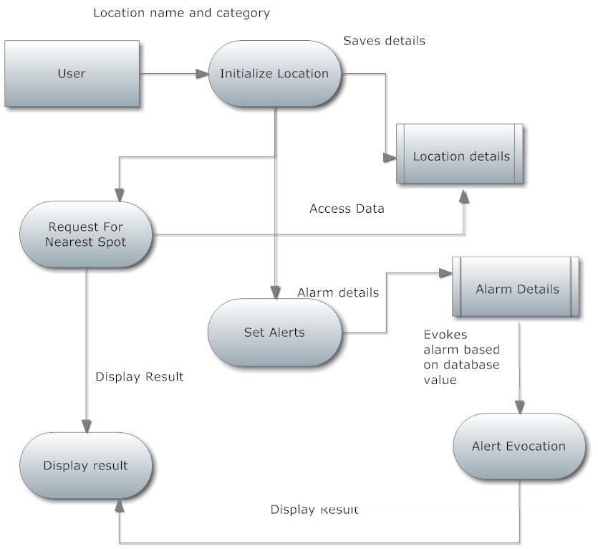

**3.1.2 UML DIAGRAMS**

3.1.2.1 Use case diagrams



3.1.2.2 State Diagram



3.1.2.3 Activity Diagram



3.1.2.4 Class Diagram



3.1.2.5 Collaboration Diagram



3.1.2.6 Sequence Diagram



3.1.2.7 Component Diagram



**4. CHAPTERS**

**CONTENTS :**

**4.1 Location Initialization**

**4.2 Setting Alerts**

**4.3 Alert Evocation**

**4.4 Finding Nearest Spot**

**4.1 LOCATION INITIALIZATION**

**INTRODUCTION**

The first step in using application is the initialization of the desired locations in the device by the user. When the person traverses through a location for the first time and if he wants a particular location to be saved in the device, he marks the coordinate of the location and gives a suitable label for that location. For example, if a person visiting a location finds a desired shop say a grocery store, he saves the corresponding coordinate of the store and labels it as ‘GROCERY’. The same process can be carried out whenever the user visits a new location and the initialization is done only for the first time.

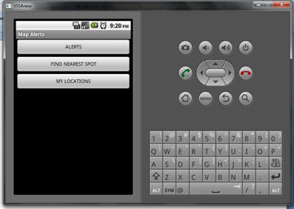

Fig 4.1.1 Welcome screen

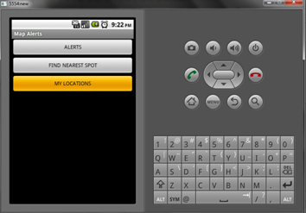

Fig 4.1.2 When My Location is clicked , it transfers to another screen

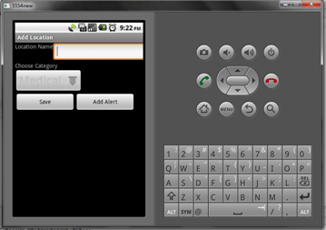

Fig 4.1.3 New location can be initialised

‘

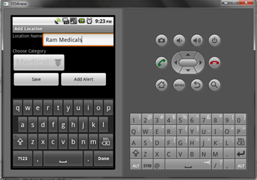

Fig 4.1.4 Location name can be added

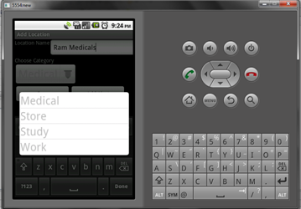

Fig 4.1.5 Needed Category can be chosen

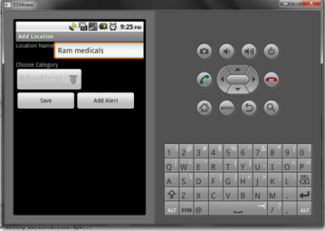

Fig 4.1.6 After entering name and category can be saved.

**CONCLUSION** – Thus by this module , the concept of geo tagging is implemented and user can save the location of his wish .

**4.2 SETTING ALERTS**

**INTRODUCTION**

One of the main functionalities of the application is the alerting based on the location of the user at a particular instance. The user is empowered to set alerts whenever he crosses a location of his desire. For example, when a user wishes to be alerted about buying a medicine on a particular day, he sets the alarm for it. On the given day, whenever the user crosses a medical shop, he will be alerted about the purchase of the medicines. A perimeter can also be set, by which when the user crosses the perimeter around a medical shop he will be alerted. Any kind of alerts can be set based on the comfort of the user.



Fig 4.2.1 Welcome screen

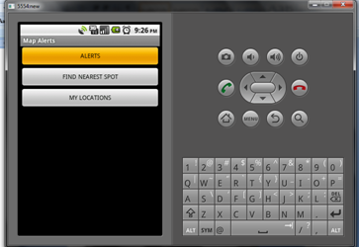

Fig 4.2.2 When Alert button is clicked , it transfers to another screen

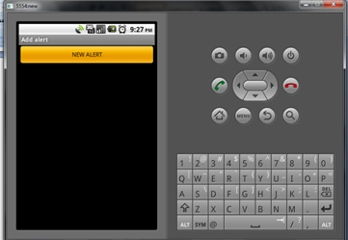

Fig 4.2.3 By clicking this New Alert can be added

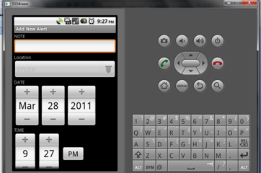

Fig 4.2.4 If we click the new alert , it transfers to this screen

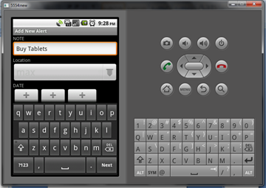

Fig 4.2.5 Note that should be displayed when the alert is evocated should be set

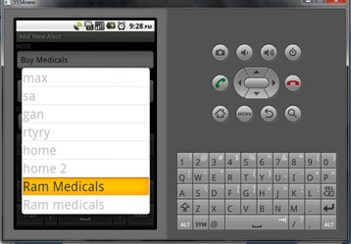

Fig 4.2.6 Location at which the alert should be evoked is set

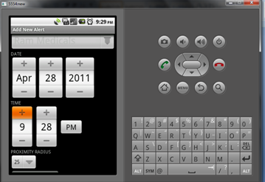

Fig 4.2.7 Date and time at which the alert should be evokes is set

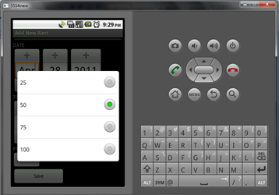

Fig 4.2.8 Proximity radius for the alert is set

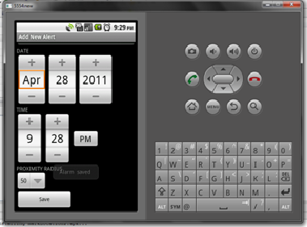

Fig 4.2.9 After including all the details , the alarm is saved

**CONCLUSION** – By this module the user can set the alert , by specifying the location and proximity radius . The user can also set the note that should be displayed when the alert is evoked.

**4.3 ALERT EVOCATION**

**INTRODUCTION**

If the users GPS co-ordinates and time matches ( of that of the alert and users current location and time) , the alert is evocated. The user can mark the alert as completed or he can reschedule the alert or he can ignore the alert.

**CONCLUSION** – This chapter deals about the way in which the alert previously set by the user is evoked.

**4.4 FINDING NEAREST SPOT**

**INTRODUCTION**

The next major use of the application is the shortest distance calculation of the desired spot. By using this the user will be able to find out the nearest spot to him which offers the service desired by him. For example, from a given location if the user wishes to find the nearby medical shop, the user will be given the distance and the route for the nearest medical shop. If the user wishes to skip this, he will be given the next nearest shop and so on.

**CONCLUSION** – This chapter deals about finding the nearest location of the particular category.