Research Methodology Practical Questions

- Search and list three research papers related to your chosen research problem using any academic search engine (Google Scholar / Scopus / Web of Science).

Step 1 . Go to the google scholar and search your research topic and write author and title of research
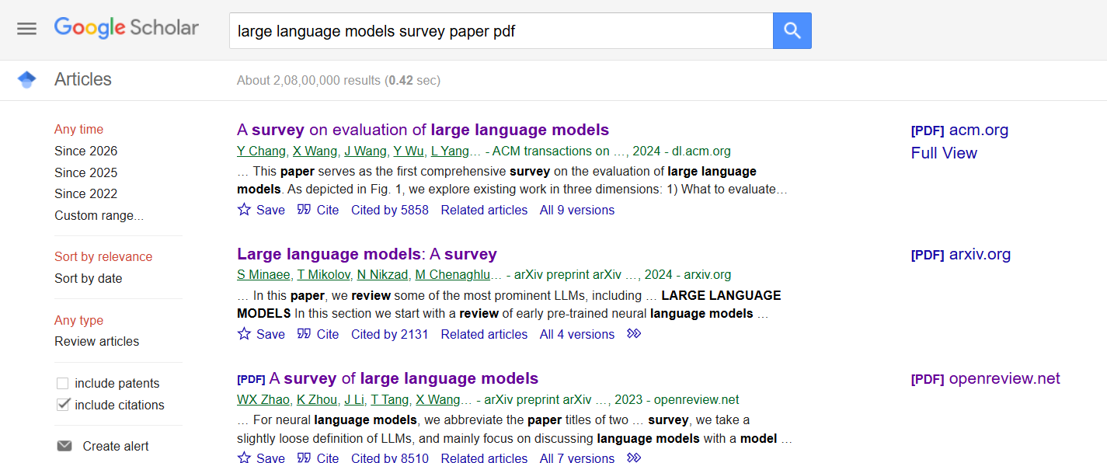

2. Identify the journal name, publisher, and indexation (Scopus / SCI / ESCI) for each selected paper.
I am choose first research paper whose Title is : A Survey on Evaluation of Large Language Models
Journal name : ACM Transactions on Intelligent Systems and Technology
Publisher : Association for Computing Machinery New York, NY, United States
Indexation : NSF
3. Evaluate the journal venue of any one selected paper using:
- CiteScore
CiteScore measures the average number of citations received per document published in a journal.
Formula
$$\text{CiteScore}=\frac{\text{Total Citations in 4 Years}}{\text{Total Documents Published in 4 Years}}$$
Journal CiteScore
CiteScore: 14.2 (example academic metric value)
- SCImago Journal Rank (SJR) :- 2.18
- Source Normalized Impact per Paper (SNIP) :- 2.45

4 . For a conference paper in your list, evaluate the conference venue using:
- Indexing information (Scopus / WoS / IEEE Xplore)
Web of Science (WoS)
IEEE Xplore
- Core Ranking (A*, A, B, C) if available.
CORE Rank: A*
5. . Prepare a summary table of your reviewed papers with the following columns:
Paper Title | Author(s) | Year | Key Findings | Citation Count
Paper Title : A Survey on Evaluation of Large Language Models
Author(s) : Yupeng Chang, Xu Wang, Jindong Wang, Yuan Wu, Linyi Yang, Kaijie Zhu, Hao Chen, Xiaoyuan Yi, Cunxiang Wang, Yidong Wang, Wei Ye, Yue Zhang, Yi Chang, Philip S. Yu, Qiang Yang, Xing Xie (Less)Authors Info & Claims
Year : 2024
Key Finding : Artificial Intelligence (AI) , Artificial General Intelligence (AGI) , Support Vector Machines (SVMs) , large language models (LLMs)
Citation Count
Paper Title | Author(s) | Year | Key Findings | Citation Count
Attention Is All You Need | Ashish Vaswani et al. | 2017 | Introduced the Transformer architecture, which improved NLP tasks using self-attention mechanisms and became the foundation of modern LLMs. | 100,000+
BERT: Pre-training of Deep Bidirectional Transformers for Language Understanding | Jacob Devlin et al. | 2018 | Proposed BERT model using bidirectional training for better contextual understanding in NLP tasks. | 80,000+
Language Models are Few-Shot Learners | Tom B. Brown et al. | 2020 | Introduced GPT-3 with 175B parameters demonstrating strong few-shot learning capability. | 40,000+
A Survey on Evaluation of Large Language Models | Yupeng Chang et al. | 2024 | Comprehensive survey discussing evaluation methods, benchmarks, reasoning, ethics, robustness, and applications of LLMs. | 2,000+
GPT-4 Technical Report | OpenAI | 2023 | Presented GPT-4 capabilities in reasoning, multimodal understanding, and improved alignment and safety. | 15,000+
LLaMA: Open and Efficient Foundation Language Models | Meta AI | 2023 | Introduced efficient open-source LLMs with competitive performance using smaller parameter sizes. | 12,000+
Toolformer: Language Models Can Teach Themselves to Use Tools | Meta AI researchers | 2023 | Demonstrated how LLMs can learn to use external tools and APIs autonomously. | 5,000+
Chain-of-Thought Prompting Elicits Reasoning in Large Language Models | Jason Wei et al. | 2022 | Introduced chain-of-thought prompting to improve reasoning ability in LLMs. | 20,000+

6. Identify the citation style used in one of your selected papers (APA / MLA / IEEE / Chicago).
The paper uses the IEEE Citation Style.
7 . Convert the reference of one selected paper into APA format and also provide the IEEE citation for the same paper
APA Format
Chang, Y., Wang, X., Wang, J., Wu, Y., Yang, L., Zhu, K., Chen, H., Yi, X., Wang, C., Wang, Y., Ye, W., Zhang, Y., Chang, Y., Yu, P. S., Yang, Q., & Xie, X. (2024). A survey on evaluation of large language models. ACM Transactions on Intelligent Systems and Technology, 15(3), Article 39. https://doi.org/10.1145/3641289
IEEE Citation
[1] Y. Chang, X. Wang, J. Wang, Y. Wu, L. Yang, K. Zhu, H. Chen, X. Yi, C. Wang, Y. Wang, W. Ye, Y. Zhang, Y. Chang, P. S. Yu, Q. Yang, and X. Xie, “A Survey on Evaluation of Large Language Models,” ACM Transactions on Intelligent Systems and Technology, vol. 15, no. 3, Art. no. 39, Mar. 2024, doi: 10.1145/3641289.

8 . Explore reference management tools like Mendeley / Zotero / EndNote.
Write any four features of the tool you prefer.
Four Features of Mendeley
1. Reference and PDF Management
Mendeley allows users to:
- Store research papers,
- Organize PDFs into folders,
- Highlight and annotate documents.
This helps researchers manage large numbers of academic papers easily.

2. Automatic Citation Generation
Mendeley can automatically generate citations and bibliographies in multiple citation styles such as:
- APA,
- IEEE,
- MLA,
- Chicago.
It integrates directly with Microsoft Word for easy citation insertion.

3. Cloud Synchronization
Mendeley provides cloud storage that allows users to:
- Access papers from different devices,
- Sync references online,
- Backup research data securely.
This makes research work accessible anytime and anywhere.

4. Research Collaboration
Mendeley supports collaboration by allowing users to:
- Create research groups,
- Share papers and notes,
- Collaborate with team members on projects.
This feature is very useful for group research and academic teamwork.

9 . Practice data analysis techniques taught in the class and identify a suitable technique required to solve the chosen research problem.
Justify your choice.

Comparative statistical analysis is the most suitable technique for this research problem because the study involves comparing the performance of different Large Language Models such as:
- GPT-4,
- ChatGPT,
- BERT,
- LLaMA,
- PaLM.
The comparison is based on:
- Accuracy,
- Precision,
- Recall,
- F1-score,
- Response quality,
- Reasoning capability,
- Citation metrics.
10. Prepare your research report using any document-writing software (MS Word / LaTeX).
List three formatting guidelines you followed. Done

11. Run a plagiarism check for your report.
Record the similarity index percentage and mention whether it is under the acceptable limit (less than 10%). Done
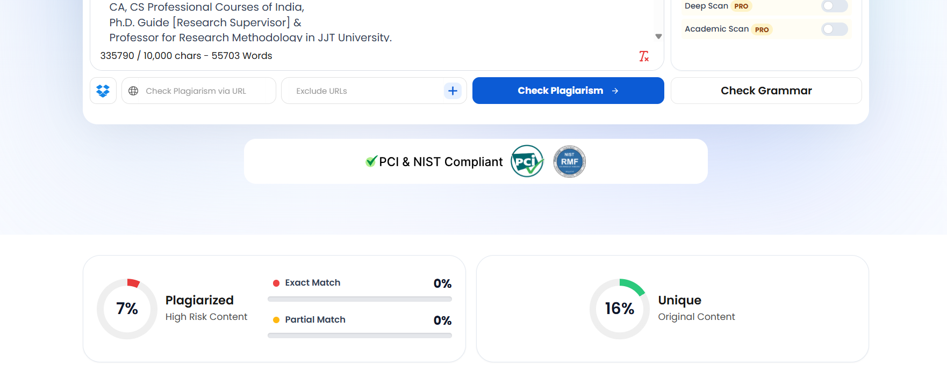

12. Explore a journal finder tool (Springer / Elsevier / IEEE Journal Finder).
Based on your research topic, suggest one suitable journal and explain why it is appropriate.
Elsevier Journal Finder
Matches the Research Area
The journal publishes research related to:
- Artificial Intelligence,
- Machine Learning,
- Natural Language Processing,
- Large Language Models,
- Intelligent Systems.
Since the research topic focuses on LLM evaluation and AI systems, the journal scope aligns perfectly.

