**First Review Document**

**COMPUTER VISION TECHNOLOGY TO ASSIST IN REHABILITATION AND TRAINING.**

Name: Adwaita Raj Modak

Reg. No.: 20BKT0095

Mobile No.: 9330554877

Mail: adwaitaraj.modak2020@vitstudent.ac.in

Guide Name: Prof. Niha K

Designation: Assistant Professor Senior Grade 1

Mobile No.: 9842444786

Mail ID: niha.k@vit.ac.in

**B.Tech.**

in

**Computer Science and Engineering with**

**spec. in Blockchain Technology**

**School of Computer Science & Engineering**

**®**



ABSTRACT

The goal of this project is to create a real-time posture recognition and correction system that will help patients properly complete workouts relevant to their ailment. Physical therapy is becoming more and more important in the management of a wide range of medical diseases. To maximise therapeutic benefits and reduce the risk of injury, proper form during exercise is essential. Conventional techniques for exercise monitoring frequently depend on human supervision, which can be labour-intensive and prone to mistakes. This study offers a novel approach to address these issues by using computer vision and machine learning techniques to provide patients automatic, precise, and real-time feedback as they exercise.

The first step in the system's process is gathering a variety of accurate and inaccurate postures related to the chosen illness or condition. The MediaPipe package is used to train a posture detection model with this dataset, which precisely monitors important human body parts in real-time. The patient is subsequently guided through their recommended workouts by the model, which is then implemented inside an intuitive interface.

The system then acquires all the landmarks on the users body to form the rough skeletal structure consisting of 33 points covering the entire body. The combination of different points are used to calculate the angles between certain parts of the body from which it can be determined that the exercise is being performed accurately or not.

The device continually evaluates the patient's motions throughout exercise sessions and compares them to the predetermined proper positions. An alert system is set off whenever deviations are found, giving the patient instant input on how to fix their form. This feedback system makes sure that patients get timely instruction to carry out activities in a safe and efficient manner.

 The device also includes a counting mechanism that counts the number of repetitions the patient completes, which provides important information for tracking improvement and training programme adherence. By providing real-time feedback on exercise technique and progress, the user interface provides a seamless experience, enabling patients to take charge of their own rehabilitation.

 This system seeks to prove its effectiveness in enhancing exercise adherence, form correctness, and ultimately patient outcomes through extensive testing and validation, including user trials with patients and healthcare professionals. This project has the potential to transform the monitoring and management of disease-specific workouts via the use of technology, improving patient quality of life and improving rehabilitation outcomes.

Key words :- Computer Vision Technology, Media pipe, pose-detection, rehabilitation, machine-learning, spinal impairments, patient empowerment.

 INTRODUCTION

The goal of computer vision, a branch of computer science, is to make it possible for machines to recognize and comprehend objects and people in pictures and movies. Similar to other forms of artificial intelligence, computer vision aims to execute and mechanize activities that mimic human skills. In this instance, computer vision aims to mimic human eyesight as well as human perception and interpretation of visual information.

Computer vision applications mimic the functioning of the human visual system by using data from sensing devices, artificial intelligence, machine learning, and deep learning. Algorithms used in computer vision applications are trained on vast volumes of visual data or cloud pictures. They identify patterns in this visual input and make inferences about the meaning of other images based on those patterns.

 Google created the open-source MediaPipe framework, which lets programmers construct multimedia apps in real time for a range of platforms and gadgets. Advanced computer vision techniques and machine learning models are included, and they are utilized for tasks like position estimation, object identification, and facial recognition. These models are perfect for multimedia applications since they are real-time and very accurate. Additionally, MediaPipe has real-time performance-optimized computer vision algorithms for applications like segmentation, depth estimation, and image and video stabilization. Because the platform's pipeline is modular and easily extendable with custom components, developers may create highly customized applications using it. In general, MediaPipe is a great option for programmers creating real-time multimedia applications.

 In several applications, including full-body gesture control, sign language recognition, and workout quantification, human position estimate from video is essential. It can serve as the foundation for applications in yoga, dance, and fitness, for instance. It can also make it possible to use augmented reality, which is the superimposition of digital data and content on top of the actual environment. MediaPipe posture is a machine learning solution for high-fidelity body posture tracking. It leverages the BlazePose research, which drives the ML Kit Pose Detection API, to infer 33 3D landmarks on the whole body from RGB video frames.

 OBJECTIVE

The need for a technology that can let patients manage their own exercise regimens and rehabilitation program independently while providing the guidance and feedback they need to complete their activities correctly without any human supervision. Thus, the goal is to make rehabilitation an automated process and help the person recover quickly from his ailment.

  LITERATURE SURVEY

[1] Body Posture Detection and Motion Tracking using AI for Medical Exercises and Recommendation System.

The study suggests using artificial intelligence (AI) and image processing to enhance and augment self-supervised exercise by creating a motion tracker that is software-based and can monitor activities and offer postural feedback. Plotting points at different body joints and monitoring movement are done using the Media Pipe framework to provide a thorough study of body tracking. This body tracking analysis may be used to create an application that monitors registered persons' medical exercise, increasing the effectiveness of the workouts. By utilising databases, the programme may be further enhanced to match registered users with approved physicians who have access to diagnostic results and workout histories.

 [2] Scoliosis: Review of diagnosis and treatment.

The paper discusses the diagnosis and treatment of idiopathic scoliosis, a common type of spine deformity. The significance of a patient's age, appearance, and natural history in determining the best course of therapy is emphasized. Numerous variables, including congenital, neuromuscular, syndrome-related, idiopathic, and secondary causes, such as spinal curvature, can result in scoliosis. Treatment for scoliosis is determined by the kind, severity of the curvature, amount of growth left, and patient's viewpoint. Determining the likelihood of curve development and the prognosis of therapy depends heavily on growth tracking using maturity markers and height measurements.

[3] Adolescent Idiopathic Scoliosis: Diagnosis and Management.

Two percent to four percent of teenagers have adolescent idiopathic scoliosis. Regular screening is not advised because of the risks. Radiologic testing might be guided by physical tests. Braces, surgery, and observation are available as forms of treatment. The onset and course of scoliosis are influenced by genetic factors. There is little data to support therapies like physical therapy and chiropractic adjustments. Patients who go untreated frequently have minimal physical disability.

 [4] Media Pipe: A Framework for Building Perception Pipelines.

The MediaPipe framework is presented in this paper, addressing the difficulties in creating applications that take in their environment. Building prototypes, measuring system performance and resource consumption on target platforms, and choosing and developing machine learning models and algorithms are all made possible by the framework. Using MediaPipe, developers can build sophisticated cross-platform applications from scratch, integrate pre-existing perceptual components, and iterate enhance their apps to provide repeatable outcomes on several platforms and devices. The study emphasizes how MediaPipe is now open-sourced, allowing programmers to utilize it as a development environment for algorithms and models.

 [5] A Survey on Computer Vision for Assistive Medical Diagnosis From Faces.

The paper examines current developments in computer vision techniques for face image analysis used in medical diagnosis. It highlights the significance of multidisciplinary cooperation and the gathering of databases that are open to the public for future study. Additionally covered in the report is the applicability of various imaging modalities for diagnosing medical complaints. The lack of training data, however, continues to restrict the application of deep learning techniques and neural networks in clinical settings.

 [6] Deep learning-enabled medical computer vision.

The study examines the developments in deep learning-driven computer vision methods for medical usage, with a particular emphasis on convolutional neural networks (CNNs) in imaging specialties such as ophthalmology, pathology, cardiology, and dermatology. It draws attention to the potential of AI models for things like reconstruction, retrieval, and picture registration. The study also demonstrates how AI algorithms might revolutionize oncology and pathology by employing digital pathology picture archives and annotations for diagnosis, prognosis, and prognosis. The usage of sub-micron tissue scanners, as well as their development and commercialization, are examined in this paper's discussion of AI-driven digital histopathology.

 [7] Automated Body Postures Assessment From Still Images Using MediaPipe.

Body postures, stance, landmarks, and the use of MediaPipe and machine learning are the main topics of this work. Regardless of the user's and reference's age, gender, or picture and video backgrounds, the system functions effectively. Vertex angles, arm angles, wrist angles, and foot angles are among the aspects for the right side of the body that are provided in the article. The system is unaffected by variations in age, gender, backdrop, or image size. The suggested structure for automated evaluation of body posture using MediaPipe shown encouraging outcomes in side-view scenarios like standing and sitting. By identifying variations in the user's posture from the reference still image, the device functioned as a smart mirror, giving real-time corrective information. The technique was used to help people avoid bad standing and sitting postures that might have unfavorable effects on their bodies, as well as to rectify their own posture.  When the outcomes from the proposed framework were compared to judgements made manually, they were similar. However, there were some observations about the identification of neck and torso bending, the necessity of camera coordinate alignment, and the significance of choosing the reference image.

[8] Automatic detection of abnormal hand gestures in patients with radial, ulnar, or median nerve injury using hand pose estimation.

The study employs hand posture estimation to automatically identify aberrant hand gestures in patients with radial, ulnar, or median nerve damage. Using a smartphone, pictures of both healthy participants and patients with nerve damage were collected. Google MediaPipe Hands was used to extract landmark coordinates so that the characteristics could be calculated. The study examined how well rule-based models performed in comparison to machine learning methods such as random forest, logistic regression, and support vector machines.

 According to the findings, the rule-based models were very successful in identifying injuries to the radial, ulnar, and median nerves with respect to accuracy, sensitivity, and specificity. Furthermore, all machine learning models exhibited sensitivity ranging from 37.5% to 100% and accuracy above 95%.The results imply that hand position estimation may be an easy-to-use screening technique for telemedicine and basic healthcare.

 [9] Fitness Movement Types and Completeness Detection Using a Transfer-Learning-Based Deep Neural Network.

This research presents a deep transfer learning-based approach to build a fitness database and train a deep neural network to identify the kind and degree of fitness motions. Yolov4 and MediaPipe were utilized by the authors to quickly identify fitness motions, and they saved the 1D fitness signal of movement in order to create a database. With a high mAP of 99.71%, accuracy of 98.56%, and F1-score of 98.23%, the fitness movement types categorization performance was accomplished. The F1-score was 92.83%, accuracy was 92.84%, and precision was 92.85 when it came to the assessment of fitness movement completeness. Classifying the completeness of a fitness action is another area where the technique excels. According to experimental data, the suggested strategy performs more accurately than alternative approaches.

 [10] A Video Image Processing Method for Continuous Object Detection.

The research focuses on optimising video image post-processing for continuous object recognition. It tackles issues including interference between small units of many objects, variables that degrade picture quality, and skew/distortion of images that arise while recognising continuous objects in complicated settings. The suggested technique in the research makes use of past information to increase detection efficiency and accuracy. With regard to scene-based optimisation and object identification in various business settings, the research attempts to address the growing demands for continuous identifying objects.

  PROBLEM STATEMENT

* Take input from the user regarding the disease and suggest exercises for rehabilitation.
* Capture video feed to get the posture of the user and convert it into frames to form the landmark on the human body.
* Calculate the angle formed between certain pin points to ensure that the activity is performed properly, and if there is an error in the posture then voice alert message is generated otherwise accuracy and count of repetitions is displayed.

SYSTEM ARCHITECTURE

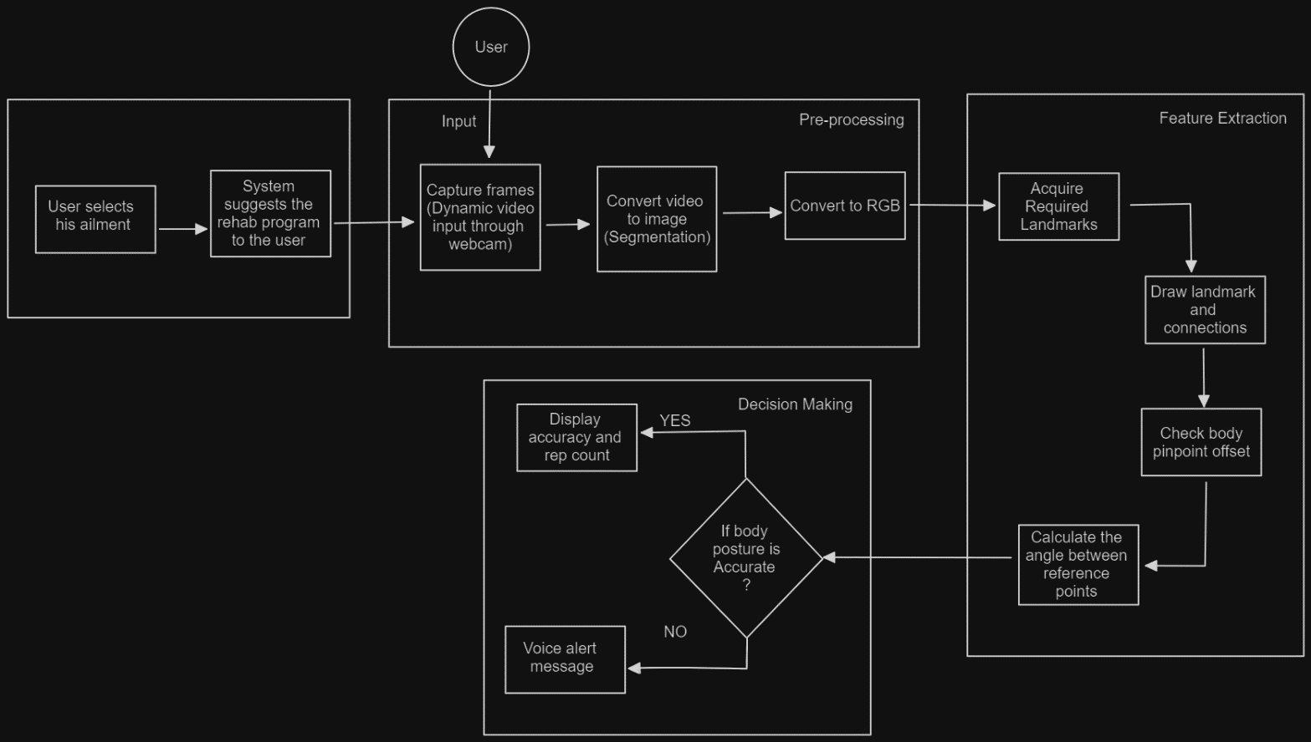

1. The admin will set up a list of rehabilitation exercises and a demo to assist the patient.
2. Once the user selects which ailment he is suffering, he will be suggested the rehab program.
3. Video feed of the user will be captured dynamically in real time through video input.
4. The system will capture the frames and acquire the required landmarks on the entire body ( consisting of 33 points covering the entire body. )
5. All the points will be connected to form a skeletal structure.
6. The admin will set precision angle at various points on the body.
7. When the user performs any exercise, the system will detect if posture is correct or not.
8. For correct posture, accuracy and repetition count will be displayed.
9. Else, an alert voice message will be triggered if his posture is not correct.

CONCLUSION

 Therefore, by developing such a system we can make the entire system automated, and yet provide accurate results over time. The patients will be supervised and guided by the system, tracking and posture correction will go on concurrently at the same time. The biggest challenge is that we have to get a large number of datasets that has to be used to train the model so that it can have greater efficiency and provide the best of results. The user should also ensure that he is facing the camera so that the media pipe technology can detect the points on his body accurately and calculate all the desired angles with greater efficiency.

Its effectiveness in enhancing exercise adherence, form correctness, and ultimately, patient outcomes is sought to be proven by this system through extensive testing and validation, including user trials with patients and healthcare professionals. The potential to transform the monitoring and management of disease-specific workouts via the use of technology, improving patient quality of life and rehabilitation outcomes, is possessed by this project.

 REFERENCES

1. Anuj Patil, D.V. Divakara Rao, Kaustubh Utturwar, T. P. Shelke, Ekta Sarda, “Body Posture Detection and Motion Tracking using AI for Medical Exercises and Recommendation System”, ITM web of conferences-Vol. 44, pp 03043-03043, 01 Jan 2022

1. JA Janicki, B Alman. Scoliosis, “Scoliosis: Review of diagnosis and treatment”, Paediatr Child Health;12(9):771-776, 2007

1. John P. Horne, Robert Flannery, Saif Usman, “Adolescent Idiopathic Scoliosis: Diagnosis and Management”, American Family Physician (Am Fam Physician)-Vol. 89, Iss: 3, pp 193-198, 01 Feb 2014

1. Camillo Lugaresi, Jiuqiang Tang, Hadon Nash, Chris McClanahan, Esha Uboweja, Michael Hays, Fan Zhang, Chuo-Ling Chang, Ming Guang Yong, Juhyun Lee, Wan-Teh Chang, Wei Hua, Manfred Georg1, Matthias Grundmann , “MediaPipe: A Framework for Building Perception Pipelines”, Google1- arXiv: Distributed, Parallel, and Cluster Computing, 14 Jun 2019

1. Jérôme Thevenot, Miguel Bordallo López, Abdenour Hadid, “A Survey on Computer Vision for Assistive Medical Diagnosis From Faces”, University of Oulu, IEEE Journal of Biomedical and Health Informatics (IEEE)-Vol. 22, Iss: 5, pp 1497-1511, 01 Sep 2018

1. Andre Esteva, Katherine Chou, Serena Yeung, Nikhil Naik, Ali Madani, Ali Mottaghi, Yun Liu, Eric J. Topol, Jeffrey Dean, Richard Socher,  “Deep learning-enabled medical computer vision”, Salesforce.com, Google, Stanford University, Scripps Health-Vol. 4, Iss: 1, pp 1-9, 08 Jan 2021

1. Mazin H. Aziz, Hamed A. Mahmood, “Automated Body Postures Assessment From Still Images Using Media Pipe”, Computer Engineering Department, University of Mosul, Mosul Journal of Optimization & Decision Making 2(2), 240-246, 202

1. Fanbin Gu, Jingyuan Fan, Chengfeng Cai, Zhaoyang Wang, Xiaoming Liu, Jiantao Yang, Qingtang Zhu, “Automatic detection of abnormal hand gestures in patients with radial, ulnar, or median nerve injury using hand pose estimation”, -Frontiers in Neurology-Vol. 13, 07 Dec 2022

1. Kuan-Yu Chen, Jungpil Shin, Md. Al Mehedi Hasan, Jiun-Jian Liaw, Yuichi Okuyama, Yoichi Tomioka, “Fitness Movement Types and Completeness Detection Using a Transfer-Learning-Based Deep Neural Network”, -Sensors-Vol. 22, Iss: 15, pp 5700-5700, 29 Jul 2022

1. Wenting Ma, Xiaohang Yuan, Jian-Ye Zhu, Hao Zhang, Zhipeng Zhang, “A Video Image Processing Method for Continuous Object Detection”, -pp 1015-1020, 21 Apr 2023