Module-5-challenge_ScreenShotDSBC_06MAY2023__Raj

Week 5th - as of 5/4/2023

Module 5 Challenge

=============================================

Student – Raj Agrawal / DS bootcamp

===========================================

terminal output screen shot

**Pymaceuticals Inc.**

**Analysis - Observations and Insights**

1. min and max mean value and correspondence value as shown Naftisol mean 54.331565 median 52.509285 variance 66.173479 standard deviation 8.134708 SEM 0.596466

Ramicane mean 40.216745 median 40.673236 variance 23.486704 standard deviation 4.846308 SEM 0.320955

1. The bar graph shows that the drug regimen, Capomulin was tested on the maximum number of mice (230), followed by Ramicane (228).
2. The male and female mice population was very close- Female 922 Male 958

The overall performance of the drug, Capomulin was satisfactory.

In [82]:



*# Dependencies and Setup*

**import** matplotlib.pyplot **as** plt

**import** pandas **as** pd

**import** scipy.stats **as** st

**import** seaborn **as** sb

​

In [83]:



*# Study data files*

mouse_metadata_path **=** "data/Mouse_metadata.csv"

study_results_path **=** "data/Study_results.csv"

​

*# Read the mouse data and the study results*

mouse_metadata **=** pd.read_csv(mouse_metadata_path)

study_results **=** pd.read_csv(study_results_path)

​

*# Combine the data into a single DataFrame*

df **=** pd.merge(study_results, mouse_metadata, on**=**"Mouse ID", how**=**"left")

​

*# Display the data table for preview-------mouse_metadata*

mouse_metadata.head()

Out[83]:

|  | **Mouse ID** | **Drug Regimen** | **Sex** | **Age_months** | **Weight (g)** |
| --- | --- | --- | --- | --- | --- |
| **0** | k403 | Ramicane | Male | 21 | 16 |
| **1** | s185 | Capomulin | Female | 3 | 17 |
| **2** | x401 | Capomulin | Female | 16 | 15 |
| **3** | m601 | Capomulin | Male | 22 | 17 |
| **4** | g791 | Ramicane | Male | 11 | 16 |

In [84]:



*# Display the data table for preview*

df.head()

Out[84]:

|  | **Mouse ID** | **Timepoint** | **Tumor Volume (mm3)** | **Metastatic Sites** | **Drug Regimen** | **Sex** | **Age_months** | **Weight (g)** |
| --- | --- | --- | --- | --- | --- | --- | --- | --- |
| **0** | b128 | 0 | 45.0 | 0 | Capomulin | Female | 9 | 22 |
| **1** | f932 | 0 | 45.0 | 0 | Ketapril | Male | 15 | 29 |
| **2** | g107 | 0 | 45.0 | 0 | Ketapril | Female | 2 | 29 |
| **3** | a457 | 0 | 45.0 | 0 | Ketapril | Female | 11 | 30 |
| **4** | c819 | 0 | 45.0 | 0 | Ketapril | Male | 21 | 25 |

In [85]:



*# additional general information added here.......*

study_results.info()

<class 'pandas.core.frame.DataFrame'>

RangeIndex: 1893 entries, 0 to 1892

Data columns (total 4 columns):

# Column Non-Null Count Dtype

--- ------ -------------- -----

0 Mouse ID 1893 non-null object

1 Timepoint 1893 non-null int64

2 Tumor Volume (mm3) 1893 non-null float64

3 Metastatic Sites 1893 non-null int64

dtypes: float64(1), int64(2), object(1)

memory usage: 59.3+ KB

In [86]:



*# additional general information added here.......*

study_results.Timepoint.value_counts()

Out[86]:

0 250

5 238

10 223

15 207

20 195

25 183

30 171

35 154

40 142

45 130

Name: Timepoint, dtype: int64

In [87]:



*# Checking the number of mice.*

len(mouse_metadata)

Out[87]:

249

In [88]:



*# Our data should be uniquely identified by Mouse ID and Timepoint*

*# Get the duplicate mice by ID number that shows up for Mouse ID and Timepoint.*

​

df.groupby(["Mouse ID", "Timepoint"]).size().sort_values(ascending**=False**).head(20)

​

Out[88]:

Mouse ID Timepoint

g989 20 2

15 2

10 2

5 2

0 2

a203 0 1

q633 0 1

q610 20 1

25 1

30 1

35 1

q633 15 1

5 1

10 1

q610 10 1

q633 20 1

25 1

q610 15 1

q597 45 1

q610 5 1

dtype: int64

In [89]:



*# Optional: Get all the data for the duplicate mouse ID.*

mask **=** df["Mouse ID"] **==** "g989"

df.loc[mask]

Out[89]:

|  | **Mouse ID** | **Timepoint** | **Tumor Volume (mm3)** | **Metastatic Sites** | **Drug Regimen** | **Sex** | **Age_months** | **Weight (g)** |
| --- | --- | --- | --- | --- | --- | --- | --- | --- |
| **107** | g989 | 0 | 45.000000 | 0 | Propriva | Female | 21 | 26 |
| **137** | g989 | 0 | 45.000000 | 0 | Propriva | Female | 21 | 26 |
| **329** | g989 | 5 | 48.786801 | 0 | Propriva | Female | 21 | 26 |
| **360** | g989 | 5 | 47.570392 | 0 | Propriva | Female | 21 | 26 |
| **620** | g989 | 10 | 51.745156 | 0 | Propriva | Female | 21 | 26 |
| **681** | g989 | 10 | 49.880528 | 0 | Propriva | Female | 21 | 26 |
| **815** | g989 | 15 | 51.325852 | 1 | Propriva | Female | 21 | 26 |
| **869** | g989 | 15 | 53.442020 | 0 | Propriva | Female | 21 | 26 |
| **950** | g989 | 20 | 55.326122 | 1 | Propriva | Female | 21 | 26 |
| **1111** | g989 | 20 | 54.657650 | 1 | Propriva | Female | 21 | 26 |
| **1195** | g989 | 25 | 56.045564 | 1 | Propriva | Female | 21 | 26 |
| **1380** | g989 | 30 | 59.082294 | 1 | Propriva | Female | 21 | 26 |
| **1592** | g989 | 35 | 62.570880 | 2 | Propriva | Female | 21 | 26 |

In [90]:



*# Create a clean DataFrame by dropping the duplicate mouse by its ID.*

​

df_backup **=** df.copy()

​

df **=** df.loc[df["Mouse ID"] **!=** "g989"].reset_index(drop**=True**)

df.info()

<class 'pandas.core.frame.DataFrame'>

RangeIndex: 1880 entries, 0 to 1879

Data columns (total 8 columns):

# Column Non-Null Count Dtype

--- ------ -------------- -----

0 Mouse ID 1880 non-null object

1 Timepoint 1880 non-null int64

2 Tumor Volume (mm3) 1880 non-null float64

3 Metastatic Sites 1880 non-null int64

4 Drug Regimen 1880 non-null object

5 Sex 1880 non-null object

6 Age_months 1880 non-null int64

7 Weight (g) 1880 non-null int64

dtypes: float64(1), int64(4), object(3)

memory usage: 117.6+ KB

In [91]:



*# Checking the number of mice in the clean DataFrame.*

​

df["Mouse ID"].nunique()

​

Out[91]:

248

**Summary Statistics**

In [92]:



*# additional general information added here.......*

df.groupby("Drug Regimen")["Tumor Volume (mm3)"].sem()

Out[92]:

Drug Regimen

Capomulin 0.329346

Ceftamin 0.469821

Infubinol 0.492236

Ketapril 0.603860

Naftisol 0.596466

Placebo 0.581331

Propriva 0.544332

Ramicane 0.320955

Stelasyn 0.573111

Zoniferol 0.516398

Name: Tumor Volume (mm3), dtype: float64

In [93]:



*# Generate a summary statistics table of mean, median, variance, standard deviation, and SEM of the tumor volume for each regimen*

​

*# Use groupby and summary statistical methods to calculate the following properties of each drug regimen:*

*# mean, median, variance, standard deviation, and SEM of the tumor volume.*

*# Assemble the resulting series into a single summary DataFrame.*

​

*# this is good info -----we did it as a group study-------*

​

means **=** df.groupby("Drug Regimen")["Tumor Volume (mm3)"].mean()

med **=** df.groupby("Drug Regimen")["Tumor Volume (mm3)"].median()

var **=** df.groupby("Drug Regimen")["Tumor Volume (mm3)"].var()

stdev **=** df.groupby("Drug Regimen")["Tumor Volume (mm3)"].std()

sems **=** df.groupby("Drug Regimen")["Tumor Volume (mm3)"].sem()

stat_summary **=** pd.DataFrame()

stat_summary["Mean"] **=** means

stat_summary["Median"] **=** med

stat_summary["Variance"] **=** var

stat_summary["Standard Deviation"] **=** stdev

stat_summary["SEM"] **=** sems

stat_summary **=** stat_summary.reset_index()

stat_summary

Out[93]:

|  | **Drug Regimen** | **Mean** | **Median** | **Variance** | **Standard Deviation** | **SEM** |
| --- | --- | --- | --- | --- | --- | --- |
| **0** | Capomulin | 40.675741 | 41.557809 | 24.947764 | 4.994774 | 0.329346 |
| **1** | Ceftamin | 52.591172 | 51.776157 | 39.290177 | 6.268188 | 0.469821 |
| **2** | Infubinol | 52.884795 | 51.820584 | 43.128684 | 6.567243 | 0.492236 |
| **3** | Ketapril | 55.235638 | 53.698743 | 68.553577 | 8.279709 | 0.603860 |
| **4** | Naftisol | 54.331565 | 52.509285 | 66.173479 | 8.134708 | 0.596466 |
| **5** | Placebo | 54.033581 | 52.288934 | 61.168083 | 7.821003 | 0.581331 |
| **6** | Propriva | 52.320930 | 50.446266 | 43.852013 | 6.622085 | 0.544332 |
| **7** | Ramicane | 40.216745 | 40.673236 | 23.486704 | 4.846308 | 0.320955 |
| **8** | Stelasyn | 54.233149 | 52.431737 | 59.450562 | 7.710419 | 0.573111 |
| **9** | Zoniferol | 53.236507 | 51.818479 | 48.533355 | 6.966589 | 0.516398 |

In [94]:



*# A more advanced method to generate a summary statistics table of mean, median, variance, standard deviation,*

*# and SEM of the tumor volume for each regimen (only one method is required in the solution)*

​

*# Using the aggregation method, produce the same summary statistics in a single line*

df.groupby("Drug Regimen").agg(["mean", "median", "var", "std", "sem"])["Tumor Volume (mm3)"]

​

*# note - any errors are just infomational*

C:\Users\rajag\AppData\Local\Temp\ipykernel_30520\2595435272.py:5: FutureWarning: ['Mouse ID', 'Sex'] did not aggregate successfully. If any error is raised this will raise in a future version of pandas. Drop these columns/ops to avoid this warning.

df.groupby("Drug Regimen").agg(["mean", "median", "var", "std", "sem"])["Tumor Volume (mm3)"]

Out[94]:

|  | **mean** | **median** | **var** | **std** | **sem** |
| --- | --- | --- | --- | --- | --- |
| **Drug Regimen** |  |  |  |  |  |
| **Capomulin** | 40.675741 | 41.557809 | 24.947764 | 4.994774 | 0.329346 |
| **Ceftamin** | 52.591172 | 51.776157 | 39.290177 | 6.268188 | 0.469821 |
| **Infubinol** | 52.884795 | 51.820584 | 43.128684 | 6.567243 | 0.492236 |
| **Ketapril** | 55.235638 | 53.698743 | 68.553577 | 8.279709 | 0.603860 |
| **Naftisol** | 54.331565 | 52.509285 | 66.173479 | 8.134708 | 0.596466 |
| **Placebo** | 54.033581 | 52.288934 | 61.168083 | 7.821003 | 0.581331 |
| **Propriva** | 52.320930 | 50.446266 | 43.852013 | 6.622085 | 0.544332 |
| **Ramicane** | 40.216745 | 40.673236 | 23.486704 | 4.846308 | 0.320955 |
| **Stelasyn** | 54.233149 | 52.431737 | 59.450562 | 7.710419 | 0.573111 |
| **Zoniferol** | 53.236507 | 51.818479 | 48.533355 | 6.966589 | 0.516398 |

**Bar and Pie Charts**

In [95]:



*# Generate a bar plot showing the total number of rows (Mouse ID/Timepoints) for each drug regimen using Pandas.*

​

data **=** df["Drug Regimen"].value_counts()

​

data.plot(kind**=**"bar", title**=**"Number of Rows per Drug", color**=**"brown")

plt.show()

​

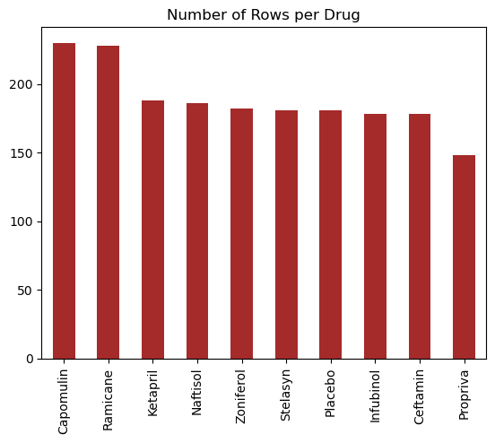

In [96]:



*# Generate a bar plot showing the total number of rows (Mouse ID/Timepoints) for each drug regimen using pyplot.*

data **=** data.sort_values().reset_index()

data.columns **=** ["Drug Regimen", "Number of Rows"]

​

​

plt.figure(figsize**=**(15,6))

plt.barh(data["Drug Regimen"], data["Number of Rows"], color**=**"purple")

plt.xlabel("Number of Observations")

plt.title("Number of Observations by Drug Regimen")

​

plt.grid(axis**=**"both", color**=**"lightgrey", alpha**=**0.3, linestyle**=**"--")

​

plt.show()

​

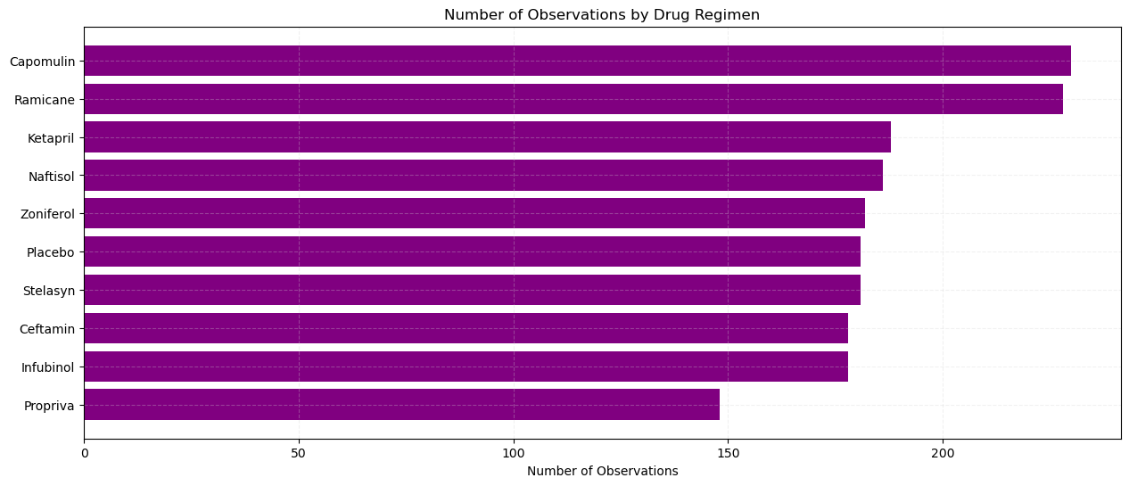

In [97]:



*# Generate a pie plot showing the distribution of female versus male mice using Pandas*

​

df.groupby("Sex").size().plot(kind**=**"pie")

plt.show()

​

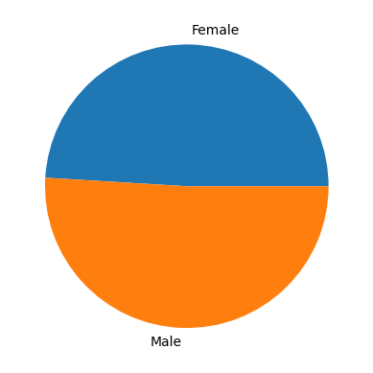

In [98]:



*# Generate a pie plot showing the distribution of female versus male mice using pyplot*

values **=** df.groupby("Sex").size().values

labels **=** ["Female", "Male"]

plt.pie(values, labels**=**labels)

plt.title("Mouse Gender Pie Chart")

plt.show()

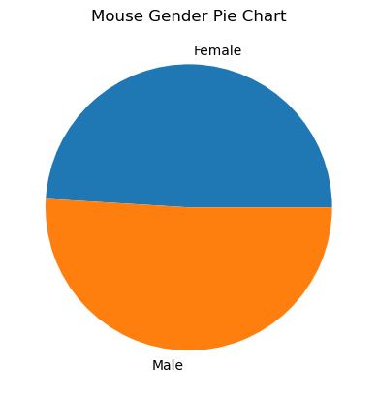

In [99]:



*# additional general information added here.......*

df.groupby("Sex").size()

Out[99]:

Sex

Female 922

Male 958

dtype: int64

**Quartiles, Outliers and Boxplots**

In [100]:



*# Calculate the final tumor volume of each mouse across four of the treatment regimens:*

*# Capomulin, Ramicane, Infubinol, and Ceftamin*

*# Start by getting the last (greatest) timepoint for each mouse*

*# Merge this group df with the original DataFrame to get the tumor volume at the last timepoint*

​

In [101]:



max_time **=** df.groupby("Mouse ID")["Timepoint"].max().reset_index()

​

last_df **=** pd.merge(max_time, df, on**=**["Mouse ID", "Timepoint"], how**=**"inner")

last_df

Out[101]:

|  | **Mouse ID** | **Timepoint** | **Tumor Volume (mm3)** | **Metastatic Sites** | **Drug Regimen** | **Sex** | **Age_months** | **Weight (g)** |
| --- | --- | --- | --- | --- | --- | --- | --- | --- |
| **0** | a203 | 45 | 67.973419 | 2 | Infubinol | Female | 20 | 23 |
| **1** | a251 | 45 | 65.525743 | 1 | Infubinol | Female | 21 | 25 |
| **2** | a262 | 45 | 70.717621 | 4 | Placebo | Female | 17 | 29 |
| **3** | a275 | 45 | 62.999356 | 3 | Ceftamin | Female | 20 | 28 |
| **4** | a366 | 30 | 63.440686 | 1 | Stelasyn | Female | 16 | 29 |
| **...** | ... | ... | ... | ... | ... | ... | ... | ... |
| **243** | z435 | 10 | 48.710661 | 0 | Propriva | Female | 12 | 26 |
| **244** | z578 | 45 | 30.638696 | 0 | Ramicane | Male | 11 | 16 |
| **245** | z581 | 45 | 62.754451 | 3 | Infubinol | Female | 24 | 25 |
| **246** | z795 | 45 | 65.741070 | 3 | Naftisol | Female | 13 | 29 |
| **247** | z969 | 45 | 73.867845 | 4 | Naftisol | Male | 9 | 30 |

248 rows × 8 columns

In [102]:



*# Put treatments into a list for for loop (and later for plot labels)*

​

*# Create empty list to fill with tumor vol data (for plotting)*

​

*# Calculate the IQR and quantitatively determine if there are any potential outliers.*

*# Locate the rows which contain mice on each drug and get the tumor volumes*

​

*# add subset*

​

*# Determine outliers using upper and lower bounds*

​

In [103]:



*# additional general information added here.......*

df2 **=** last_df.loc[last_df["Drug Regimen"].isin(["Capomulin", "Ramicane", "Infubinol", "Ceftamin"])].reset_index(drop**=True**)

df2

Out[103]:

|  | **Mouse ID** | **Timepoint** | **Tumor Volume (mm3)** | **Metastatic Sites** | **Drug Regimen** | **Sex** | **Age_months** | **Weight (g)** |
| --- | --- | --- | --- | --- | --- | --- | --- | --- |
| **0** | a203 | 45 | 67.973419 | 2 | Infubinol | Female | 20 | 23 |
| **1** | a251 | 45 | 65.525743 | 1 | Infubinol | Female | 21 | 25 |
| **2** | a275 | 45 | 62.999356 | 3 | Ceftamin | Female | 20 | 28 |
| **3** | a411 | 45 | 38.407618 | 1 | Ramicane | Male | 3 | 22 |
| **4** | a444 | 45 | 43.047543 | 0 | Ramicane | Female | 10 | 25 |
| **...** | ... | ... | ... | ... | ... | ... | ... | ... |
| **95** | y769 | 45 | 68.594745 | 4 | Ceftamin | Female | 6 | 27 |
| **96** | y793 | 45 | 31.896238 | 2 | Capomulin | Male | 17 | 17 |
| **97** | y865 | 45 | 64.729837 | 3 | Ceftamin | Male | 23 | 26 |
| **98** | z578 | 45 | 30.638696 | 0 | Ramicane | Male | 11 | 16 |
| **99** | z581 | 45 | 62.754451 | 3 | Infubinol | Female | 24 | 25 |

100 rows × 8 columns

In [104]:



*# Generate a box plot that shows the distrubution of the tumor volume for each treatment group.*

sb.boxplot(data**=**df2, x**=**"Drug Regimen", y**=**"Tumor Volume (mm3)")

plt.show()

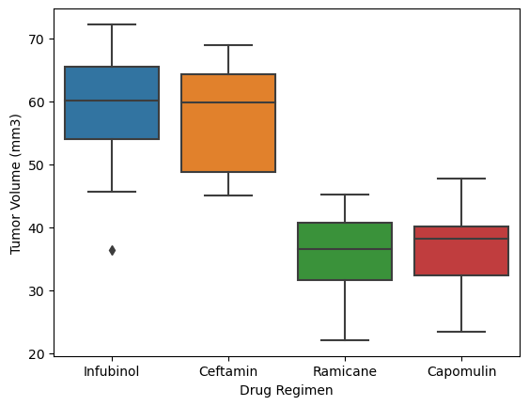

In [105]:



sb.violinplot(data**=**df2, x**=**"Drug Regimen", y**=**"Tumor Volume (mm3)",hue**=**"Sex", split**=True**)

plt.show()

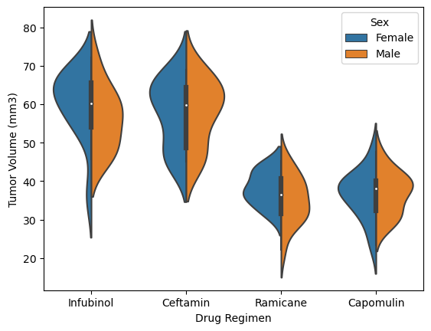

In [106]:



*# Put treatments into a list for for loop (and later for plot labels)*

treatment_list **=** ["Capomulin", "Ramicane", "Infubinol", "Ceftamin"]

​

*# Create empty list to fill with tumor vol data (for plotting)*

tumor_vol_list **=** []

​

*# Calculate the IQR and quantitatively determine if there are any potential outliers.*

**for** drug **in** treatment_list:

*# Locate the rows which contain mice on each drug and get the tumor volumes*

final_tumor_vol **=** last_df.loc[last_df["Drug Regimen"] **==** drug, 'Tumor Volume (mm3)']

*# add subset*

tumor_vol_list.append(final_tumor_vol)

*# Determine outliers using upper and lower bounds*

quartiles **=** final_tumor_vol.quantile([.25,.5,.75])

lowerq **=** quartiles[0.25]

upperq **=** quartiles[0.75]

iqr **=** upperq**-**lowerq

lower_bound **=** lowerq **-** (1.5**\***iqr)

upper_bound **=** upperq **+** (1.5**\***iqr)

outliers **=** final_tumor_vol.loc[(final_tumor_vol **<** lower_bound) **|** (final_tumor_vol **>** upper_bound)]

print(f"{drug}'s potential outliers: {outliers}")

Capomulin's potential outliers: Series([], Name: Tumor Volume (mm3), dtype: float64)

Ramicane's potential outliers: Series([], Name: Tumor Volume (mm3), dtype: float64)

Infubinol's potential outliers: 31 36.321346

Name: Tumor Volume (mm3), dtype: float64

Ceftamin's potential outliers: Series([], Name: Tumor Volume (mm3), dtype: float64)

In [107]:



*# Generate a box plot that shows the distrubution of the tumor volume for each treatment group.*

plt.boxplot(tumor_vol_list, labels **=** treatment_list)

plt.ylabel('Final Tumor Volume (mm3)')

plt.show()

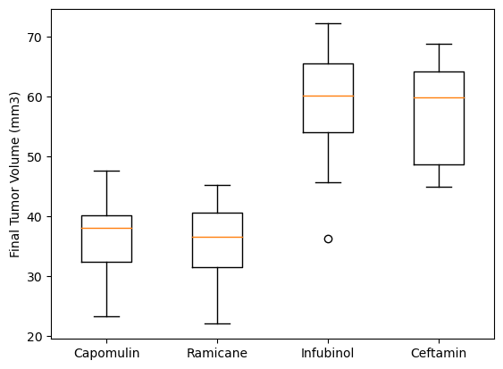

**Line and Scatter Plots**

In [108]:



*# Generate a line plot of tumor volume vs. time point for a single mouse treated with Capomulin*

df_sub **=** df.loc[df["Mouse ID"] **==** "l509"]

​

plt.figure(figsize**=**(10,6))

plt.plot(df_sub.Timepoint, df_sub["Tumor Volume (mm3)"], color**=**"blue", linewidth**=**3)

plt.title("Capomulin Treatment of mouse L509")

plt.xlabel("Timepoint (days)")

plt.ylabel("Tumor Volume (mm3)")

plt.grid(axis**=**"both", color**=**"lightgrey", alpha**=**0.2, linestyle**=**"--")

plt.show()

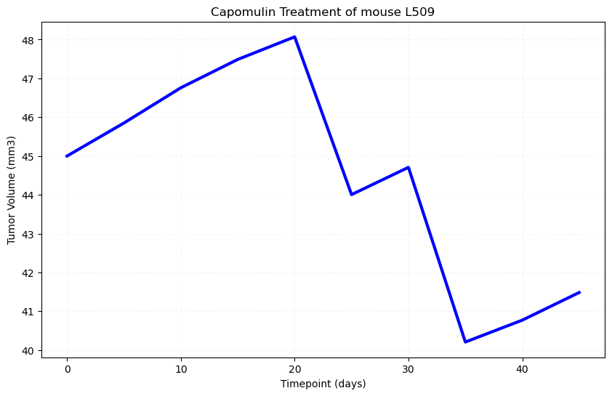

In [109]:



*# Generate a scatter plot of mouse weight vs. the average observed tumor volume for the entire Capomulin regimen*

data **=** df.loc[df["Drug Regimen"] **==** "Capomulin"].groupby("Mouse ID").agg({"Weight (g)": "mean", "Tumor Volume (mm3)": "mean"}).reset_index()

data.columns **=** ["Mouse ID", "Average Weight", "Average Tumor Size"]

​

plt.scatter(data["Average Weight"], data["Average Tumor Size"])

plt.show()

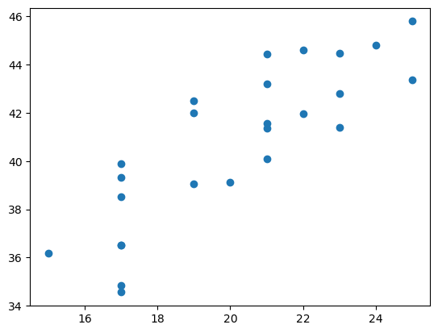

**Correlation and Regression**

In [110]:



*# Calculate the correlation coefficient and a linear regression model*

*# for mouse weight and average observed tumor volume for the entire Capomulin regimen*

​

**import** numpy **as** np

data **=** df.loc[df["Drug Regimen"] **==** "Capomulin"].groupby("Mouse ID").agg({"Weight (g)": "mean", "Tumor Volume (mm3)": "mean"}).reset_index()

data.columns **=** ["Mouse ID", "Average Weight", "Average Tumor Size"]

*# fit a linear regression line to the data*

slope, intercept **=** np.polyfit(data["Average Weight"], data["Average Tumor Size"], 1)

line **=** slope **\*** data ["Average Weight"] **+** intercept

​

plt.scatter(data["Average Weight"], data["Average Tumor Size"])

plt.plot(data["Average Weight"], line, color**=**'brown')

plt.show()

