**credit-risk-classification-model20-challenge-screenshots**

**Module 20 Challenge – credit-risk-classification**

**SMU DS – Raj Agrawal**

**Submitted on: 03-SEP-2023**

**Repository – https://github.com/RajAgrawal99/SMU_DS_Bootcamp_March2023_RA.git**

**Folder – credit-risk-classification-Challenge**

**Data source -** lending_data.csv

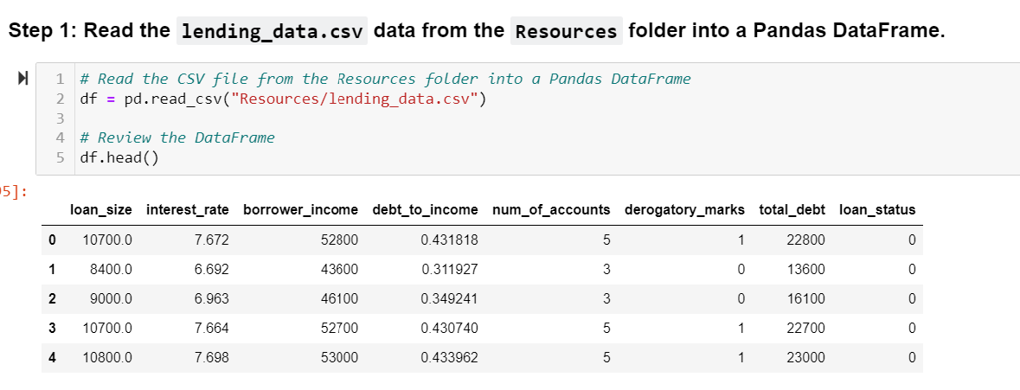

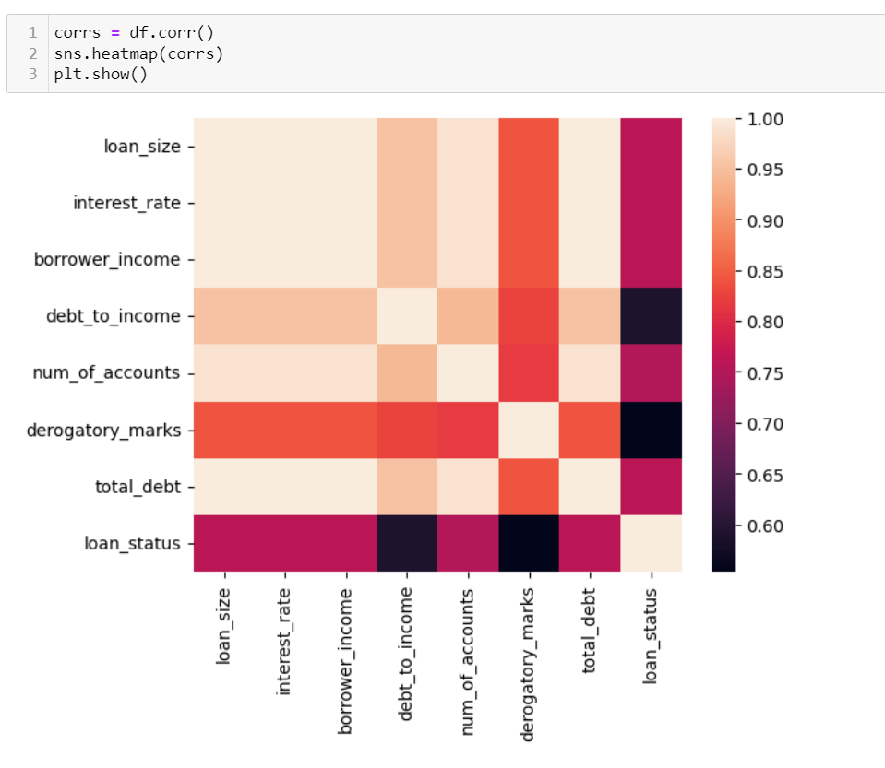

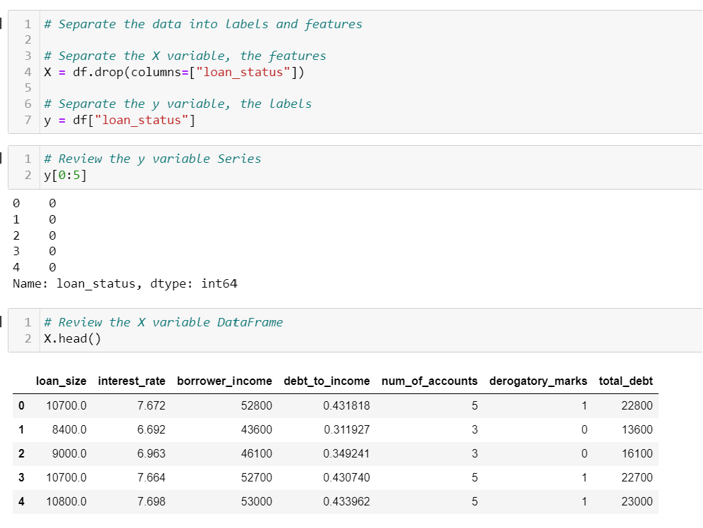

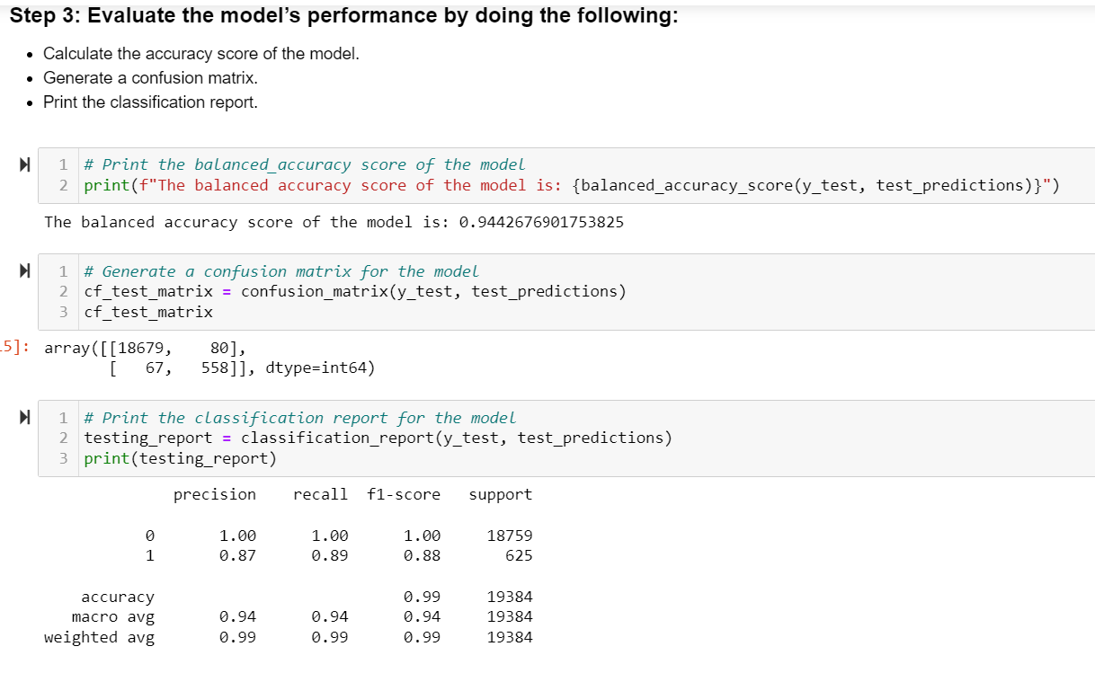

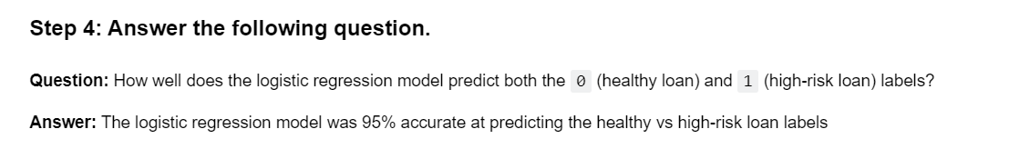

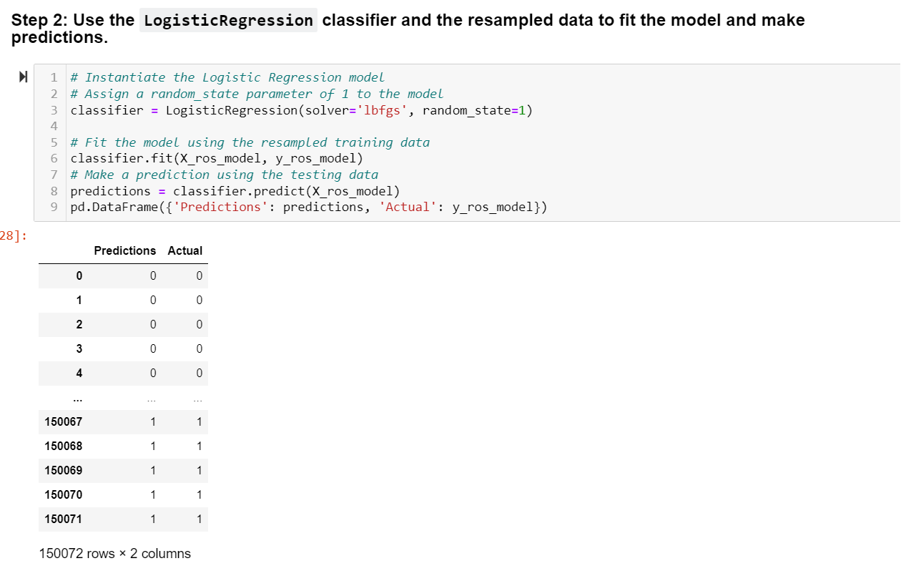

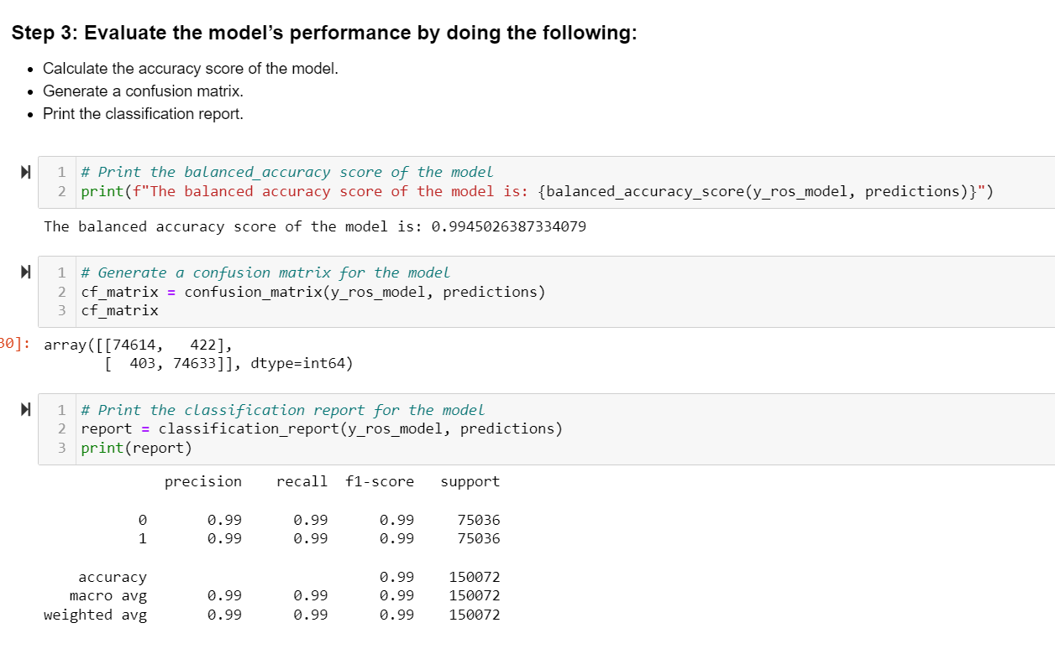

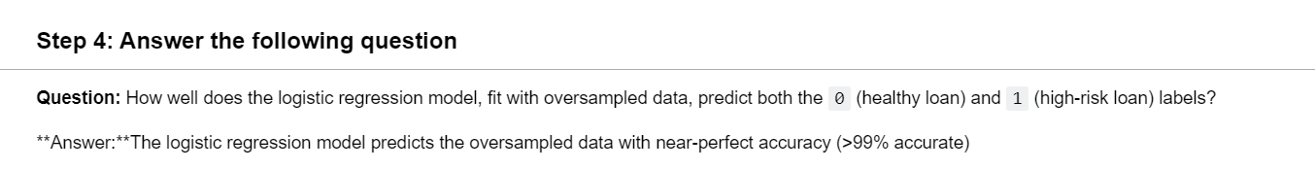

**Write a Credit Risk Analysis Report**

1. **An overview of the analysis:** Explain the purpose of this analysis.

* The purpose of this analysis is to create and evaluate the accuracy of a data model that predicts the credity worthiness of potential borrowers from peer-to-peer lending services

1. **The results:** Using a bulleted list, describe the accuracy score, the precision score, and recall score of the machine learning model.

* Balanced Accuracy Score: 95.20% --> this means that when taking into account the sensitivity (recall and/or true positive rate) and specificity (true negative rate) of the model, the balanced prediction accuracy was 95.2%
* -   Precision Score: 92% --> This means 92% of predicted positives were correct
* -   Recall Score: 95% --> this means that the model was 95% precise in measuring true positive values our of all positive predictions made

1. **A summary:** Summarize the results from the machine learning model. Include your justification for recommending the model for use by the company. If you don’t recommend the model, justify your reasoning.

* I would recommend using this model to predict the creditworthiness of borrowers, because it has over 95% accuracy in predicting the outcome of the repayment of the initial loan. That accuracy range could be easily molded into a business risk profile to ensure sufficient capital flow for the lenders to remain in business/make a profit.