*python-api-challenge*

*Module-6-challenge_ScreenShotDSBC_25MAY2023__Raj*

*Week 6th - Module 6 Challenge*

*=============================================*

*Student – Raj Agrawal / DS bootcamp*

*# WeatherPy – screen shots*

*# Build scatter plot for latitude vs. temperature*

​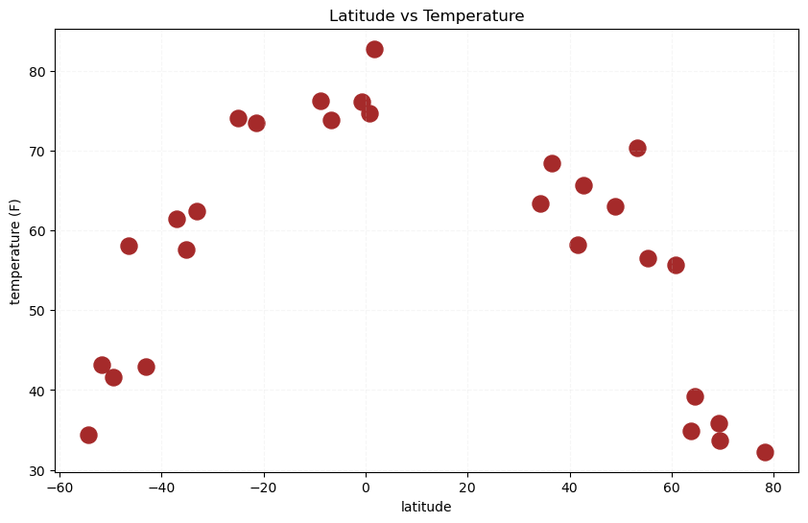

*# Build the scatter plots for latitude vs. humidity*

​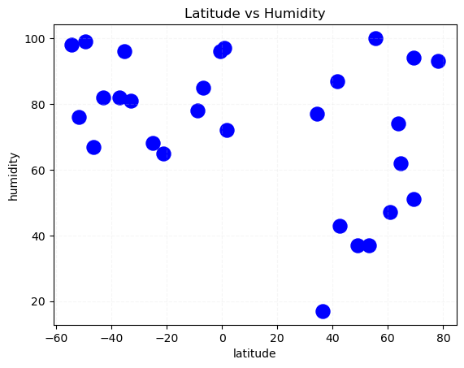

*# Build the scatter plots for latitude vs. cloudiness*

​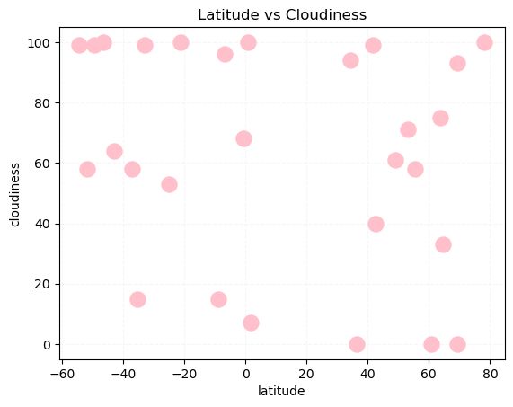

*# Build the scatter plots for latitude vs. wind speed*

​

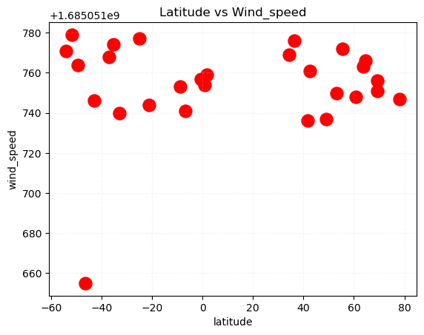

*# Define a function to create Linear Regression plots*

*# Linear regression on Northern Hemisphere*

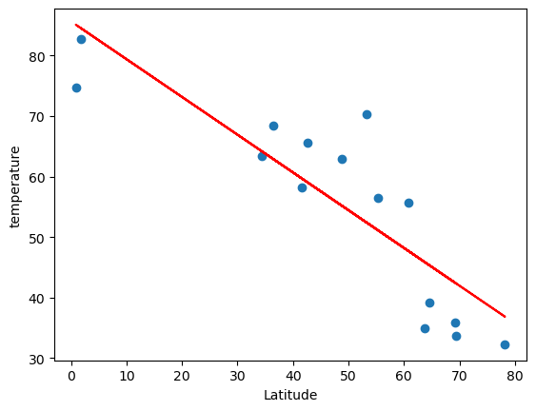

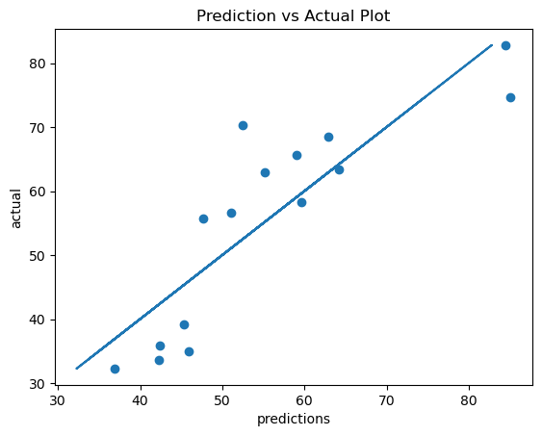

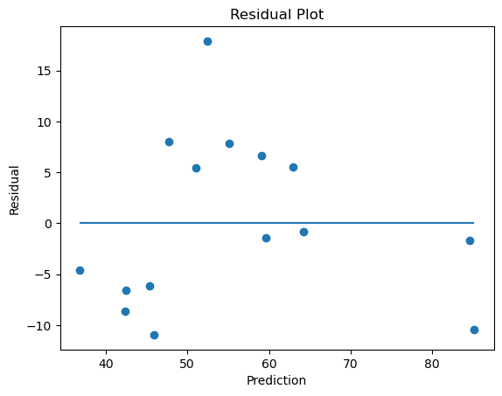

*# Linear regression on Southern Hemisphere*

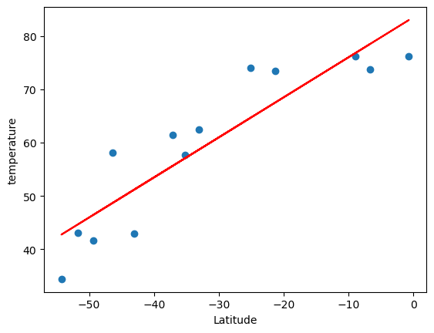

*# VacationPy– screen shots*

### Create a map that displays a point for every city in the city_data_df DataFrame. The size of the point should be the humidity in each city.

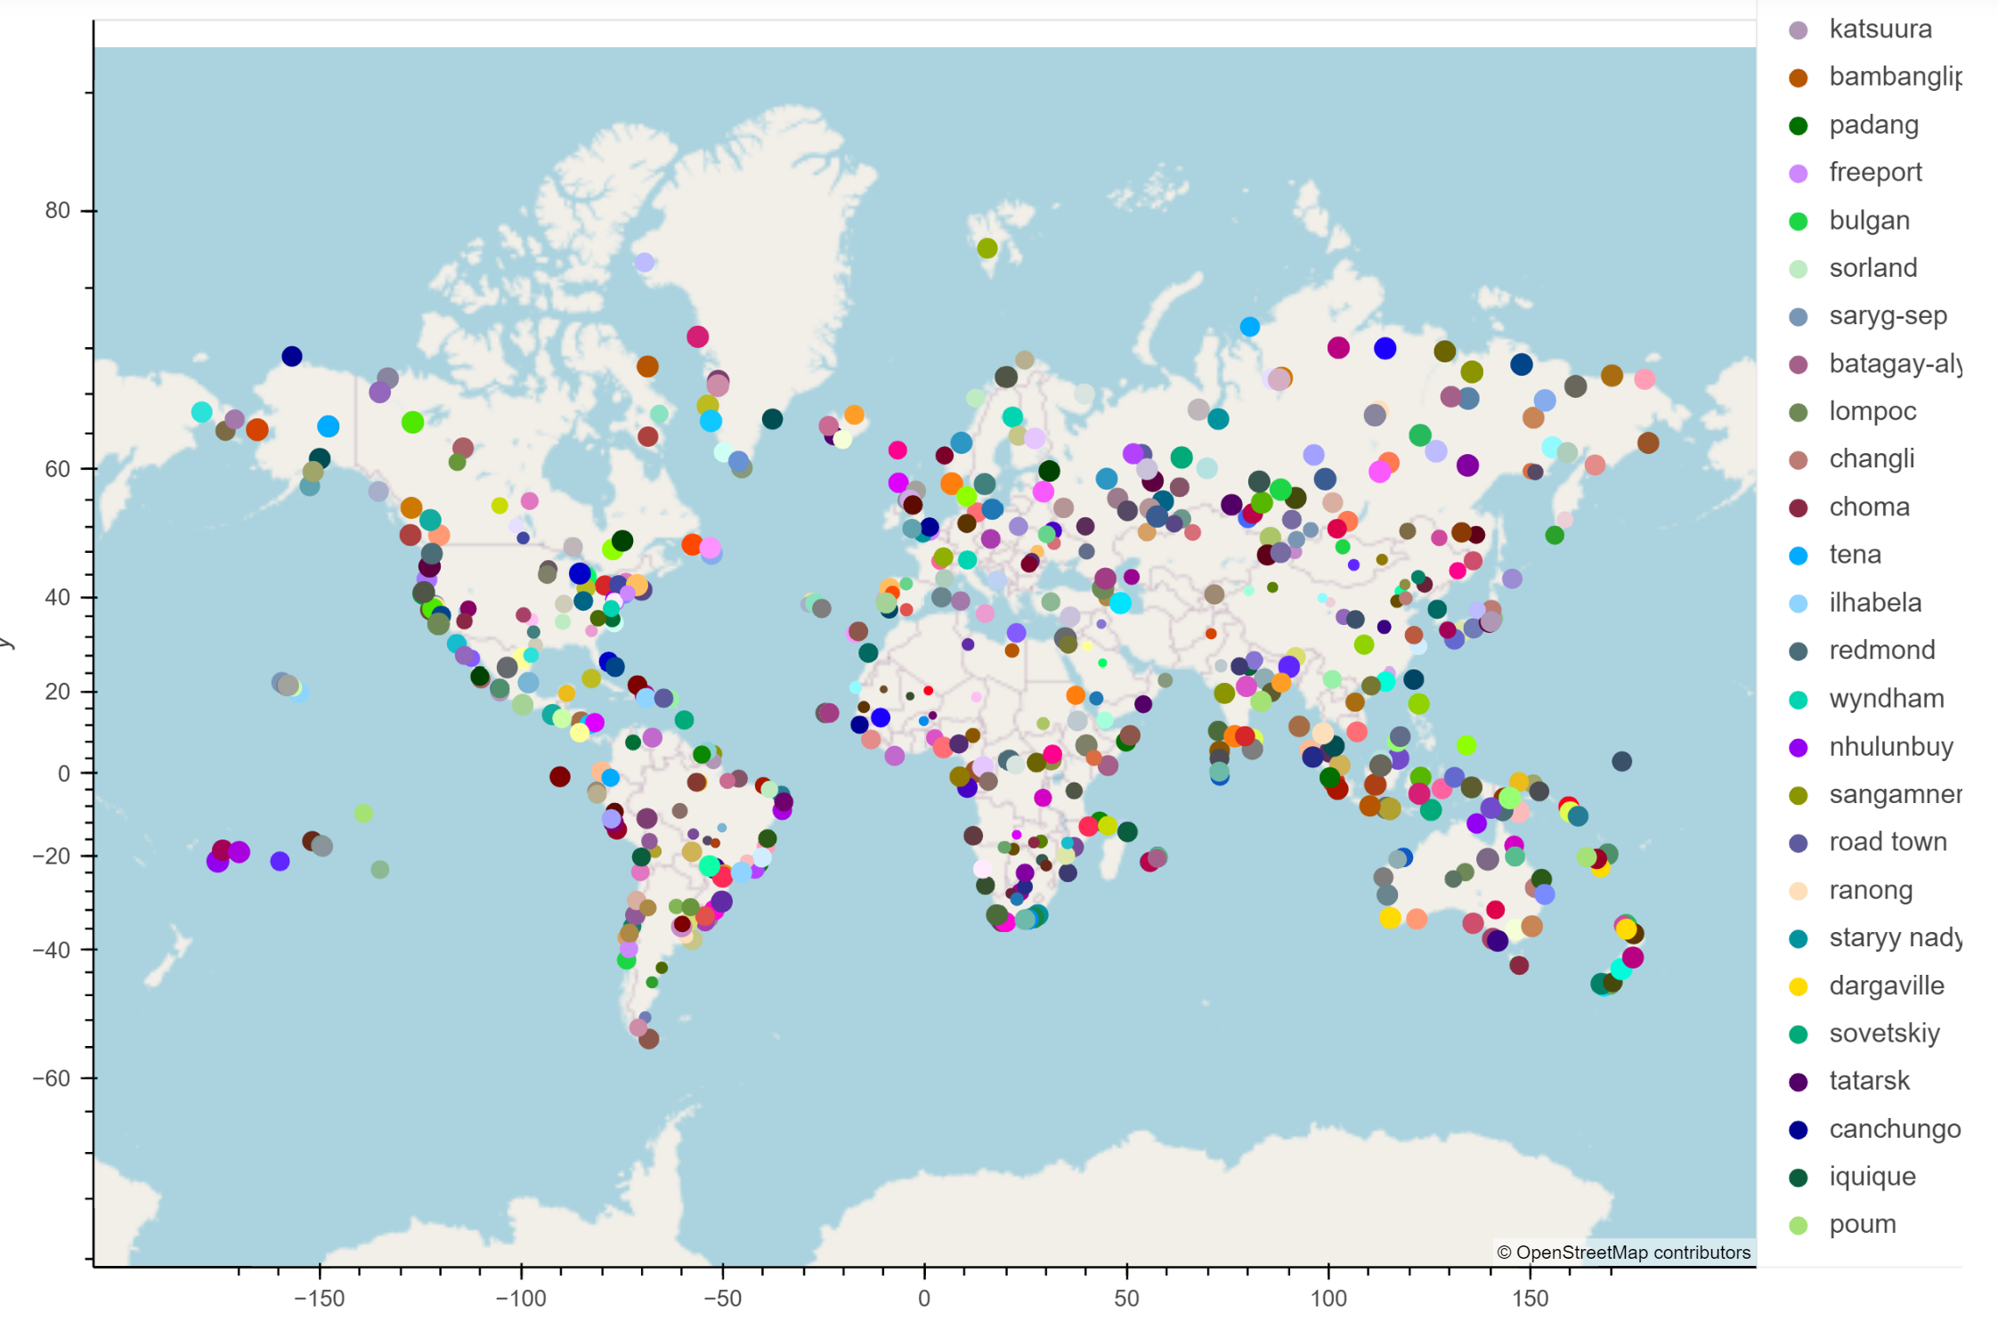

### Add the hotel name and the country as additional information in the hover message for each city in the map.[¶](http://localhost:8889/notebooks/WeatherPy/VacationPy-RajCopy.ipynb#Step-5:-Add-the-hotel-name-and-the-country-as-additional-information-in-the-hover-message-for-each-city-in-the-map.)

