Week 3rd - as of 4/21/2023

Module 3 Challenge

python challenge

=============================================

Student – Raj Agrawal / DS bootcamp

===========================================

PyBank – terminal output screen shot

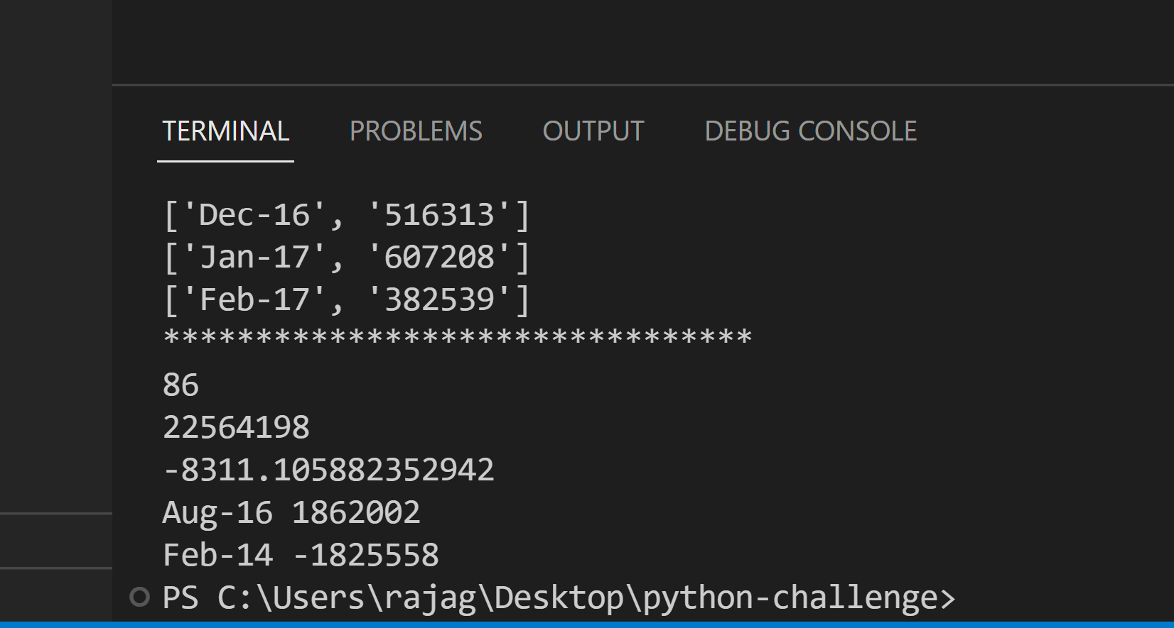

PyPoll – terminal output screen shot

