
Tribhuvan University
Faculty of Humanities and Social Science
A PROJECT REPORT FOR
"Bus Ticketing System using Closest Pickup and Content Based Algorithms"

Submitted to
Department of Computer Application
Advanced College of Engineering and Management
Kalanki, Kathmandu

In partial fulfillment of the requirements for the bachelor’s in computer application

Submitted by
Stephen G. Shrestha Rubek Maharjan 37602025 37602021
BCA 6th Semester BCA 6th Semester

Under the Supervision of
Er. Sakriya Maharjan
11/22/2024


Tribhuvan University
Faculty of Humanities and Social Science
Advance College of Engineering and Management
Kalanki, Kathmandu
Bachelor in Computer Application (BCA)

SUPERVISOR’S RECOMMENDATION
I hereby recommend that this project prepared under my supervision by Rubek Maharjan and Stephen G. Shrestha entitled “Bus Ticketing System using Closest Pickup and Content Based Algorithms” in partial fulfillment of the requirements for the degree of Bachelor of Computer Application is recommended for the final evaluation.

…………………………………….
Er. Sakriya Maharjan
SUPERVISOR
Department of Computer Application
Advanced College of Engineering and Management
Kalanki, Kathmandu


Tribhuvan University
Faculty of Humanities and Social Science
ADVANCED COLLEGE OF ENGINEERING AND MANAGEMENT

LETTER OF ACCEPTANCE

This is to certify that this project prepared by “Rubek Maharjan and Stephen G. Shrestha” entitled “MahaBus” in partial fulfillment of the requirements for the 6th semester of Bachelor in Computer Application has been evaluated. In our opinion it is satisfactory in the scope and quality as a project for the defense project.

Er. Sakriya Maharjan Er. Kritika Gulati
Project Supervisor Head of Department
BCA Department ACEM
ACEM

External Examiner Internal Examiner
Tribhuvan University

ABSTRACT
The Bus Ticketing System is a comprehensive platform designed to streamline the booking and management of bus tickets. It allows users to search for bus routes, book tickets, and access travel schedules, ensuring a convenient and efficient booking experience. The system features a dual-panel architecture, with distinct capabilities for users and administrators. Users can easily view available routes, select preferred seats, and make payments, while administrators can manage schedules, allocate buses, and monitor ticket sales and occupancy rates. This organized approach enhances operational efficiency and minimizes manual errors, providing a seamless experience for all stakeholders. The system's architecture supports extensive data collection and processing, ensuring efficient management of both user interactions and administrative tasks. The software aims to improve the ticketing process by offering an intuitive interface and integrated communication features. Future developments will focus on advanced data analytics and machine learning techniques to optimize route planning, enhance user experience, and provide detailed insights into travel patterns and preferences. This innovative technology offers a forward-thinking solution for improving the organization and execution of bus ticketing in an increasingly digital world.

Keywords: HTML, CSS, JavaScript, PHP, Content-Based Filtering, SQL, Map Integration, UI/UX

ACKNOWLEDGEMENT
We take this opportunity to express our deepest and sincere gratitude to our Supervisor Er. Sakriya Maharjan for her insightful advice, motivating suggestions, invaluable guidance, help, and support in the successful completion of this project, and also for her constant encouragement and advice throughout our Bachelor’s program.
We express our deep gratitude to the Head of the Computer Application Department, Er. Kritika Gulati for her indispensable guidance and support to harness our skills.
The in-time facilities provided by the department throughout the Bachelor’s program are also equally acknowledgeable.
We would like to convey our thanks to the teaching and non-teaching staff of the Department of Computer Application, ACEM for their invaluable help and support throughout the period of Bachelor’s Degree. We are also grateful to all our classmates for their help, encouragement, and invaluable suggestions.
Yours Sincerely,
Rubek Maharjan
Stephen G. Shrestha

TABLE OF CONTENTS
SUPERVISOR’S RECOMMENDATION i
LETTER OF ACCEPTANCE ii
ABSTRACT iii
ACKNOWLEDGEMENT iv
LIST OF ABBREVIATIONS vii
LIST OF FIGURES viii
LIST OF TABLES ix
CHAPTER 1 INTRODUCTION 1
1.1 Introduction 1
1.2 Problem Statement: 1
1.3 Objectives: 1
1.4 Scope & Limitation 2
1.4.1 Scope 2
1.4.2 Limitation 2
1.5 Report Organization 3
CHAPTER 2 BACKGROUND STUDY AND LITERATURE REVIEW 4
2.1 Background Study 4
2.2 Literature Review 4
CHAPTER 3 SYSTEM ANALYSIS AND DESIGN 7
3.1 System Analysis 7
3.1.1 Requirement Analysis 7
3.1.2 Feasibility Analysis 8
3.1.3 Data Modeling (ER Diagram) 9
3.1.4 Process Modeling (DFD) 10
3.2 System Design 13
3.2.1 Architectural Design 13
3.2.2 Database Schema Design 14
3.2.3 User Interface Design 14
CHAPTER 4 IMPLEMENTATION AND TESTING 17
4.1 Implementation 17
4.1.1 Tools Used 17
4.1.2 Implementation details of modules (Description of Procedures/Functions) 19
4.1.3 Algorithms 20
4.2 Testing 24
CHAPTER 5 CONCLUSION AND FUTURE RECOMMENDATION 29
5.1 Lesson Learnt/Outcome 29
5.1.1 Lesson Learnt 29
5.1.2 Outcomes 29
5.2 Conclusion 30
5.3 Future Recommendation 30
REFERENCES 31
APPENDIX

LIST OF ABBREVIATIONS
CASE | Computer Aided Software Engineering
CSS | Cascading Style Sheet
DFD | Data Flow Diagram
ERD | Entity Relationship Diagram
HTML | Hypertext Markup Language
JS | JavaScript
MySQL | Microsoft Server Structured Query Language
PHP | Hypertext Preprocessor
SQL | Structured Query Language
UI | User Interface
RDMS | Relational Database Management System

LIST OF FIGURES
Figure 3. 1 Use Case Diagram of Bus Ticketing System 7
Figure 3. 2 ER Diagram of Bus Ticketing System 9
Figure 3. 3 Context Modeling of Bus Ticketing System 10
Figure 3. 4 Level 1 DFD of Bus Ticketing System 10
Figure 3. 5 Level 2 DFD of Bus Ticketing System 11
Figure 3. 6 Physical DFD of Bus Ticketing System 12
Figure 3. 7 Architectural Design of Bus Ticketing System 13
Figure 3. 8 Database Schema Design of Bus Ticketin System 14
Figure 3. 9 Login Page of Bus Ticketing System 14
Figure 3. 10 Home Page of Bus Ticketing System 15
Figure 3. 11 Explore Page of Bus Ticketing System 15
Figure 3. 12 Seats Detail Page of Bus Ticketing System 16
Figure 4. 1 Pseudo Code for Closest Pickup Location Algorithm 21
Figure 4. 2 Pseudo Code for Bus Sorting Algorithm 23

LIST OF TABLES
Table 4. 1 Test Cases for Unit Testing 24
Table 4. 2 Search Buses 25
Table 4. 3 Book a Seat 25
Table 4. 4 Test Plan for System Testing 25
Table 4. 5 Test Case 1 for Registration Module 26
Table 4. 6 Test Case 2 for Login Module 26
Table 4. 7 Test Case 3 for Admin Upload Module 26
Table 4. 8 Test Case 4 for Search Module 27
Table 4. 9 Test Case for Closest Pickup Algorithm 27
Table 4. 10 Test Case for Content Base Algorithm 28

CHAPTER 1

INTRODUCTION

Introduction
In the current era of digital transformation, public transportation systems are undergoing significant changes to enhance service efficiency, accessibility, and passenger satisfaction. One critical aspect of these advancements is the modernization of bus ticketing systems. Traditional ticketing methods, often characterized by long queues, paper tickets, and manual processing, are increasingly becoming obsolete. [1]
The proposed Bus Ticketing System aims to address the challenges faced by both passengers and transportation providers. For passengers, the system will offer an intuitive platform to easily book, manage, and validate bus tickets through website. The system will contribute to sustainable mobility by reducing the reliance on paper tickets and supporting the development of smart cities.

1.2 Problem Statement:
Booking bus tickets in Nepal is often complicated and time-consuming, causing frustration for both passengers and bus operators. Passengers face challenges such as unclear booking processes and limited access to information, while bus companies struggle with managing bookings efficiently.
This project aims to develop a user-friendly Bus Ticket Booking System specifically for Nepal. The system will simplify ticket reservations for passengers, ensuring a smoother booking experience. For bus operators, it will provide tools to manage schedules effectively and improve customer service, ultimately enhancing the overall efficiency of the bus transport system in Nepal.

1.3 Objectives:
- To create simple platform to book bus tickets efficiently.
- To develop tools for bus operators to manage schedules, seats, and routes.

1.4 Scope & Limitation

1.4.1 Scope
The objective of this project is to design, develop, and deploy a comprehensive online platform for booking bus tickets. The system will serve as a centralized hub where users can search for bus routes, compare schedules, select seats, and complete their ticket purchases. The platform will provide detailed bus information, real-time seat availability, and payment options, delivering a seamless experience for both passengers and bus operators.
The project will involve the following key components:
User Registration and Authentication: Users will be able to create accounts, log in, and manage their profiles. They can also save routes, track bookings, and receive notifications about upcoming trips, special offers, and updates.
Bus Schedule and Route Listings: The system will provide a comprehensive database of bus routes and schedules. Users will be able to search for buses by departure and destination locations, dates, times, and bus type (luxury or regular). Detailed information on each route, including departure times, travel durations, stops, and end destination.
Ticket Booking and Payment: Users will be able to select their desired bus, route, time, and seats and proceed to book their tickets. The platform will support multiple payment options, including credit/debit cards, digital wallets, and online banking. Users will have the option to modify or cancel their bookings within the system’s cancellation policies.

1.4.2 Limitation
Dependence on Internet Connectivity: The system relies heavily on internet access for users to book tickets, view schedules, and check real-time seat availability. Limited or no internet access could prevent passengers from using the platform, especially in rural areas or during travel.
Real-Time Data Sync Issues: The system’s accuracy depends on real-time updates from bus operators. Delays or failures in syncing data (seat availability, cancellations) could lead to inaccurate information being displayed, resulting in booking errors or double bookings.
Scalability Challenges: As the number of users, routes, and transactions grows, the system may face scalability challenges. If not built with scalability in mind, it could experience slowdowns or crashes during periods of high demand, such as holidays or peak travel times.
Refund and Cancellation Delays: While the system automates ticket cancellations and refunds, delays in processing refunds due to banking systems or payment gateway issues could lead to dissatisfaction among passengers, especially in urgent situations.

1.5 Report Organization
Chapter 1 introduces the system, we outline its objectives, limitations, and the compelling reasons that drove its development. By providing a concise overview, we aim to offer a clear understanding of the system's purpose and the boundaries it operates within.
Chapter 2 summarizes system management, various applications have been developed with intriguing features.
Chapter 3 encompass various aspects, including functional and non-functional requirements, feasibility analysis, ER diagram, DFD, system design, system architecture, database schema, and interface design.
Chapter 4 talks about various tools that were used in the system development process to facilitate implementation. Detailed implementation procedures were followed, including thorough testing to assess the system's performance and functionality.
Chapter 5 highlights a brief summary of lessons learnt, outcome and conclusion of the whole project and explains what has been done and what further improvements could be done.

CHAPTER 2

BACKGROUND STUDY AND LITERATURE REVIEW

2.1 Background Study
In many countries, the bus transportation system operates informally, with no centralized or standardized platform for ticketing, scheduling, or managing bus routes. Often, passengers have to rely on physical ticket counters, bus terminals, or local agents to book tickets, leading to inconsistent pricing, lack of transparency, and frequent overbooking. Furthermore, pricing is often non-standardized, with rates varying based on demand or the operator’s discretion.
Due to these challenges, several bus ticketing websites and mobile applications have emerged in the market. Some platforms favor larger bus operators, leaving smaller regional services underrepresented, while others may not provide users with the flexibility to modify or cancel bookings easily. [2]
In response to this situation, we are developing a comprehensive bus ticketing website that addresses the needs of both passengers and bus operators. The goal is to provide a user-friendly platform that offers a transparent, real-time view of bus schedules, seat availability, and pricing. The system will also allow bus operators to list and manage their routes, prices, and services in a competitive environment. By balancing the needs of passengers, operators, and local businesses, this platform aims to standardize the bus ticketing process, making it accessible, efficient, and equitable for all users involved.

2.2 Literature Review
A study by Sharma explores how user experience impacts the adoption and satisfaction of online bus ticket booking systems. Findings highlight that interface design, ease of use, and customer support significantly influence user behavior and system effectiveness, crucial for enhancing service quality and user satisfaction. [3]
According to a report by World Bank, technological innovations such as real-time data integration, mobile applications, and AI-driven analytics are transforming transportation management systems. These innovations improve operational efficiency, scheduling accuracy, and customer service within bus ticket booking platforms, fostering a more responsive and reliable travel experience. [4]
Research by J.D. Power examines customer satisfaction and loyalty in online travel booking, including bus ticket reservations. The study identifies key drivers such as service quality, price transparency, booking convenience, and post-purchase support, influencing customer retention and brand loyalty in competitive travel markets. [5]
MarketsandMarkets' report explores the integration of Internet of Things (IoT) devices, such as smart ticketing systems and vehicle trackers, in public transportation. IoT platforms and edge computing enable real-time data processing, enhancing operational efficiency and passenger experience. [6]
McKinsey & Company's analysis explores the application of AI and machine learning algorithms in personalizing travel recommendations and optimizing pricing strategies. AI-driven chatbots, predictive analytics, and dynamic pricing models enhance customer engagement and revenue generation in bus ticketing platforms. [7]
Studies by UC Berkeley assess the impact of ride-sharing services (e.g., Uber, Lyft) on bus travel demand and service utilization. Integration with multi-modal transportation apps and shared mobility solutions offer commuters flexible travel options and influence modal shift behaviors in urban areas. [8]
Security measures in bus ticketing systems include HTTPS protocol for secure data transmission, SSL/TLS encryption for data protection, and OAuth/JWT for secure authentication. Regular security audits and vulnerability assessments are conducted to detect and mitigate threats, complemented by firewall configurations and intrusion detection systems (IDS) to ensure compliance with regulatory standards like PCI-DSS, maintaining user trust and system integrity. [9]
According to Mbarika manual systems were prone to errors, with issues like overbooking or inconsistent pricing being common. Moreover, passengers lacked access to real-time information, such as bus schedules, delays, or cancellations. [10]
Grob and Bernon discuss how the introduction of digital ticketing revolutionized the transportation sector, as users could book tickets online or through mobile devices, reducing the reliance on physical ticket counters and improving operational efficiency. [11]
Shiroor analyze the development of online ticketing platforms, noting that the integration of web-based and mobile applications has become a game-changer for public transport. These platforms provide users with the ability to search for available buses, view schedules, select seats, and pay for tickets online. [12]
Kaur and Sandhu, online systems offer bus operators the ability to optimize route planning and dynamically adjust prices based on demand. [13]
According to Kumar, allowed users to book tickets on the go, view seat layouts, and receive real-time alerts. The convenience provided by these apps enhanced the user experience and widened the customer base, as passengers no longer needed access to desktop computers to make bookings. [14]
Sasidharan highlight the issue of digital divide, where passengers in rural areas or regions with poor internet connectivity may struggle to use online systems. In these cases, the reliance on manual or agent-based ticketing still persists, which can limit the reach of digital platforms. [15]

CHAPTER 3

SYSTEM ANALYSIS AND DESIGN

3.1 System Analysis

3.1.1 Requirement Analysis
The requirement analysis for a Bus Ticket Booking System in Nepal involves identifying and documenting the functional and non-functional requirements necessary to develop a comprehensive and efficient system. This analysis aims to ensure that the system meets the needs of users, bus operators, and other stakeholders.
i. Functional Requirement
There are various basic as well as secondary functional requirements for a bus ticketing website. Some of them are user registration and authentication, manages buses, view buses, book seats, view ticket etc. User authentication should ensure that only authorized users can access certain features and information. Similarly, users should be able to search and view for buses based on various criteria, such as location and specific features.
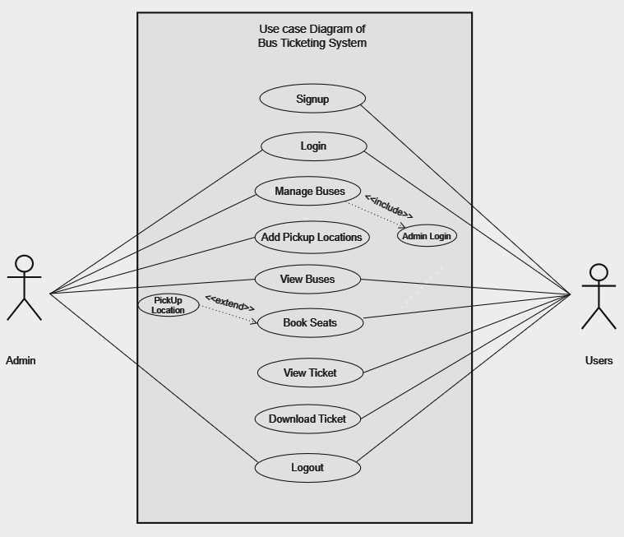
Figure 3. 1 Use Case Diagram of Bus Ticketing System
In the above use case diagram, there are two actors (admin and users). The actors can login and logout. The admin initiates the manage buses, add pickup location and view buses. User’s initiates view buses, book seats, view ticket and download ticket.
ii. Non-Functional Requirement
Performance, usability, user experience and security are important non-functional requirements for a website. The website should have fast loading times to ensure a smooth user experience. Content and features should adapt to smaller screens without loss of functionality or readability. The website should employ robust security measures to protect user data and prevent unauthorized access. User login and authentication processes should be secure and follow best practices.

3.1.2 Feasibility Analysis
Feasibility study is a process of analyzing technical, operational and economic viability of a project. It ensures that the proposed system aligns with the team's goals, resources, and capabilities.
i. Technical
The technology needed to build the Bus Ticket Booking System is readily available. We can use existing platforms and tools to develop both web and mobile applications. Reliable internet connectivity and smartphone usage are growing in Nepal, making it feasible to implement and use this system.
HTML, CSS and JavaScript will be the frontend technologies for this website. Similarly, its backend will be written on PHP and MySQL will be used as database. Additionally, the website will require regular maintenance and updates to ensure it remains up-to-date with the latest technologies and security standards.
ii. Operational
The system will simplify the bus ticket booking process for users and bus operators. Users will find it easier to search for and book tickets online, reducing the need for physical ticket counters. Bus operators will benefit from automated booking management, reducing manual errors and improving efficiency. The system will include customer support and notifications, enhancing user satisfaction.

iii. Economic
Developing the system requires an initial investment in software development, server hosting, and marketing. However, the costs can be offset by the revenue generated from booking fees and partnerships with bus operators. The convenience and improved service quality will attract more users, leading to increased bookings and profitability over time. Overall, the long-term financial benefits outweigh the initial costs.

3.1.3 Data Modeling (ER Diagram)
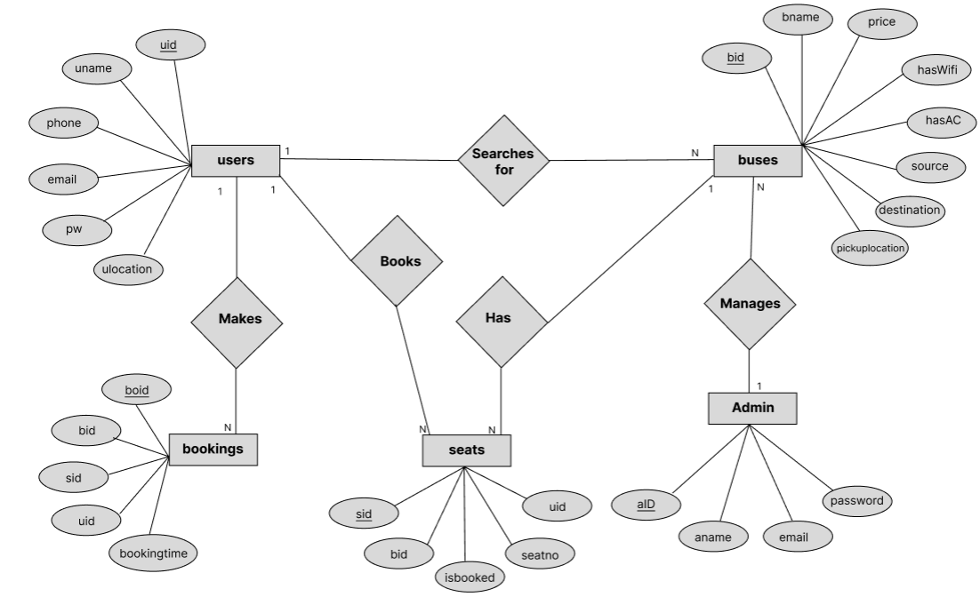
Figure 3. 2 ER Diagram of Bus Ticketing System
In above ER Diagram, users, buses, bookings, admin and seats are the entities which are represent by the rectangle. ulocation, phone, email, pw, uname, source, destination etc are the attributes of the entities. Eclipse is used to represent an attribute. Books, Searches for, manages, makes and has are the relationship which is used to describe the relation between entities. Diamond is used to represent the relationship.

3.1.4 Process Modeling (DFD)
3.1.4.1 Context Diagram
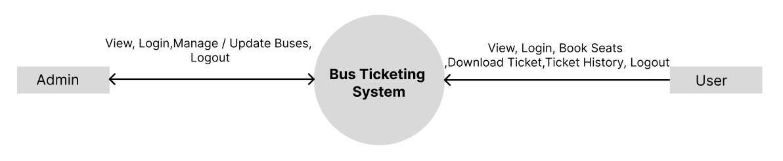
Figure 3. 3 Context Modeling of Bus Ticketing System
Level 0 Data Flow Diagram (DFD) provides a high-level overview of the project functionality, illustrating the interactions between external entities and the system itself.
In the diagram above, the external entity are admin and user. The entities can view system as well as login and logout. The entity (admin) can manage & update the buses whereas entity (user) can book seats, download ticket and view the past history.
3.1.4.2 Level 1 DFD
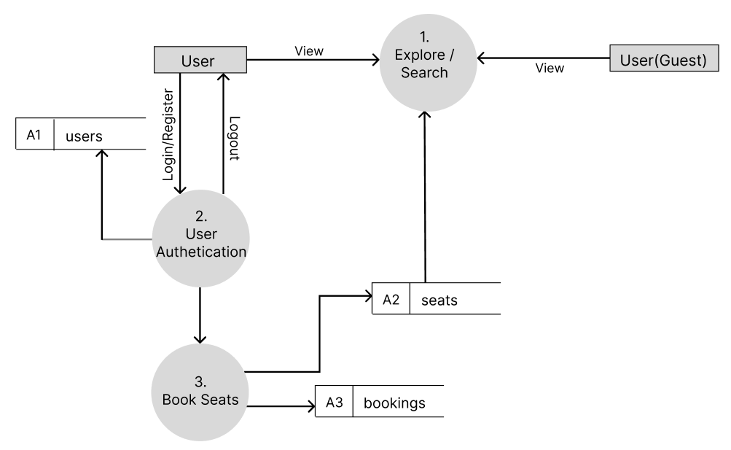
Figure 3. 4 Level 1 DFD of Bus Ticketing System
The above diagram illustrates level 1 DFD diagram where the user firstly opens the website. Then the user can register their account to use all the facilities that are provided by the web application. After login, user can view buses and book the seats on this website. The data entered by the user are stored in different databases. The user(guest) can use the explore option based on their needs.
3.1.4.3 Level 2 DFD
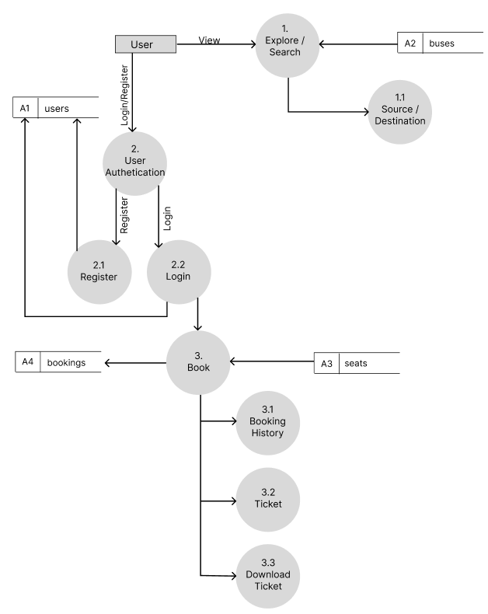
Figure 3. 5 Level 2 DFD of Bus Ticketing System
The above diagram illustrates level 1 DFD diagram where the user firstly opens the website. If the user is using the system then the system asks for user authentication. If the user has their account then they can use all the facilities that are provided by the web application. Each user's details are stored in database. After login, user can view buses, book the seats and watch the past booking history on this website. The user can also download the ticket easily on their devices. The data enter by the users are stored in different database
3.1.4.4 Physical DFD
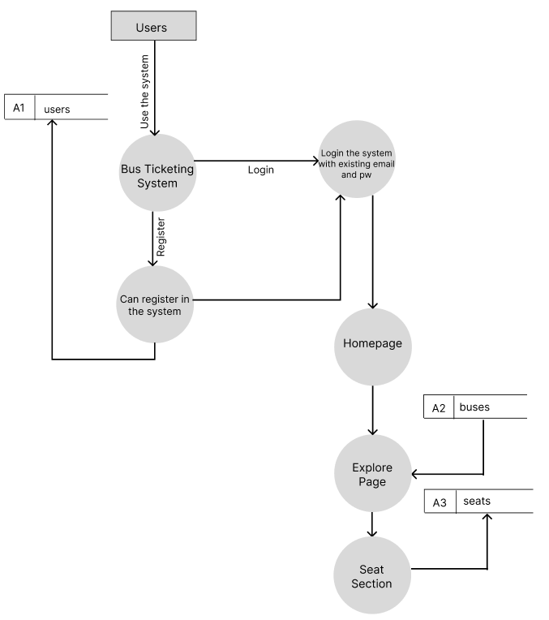
Figure 3. 6 Physical DFD of Bus Ticketing System
The above diagram depicts physical DFD of Bus Ticketing System. User can login or register to the website. The registered data is stored in users table in database. Similarly, a user can browse home page, explore and book the seats. All the data related to specific section are stored in specific table.

3.2 System Design

3.2.1 Architectural Design
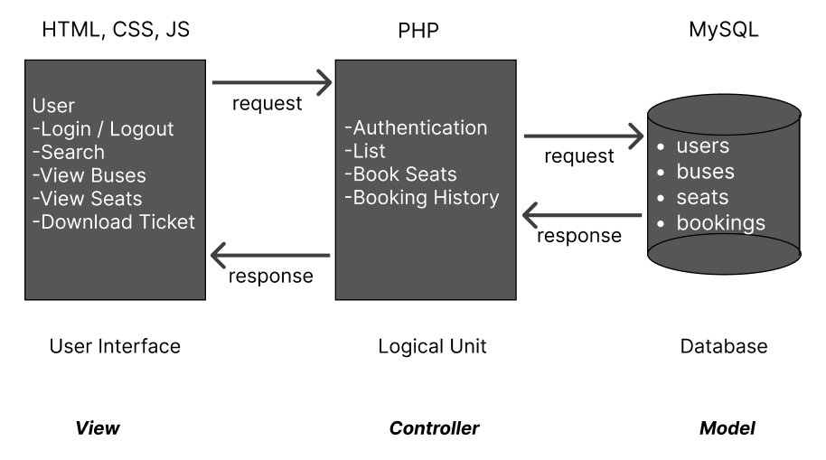
Figure 3. 7 Architectural Design of Bus Ticketing System
In above architecture design, the main element in charge of processing the data gathered from the various input systems is the system server. User can explore the system but for booking user need to register first. After authentication, user can view buses and book the seats. The booked ticket can be also download on the user’s device. Each user's data is stored in a database.

3.2.2 Database Schema Design
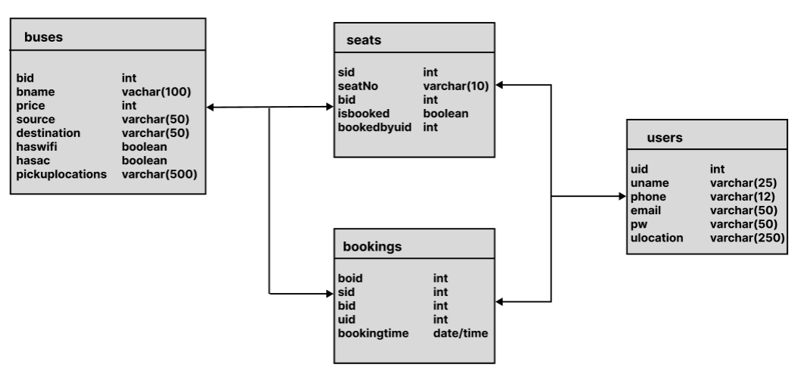
Figure 3. 8 Database Schema Design of Bus Ticketing System
The above diagram is database schema design of Bus Ticketing System. There are four tables: users, buses, seats and bookings. Every table has a unique key. Similarly, the tables also use foreign keys. The database follows normalization principles.

3.2.3 User Interface Design
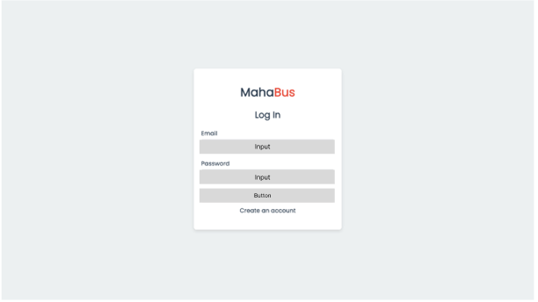
Figure 3. 9 Login Page of Bus Ticketing System
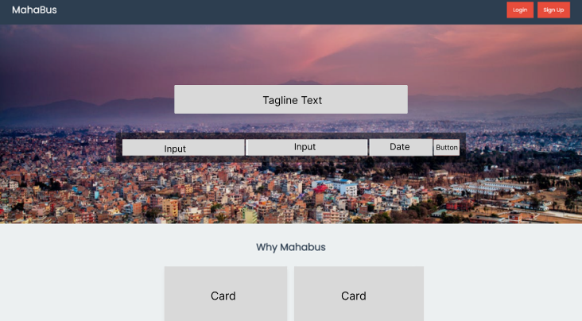
Figure 3. 10 Home Page of Bus Ticketing System
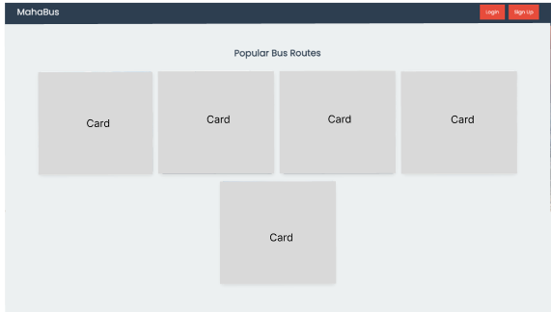
Figure 3. 11 Explore Page of Bus Ticketing System
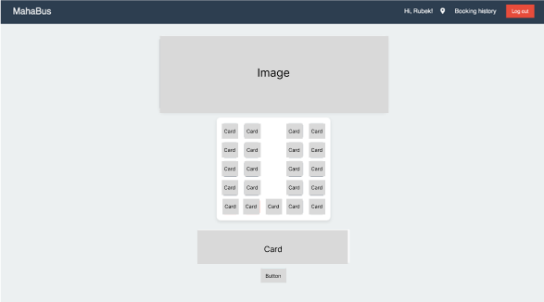
Figure 3. 12 Seats Detail Page of Bus Ticketing System

CHAPTER 4

IMPLEMENTATION AND TESTING

4.1 Implementation
Data was gathered in the initial phase. Data collection takes longer than the other phases. The entire project's physical design has been translated into functional computer code. The chapter before addressed a variety of techniques and technologies that were used to construct the system.

4.1.1 Tools Used
The tools that are used while designing this web application are:
Frontend: HTML, CSS, JavaScript
Backend: PHP
Database: MySQL
Documentation tools: Microsoft Word, Microsoft Excel, Microsoft PowerPoint
- Visual Studio Code(VS Code)
Visual Studio Code (VS Code) is a popular source code editor that supports HTML and CSS development. VS Code provides syntax highlighting, auto-completion, and code formatting for HTML files. We can create and edit HTML documents using the built-in HTML language. We can write CSS code and apply styles to HTML elements. We can use CSS to define the visual appearance of our web pages, including colors, fonts, layout, and more. VS Code provides debugging capabilities for JavaScript, which is commonly used to enhance interactivity and functionality in web development. [16]
- HTML(Hypertext Markup Language) & CSS(Cascading Style Sheet)
In this project, we use HTML and CSS for web development. These are essential technologies for web development. They work together to create the structure, layout, and visual presentation of web pages. HTML is used to create the basic structure and elements of a web page. It defines the headings, paragraphs, lists, tables, forms, images, and other content on the page. And CSS enables you to build responsive websites that adapt and scale based on the device or screen size. By using CSS media queries, you can apply different styles to different devices, making your site mobile-friendly and ensuring a good user experience across various devices. [17]
- JavaScript(JS)
In this project, we made the use of JavaScript to add interactivity to webpages and also for some client side form validation. JS is a versatile programming language that is primarily used for adding interactivity and dynamic functionality to websites. By transforming a static web page into an interactive one, JS augmentation enhances the user experience of the website. Just to review, JS gives web pages behavior. [18]
- PHP
PHP (Hypertext Preprocessor) is used extensively in this project for backend programming or server side scripting. It is also used to integrate and connect SQL queries. It is a server-side scripting language used for web development. It is designed to interact with databases. It enables you to build applications that store and retrieve data dynamically. We can use PHP to retrieve data from databases, insert or update data, and perform queries to fetch specific information. [19]
- MySQL
In this project, we used MySQL as to store data in the form of various tables such as user table, property table and photos table. MySQL is an open-source relational database management system (RDBMS) that is used to store, manage, and retrieve structured data. It allows you to create and organize structured data in tables, with each table consisting of rows and columns. It enables you to retrieve data from the database using SQL (Structured Query Language) queries. [20]
- XAMPP Server
We utilized XAMPP Server to host our project locally. It acted as a host for the PHP website as well as MySQL database. XAMPP is a software package that simplifies the setup and deployment of a local web server environment. It provides the necessary tools and services to develop and test websites locally before deploying them to a live server. [21]
- Microsoft Word
Microsoft Word is a computer program that helps you create and edit documents. It's like a digital notepad where you can type letters, stories, reports, or anything you want to write. In this project, we used it for documentation purposes and report making purpose. You can change the text's appearance, like making it bold or colorful, and add pictures to your documents. It's handy for making things look neat and organized before you print them or share them with others. [22]
- Microsoft Excel
Microsoft Excel is like a digital spreadsheet. We used excel to record timeline of the project in the form of Gantt chart. It helps you organize and calculate numbers. Imagine a table where you can put numbers and do math with them easily. You can make lists, budgets, or charts to show information in a clear way. It's great for managing finances, keeping track of data, and making things like graphs and tables.
- Microsoft PowerPoint
Microsoft PowerPoint is like a digital tool for making presentations. It helps you create slides that show pictures, text, and even videos to explain or share something. It's like making a picture story to tell people about a topic. You can make each slide look nice and add transitions to make the presentation interesting. In our project, we used PowerPoint to create presentations.

4.1.2 Implementation details of modules (Description of Procedures/Functions)
- Registration Module
When creating an account, the form's fields for name, email and password must all be filled out. The user is required to enter all the necessary information when filling out the input box. After filling out registration form when creating an account, user data is kept in the database. The technology allows users to log in once an account has been successfully created. While registering, the user needs to compulsorily provide username, email and password and phone number. After the user is registered, they can further process to log in.
- Login Module
After successfully creating an account, a user can log in to the system using the login module. It has two fields, including an email and password field. Only user can access when the email address and password match with those in the database. An error message is displayed if the user enters the invalid email address and password.

c. List Buses Module
After logging into the system, the user will be able to access the List Buses module. In this module, the user can search for available buses by entering relevant criteria such as source and destination locations. The system will then display a list of buses that match the entered criteria.
For each listed bus, details such as price and available amenities (e.g., Wi-Fi, air conditioning) will be shown. The user can then select a bus to proceed. All this information is pulled from the database and displayed in real time.
d. View Seats Module
Once a user selects a bus from the List Buses module, they can access the View Seats module. This module provides the user with a visual representation of the seating layout of the selected bus.
Seats that are already booked will be marked as unavailable (often shown in grey), while available seats will be selectable by the user. The seat availability information is retrieved from the database and displayed in real time. If there are no available seats for the selected bus, an error message will inform the user.
e. Book Seat Module
After selecting a seat from the View Seats module, the user is redirected to the Book Seat module. In this module, the selected seat and bus details (e.g., seat number, bus route, departure) are displayed. The user will need to confirm their booking by reviewing the details. The displayed ticket can be downloaded also on user's device.

4.1.3 Algorithms
1. Closest Pickup Location Algorithm
Breakdown of the Algorithm:
Distance Calculation: It calculates the distance between the user's location and a list of coordinates (potential pickup locations) using the Haversine formula.
Reverse Geocoding: Once the closest location is found, it uses a reverse geocoding service to convert the coordinates of that location into a human-readable place name.
Finding the Best Pickup: It identifies the nearest pickup location by comparing distances and returns the corresponding place name.
This algorithm is useful for applications like a bus ticketing system, where you need to suggest the nearest bus stops or pickup points based on the user's location. [23]
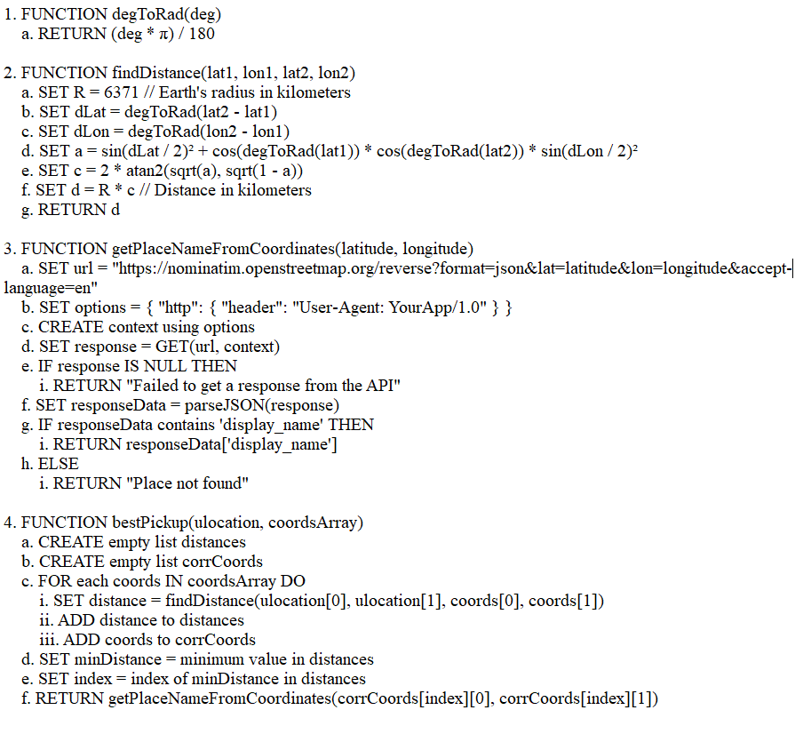
Figure 4. 1 Pseudo Code for Closest Pickup Location Algorithm
This algorithm is composed of several functions that calculate distances, convert coordinates, and identify the best pickup point based on a user's location. The degToRad function converts degrees to radians, which is essential for geographic calculations involving the Earth's curvature. The findDistance function implements the Haversine formula to calculate the shortest distance between two points on Earth given their latitude and longitude.
The getPlaceNameFromCoordinates function uses the Nominatim API to fetch the name of a place based on its latitude and longitude. It constructs a request URL with the coordinates, sends the request using an HTTP context with a custom user-agent, and parses the response. If successful, it retrieves the place's display name from the API response; otherwise, it returns an error message or "Place not found."
The bestPickup function finds the closest coordinate to a user's location from an array of coordinates. It calculates the distances of all points using findDistance, identifies the minimum distance, and determines the corresponding point.
Finally, it calls getPlaceNameFromCoordinates to fetch the human-readable name of the closest location, rounding the coordinates for precision. This is useful for optimizing logistics or suggesting nearby locations.
2. User Preference Analysis and Bus Sorting Algorithm Breakdown of the Algorithm:
Breakdown of the Algorithm:
User Preference Analysis: It calculates the average price of bookings and determines whether the user prefers buses with Wi-Fi and air conditioning based on their booking history.
Bus Sorting by Preferences: It sorts a list of buses based on the user's preferences, prioritizing those that are closer to the average price, followed by availability of Wi-Fi and AC, and finally by bus name. [24]

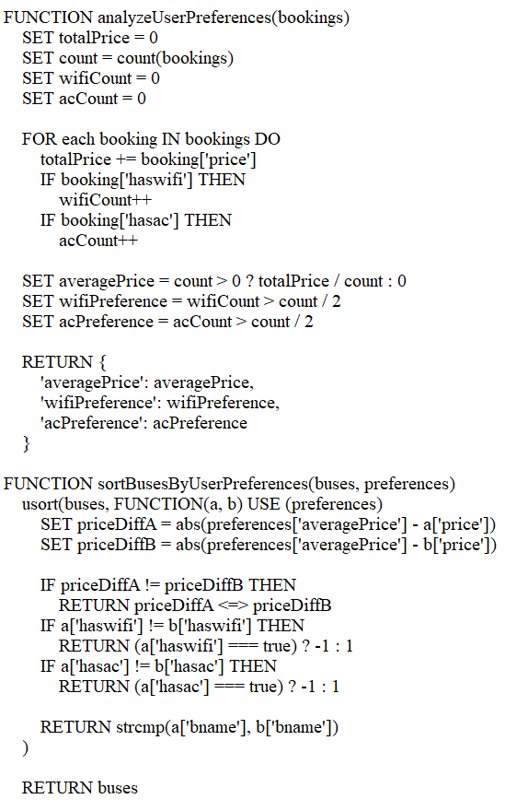
Figure 4. 2 Pseudo Code for Bus Sorting Algorithm
The analyzeUserPreferences function processes a user's past bookings to extract insights. It calculates the average price of booked buses, as well as the user's preference for Wi-Fi and air conditioning (AC) based on the count of buses with these features. Wi-Fi or AC is marked as preferred if more than half of the bookings include it. This information provides a baseline for understanding the user's needs.

The sortBusesByUserPreferences function organizes buses according to the user's preferences. It prioritizes buses with ticket prices closer to the user's average spending. If two buses have the same price difference, Wi-Fi and AC preferences are considered, giving priority to buses with these amenities. If all else is equal, the buses are sorted alphabetically by name, ensuring a consistent ranking order.
The contentBased function combines the above functionalities to recommend buses tailored to the user's preferences. It first analyzes past bookings to understand user behavior, then sorts the available buses using the derived preferences. The result is a list of buses ranked in order of suitability, helping users find options that best match their past choices and needs.

4.2 Testing
The different training and testing datasets are used to test the system. The purpose of this test is to determine whether or not the system is delivering the correct summaries. Our system is continually tested since it is in the development phase. Following are the tests that were run:
Table 4. 1 Test Cases for Unit Testing
Test case ID | Test Scenario | Test Steps | Test Data | Expected Result | Pass/ Fail
T1 | User Register new account | Email: shyam@gmail.com  Password: shyam | Redirect to success page | As expected | Pass
T2 | User enters wrong email and password | Email: shyamm@gmail.com  Password: shyaam | Redirect to error page | As expected | Pass
T3 | User enters right email and password | Email:  shyam@gmail.com  Password: shyam | Redirect to home page | As expected | Pass

Table 4. 2 Search Buses
Test case ID | Test Scenario | Test Steps | Test Data | Expected Result | Pass/ Fail
T1 | Search buses with pickup and destination | Pickup Destination: Kathmandu  To Destination: Pokhara | List the available bus data | As expected | Pass
T2 | Search buses with wrong pickup and destination | Pickup Destination: Kathmandu  To Destination: Delhi | No tickets found | As expected | Pass

Table 4. 3 Book a Seat
Test case ID | Test Scenario | Test Steps | Test Data | Expected Result | Pass/ Fail
T1 | Book seat/s while logged in | Login and book the seats | The seat/s gets booked and updated to the database | As expected | Pass
T2 | Book seat/s while logged out | Book the seat/s while logged out | The book button is not displayed to the user | As expected | Pass

Test Cases for System Testing
In the following table, different test cases have been tested in following:
Table 4. 4 Test Plan for System Testing
S.N | Test Plan
1 | To check if the user registration module works properly.
2 | To check if the user login module works properly.
3 | To check if the admin upload module works properly.
4 | To check if the search module works properly.

Table 4. 5 Test Case 1 for Registration Module
Test no. | 1
Test case | To check if user is created or not
Expected result | Users should be created.
Actual result | User was created.
Conclusion | Expected and actual results matched.

Table 4. 6 Test Case 2 for Login Module
Test no. | 2
Test case | To check if the login module works.
Expected result | Users should be redirected to the Dashboard.
Actual result | User redirected to the Dashboard.
Conclusion | Expected and actual results matched.

Table 4. 7 Test Case 3 for Admin Upload Module
Test no. | 3
Test case | To check if upload module works
Expected result | Uploaded data should be added.
Actual result | Uploaded data added.
Conclusion | Expected and actual results matched.

Table 4. 8 Test Case 4 for Search Module
Test no. | 4
Test case | To check if the search module works.
Expected result | Buses should be listed according to the search address.
Actual result | Buses listed according to search address.
Conclusion | Expected and actual results matched.

Test Cases for Algorithm
In the following table, different test cases have been tested in following:
Table 4. 9 Test Case for Closest Pickup Algorithm
Test no. | 1
Test case | To check if closest pickup location is suggested.
Expected result | Closest pickup location should be suggested.
Actual result | Closest pickup location is suggested.
Conclusion | Expected and actual results matched.

Table 4. 10 Test Case for Content Base Algorithm
Test no. | 1
Test case | To check if buses are suggested according to the user preferences.
Expected result | Buses should be suggested according to the user preferences.
Actual result | Buses suggested according to the user preferences.
Conclusion | Expected and actual results matched.

CHAPTER 5

CONCLUSION AND FUTURE RECOMMENDATION

5.1 Lesson Learnt/Outcome

5.1.1 Lesson Learnt
This project's completion made it feasible to accomplish the project's objective. The user can view & search the seats through a web browser after completing the registration form. Every project forces us to grow and learn in a variety of ways. With this project, we have mastered the problem solving skills independently, writing skills, making correct use of instructions, communicating effectively, time management, and team leadership. Most importantly, we have learnt version control tools and PHP programming.
5.1.1.1 Soft Skills
The soft skills we acquired include carrying out the mission, setting goals, displaying self-assurance through effective communication, having a positive outlook, participating in teamwork, problem-solving abilities, writing abilities, correctly using instructions, time management, and team leadership.
5.1.1.2 Hard Skills
The process of working on this project often involved the development of various talents. First and foremost, knowledge of web development languages like HTML, CSS, and JavaScript was necessary. These coding languages made it possible to create interactive and aesthetically pleasing web pages. Additionally, for the implementation of dynamic functionality and database management, proficiency in the backend programming language PHP was essential. To effectively address technical challenges, additional crucial hard skills include proficiency in debugging and troubleshooting. The ability to master these hard skills gives people the resources they need to successfully create, manage, and optimize websites.

5.1.2 Outcomes
In the project that follows, we have mastered the problem solving skills independently, writing skills, making correct use of instructions, communicating effectively, time management, and team leadership

5.2 Conclusion
After the successful completion of the project, the user will be able to view & search from anywhere with a simple login in our website. This project is based in UI/UX Design so the users can easily use it. This project has been developed in PHP and database keeping in mind the specifications of the system has been created in My SQL server. By integrating real-time seat availability, multiple payment methods, and a dynamic search system, the platform will meet the needs of both passengers and bus operators, enhancing overall efficiency and customer satisfaction. The authors have achieved the objectives of this project work.

5.3 Future Recommendation
Future additions to this website can enhance several aspects, including portability and user experience. There is still work to be done, so this application might be thought of as the beginning of something much bigger. While each of these will need more time and resources to fulfill, they are all still very attainable and realistic objectives.
- Greater User Experience
- Add forget password options
- Add online payment system
- OTP (One Time Password) feature can be added.

REFERENCES
[1] | "ResearchGate," researchcom, January 2020. [Online]. Available: https://www.researchgate.net/publication/353793655_DESIGN_AND_IMPLEMENTATION_OF_AN_ONLINE_BUS_TICKETING_SYSTEM.
[2] | RUDLIM, "Ticketing System," Perak, 2012.
[3] | al.Sharma, "Adopation and Satisfaction of Tickietng System," 2020.
[4] | D. Raj, "Technological Innvoation," 2019.
[5] | J. Power, Customer Satisfaction, 2021.
[6] | MarketsandMarkets, "Integration of Internet," 2020.
[7] | McKinsey, "Application of AI," Comapny Analysis, 2020.
[8] | Berkeley, "Imapct of Ride Sharing Services," Berlin, 2018.
[9] | P. D.K, "Security," May 2016. [Online]. Available: https://www.cloudflare.com/learning/ssl/what-is-https/.
[10] | Mbarika, "Evolution of System," 2002.
[11] | G. a. Bernon, "Introduction of Digital Ticketing," 2006.
[12] | S. e. al., "Development of Online System," March 2014. [Online]. Available: https://www.digitalpolicy.gov.hk/en/our_work/digital_infrastructure/methodology/system_development/.
[13] | K. a. Sandhu, Interviewee, Digital Online. [Interview]. June 2015.
[14] | K. e. al., Mobile Ticketing, Anna Publisher, 2016.
[15] | S. e. al., Issue of Digital Divide, 2017.
[16] | "Edu," Microsoft, July 2014. [Online]. Available: https://vscodeedu.com/.
[17] | "Web Docs," mozilla.org, April 2021. [Online]. Available: https://developer.mozilla.org/en-US/docs/Web/HTML.
[18] | D. Jamie, "scrpit.com," December 2018. [Online]. Available: https://www.javascript.com/.
[19] | P. BK, "php," 2014. [Online]. Available: https://www.php.net/docs.php.
[20] | Cloud, "oci," October 2019. [Online]. Available: https://www.oracle.com/mysql/what-is-mysql/.
[21] | Peral, "ApacheFriends," apache.org, [Online]. Available: https://www.apachefriends.org/.
[22] | Gates, "Microsoft 365," microsoft, [Online]. Available: https://www.microsoft.com/en-us/microsoft-365/word.
[23] | "StackOverflow," 2019. [Online]. Available: https://stackoverflow.com/questions/56844336/what-approach-would-be-suitable-for-clustering-customers-based-on-pickup-and-dro.
[24] | Henry, "Application of User Preference," 2022.

APPENDIX
System Screenshots:
Database Overviews:
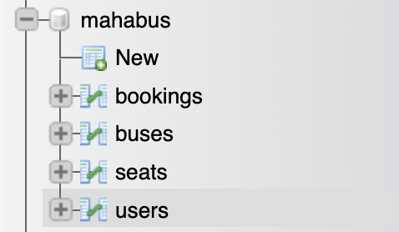

1.Users Table
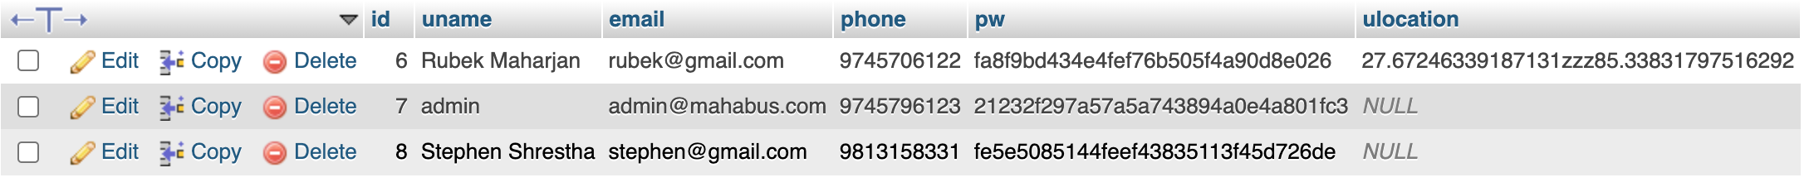
2. Seats Table 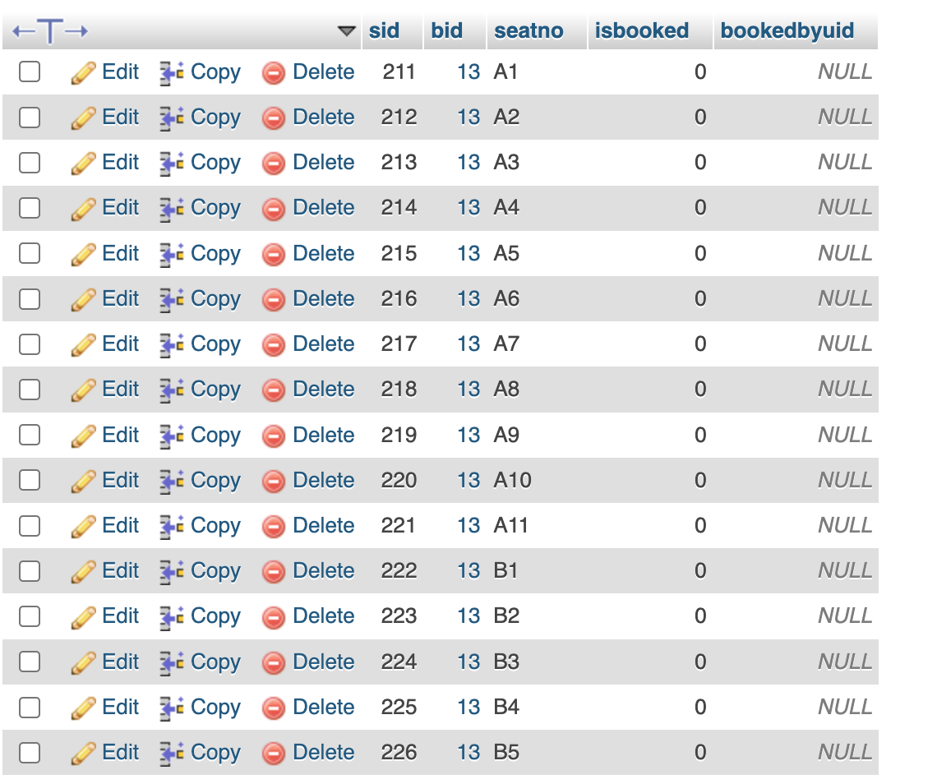

3. Buses Table
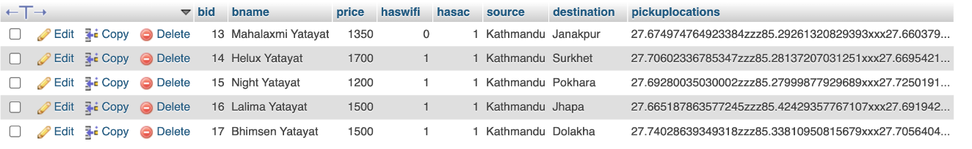
4. Bookings Table
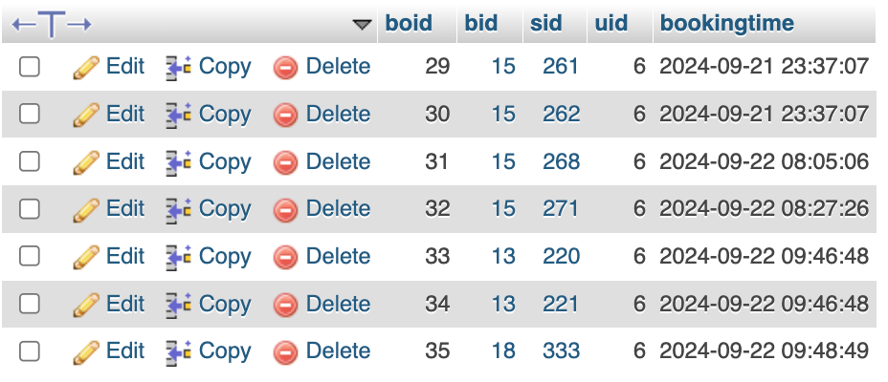

User Interface:
1.Signup/ Signin
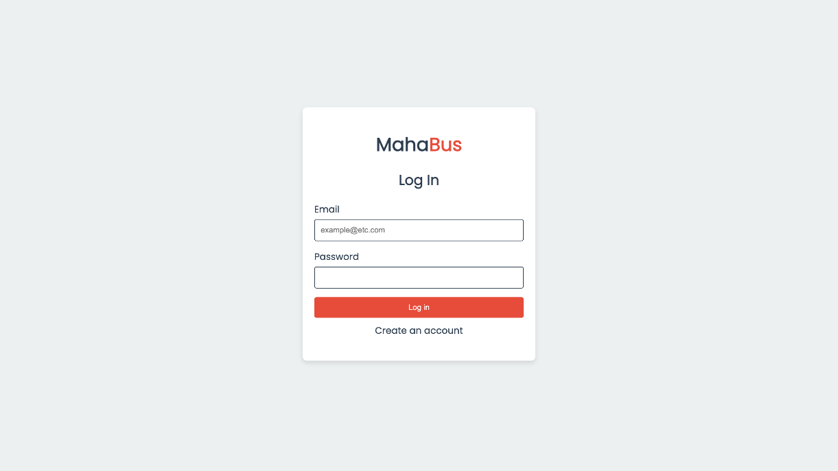

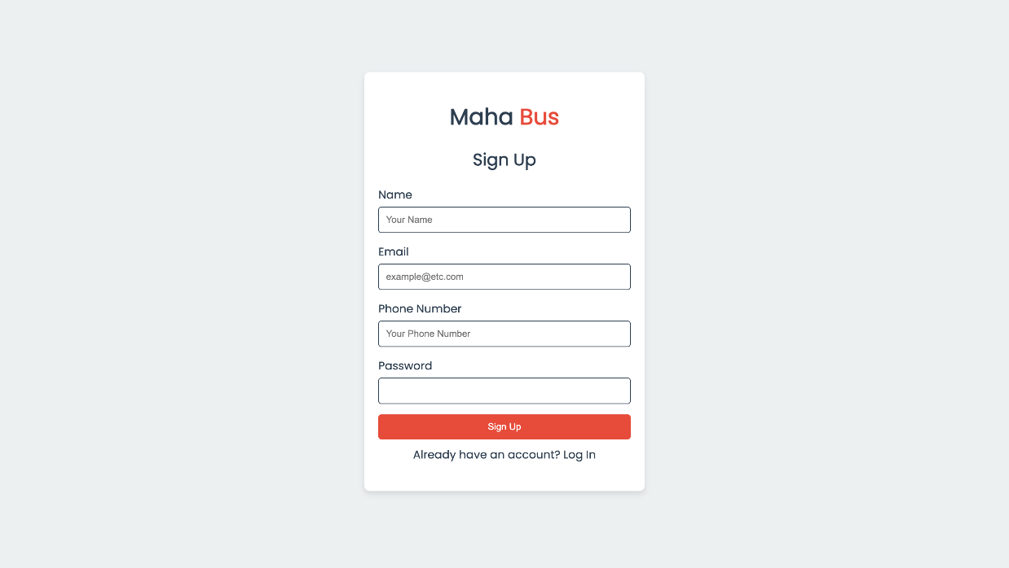

2. Home Page
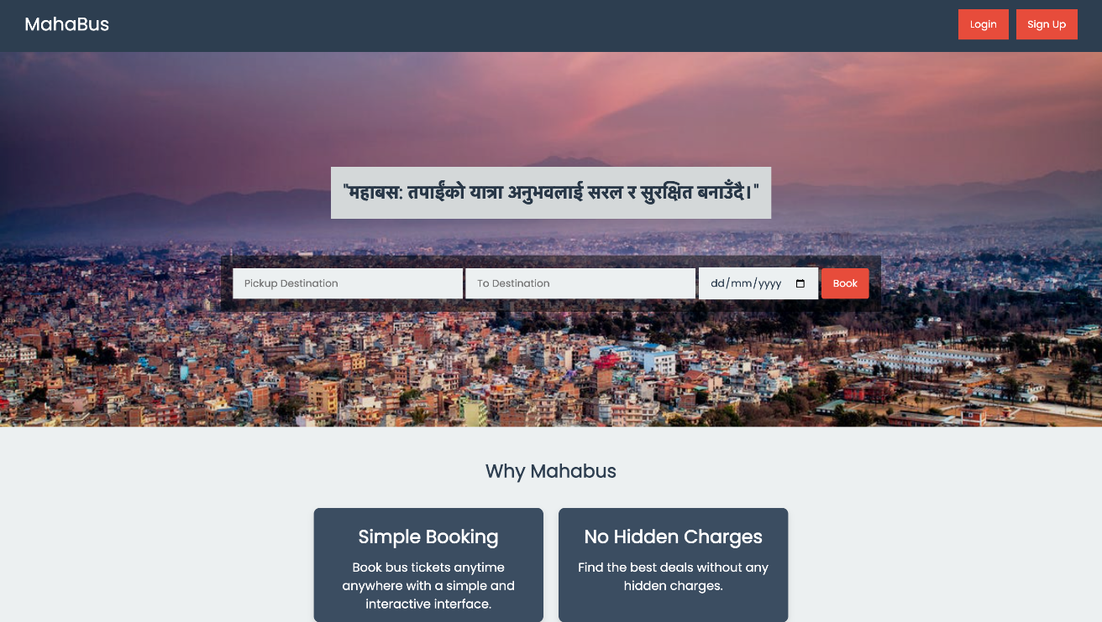

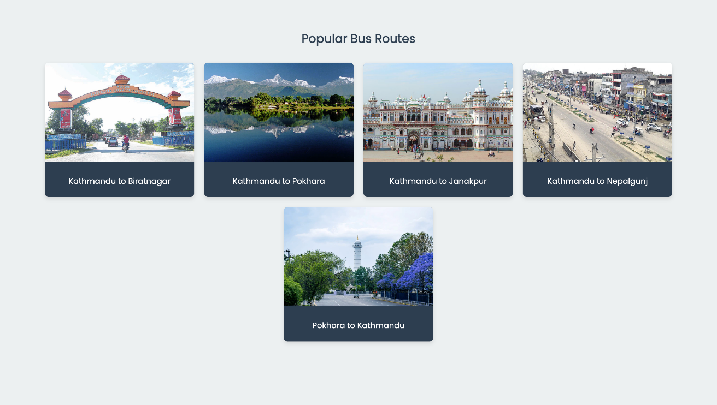

3. Book Seats
a. Get User Location
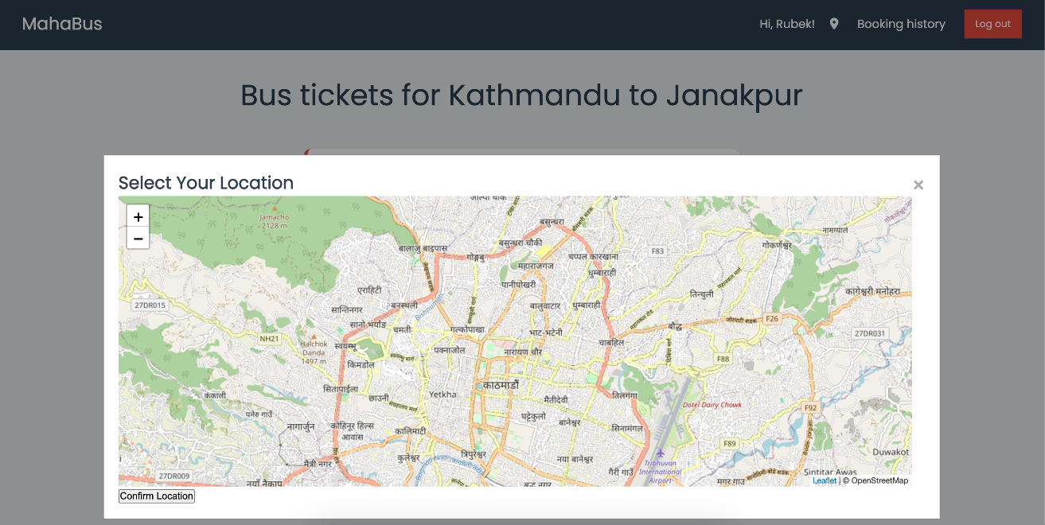

b.Choose a Bus
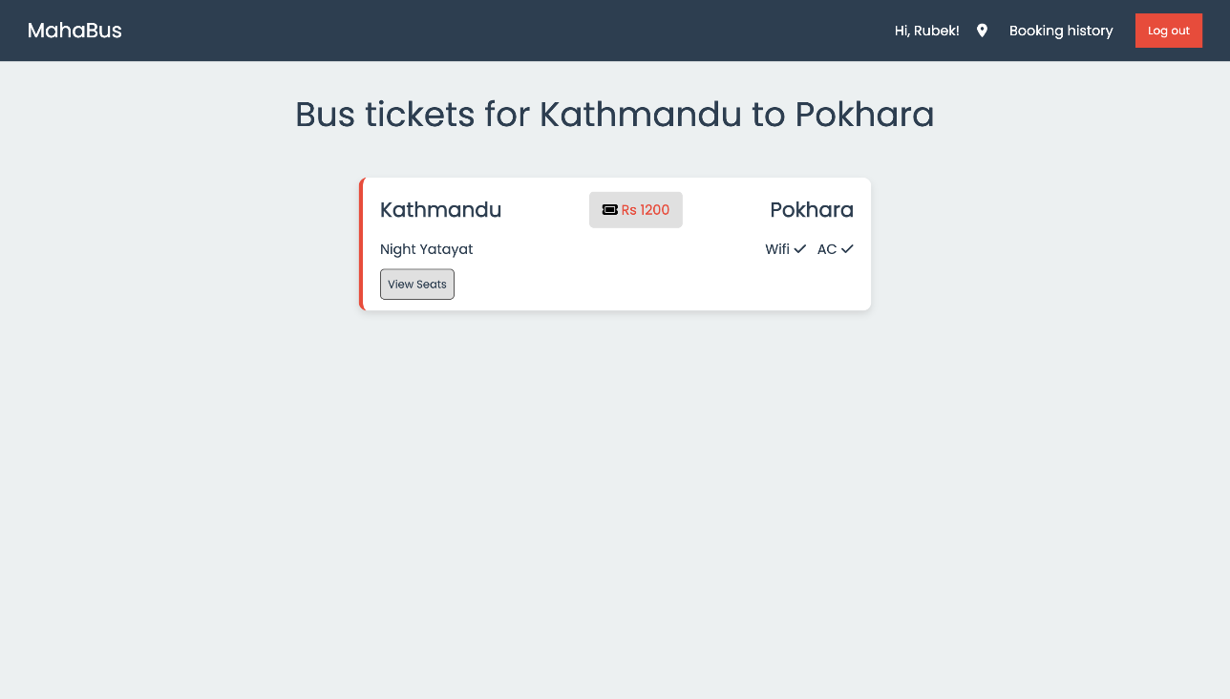

- Book Seats
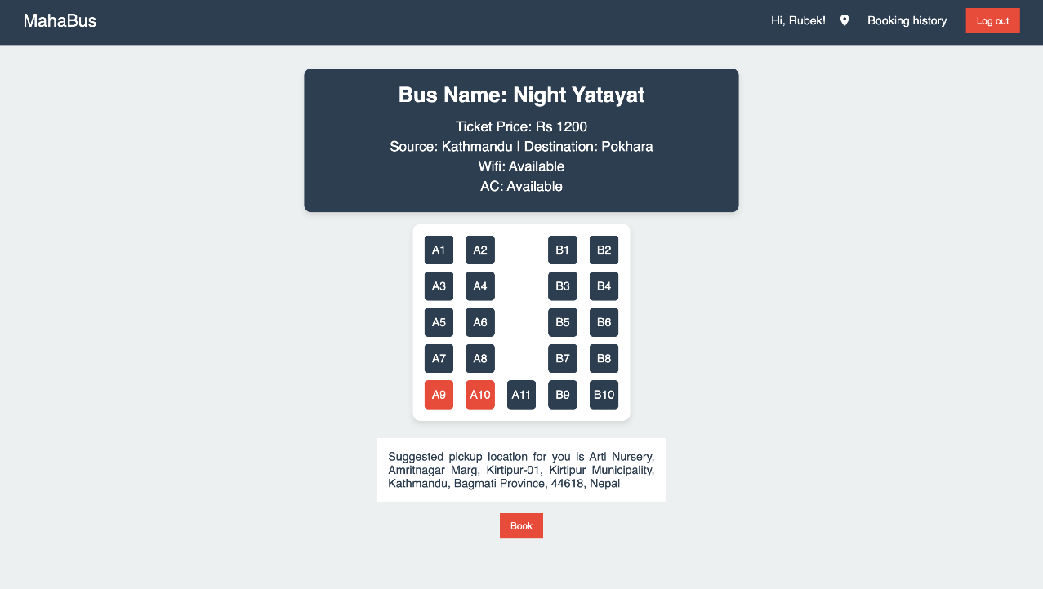

- View Ticket

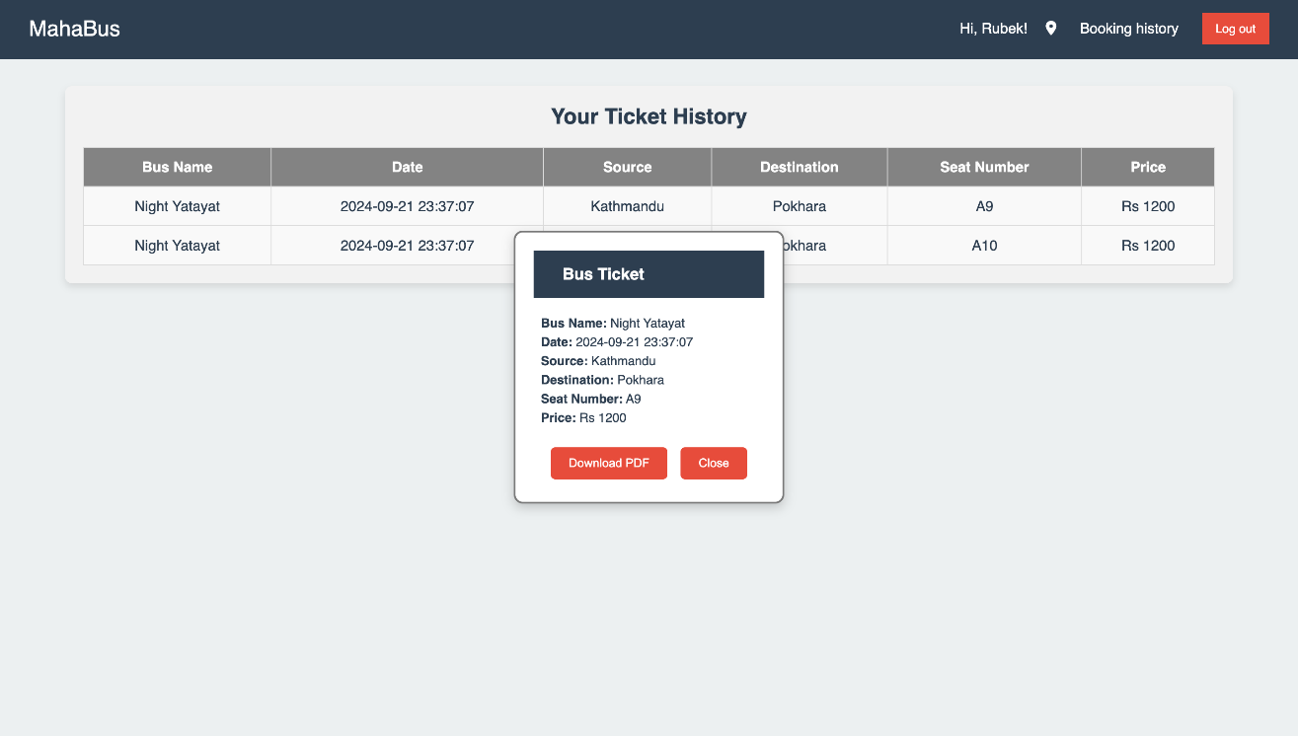

4. Admin Panel
