XAVIER INSTITUTE OF ENGINEERING
Mumbai
Department of Computer Science and Engineering

MINI PROJECT REPORT
on
Real-Time Public Transport Tracking System for Small Cities
(Smart India Hackathon 2025 – Problem Statement SIH25013)

A Database Management System Mini Project
Submitted by
Raj Bharwada Roll No. 13
Shaantanu Barao Roll No. 8

Under the guidance of
Prof. Lalita Moharkar

Bachelor of Engineering in Computer Science and Engineering
Academic Year 2026–2027

CERTIFICATE
This is to certify that the mini project report entitled “Real-Time Public Transport Tracking System for Small Cities” submitted by Raj Bharwada (Roll No. 13) and Shaantanu Barao (Roll No. 8) in partial fulfilment of the requirements for the award of the degree of Bachelor of Engineering in Computer Science and Engineering of Xavier Institute of Engineering, Mumbai, is a bonafide record of the project work carried out by the students under the supervision and guidance of the project guide during the academic year 2026–2027.
To the best of my knowledge, the work embodied in this report has not been submitted to any other university or institution for the award of any degree or diploma.

Project Guide Head of Department
Date:

Place: Mahim, Mumbai

DECLARATION
We declare that this written submission on the project “Real-Time Public Transport Tracking System for Small Cities” represents our own work, carried out under the supervision of the project guide. Wherever the ideas, words or results of others have been used, they have been appropriately acknowledged and referenced.
We further declare that the database design, implementation, queries, outputs, diagrams and results presented in this report correspond to the work carried out for the mini project.
Raj Bharwada (Roll No. 13)
Shaantanu Barao (Roll No. 8)

Date: Place: Mahim, Mumbai

ACKNOWLEDGEMENT
We express our sincere gratitude to our project guide, Prof. Lalita Moharkar, for the guidance, suggestions and encouragement provided throughout the mini project.
We are thankful to the Head of the Department of Computer Science and Engineering, the Principal, faculty members and non-teaching staff of Xavier Institute of Engineering for providing the facilities and support required to complete this project.
We also thank our classmates and friends for their valuable feedback and assistance during the development, testing and documentation of the project.

ABSTRACT
This mini project presents a database management system for real-time public transport tracking in small cities, based on Smart India Hackathon 2025 problem statement SIH25013. Small-city bus services usually lack live location data, delay records and consistent bus, driver and trip records. The project addresses this with a MySQL 8.0 database named bus_tracking, demonstrated with Mumbai as the sample city.
The database has eleven tables in BCNF/3NF (City, Route, Stop, Route_Stop, Driver, Bus, Trip, GPS_Log, Stop_Arrival, Delay_Alert and Users). Integrity is enforced with primary, foreign and unique keys, CHECK, DEFAULT and NOT NULL constraints and five triggers that reject inactive or double-booked buses and drivers, refuse GPS pings for trips that are not running, compute stop delays and raise delay alerts. Four views and four stored procedures provide live positions, delay statistics and next-bus estimates, and transactions with rollback keep trip start and end operations atomic. Role-based security is implemented with MySQL roles, per-role accounts, GRANT and REVOKE.
A lightweight Flask web application with a Leaflet and OpenStreetMap live map, a driver console and an administrator console uses the database for all operations, and a GPS simulator allows the system to be demonstrated without hardware. All 33 test cases, covering valid operations, rejected invalid data, views, procedures, transactions and privileges, gave the expected results.
Keywords: DBMS, MySQL, Relational Database, ER Diagram, Normalization, Triggers, Stored Procedures, Transactions, Role-Based Access, Public Transport Tracking

TABLE OF CONTENTS
CERTIFICATE 2
DECLARATION 3
ACKNOWLEDGEMENT 4
ABSTRACT 5
CHAPTER 1 – INTRODUCTION 7
CHAPTER 2 – EXISTING SYSTEM AND PROPOSED SYSTEM 10
CHAPTER 3 – REQUIREMENT ANALYSIS 12
CHAPTER 4 – DATABASE DESIGN 14
CHAPTER 5 – METHODOLOGY 19
CHAPTER 6 – SYSTEM IMPLEMENTATION 22
CHAPTER 7 – SQL QUERIES AND OPERATIONS 29
CHAPTER 8 – RESULTS AND TESTING 32
CHAPTER 9 – SECURITY, INTEGRITY AND TRANSACTIONS 43
CHAPTER 10 – LIMITATIONS AND FUTURE SCOPE 46
CHAPTER 11 – CONCLUSION 47
REFERENCES 48

CHAPTER 1 – INTRODUCTION

1.1 Background
Public buses are the main form of transport in most Indian small and medium cities, yet commuters in these cities usually have no way of knowing where a bus is or when it will reach their stop. Large-city operators have started to offer live-tracking applications, but smaller towns often lack the funds, connectivity and technical staff to run such systems. Passengers therefore wait at stops without information, and the transport department has no reliable record of how its buses actually perform.
This project is based on Smart India Hackathon 2025 Problem Statement SIH25013, “Real-Time Public Transport Tracking for Small Cities”, submitted by the Department of Higher Education, Government of Punjab. The problem asks for a low-cost tracking system that works on limited network bandwidth. For our DBMS mini project we treat this as a data-management problem: buses, routes, stops, trips, GPS pings and delays must be stored in a consistent form, so that every screen a commuter, driver or administrator sees is derived from one trustworthy database.
A database is required because the data is highly inter-related and changes every few seconds. A trip belongs to exactly one route, bus and driver; a GPS ping belongs to exactly one running trip; a delay alert belongs to exactly one stop arrival. Keeping these rules in spreadsheets or in application code alone would allow contradictory records, such as two trips using the same bus at the same time. A relational DBMS lets us enforce these rules centrally with keys, constraints, triggers and transactions. We use Mumbai only as the demonstration city; the schema itself is city-independent.

1.2 Problem Statement
Small-city public transport operators typically rely on paper timetables, phone calls to drivers and spreadsheets maintained by clerks. This creates the following problems:
- Commuters cannot see the current position of a bus or an estimate of its arrival time, so waiting time is unpredictable.
- Delays are noticed only when passengers complain; there is no systematic record of how late a bus was at each stop.
- Records kept in separate files drift apart: a bus under maintenance can still be assigned to a trip, or one driver can be rostered on two buses at once.
- Location data arrives continuously and, if stored carelessly, accepts impossible values (latitude above 90°, negative speed) or pings from trips that are not running.
- Everybody who can open the file can change anything; there is no separation between what a commuter, a driver and an administrator may do.
- Solutions built for large cities assume high-bandwidth connectivity and heavy mobile applications, which are unsuitable for small-city conditions.
The need is therefore a database-centred system that keeps transport data consistent, protects it by role, and exposes live positions and delays through a light web interface.

1.3 Objectives
The objectives of the project are:
- Data storage: design a normalised relational database (BCNF/3NF) for cities, routes, stops, buses, drivers, trips, GPS pings, stop arrivals, delay alerts and user accounts.
- Integrity: enforce entity, referential and domain integrity using primary keys, foreign keys with explicit ON DELETE rules, UNIQUE, NOT NULL, DEFAULT and CHECK constraints, and use triggers for rules that constraints cannot express.
- Retrieval: provide views and stored procedures for live bus positions, route stops, a driver’s trips, delay statistics and the next buses arriving at a stop.
- Reliability: use transactions with rollback so that starting or ending a trip either completes fully or leaves the data unchanged.
- Security: implement role-based access in MySQL itself (roles, users, GRANT and REVOKE) and store application passwords only as salted hashes.
- Reporting and frontend: build a lightweight web interface with a live map (Leaflet and OpenStreetMap), a driver console and an administrator console with a delay report.

1.4 Scope
In scope:
- Relational schema of 11 tables with constraints, 5 triggers, 4 views and 4 stored procedures in MySQL 8.0.
- A Flask web application with three roles (commuter, driver, administrator) using parameterised queries and a separate MySQL account for each role.
- A live map that refreshes every 5 seconds from the database, an ETA lookup for a stop, a driver console for starting trips, sending positions and recording stop arrivals, and an administrator console showing trips and the delay report.
- A GPS simulator script that plays the part of a bus device, so the system can be demonstrated without hardware.
- Backup and restore using mysqldump.
- Mumbai is used as the sample city, with 7 stops, 2 routes, 4 buses and 4 drivers.
Out of scope:
- Real GPS hardware or a native mobile application; positions come from the simulator or the driver console.
- Predictive ETA using machine learning or traffic data; the ETA is the scheduled time plus the latest recorded delay.
- Ticketing, payments, fare calculation and passenger accounts.
- An administrator screen for creating routes and stops; routes and stops are loaded through SQL scripts.
- Production deployment, HTTPS, load balancing and multi-server replication.

CHAPTER 2 – EXISTING SYSTEM AND PROPOSED SYSTEM

2.1 Existing System
In most small cities the existing arrangement is manual or only partly digital. Timetables are printed and rarely updated; the depot keeps duty rosters and bus allocation in registers or spreadsheets; drivers report delays by phone. Where a digital system exists, it is usually a generic fleet-tracking product that is costly to run, depends on continuous high-speed data, and is built around the needs of large metropolitan operators.
Well-known passenger applications for large cities (for example the Chalo app) show that live tracking is valuable, but they depend on operator-side GPS hardware, paid back-end infrastructure and good mobile coverage. We also reviewed several public hackathon prototypes for this problem statement on GitHub and Kaggle. Most of them focus on the map or on a mobile client and keep the data in a single flat table or in JSON, with little validation. They helped us understand the expected features, but none gave database integrity the central place that this DBMS project requires.

2.2 Limitations of Existing System
The limitations of the existing approach are summarised below.
Limitation | Effect
No live position | Commuters cannot plan their wait; crowding and missed buses.
Data redundancy | The same bus or driver details are typed into several registers and differ between them.
Inconsistency | A bus in maintenance can still be rostered; a driver can be assigned to two trips at once.
Difficult searching | Finding all trips of a driver or all late arrivals on a route requires manual search.
No delay history | Late running is not measured, so service problems are never quantified.
Poor security | Anyone with the file can edit any record; there is no role separation or audit.
No reporting | Averages, maximum delay and alert counts per route cannot be produced quickly.
High bandwidth assumption | Existing app-based solutions need good coverage and heavy clients, unsuitable for small cities.

2.3 Proposed System
The proposed system stores all transport data in one MySQL database and lets the database itself guard the rules. The Flask application is deliberately thin: it authenticates users, calls views and stored procedures, and returns compact JSON to a browser page that draws the map.
- Normalised schema: 11 tables in BCNF/3NF so that each fact is stored once.
- Constraints and triggers: invalid data is refused by the database even if the application has a bug. Triggers stop a trip from using an inactive bus or a bus/driver that is already running, refuse GPS pings for trips that are not running, compute the delay of every stop arrival and raise a Delay_Alert when it is five minutes or more.
- Views and procedures: v_live_buses, v_delay_report, v_route_stops and v_driver_trips for reading; sp_start_trip, sp_end_trip, sp_record_arrival and sp_next_buses for actions that must be atomic.
- Role-based security in MySQL: the web application connects as admin1, driver1, commuter1 or auth1 depending on what the logged-in user may do, so even a compromised page cannot exceed that role’s privileges.
- Low-bandwidth friendly: the browser polls a small JSON response every 5 seconds, positions are the only data that change, and the ETA is computed on the server rather than in the client.

2.4 Advantages
- Single source of truth: every screen reads from the same tables and views, so the map, the ETA and the report always agree.
- Integrity is enforced by the DBMS, not by the programmer: constraints, foreign keys and triggers apply to every client.
- Atomic operations: starting or ending a trip uses a transaction with rollback, so a failure leaves no half-created data.
- Least-privilege access: commuters can only read live positions and call the next-bus procedure; drivers can only add pings and run trip procedures; only the administrator has full access.
- Measurable service quality: stop-level delays are stored automatically and summarised by route.
- Light and cheap: runs on a single Linux laptop or a small server with open-source software and needs no special hardware.
- Reusable for any city: only data rows need to change, not the schema.

CHAPTER 3 – REQUIREMENT ANALYSIS

3.1 Functional Requirements
The functions that the system supports are listed in Table 3.1.
Table 3.1: Functional requirements
ID | Requirement | Role
FR1 | Log in with a username and password; the session decides which pages and database account are used. | All
FR2 | View live bus positions on a map, refreshed every 5 seconds. | Commuter, Driver, Admin
FR3 | View the ordered stops of a route with coordinates. | All
FR4 | Look up the next buses expected at a stop with delay and ETA. | All
FR5 | View assigned trips and start or end a trip. | Driver
FR6 | Send a GPS position (latitude, longitude, speed) for a running trip. | Driver (or simulator)
FR7 | Record the arrival of a bus at a stop; delay is computed automatically. | Driver
FR8 | Raise a delay alert automatically when a delay is 5 minutes or more. | System
FR9 | View all trips, the delay report per route and the alert list. | Admin
FR10 | Reject invalid operations (inactive bus, double-booked bus or driver, ping for a non-running trip, out-of-range values). | System
FR11 | Restrict each role to the permitted pages and database objects. | System
FR12 | Back up and restore the database. | Admin

3.2 Non-Functional Requirements
- Performance: a live-position query and a next-bus query must return within a fraction of a second on the demo data; an index on GPS_Log(trip_id, logged_at) supports the “latest ping” lookup.
- Security: passwords are stored as scrypt hashes; SQL is always parameterised; database accounts are separated by role with least privilege.
- Usability: a plain browser interface with a single map page, a driver console and an admin console; no installation on the commuter’s side.
- Reliability: trip start and end run as transactions; foreign keys prevent orphan rows; a mysqldump backup can restore the data.
- Bandwidth: responses are compact JSON and the page polls at a 5-second interval, which suits low-bandwidth networks.
- Maintainability: business rules live in the database (triggers, procedures, views) and the application code stays short; the schema is independent of the city.

3.3 Hardware and Software Requirements
The system was developed and tested on the following configuration.
Table 3.2: Hardware requirements
Item | Specification
Machine | Lenovo ThinkPad E14
Processor | AMD Ryzen 7
Memory | 16 GB RAM
Storage | 512 GB SSD
Display / network | Standard laptop display; any Wi-Fi or LAN connection

Table 3.3: Software requirements
Item | Specification
Operating system | Linux Mint (Ubuntu 24.04 base)
Database | MySQL Server 8.0.46
Database tool | MySQL Workbench (queries, ER inspection, action log)
Language and framework | Python 3, Flask
Python libraries | mysql-connector-python, Werkzeug (password hashing)
Map | Leaflet 1.9.4 with OpenStreetMap tiles
Frontend | HTML, CSS and JavaScript (plain)
Editor | Visual Studio Code
Browser | Any modern browser (Firefox or Chrome)
Utilities | mysqldump for backup, a Python GPS simulator script

CHAPTER 4 – DATABASE DESIGN

4.1 Identification of Entities
From the requirements, the following eleven entities were identified. Route_Stop is an associative entity that resolves the many-to-many relationship between Route and Stop.
Table 4.1: Entities
Entity | Description
City | A city in which the service runs (Mumbai in the demo).
Route | A numbered bus route belonging to a city.
Stop | A bus stop with latitude and longitude.
Route_Stop | Ordered stops of a route with the scheduled minute offset from the start.
Driver | A driver with phone and licence number.
Bus | A bus with registration number, capacity and status.
Trip | One run of a bus on a route by a driver at a start time.
GPS_Log | A position ping sent during a running trip.
Stop_Arrival | Scheduled and actual time of a trip at a stop, with the computed delay.
Delay_Alert | An alert raised when a delay is 5 minutes or more.
Users | Application login with role; a driver user links to a Driver row.

4.2 Attributes
Primary keys are underlined in the tables below by the tag PK; FK marks a foreign key and UK a unique key.
Table 4.2: Attributes of each entity
Entity | Attributes (type) – keys and constraints
City | city_id INT (PK, auto), name VARCHAR(60) NOT NULL, state VARCHAR(60) NOT NULL; UNIQUE (name, state)
Route | route_id INT (PK), route_no VARCHAR(10) NOT NULL (UK), name VARCHAR(100) NOT NULL, city_id INT NOT NULL (FK)
Stop | stop_id INT (PK), name VARCHAR(100) NOT NULL, latitude DECIMAL(9,6) NOT NULL CHECK -90..90, longitude DECIMAL(9,6) NOT NULL CHECK -180..180, city_id INT NOT NULL (FK)
Route_Stop | route_id INT (PK part, FK), stop_seq SMALLINT (PK part) CHECK > 0, stop_id INT NOT NULL (FK), sched_offset_min SMALLINT NOT NULL DEFAULT 0 CHECK >= 0; UNIQUE (route_id, stop_id)
Driver | driver_id INT (PK), name VARCHAR(80) NOT NULL, phone VARCHAR(15) NOT NULL (UK), license_no VARCHAR(20) NOT NULL (UK)
Bus | bus_id INT (PK), reg_no VARCHAR(15) NOT NULL (UK), capacity SMALLINT NOT NULL CHECK 10..100, status ENUM('active','maintenance','retired') DEFAULT 'active'
Trip | trip_id INT (PK), route_id, bus_id, driver_id (all FK, NOT NULL), start_time DATETIME NOT NULL, end_time DATETIME NULL, status ENUM('scheduled','running','completed','cancelled') DEFAULT 'scheduled'; CHECK end_time IS NULL OR end_time >= start_time
GPS_Log | log_id BIGINT (PK, auto), trip_id INT NOT NULL (FK), latitude, longitude DECIMAL(9,6) with range CHECKs, speed_kmph DECIMAL(5,2) CHECK >= 0, logged_at DATETIME DEFAULT CURRENT_TIMESTAMP
Stop_Arrival | arrival_id INT (PK), trip_id INT NOT NULL (FK), stop_id INT NOT NULL (FK), scheduled_time DATETIME NOT NULL, actual_time DATETIME NULL, delay_min INT NULL; UNIQUE (trip_id, stop_id)
Delay_Alert | alert_id INT (PK), arrival_id INT NOT NULL (FK, UK), delay_min INT NOT NULL, created_at DATETIME DEFAULT CURRENT_TIMESTAMP
Users | user_id INT (PK), username VARCHAR(50) NOT NULL (UK), password_hash VARCHAR(255) NOT NULL, role ENUM('admin','driver','commuter') NOT NULL, driver_id INT NULL (FK, UK)

4.3 Relationships
Table 4.3 lists the relationships with their cardinality and the ON DELETE rule chosen for each foreign key. RESTRICT is used wherever deleting a parent would destroy history that must be kept; CASCADE is used only for rows that have no meaning without their parent.
Table 4.3: Relationships and referential actions
Relationship | Cardinality | Foreign key | ON DELETE
City has Route | 1 : N | Route.city_id | RESTRICT
City contains Stop | 1 : N | Stop.city_id | RESTRICT
Route serves Stop (via Route_Stop) | M : N | Route_Stop.route_id  Route_Stop.stop_id | CASCADE  RESTRICT
Route runs as Trip | 1 : N | Trip.route_id | RESTRICT
Bus operates Trip | 1 : N | Trip.bus_id | RESTRICT
Driver drives Trip | 1 : N | Trip.driver_id | RESTRICT
Trip logs GPS_Log | 1 : N | GPS_Log.trip_id | CASCADE
Trip records Stop_Arrival | 1 : N | Stop_Arrival.trip_id | CASCADE
Stop visited in Stop_Arrival | 1 : N | Stop_Arrival.stop_id | RESTRICT
Stop_Arrival raises Delay_Alert | 1 : 0..1 | Delay_Alert.arrival_id (UNIQUE) | CASCADE
Driver has login Users | 1 : 0..1 | Users.driver_id (UNIQUE) | SET NULL

4.4 ER Diagram
Figure 4.1 shows the conceptual ER diagram. Rectangles are entities, diamonds are relationships and the labels 1, N, M and 0..1 give the cardinality. Route_Stop is drawn with a double border to show that it is an associative entity carrying its own attributes (stop sequence and scheduled offset).
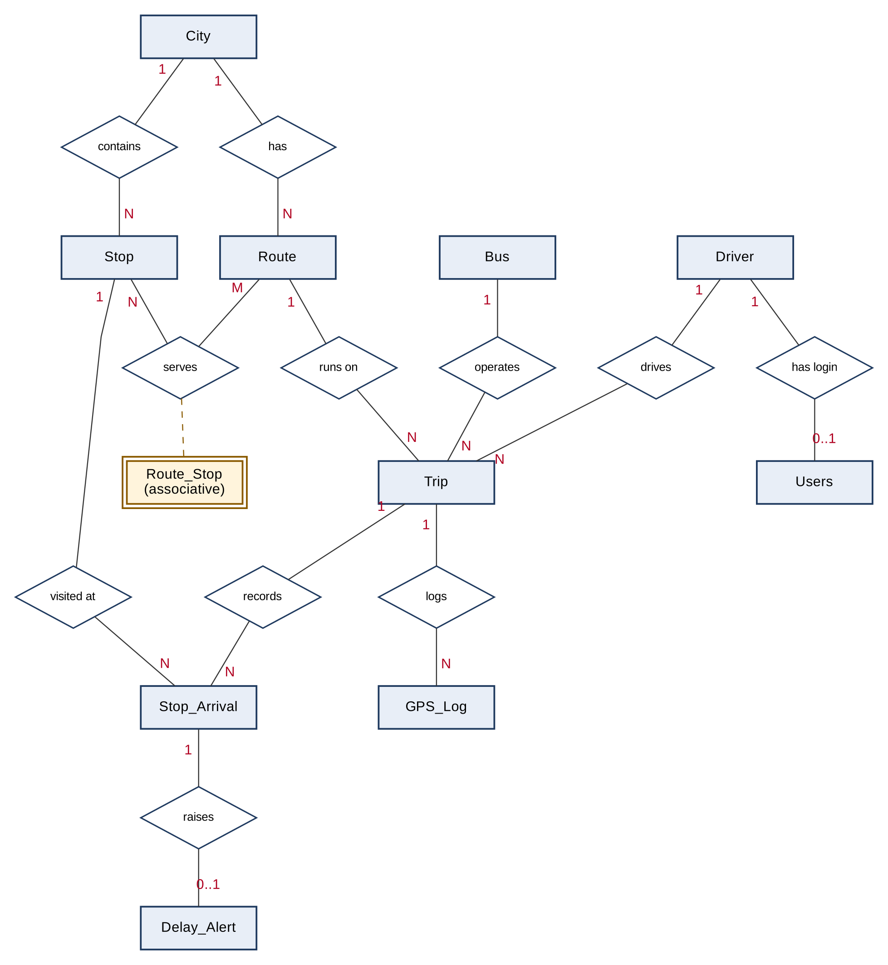
Figure 4.1: Entity-Relationship diagram of the Public Transport Tracking database

4.5 Relational Schema
Figure 4.2 gives the relational schema of the eleven tables with primary keys (PK), foreign keys (FK) and unique keys (UK). Lines join each foreign key to the table it references; 1 marks the parent side and N the child side.
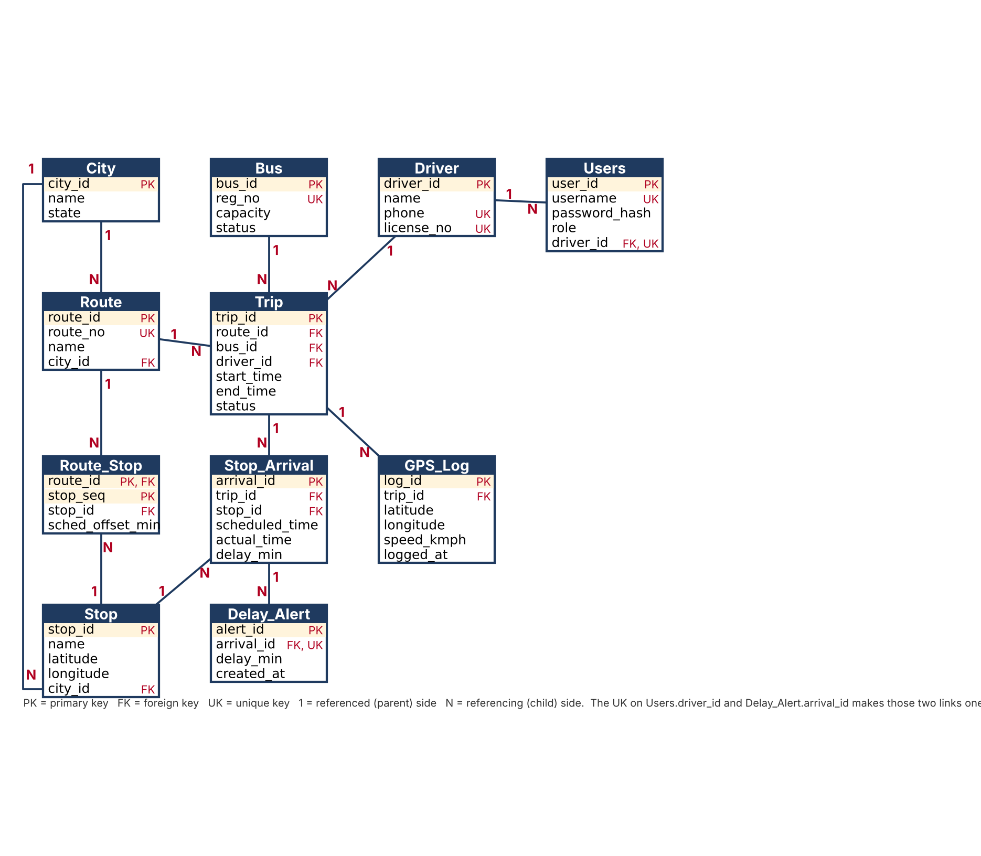
Figure 4.2: Relational schema with primary and foreign keys
In compact notation (primary keys in capitals followed by the column list):
City(CITY_ID, name, state)
Route(ROUTE_ID, route_no, name, city_id -> City)
Stop(STOP_ID, name, latitude, longitude, city_id -> City)
Route_Stop(ROUTE_ID -> Route, STOP_SEQ, stop_id -> Stop, sched_offset_min)
Driver(DRIVER_ID, name, phone, license_no)
Bus(BUS_ID, reg_no, capacity, status)
Trip(TRIP_ID, route_id -> Route, bus_id -> Bus, driver_id -> Driver,
start_time, end_time, status)
GPS_Log(LOG_ID, trip_id -> Trip, latitude, longitude, speed_kmph, logged_at)
Stop_Arrival(ARRIVAL_ID, trip_id -> Trip, stop_id -> Stop,
scheduled_time, actual_time, delay_min)
Delay_Alert(ALERT_ID, arrival_id -> Stop_Arrival, delay_min, created_at)
Users(USER_ID, username, password_hash, role, driver_id -> Driver)

4.6 Normalization
Unnormalised form. A first, flat record of a bus trip would look like: Trip(trip_id, start_time, route_no, route_name, city_name, state, bus_reg_no, capacity, driver_name, phone, {stop_name, latitude, longitude, scheduled_time, actual_time, delay}). It repeats route, city, bus and driver details on every trip and contains a repeating group of stops.
First normal form (1NF). The repeating group of stops is moved out into its own rows, so every attribute holds a single atomic value. Each stop visit becomes one row identified by (trip_id, stop_id), which became the Stop_Arrival table.
Second normal form (2NF). In the flat table, route_name, city, bus and driver attributes depend only on part of the key (the trip or the route), not on the whole (trip_id, stop_id). They were separated into Route, City, Bus and Driver, and stop attributes (name, latitude, longitude) into Stop.
Third normal form (3NF). Transitive dependencies such as route_id → city_id → state were removed: the state is stored once in City and referenced by city_id. The ordered list of stops of a route and the scheduled offset depend on (route_id, stop_seq) and were placed in Route_Stop.
BCNF check. In every table the only determinants are candidate keys. For example, in Bus both bus_id and reg_no determine every other attribute and both are candidate keys; in Route_Stop the keys (route_id, stop_seq) and (route_id, stop_id) are both candidate keys and are the only determinants. No relation contains a non-key determinant, so all eleven relations are in BCNF (and therefore 3NF).
Deliberate, controlled redundancy. Two columns repeat information on purpose. Stop_Arrival.delay_min is derived from scheduled_time and actual_time, but it is computed by a trigger so it can never disagree with them and makes reports simple. Delay_Alert.delay_min stores a snapshot of that delay at the moment the alert was raised, so the alert remains an audit record even if the arrival is later corrected. Both are maintained by the database, not by hand.

CHAPTER 5 – METHODOLOGY

5.1 Development Method
The project followed a staged approach, with each stage verified before moving on:
- Requirement analysis: studied problem statement SIH25013, reviewed existing apps and public prototypes, and fixed the scope (database integrity plus a light frontend with a map).
- Conceptual design: identified entities, attributes and relationships and drew the ER diagram.
- Logical design: mapped the ER model to relations, chose keys and ON DELETE rules, and normalised to BCNF/3NF.
- Physical implementation: created the database and tables in MySQL 8.0 with constraints and an index, then added triggers, views and stored procedures.
- Data population: loaded the Mumbai sample data (1 city, 7 stops, 2 routes, 4 drivers, 4 buses).
- Security setup: created roles and users and granted only the privileges each role needs.
- Application development: built the Flask API, login and role checks, the Leaflet map, driver and admin consoles, and the GPS simulator.
- Testing: executed valid and invalid operations in MySQL Workbench and the terminal, then tested the application for each role (Chapter 8).
- Backup: created a mysqldump backup with routines and triggers.

5.2 Database Creation Process
The database was created in MySQL Workbench with the script run in this order, so that every foreign key finds its parent table:
- CREATE DATABASE bus_tracking with the utf8mb4 character set, then USE bus_tracking.
- Create the parent tables first: City, Driver, Bus; then Route, Stop; then Route_Stop, Trip, GPS_Log, Stop_Arrival, Delay_Alert; and Users last.
- Define constraints inside each CREATE TABLE: primary key, NOT NULL, UNIQUE, DEFAULT, CHECK and FOREIGN KEY with ON DELETE rules (section 6.2).
- Create the index idx_gps_trip_time on GPS_Log(trip_id, logged_at) for the latest-ping query.
- Create the triggers, views and stored procedures (sections 6.3 to 6.5).
- Insert the sample data: the city, stops, routes with Route_Stop rows, drivers and buses, followed by test trips and pings.
- Create the roles and accounts and issue GRANT statements (section 9.2); insert application users with scrypt password hashes generated by Werkzeug.
SHOW TABLES confirmed that all eleven tables exist (Figure 8.1 in Chapter 8).

5.3 Data Flow / Workflow
Figure 5.1 shows the system architecture. Browsers talk to the Flask application, which opens a MySQL connection using the account that matches the role of the logged-in user. All rules are enforced below that line, inside the database.
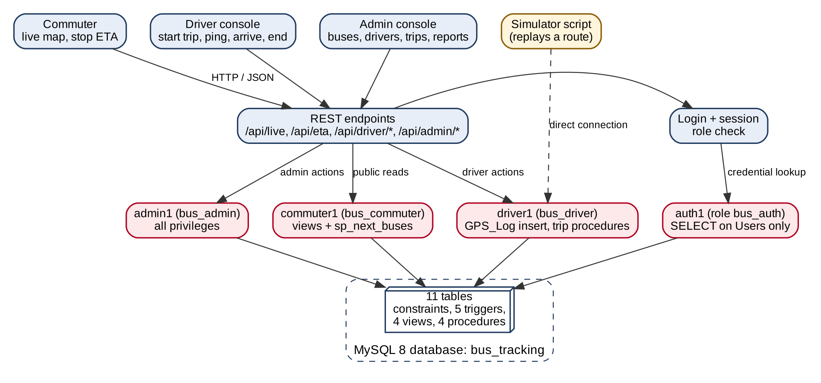
Figure 5.1: System architecture with one MySQL account per role
Figure 5.2 shows the life cycle of a trip and how data moves through the database objects: scheduling a trip (checked by a trigger), starting it through a transaction, receiving GPS pings, showing them on the map through v_live_buses, recording arrivals that compute the delay and raise alerts, answering next-bus queries and finally ending the trip.
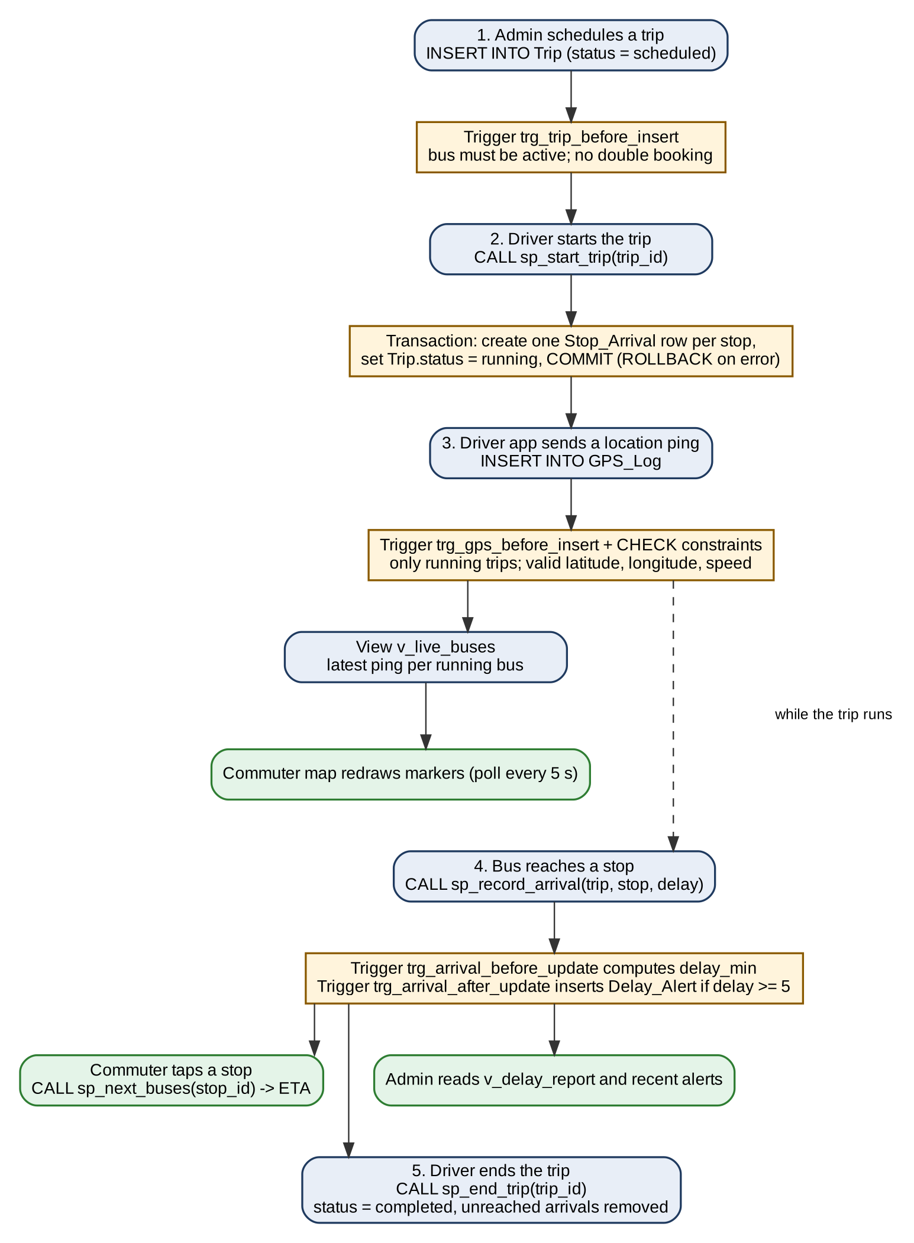
Figure 5.2: Data flow during the life cycle of a trip

CHAPTER 6 – SYSTEM IMPLEMENTATION

6.1 Database Creation
The database and the tables are created as follows. Parent tables come first so that foreign keys can be resolved.
CREATE DATABASE bus_tracking CHARACTER SET utf8mb4;
USE bus_tracking;

CREATE TABLE City (
city_id INT AUTO_INCREMENT PRIMARY KEY,
name VARCHAR(60) NOT NULL,
state VARCHAR(60) NOT NULL,
UNIQUE (name, state)
) ENGINE=InnoDB;

CREATE TABLE Driver (
driver_id INT AUTO_INCREMENT PRIMARY KEY,
name VARCHAR(80) NOT NULL,
phone VARCHAR(15) NOT NULL UNIQUE,
license_no VARCHAR(20) NOT NULL UNIQUE
) ENGINE=InnoDB;

CREATE TABLE Bus (
bus_id INT AUTO_INCREMENT PRIMARY KEY,
reg_no VARCHAR(15) NOT NULL UNIQUE,
capacity SMALLINT NOT NULL CHECK (capacity BETWEEN 10 AND 100),
status ENUM('active','maintenance','retired') NOT NULL DEFAULT 'active'
) ENGINE=InnoDB;

CREATE TABLE Route (
route_id INT AUTO_INCREMENT PRIMARY KEY,
route_no VARCHAR(10) NOT NULL UNIQUE,
name VARCHAR(100) NOT NULL,
city_id INT NOT NULL,
FOREIGN KEY (city_id) REFERENCES City(city_id) ON DELETE RESTRICT
) ENGINE=InnoDB;

CREATE TABLE Stop (
stop_id INT AUTO_INCREMENT PRIMARY KEY,
name VARCHAR(100) NOT NULL,
latitude DECIMAL(9,6) NOT NULL CHECK (latitude BETWEEN -90 AND 90),
longitude DECIMAL(9,6) NOT NULL CHECK (longitude BETWEEN -180 AND 180),
city_id INT NOT NULL,
FOREIGN KEY (city_id) REFERENCES City(city_id) ON DELETE RESTRICT
) ENGINE=InnoDB;

CREATE TABLE Route_Stop (
route_id INT NOT NULL,
stop_seq SMALLINT NOT NULL CHECK (stop_seq > 0),
stop_id INT NOT NULL,
sched_offset_min SMALLINT NOT NULL DEFAULT 0 CHECK (sched_offset_min >= 0),
PRIMARY KEY (route_id, stop_seq),
UNIQUE (route_id, stop_id),
FOREIGN KEY (route_id) REFERENCES Route(route_id) ON DELETE CASCADE,
FOREIGN KEY (stop_id) REFERENCES Stop(stop_id) ON DELETE RESTRICT
) ENGINE=InnoDB;

CREATE TABLE Trip (
trip_id INT AUTO_INCREMENT PRIMARY KEY,
route_id INT NOT NULL,
bus_id INT NOT NULL,
driver_id INT NOT NULL,
start_time DATETIME NOT NULL,
end_time DATETIME NULL,
status ENUM('scheduled','running','completed','cancelled')
NOT NULL DEFAULT 'scheduled',
CHECK (end_time IS NULL OR end_time >= start_time),
FOREIGN KEY (route_id) REFERENCES Route(route_id) ON DELETE RESTRICT,
FOREIGN KEY (bus_id) REFERENCES Bus(bus_id) ON DELETE RESTRICT,
FOREIGN KEY (driver_id) REFERENCES Driver(driver_id) ON DELETE RESTRICT
) ENGINE=InnoDB;

CREATE TABLE GPS_Log (
log_id BIGINT AUTO_INCREMENT PRIMARY KEY,
trip_id INT NOT NULL,
latitude DECIMAL(9,6) NOT NULL CHECK (latitude BETWEEN -90 AND 90),
longitude DECIMAL(9,6) NOT NULL CHECK (longitude BETWEEN -180 AND 180),
speed_kmph DECIMAL(5,2) NOT NULL CHECK (speed_kmph >= 0),
logged_at DATETIME NOT NULL DEFAULT CURRENT_TIMESTAMP,
FOREIGN KEY (trip_id) REFERENCES Trip(trip_id) ON DELETE CASCADE,
INDEX idx_gps_trip_time (trip_id, logged_at)
) ENGINE=InnoDB;

CREATE TABLE Stop_Arrival (
arrival_id INT AUTO_INCREMENT PRIMARY KEY,
trip_id INT NOT NULL,
stop_id INT NOT NULL,
scheduled_time DATETIME NOT NULL,
actual_time DATETIME NULL,
delay_min INT NULL,
UNIQUE (trip_id, stop_id),
FOREIGN KEY (trip_id) REFERENCES Trip(trip_id) ON DELETE CASCADE,
FOREIGN KEY (stop_id) REFERENCES Stop(stop_id) ON DELETE RESTRICT
) ENGINE=InnoDB;

CREATE TABLE Delay_Alert (
alert_id INT AUTO_INCREMENT PRIMARY KEY,
arrival_id INT NOT NULL UNIQUE,
delay_min INT NOT NULL,
created_at DATETIME NOT NULL DEFAULT CURRENT_TIMESTAMP,
FOREIGN KEY (arrival_id) REFERENCES Stop_Arrival(arrival_id) ON DELETE CASCADE
) ENGINE=InnoDB;

CREATE TABLE Users (
user_id INT AUTO_INCREMENT PRIMARY KEY,
username VARCHAR(50) NOT NULL UNIQUE,
password_hash VARCHAR(255) NOT NULL,
role ENUM('admin','driver','commuter') NOT NULL,
driver_id INT NULL UNIQUE,
FOREIGN KEY (driver_id) REFERENCES Driver(driver_id) ON DELETE SET NULL
) ENGINE=InnoDB;
Sample data for Mumbai (the demo city) was then inserted:
INSERT INTO City (name, state) VALUES ('Mumbai','Maharashtra');
INSERT INTO Stop (name, latitude, longitude, city_id) VALUES
('Dadar Station',19.018600,72.843200,1), ('Shivaji Park',19.027600,72.838900,1),
('Mahim Causeway',19.040700,72.840500,1),
('Xavier Institute of Engineering',19.0286,72.8378,1),
('Bandra Station',19.054400,72.840000,1), ('Sion Hospital',19.039500,72.862100,1),
('Bandra Kurla Complex',19.065900,72.868900,1);
INSERT INTO Route (route_no, name, city_id) VALUES
('R1','Dadar - Bandra',1), ('R2','Sion Hospital - BKC',1);
INSERT INTO Route_Stop VALUES
(1,1,1,0),(1,2,2,6),(1,3,3,11),(1,4,4,16),(1,5,5,22),
(2,1,6,0),(2,2,1,10),(2,3,3,18),(2,4,5,26),(2,5,7,38);
INSERT INTO Driver (name, phone, license_no) VALUES
('Rajesh Patil','9876500001','MH01-DL-0001'), ('Sunita Shinde','9876500002','MH01-DL-0002'),
('Imran Shaikh','9876500003','MH01-DL-0003'), ('Vikas Jadhav','9876500004','MH01-DL-0004');
INSERT INTO Bus (reg_no, capacity, status) VALUES
('MH01AB1001',40,'active'), ('MH01AB1002',40,'active'),
('MH01AB1003',35,'active'), ('MH01AB1004',35,'maintenance');
Note: the coordinates, phone numbers and licence numbers above are illustrative sample values for the demonstration city.

6.2 Constraints
The constraints used in the schema and what each protects are summarised in Table 6.1; the statements are part of the CREATE TABLE scripts in section 6.1.
Table 6.1: Constraints used
Constraint | Where used | Purpose
PRIMARY KEY | All tables; composite (route_id, stop_seq) in Route_Stop | Entity integrity: every row is uniquely identified
FOREIGN KEY | 11 relationships (Table 4.3) | Referential integrity with RESTRICT, CASCADE or SET NULL
NOT NULL | Names, coordinates, times, status, role, hashes | Mandatory data is always present
UNIQUE | Bus.reg_no, Driver.phone, Driver.license_no, Route.route_no, Users.username, (trip_id, stop_id), (route_id, stop_id), Delay_Alert.arrival_id, Users.driver_id | No duplicates; makes two links one-to-one
CHECK | Latitude -90..90, longitude -180..180, speed >= 0, capacity 10..100, stop_seq > 0, offset >= 0, Trip end_time >= start_time | Domain integrity
DEFAULT | Bus.status = 'active', Trip.status = 'scheduled', GPS_Log.logged_at = CURRENT_TIMESTAMP, Route_Stop offset = 0 | Sensible values when omitted
ENUM | Bus.status, Trip.status, Users.role | Only permitted states are accepted

Examples of constraint behaviour are demonstrated in Chapter 8 (tests T10 to T16). A representative statement that violates a CHECK constraint is:
INSERT INTO GPS_Log (trip_id, latitude, longitude, speed_kmph)
VALUES (1, 100, 72.8, 20); -- ERROR 3819: Check constraint violated

6.3 Views
Four views hide joins from the application and, because privileges can be granted on a view, also limit what each role can see.
CREATE VIEW v_live_buses AS
SELECT t.trip_id, b.reg_no, r.route_no, r.name AS route_name,
d.name AS driver_name, g.latitude, g.longitude, g.speed_kmph, g.logged_at
FROM Trip t
JOIN Bus b ON b.bus_id = t.bus_id
JOIN Route r ON r.route_id = t.route_id
JOIN Driver d ON d.driver_id = t.driver_id
JOIN GPS_Log g ON g.trip_id = t.trip_id
WHERE t.status = 'running'
AND g.log_id = (SELECT MAX(g2.log_id) FROM GPS_Log g2
WHERE g2.trip_id = t.trip_id);

CREATE VIEW v_route_stops AS
SELECT r.route_no, rs.stop_seq, s.stop_id, s.name,
s.latitude, s.longitude, rs.sched_offset_min
FROM Route_Stop rs
JOIN Route r ON r.route_id = rs.route_id
JOIN Stop s ON s.stop_id = rs.stop_id;

CREATE VIEW v_driver_trips AS
SELECT t.trip_id, t.driver_id, r.route_no, r.name AS route_name,
b.reg_no, t.status, t.start_time
FROM Trip t
JOIN Route r ON r.route_id = t.route_id
JOIN Bus b ON b.bus_id = t.bus_id
WHERE t.status IN ('scheduled','running');

CREATE VIEW v_delay_report AS
SELECT r.route_no,
COUNT(sa.arrival_id) AS arrivals_recorded,
ROUND(AVG(sa.delay_min), 1) AS avg_delay_min,
MAX(sa.delay_min) AS max_delay_min,
COUNT(da.alert_id) AS alerts_raised
FROM Route r
JOIN Trip t ON t.route_id = r.route_id
JOIN Stop_Arrival sa ON sa.trip_id = t.trip_id AND sa.actual_time IS NOT NULL
LEFT JOIN Delay_Alert da ON da.arrival_id = sa.arrival_id
GROUP BY r.route_id, r.route_no;
View | Purpose | Used by
v_live_buses | Latest ping (highest log_id) of every running trip with bus, route and driver | Map page (all roles)
v_route_stops | Ordered stops of a route with coordinates and offsets | Map page, ETA
v_driver_trips | A driver’s scheduled and running trips with route, bus and status | Driver console
v_delay_report | Per-route arrivals recorded, average delay, maximum delay and alerts raised | Admin console

6.4 Functions and Procedures
User-defined functions. The project does not define any user-defined functions. Built-in MySQL functions are used where needed: TIMESTAMPDIFF, COALESCE, NOW, ROUND, AVG, COUNT, MAX and ROW_COUNT. The logic that returns a result set (next buses at a stop) is written as a stored procedure because a MySQL stored function can return only a single scalar value, not a table of rows.
Stored procedures. Four procedures implement the operations that must be atomic or that return a result set.
DELIMITER //
CREATE PROCEDURE sp_start_trip(IN p_trip_id INT)
BEGIN
DECLARE v_status VARCHAR(20);
DECLARE v_route INT;
DECLARE v_start DATETIME;
DECLARE EXIT HANDLER FOR SQLEXCEPTION
BEGIN
ROLLBACK;
RESIGNAL;
END;
START TRANSACTION;
SELECT status, route_id INTO v_status, v_route
FROM Trip WHERE trip_id = p_trip_id FOR UPDATE;
IF v_status IS NULL OR v_status <> 'scheduled' THEN
SIGNAL SQLSTATE '45000'
SET MESSAGE_TEXT = 'Cannot start: trip not found or not in scheduled state';
END IF;
SET v_start = NOW();
INSERT INTO Stop_Arrival (trip_id, stop_id, scheduled_time)
SELECT p_trip_id, rs.stop_id, v_start + INTERVAL rs.sched_offset_min MINUTE
FROM Route_Stop rs WHERE rs.route_id = v_route;
UPDATE Trip SET status = 'running', start_time = v_start
WHERE trip_id = p_trip_id;
COMMIT;
END//

CREATE PROCEDURE sp_end_trip(IN p_trip_id INT)
BEGIN
DECLARE v_status VARCHAR(20);
DECLARE EXIT HANDLER FOR SQLEXCEPTION
BEGIN
ROLLBACK;
RESIGNAL;
END;
START TRANSACTION;
SELECT status INTO v_status FROM Trip WHERE trip_id = p_trip_id FOR UPDATE;
IF v_status IS NULL OR v_status <> 'running' THEN
SIGNAL SQLSTATE '45000'
SET MESSAGE_TEXT = 'Cannot end: trip not found or not running';
END IF;
DELETE FROM Stop_Arrival WHERE trip_id = p_trip_id AND actual_time IS NULL;
UPDATE Trip SET status = 'completed', end_time = NOW()
WHERE trip_id = p_trip_id;
COMMIT;
END//

CREATE PROCEDURE sp_record_arrival(
IN p_trip_id INT, IN p_stop_id INT, IN p_delay_min INT)
BEGIN
IF (SELECT status FROM Trip WHERE trip_id = p_trip_id) <> 'running' THEN
SIGNAL SQLSTATE '45000' SET MESSAGE_TEXT = 'Arrival rejected: trip is not running';
END IF;
UPDATE Stop_Arrival
SET actual_time = scheduled_time + INTERVAL p_delay_min MINUTE
WHERE trip_id = p_trip_id AND stop_id = p_stop_id AND actual_time IS NULL;
IF ROW_COUNT() = 0 THEN
SIGNAL SQLSTATE '45000'
SET MESSAGE_TEXT = 'Arrival rejected: stop not expected or already recorded';
END IF;
END//

CREATE PROCEDURE sp_next_buses(IN p_stop_id INT)
BEGIN
SELECT r.route_no, b.reg_no,
COALESCE(ld.delay_min, 0) AS current_delay_min,
t.start_time + INTERVAL (rs.sched_offset_min + COALESCE(ld.delay_min, 0)) MINUTE AS eta,
TIMESTAMPDIFF(MINUTE, NOW(),
t.start_time + INTERVAL (rs.sched_offset_min + COALESCE(ld.delay_min, 0)) MINUTE)
AS minutes_away
FROM Trip t
JOIN Route r ON r.route_id = t.route_id
JOIN Bus b ON b.bus_id = t.bus_id
JOIN Route_Stop rs ON rs.route_id = t.route_id AND rs.stop_id = p_stop_id
LEFT JOIN Stop_Arrival done
ON done.trip_id = t.trip_id AND done.stop_id = p_stop_id
AND done.actual_time IS NOT NULL
LEFT JOIN (
SELECT sa.trip_id, sa.delay_min FROM Stop_Arrival sa
WHERE sa.actual_time IS NOT NULL
AND sa.actual_time = (SELECT MAX(x.actual_time) FROM Stop_Arrival x
WHERE x.trip_id = sa.trip_id
AND x.actual_time IS NOT NULL)
) ld ON ld.trip_id = t.trip_id
WHERE t.status = 'running' AND done.arrival_id IS NULL
ORDER BY eta;
END//
DELIMITER ;
sp_start_trip locks the trip row (FOR UPDATE), creates one Stop_Arrival row for every stop of the route with its scheduled time, and only then marks the trip running and stamps its start time; if any statement fails, the EXIT HANDLER rolls everything back. sp_end_trip refuses a trip that is not running. sp_next_buses lists running trips that have not yet reached the given stop; the ETA is the trip’s start time plus the stop’s scheduled offset plus the delay of its latest recorded arrival, a deliberately simple estimate.

6.5 Triggers
Five triggers enforce rules that CHECK constraints cannot express because they need to look at other rows or tables.
Trigger | Event | Behaviour
trg_trip_before_insert | BEFORE INSERT on Trip | Rejects a scheduled or running trip whose bus is not active, and a running trip whose bus or driver is already on a running trip.
trg_trip_before_update | BEFORE UPDATE on Trip | Applies the same checks when a trip is updated (for example set to running), ignoring the trip itself.
trg_gps_before_insert | BEFORE INSERT on GPS_Log | Rejects a ping unless its trip has status running.
trg_arrival_before_update | BEFORE UPDATE on Stop_Arrival | When actual_time is set, computes delay_min = TIMESTAMPDIFF(MINUTE, scheduled_time, actual_time).
trg_arrival_after_update | AFTER UPDATE on Stop_Arrival | If delay_min >= 5, inserts a Delay_Alert (or updates it if one exists).

DELIMITER //
CREATE TRIGGER trg_trip_before_insert BEFORE INSERT ON Trip
FOR EACH ROW
BEGIN
IF NEW.status IN ('scheduled','running') THEN
IF (SELECT status FROM Bus WHERE bus_id = NEW.bus_id) <> 'active' THEN
SIGNAL SQLSTATE '45000' SET MESSAGE_TEXT = 'Trip rejected: bus is not active';
END IF;
END IF;
IF NEW.status = 'running' THEN
IF EXISTS (SELECT 1 FROM Trip WHERE bus_id = NEW.bus_id AND status = 'running') THEN
SIGNAL SQLSTATE '45000'
SET MESSAGE_TEXT = 'Trip rejected: bus is already on a running trip';
END IF;
IF EXISTS (SELECT 1 FROM Trip WHERE driver_id = NEW.driver_id AND status = 'running') THEN
SIGNAL SQLSTATE '45000'
SET MESSAGE_TEXT = 'Trip rejected: driver is already on a running trip';
END IF;
END IF;
END//

CREATE TRIGGER trg_trip_before_update BEFORE UPDATE ON Trip
FOR EACH ROW
BEGIN
IF NEW.status IN ('scheduled','running') THEN
IF (SELECT status FROM Bus WHERE bus_id = NEW.bus_id) <> 'active' THEN
SIGNAL SQLSTATE '45000' SET MESSAGE_TEXT = 'Trip rejected: bus is not active';
END IF;
END IF;
IF NEW.status = 'running' THEN
IF EXISTS (SELECT 1 FROM Trip WHERE bus_id = NEW.bus_id
AND status = 'running' AND trip_id <> NEW.trip_id) THEN
SIGNAL SQLSTATE '45000'
SET MESSAGE_TEXT = 'Trip rejected: bus is already on a running trip';
END IF;
IF EXISTS (SELECT 1 FROM Trip WHERE driver_id = NEW.driver_id
AND status = 'running' AND trip_id <> NEW.trip_id) THEN
SIGNAL SQLSTATE '45000'
SET MESSAGE_TEXT = 'Trip rejected: driver is already on a running trip';
END IF;
END IF;
END//

CREATE TRIGGER trg_gps_before_insert BEFORE INSERT ON GPS_Log
FOR EACH ROW
BEGIN
IF (SELECT status FROM Trip WHERE trip_id = NEW.trip_id) <> 'running' THEN
SIGNAL SQLSTATE '45000' SET MESSAGE_TEXT = 'GPS ping rejected: trip is not running';
END IF;
END//

CREATE TRIGGER trg_arrival_before_update BEFORE UPDATE ON Stop_Arrival
FOR EACH ROW
BEGIN
IF NEW.actual_time IS NOT NULL THEN
SET NEW.delay_min = TIMESTAMPDIFF(MINUTE, NEW.scheduled_time, NEW.actual_time);
END IF;
END//

CREATE TRIGGER trg_arrival_after_update AFTER UPDATE ON Stop_Arrival
FOR EACH ROW
BEGIN
IF NEW.delay_min IS NOT NULL AND NEW.delay_min >= 5 THEN
INSERT INTO Delay_Alert (arrival_id, delay_min)
VALUES (NEW.arrival_id, NEW.delay_min)
ON DUPLICATE KEY UPDATE delay_min = NEW.delay_min;
END IF;
END//
DELIMITER ;
trg_trip_before_update is what protects sp_start_trip: when the procedure changes a trip to running, the same bus, driver and status checks are applied. The triggers listed by SHOW TRIGGERS are shown in Figure 8.3.

CHAPTER 7 – SQL QUERIES AND OPERATIONS

7.1 DDL Operations
CREATE statements for the database and all tables are given in section 6.1. The following statements illustrate the remaining DDL commands. They are shown on a scratch table named Notice_Demo created only for illustration, so that the project tables are not altered.
CREATE TABLE Notice_Demo (notice_id INT PRIMARY KEY, message VARCHAR(100));

ALTER TABLE Notice_Demo ADD COLUMN created_on DATE; -- add a column
ALTER TABLE Notice_Demo MODIFY message VARCHAR(200) NOT NULL; -- change a column

TRUNCATE TABLE Notice_Demo; -- remove all rows, keep the table
DROP TABLE Notice_Demo; -- remove the table
These four statements illustrate ALTER, TRUNCATE and DROP; they were not part of the operational database. On the real tables TRUNCATE and DROP are blocked for the non-administrator roles, because those roles hold no such privilege (section 9.2).

7.2 DML Operations
INSERT statements for the sample data are in section 6.1. Further DML used during testing:
-- schedule three trips (accepted: bus active, no conflict)
INSERT INTO Trip (route_id, bus_id, driver_id, start_time, status) VALUES
(1,1,1,NOW(),'running'), (2,2,2,NOW(),'running'), (1,3,3,NOW(),'scheduled');

-- GPS pings for the running trip 1
INSERT INTO GPS_Log (trip_id, latitude, longitude, speed_kmph) VALUES
(1,19.0286,72.8378,24.50), (1,19.0407,72.8405,18.00);

-- UPDATE: record an arrival 8 minutes late (trigger computes delay, raises alert)
UPDATE Stop_Arrival
SET actual_time = DATE_ADD(scheduled_time, INTERVAL 8 MINUTE)
WHERE trip_id = 1 AND stop_id = 3;

-- UPDATE: send a bus for maintenance
UPDATE Bus SET status = 'maintenance' WHERE reg_no = 'MH01AB1004';

-- DELETE: remove an unreached arrival row of a trip
DELETE FROM Stop_Arrival WHERE trip_id = 3 AND actual_time IS NULL;

7.3 DQL Operations
Typical SELECT queries with filtering, sorting, grouping and aggregate functions:
-- active buses ordered by capacity
SELECT reg_no, capacity FROM Bus WHERE status = 'active' ORDER BY capacity DESC;

-- number of buses per status
SELECT status, COUNT(*) AS buses, SUM(capacity) AS seats FROM Bus GROUP BY status;

-- late arrivals only
SELECT trip_id, stop_id, delay_min FROM Stop_Arrival
WHERE delay_min >= 5 ORDER BY delay_min DESC;

-- average and maximum delay of each route that has more than one measured arrival
SELECT t.route_id, ROUND(AVG(sa.delay_min),1) AS avg_delay, MAX(sa.delay_min) AS max_delay
FROM Stop_Arrival sa JOIN Trip t ON t.trip_id = sa.trip_id
WHERE sa.actual_time IS NOT NULL
GROUP BY t.route_id HAVING COUNT(*) > 1;

-- drivers whose name starts with 'S'
SELECT name, phone FROM Driver WHERE name LIKE 'S%';

7.4 Joins
INNER JOIN – the stops of each route in order (also the basis of v_route_stops):
SELECT r.route_no, rs.stop_seq, s.name, rs.sched_offset_min
FROM Route r
JOIN Route_Stop rs ON rs.route_id = r.route_id
JOIN Stop s ON s.stop_id = rs.stop_id
ORDER BY r.route_no, rs.stop_seq;
LEFT JOIN – all buses with the number of trips they have run, including buses with no trips:
SELECT b.reg_no, b.status, COUNT(t.trip_id) AS trips
FROM Bus b LEFT JOIN Trip t ON t.bus_id = b.bus_id
GROUP BY b.bus_id, b.reg_no, b.status;
LEFT JOIN with IS NULL – stops that no route uses:
SELECT s.name FROM Stop s
LEFT JOIN Route_Stop rs ON rs.stop_id = s.stop_id
WHERE rs.stop_id IS NULL;
RIGHT JOIN – every driver with their trips (equivalent to a LEFT JOIN written from the other side):
SELECT d.name, t.trip_id, t.status
FROM Trip t RIGHT JOIN Driver d ON d.driver_id = t.driver_id;
The listing of Route_Stop joined with Route and Stop is shown in Figure 8.2.

7.5 Subqueries
Single-row subquery – buses with capacity above the average capacity:
SELECT reg_no, capacity FROM Bus
WHERE capacity > (SELECT AVG(capacity) FROM Bus);
Multi-row subquery with IN – drivers currently on a running trip:
SELECT name FROM Driver
WHERE driver_id IN (SELECT driver_id FROM Trip WHERE status = 'running');
NOT EXISTS – buses that have never been assigned to a trip:
SELECT reg_no FROM Bus b
WHERE NOT EXISTS (SELECT 1 FROM Trip t WHERE t.bus_id = b.bus_id);
Correlated subquery – the latest GPS ping of every trip (the same technique is used inside v_live_buses):
SELECT g.trip_id, g.latitude, g.longitude, g.logged_at
FROM GPS_Log g
WHERE g.logged_at = (SELECT MAX(g2.logged_at) FROM GPS_Log g2
WHERE g2.trip_id = g.trip_id);

7.6 Advanced Queries
Views, procedures and triggers are defined in sections 6.3 to 6.5. Examples of calling them:
SELECT * FROM v_live_buses; -- live position of every running bus
SELECT * FROM v_delay_report; -- per-route delay statistics
CALL sp_next_buses(5); -- next buses at Bandra Station (stop 5)
CALL sp_start_trip(3); -- transaction: create arrivals, set running
CALL sp_end_trip(3); -- transaction: drop unreached arrivals, complete
Transaction with SAVEPOINT. The following sequence, run on bus 3 (capacity 35, status active), shows a partial rollback inside one unit of work:
START TRANSACTION;
UPDATE Bus SET capacity = 50 WHERE bus_id = 3; -- step A
SAVEPOINT after_capacity;
UPDATE Bus SET status = 'retired' WHERE bus_id = 3; -- step B
SELECT capacity, status FROM Bus WHERE bus_id = 3; -- 50, retired
ROLLBACK TO SAVEPOINT after_capacity; -- undo step B only
SELECT capacity, status FROM Bus WHERE bus_id = 3; -- 50, active
ROLLBACK; -- undo step A as well
SELECT capacity, status FROM Bus WHERE bus_id = 3; -- 35, active
In testing, bus 3 was observed as 50/retired, then 50/active, then 35/active (Figures 8.13 to 8.15 and section 9.3).

CHAPTER 8 – RESULTS AND TESTING

8.1 Test Cases
The test cases in Table 8.1 cover valid operations, every kind of integrity rule, the views and procedures, transactions, privileges and the web application. Database tests were executed in MySQL Workbench or the mysql client; T32 and T33 were carried out on the running web application and were confirmed by the team.
Table 8.1: Test cases
ID | Input / action | Expected output | Actual output | Status
T01 | Run the table-creation script; SHOW TABLES | 11 tables listed | 11 tables listed (Fig. 8.1) | Pass
T02 | Load sample data; join Route, Route_Stop, Stop | 10 route-stop rows in order | 10 rows returned (Fig. 8.2) | Pass
T03 | SHOW TRIGGERS | 5 triggers present | 5 triggers listed (Fig. 8.3) | Pass
T04 | Insert 3 valid trips (active bus, no conflict) | Accepted | 3 rows inserted (Fig. 8.5) | Pass
T05 | Insert 2 GPS pings for a running trip | Accepted | 2 rows inserted (Fig. 8.4) | Pass
T06 | Insert a trip using bus in maintenance | Rejected by trigger | Error 1644: bus is not active | Pass
T07 | Insert a running trip for a bus already running | Rejected by trigger | Error 1644: bus is already on a running trip | Pass
T08 | Insert a running trip for a driver already running | Rejected by trigger | Error 1644: driver is already on a running trip | Pass
T09 | GPS ping for a trip that is not running | Rejected by trigger | Error 1644: trip is not running | Pass
T10 | GPS ping with latitude 100 | Rejected by CHECK | Error 3819: check constraint violated | Pass
T11 | GPS ping with speed -5 | Rejected by CHECK | Error 3819: check constraint violated | Pass
T12 | Trip whose end_time is before start_time | Rejected by CHECK | Error 3819: Trip_chk_1 violated | Pass
T13 | DELETE a route that has trips | Rejected by RESTRICT | Error 1451: cannot delete a parent row | Pass
T14 | Insert a driver with a duplicate phone | Rejected by UNIQUE | Error 1062: duplicate entry | Pass
T15 | Record arrival with 2-minute delay | delay_min = 2, no alert | delay_min computed; no Delay_Alert row | Pass
T16 | Record arrival with 8-minute delay | delay_min = 8 and an alert | Alert 1 for arrival 2, delay 8 (Fig. 8.6) | Pass
T17 | SELECT * FROM v_live_buses | One row per running trip, latest ping | 1 row: trip 1, MH01AB1001, 24.50 km/h (Fig. 8.7) | Pass
T18 | SELECT * FROM v_delay_report | Per-route statistics | R1: 2 arrivals, avg 5.0, max 8, 1 alert (Fig. 8.8) | Pass
T19 | CALL sp_next_buses(5) | Running buses due at stop 5 sorted by ETA | R2 MH01AB1002 delay 0; R1 MH01AB1001 delay 8 (Fig. 8.9) | Pass
T20 | CALL sp_next_buses(1) | Only buses that have not yet passed stop 1 | Only R2 returned (Fig. 8.10) | Pass
T21 | CALL sp_start_trip(3) | 5 Stop_Arrival rows; trip running | 5 rows created, trip running (Fig. 8.11) | Pass
T22 | CALL sp_start_trip(4) while its bus is running | Error and rollback | Error raised; trip 4 stayed scheduled | Pass
T23 | CALL sp_end_trip(3) | Unreached arrivals removed; trip completed | 0 remaining arrivals (Fig. 8.12) | Pass
T24 | Savepoint sequence on bus 3 | 50/retired, 50/active, 35/active | As expected (Figs. 8.13–8.15) | Pass
T25 | commuter1: SELECT v_live_buses; CALL sp_next_buses | Allowed | Both succeeded | Pass
T26 | commuter1: SELECT Bus; INSERT INTO City | Denied | Error 1142 for both | Pass
T27 | driver1: INSERT into GPS_Log | Allowed | Row inserted | Pass
T28 | driver1: SELECT Driver; DELETE GPS_Log | Denied | Error 1142 for both | Pass
T29 | admin1: SELECT COUNT(*) FROM Bus | Allowed | Returned 4 | Pass
T30 | REVOKE INSERT on GPS_Log from bus_driver; driver1 inserts | Denied after revoke | Error 1142 (grant restored afterwards) | Pass
T31 | auth1: SELECT Users; SELECT Bus | Users allowed, Bus denied | Hashes visible, Bus denied | Pass
T32 | Application: login as admin, driver and commuter; open /admin as driver and commuter | Correct landing page per role; protected pages blocked | Behaved as expected (confirmed by the team) | Pass
T33 | Application: simulator running; map and delay alerts | Bus moves every 5 s; alerts recorded | Map updated; 5 alerts recorded (Figs. 8.17–8.21) | Pass

8.2 Query Results
The screenshots below were taken from MySQL Workbench while the tests were run. Figure 8.1 confirms that the database contains the eleven tables, and Figure 8.2 lists the routes and their ordered stops with scheduled offsets.
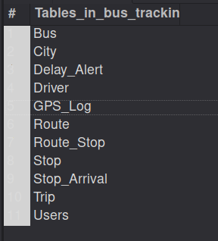
Figure 8.1: SHOW TABLES – the eleven tables of bus_tracking
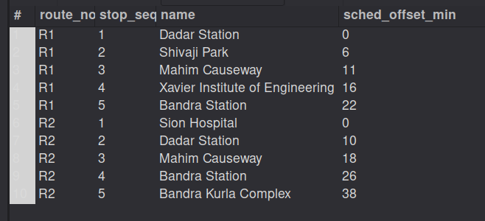
Figure 8.2: Routes with their ordered stops (join of Route, Route_Stop and Stop)
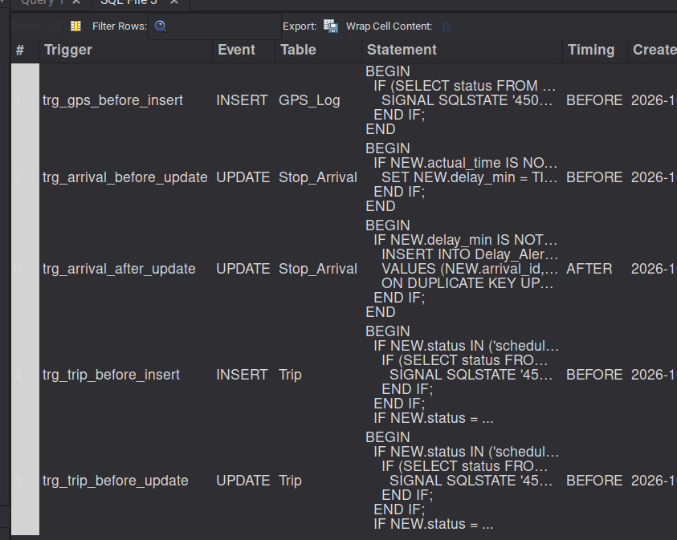
Figure 8.3: SHOW TRIGGERS – the five triggers
Valid GPS pings were accepted (Figure 8.4). The Workbench action log in Figure 8.5 shows the successful inserts followed by the rejected statements: the green ticks are accepted statements and the red crosses are rows refused by triggers (error 1644), CHECK constraints (3819), the foreign key (1451) and the UNIQUE key (1062).
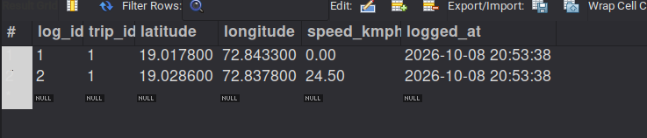
Figure 8.4: GPS_Log after two valid pings
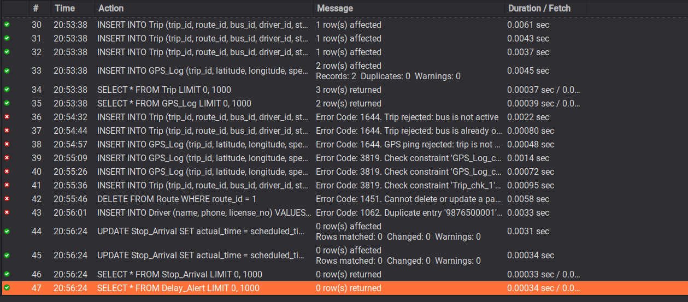
Figure 8.5: Action log – accepted inserts and rejected invalid statements
After an arrival with an 8-minute delay was recorded, the trigger created the alert shown in Figure 8.6. The log also shows (row 48) the rejection of a trip for a driver who was already running.
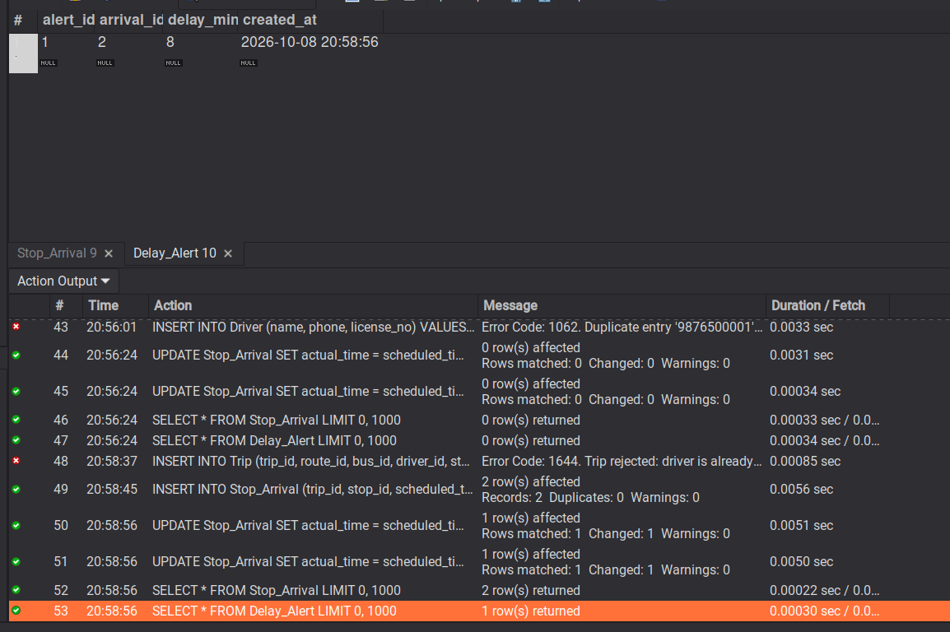
Figure 8.6: Delay_Alert row created automatically, with the log showing the driver-conflict rejection
Views and procedures returned the following results.
Figure 8.7: v_live_buses – latest position of the running bus
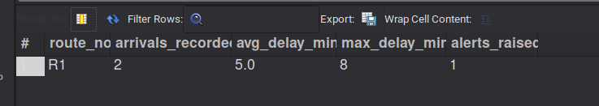
Figure 8.8: v_delay_report – delay statistics for route R1
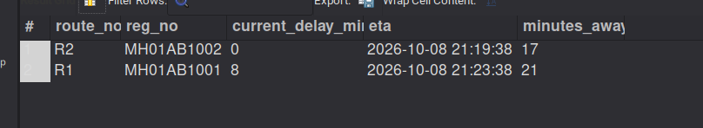
Figure 8.9: CALL sp_next_buses(5) – next buses at Bandra Station
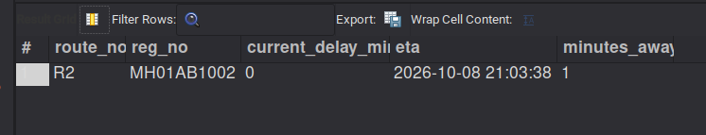
Figure 8.10: CALL sp_next_buses(1) – only the bus that has not yet passed Dadar Station
Transaction tests: sp_start_trip created the five Stop_Arrival rows of trip 3 (Figure 8.11) and sp_end_trip removed the unreached ones (Figure 8.12). The SAVEPOINT test on bus 3 is shown in Figures 8.13 to 8.15.
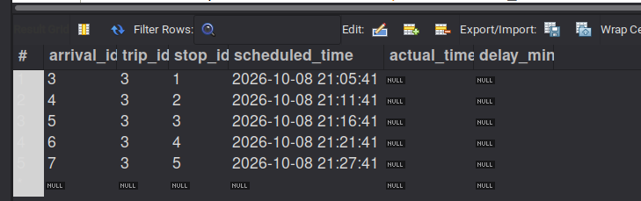
Figure 8.11: Stop_Arrival rows created by sp_start_trip(3)
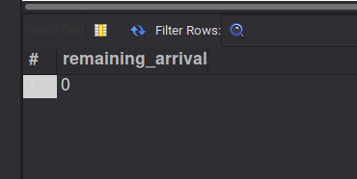
Figure 8.12: Remaining arrivals of trip 3 after sp_end_trip(3)
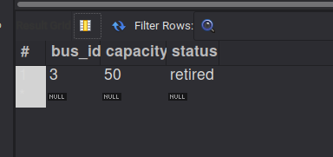
Figure 8.13: Bus 3 after step B inside the transaction (capacity 50, retired)
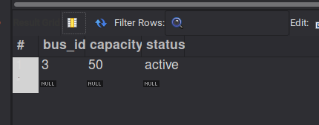
Figure 8.14: Bus 3 after ROLLBACK TO SAVEPOINT (capacity 50, active)
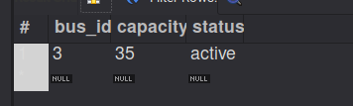
Figure 8.15: Bus 3 after ROLLBACK (capacity 35, active)

8.3 System Screenshots
Figure 8.16 shows the live map with a bus at Mahim Causeway on route R1. Figure 8.17 shows the alert created by the driver console when an arrival was recorded 6 minutes late. Figure 8.18 shows the map together with the simulator terminal sending positions, and Figure 8.19 shows the delay report updated by the simulated arrivals.
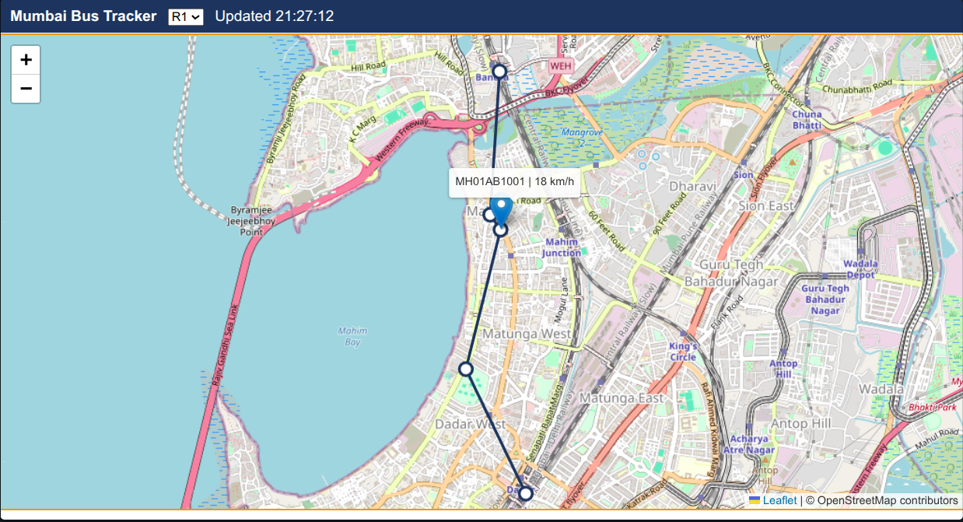
Figure 8.16: Live map with a running bus (Leaflet and OpenStreetMap)
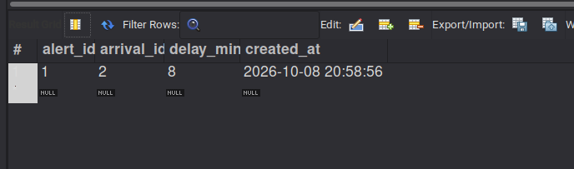
Figure 8.17: Delay_Alert row created from the driver console
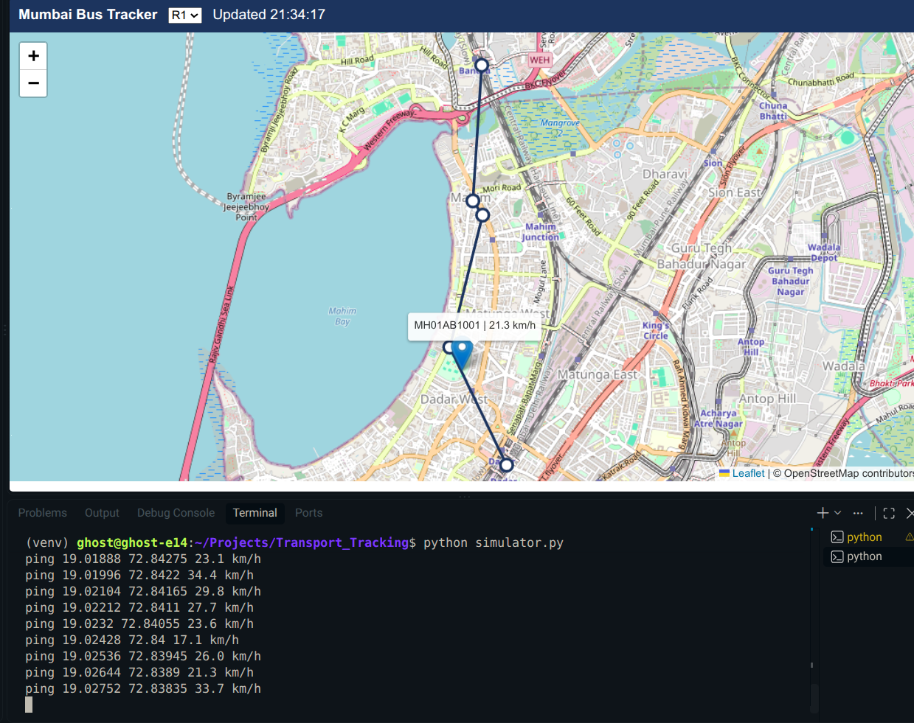
Figure 8.18: Map and GPS simulator running together
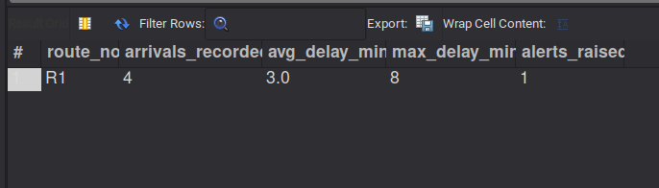
Figure 8.19: v_delay_report after simulator arrivals
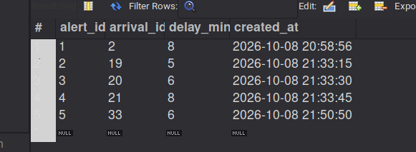
Figure 8.20: Delay_Alert table with five alerts
The administrator console in Figure 8.21 lists all trips, the delay report (13 arrivals, average 3.3, maximum 8 minutes, 5 alerts) and the alert list.
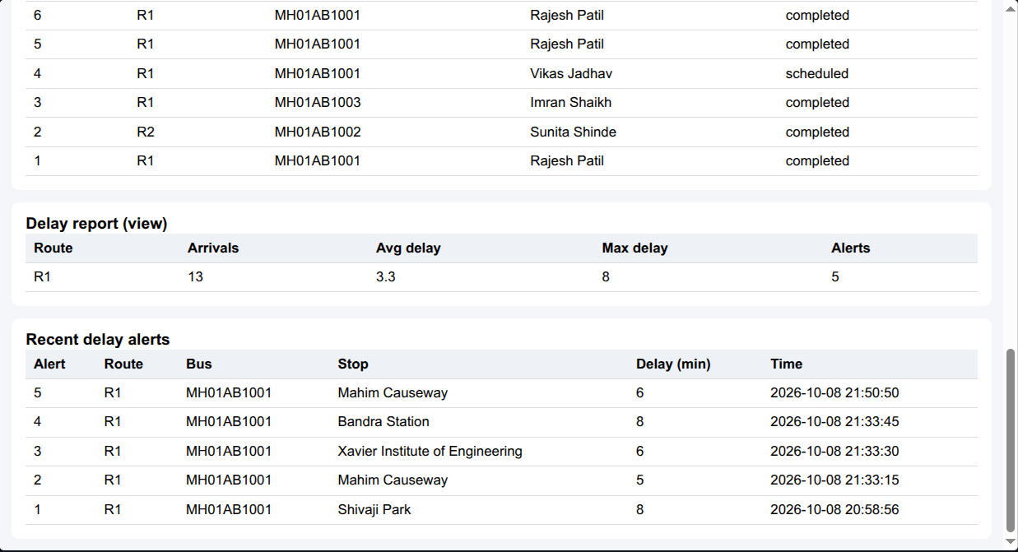
Figure 8.21: Administrator console
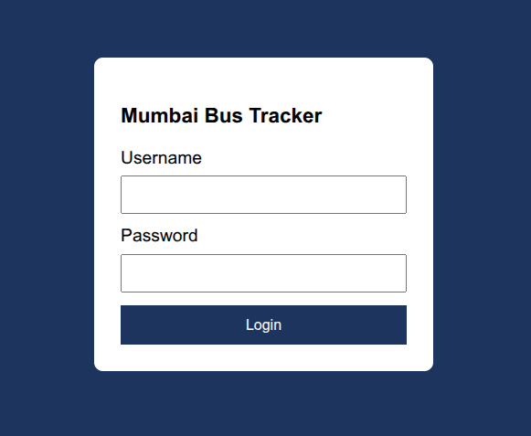
Figure 8.22: Login page of the application
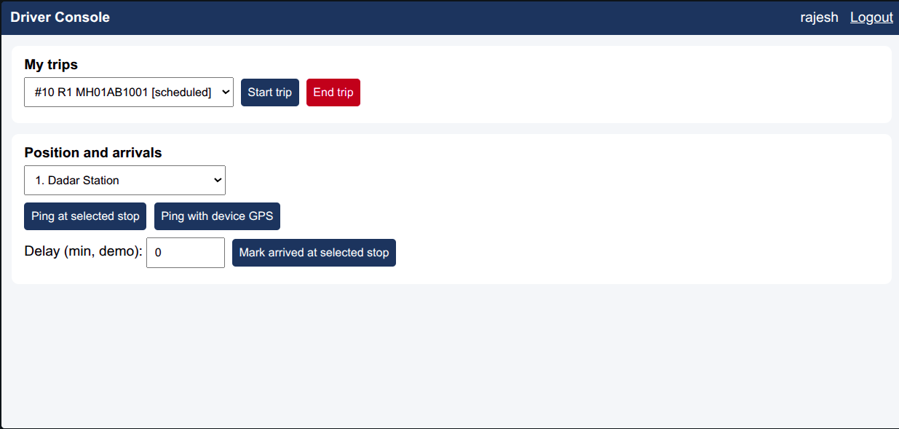
Figure 8.23: Driver console with a scheduled trip and the stops of route R1

8.4 Result Analysis
All 33 test cases produced the expected result. The analysis against the requirements is:
- Storage and normalisation (FR1–FR12): the eleven-table schema in BCNF/3NF stored all sample and test data without redundancy, other than the two deliberate delay columns.
- Integrity (FR10): every invalid operation tried – inactive bus, double-booked bus or driver, ping for a non-running trip, out-of-range latitude, negative speed, reversed trip times, deletion of a referenced route and duplicate phone – was refused by the database itself with a specific error code.
- Retrieval (FR2–FR4, FR9): the four views and sp_next_buses gave correct live positions, ordered stops, delay statistics and ETAs, and the map refreshed from the database every 5 seconds.
- Reliability: sp_start_trip, sp_end_trip and the SAVEPOINT test showed that failed or reversed operations leave no partial data.
- Security (FR11): each of the four database accounts could do only what its role allows; removing a privilege with REVOKE took effect immediately.
- Automatic alerts (FR8): delays below 5 minutes created no alert; delays of 5 minutes or more created exactly one alert per arrival.
- Limits: the evaluation used a small data set (2 routes, 4 buses, a handful of trips) and a simulator in place of real GPS devices, so these results demonstrate correctness and integrity, not performance at city scale.
The implemented database therefore meets the stated requirements within the scope defined in section 1.4.

CHAPTER 9 – SECURITY, INTEGRITY AND TRANSACTIONS

9.1 Data Integrity
Entity integrity. Every table has a primary key (composite for Route_Stop) and primary-key columns can never be NULL or duplicated. Additional UNIQUE keys prevent duplicate bus registrations, phone numbers, licence numbers, route numbers and usernames, and make Delay_Alert and Users.driver_id one-to-one links.
Referential integrity. All eleven relationships are enforced by foreign keys in InnoDB. RESTRICT stops the deletion of a route, bus, driver, stop or city that is still in use (test T13), CASCADE removes dependent rows that have no meaning alone (GPS pings, arrivals and alerts of a deleted trip, stops of a deleted route), and SET NULL lets a driver record be removed without deleting the login row.
Domain integrity. Data types (DECIMAL for coordinates, DATETIME for times), ENUM lists, NOT NULL, DEFAULT and CHECK constraints restrict values to legal ranges: latitude -90 to 90, longitude -180 to 180, speed not negative, capacity 10 to 100, trip end not before start.
Business-rule integrity. Rules that involve other rows are enforced by triggers: a trip needs an active bus; one bus and one driver cannot be on two running trips at once; a GPS ping is accepted only for a running trip; delay is always derived from the recorded times; and an alert exists exactly when the delay is 5 minutes or more.
Concurrency. sp_start_trip locks the trip row with SELECT ... FOR UPDATE inside a transaction, so two clients cannot start the same trip twice.

9.2 Database Security
Authentication. Application users log in with a username and password. Passwords are never stored in plain text; they are saved in Users.password_hash as salted scrypt hashes generated by Werkzeug. Flask sessions keep the logged-in user, and role-checking decorators protect each page and API.
Authorisation inside the database. MySQL roles were created for each type of user and each application account was granted one role. The Flask application opens its connection with the account matching the logged-in role, so the DBMS itself refuses anything outside the role even if the application code is bypassed. All SQL in the application is parameterised to prevent SQL injection.
Table 9.1: Roles and privileges
Role / account | Privileges granted
bus_admin / admin1 | ALL PRIVILEGES on bus_tracking.*
bus_driver / driver1 | SELECT on v_live_buses, v_route_stops, v_driver_trips; INSERT on GPS_Log; EXECUTE on sp_start_trip, sp_end_trip, sp_next_buses, sp_record_arrival
bus_commuter / commuter1 | SELECT on v_live_buses, v_route_stops; EXECUTE on sp_next_buses
bus_auth / auth1 | SELECT on Users (used only to verify logins)

CREATE ROLE bus_admin, bus_driver, bus_commuter, bus_auth;

GRANT ALL PRIVILEGES ON bus_tracking.* TO bus_admin;

GRANT SELECT ON bus_tracking.v_live_buses TO bus_driver, bus_commuter;
GRANT SELECT ON bus_tracking.v_route_stops TO bus_driver, bus_commuter;
GRANT SELECT ON bus_tracking.v_driver_trips TO bus_driver;
GRANT INSERT ON bus_tracking.GPS_Log TO bus_driver;
GRANT EXECUTE ON PROCEDURE bus_tracking.sp_start_trip TO bus_driver;
GRANT EXECUTE ON PROCEDURE bus_tracking.sp_end_trip TO bus_driver;
GRANT EXECUTE ON PROCEDURE bus_tracking.sp_record_arrival TO bus_driver;
GRANT EXECUTE ON PROCEDURE bus_tracking.sp_next_buses TO bus_driver, bus_commuter;
GRANT SELECT ON bus_tracking.Users TO bus_auth;

CREATE USER 'admin1'@'localhost' IDENTIFIED BY '<password>';
CREATE USER 'driver1'@'localhost' IDENTIFIED BY '<password>';
CREATE USER 'commuter1'@'localhost' IDENTIFIED BY '<password>';
CREATE USER 'auth1'@'localhost' IDENTIFIED BY '<password>';
GRANT bus_admin TO 'admin1'@'localhost';
GRANT bus_driver TO 'driver1'@'localhost';
GRANT bus_commuter TO 'commuter1'@'localhost';
GRANT bus_auth TO 'auth1'@'localhost';
SET DEFAULT ROLE ALL TO 'admin1'@'localhost', 'driver1'@'localhost',
'commuter1'@'localhost', 'auth1'@'localhost';
The passwords were demonstration passwords chosen for the project and are shown here as placeholders. The verification of privileges from the terminal is summarised in Table 9.2 and Figure 9.1 shows SHOW GRANTS for commuter1.
Table 9.2: Privilege tests from the terminal
Account | Statement | Result
commuter1 | SELECT * FROM v_live_buses; CALL sp_next_buses(5) | Allowed
commuter1 | SELECT * FROM Bus | ERROR 1142 – SELECT command denied
commuter1 | INSERT INTO City ... | ERROR 1142 – INSERT command denied
driver1 | INSERT INTO GPS_Log ... | Allowed
driver1 | SELECT * FROM Driver | ERROR 1142 – SELECT command denied
driver1 | DELETE FROM GPS_Log | ERROR 1142 – DELETE command denied
admin1 | SELECT COUNT(*) FROM Bus | Allowed – returned 4
driver1 (after REVOKE INSERT ON GPS_Log FROM bus_driver) | INSERT INTO GPS_Log ... | ERROR 1142 – INSERT command denied (privilege then re-granted)
auth1 | SELECT username, password_hash FROM Users | Allowed – only scrypt hashes visible
auth1 | SELECT * FROM Bus | Denied

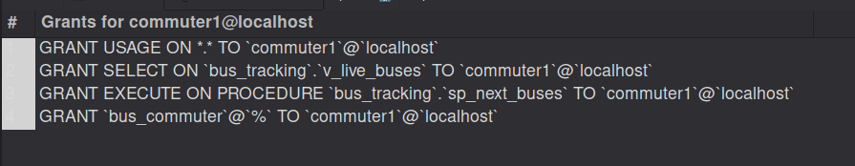
Figure 9.1: SHOW GRANTS FOR commuter1

9.3 Transactions
InnoDB provides ACID transactions. The project uses them in two ways.
Stored-procedure transactions. sp_start_trip and sp_end_trip each run START TRANSACTION … COMMIT with an EXIT HANDLER FOR SQLEXCEPTION that issues ROLLBACK and re-raises the error. If starting a trip fails halfway (for example because the bus is already running, which makes a trigger raise error 1644), no Stop_Arrival rows remain and the trip stays scheduled; this was observed for trip 4 (test T22).
SAVEPOINT demonstration. Section 7.6 shows a transaction on bus 3 with a SAVEPOINT. After the second change the row read 50/retired (Figure 8.13), ROLLBACK TO SAVEPOINT restored 50/active (Figure 8.14) and a full ROLLBACK restored the original 35/active (Figure 8.15). This shows partial and complete rollback.
Isolation and locking. SELECT ... FOR UPDATE in sp_start_trip locks the trip row, so concurrent starts of the same trip are serialised. The default InnoDB isolation level (REPEATABLE READ) was used.

9.4 Backup and Recovery
The database is backed up with mysqldump, including stored procedures and triggers:
sudo mysqldump --routines --triggers bus_tracking > bus_tracking_backup.sql
The resulting dump file was about 41 KB and contained the four stored procedures and the five triggers. To recover, create an empty database and load the file:
mysql -u root -p -e "CREATE DATABASE IF NOT EXISTS bus_tracking"
mysql -u root -p bus_tracking < bus_tracking_backup.sql
On the development machine the root account uses socket authentication, so the command is run with sudo. Roles and user accounts are stored in the mysql system database and are not part of this dump; after a restore on a new server the GRANT script of section 9.2 is run again. For a production system a scheduled daily dump, binary logging for point-in-time recovery and storage of copies on a different machine would be added.

CHAPTER 10 – LIMITATIONS AND FUTURE SCOPE

10.1 Limitations
- Routes and stops are loaded through SQL scripts; there is no administrator screen to add or edit them.
- The database account passwords and the Flask secret key are written in the application source; they are suitable only for a demonstration and must move to environment variables or a secrets file for real use.
- There is no self-registration; application users are created by the administrator in the database.
- The ETA is simple: the scheduled time plus the latest delay observed on the trip. It does not use traffic, speed history or prediction.
- Positions come from a simulator or the driver console, not from real GPS devices.
- The map draws straight lines between stops rather than following roads.
- The system was tested with a small sample data set on a single machine; load and scalability have not been measured.
- Polling every 5 seconds is simple but not the most efficient method; ticketing, fares and passenger accounts are not covered.

10.2 Future Scope
- An administrator interface for managing cities, routes, stops, buses and drivers.
- Android or low-cost GPS tracker integration that posts positions to the same GPS_Log table over a compact protocol.
- Better ETA estimation from historical delays stored in Stop_Arrival, and road-following routes.
- Push or SMS notifications to commuters when a bus on their route raises a Delay_Alert, which suits low-bandwidth areas.
- Partitioning or archiving of GPS_Log, and a read replica to support more cities and more commuters.
- Cloud deployment with HTTPS, secrets management, scheduled backups and monitoring.
- Analytics dashboards for the transport department: punctuality by route and time of day, bus utilisation and driver workload.
- Multilingual interface (Hindi, Punjabi and Marathi) and accessibility improvements.

CHAPTER 11 – CONCLUSION

11.1 Conclusion
This project designed and implemented a database-centred real-time public transport tracking system based on SIH25013. An eleven-table relational schema in BCNF/3NF was built in MySQL 8.0 and demonstrated with Mumbai as the sample city. Integrity is protected at every level: primary and unique keys, foreign keys with deliberate ON DELETE rules, CHECK, DEFAULT, NOT NULL and ENUM constraints, and five triggers for rules that span rows. Four views and four stored procedures provide live positions, route stops, delay statistics and next-bus estimates, while transactions with rollback and savepoints keep multi-step operations all-or-nothing. Role-based security is implemented in the DBMS with roles, per-role accounts, GRANT and REVOKE, and application passwords are stored as hashes.
On top of the database, a light Flask and Leaflet application with commuter, driver and administrator roles shows buses on a live map and reports delays, and a simulator makes the system demonstrable without hardware. All 33 test cases passed. The main outcome is that a small city can obtain reliable tracking and delay data from a single open-source database whose own rules prevent inconsistent records. The limitations in section 10.1 describe what remains before real deployment.

REFERENCES

References
[1] R. Elmasri and S. B. Navathe, Fundamentals of Database Systems, 7th ed., Pearson, 2016.
[2] A. Silberschatz, H. F. Korth and S. Sudarshan, Database System Concepts, 7th ed., McGraw-Hill, 2019.
[3] Oracle Corporation, MySQL 8.0 Reference Manual. https://dev.mysql.com/doc/refman/8.0/en/
[4] Oracle Corporation, MySQL Connector/Python Developer Guide. https://dev.mysql.com/doc/connector-python/en/
[5] Pallets Projects, Flask Documentation. https://flask.palletsprojects.com/
[6] Pallets Projects, Werkzeug Documentation (password hashing). https://werkzeug.palletsprojects.com/
[7] Leaflet – an open-source JavaScript library for interactive maps, version 1.9.4. https://leafletjs.com/
[8] OpenStreetMap contributors, OpenStreetMap map data and tiles. https://www.openstreetmap.org/copyright
[9] Smart India Hackathon 2025, Problem Statement SIH25013 – Real-Time Public Transport Tracking for Small Cities, Government of Punjab, Department of Higher Education. https://www.sih.gov.in/
[10] Public prototypes for SIH25013 and similar public-transport tracking projects on GitHub and Kaggle, reviewed during requirement analysis. [Team to add the exact repository links reviewed]

