PHASE 1 v2
Demo Website Generator and GTM Funnel
Personalized demo workflow, outreach funnel, and demo-to-client handoff.

Document ID | P1V2-03
Version | 2.0 - Enhanced after Phase 1 review
Prepared for | Internal founding team
Target niche | Independent restaurants, cafes, and small restaurant groups
Primary backend language | Golang for backend services and workers; Next.js/TypeScript for web UI

Core principle: validate demand through personalized demos before building a full SaaS platform.

1. Demo Website Generator Strategy
The personalized demo website is the primary sales mechanism. It should feel like a preview of a real deliverable, while still being fast enough for the team to create repeatedly.

Figure 1. MVP flow from internal admin to restaurant owner sales call.

2. Demo Composer Design

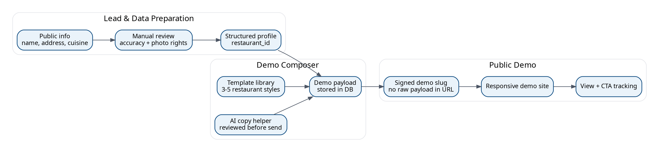
Figure 2. Demo composer separates data preparation, template rendering, and public tracking.

Stage | Inputs | Outputs | Quality gate
Lead intake | Restaurant name, contact, current website, cuisine, notes. | Restaurant record. | Required fields present.
Data enrichment | Public website, menu, hours, photos, Google Maps link. | Draft profile and menu. | Manual verification and photo rights check.
Copy drafting | Cuisine, pain points, current website issues. | Hero copy, service bullets, CTA copy. | Human approval before publishing.
Template rendering | Template ID, restaurant payload, theme settings. | Public demo page. | Responsive QA and link check.
Outreach send | Email template, demo URL, owner contact. | Email step sent. | Opt-out language and correct identity.
Tracking | Views, clicks, replies, reservations. | Lead status and sales signal. | No hidden sensitive tracking beyond intended events.

3. Demo Site Page Requirements
- Hero: restaurant name, cuisine-specific promise, primary CTA, phone/location visibility.
- Menu preview: 3-5 categories with sample/reviewed items; clear note if prices are sample/demo values.
- Reservation section: simple request flow, not a real-time guarantee unless implemented.
- Missed-call section: explain AI receptionist as an optional service with a demo CTA.
- Content automation section: show sample caption/script generated for the restaurant.
- Trust section: explain that the demo can be made live and customized after approval.
- Footer: contact, map, hours, demo disclaimer, and your company CTA.

4. GTM Funnel

Figure 3. Outreach funnel built around personalized demo engagement signals.

Email step | Purpose | Message angle | CTA
Email 1 | Introduce custom demo. | We created a quick preview of how your restaurant site could look and capture reservations. | Open demo link.
Email 2 | Highlight operational pain. | Many restaurants lose calls and reservations during rush hours; the demo shows a missed-call solution. | See AI receptionist section or reply.
Email 3 | Close the loop respectfully. | Should we improve this demo, make it live, or remove it? | Reply yes/no or book 10-minute call.

5. Sales Call Demo Script
- Start with the restaurant owner’s current website and friction points, not your technology stack.
- Show the personalized demo homepage and mobile layout.
- Submit a sample reservation and show it in the dashboard.
- Show a scripted AI receptionist call or recorded safe demo.
- Show content automation output for one restaurant-specific prompt.
- Offer a simple next step: make the demo live, schedule onboarding, or run a missed-call pilot.

6. Demo-to-Client Handoff
Handoff item | Owner | Definition of ready
Restaurant data | Admin | Name, address, hours, menu, phone, email reviewed and approved.
Website design | Developer 1 | Template selected, colors/copy adjusted, mobile QA complete.
Domain/hosting | Developer 1 | Domain plan confirmed, DNS checklist ready.
Reservation settings | Developer 1 | Notification email/phone, policy text, test submission complete.
AI receptionist | Developer 2 | Approved knowledge base, scripted test calls passed, escalation contact set.
Content automation | Developer 2 | Brand voice notes, sample content reviewed, content history enabled.

7. Demo Safety Rules
- Do not imply the restaurant has approved or purchased the demo.
- Do not use copyrighted photos unless permission/license is clear; use placeholders or public assets safely.
- Do not show unverified prices or hours as facts without a demo disclaimer.
- Do not expose restaurant owner email or internal notes on public demo pages.
- Do not send demo links before human review.

