PHASE 1 v2
System Architecture and Golang Backend Design
Go-first backend architecture, modular monolith, queues, adapters, and deployment.

Document ID | P1V2-04
Version | 2.0 - Enhanced after Phase 1 review
Prepared for | Internal founding team
Target niche | Independent restaurants, cafes, and small restaurant groups
Primary backend language | Golang for backend services and workers; Next.js/TypeScript for web UI

Core principle: validate demand through personalized demos before building a full SaaS platform.

1. Architecture Goals
- Use Go as the primary backend language for APIs, background workers, webhook handlers, and integration adapters.
- Keep the frontend fast to build using Next.js/TypeScript for admin, restaurant dashboard, and public demo pages.
- Use a modular monolith first. Avoid microservices until traffic, team size, or deployment needs require them.
- Use provider adapters so email, voice, LLM, STT, and TTS providers can be swapped without rewriting business logic.
- Make async workflows observable and retryable from the start.

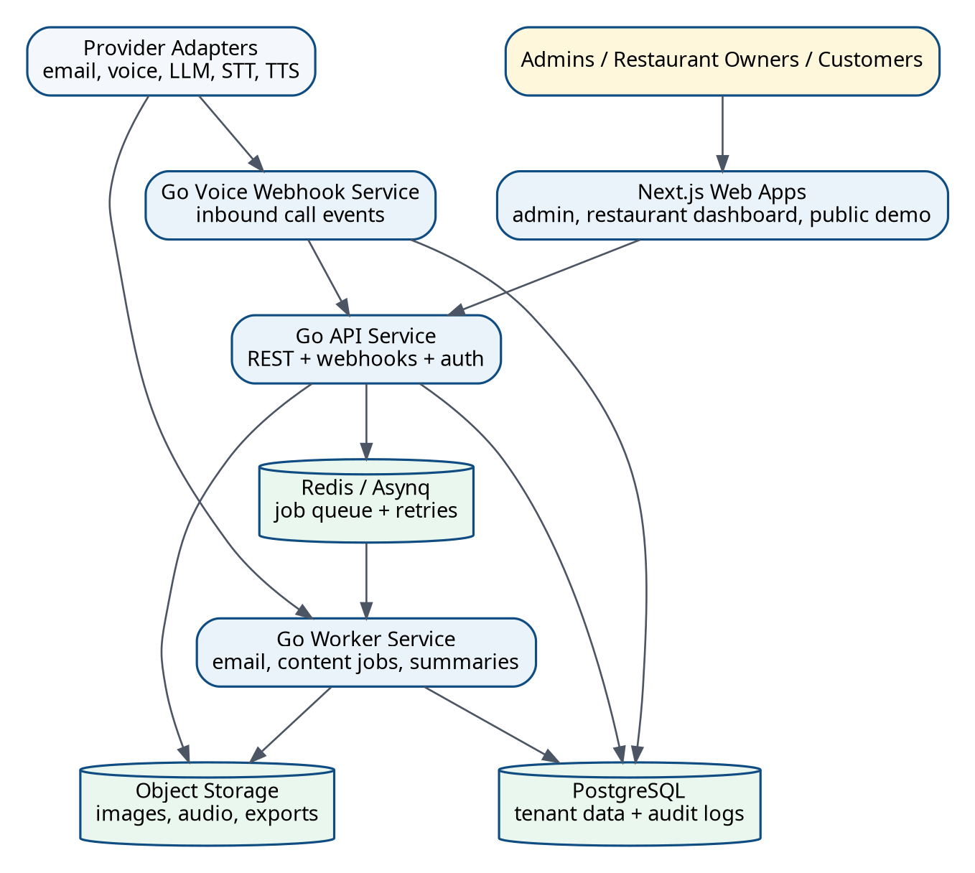
Figure 1. Go-first MVP architecture with API service, workers, webhook service, and provider adapters.

2. Recommended Backend Shape
Component | Recommended choice | Reason
API service | Go, chi/Gin/Fiber or standard net/http | Fast, reliable, simple deployment, good for webhook-heavy systems.
Database access | PostgreSQL with pgx + sqlc or Ent/go | Strong typing and explicit SQL are useful for a small team.
Migrations | Goose or Atlas | Repeatable schema changes across local/staging/prod.
Queue | Redis + Asynq for MVP; Temporal later | Email/content/call summaries need retries and delayed jobs.
Auth | Session/JWT with role-based authorization | Admin and restaurant dashboards require protected routes.
Storage | S3-compatible object storage | Images, audio recordings if enabled, generated assets, exports.
Observability | Structured logs, request IDs, metrics, error tracking | Needed for voice/email failures and client trust.

3. Modular Monolith Package Structure
Use a modular monolith so the team can move fast without microservice overhead. Clear package boundaries still make later extraction possible.
Path | Purpose
cmd/api | Main HTTP API server for dashboard, demo, reservations, and admin APIs.
cmd/worker | Background job processor for emails, content jobs, call summaries, retries.
cmd/voice-webhook | Optional separate process for phone provider webhooks if scaling/reliability requires it.
internal/restaurants | Restaurant profiles, lead status, tenant root logic.
internal/menus | Menus, categories, menu items.
internal/demos | Demo payloads, template selection, signed slugs.
internal/reservations | Reservation requests, status transitions, notifications.
internal/campaigns | Email sequences, steps, opt-outs, tracking events.
internal/ai | LLM prompts, provider adapters, evaluation helpers.
internal/voice | Inbound call sessions, transcripts, call summaries, escalation.
internal/content | Prompt-to-caption/script workflows.
internal/analytics | Event ingestion and funnel metrics.
internal/platform | Auth, config, logging, database, queue, storage, errors.

4. Deployment Model
- MVP deployment: one frontend deployment, one Go API container, one Go worker container, managed Postgres, managed Redis, object storage.
- Staging required: all email/voice/AI integrations must be validated in staging before production.
- Separate provider credentials: never reuse production email/voice/LLM keys in local or staging.
- Webhook reliability: webhook endpoints must verify signatures where providers support it and log request IDs.
- Rollback: deployment must support reverting the API and frontend without data loss.

5. Engineering Decisions
Decision | Recommendation | Why
Database per tenant? | No for MVP; use one multi-tenant DB with restaurant_id. | Simpler operations for a two-developer team.
AI-generated full websites? | No for MVP; use templates + AI-assisted copy. | More reliable design quality and faster generation.
Payload in URL? | No; use signed slug/token referencing DB payload. | Safer, shorter, auditable.
Outbound AI calling? | No for Phase 1. | Compliance and reputation risk.
Microservices? | No; modular monolith first. | Lower overhead and faster iteration.
Provider lock-in? | Avoid through adapter interfaces. | Allows cost/quality optimization later.

