PHASE 1 v2
Data Model, APIs, and Integration Contracts
Core tables, API contracts, event taxonomy, and provider integration boundaries.

Document ID | P1V2-05
Version | 2.0 - Enhanced after Phase 1 review
Prepared for | Internal founding team
Target niche | Independent restaurants, cafes, and small restaurant groups
Primary backend language | Golang for backend services and workers; Next.js/TypeScript for web UI

Core principle: validate demand through personalized demos before building a full SaaS platform.

1. Data Model Overview
The restaurant is the tenant root. Every important record should include restaurant_id or a clear relationship to a restaurant. This simplifies permissions, analytics, and future billing.

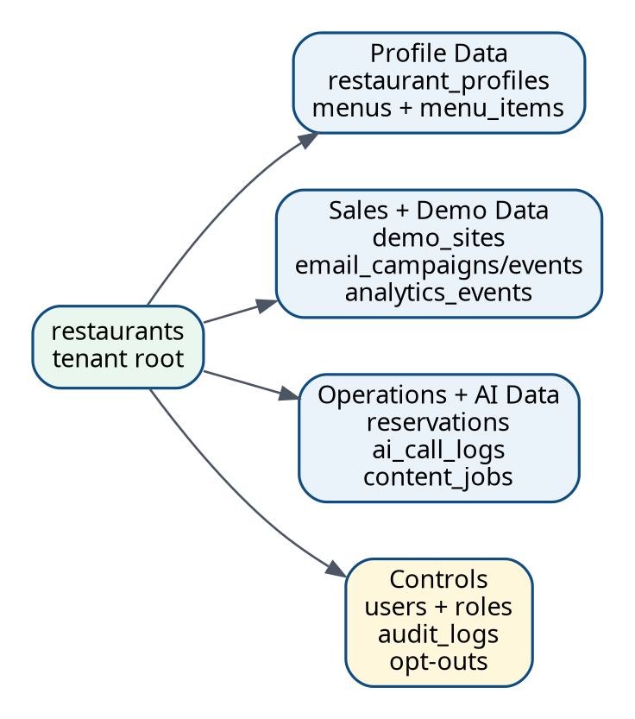
Figure 1. Core Phase 1 data map.

2. Core Tables
Table | Purpose | Important fields
restaurants | Tenant root and lead/client status. | id, name, cuisine_type, phone, email, address, website_url, status, lead_score, created_at.
restaurant_profiles | Extended restaurant context. | restaurant_id, description, opening_hours_json, reservation_policy, parking_info, approved_context_json.
menus | Menu grouping. | id, restaurant_id, name, status.
menu_items | Individual menu items. | menu_id, name, description, price, category, image_url, is_verified.
demo_sites | Public demo records. | restaurant_id, slug, signed_token_hash, template_id, payload_json, status, expires_at.
reservations | Reservation requests. | restaurant_id, customer_name, phone, email, date, time, party_size, status, source.
email_campaigns | Outreach sequences. | restaurant_id, sequence_type, status, current_step, opt_out_at.
email_events | Email and link tracking. | campaign_id, event_type, metadata_json, event_time.
ai_call_logs | AI receptionist call data. | restaurant_id, caller_phone_hash, transcript, summary, intent, escalation_required, reservation_id.
content_jobs | Content generation jobs. | restaurant_id, prompt, output_caption, output_script, status, review_status.
analytics_events | Product and funnel events. | restaurant_id, event_type, actor_type, metadata_json, occurred_at.
audit_logs | Internal/admin changes. | actor_id, entity_type, entity_id, action, before_json, after_json.

3. Demo Payload Contract
The demo payload should be a server-side JSON object generated from reviewed restaurant data. Public URLs should not contain the full payload.
Field | Description | Required
restaurant.name | Public restaurant name shown on demo. | Yes
restaurant.cuisine_type | Used for copy and template selection. | Yes
restaurant.address | Shown in location section. | Yes
restaurant.phone | Used for call CTA; can be omitted if unknown. | No
restaurant.hours | Opening hours JSON. | Recommended
menu.categories | Grouped menu sections. | Recommended
theme.template_id | Selected website template. | Yes
theme.colors | Optional theme color hints. | No
sections.ai_receptionist | Missed-call upsell demo copy. | Yes
sections.content_automation | Prompt-to-content sample. | Yes
disclaimer | Demo/non-approved content disclaimer. | Yes

4. API Surface
Area | Endpoint | Purpose
Restaurants | POST /api/restaurants | Create lead/client record.
Restaurants | GET /api/restaurants?status= | List leads by funnel status.
Restaurants | PUT /api/restaurants/{id} | Update profile and status.
Menus | POST /api/restaurants/{id}/menus | Create menu.
Menus | POST /api/menus/{id}/items | Add item.
Demos | POST /api/restaurants/{id}/demo-sites | Generate demo payload and slug.
Demos | GET /api/demo-sites/{slug} | Public demo payload for frontend render.
Reservations | POST /api/restaurants/{id}/reservations | Create reservation request.
Reservations | PUT /api/reservations/{id}/status | Confirm/reject/contacted.
Campaigns | POST /api/restaurants/{id}/campaigns | Create outreach sequence.
Campaigns | POST /api/campaigns/{id}/send-step | Send or schedule email step.
Tracking | POST /api/events | Track demo views/CTA clicks.
Voice | POST /api/voice/inbound | Phone provider inbound webhook.
Content | POST /api/restaurants/{id}/content-jobs | Generate content draft.

5. Event Taxonomy
Event | When fired | Used for
lead.created | Restaurant lead added. | Lead funnel metrics.
demo.generated | Demo payload/slug created. | Operational throughput.
demo.viewed | Public demo opened. | Sales signal.
demo.cta_clicked | Owner clicks AI/reservation/content CTA. | Lead prioritization.
email.sent | Email step sent. | Campaign health.
email.opted_out | Lead opts out. | Compliance and suppression.
reservation.created | Customer/AI creates reservation request. | Operational value proof.
ai_call.completed | Inbound AI call ended. | Call quality review.
content.generated | Content job completed. | Usage and cost analysis.

6. Integration Contracts
- Email provider adapter must support send, event webhook parsing, suppression/opt-out, and delivery error logging.
- Voice provider adapter must support inbound call webhook, call session ID, transcript events, and completion callbacks.
- LLM provider adapter must support prompt execution, model metadata, token/cost logging, retries, and output validation.
- Storage adapter must support upload, signed read URLs when needed, delete/retention policy, and content type validation.
- All provider webhooks should be idempotent using provider event IDs.

