PHASE 1 v2
AI Receptionist, Reservations, and Content Automation
Bounded AI receptionist, reservation capture, content automation, and AI evaluation.

Document ID | P1V2-06
Version | 2.0 - Enhanced after Phase 1 review
Prepared for | Internal founding team
Target niche | Independent restaurants, cafes, and small restaurant groups
Primary backend language | Golang for backend services and workers; Next.js/TypeScript for web UI

Core principle: validate demand through personalized demos before building a full SaaS platform.

1. AI Receptionist MVP
The AI receptionist should be a bounded inbound assistant, not a fully autonomous restaurant operator. It should disclose that it is an AI assistant, answer only from approved restaurant data, and escalate when unsure.

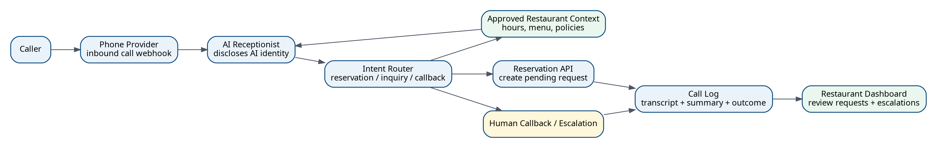
Figure 1. Inbound AI receptionist flow with reservation and escalation paths.

2. Supported AI Receptionist Intents
Intent | MVP behavior | Fallback
Hours | Answer using approved opening hours. | Offer callback if holiday/special hours are unknown.
Location/parking | Provide address and approved parking notes. | Offer to send details by SMS/email later if implemented.
Menu questions | Answer only from reviewed menu data. | Say it does not have that detail and offer callback.
Reservation request | Collect name, phone, date, time, party size, notes; create pending request. | Escalate if request is complex or party size exceeds policy.
Callback request | Collect caller name, phone, reason, preferred time. | Notify restaurant owner/admin.
Unsupported task | Politely decline or offer human follow-up. | Escalate.

3. AI Receptionist Guardrails
- Always disclose AI identity at the beginning of the call.
- Do not claim a reservation is confirmed unless the restaurant has configured instant confirmation.
- Do not invent prices, allergen guarantees, dietary claims, promotions, or availability.
- Repeat key reservation details before creating the request.
- Escalate when caller is angry, asks for a manager, requests refunds, or asks about employment/legal/medical/allergy guarantees.
- Log transcript, summary, intent, outcome, and escalation flag.

4. Reservation Capture Rules
Rule | Phase 1 recommendation
Status | All reservations start as pending unless a restaurant explicitly enables instant confirmation later.
Required fields | Name, phone, date, time, party size. Email and notes optional.
Notifications | Send owner/admin notification by email initially; SMS later.
Double booking | Phase 1 does not guarantee table availability; dashboard must make status clear.
Source tracking | Every reservation should store source: demo_site, live_site, ai_call, admin, manual.

5. Content Automation MVP
Content automation should start with useful drafts, not fully autonomous video production. The first useful output is a caption, hashtags, short video script, scene list, and CTA tailored to the restaurant.
Step | Description | Output
Prompt intake | Owner/admin enters content idea. | Prompt and goal.
Context assembly | System loads restaurant cuisine, menu, brand tone, offers. | Prompt context.
Draft generation | LLM generates caption, hashtags, and video script. | Content draft.
Safety review | Validate no unsupported offers, prices, claims, or banned content. | Review status.
Approval/copy | Owner/admin copies or approves draft. | Usable content.

6. AI Evaluation Checklist
- Create at least 25 scripted AI receptionist test calls before production pilot.
- Measure task success, wrong answer rate, fallback rate, reservation completion rate, and average call cost.
- Create at least 20 content prompts across cuisines and offers to test tone and safety.
- Store model/provider name, prompt version, and output version for debugging.
- Use human review before any AI-generated content appears in outreach or client-facing deliverables.

7. Prompt Contract Pattern
Prompts should be versioned and treated like product code. Each prompt should have purpose, allowed inputs, refusal rules, output schema, and evaluation cases.
Prompt field | Example
prompt_id | ai_receptionist_intent_router_v1
goal | Classify caller intent into reservation, hours, menu, location, callback, unsupported.
inputs | Transcript so far, restaurant approved context, caller metadata if available.
output schema | intent, confidence, next_question, escalation_required, reason.
refusal rule | If context is missing or confidence is low, choose callback/escalation.
eval set | Scripted calls and expected outputs stored in repository.

