PHASE 1 v2
Sprint Plan, Developer Split, and Runbook
Six-week execution plan, owner split, rituals, release loop, and founder sales runbook.

Document ID | P1V2-08
Version | 2.0 - Enhanced after Phase 1 review
Prepared for | Internal founding team
Target niche | Independent restaurants, cafes, and small restaurant groups
Primary backend language | Golang for backend services and workers; Next.js/TypeScript for web UI

Core principle: validate demand through personalized demos before building a full SaaS platform.

1. Developer Responsibility Split

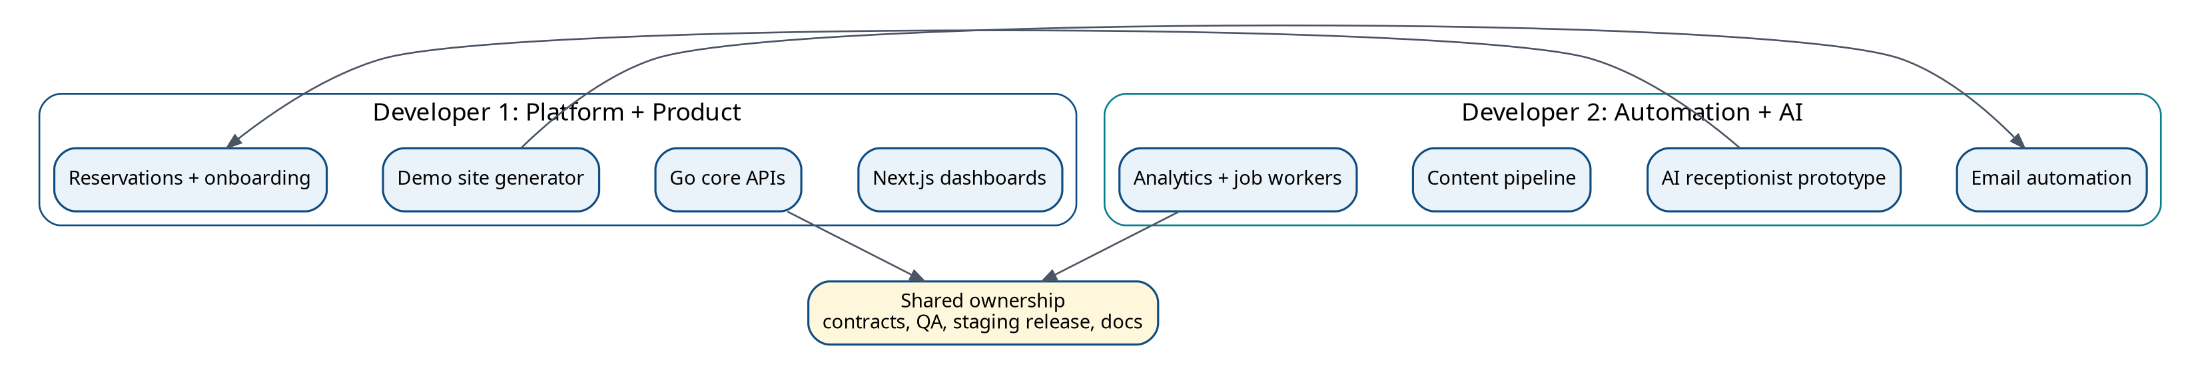
Figure 1. Two-developer ownership model.

Developer | Owns | Secondary support
Developer 1 | Frontend, Go core API, restaurant/menu/demo/reservation, dashboards, deployment. | Analytics UI, client onboarding, QA.
Developer 2 | Email automation, AI receptionist, content automation, Go workers, provider adapters, analytics events. | Backend contracts, dashboard integration, QA.

2. Six-Week Execution Plan
Week | Theme | Developer 1 | Developer 2 | Exit criteria
1 | Foundation | Repo, Go API, Postgres, auth skeleton, restaurant CRUD. | Provider adapter interfaces, campaign model, AI flow design, analytics model. | Local/staging foundation works; restaurant lead can be created.
2 | Demo core | Menu CRUD, demo payload generator, first template, public slug route. | Email templates, preview flow, tracking events. | Admin can generate and preview personalized demo.
3 | Outreach and reservations | Reservation API/form/dashboard. | Email sending, click tracking, follow-up sequence. | Tracked email opens/clicks and reservation submissions work in staging.
4 | AI receptionist pilot | Reservation dashboard polish, owner dashboard shell. | Inbound voice sandbox, intent router, reservation from call, call summaries. | Scripted AI call can create pending reservation.
5 | Content and onboarding | Client onboarding checklist, live-site conversion flow. | Content generation job/API/UI, content safety review, analytics dashboard. | Demo can become client record; content draft works.
6 | QA and sales readiness | Mobile polish, deployment hardening, release checklist. | AI/content evals, email compliance checklist, demo campaign reporting. | Founders can confidently show MVP to real restaurants.

3. Weekly Rituals
- Monday planning: select tickets that directly support demo generation, outreach, reservations, or sales readiness.
- Daily 15-minute sync: blockers, decisions, and integration points only.
- Wednesday integration check: merge and test frontend/backend/provider flows; avoid end-of-week integration surprises.
- Friday demo: show working software, not slides; record gaps and next-week priorities.
- End-of-week retro: decide what to cut, simplify, or defer based on validation goals.

4. Definition of Done
- Acceptance criteria are met and tested locally.
- Feature works in staging with staging credentials.
- Input validation and error handling are implemented.
- User-facing UI handles empty/loading/error states.
- Structured logs include request/job IDs without leaking sensitive data.
- Critical paths have basic tests or documented smoke tests.
- Feature is included in the release checklist if client-facing.
- Documentation and runbook are updated.

5. Founder Sales Runbook
- Build a list of 50 high-fit restaurants using the lead score model.
- Create and manually review 10 demo sites before sending any email.
- Send in small batches of 5-10 emails to protect reputation and learn from responses.
- Prioritize leads with clicks, CTA interactions, or replies.
- Use sales calls to validate whether website, reservations, AI receptionist, or content is the strongest pain.
- Offer a paid pilot or setup package immediately when pain is clear.
- Update product roadmap only from repeated sales evidence, not isolated requests.

6. Release Loop

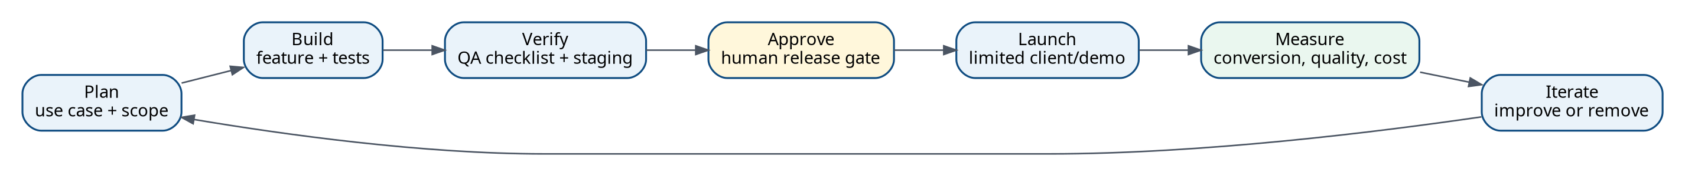
Figure 2. Phase 1 release loop with explicit approval and measurement gates.

