**Power BI Assignment 2**

1. Explain the advantages of Natural Queries in PowerBi with an example?

Sometimes the fastest way to get an answer from your data is to perform a search over your data using natural language.

The Q&A feature in Power BI lets you explore your data in your own words by using natural language. Q&A is interactive, even fun.

Asking the question is just the beginning. Travel through your data, refining or expanding your question, uncovering new information, zeroing in on details, or zooming out for a broader view.

* **Autocomplete**

As you type your question, Power BI Q&A shows relevant and contextual suggestions to help you quickly become productive with natural language.

As you type, you get immediate feedback and results. The experience is similar to typing in a search engine. For Example.

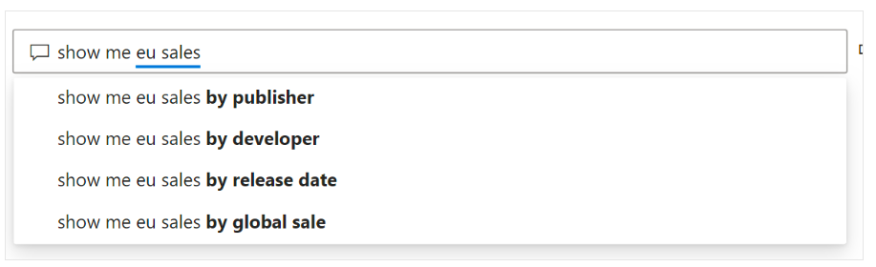

* **Red/Blue/Orange underlines**

Q&A shows words with underlines to help you see which words the system recognized or didn't recognize. A solid blue underline indicates that the system successfully matched the word to a field or value in the data-model.

The following example shows that Q&A recognized the words *EU Sales*.

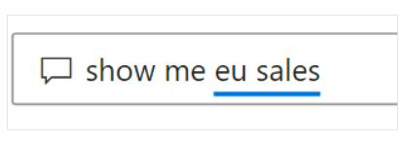

An orange dotted underline indicates that the word or phrase is categorized as *low confidence*. If you enter a vague or ambiguous word, the field is underlined in orange dots. An example could be the word 'Sales'.

Multiple fields could contain the word 'Sales', so the system uses an orange dotted underline to prompt you to choose the field you mean.

A red double-underline means Q&A didn't recognize the word at all. You could encounter this issue by using a domain-specific term that isn't mentioned anywhere in the data, or the data fields are incorrectly named. An example could be using the word 'Costs' if the word doesn't exist anywhere in the data. The word is in the English dictionary, but Q&A marks this term with a red double-underline to indicate it can't find this term in the data.

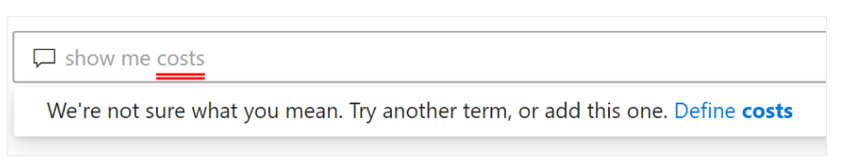

* **Visualization results**

As you enter your question, Q&A tries to instantly interpret and visualize the answer. As part of the latest updates, Q&A now tries to interpret the question and plot the fields automatically to the correct axis.

For example, if you enter 'Sales by year', Q&A detects that year is a date field and always prioritizes placing this field on the X axis. If you want to change the visualization type, enter 'as chart type' after the question.

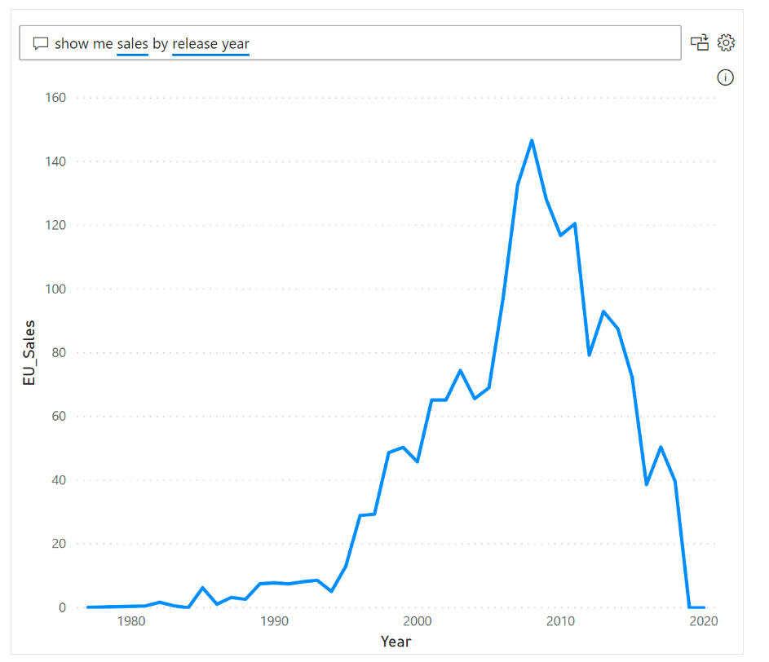

1. Explain Web Front End(WFE) cluster from Power BI Service Architecture?

The WFE cluster provides the user's browser with the initial HTML page contents on site load, as well as pointers to CDN content used to render the site in the browser.

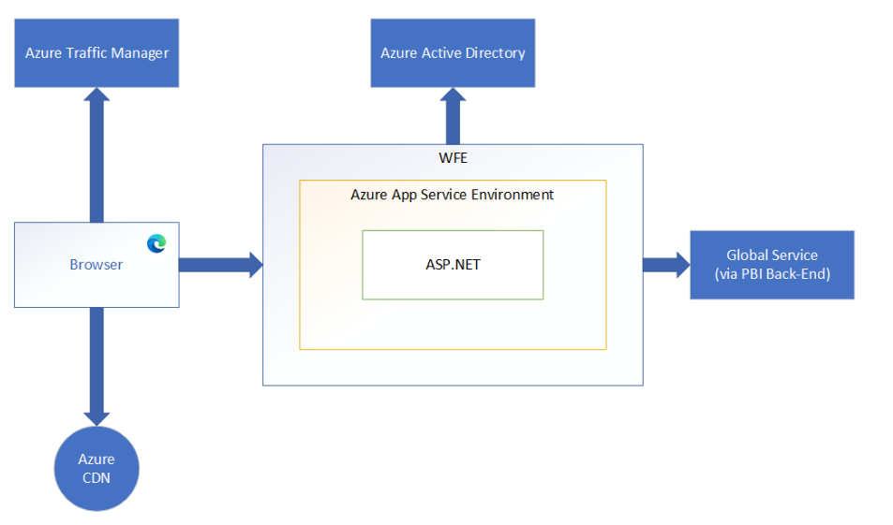

A WFE cluster consists of an ASP.NET website running in the Azure App Service Environment.

When users attempt to connect to the Power BI service, the client's DNS service may communicate with the Azure Traffic Manager to find the most appropriate (usually nearest) datacenter with a Power BI deployment.

Static resources such as *.js, *.css, and image files are mostly stored on Azure Content Delivery Network (CDN) and retrieved directly by the browser.

1. Explain Back End cluster from Power BI Service Architecture?

The back-end cluster is the backbone of all the functionality available in Power BI.

It consists of several service endpoints consumed by Web Front End and API clients as well as background working services, databases, caches, and various other components.

The back end is available in most Azure regions, and is being deployed in new regions as they become available.

A single Azure region hosts one or more back-end clusters that allow unlimited horizontal scaling of the Power BI service once the vertical and horizontal scaling limits of a single cluster are exhausted.

Each back-end cluster is stateful and hosts all the data of all the tenants assigned to that cluster. A cluster that contains the data of a specific tenant is referred to as the tenant's home cluster. An authenticated user's home cluster information is provided by Global Service and used by the Web Front End to route requests to the tenant's home cluster.

Each back-end cluster consists of multiple virtual machines combined into multiple resizable-scale sets tuned for performing specific tasks, stateful resources such as SQL databases, storage accounts, service buses, caches, and other necessary cloud components.

Tenant metadata and data are stored within cluster limits except for data replication to a secondary back-end cluster in a paired Azure region in the same Azure geography. The secondary back-end cluster serves as a failover cluster in case of regional outage, and is passive at any other time.

Back-end functionality is served by micro-services running on different machines within the cluster's virtual network that are not accessible from the outside, except for two components that can be accessed from the public internet:

1. Gateway Service
2. Azure API Management

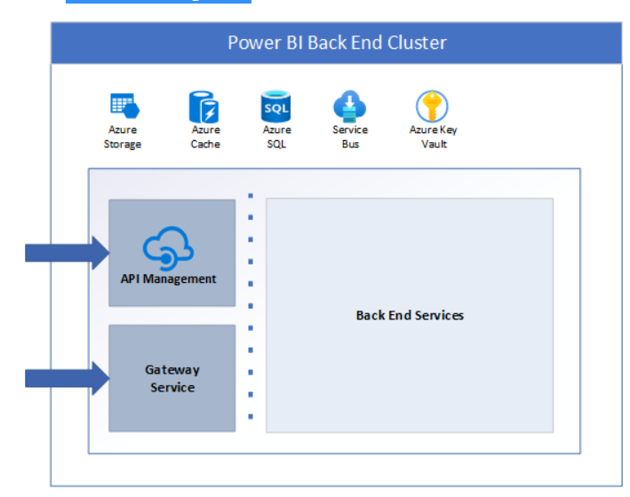

1. What ASP.NET component does in Power BI Service Architecture?

ASP.NET is a free web framework for building great websites and web applications using HTML, CSS, and JavaScript. You can also create Web APIs and use real-time technologies like Web Sockets.

In power BI Architecture , the WFE cluster provides the user's browser with the initial HTML page contents on site load, as well as pointers to CDN content used to render the site in the browser. A WFE cluster consists of an ASP.NET website running in the Azure App Service Environment.

1. Compare Microsoft Excel and PowerBi Desktop on the following features:

|  |  |  |
| --- | --- | --- |
|  | Microsoft Excel | PowerBi Desktop |
| Data import | Microsoft Excel has very limited type of data source option. Form where data can be imported. | Power BI has a wide variety of data source options to load the data . We can import many types of data as compared to Excel |
| Data transformation | Excel itself has vast number of functions that allows to transform the data. | Power Bi uses Power query editor to transform the data . |
| Modeling | Excel is having ability to work on simple and structured data models | Power bi is having ability to build more complex structures on top of it. |
| Reporting | Excel reports are normal and ordinary comparing to Powerbi.  Excel reports are available to specific limited users | Powerbi offers beautiful branded reports compared to Excel.  Reports are available to broad level users |
| Server Deployment | Cloud | Power BI report can be deployed in Azure VMs if licensed thorugh PowerBI premium |
| Convert Models | Excel totally focused on structured and simple data models with wide range of features. | Powerbi really focused on data ingest and building potentially complex data models easily. |
| Cost | Microsoft excel comes with Microsoft Office tools mostly free with buying laptops which are having Windows as operating system. | Power bI desktop is free to download and use for personal use but it takes $10 per month per user to share reports with others. |

6. List 20 data sources supported by Power Bi desktop.

**File data sources**

The File category provides the following data connections:

* Excel Workbook
* Text/CSV
* XML
* JSON
* Folder
* PDF
* Parquet
* SharePoint folder

**Database data sources**

The Database category provides the following data connections:

* SQL Server database
* Access database
* SQL Server Analysis Services database
* Oracle database
* IBM Db2 database
* IBM Informix database (Beta)
* IBM Netezza
* MySQL database
* PostgreSQL database
* Sybase database
* Teradata database
* SAP HANA database
* SAP Business Warehouse Application Server
* SAP Business Warehouse Message Server
* Amazon Redshift
* Impala
* Google BigQuery
* Google BigQuery (Azure AD)(Beta)
* Vertica
* Snowflake
* Essbase
* Actian (Beta)
* Amazon Athena
* AtScale cubes
* BI Connector
* Data Virtuality LDW
* Denodo
* Dremio Software
* Dremio Cloud (Beta)
* Exasol
* Indexima
* InterSystems IRIS (Beta)
* Jethro (Beta)
* Kyligence
* Linkar PICK Style / MultiValue Databases (Beta)
* MariaDB
* MarkLogic
* TIBCO® Data Virtualization