**Power BI Assignment 3**

1. List and explain different PowerBi products?

Microsoft Power BI is a collection of tools used to import, aggregate and present data in the form of immersive and easy-to-digest reports and visuals.

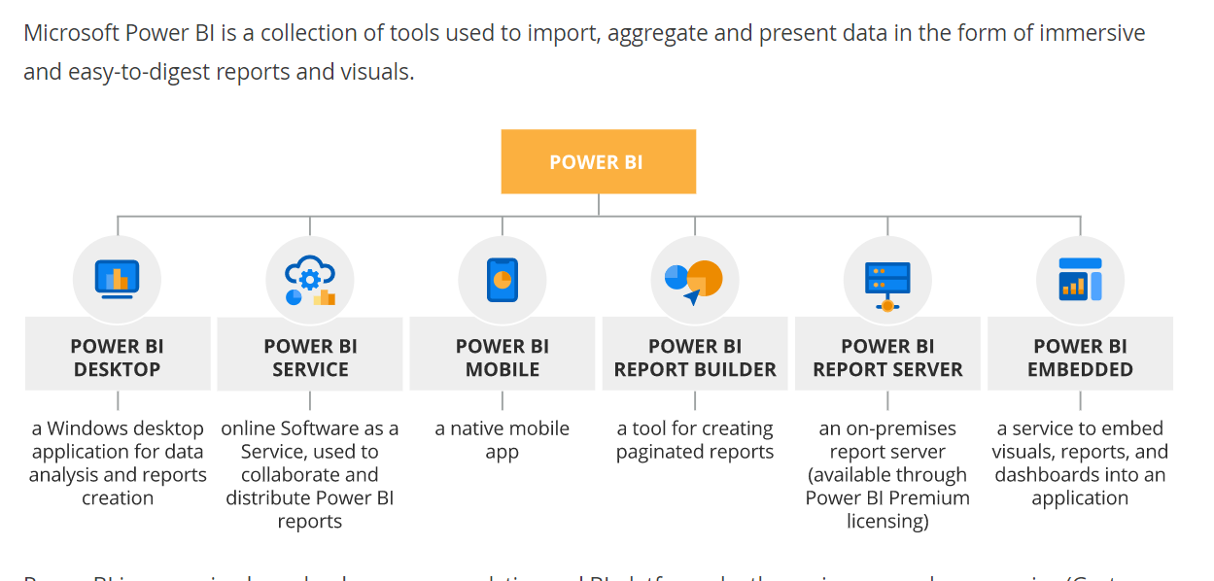

**Power BI Desktop**

* Creating and editing customized reports for every level of expertise.
* Data ingestion from hundreds of supported data sources.
* Data transformation, cleaning, data model creation with built-in Power Query Editor.
* AI-driven analytics.
* Interactive reporting with pre-built or custom visuals.

**Power BI Mobile**

* These days, all business software needs to be mobile compatible.
* Fortunately, you can access Power BI on Windows, Android and iOS devices with the corresponding app.
* The functionalities aren’t quite as extensive, but you have everything you need for indexing data and creating reports on the move.
* Create mobile-optimized dashboards and reports with interactive drill-down/up capabilities.

**Power BI Report Server**

* The report server hosts Power BI reports on-premises. One can share reports and collaborate with other users by using the on-premises report server. Also, it has the unique capability to deploy and use mobile reports (.rsmobile), paginated reports (.rdl) and KPIs.
* It can render custom visualizations. Users hosting their Power BI reports on this on-premises server gets an added 100 custom visuals to the default ones.
* Users can connect to the this from Power BI Mobile. They can access reports from the report server easily. Presently, the report server is supported by iOS, Android, Windows mobile platforms.
* From the on-premises report server, users can access and interact with reports on a web platform. They can use and apply actions like cross-filtering, tooltips, slicers, data exploration, etc.
* Users can export data from reports hosted on a Report Server to a CSV format file.

**Power BI Pro**

* Self-service BI in the cloud.
* Creating, editing and sharing reports and dashboards among users.
* Collaboration in personal and team workspaces.
* 10 GB of storage per user.

**Power BI Premium**

* Enterprise BI both on-premises and in the cloud.
* Dedicated storage (100 TB) and compute resources.
* Consumption of Power BI content without individual licensing.
* Maintaining BI assets on-premises with the Power BI Report server.
* Paginated reporting.
* Multi-geo capability.

**Power BI Embedded**

* Reports, dashboards and visual analytics embedded into applications.
* An extensive library of data connectors, APIs, and fully documented SDKs.

1. What limitations of Excel, Microsoft solved by PowerBi?
2. Excel is used to organize data, transform it and perform mathematical operations and calculations. On the other hand, Power BI was conceived as a business intelligence and data visualization tool for businesses.
3. Excel has limitations in the amount of data it can work with. In contrast, Power BI can handle much larger amounts of data.
4. Power BI can connect to a large number of data sources, while Excel's connectivity capacity is limited. Also, unlike Excel, Power BI can be easily used from mobile devices.
5. Power BI has faster processing than Excel.
6. Power BI dashboards are more visually appealing, interactive and customizable than those in Excel.
7. Power BI is a more powerful tool than Excel in terms of comparison between tables, reports or data files.
8. Power BI is more user friendly and easy to use than Excel.
9. Explain PowerQuery?

* Power Query is a data transformation and data preparation engine.
* Power Query comes with a graphical interface for getting data from sources and a Power Query Editor for applying transformations.
* Because the engine is available in many products and services, the destination where the data will be stored depends on where Power Query was used.
* Using Power Query, one can perform the extract, transform, and load (ETL) processing of data.

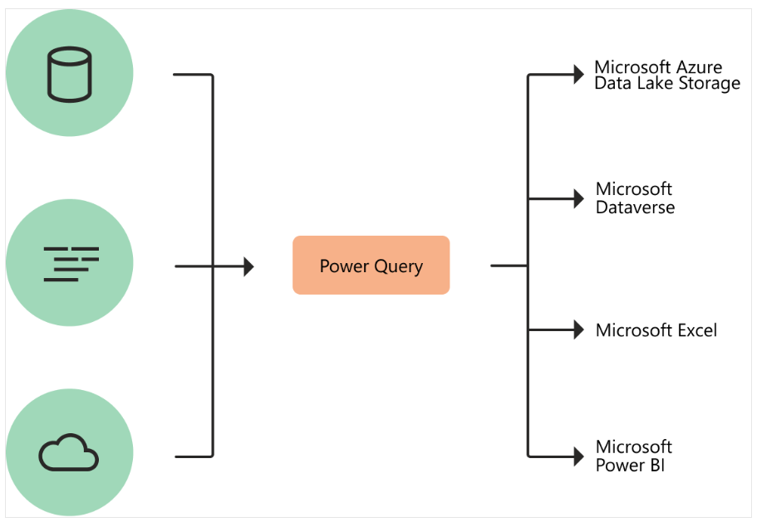

How Power Query helps with data acquisition :

* Power Query enables connectivity to a wide range of data sources, including data of all sizes and shapes.
* Consistency of experience, and parity of query capabilities over all data sources.
* Highly interactive and intuitive experience for rapidly and iteratively building queries over any data source, of any size.
* Power Query offers the ability to work against a subset of the entire dataset to define the required data transformations, allowing you to easily filter down and transform your data to a manageable size.
* Power Query queries can be refreshed manually or by taking advantage of scheduled refresh capabilities in specific products (such as Power BI) or even programmatically (by using the Excel object model).

Power Query experiences :

* The Power Query user experience is provided through the Power Query Editor user interface. The goal of this interface is to help to apply the transformations by interacting with a user-friendly set of ribbons, menus, buttons, and other interactive components.
* When we create a new transformation step by interacting with the components of the Power Query interface, Power Query automatically creates the M code required to do the transformation so don't need to write any code.

Currently, two Power Query experiences are available:

* **Power Query Online** — Found in integrations such as Power BI dataflows, Microsoft Power Platform dataflows, Azure Data Factory wrangling dataflows, and many more that provide the experience through an online webpage.
* **Power Query for Desktop** — Found in integrations such as Power Query for Excel and Power BI Desktop.

1. Explain PowerMap?

* Microsoft Power Map is a three-dimensional (3-D) data visualization tool that lets you look at information in new ways.
* A power map lets you discover insights you might not see in traditional two-dimensional (2-D) tables and charts.
* Power Map is used to visualize geospatial data in 3D mode.
* As soon as the visualization renders in 3D mode, it provides another dimension to it.
* In Power Map, you can assume one attribute as the length of a column in 3D and another attribute as a heatmap view.
* Based on a geographical location, the data can be highlighted. Geographical locations can be a country, state, city, or street address.
* To get the best visualization, Power Map works with the Bing Maps based on the geographical latitude or longitude or a country, state, city, or street address data.

1. How powerBi eliminated the need to host SharePoint Server on premises?

* The on-premises reporting scenario is one of several hybrid and custom scenarios for deploying Power BI solutions without using the Power BI service.
* This scenario involves using Power BI Report Server, which is an on-premises portal for publishing, sharing, and consuming business intelligence content within the organizational network.
* It's useful when the organization needs an alternative to the cloud-based Power BI service for deploying some (or all) BI content.
* We can use Power BI and its content using power BI report server. For Power BI report server , some new features added which were previously available only through sharepoint server for on-premises deployment.
* Power BI provided with scheduled date refresh facility which refresh the data as per schedule
* Many organisations uses sharepoint to handle claim based authentication scenarios for their users. Power BI report sever is provided with native support for ADFS/AAD authentication.

1. Explain the updates done in Power Bi Service(power BI 2.0) as compared to older version

**Here’s an overview of the changes:**

* **Browse changes :** The left navigation links for Recent, Favorites, and Shared with me full page lists are being combined in a new Browse tab. One can still search and filter these lists, and now you can even filter by keyword.
* **Left navigation changes** : A major change coming to the left navigation pane is tooltips. Before, to see what an icon represented in the left navigation pane, you had to expand the entire menu.
* **Workspace flyout menu changes** : The My Workspace link moves below the Search box in the workspace flyout menu.
* **Get Data changes :** The Get Data experience moves from the bottom of the left navigation pane to the Create tab.
* **Improved filtering :** It’s easier to find content in these lists with a new experience for filtering by keyword and improved filtering by content type, time, and endorsement.