EV POWERTRAIN MODELING AND SIMULATION
USING MATLAB/SIMULINK

Project Report
Submitted by
RAJA SEKHAR DEVU
Simulation Tool: MATLAB/Simulink
2025

Abstract
Electric Vehicles (EVs) have become a key technology in modern transportation due to their high efficiency, reduced emissions, and improved energy utilization. This project presents the modeling and simulation of an EV powertrain using MATLAB/Simulink. The developed model includes a drive cycle, PID-based driver controller, motor and inverter subsystem, transmission, vehicle body dynamics, and battery pack model. The vehicle model incorporates realistic forces such as rolling resistance, aerodynamic drag, and road grade effects. Battery power, battery current, state of charge (SOC), and regenerative braking are analyzed under three scenarios: flat road, uphill, and downhill. Simulation results demonstrate accurate speed tracking and realistic energy consumption under all driving conditions.

1. Introduction
Electric vehicles use electrical energy stored in batteries to power traction motors. The performance of an EV critically depends on the interaction between the battery, motor drive, transmission, and vehicle dynamics. MATLAB/Simulink provides an efficient environment for developing and testing EV control strategies prior to hardware implementation.
The objective of this project is to develop a complete EV powertrain model capable of simulating vehicle motion, energy consumption, and regenerative braking under different road conditions. Three scenarios are evaluated: flat road (0° grade), uphill road (+5° grade), and downhill road (−5° grade).

2. Objectives
- Develop a complete EV powertrain model in MATLAB/Simulink
- Design a PID-based speed tracking controller
- Model vehicle longitudinal dynamics including traction, drag, and grade forces
- Include rolling resistance and aerodynamic drag
- Analyze flat road and road grade conditions (±5°)
- Calculate battery power and battery current during operation
- Estimate battery State of Charge (SOC) over the drive cycle
- Demonstrate regenerative braking operation during deceleration

3. System Architecture
The EV powertrain model consists of modular subsystems connected in a signal-flow architecture. The drive cycle generates the reference speed profile which is fed to the PID driver controller. The controller outputs a torque demand that drives the motor and inverter subsystem. The motor and inverter are represented using a simplified lumped-efficiency electric drive model. Torque is then transmitted through the gearbox to the wheels, and vehicle body dynamics calculate the resulting vehicle speed.
The battery pack subsystem takes motor torque and angular speed as inputs and calculates battery power, current, and state of charge in real time. The complete signal flow is:
Drive Cycle → Driver Controller (PID) → Motor & Inverter → Transmission → Vehicle Body → Vehicle Speed
Motor Torque + Speed → Battery Pack → Battery Power, Current, SOC

4. Mathematical Model

4.1 Traction Force
The wheel traction force is derived from the wheel torque and wheel radius:
F_traction = T_wheel / R_wheel
where T_wheel is the wheel torque (Nm) and R_wheel is the wheel radius (m).

4.2 Rolling Resistance
F_rolling = m × g × C_rr
where m is vehicle mass (kg), g = 9.81 m/s², and C_rr is the rolling resistance coefficient.

4.3 Aerodynamic Drag
F_drag = 0.5 × ρ × C_d × A × V²
where ρ is air density (1.225 kg/m³), C_d is the drag coefficient, A is frontal area, and V is vehicle speed.

4.4 Grade Force
F_grade = m × g × sin(θ)
where θ is the road grade angle. Positive θ represents uphill conditions; negative θ represents downhill.

4.5 Net Force and Vehicle Dynamics
F_net = F_traction − F_rolling − F_drag − F_grade
a = F_net / m V = ∫a dt

4.6 Battery Model
Mechanical power is computed from motor torque and angular speed. During motoring, battery power accounts for drive efficiency:
Mechanical Power = T_motor × ω_motor
Battery Power = Mechanical Power / drive efficiency
I_battery = P_battery / V_battery
SOC = SOC_init − [∫I dt / (C_battery × 3600)] × 100
Negative battery current and power values indicate regenerative braking — the motor operates as a generator, returning energy to the battery during deceleration.

5. Simulation Parameters
The following parameters were used across all three simulation scenarios:

Parameter | Value
Vehicle Mass | 1500 kg
Wheel Radius | 0.3 m
Gear Ratio | 9
Transmission Efficiency | 95%
Air Density | 1.225 kg/m³
Drag Coefficient (Cd) | 0.29
Frontal Area | 2.12 m²
Rolling Resistance Coefficient | 0.015
Battery Voltage | 400 V
Initial SOC | 90%
PID Kp | 60
PID Ki | 10
PID Kd | 0

6. Controller Design
A Proportional-Integral-Derivative (PID) controller is implemented to ensure the actual vehicle speed accurately follows the reference drive cycle profile. The controller computes torque demand based on the instantaneous speed tracking error.
The PID control law is:
u(t) = Kp·e(t) + Ki·∫e(t)dt + Kd·(de/dt)
Tuned parameters: Kp = 60, Ki = 10, Kd = 0. The derivative term is set to zero to reduce noise amplification while the proportional and integral terms provide adequate steady-state accuracy and disturbance rejection across all road conditions.

7. Simulation Scenarios
Three road conditions are simulated over a 100-second drive cycle. Each scenario uses an identical drive profile: acceleration from rest (0–30 s), constant cruising speed of approximately 17 m/s (30–60 s), and controlled deceleration to rest (60–80 s), followed by a stationary phase.

Scenario 1: Flat Road (θ = 0°)
No grade force is applied. This represents the baseline operating condition on a level road surface.

Scenario 2: Uphill Road (θ = +5°)
A positive grade angle of 5° is applied throughout the simulation, generating a significant opposing grade force that demands higher motor torque and battery power compared to flat road operation.

Scenario 3: Downhill Road (θ = −5°)
A negative grade angle of 5° is applied. The grade force now assists vehicle motion, resulting in predominantly negative motor torque and battery current. This scenario maximises regenerative braking energy recovery.

8. Results and Discussion
The following sections present MATLAB/Simulink scope outputs for each simulation scenario. Results are organised by scenario, with each set of plots covering speed tracking, torque response, battery current, battery power, and state of charge.

8.1 Scenario 1: Flat Road

8.1.1 Speed Tracking
The actual vehicle speed (blue) closely tracks the reference profile (yellow). A small lag is visible during initial acceleration due to vehicle inertia, and a minor undershoot occurs after the deceleration phase at t = 80 s. The PID controller achieves good steady-state speed accuracy during the cruising phase (30–60 s).
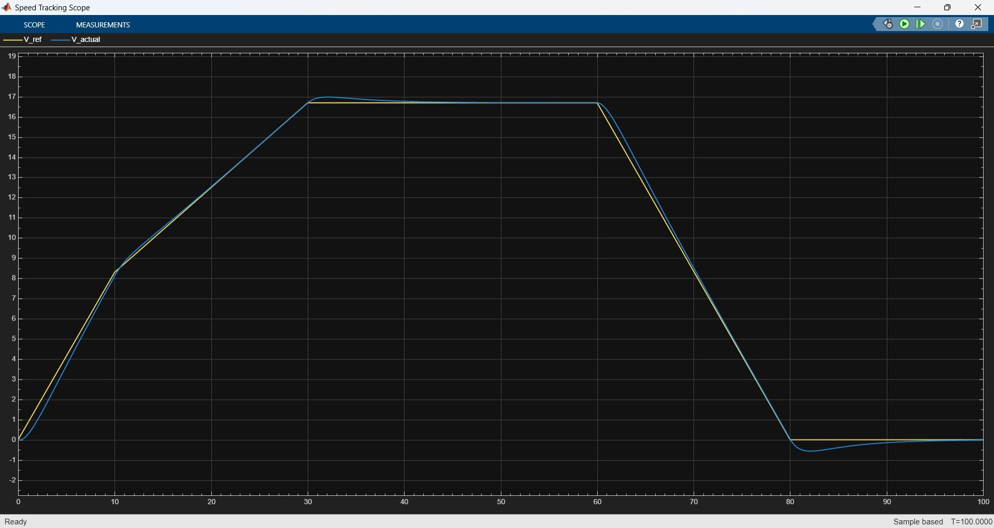
Figure 1: Flat Road — Speed Tracking (V_ref vs V_actual, m/s)

8.1.2 Torque Response
During acceleration (0–10 s), wheel torque peaks near 480 Nm as the vehicle builds speed. Torque reduces to a maintenance level (~100 Nm) during cruising. At t = 60 s, deceleration begins and torque becomes strongly negative (~−330 Nm at the wheels), indicating active regenerative braking. Motor torque (blue) mirrors the wheel torque scaled by the gear ratio.
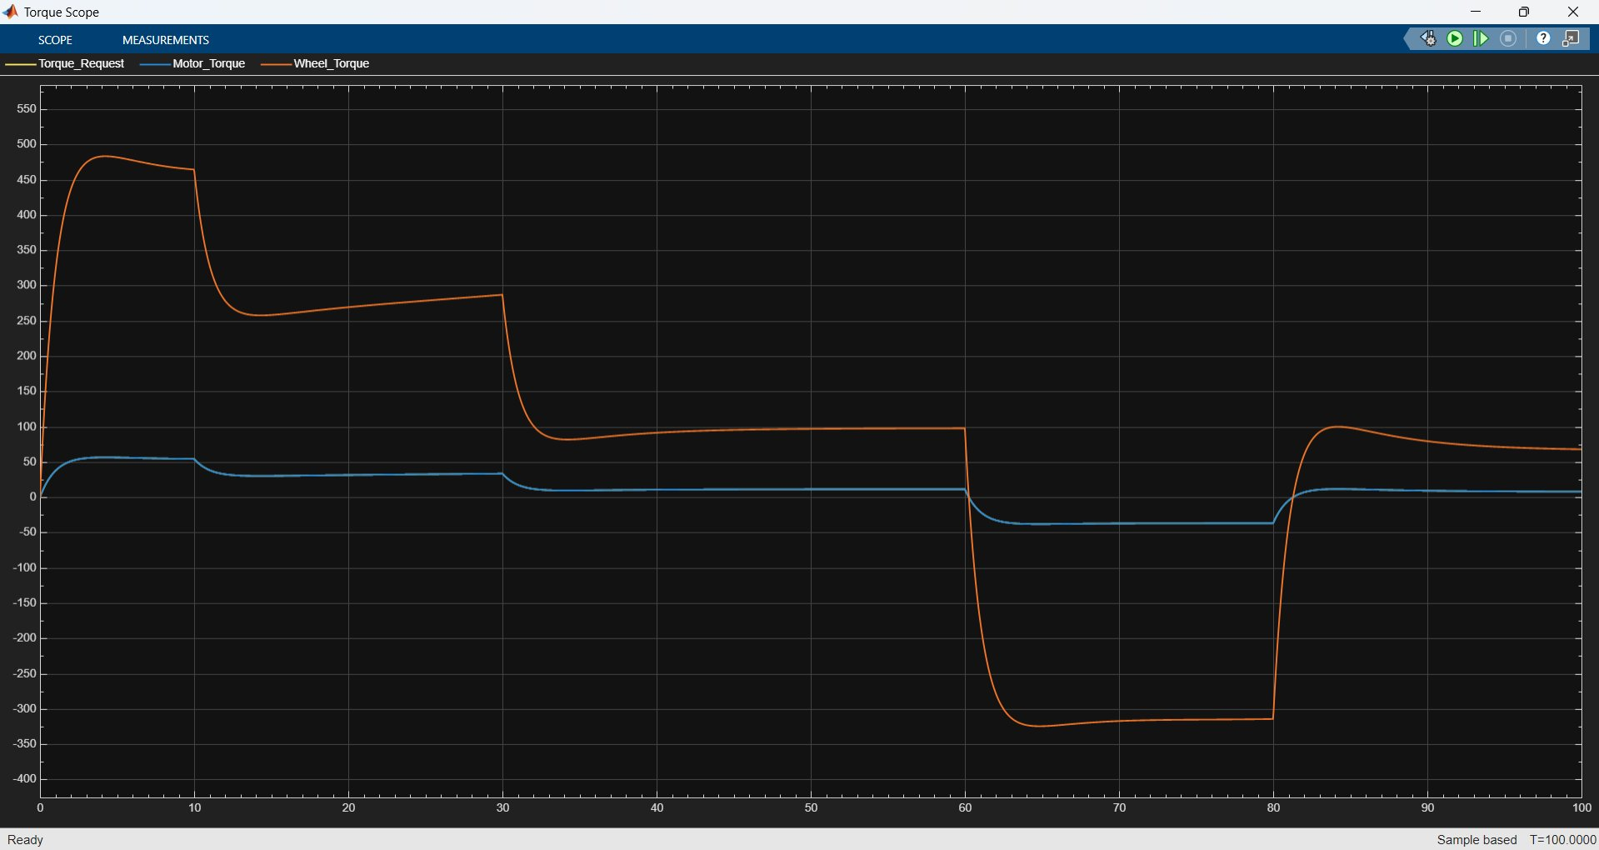
Figure 2: Flat Road — Torque Response (Torque_Request, Motor_Torque, Wheel_Torque, Nm)

8.1.3 Battery Current
Battery current peaks at approximately 44 A during the final acceleration phase before cruising. During cruising (30–60 s), current stabilises around 13 A to overcome rolling resistance and aerodynamic drag. A peak negative current of approximately −44 A is observed during braking (60–80 s), confirming successful energy recovery. Current returns to near zero at rest.
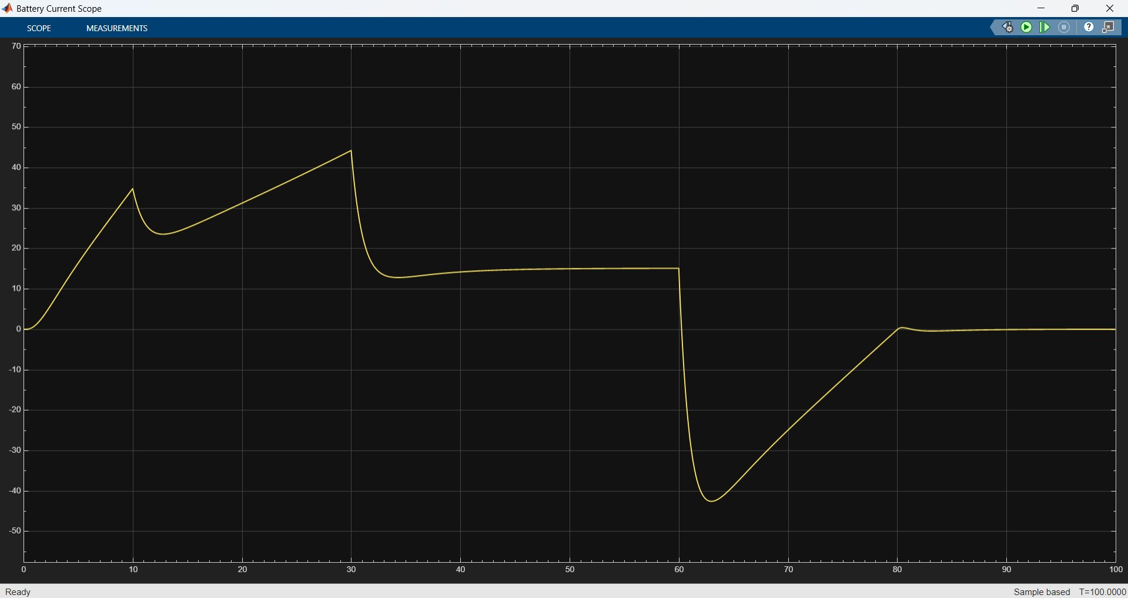
Figure 3: Flat Road — Battery Current (A)

8.1.4 Battery Power
Battery power follows the same profile as current, scaled by the 400 V bus voltage. Peak discharge power is approximately 17.5 kW, steady-state cruising power is around 5.5 kW, and peak regenerative power reaches −17 kW during braking.
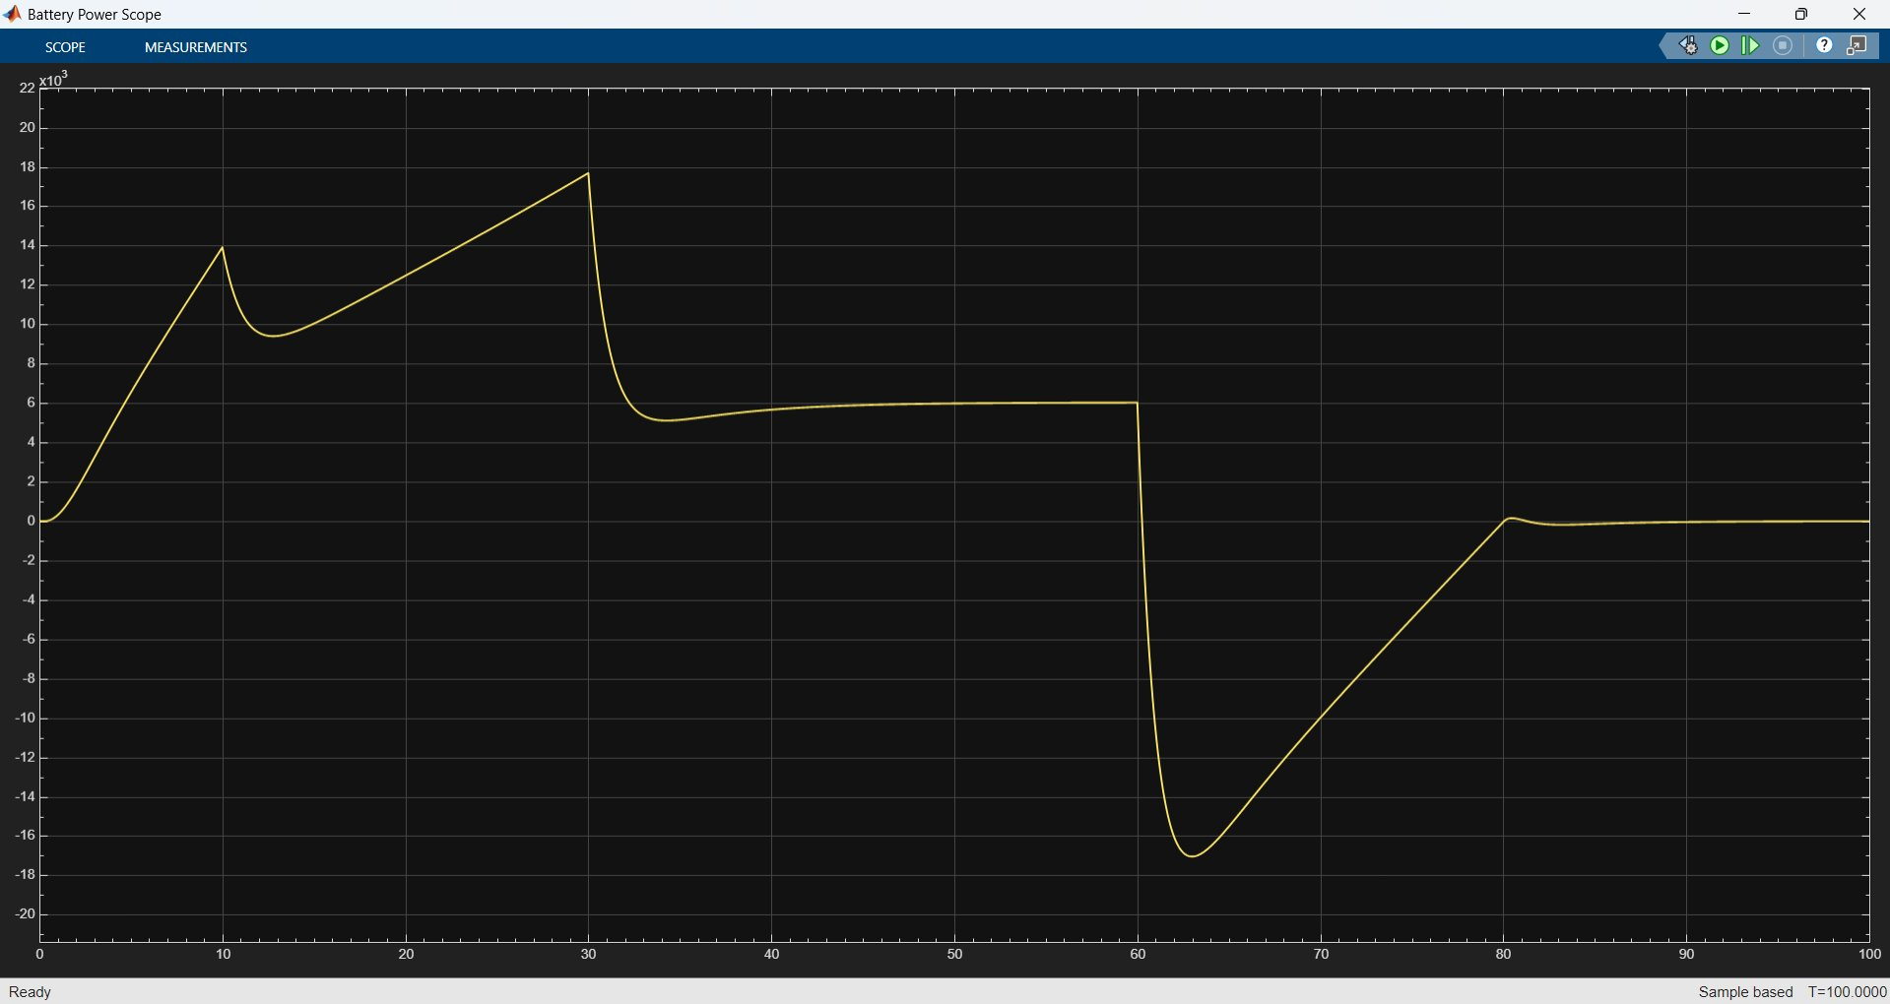
Figure 4: Flat Road — Battery Power (W, ×10³)

8.1.5 State of Charge
SOC begins at 90% and decreases gradually to approximately 89.7% by the end of the drive cycle. The slight recovery visible between t = 60–80 s corresponds to the energy returned during regenerative braking. Net energy consumption is modest, reflecting the efficient flat-road driving condition.
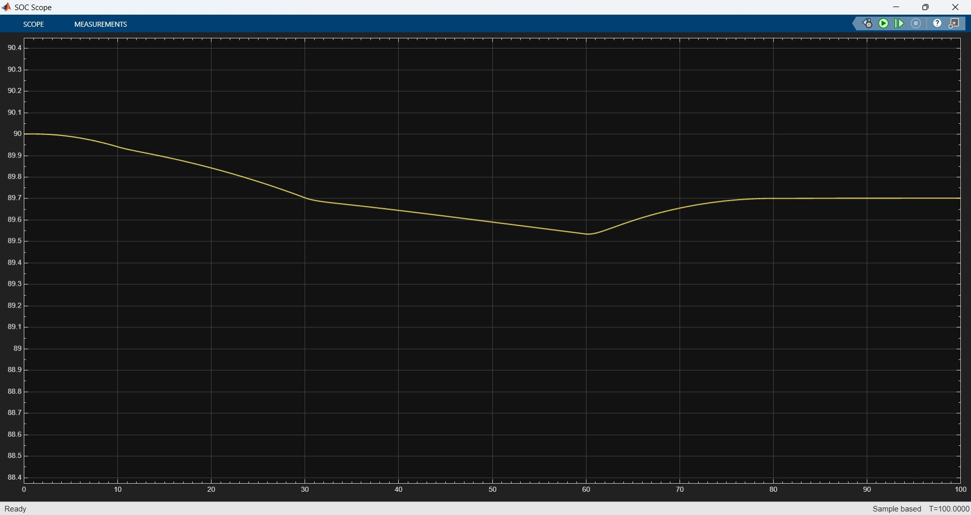
Figure 5: Flat Road — State of Charge (%)

8.2 Scenario 2: Uphill Road (+5°)

8.2.1 Speed Tracking
Speed tracking performance remains excellent on the uphill gradient. The PID controller compensates for the increased load, and the actual speed closely follows the reference throughout acceleration and cruising phases. A slight lag during initial acceleration is consistent with the greater torque demand at low speed.
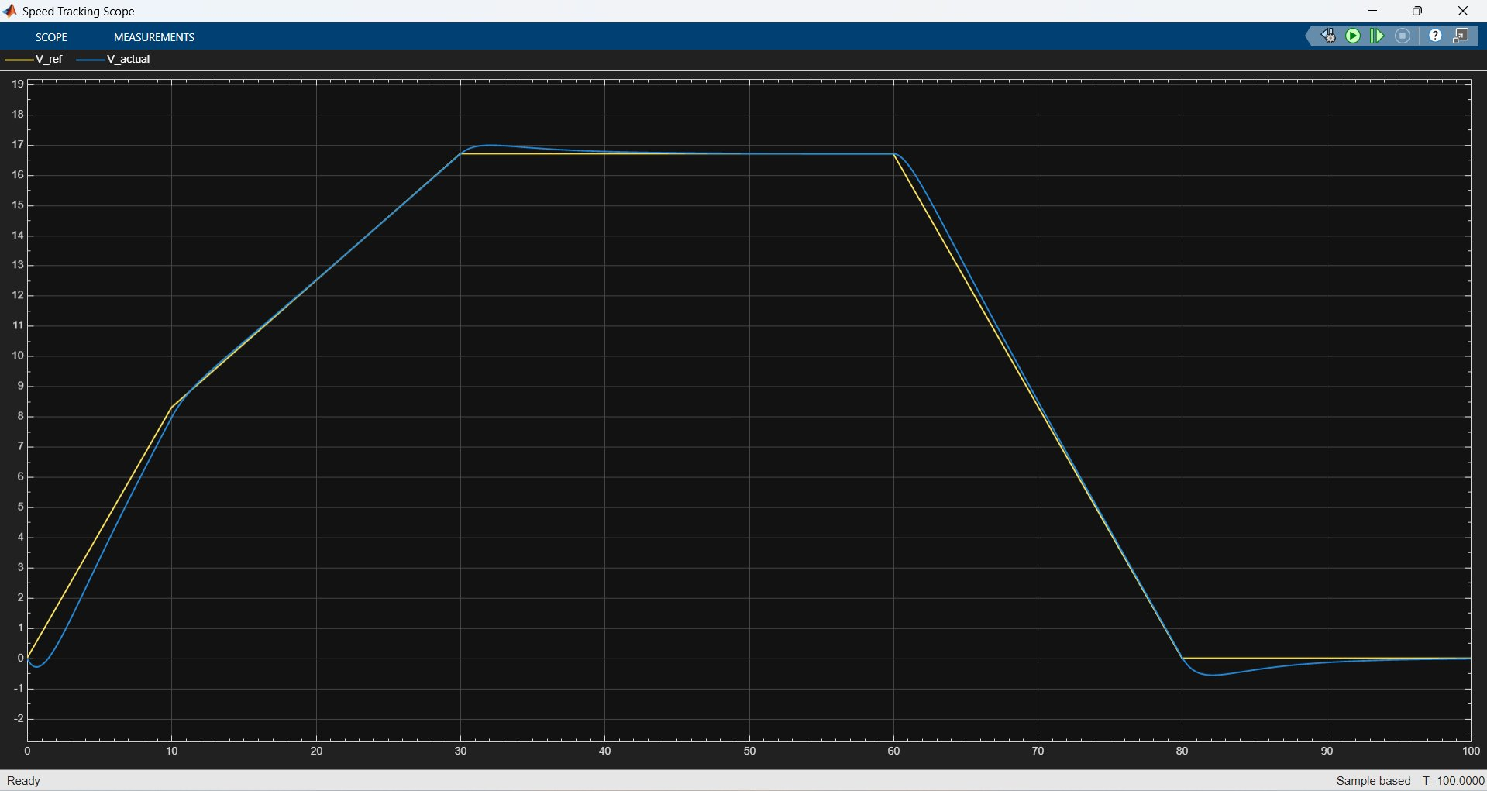
Figure 7: Uphill Road — Speed Tracking (V_ref vs V_actual, m/s)

8.2.3 Torque Response
The uphill condition significantly elevates torque demand. Wheel torque peaks near 900 Nm during initial acceleration — nearly double the flat road value — and settles at approximately 660 Nm during cruising to overcome the combined effect of grade force, rolling resistance, and aerodynamic drag. During deceleration, the grade force assists braking so regenerative torque is reduced to approximately −330 Nm at the wheel.
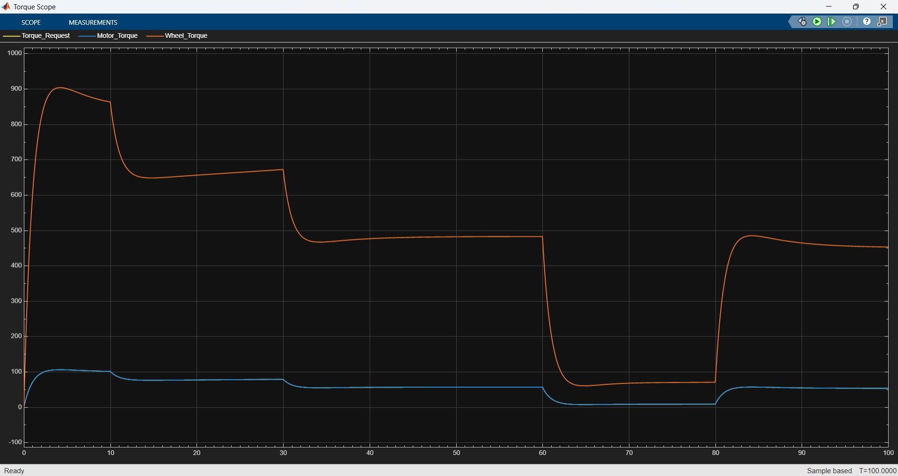
Figure 8: Uphill Road — Torque Response (Nm)

8.2.4 Battery Current
Peak discharge current reaches approximately 104 A — more than double the flat road peak — reflecting the elevated power demand. Steady-state cruising current is around 73 A. Negative current during braking is reduced compared to flat road, as the grade force assists deceleration and less regenerative effort is needed.
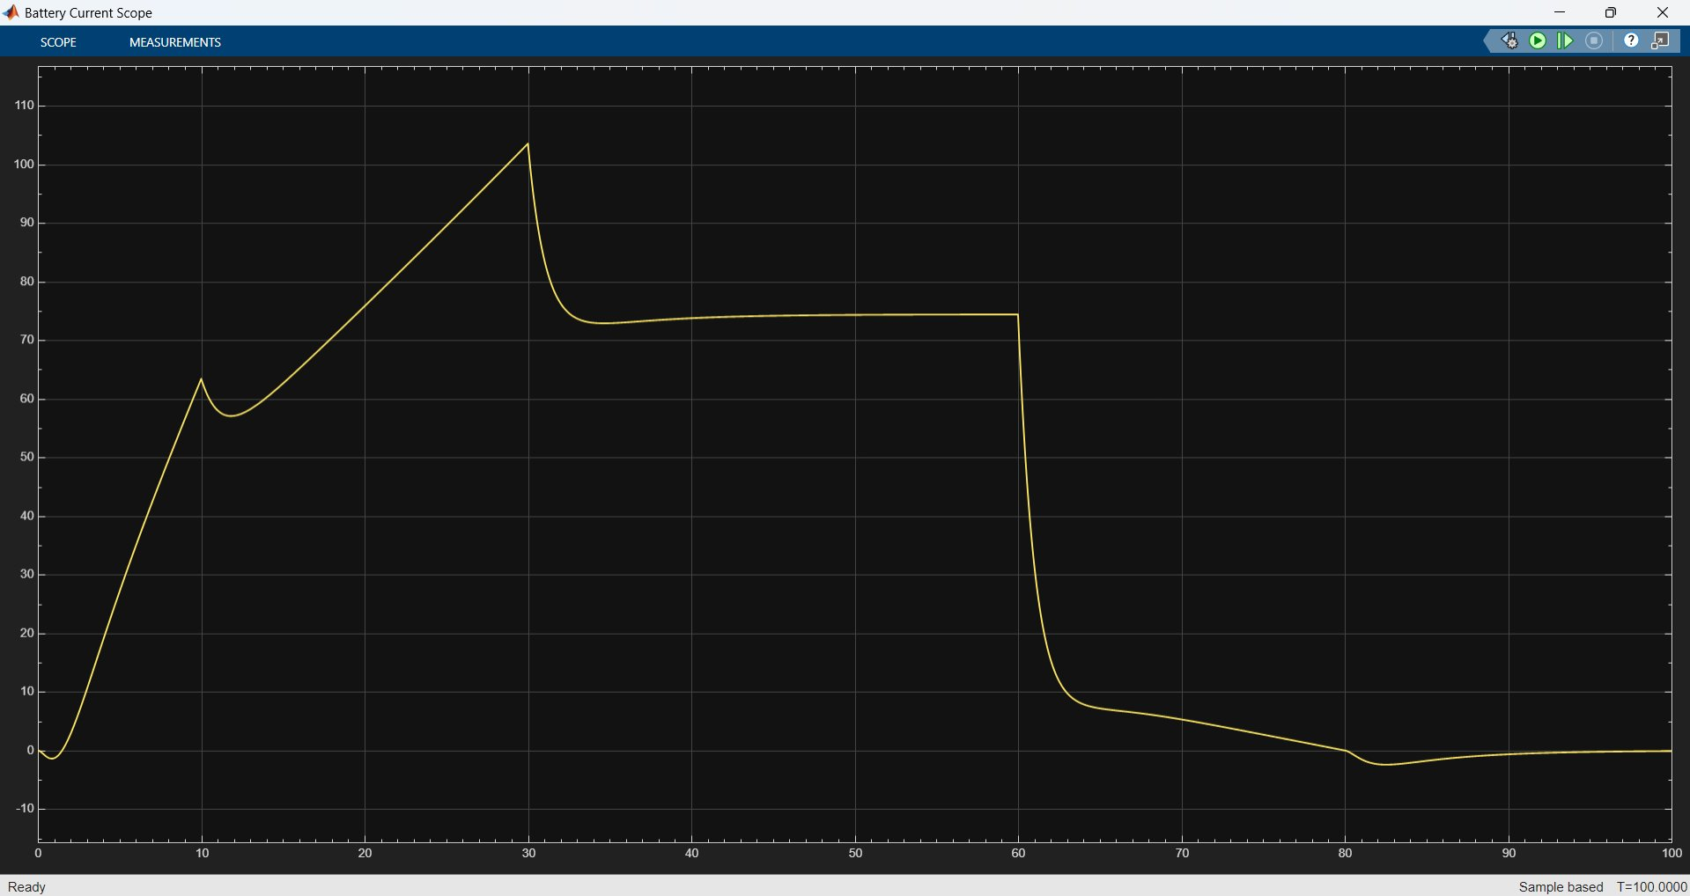
Figure 9: Uphill Road — Battery Current (A)

8.2.5 Battery Power
Peak battery power exceeds 41 kW during acceleration, and sustained cruising power is approximately 29 kW. These values illustrate the substantially higher energy demand of sustained uphill driving. Regenerative power during braking is correspondingly smaller in magnitude than in the flat road scenario.
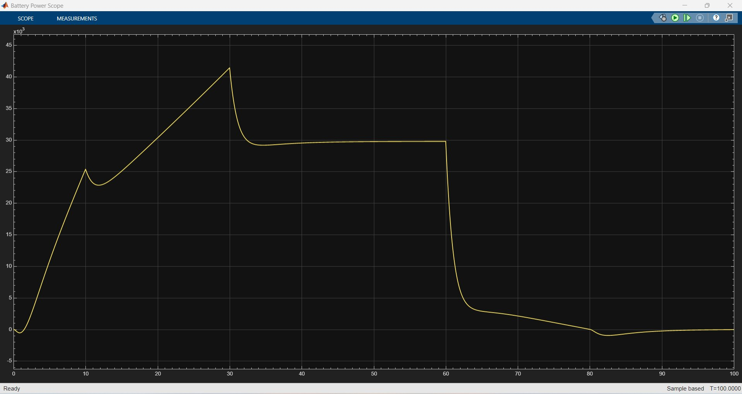
Figure 10: Uphill Road — Battery Power (W, ×10³)

8.2.6 State of Charge
SOC decreases from 90% to approximately 88.45% by the end of the drive cycle — a net reduction of 1.55 percentage points, approximately three times the flat road depletion. This confirms the significantly higher energy consumption associated with uphill driving. Negligible SOC recovery is visible during braking due to the reduced regenerative contribution.
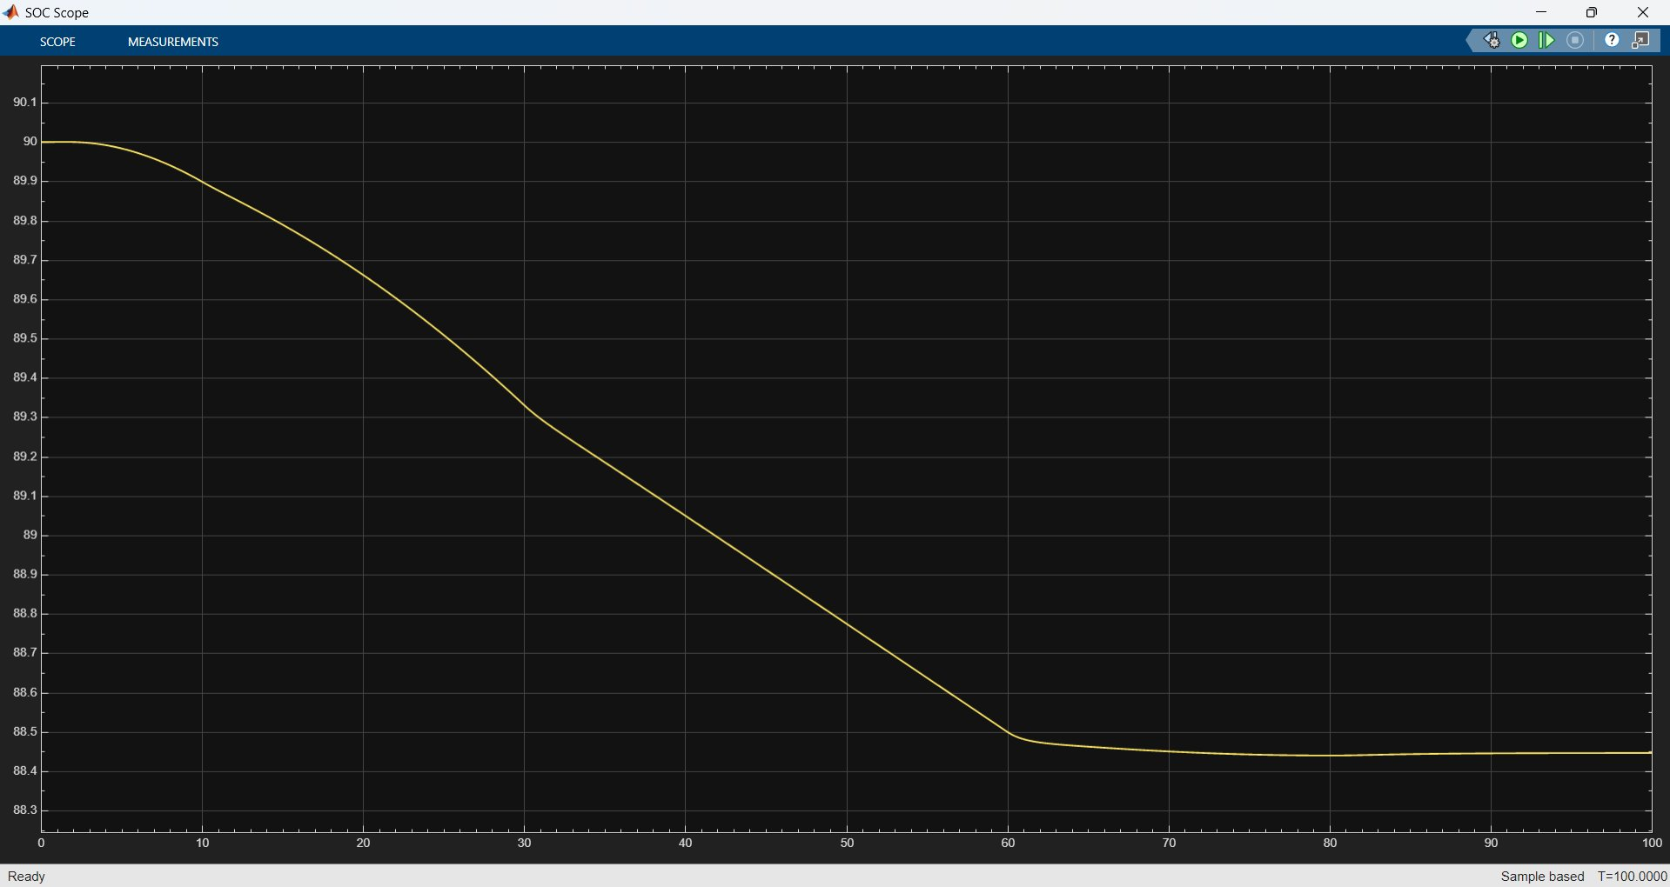
Figure 11: Uphill Road — State of Charge (%)

8.3 Scenario 3: Downhill Road (−5°)

8.3.1 Speed Tracking
On the downhill gradient, the grade force assists acceleration and tends to push the vehicle beyond the reference speed. The PID controller correctly applies negative torque demand from an early stage to prevent over-speeding. After deceleration, a brief negative speed excursion of approximately −1.5 m/s is visible before the vehicle settles at rest — a known artefact of aggressive braking with the present PID tuning on steep grades.
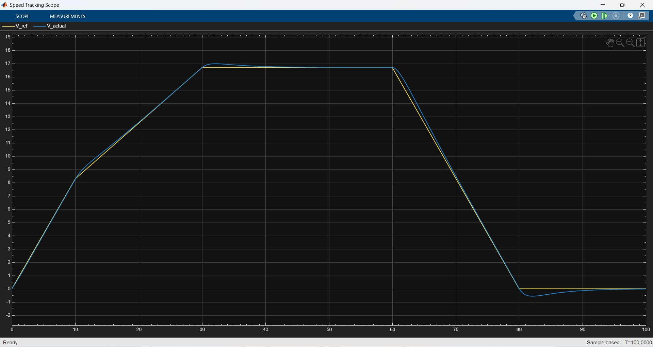
Figure 12: Downhill Road — Speed Tracking (V_ref vs V_actual, m/s)

8.3.2 Torque Response
In the downhill scenario, negative motor and wheel torques dominate throughout the drive cycle. The motor acts predominantly as a generator, applying braking torque to maintain the reference speed against the grade force. Wheel braking torque peaks at approximately −720 Nm during the final deceleration phase (60–80 s). Only a brief positive torque pulse is required at the very start of acceleration.
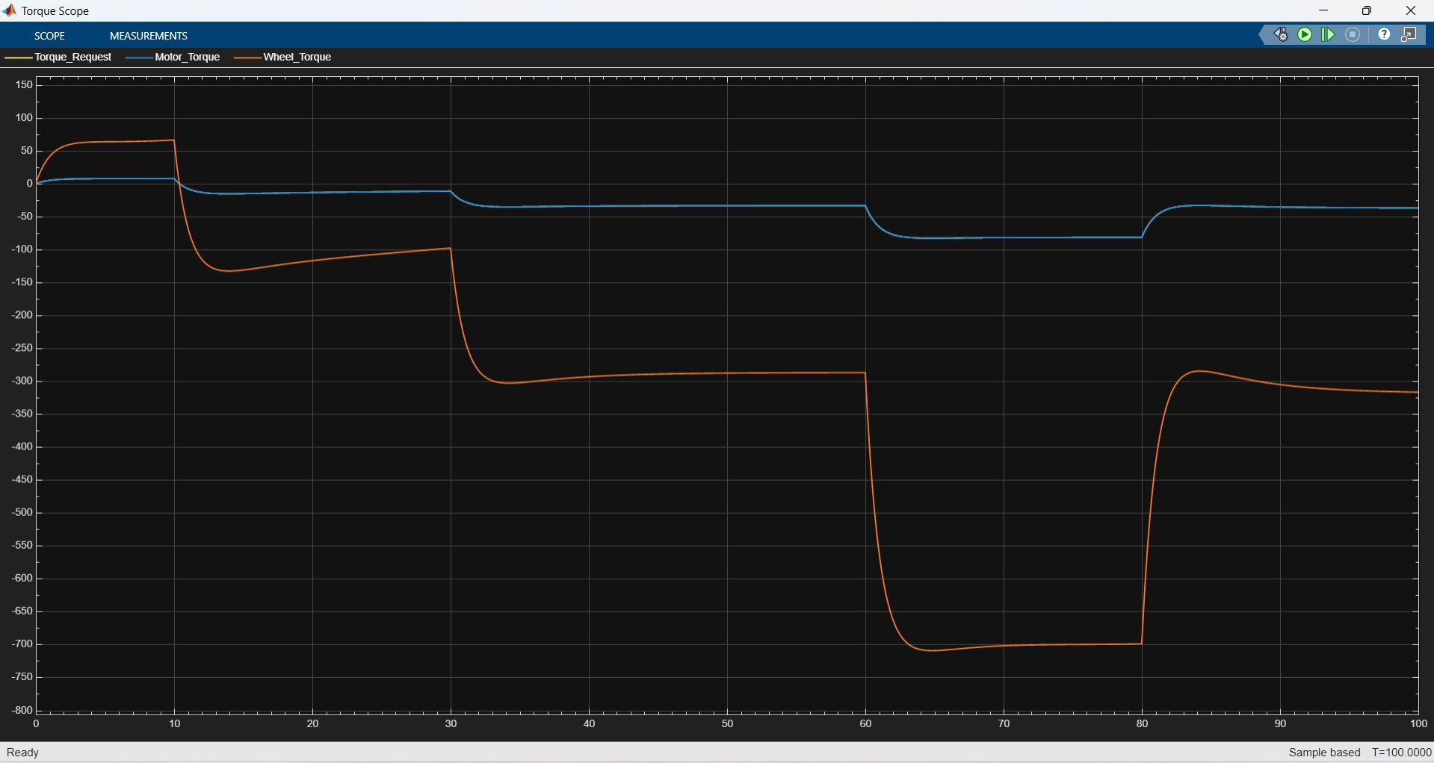
Figure 13: Downhill Road — Torque Response (Nm)

8.3.3 Battery Current
Battery current is predominantly negative throughout the simulation, confirming continuous energy recovery. The current reaches approximately −95 A during the peak braking phase (t ≈ 65 s). A brief positive current spike at the start is the only discharging event, as the vehicle quickly reaches speed with minimal motor input on the downhill grade.
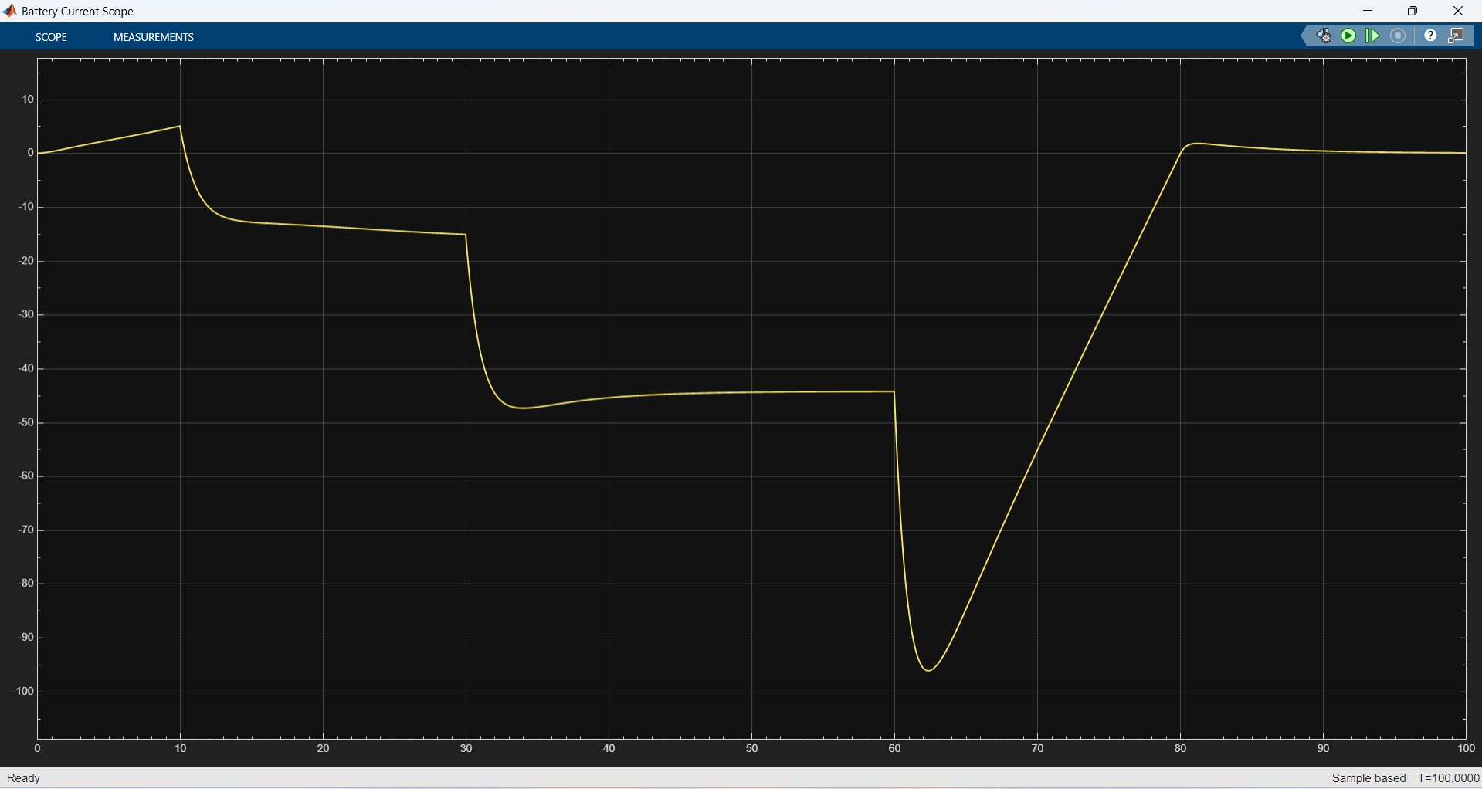
Figure 14: Downhill Road — Battery Current (A)

8.3.4 Battery Power
Battery power is largely negative, peaking at approximately −37 kW during maximum regenerative braking. The sustained negative power from t = 10 s onward confirms that the motor operates almost entirely in regenerative mode on the downhill grade.
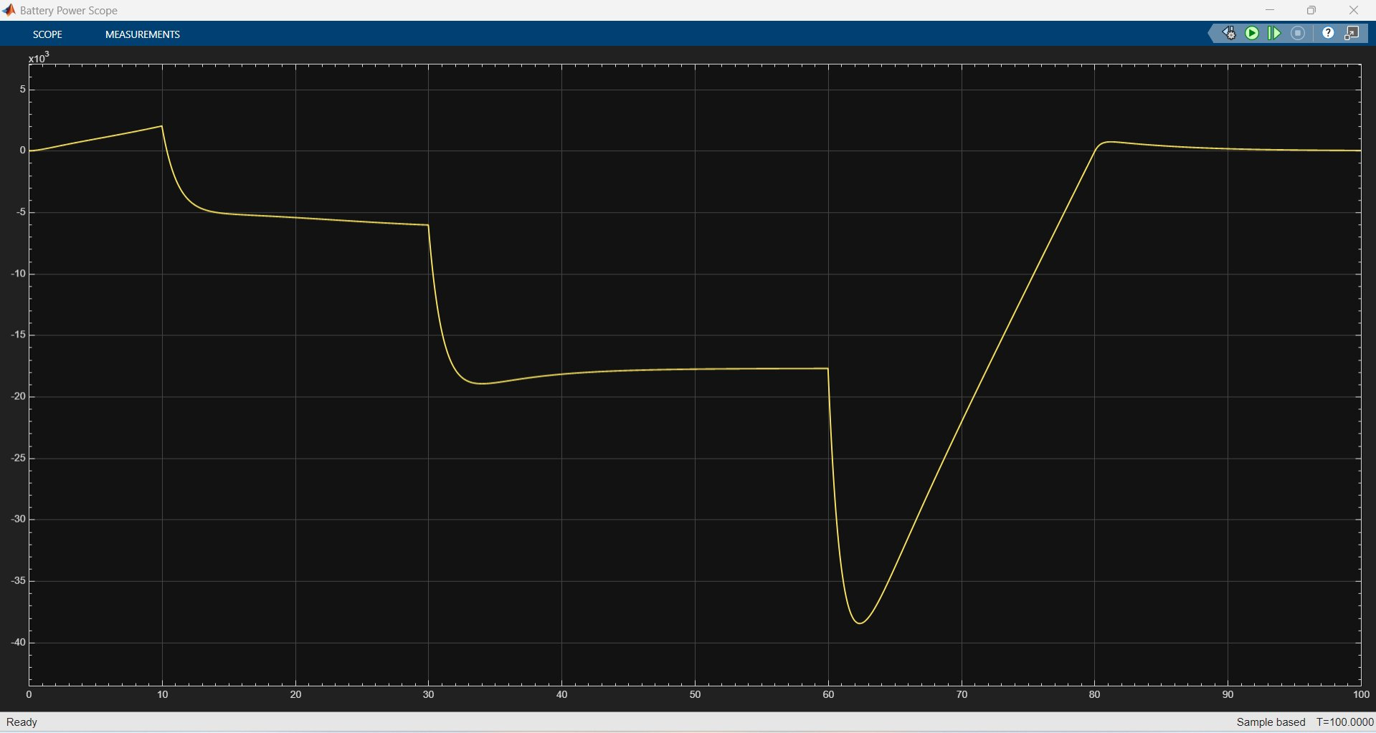
Figure 15: Downhill Road — Battery Power (W, ×10³)

8.3.5 State of Charge
The downhill SOC plot is the most distinctive result. Starting at 90%, SOC rises continuously to approximately 91% by the end of the simulation — a net gain of approximately 1 percentage point. This demonstrates the effectiveness of regenerative braking in recovering gravitational potential energy during downhill descent, with the battery acting as the energy storage medium. Note that this result is based on the simplified regenerative braking model used in this simulation.
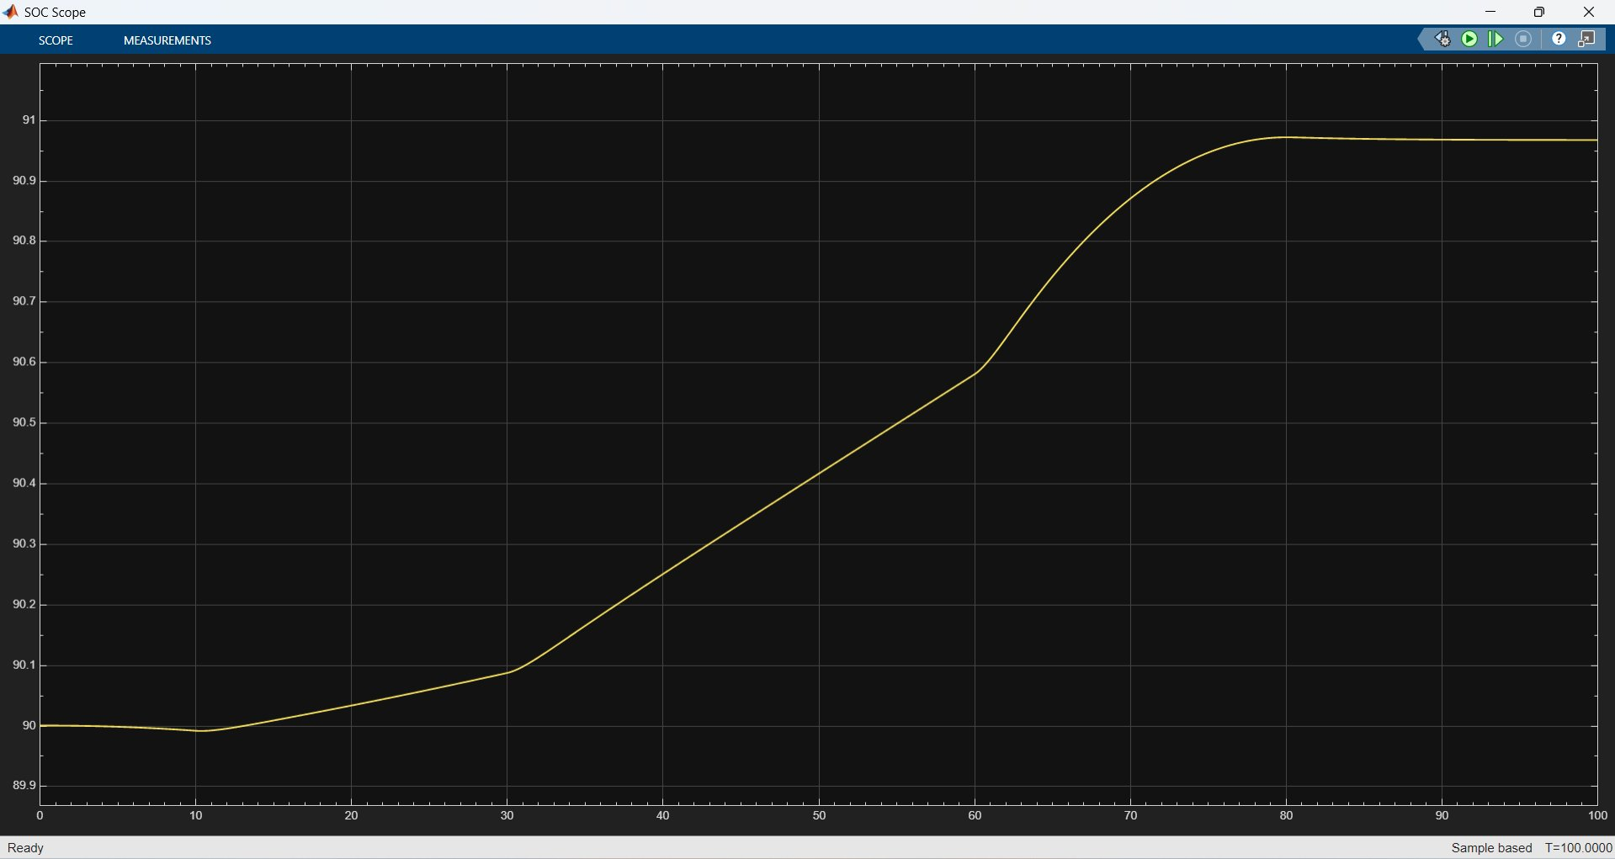
Figure 16: Downhill Road — State of Charge (%)

9. Comparative Analysis
The table below summarises the key performance metrics across all three simulation scenarios:

Parameter | Flat Road | Uphill (+5°) | Downhill (−5°)
Peak Battery Current | ~44 A | ~104 A | −95 A (regen)
Peak Battery Power | ~17.5 kW | ~41 kW | −37 kW (regen)
SOC Change | −0.5% | −1.6% | +1% (net gain)
Wheel Torque (accel) | ~480 Nm | ~900 Nm | ~55 Nm
Speed Tracking | Excellent | Excellent | Good (slight overshoot)

The comparison highlights the dominant role of road grade in EV energy consumption. The uphill scenario requires approximately 3× the battery energy of flat road driving, while the downhill scenario results in a net SOC gain. These results validate both the accuracy of the vehicle dynamics model and the effectiveness of the regenerative braking implementation.

10. Advantages of the Developed Model
- Modular subsystem-based Simulink design enables easy modification and extension
- Parameters are centralised in MATLAB scripts for rapid scenario reconfiguration
- Supports multiple driving conditions through a single parameterised model
- Realistic force modelling: rolling resistance, aerodynamic drag, and grade forces
- Regenerative braking is fully integrated and validated against expected physics
- Battery power, current, and SOC are monitored in real time throughout the drive cycle

11. Applications
- Electric vehicle powertrain design and sizing studies
- Vehicle control strategy development and validation
- Battery energy management and range estimation
- EV powertrain research in academic and industrial contexts
- Baseline model for hardware-in-the-loop (HIL) testing environments

12. Conclusion
A complete EV powertrain model was successfully developed and simulated in MATLAB/Simulink. The model accurately tracks reference speed using a PID controller across three road conditions — flat, uphill, and downhill — and incorporates realistic vehicle dynamics including transmission effects, rolling resistance, aerodynamic drag, and road grade forces.
Battery power, battery current, and state of charge were monitored throughout each drive cycle. Regenerative braking was successfully implemented and validated, demonstrating meaningful energy recovery during deceleration — particularly in the downhill scenario where the battery SOC increased by approximately 1% over the 100-second simulation.
The simulation results demonstrate the effectiveness and accuracy of the proposed EV powertrain architecture. The modular Simulink model provides a versatile platform for future EV control and energy management research.

13. Future Work
- Detailed Permanent Magnet Synchronous Motor (PMSM) model with field-oriented control
- PWM-based inverter modelling with switching losses
- Advanced battery equivalent circuit model (Thevenin / Randles)
- Battery thermal modelling and temperature effects on SOC
- Battery Management System (BMS) implementation
- State of Health (SOH) estimation algorithms
- Adaptive and Model Predictive Control (MPC) for improved energy management
- Variable road grade profiles and real-world drive cycles (e.g. WLTP, UDDS)

