**My Great Plan as a Tech Blogger and Web Developer**

**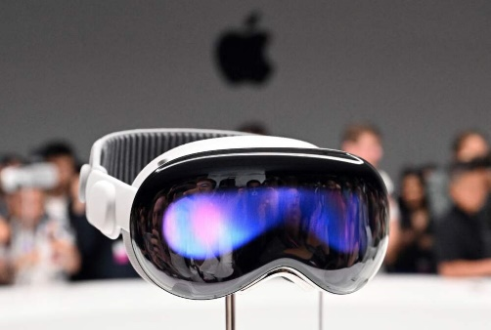I plan on creating a tech blog website that will cover the most recent technological developments, such as updates on mobile devices, laptops, CPUs, apps, big technology events, product displays, and car showcases. The website will highlight developments from businesses such as Apple, Nvidia, Tesla, Samsung, MI, OnePlus, Oppo, Huawei, Google, and Meta (Facebook), with a focus on product innovations, robotics, and cutting-edge technology in both the tech and automotive industries. For example, I will cover Samsung's Galaxy Ring, Apple's** Vision Pro**, and Meta's upcoming product releases.**

**The blog will also include practical tips and tricks for using various applications and websites to help people maximize their full potential. The material will be focused on user-centric topics, according to individual interests. Readers can interact with articles by liking C:\Users\My PC\Downloads\+1.png, commentingC:\Users\My PC\Downloads\speech_balloon.png , and sharing C:\Users\My PC\Downloads\link.png**  **them, creating a community.**

**To keep the material fresh and reliable, I will focus on maintaining credibility and regularly updating the site. By overcoming challenges in content management and web development, I will improve my skills and create a platform that provides up-to-date tech insights to my audience.**