Car Accident Detection Project

Anomaly Detection:
Anomaly detection (aka outlier analysis) is a step in data mining that identifies data points, events, and/or observations that deviate from a dataset's normal behavior. Anomalous data can indicate critical incidents, such as a technical glitch, or potential opportunities, for instance a change in consumer behavior.

SpatioTemporal:
Spatial refers to space. Temporal refers to time. Spatiotemporal, or spatial temporal, is used in data analysis when data is collected across both space and time. It describes a phenomenon in a certain location and time — for example, shipping movements across a geographic area over time (see above example image).

C3D
((Reference: https://arxiv.org/pdf/1412.0767.pdf))
=> It Means “Convolution 3D”
=> C3D is obtained by training a deep 3D convolutional network on a large annotated video dataset(UCF crime dataset).
=> The dataset contains various concepts encompassing objects, actions, scenes and other frequently occurring categories in videos.

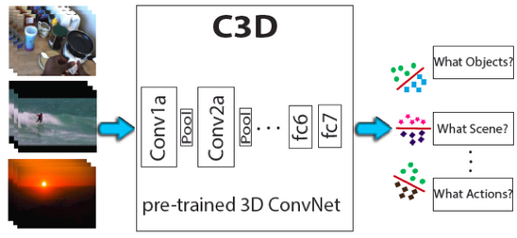

=> Compared with Recurrent Neural Networks (RNN) based methods, C3D outperforms Long-term Recurrent Convolutional Networks (LRCN) and LSTM composite model by 14.1% and 9.4%, respectively.

C3D Architecture:
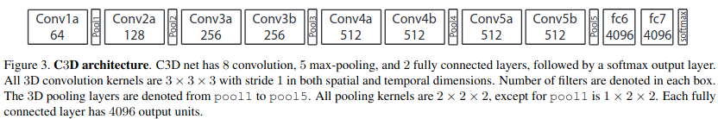

C3D Feature Extraction:
To extract C3D feature, a video is split into 16 frame long clips with a 8-frame overlap between two consecutive clips. These clips are passed to the C3D network to extract fc6 activations. These clip fc6 activations are averaged to form a 4096-dim video descriptor which is then followed by an L2-normalization. We refer to this representation as C3D video descriptor/feature in all experiments, unless weclearly specify the difference.

C3D Performance:
=> Using C3D features and a simple linear SVM, we achieve state of the art performance on scene classification (96.7% on YUPENN and 77.7% on Maryland), objet classification (15.3% on egocentric object) and action similarity labeling (72.9% on ASLAN) problems in the video domain. We also approach the current best performance on action classification (76.4% on UCF101) without using optical flow.
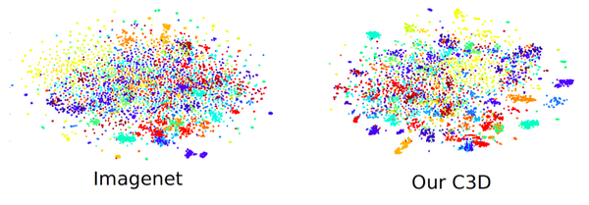
Folder Structure:
1. fe_c3d:
* It has all the C3D related files those are
1. c3d.py -> architecture build, processing of input video
2. classifier.py -> classifier model build
3. configuration.py -> Initialization file paths
4. extract_feature.py -> it is the starting point for feature extraction
5. parameters.py -> parameters initialization
6. plot_controller.py -> classifier build, savitzky_golay build
2. catalog: (Django App)
* static -> all the static files (CSS JS)
* templates -> html templates
* Django files: admin.py, apps.py, forms.py, middleware.py, models.py, tasks.py, urls.py, views.py
3. locallibrary: (Django Home/Project Directory)
* settings.py -> all the settings related to the project
* urls.py -> url paths and redirections
* wsgi.py -> django generated files
4. media:
* features -> it contains .npy files(stored features)
* output -> output files (Processed files)
* video -> input -> for saving input videos
5. staticfiles:
it contains all the static files like images, css, fonts, js

6. templates:
Base html templates

Execution Of the Project:

1. Get sports1m model weight:
- Download file ((https://github.com/adamcasson/c3d/releases/download/v0.1/sports1M_weights_tf.h5, rename and save in ‘c3d/trained_models/c3d_sports1m.h5’))

2. Start Django web app:
```
python manage.py makemigrations
python manage.py migrate
python manage.py collectstatic
python manage.py runserver
```
3. Open brower to `http://127.0.0.1:8000`.

References:
* Research Paper: https://arxiv.org/pdf/1412.0767.pdf
* http://vlg.cs.dartmouth.edu/c3d/
* https://research.fb.com/blog/2014/12/c3d-generic-features-for-video-analysis/
* https://github.com/facebookarchive/C3D

