1. Install and setup WSL: <https://docs.microsoft.com/en-us/windows/wsl/install-manual>
2. Update Ubuntu first: sudo apt-get update
3. Install GCC: sudo apt install gcc
4. Check GCC installation status: gcc -v
5. Install Nasm assembler (Used for assembly code): sudo apt install nasm
6. Check Nasm installation: nasm -v
7. Install Bosch Emulator 2.6.11 (64-bit) (It is a virtual machine: <https://bochs.sourceforge.io/>
8. Edit environment variable
9. Open powershell and run ‘bximage’ to create image file
10. Enter 1 for creating harddisk image

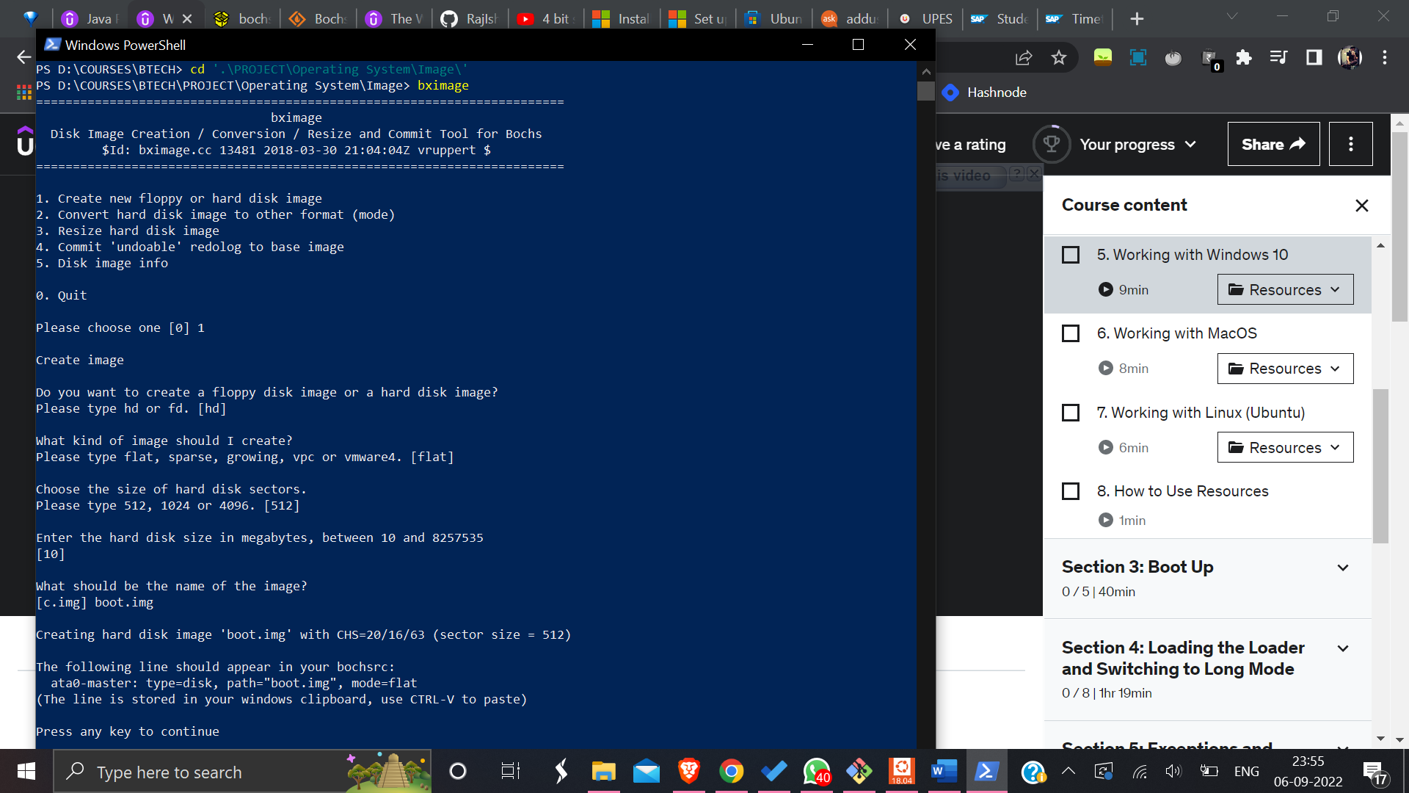

1. Open Bosch
2. Edit CPUID:
   1. X86-64 and long mode [enable]
   2. 1G pages support in long mode [enable]
3. Edit Memory:
   1. Memory size [1024]
   2. Host allocated memory size [1024]
4. Edit Disk & Boot:
   1. ATA channel 0:
      1. First HD/CD on channel 0
         1. Type of ATA device [disk]
         2. Path or physical device name [boot.img]
         3. Cylinders [20]
         4. Heads [16]
         5. Sectors per track [63]
   2. Boot Options
      1. Boot drive #1 [disk]
5. Save the configuration file and open the file in VS Code
6. Install C/C++ and x8664assembly (by fredhappyface) extensions in vs code.
7. Install Rufus which is used to create bootable usb flash drive: <https://rufus.ie/en/>
8. Write assembly code (boot.asm) and build script file (build.sh)
9. After writing codes, open Ubuntu Windows Sub-system and go to the folder where these files are located use cd /mnt/<the local drive>/ command as it will basically mount our local drive to ubuntu. (Keep these files in the same directory where boot.img file is located.)
10. Now it’s time to build the project. Run the build script using ./build.sh
11. We would be able to see the generated binary file using hexdump command

Example: hexdump -c boot.bin

1. Now open bochs configuration file and change the boot.img directory path at line 13

It must look like this: ata0-master: type=disk, path="D:\COURSES\BTECH\PROJECT\Operating System\Image\boot.img"

1. Now start bochs configuration file by double clicking on it.
2. Now we will write the boot file into USB drive. Open Rufus. Select boot image. Select USB Drive. Click Start.
3. Now we want to configure our Test System. Open BIOS Interface. Go to BIOS Option. Enable CSM Support.