**Instructions:**

Step 1.> to login type your phone number on which the AAP is installed, the Kisan Mitra AAP will automatically generate an OTP and fill it in your phone, once verified, you will be logged in.

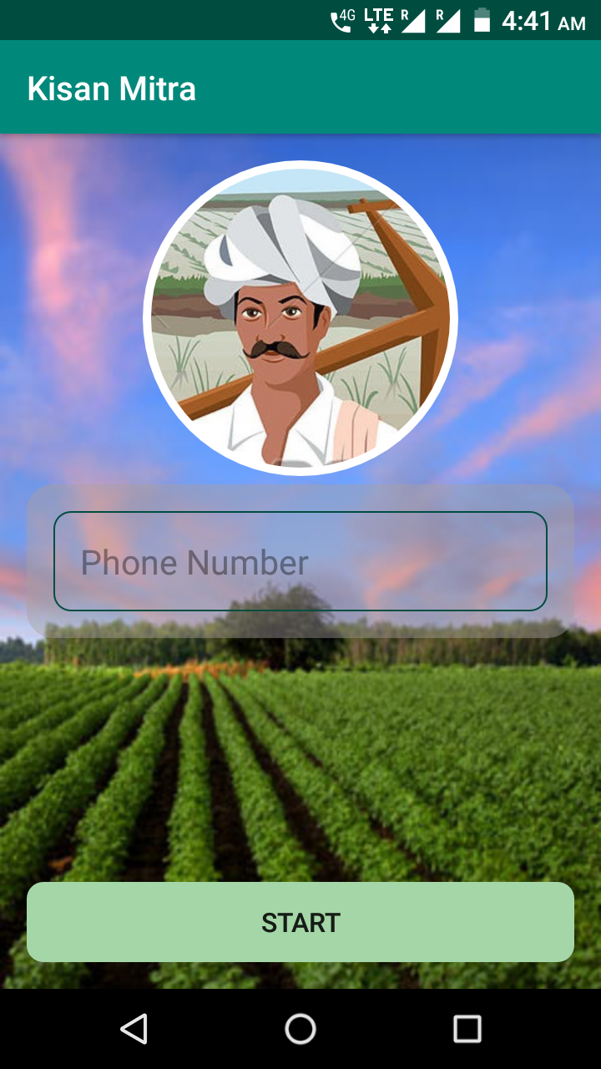

Step2.>Enter your username, the Area of your farm and which district and state you belong.

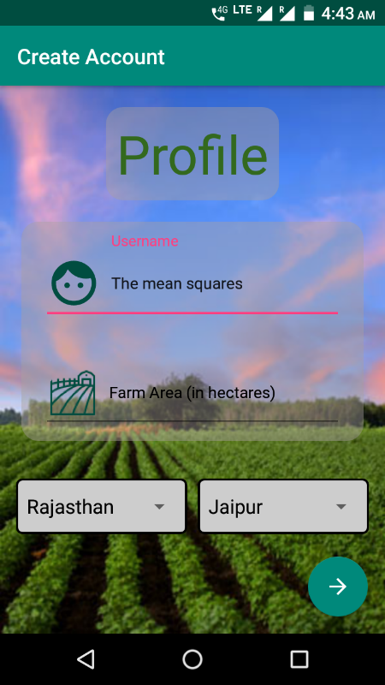

**Disease detection:**

Step1.>click on upload photo.

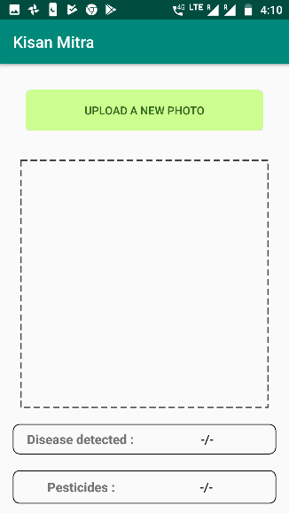

Step2.>take a snapshot or select an image from gallery.

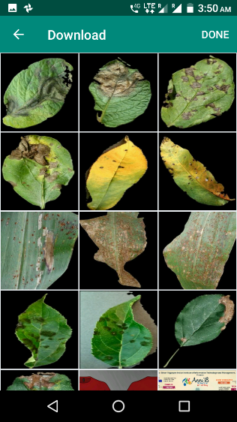

Click on this

Step3.>click on done. The disease will be detected and pesticide will be suggested.

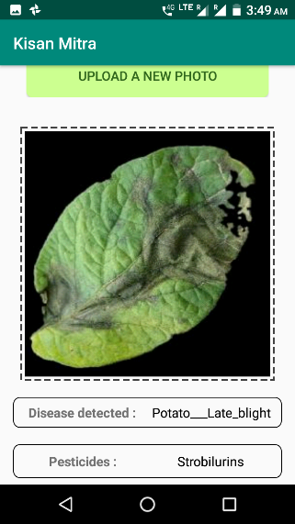

**Price prediction:**

Step1.>select the crop you want to grow from the suggested list.

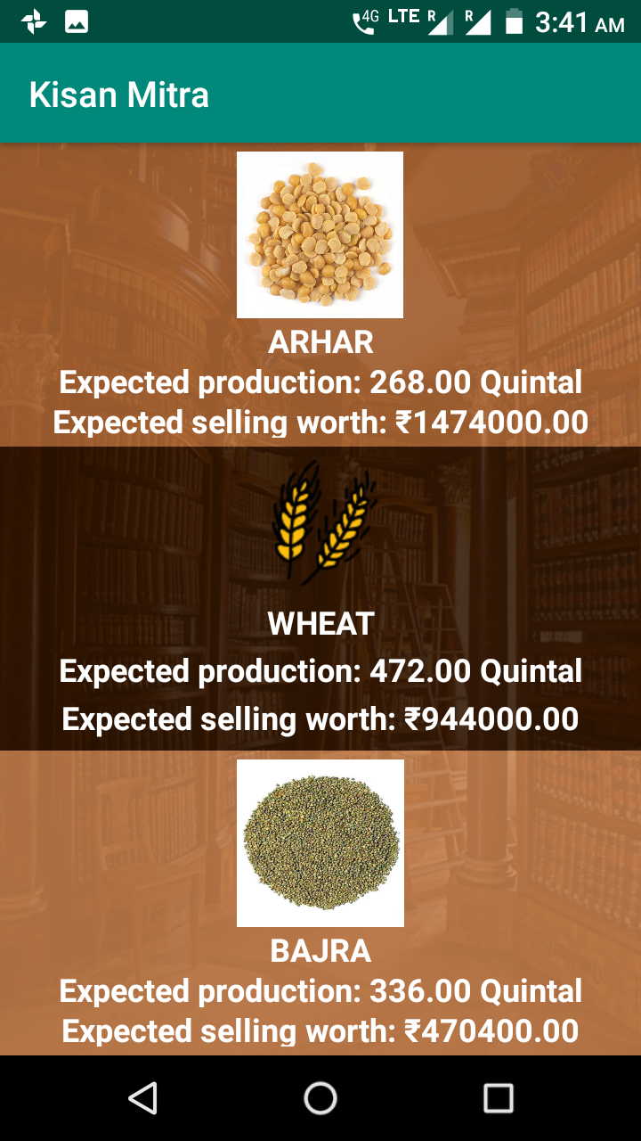

Step2.>click on the button to view the future price predictions of the selected crop.

Click on this

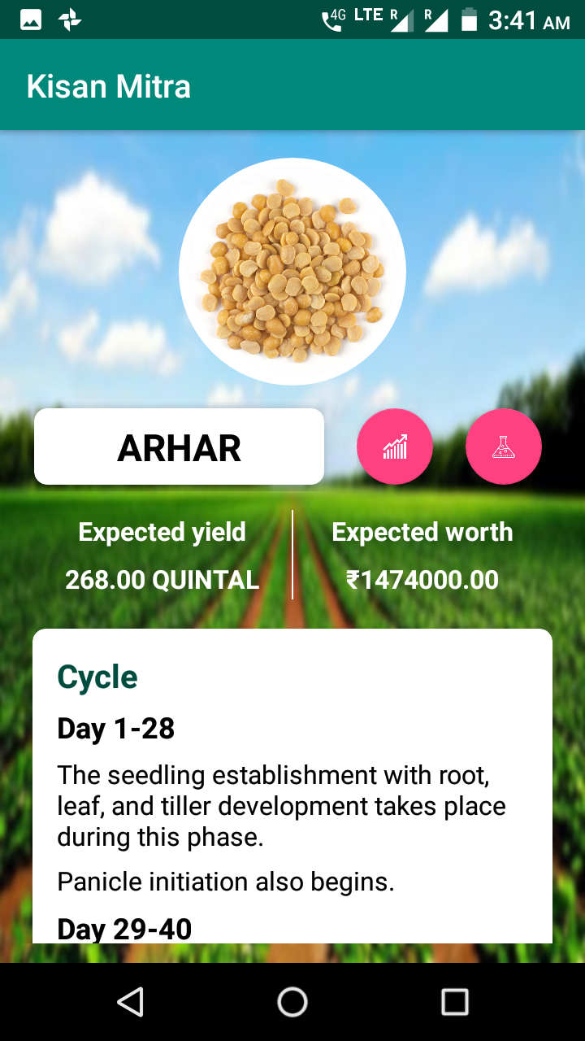

Step3.> the future predictions and graph are shown.

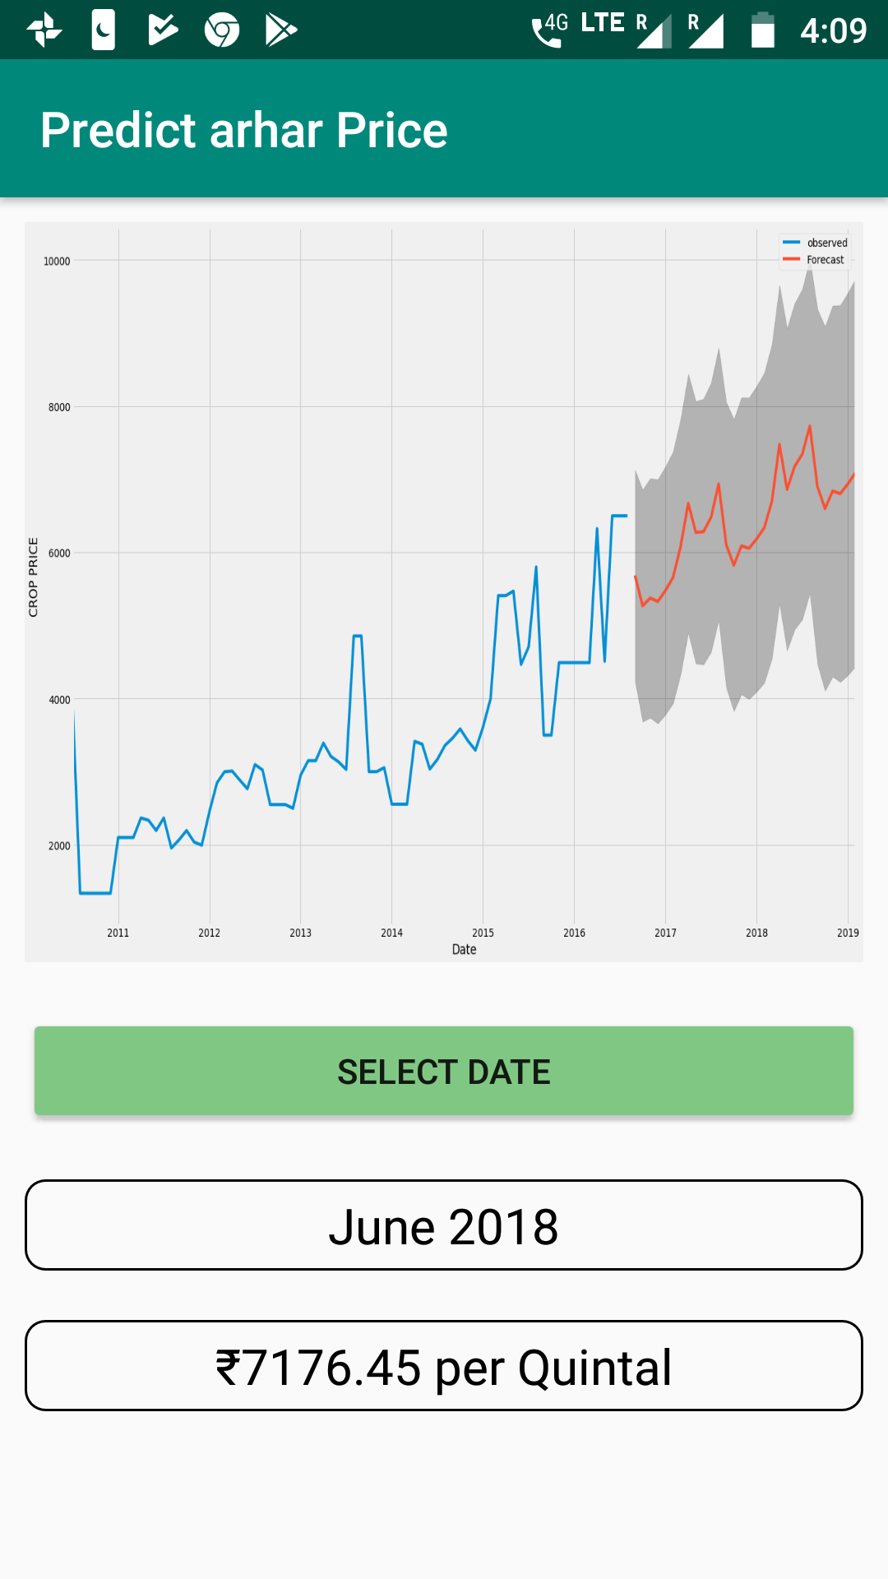

**Farmer friendly chat-bot:**

Step1.> type the questions you want to ask. (e.g.: how to take a soil sample?)

Step2.>press the send button to get instant reply.

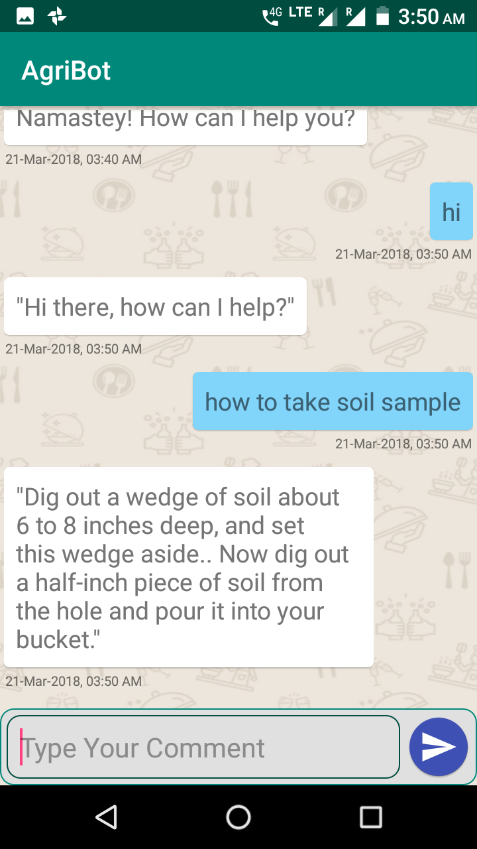

**Fertilizer recommendation:**

Step1.>click on the button to view the future price predictions of the selected crop.

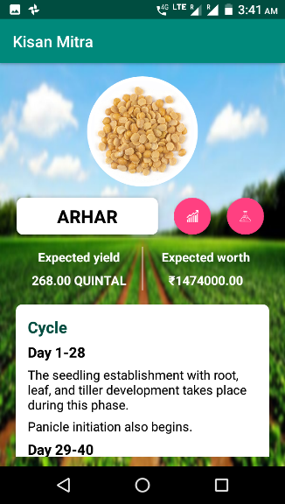

Click on this

Step2.>Enter the values of minerals as questioned in form.

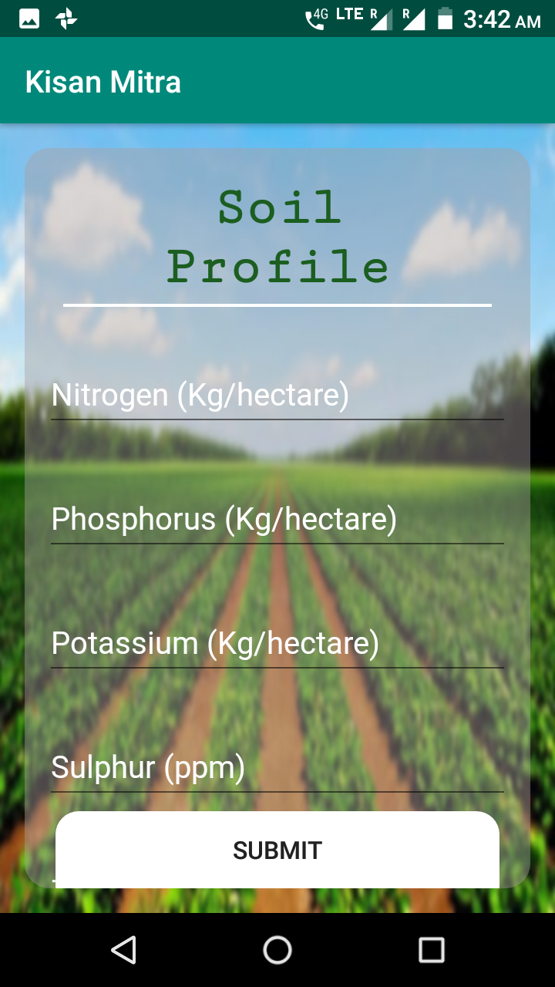

Step3.>click on submit to generate recommended fertilizers.

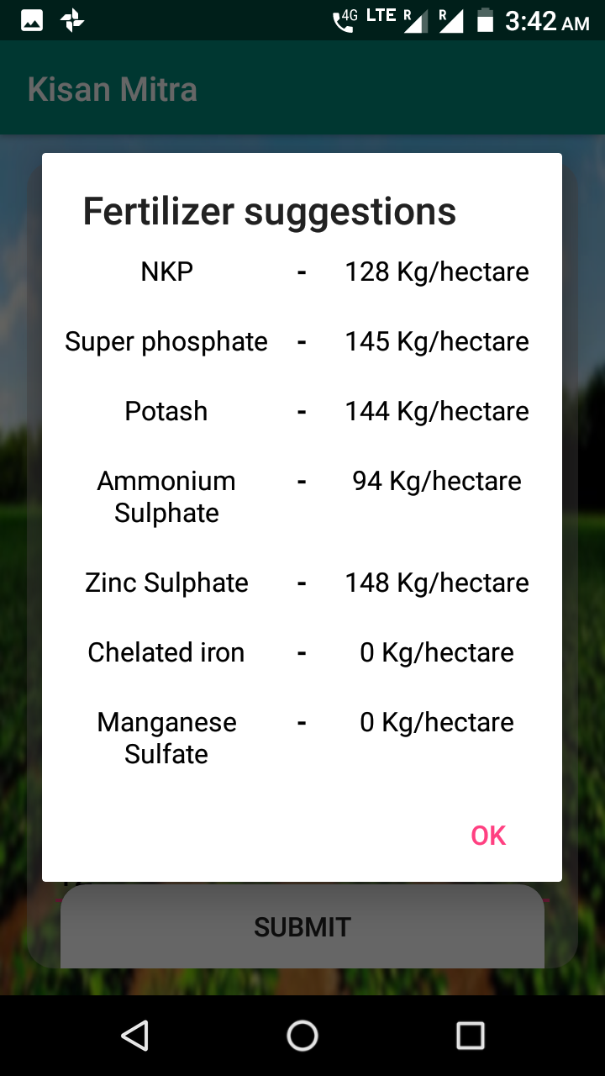

**Alert Broadcasting:**

The admin can broadcast important notification to the farmer for the things like hailstorm, wide spread infection of the crop in the area.

*(This feature is for admin)*

Step1.> select the district and the state you want to broadcast the notification.

Step2.> type the broadcast message.

Step3.>click on send button.

