Experiment 1:

Date:Aug 12 2023

Code:

<!DOCTYPE html>

<html>

<head>

<!-- This is simple image and text. -->

<title>EX1</title>

</head>

<body>

<h1>Cat Image</h1>

<img src="/home/caculo/Desktop/B_21_1312/graycat" height="200" width="200">

<p style="background-color: blue; font-family: cursive; font-size: 40px">

The cat (Felis catus) is a domestic species of small carnivorous mammal. It is the only domesticated species in the family Felidae and is commonly referred to as the domestic cat or house cat to distinguish it from the wild members of the family. Cats are commonly kept as house pets but can also be farm cats or feral cats; the feral cat ranges freely and avoids human contact. Domestic cats are valued by humans for companionship and their ability to kill vermin. About 60 cat breeds are recognized by various cat registries.

</p>

</body>

</html>

Output:

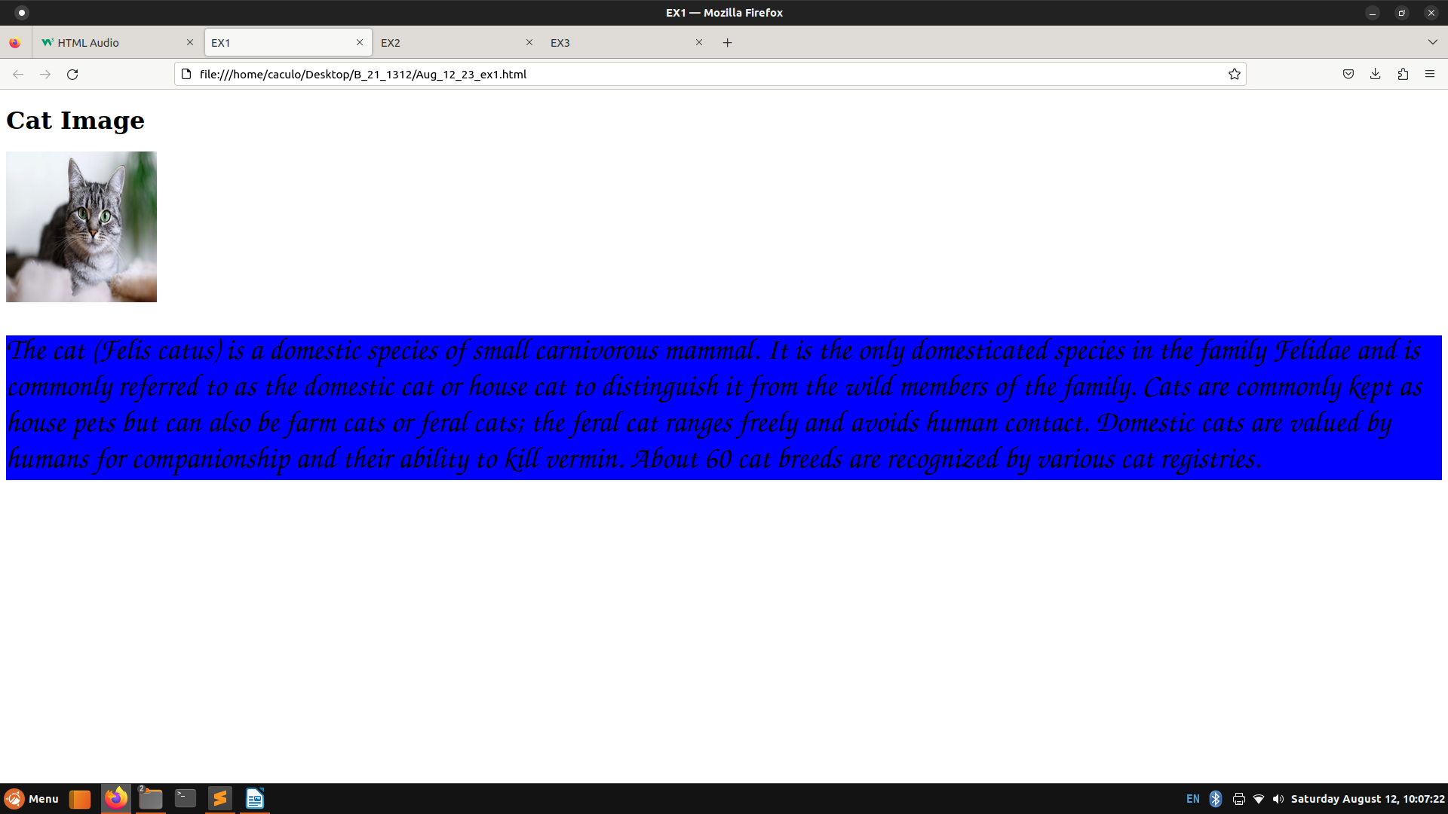j

Experiment 2:

Date:Aug 12 2023

Code:

<!DOCTYPE html>

<html>

<head>

<!-- This is simple video playing. -->

<title>EX2</title>

<style type="text/css">

p{

color: red;

font-size: 20px;

}

</style>

</head>

<body style="background-color: lightblue;">

<h1>A Rainy Day!!</h1>

<p>This is a 30secs animated video depicting a rainy day.</p>

<video controls height="600" width="600">

<source src="RainyDayAnimation.mp4" type="video/mp4">

This video cannot be displayed

</video>

<p style="font-size: 30px; color: purple;">

This is a 30 secs animated video. It depicts a perfect rainy day. It has thunderstroms and lighting too.

</p>

</body>

</html>

Output:

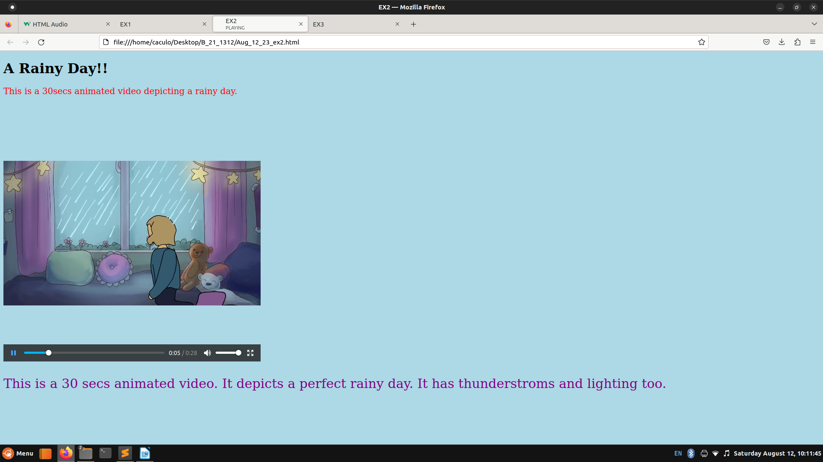

Experiment 3:

Date:Aug 12 2023

Code:

<!DOCTYPE html>

<html>

<head>

<!-- This is simple audio playing. -->

<title>EX3</title>

<style type="text/css">

p{

color: blue;

font-size: 20px;

}

</style>

</head>

<body style="background-color: lightpink;">

<h1>Happy Now Song.</h1>

<p>This is a music audio.</p>

<audio controls>

<source src="Kygo_HappyNow" type="audio/mpeg">

This audio cannot be played

</audio>

<p style="font-size: 30px; color: red;">

This is a music audio by Kygo. The song is called "Happy Now". It is a EDM style music.

</p>

</body>

</html>

Output:

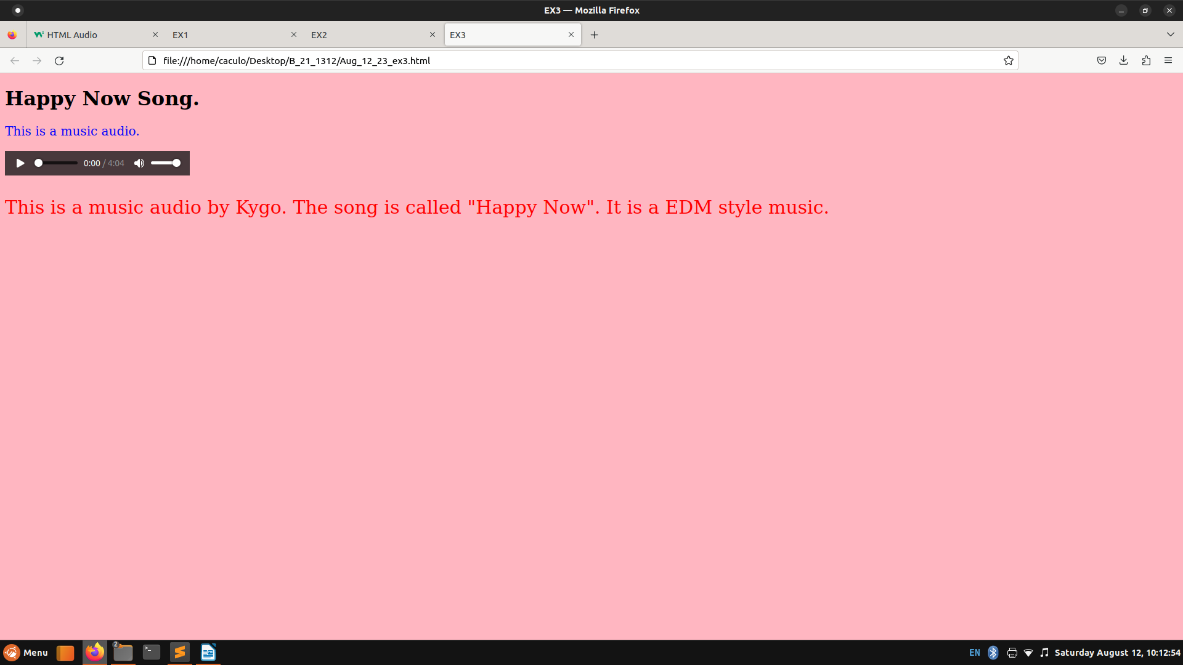

Experiment 4:

Date:Aug 12 2023

Code:

<!DOCTYPE html>

<html>

<head>

<title>DIVEX2</title>

<style type="text/css">

#div1{

color: red;

}

#div2{

color: green;

}

#div3{

color: blue;

}

#div4{

color: black;

}

#div5{

color: purple;

}

</style>

</head>

<body style="background-color: pink;">

<div id="div1" style="font-family: all; font-size: 30px">The cat (Felis catus) is a domestic species of small carnivorous mammal.[1][2] It is the only domesticated species in the family Felidae and is commonly referred to as the domestic cat or house cat to distinguish it from the wild members of the family.[4] Cats are commonly kept as house pets but can also be farm cats or feral cats; the feral cat ranges freely and avoids human contact.[5] Domestic cats are valued by humans for companionship and their ability to kill vermin. About 60 cat breeds are recognized by various cat registries.[6]</div>

<br>

<div id="div2" style="font-family: cursive; font-size: 30px"> The dog (Canis familiaris[4][5] or Canis lupus familiaris[5]) is a domesticated descendant of the wolf. Also called the domestic dog, it is derived from extinct Pleistocene wolves,[6][7] and the modern wolf is the dog's nearest living relative.[8] Dogs were the first species to be domesticated[9][8] by hunter-gatherers over 15,000 years ago[7] before the development of agriculture.[1] Due to their long association with humans, dogs have expanded to a large number of domestic individuals[10] and gained the ability to thrive on a starch-rich diet that would be inadequate for other canids.[11]</div>

<br>

<div id="div3" style="font-family: serif; font-size: 30px"> Humans or modern humans (Homo sapiens) are the most common and widespread species of primate. A great ape characterized by their hairlessness, bipedalism, and high intelligence, humans have a large brain and resulting cognitive skills that enable them to thrive in varied environments and develop complex societies and civilizations. Humans are highly social and tend to live in complex social structures composed of many cooperating and competing groups, from families and kinship networks to political states. As such, social interactions between humans have established a wide variety of values, social norms, languages, and rituals, each of which bolsters human society. The desire to understand and influence phenomena has motivated humanity's development of science, technology, philosophy, mythology, religion, and other conceptual frameworks. </div>

<br>

<div id="div4" style="font-family: cursive; font-size: 30px"> Parrots, also known as psittacines (/ˈsɪtəsaɪnz/),[1][2] are birds of the order Psittaciformes (/ˈsɪtəsɪfɔːrmiːz/) and are found mostly in tropical and subtropical regions. They are made up of four families that contain roughly 410 species in 101 genera. The four families are: Psittaculidae (Old World parrots) , the Psittacidae (African and New World parrots), the Cacatuoidea (cockatoos), and the Strigopidae (New Zealand parrots). One-third of all parrot species are threatened by extinction, with higher aggregate extinction risk (IUCN Red List Index) than any other comparable bird group.[3] Parrots have a generally pantropical distribution with several species inhabiting temperate regions in the Southern Hemisphere, as well. The greatest diversity of parrots is in South America[4] and Australasia.[5] </div>

<br>

<div id="div5" style="font-family: sans-serif; font-size: 30px"> Hummingbirds are birds native to the Americas and comprise the biological family Trochilidae. With about 366 species and 113 genera,[1] they occur from Alaska to Tierra del Fuego, but most species are found in Central and South America.[2] About 28 hummingbird species are listed as endangered or critically endangered, with numerous species declining in population.[2][3] </div>

</body>

</html>

Output:

