Experiment 1:
Date:Aug 12 2023
Code:
<!DOCTYPE html>
<html>
<head>
<!-- This is simple image and text. -->
<title>EX1</title>
</head>
<body>
<h1>Cat Image</h1>
<img src="/home/caculo/Desktop/B_21_1312/graycat" height="200" width="200">
<p style="background-color: blue; font-family: cursive; font-size: 40px">
The cat (Felis catus) is a domestic species of small carnivorous mammal. It is the only domesticated species in the family Felidae and is commonly referred to as the domestic cat or house cat to distinguish it from the wild members of the family. Cats are commonly kept as house pets but can also be farm cats or feral cats; the feral cat ranges freely and avoids human contact. Domestic cats are valued by humans for companionship and their ability to kill vermin. About 60 cat breeds are recognized by various cat registries.
</p>
</body>
</html>

Output:
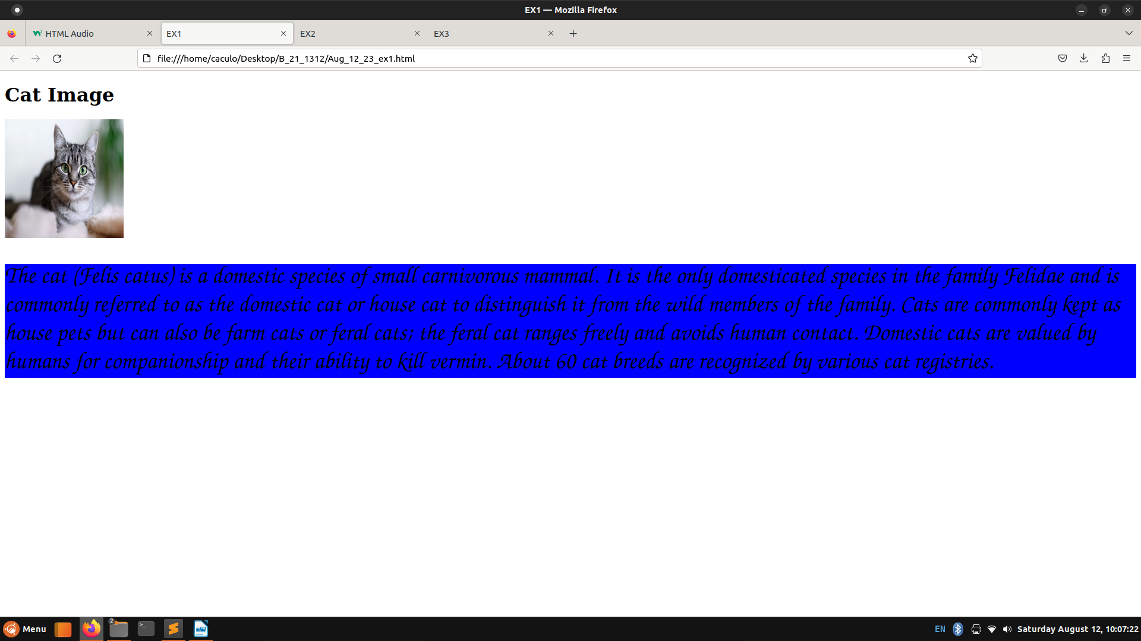
j

Experiment 2:
Date:Aug 12 2023
Code:
<!DOCTYPE html>
<html>
<head>
<!-- This is simple video playing. -->
<title>EX2</title>
<style type="text/css">
p{
color: red;
font-size: 20px;
}
</style>
</head>
<body style="background-color: lightblue;">
<h1>A Rainy Day!!</h1>
<p>This is a 30secs animated video depicting a rainy day.</p>
<video controls height="600" width="600">
<source src="RainyDayAnimation.mp4" type="video/mp4">
This video cannot be displayed
</video>
<p style="font-size: 30px; color: purple;">
This is a 30 secs animated video. It depicts a perfect rainy day. It has thunderstroms and lighting too.
</p>
</body>
</html>

Output:
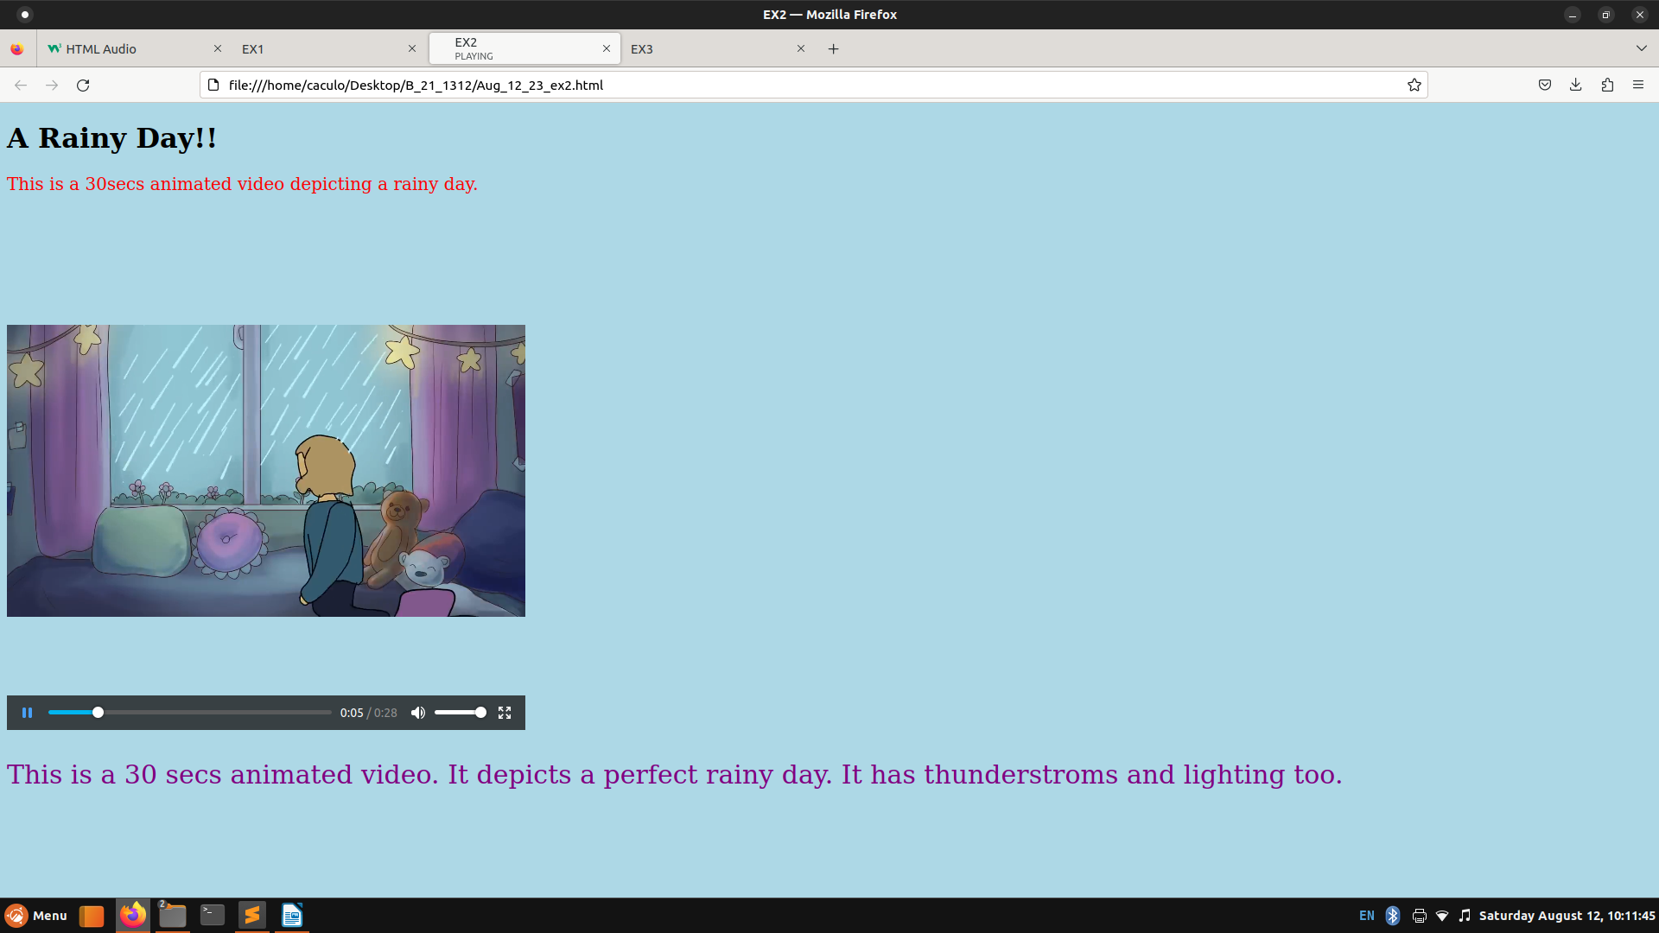

Experiment 3:
Date:Aug 12 2023
Code:
<!DOCTYPE html>
<html>
<head>
<!-- This is simple audio playing. -->
<title>EX3</title>
<style type="text/css">
p{
color: blue;
font-size: 20px;
}
</style>
</head>
<body style="background-color: lightpink;">
<h1>Happy Now Song.</h1>
<p>This is a music audio.</p>
<audio controls>
<source src="Kygo_HappyNow" type="audio/mpeg">
This audio cannot be played
</audio>
<p style="font-size: 30px; color: red;">
This is a music audio by Kygo. The song is called "Happy Now". It is a EDM style music.
</p>
</body>
</html>

Output:
