
Tag 9 - Group 20
A Mocktail of Source Code Representations

Problem statement:
In the industry of software engineering, accurately representing source code is critical for performing various tasks such as code classification, summarization, and method name prediction. Traditional approaches, which rely on Abstract Syntax Trees (ASTs), are limited in their ability to capture the full range of syntactic and semantic information of the source code.
- These limitations can lead to below par performance in crucial tasks, resulting in inaccuracies and inefficiencies in software development processes.

- Specifically, methods that depend exclusively on ASTs struggle to encapsulate complex code structures, relationships, and dependencies, which are essential for advanced software engineering tasks.

So our task is to find a representation model which is efficient and accurate than the traditional models like AST,CFG and PDG.
Abstract Syntax Tree (AST):
- Represents the syntactical structure of code in a tree format. Each node in the tree corresponds to a construct in the source code, such as expressions, statements, or declarations.
- Great for understanding the syntactic structure of the code, such as parsing, refactoring, and formatting tasks.
- But does not capture control flow or data dependencies.
- Not sufficient for understanding how the code actually executes (e.g., how data flows through the program).

Control Flow Graph (CFG):
- Represents the flow of control through a program, with nodes representing basic blocks of code and edges representing control flow paths (e.g., if/else branches, loops).
- Excellent for analysing potential execution paths, finding unreachable code, and optimizing control flow.
- Does not provide information on how data flows between variables.

Program Dependence Graph (PDG):
- Represents the data and control dependencies between various parts of the code. Nodes represent operations/statements, and edges represent data and control dependencies.
- Captures both data and control dependencies, which is crucial for understanding how data is manipulated across the program.
- PDGs are more complex to generate and analyse compared to ASTs and CFGs and can be computationally expensive, especially for large codebases.

Code Property Graph (CPG):
- A hybrid graph that combines AST, CFG, and PDG into a single unified graph. It captures the syntactic structure, control flow, and data dependencies of the code.
- Highly effective for vulnerability analysis and detecting complex security issues like clone detection, code injection, buffer overflows, etc.
- The complexity and size of a CPG can be significantly higher than any individual graph. So building and querying of a CPG requires more computational resources and time.

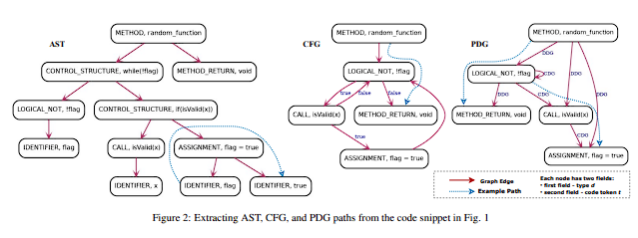
Which One is the Best?
- AST: Best for tasks that involve syntactical analysis, such as parsing, code generation, and refactoring.
- CFG: Ideal for analysing cont+rol flow, execution paths, and optimizing code by identifying unreachable or redundant paths.
- PDG: Best suited for data flow analysis, parallelization, and program slicing, where understanding data dependencies is crucial.
- CPG: The best choice for comprehensive code analysis, especially in security and vulnerability detection, where understanding both control flow and data dependencies is essential.
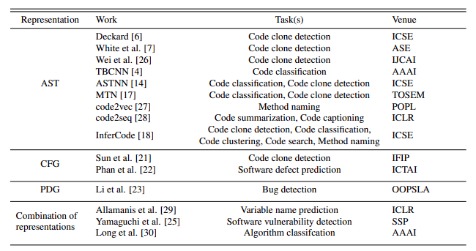
Accuracy data for each representation:
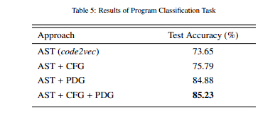
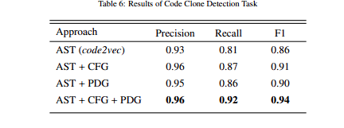

So we choose CPG (AST+CFG+PDG) as the mocktail representation.

Methodology:
- Collect various codes of java as dataset.
- Generate AST representation for the collected code dataset.

Implementation Of AST:
import javalang
import matplotlib.pyplot as plt
import networkx as nx

java_code = """
public class HelloWorld {
public static void main(String[] args) {
int x = 0;
if (x < 10) {
x = x + 1;
} else {
x = x - 1;
}
while (x < 20) {
x = x + 2;
}
System.out.println(x);
}
}
"""

tokens = javalang.tokenizer.tokenize(java_code)
parser = javalang.parser.Parser(tokens)
tree = parser.parse()

def ast_to_nx_graph(node, graph=None, parent=None):
if graph is None:
graph = nx.DiGraph()

if parent is not None:
graph.add_edge(parent, node)

if hasattr(node, 'children'):
for child in (node.children if isinstance(node.children, list) else [node.children]):
if isinstance(child, javalang.ast.Node):
ast_to_nx_graph(child, graph, node)
elif isinstance(child, (list, tuple)):
for item in child:
if isinstance(item, javalang.ast.Node):
ast_to_nx_graph(item, graph, node)

return graph

graph = ast_to_nx_graph(tree)

plt.figure(figsize=(50, 50))
pos = nx.spring_layout(graph, seed=42)
nx.draw(graph, pos, with_labels=True, arrows=True, node_size=1000, node_color='skyblue', font_size=10, font_weight='bold', edge_color='gray')
plt.title('AST Tree Visualization')
plt.show()

Output:
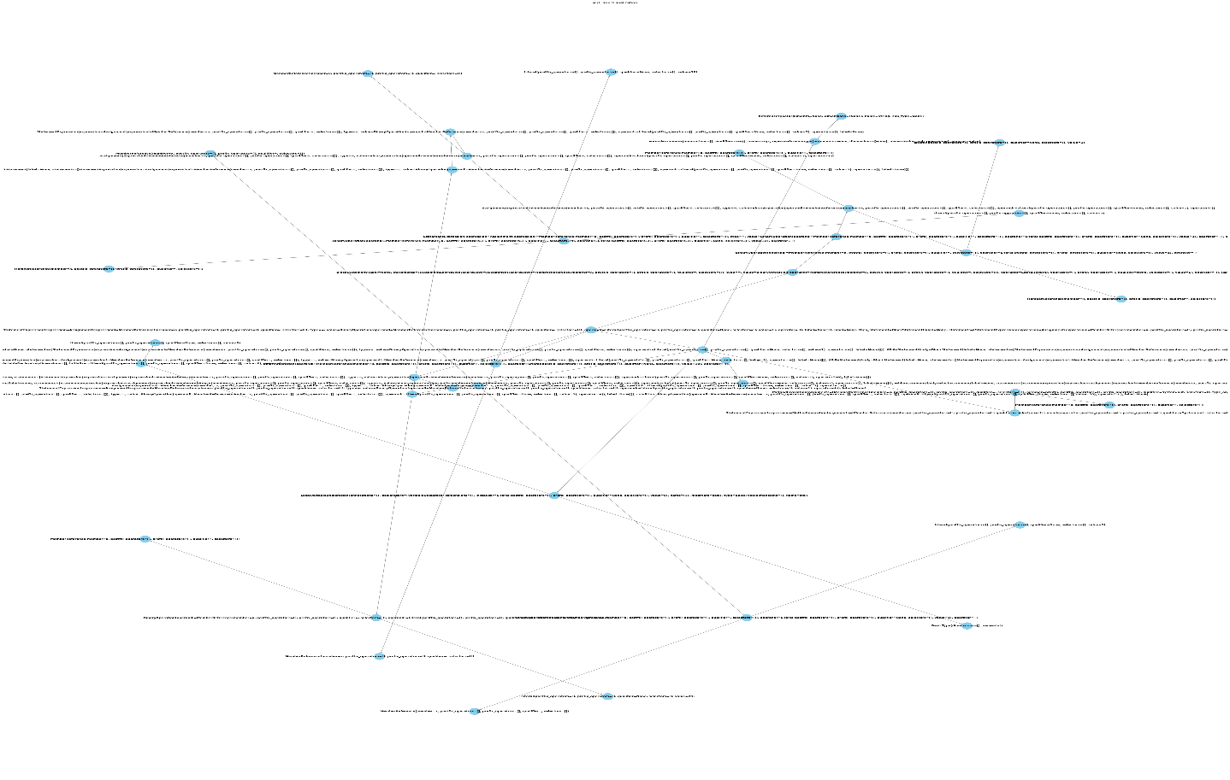
Similarly,
- Generate CFG, PDG representations for the same.
- At last, Generate CPG representation from the previous representations, as CPG has the best accuracy in detecting bugs in the code.
References:
[1] Karthik Chandra Swarnaa , Noble Saji Mathewsa , Dheeraj Vagavolua , Sridhar Chimalakondaa , “On the Impact of Multiple Source Code Representations on Software Engineering Tasks - An Empirical Study”, Department of Computer Science and Engineering, 2023
IEEE link : On the impact of multiple source code representations on software engineering tasks — An empirical study - ScienceDirect
[2] Fabian Yamaguchi , Nico Golde , Daniel Arp , Konrad Rieck , “Modeling and Discovering Vulnerabilities with Code Property Graphs” , University of Gottingen, 2014
IEEE link: https://ieeexplore.ieee.org/document/6956589

