Question 1. 6, 23, 47, ?, 130, 189 Find the missing number.

1. 83
2. 84
3. 85
4. 86

Question 2. 29.98% of 880.001 = ? + 110.9

1. 144
2. 153
3. 158
4. 160

Question 3. Four of the following five are similar in some way, so they form a group. Which is the one that does not belong in this group ?

1. F
2. D
3. B
4. R
5. C

Question 4. If a car goes at a speed of 40 km/h and comes back with a speed of 50 km/h, what will be the average speed of the car ?

1. 90 km/h
2. 45km/h
3. insufficient data
4. None of them above

Question 5. Raju is Raman's uncle. Raman's grandfather has only two children, one of whom is Kiran's brother-in-law. Raman is not Kiran's son. How is Raju related to Kiran?

1. Uncle
2. Brother
3. Sister
4. Husband

Question 6. If H.C.F. and L.C.M. of two numbers are 3 and 60 respectively and. one number is 12 then find the other number.

1. 14
2. 15
3. 16
4. None of them above

Question 7. 465 coins consists of 1 rupee, 50 paise and 25 paise coin. Their values are in the ratio 5:3:1. The number of each type of coins respectively is

1. 155, 186, 124
2. 154, 185, 126
3. 154, 187, 124
4. 150, 140, 175

Question 8. A single discount equal to a discount series of 10% and 20% is

1. 25%
2. 28%
3. 30%
4. 35%

Question 9. How many triangles are there in the following figures ?

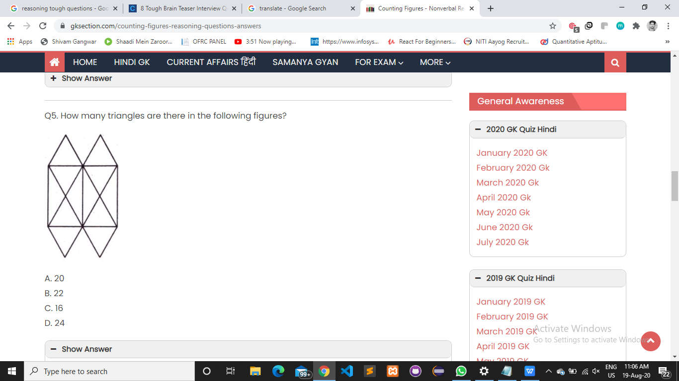

1. 20
2. 24
3. 16
4. 22

Question 10. In a class of 120 students numbered 1 to 120, all even numbered students opt for Physics, whose numbers are divisible by 5 opt for Chemistry and those whose numbers are divisible by 7 opt for Math. How many opt for none of the three subjects?.

1. 19
2. 41
3. 26
4. 21